Supplementary Materials
Supplementary Figures and Figure Legends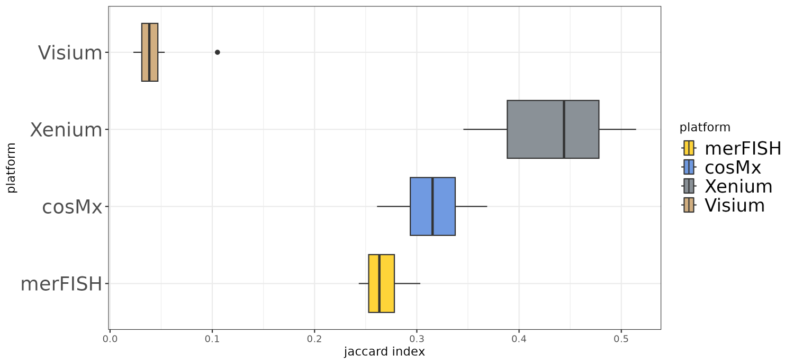
Supplementary Figure 1. Similarity between HVG and SVG for the benchmarked datasets, divided by platform.

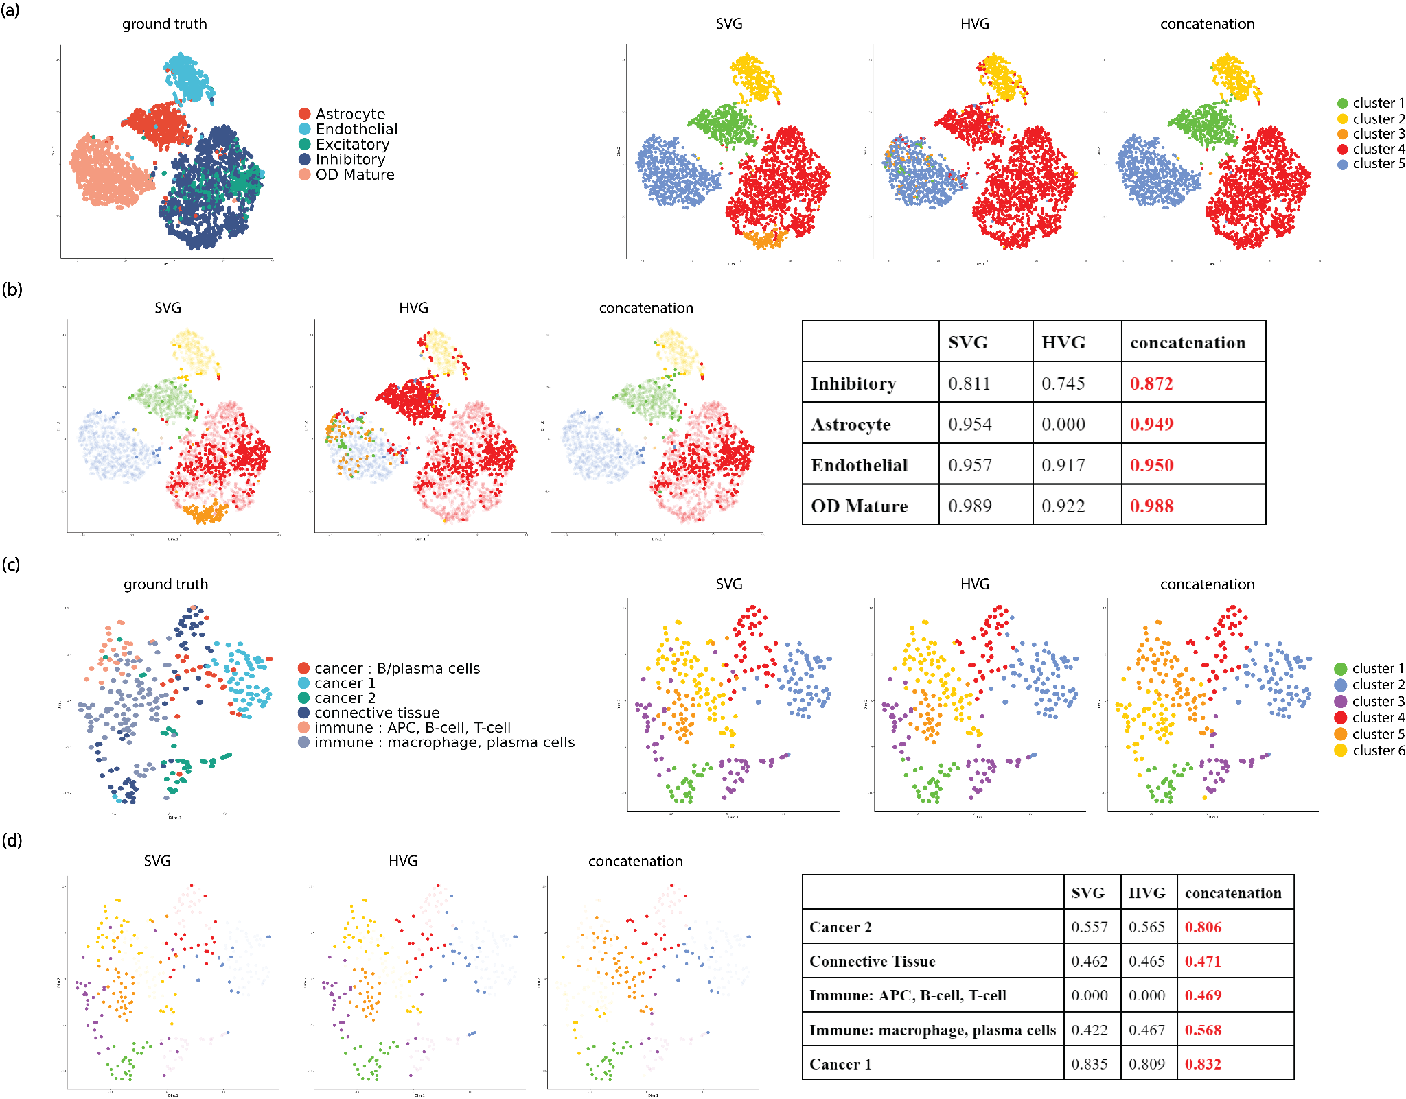
Supplementary Figure 2. Comparison of cluster performance of SV genes, HV genes, and their union set for Leiden for representative datasets on the tSNE space for the union set. (a) comparison of clustering labels for merFISH mouse hypothalamus dataset (bregma: 210). (b) comparison of tSNE space highlighting mis-classified clusters for each gene set for merFISH mouse hypothalamus dataset (bregma: 210), with cluster-specific F1 scores for each gene set summarized in a table. (c) comparison of clustering labels for Visium Breast Cancer dataset (sample D1). (d) comparison of tSNE space highlighting mis-classified clusters for each gene set in Visium Breast Cancer dataset (sample D1), with cluster-specific F1 scores for each gene set summarized in a table.
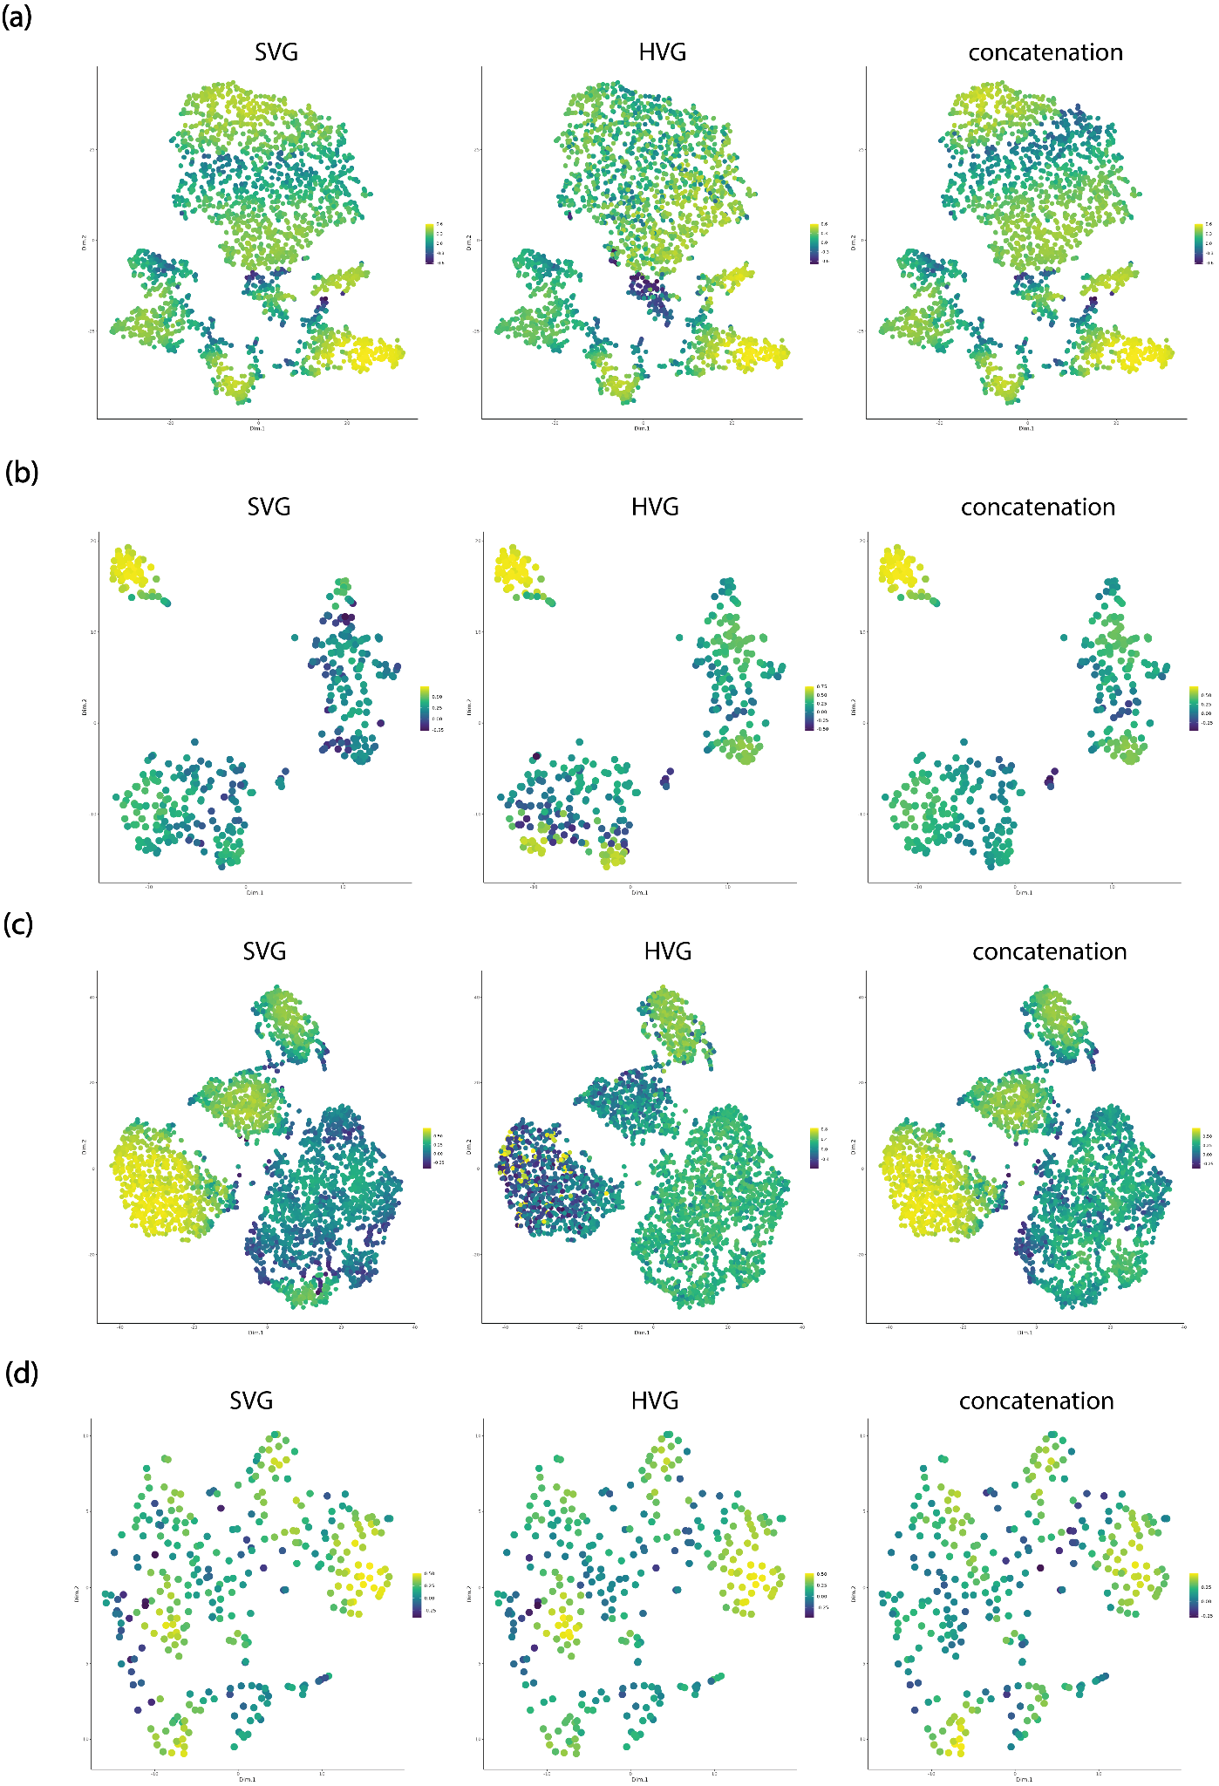
Supplementary Figure 3. Comparison of cell / spot-level silhouette widths of representative datasets (a) cosMx NSCLC dataset for patient 2, FOV 7, (b) Xenium Kidney dataset sample N7, (c) merFISH mouse hypothalamus dataset (bregma: 210), and (d) Visium Breast Cancer dataset, sample D1.

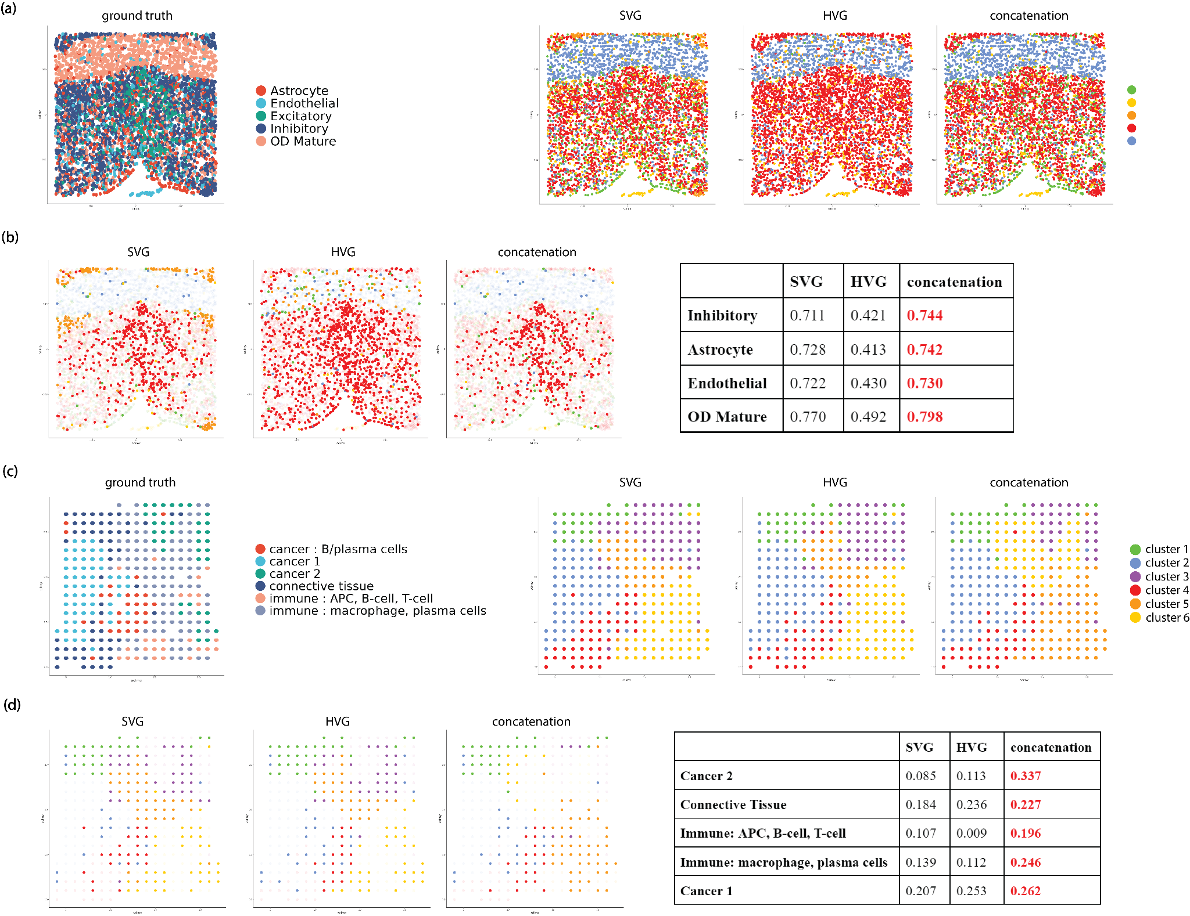
Supplementary Figure 4. Comparison of cluster performance of SV genes, HV genes, and their union set for Leiden for representative datasets on the tissue space. (a) comparison of clustering labels for merFISH mouse hypothalamus dataset (bregma: 210). (b) comparison of tissue space highlighting mis-classified clusters for each gene set in merFISH mouse hypothalamus dataset (bregma: 210), with cluster-specific spatial AMI scores for each gene set summarized in a table. (c) comparison of clustering labels for Visium Breast Cancer dataset (sample D1). (d) comparison of tissue space highlighting mis-classified clusters for each gene set in Visium Breast Cancer dataset (sample D1), with cluster-specific spatial AMI scores for each gene set summarized in a table.

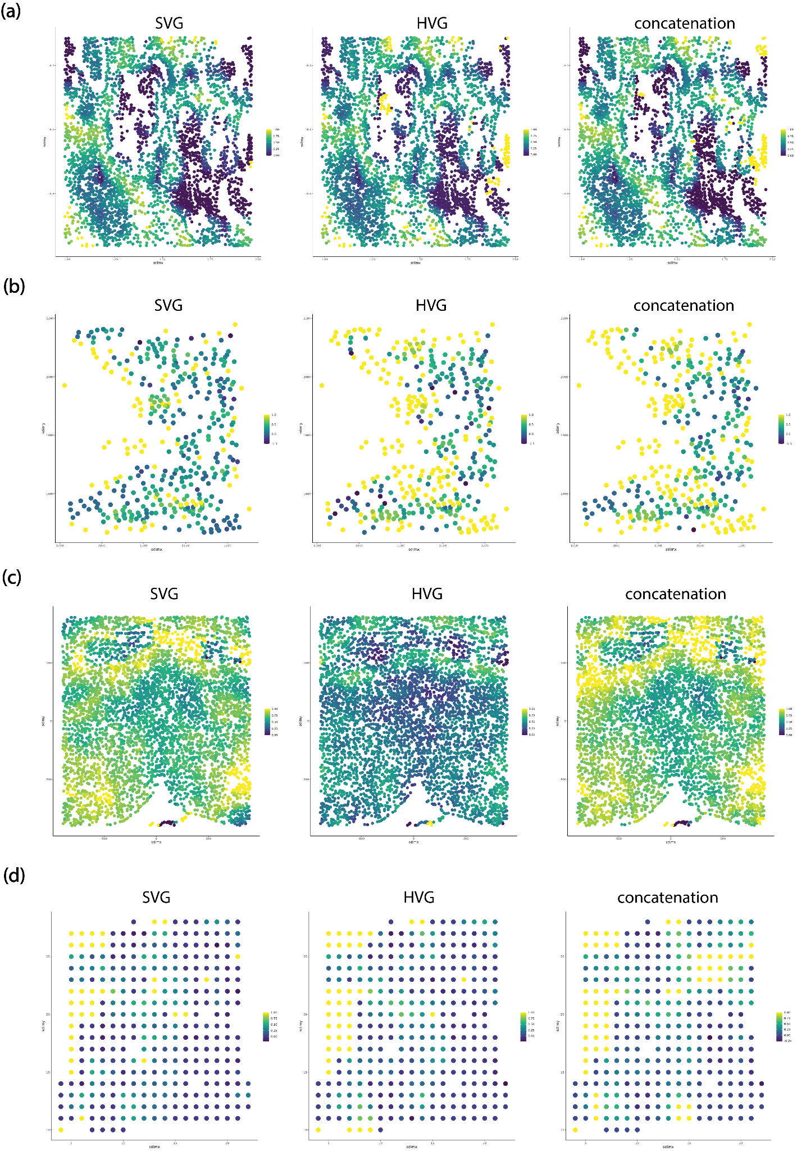
Supplementary Figure 5. Comparison of cell / spot-level spatial AMI of representative datasets (a) cosMx NSCLC dataset for patient 2, FOV 7, (b) Xenium Kidney dataset sample N7, (c) merFISH mouse hypothalamus dataset (bregma: 210), and (d) Visium Breast Cancer dataset, sample D1.

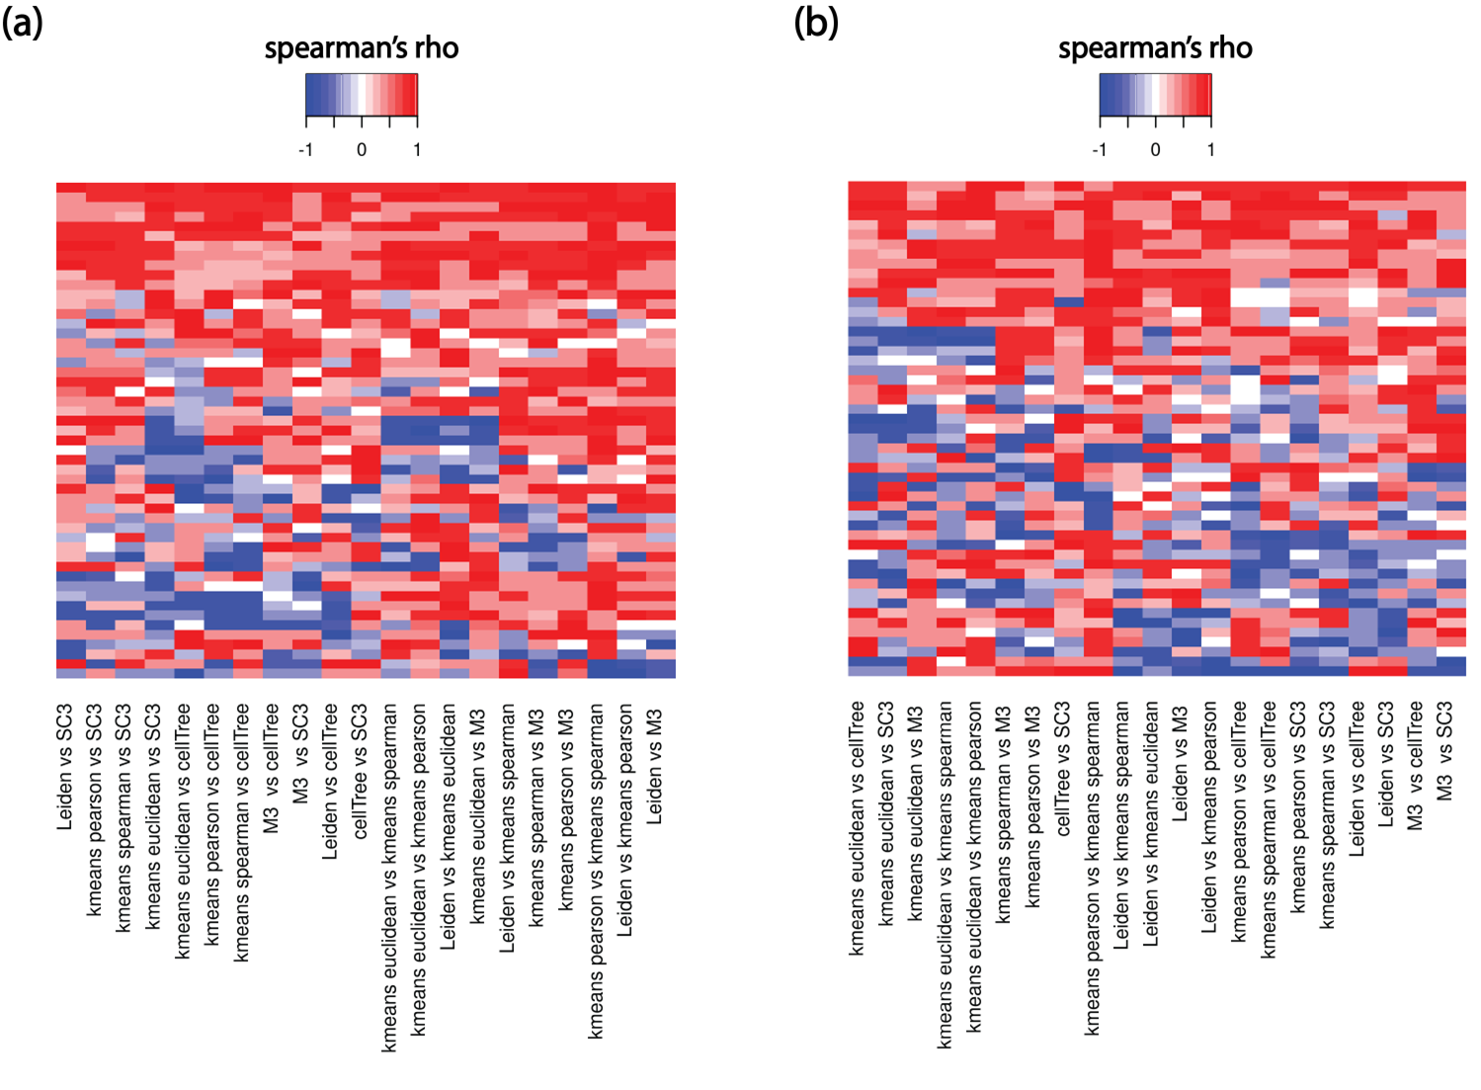
Supplementary Figure 6. (a) Spearman’s rho of the gene sets’ ranking in AMI between different clustering methods. (b) Spearman’s rho of the gene sets’ ranking in Spatial Concordance between different clustering methods.

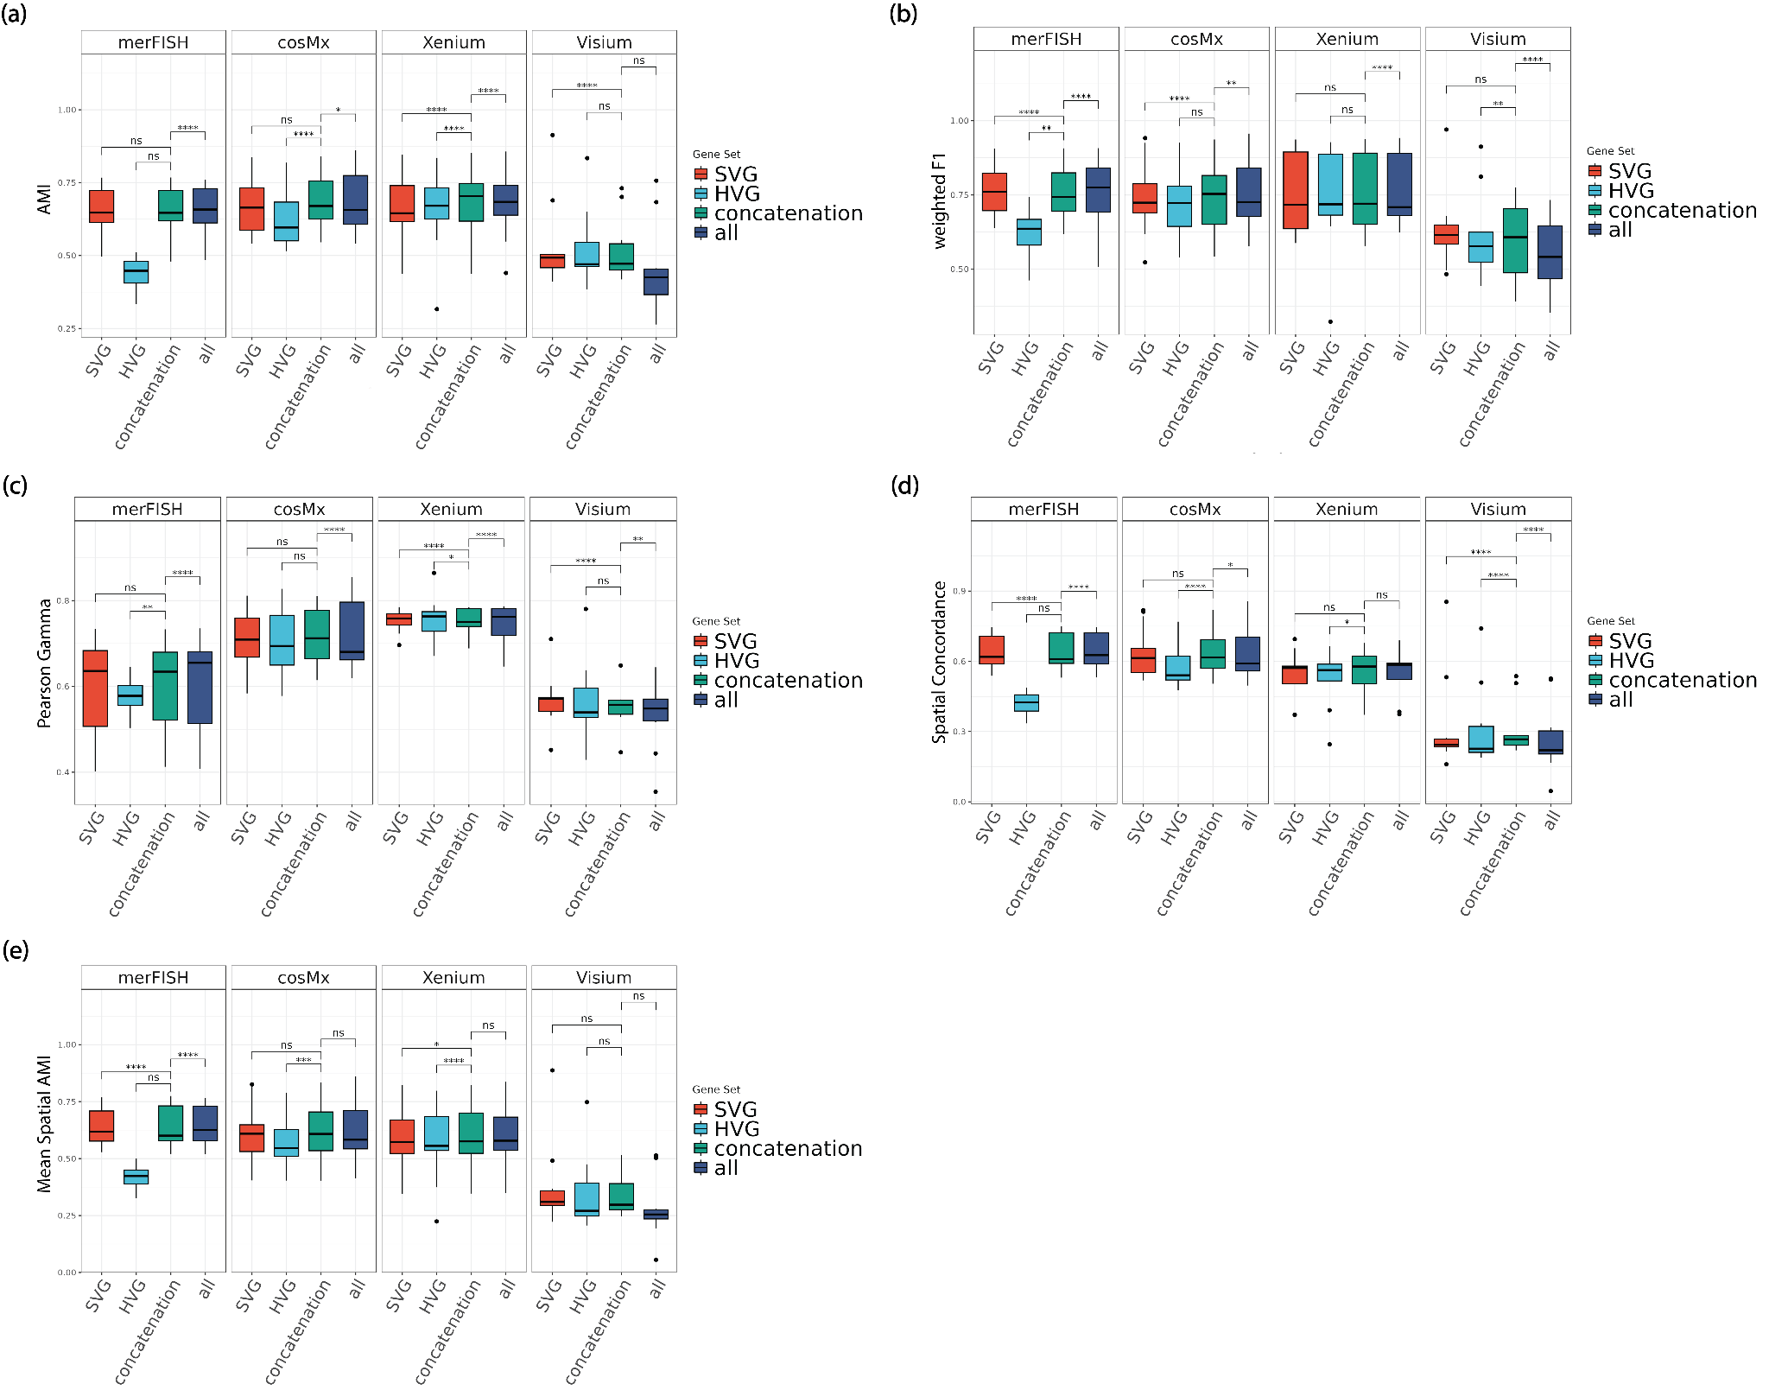
Supplementary Figure 7. Comparison of cluster performance of SV genes, HV genes, their union set, and all genes for Monocle3: (a) AMI. (b) weighted F1. (c) Pearson Gamma. (d) Spatial Concordance. (e) Mean Spatial AMI.
Note: ****: p-value<1e-3; ***: 1e-3 ≤ p-value < 1e-2; **: 1e-2 ≤ p-value < 5e-2; *: 5e-2 ≤ p-value < 0.1; ns: 0.1 ≤ p-value ≤ 1.

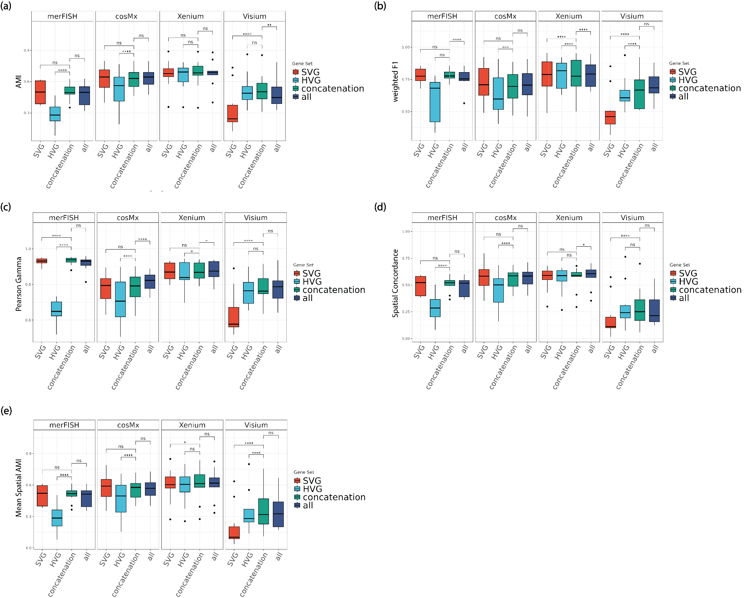
Supplementary Figure 8. Comparison of cluster performance of SV genes, HV genes, their union set, and all genes for SC3: (a) AMI. (b) weighted F1. (c) Pearson Gamma. (d) Spatial Concordance. (e) Mean Spatial AMI.
Note: ****: p-value<1e-3; ***: 1e-3 ≤ p-value < 1e-2; **: 1e-2 ≤ p-value < 5e-2; *: 5e-2 ≤ p-value < 0.1; ns: 0.1 ≤ p-value ≤ 1.

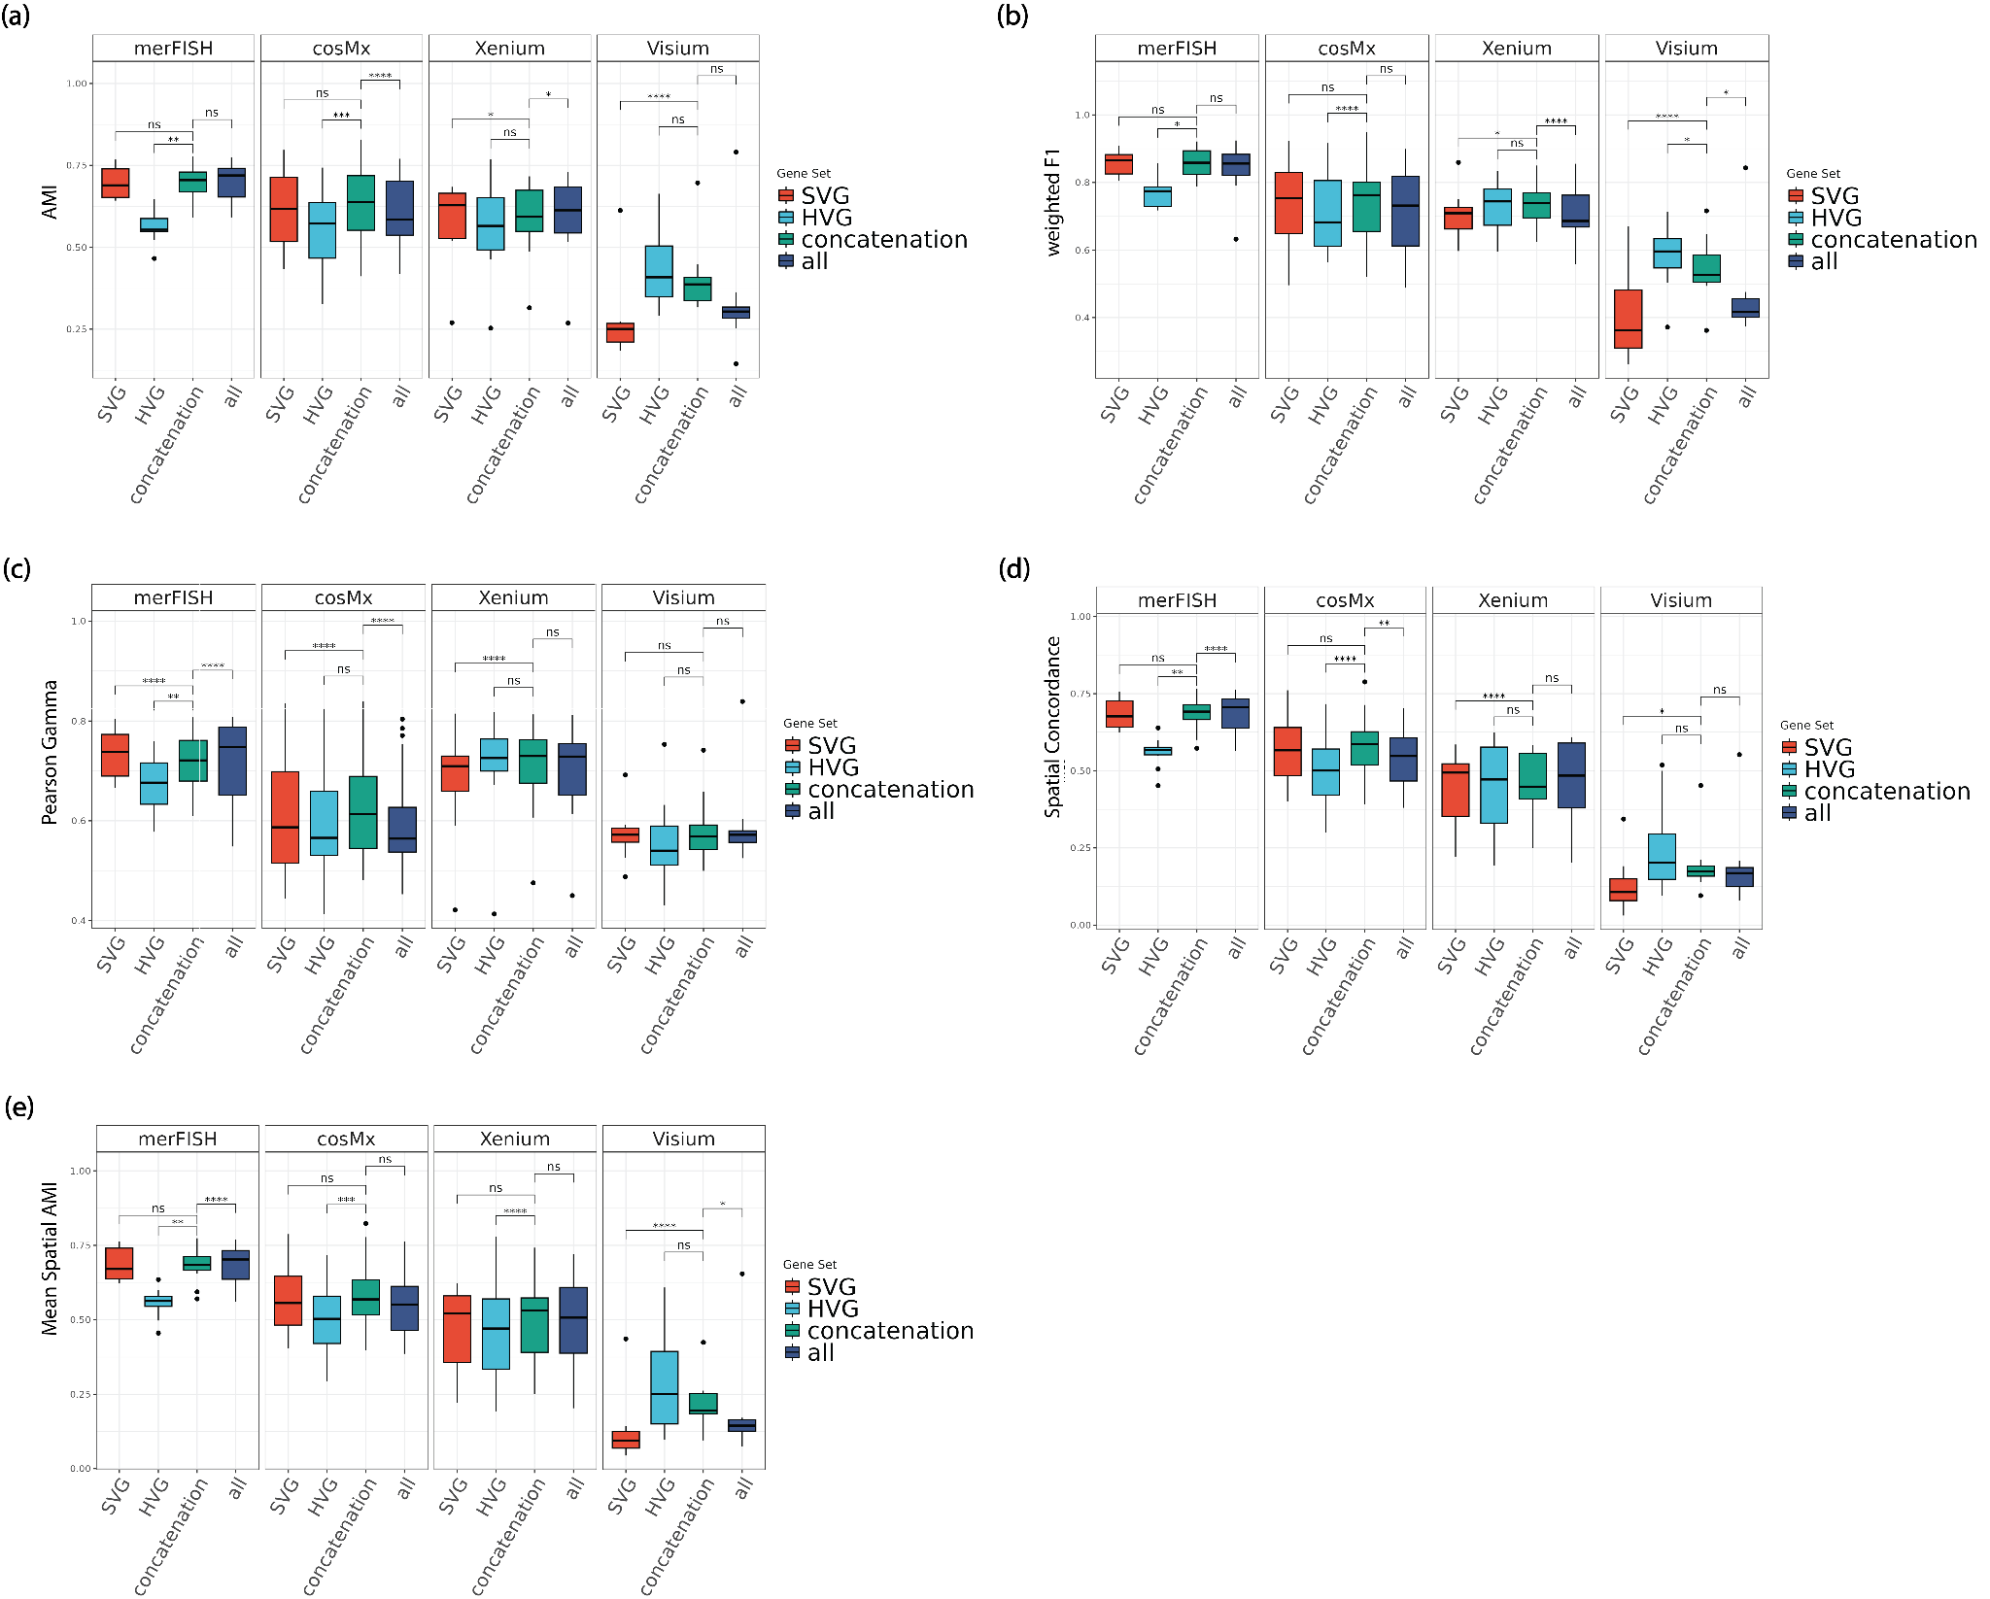
Supplementary Figure 9. Comparison of cluster performance of SV genes, HV genes, their union set, and all genes for cellTree: (a) AMI. (b) weighted F1. (c) Pearson Gamma. (d) Spatial Concordance. (e) Mean Spatial AMI.
Note: ****: p-value<1e-3; ***: 1e-3 ≤ p-value < 1e-2; **: 1e-2 ≤ p-value < 5e-2; *: 5e-2 ≤ p-value < 0.1; ns: 0.1 ≤ p-value ≤ 1.

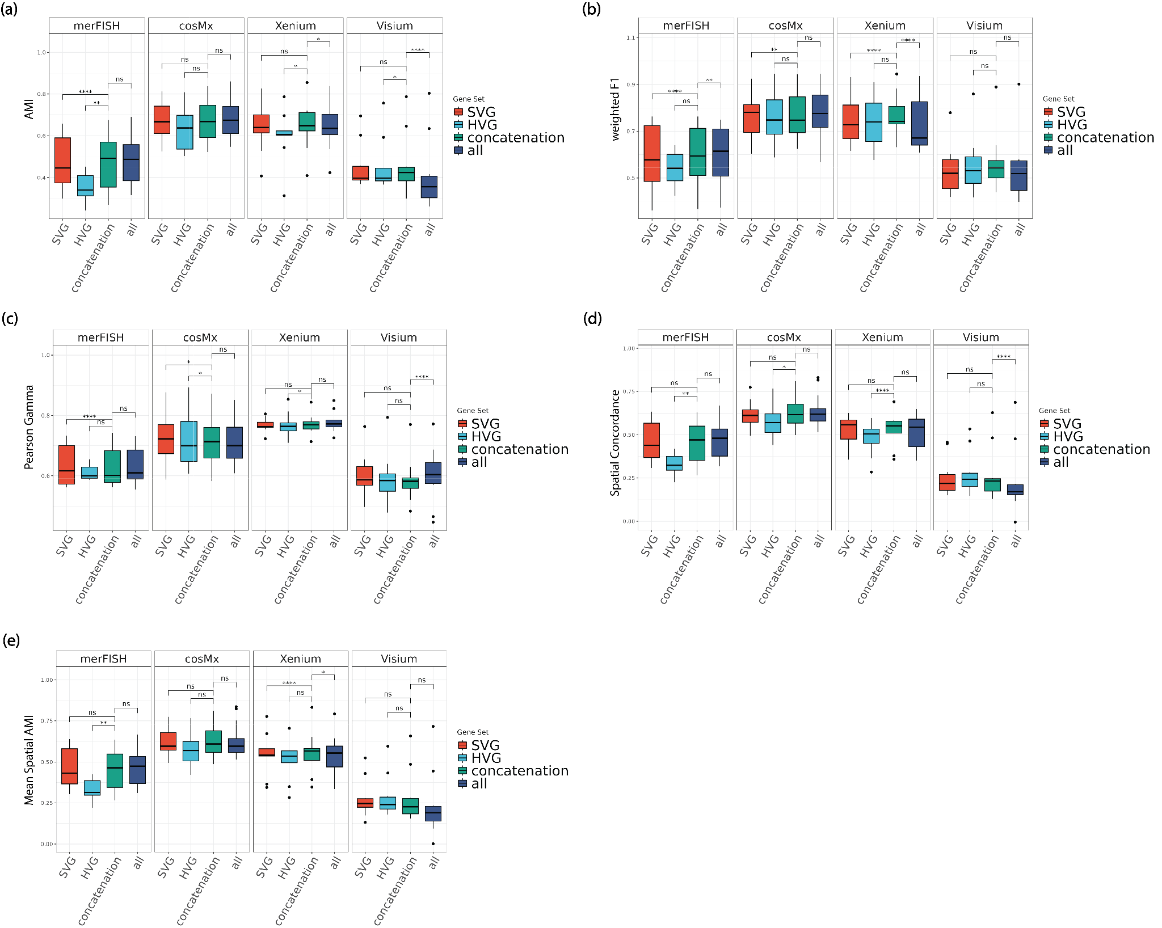
Supplementary Figure 10. Comparison of cluster performance of SV genes, HV genes, their union set, and all genes for kmeans (pearson): (a) AMI. (b) weighted F1. (c) Pearson Gamma. (d) Spatial Concordance. (e) Mean Spatial AMI.
Note: ****: p-value<1e-3; ***: 1e-3 ≤ p-value < 1e-2; **: 1e-2 ≤ p-value < 5e-2; *: 5e-2 ≤ p-value < 0.1; ns: 0.1 ≤ p-value ≤ 1.

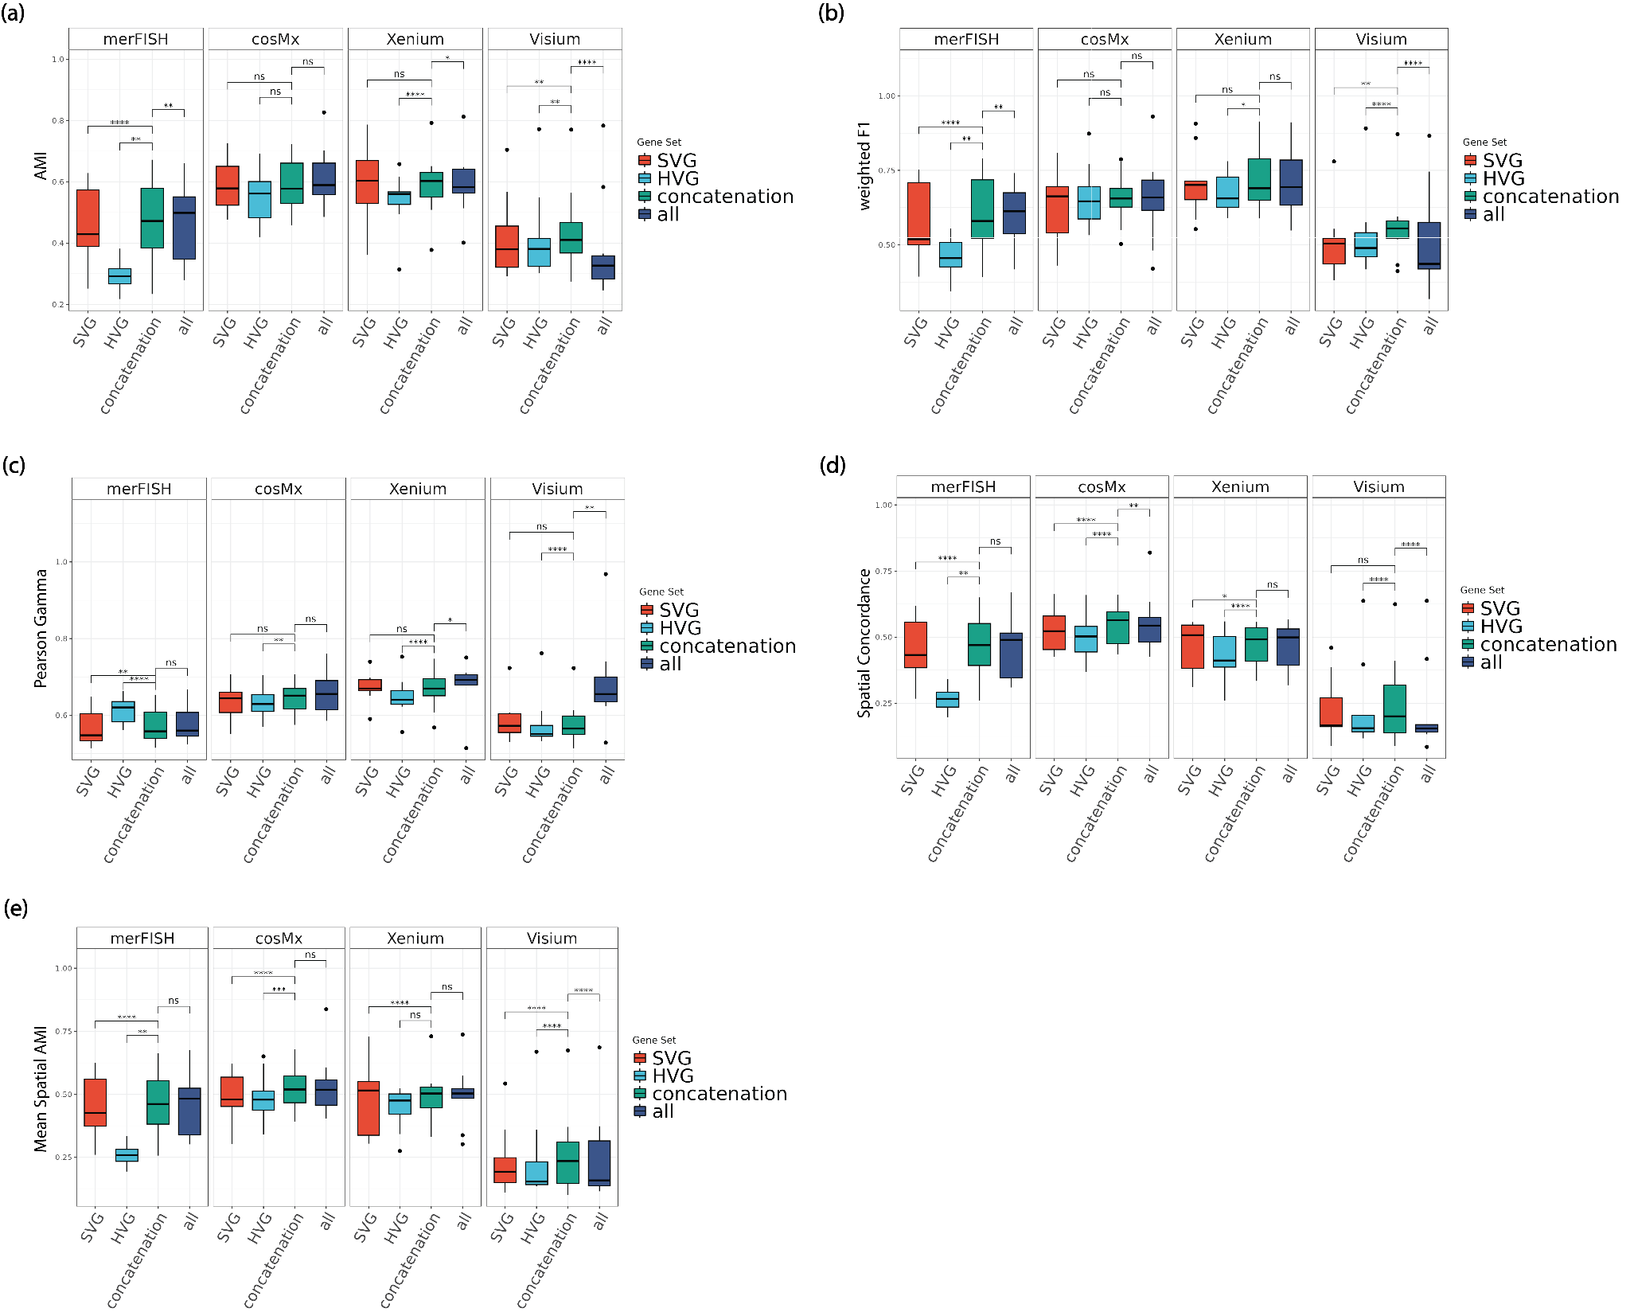
Supplementary Figure 11. Comparison of cluster performance of SV genes, HV genes, their union set, and all genes for kmeans (spearman): (a) AMI. (b) weighted F1. (c) Pearson Gamma. (d) Spatial Concordance. (e) Mean Spatial AMI.
Note: ****: p-value<1e-3; ***: 1e-3 ≤ p-value < 1e-2; **: 1e-2 ≤ p-value < 5e-2; *: 5e-2 ≤ p-value < 0.1; ns: 0.1 ≤ p-value ≤ 1.

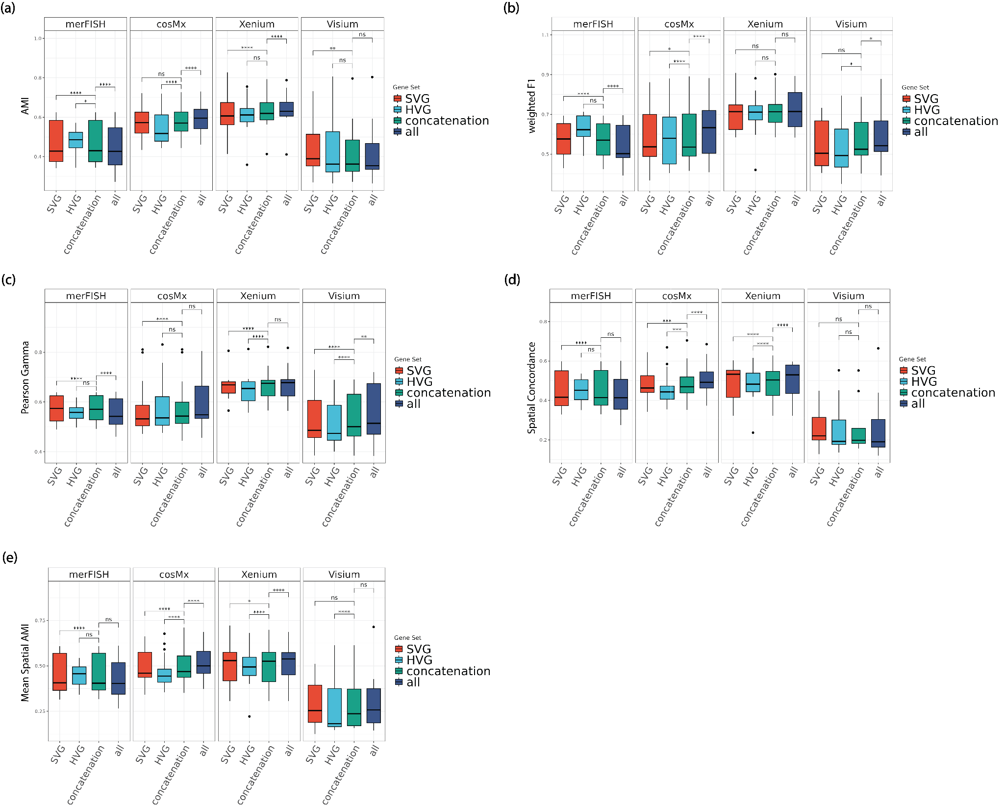
Supplementary Figure 12. Comparison of cluster performance of SV genes, HV genes, their union set, and all genes for kmeans (eulidean): (a) AMI. (b) weighted F1. (c) Pearson Gamma. (d) Spatial Concordance. (e) Mean Spatial AMI.
Note: ****: p-value<1e-3; ***: 1e-3 ≤ p-value < 1e-2; **: 1e-2 ≤ p-value < 5e-2; *: 5e-2 ≤ p-value < 0.1; ns: 0.1 ≤ p-value ≤ 1.

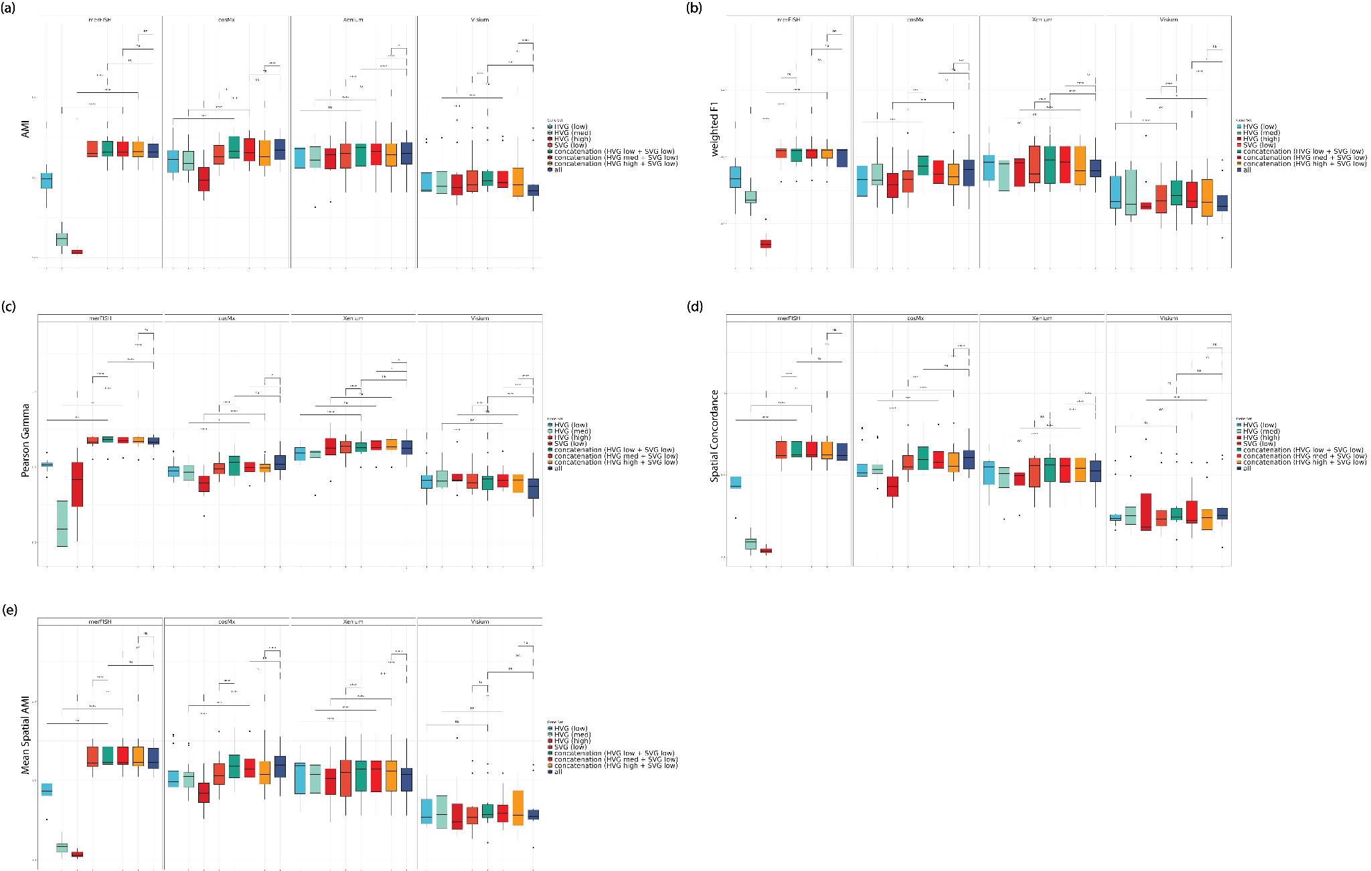
Supplementary Figure 13. Comparisons of clustering performance of real spatial transcriptomics datasets, in four representative platforms including merFISH, cosMx, Xenium, and Visium at varying HV genes thresholds with respect to (a) AMI, (b) weighted F1, (c) Pearson Gamma, (d) Spatial Concordance, (e) Mean Spatial AMI.
Note: ****: p-value<1e-3; ***: 1e-3 ≤ p-value < 1e-2; **: 1e-2 ≤ p-value < 5e-2; *: 5e-2 ≤ p-value < 0.1; ns: 0.1 ≤ p-value ≤ 1.

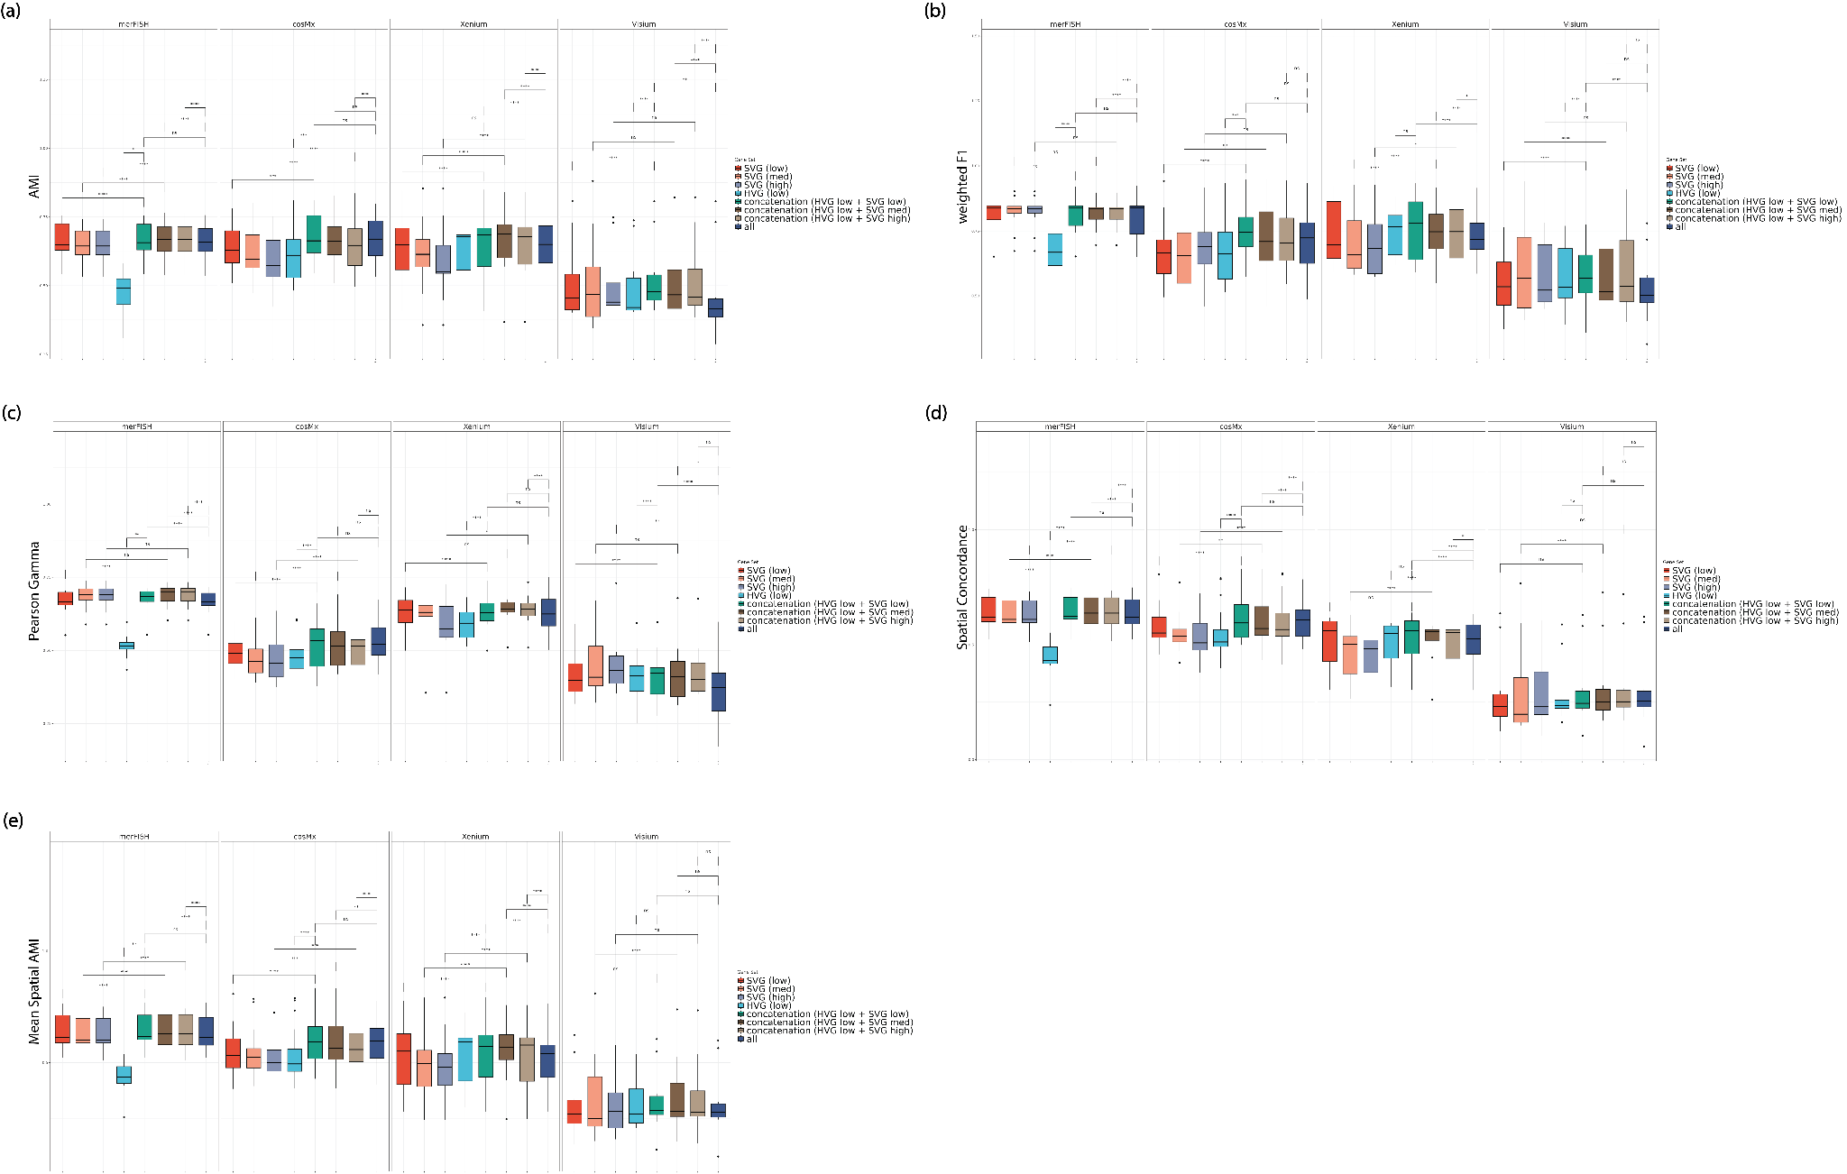
Supplementary Figure 14. Comparisons of clustering performance of real spatial transcriptomics datasets, in four representative platforms including merFISH, cosMx, Xenium, and Visium at varying SV genes thresholds with respect to (a) AMI, (b) weighted F1, (c) Pearson Gamma, (d) Spatial Concordance, (e) Mean Spatial AMI.
Note: ****: p-value<1e-3; ***: 1e-3 ≤ p-value < 1e-2; **: 1e-2 ≤ p-value < 5e-2; *: 5e-2 ≤ p-value < 0.1; ns: 0.1 ≤ p-value ≤ 1.

Supplementary Tables and Table Legends
Supplementary Table 1: Summary of highly variable genes and spatially variable genes at different threshold levels.
Dataset | HV genes (low) | HV genes (med) | HV genes (high) | SV genes (low) | SV genes (med) | SV genes (high)
Mouse Brain Olfactory Bulb Dataset (replicate 1) | 2339 | 1404 | 468 | 973 | 487 | 244
HER2 Breast Cancer Dataset (sample A3) | 1833 | 1100 | 367 | 720 | 360 | 180
HER2 Breast Cancer Dataset (sample B3) | 1255 | 753 | 251 | 713 | 357 | 179
HER2 Breast Cancer Dataset (sample B6) | 1502 | 901 | 301 | 854 | 427 | 214
HER2 Breast Cancer Dataset (sample D1) | 2175 | 1305 | 435 | 595 | 298 | 149
HER2 Breast Cancer Dataset (sample D2) | 1951 | 1171 | 391 | 733 | 367 | 184
HER2 Breast Cancer Dataset (sample D3) | 1953 | 1172 | 391 | 719 | 360 | 180
HER2 Breast Cancer Dataset (sample D5) | 1865 | 1119 | 373 | 607 | 304 | 152
HER2 Breast Cancer Dataset (sample E1) | 951 | 571 | 191 | 528 | 264 | 132
Ovarian Cancer Dataset (sample B_GTFB1191) | 1742 | 1045 | 349 | 10101 | 5051 | 3684
Human Kidney Dataset (sample N7) | 87 | 68 | 49 | 106 | 53 | 27
Human Kidney Dataset (sample O7) | 100 | 78 | 56 | 162 | 81 | 50
Human Kidney Dataset (sample O8) | 124 | 96 | 69 | 205 | 108 | 78
Human Kidney Dataset (sample R7) | 100 | 78 | 56 | 222 | 111 | 111
Human Kidney Dataset (sample S7) | 113 | 88 | 63 | 224 | 128 | 108
Human Kidney Dataset (sample T7) | 110 | 86 | 62 | 211 | 106 | 69
Human Kidney Dataset (sample U7) | 101 | 79 | 57 | 198 | 99 | 65
Mouse Brain ATN Dataset (sample S1 anterior) | 79 | 61 | 44 | 178 | 92 | 82
Mouse Brain ATN Dataset (sample S2 interior) | 83 | 65 | 47 | 189 | 128 | 128
Mouse Brain Hypothalamus Dataset (bregma: -140) | 42 | 25 | 9 | 147 | 107 | 107
Mouse Brain Hypothalamus Dataset (bregma: -190) | 42 | 25 | 9 | 148 | 105 | 105
Mouse Brain Hypothalamus Dataset (bregma: -240) | 43 | 26 | 9 | 139 | 99 | 99
Mouse Brain Hypothalamus Dataset (bregma: -290) | 43 | 26 | 9 | 141 | 102 | 102
Mouse Brain Hypothalamus Dataset (bregma: -40) | 43 | 26 | 9 | 147 | 101 | 101
Mouse Brain Hypothalamus Dataset (bregma: -90) | 42 | 25 | 9 | 146 | 106 | 106
Mouse Brain Hypothalamus Dataset (bregma: 10) | 44 | 26 | 9 | 144 | 114 | 114
Mouse Brain Hypothalamus Dataset (bregma: 110) | 39 | 24 | 8 | 144 | 98 | 98
Mouse Brain Hypothalamus Dataset (bregma: 160) | 46 | 28 | 10 | 143 | 101 | 101
Mouse Brain Hypothalamus Dataset (bregma: 210) | 43 | 26 | 9 | 141 | 98 | 98
Mouse Brain Hypothalamus Dataset (bregma: 260) | 40 | 24 | 8 | 139 | 82 | 82
Mouse Brain Hypothalamus Dataset (bregma: 60) | 43 | 26 | 9 | 148 | 107 | 107
Human Lung NSCLC Dataset (patient 5, Rep 1, FOV 1) | 154 | 92 | 31 | 300 | 150 | 86
Human Lung NSCLC Dataset (patient 5, Rep 1, FOV 23) | 191 | 115 | 39 | 307 | 154 | 82
Human Lung NSCLC Dataset (patient 5, Rep 1, FOV 25) | 157 | 94 | 32 | 360 | 180 | 110
Human Lung NSCLC Dataset (patient 5, Rep 2, FOV 14) | 279 | 168 | 56 | 204 | 102 | 56
Human Lung NSCLC Dataset (patient 5, Rep 2, FOV 18) | 255 | 153 | 51 | 357 | 179 | 107
Human Lung NSCLC Dataset (patient 5, Rep 2, FOV 20) | 184 | 111 | 37 | 407 | 204 | 133
Human Lung NSCLC Dataset (patient 5, Rep 2, FOV 21) | 223 | 134 | 45 | 330 | 165 | 103
Human Lung NSCLC Dataset (patient 5, Rep 2, FOV 24) | 217 | 130 | 44 | 208 | 104 | 61
Human Lung NSCLC Dataset (patient 5, Rep 2, FOV 7) | 215 | 129 | 43 | 581 | 339 | 289
Human Lung NSCLC Dataset (patient 5, Rep 3, FOV 12) | 142 | 85 | 29 | 492 | 259 | 204
Human Lung NSCLC Dataset (patient 5, Rep 3, FOV 13) | 156 | 94 | 32 | 422 | 211 | 143
Human Lung NSCLC Dataset (patient 5, Rep 3, FOV 14) | 173 | 104 | 35 | 228 | 114 | 59
Human Lung NSCLC Dataset (patient 5, Rep 3, FOV 15) | 184 | 110 | 37 | 503 | 260 | 210
Human Lung NSCLC Dataset (patient 5, Rep 3, FOV 19) | 162 | 97 | 33 | 331 | 166 | 83
Human Lung NSCLC Dataset (patient 5, Rep 3, FOV 22) | 180 | 108 | 36 | 328 | 164 | 90
Human Lung NSCLC Dataset (patient 5, Rep 3, FOV 24) | 151 | 91 | 31 | 247 | 124 | 74
Human Lung NSCLC Dataset (patient 5, Rep 3, FOV 25) | 132 | 79 | 27 | 303 | 152 | 78
Human Lung NSCLC Dataset (patient 5, Rep 3, FOV 27) | 143 | 86 | 29 | 417 | 213 | 162
Human Lung NSCLC Dataset (patient 5, Rep 3, FOV 28) | 204 | 123 | 41 | 605 | 322 | 283
Human Lung NSCLC Dataset (patient 5, Rep 3, FOV 30) | 144 | 87 | 29 | 345 | 173 | 93

Supplementary Table 2: Summary of concatenation gene sets at different highly variable genes and spatially variable genes threshold levels.
Dataset | Concatenation (HV genes low + SV genes low) | Concatenation (HV genes low + SV genes med) | Concatenation (HV genes low + SV genes high) | Concatenation (HV genes med + SV genes low) | Concatenation (HV genes high + SV genes low)
Mouse Brain Olfactory Bulb Dataset (replicate 1) | 3144 | 2738 | 2539 | 2271 | 1406
HER2 Breast Cancer Dataset (sample A3) | 2488 | 2139 | 1994 | 1753 | 1067
HER2 Breast Cancer Dataset (sample B3) | 1913 | 1587 | 1418 | 1430 | 957
HER2 Breast Cancer Dataset (sample B6) | 2248 | 1876 | 1684 | 1690 | 1132
HER2 Breast Cancer Dataset (sample D1) | 2689 | 2430 | 2305 | 1849 | 1010
HER2 Breast Cancer Dataset (sample D2) | 2590 | 2267 | 2107 | 1846 | 1108
HER2 Breast Cancer Dataset (sample D3) | 2568 | 2247 | 2102 | 1832 | 1092
HER2 Breast Cancer Dataset (sample D5) | 2391 | 2128 | 1999 | 1680 | 965
HER2 Breast Cancer Dataset (sample E1) | 1446 | 1199 | 1076 | 1077 | 708
Ovarian Cancer Dataset (sample B_GTFB1191) | 10717 | 6246 | 5024 | 10476 | 10223
Human Kidney Dataset (sample N7) | 139 | 109 | 97 | 128 | 120
Human Kidney Dataset (sample O7) | 173 | 119 | 107 | 167 | 164
Human Kidney Dataset (sample O8) | 224 | 153 | 142 | 218 | 214
Human Kidney Dataset (sample R7) | 223 | 134 | 134 | 223 | 222
Human Kidney Dataset (sample S7) | 228 | 160 | 145 | 227 | 225
Human Kidney Dataset (sample T7) | 216 | 144 | 128 | 216 | 214
Human Kidney Dataset (sample U7) | 210 | 134 | 114 | 206 | 203
Mouse Brain ATN Dataset (sample S1 anterior) | 191 | 122 | 113 | 183 | 180
Mouse Brain ATN Dataset (sample S2 interior) | 200 | 153 | 153 | 197 | 193
Mouse Brain Hypothalamus Dataset (bregma: -140) | 149 | 125 | 125 | 148 | 148
Mouse Brain Hypothalamus Dataset (bregma: -190) | 149 | 120 | 120 | 149 | 149
Mouse Brain Hypothalamus Dataset (bregma: -240) | 146 | 117 | 117 | 146 | 142
Mouse Brain Hypothalamus Dataset (bregma: -290) | 148 | 119 | 119 | 147 | 144
Mouse Brain Hypothalamus Dataset (bregma: -40) | 151 | 115 | 115 | 151 | 149
Mouse Brain Hypothalamus Dataset (bregma: -90) | 150 | 121 | 121 | 149 | 148
Mouse Brain Hypothalamus Dataset (bregma: 10) | 148 | 125 | 125 | 148 | 148
Mouse Brain Hypothalamus Dataset (bregma: 110) | 146 | 114 | 114 | 145 | 145
Mouse Brain Hypothalamus Dataset (bregma: 160) | 145 | 118 | 118 | 145 | 143
Mouse Brain Hypothalamus Dataset (bregma: 210) | 143 | 115 | 115 | 143 | 141
Mouse Brain Hypothalamus Dataset (bregma: 260) | 143 | 104 | 104 | 143 | 141
Mouse Brain Hypothalamus Dataset (bregma: 60) | 148 | 123 | 123 | 148 | 148
Human Lung NSCLC Dataset (patient 5, Rep 1, FOV 1) | 357 | 239 | 207 | 323 | 300
Human Lung NSCLC Dataset (patient 5, Rep 1, FOV 23) | 367 | 261 | 216 | 327 | 311
Human Lung NSCLC Dataset (patient 5, Rep 1, FOV 25) | 398 | 256 | 206 | 375 | 361
Human Lung NSCLC Dataset (patient 5, Rep 2, FOV 14) | 383 | 320 | 296 | 290 | 213
Human Lung NSCLC Dataset (patient 5, Rep 2, FOV 18) | 456 | 332 | 304 | 396 | 363
Human Lung NSCLC Dataset (patient 5, Rep 2, FOV 20) | 452 | 287 | 250 | 419 | 407
Human Lung NSCLC Dataset (patient 5, Rep 2, FOV 21) | 404 | 292 | 262 | 355 | 330
Human Lung NSCLC Dataset (patient 5, Rep 2, FOV 24) | 328 | 265 | 241 | 268 | 214
Human Lung NSCLC Dataset (patient 5, Rep 2, FOV 7) | 590 | 381 | 352 | 583 | 581
Human Lung NSCLC Dataset (patient 5, Rep 3, FOV 12) | 502 | 295 | 256 | 494 | 492
Human Lung NSCLC Dataset (patient 5, Rep 3, FOV 13) | 449 | 285 | 237 | 432 | 422
Human Lung NSCLC Dataset (patient 5, Rep 3, FOV 14) | 305 | 223 | 194 | 257 | 233
Human Lung NSCLC Dataset (patient 5, Rep 3, FOV 15) | 520 | 341 | 309 | 507 | 503
Human Lung NSCLC Dataset (patient 5, Rep 3, FOV 19) | 369 | 240 | 190 | 344 | 332
Human Lung NSCLC Dataset (patient 5, Rep 3, FOV 22) | 386 | 267 | 226 | 350 | 330
Human Lung NSCLC Dataset (patient 5, Rep 3, FOV 24) | 294 | 206 | 174 | 258 | 248
Human Lung NSCLC Dataset (patient 5, Rep 3, FOV 25) | 329 | 215 | 163 | 313 | 305
Human Lung NSCLC Dataset (patient 5, Rep 3, FOV 27) | 435 | 269 | 237 | 421 | 418
Human Lung NSCLC Dataset (patient 5, Rep 3, FOV 28) | 618 | 383 | 358 | 608 | 605
Human Lung NSCLC Dataset (patient 5, Rep 3, FOV 30) | 371 | 231 | 187 | 355 | 346

Supplementary Table 3: Summary of clustering methods
Method | Required input data | Working principle
cellTree | raw | Latent Dirichlet Allocation
kmeans | normalized | kmeans
Leiden | normalized | Community detection on shared nearest neighbor network
Monocle3 | normalized | Community detection on k nearest neighbor network
SC3 | normalized | Consensus clustering

Supplementary Table 4: Summary of datasets.
Dataset | Platform | Resolution | Number of spots or cells | Number of total genes | Ground Truth Labels
Mouse Brain Olfactory Bulb Dataset (replicate 1) | Visium | non-single-cell | 265 | 16573 | Obtained from original study: manual annotation based on cluster-specific differentially expressed marker genes.
HER2 Breast Cancer Dataset (sample A3) | Visium | non-single-cell | 343 | 14851 | Obtained from original study: manual annotation based on top, cluster-specific enriched pathways based on Gene Ontology—Biological Processes database.
HER2 Breast Cancer Dataset (sample B3) | Visium | non-single-cell | 262 | 14583 | Obtained from original study: manual annotation based on top, cluster-specific enriched pathways based on Gene Ontology—Biological Processes database.
HER2 Breast Cancer Dataset (sample B6) | Visium | non-single-cell | 239 | 14721 | Obtained from original study: manual annotation based on top, cluster-specific enriched pathways based on Gene Ontology—Biological Processes database.
HER2 Breast Cancer Dataset (sample D1) | Visium | non-single-cell | 306 | 15301 | Obtained from original study: manual annotation based on top, cluster-specific enriched pathways based on Gene Ontology—Biological Processes database.
HER2 Breast Cancer Dataset (sample D2) | Visium | non-single-cell | 302 | 14992 | Obtained from original study: manual annotation based on top, cluster-specific enriched pathways based on Gene Ontology—Biological Processes database.
HER2 Breast Cancer Dataset (sample D3) | Visium | non-single-cell | 300 | 15088 | Obtained from original study: manual annotation based on top, cluster-specific enriched pathways based on Gene Ontology—Biological Processes database.
HER2 Breast Cancer Dataset (sample D5) | Visium | non-single-cell | 304 | 15165 | Obtained from original study: manual annotation based on top, cluster-specific enriched pathways based on Gene Ontology—Biological Processes database.
HER2 Breast Cancer Dataset (sample E1) | Visium | non-single-cell | 586 | 14884 | Obtained from original study: manual annotation based on top, cluster-specific enriched pathways based on Gene Ontology—Biological Processes database.
Ovarian Cancer Dataset (sample B_GTFB1191) | Visium | non-single-cell | 2389 | 15508 | Obtained from original study: manual annotation based on cluster-specific GSEA.
Human Kidney Dataset (sample N7) | Xenium | single-cell | 394 | 345 | Obtained from original study: topological automatic cell type identification (TopACT) using multiscale gene expression data.
Human Kidney Dataset (sample O7) | Xenium | single-cell | 658 | 357 | Obtained from original study: topological automatic cell type identification (TopACT) using multiscale gene expression data.
Human Kidney Dataset (sample O8) | Xenium | single-cell | 1245 | 364 | Obtained from original study: topological automatic cell type identification (TopACT) using multiscale gene expression data.
Human Kidney Dataset (sample R7) | Xenium | single-cell | 2382 | 374 | Obtained from original study: topological automatic cell type identification (TopACT) using multiscale gene expression data.
Human Kidney Dataset (sample S7) | Xenium | single-cell | 1904 | 375 | Obtained from original study: topological automatic cell type identification (TopACT) using multiscale gene expression data.
Human Kidney Dataset (sample T7) | Xenium | single-cell | 1556 | 375 | Obtained from original study: topological automatic cell type identification (TopACT) using multiscale gene expression data.
Human Kidney Dataset (sample U7) | Xenium | single-cell | 988 | 370 | Obtained from original study: topological automatic cell type identification (TopACT) using multiscale gene expression data.
Mouse Brain ATN Dataset (sample S1 anterior) | Xenium | single-cell | 641 | 297 | Obtained from original study: manual annotation based on markers from matched scRNA-seq data.
Mouse Brain ATN Dataset (sample S2 interior) | Xenium | single-cell | 713 | 297 | Obtained from original study: manual annotation based on markers from matched scRNA-seq data.
Mouse Brain Hypothalamus Dataset (bregma: -140) | merFISH | single-cell | 5024 | 152 | Obtained from original study: manual annotation based on matched scRNA-seq data.
Mouse Brain Hypothalamus Dataset (bregma: -190) | merFISH | single-cell | 5193 | 151 | Obtained from original study: manual annotation based on matched scRNA-seq data.
Mouse Brain Hypothalamus Dataset (bregma: -240) | merFISH | single-cell | 4926 | 152 | Obtained from original study: manual annotation based on matched scRNA-seq data.
Mouse Brain Hypothalamus Dataset (bregma: -290) | merFISH | single-cell | 4913 | 151 | Obtained from original study: manual annotation based on matched scRNA-seq data.
Mouse Brain Hypothalamus Dataset (bregma: -40) | merFISH | single-cell | 4852 | 153 | Obtained from original study: manual annotation based on matched scRNA-seq data.
Mouse Brain Hypothalamus Dataset (bregma: -90) | merFISH | single-cell | 4984 | 153 | Obtained from original study: manual annotation based on matched scRNA-seq data.
Mouse Brain Hypothalamus Dataset (bregma: 10) | merFISH | single-cell | 4985 | 152 | Obtained from original study: manual annotation based on matched scRNA-seq data.
Mouse Brain Hypothalamus Dataset (bregma: 110) | merFISH | single-cell | 4699 | 151 | Obtained from original study: manual annotation based on matched scRNA-seq data.
Mouse Brain Hypothalamus Dataset (bregma: 160) | merFISH | single-cell | 4749 | 150 | Obtained from original study: manual annotation based on matched scRNA-seq data.
Mouse Brain Hypothalamus Dataset (bregma: 210) | merFISH | single-cell | 4374 | 148 | Obtained from original study: manual annotation based on matched scRNA-seq data.
Mouse Brain Hypothalamus Dataset (bregma: 260) | merFISH | single-cell | 4417 | 148 | Obtained from original study: manual annotation based on matched scRNA-seq data.
Mouse Brain Hypothalamus Dataset (bregma: 60) | merFISH | single-cell | 4698 | 152 | Obtained from original study: manual annotation based on matched scRNA-seq data.
Human Lung NSCLC Dataset (patient 5, Rep 1, FOV 1) | cosMx | single-cell | 1803 | 960 | Obtained from original study: cell type annotated through morphology-based cell segmentation (Insitutype).
Human Lung NSCLC Dataset (patient 5, Rep 1, FOV 23) | cosMx | single-cell | 2436 | 960 | Obtained from original study: cell type annotated through morphology-based cell segmentation (Insitutype).
Human Lung NSCLC Dataset (patient 5, Rep 1, FOV 25) | cosMx | single-cell | 3589 | 960 | Obtained from original study: cell type annotated through morphology-based cell segmentation (Insitutype).
Human Lung NSCLC Dataset (patient 5, Rep 2, FOV 14) | cosMx | single-cell | 2067 | 960 | Obtained from original study: cell type annotated through morphology-based cell segmentation (Insitutype).
Human Lung NSCLC Dataset (patient 5, Rep 2, FOV 18) | cosMx | single-cell | 2759 | 960 | Obtained from original study: cell type annotated through morphology-based cell segmentation (Insitutype).
Human Lung NSCLC Dataset (patient 5, Rep 2, FOV 20) | cosMx | single-cell | 3627 | 960 | Obtained from original study: cell type annotated through morphology-based cell segmentation (Insitutype).
Human Lung NSCLC Dataset (patient 5, Rep 2, FOV 21) | cosMx | single-cell | 2489 | 960 | Obtained from original study: cell type annotated through morphology-based cell segmentation (Insitutype).
Human Lung NSCLC Dataset (patient 5, Rep 2, FOV 24) | cosMx | single-cell | 2055 | 960 | Obtained from original study: cell type annotated through morphology-based cell segmentation (Insitutype).
Human Lung NSCLC Dataset (patient 5, Rep 2, FOV 7) | cosMx | single-cell | 3215 | 960 | Obtained from original study: cell type annotated through morphology-based cell segmentation (Insitutype).
Human Lung NSCLC Dataset (patient 5, Rep 3, FOV 12) | cosMx | single-cell | 2340 | 960 | Obtained from original study: cell type annotated through morphology-based cell segmentation (Insitutype).
Human Lung NSCLC Dataset (patient 5, Rep 3, FOV 13) | cosMx | single-cell | 2016 | 960 | Obtained from original study: cell type annotated through morphology-based cell segmentation (Insitutype).
Human Lung NSCLC Dataset (patient 5, Rep 3, FOV 14) | cosMx | single-cell | 2126 | 960 | Obtained from original study: cell type annotated through morphology-based cell segmentation (Insitutype).
Human Lung NSCLC Dataset (patient 5, Rep 3, FOV 15) | cosMx | single-cell | 1967 | 960 | Obtained from original study: cell type annotated through morphology-based cell segmentation (Insitutype).
Human Lung NSCLC Dataset (patient 5, Rep 3, FOV 19) | cosMx | single-cell | 2099 | 960 | Obtained from original study: cell type annotated through morphology-based cell segmentation (Insitutype).
Human Lung NSCLC Dataset (patient 5, Rep 3, FOV 22) | cosMx | single-cell | 1971 | 960 | Obtained from original study: cell type annotated through morphology-based cell segmentation (Insitutype).
Human Lung NSCLC Dataset (patient 5, Rep 3, FOV 24) | cosMx | single-cell | 2180 | 960 | Obtained from original study: cell type annotated through morphology-based cell segmentation (Insitutype).
Human Lung NSCLC Dataset (patient 5, Rep 3, FOV 25) | cosMx | single-cell | 3466 | 960 | Obtained from original study: cell type annotated through morphology-based cell segmentation (Insitutype).
Human Lung NSCLC Dataset (patient 5, Rep 3, FOV 27) | cosMx | single-cell | 3239 | 960 | Obtained from original study: cell type annotated through morphology-based cell segmentation (Insitutype).
Human Lung NSCLC Dataset (patient 5, Rep 3, FOV 28) | cosMx | single-cell | 2643 | 960 | Obtained from original study: cell type annotated through morphology-based cell segmentation (Insitutype).
Human Lung NSCLC Dataset (patient 5, Rep 3, FOV 30) | cosMx | single-cell | 3892 | 960 | Obtained from original study: cell type annotated through morphology-based cell segmentation (Insitutype).

