Accounting for imperfect detection to understand spatial and temporal breeding patterns of a cryptic burrowing amphibian

Section A1: Summary of the giant burrowing frog, Heleioporus a. australiacus
The giant burrowing frog, Heleioporus a. australiacus (HAA), is a large terrestrial frog that inhabits sclerophyll forests and heath communities along the eastern side of the Great Dividing Range from the Hunter River, New South Wales (NSW) in the north, towards Walhalla, Victoria (VIC) in the south (Gillespie 1990; Mahony 1993; Lemckert et al. 1998; Penman et al. 2005a; Mahoney et al., 2021). Breeding has been observed in hanging swamps and ponds formed in sandstone creeks, and calling usually occurs in burrows besides the waterbody (Penman, Lemckert, & Mahony, 2004). There is a distinct gap in records of HAA south of Jervis Bay to Narooma, despite this area being climatically suitable (Penman et al., 2005b). Recent genetic studies have revealed that the populations separated by this gap represent two divergent lineages, which have been given subspecies status (HAA and H. a. flavopunctatus, Mahony et al., 2021). Currently, HAA is listed as vulnerable under the Threatened Species Conservation Act 1995 in New South Wales, and nationally under the Commonwealth Environmental Protection and Biodiversity Conservation Act 2000. However, a conservation status assessment based on distribution records determined that HAA met the International Union for Conservation of Nature (IUCN) Red List Index (RLI) criteria for endangered (Mahony et al. 2021). A challenge in conservation management of HAA is determining whether the low number of records is due to inadequate survey methods and detection or because the animal is genuinely rare.
Detection probabilities are typically low of HAA (Penman, Lemckert & Mahony, 2004; Beranek et al. 2022) and its calling behaviour is known to be cryptic (Penman et al., 2006a). Although it is a large frog, the reproductive call of HAA is relatively soft (Mahoney et al., 2021). Thus, they are often not detected in auditory field surveys (traditionally considered the same as visual encounter surveys) unless the surveyors walk along the drainage lines where the male frogs call from secluded burrows or cover at the edge of pools (Penman, Lemckert & Mahony, 2004). Alternative monitoring techniques that survey away from breeding sites, such as nocturnal road transects and pitfall trapping, yield similarly low detection rates and are not suitable for determining new information on the breeding habitat requirements of HAA (Kavanagh & Webb, 1998; Gillespie, 1990; Penman, 2005; Penman, Lemckert & Mahony, 2008a).

Table A1: Summary of the sub-bioregions in our study.
Subregion | Number of sites in study | Main characteristics | Vegetation characteristics | Dominant canopy species
Hunter | 17 | Rolling hills, wide valleys with a meandering river system on a wide flood plain. Small swamps in upper catchment areas, extensive estuarine swamps behind coastal barriers. | Forests and open woodlands with patches of rainforest brush in the lower valleys. Mangroves, salt marsh and freshwater reed swamps in estuaries. | Eucalyptus albens, E. tereticornis, E. crebra, Angophora floribunda and Casuarina glauca
Wollemi | 16 | Highest area of the Blue Mountains. Sandstone plateau, benched rock outcrops. Creek direction influenced by deep gorge of Capertree and Wolgan Rivers. | Bloodwood and gum forests, with diverse shrubs and heaths on sandstone plateaus. Eucalypt and turpentine rainforests in gullies and canyon heads. | Corymbia gummifera, C. eximia, Angophora floribunda, A. costata, and Eucalyptus haemastoma, E. punctata
Jervis | 7 | Escarpment faces south and west. Sandstone plateau rises to a small peak. Waterfalls and gorges, low hills, and coastal ramps on siltstones. Cliff top dunes on the peninsula with fresh lakes. | Coastal forests on shale. Rainforest elements and watergum along streams. Sand dunes separated by tea-tree, banksia, and wattle from forest and scrubs. Swamps and sedgeland in wide valleys on shale, behind dunes. Swamp oak, salt marsh and mangroves are found in estuaries. | Eucalyptus sieberi, E. pilularis, E. botryoides, and Corymbia maculata
Pittwater | 2 | Plateau of quartz sandstone, occasional shale caps. Small beaches, dunes and lagoons act as a barrier system. Steep coastal cliffs and rocky platforms. | Tall forests along shale caps and sandstone plateau. The sandstone plateau has diverse shrubs and patches of heath. | Eucalypts, Syncarpia, and Corymbia
(NSW NPWS, 2003).
Table A2: Final set of variables to inform the detection and occupancy models for the giant burrowing frog, Heleioporus australiacus australiacus.
Ecological reason | Name | Model | Definition | Relevance | Source | Unit | Abbreviation
Seasonality | Julian Date | Det | The continuous count of days. | Shows when calling occurs throughout the year and its relevance to seasons. | calculated | days | JDate
Seasonality | Moon phase | Det | The fraction of the moon illuminated per night. | Moon light has been reported to influences some frog species. | U.S Naval Observatory | dimensionless | moon
Climate | Survey temperature | Det | The temperature at the time of the PAR survey (22:00). | Temperature influences many aspects of amphibian life and their environment. | R package chillR | °C | temp
Climate | Daily rainfall | Det | Total rainfall on the date of a PAR survey. | Moisture is important for amphibian breeding. Both low and high rainfall can impact breeding behaviours. | R package chillR | mm | rain1
Climate | Barometric pressure | Det | The barometric pressure recorded at 9am on the day of the PAR survey | Changes in barometric pressure have previously been found to influence the timing of frog reproduction. | SILO | hPa | baro
Climate | Vapour pressure | Det | The partial pressure of water vapour in the atmosphere. | Relates to humidity, which impacts moisture levels in the environment. | SILO | hPa | vape
Climate | Evaporation | Det | The amount of water that is evaporating from open water or bare ground. | Relates to changes in water availability in breeding habitats. | SILO | mm | evap
Climate | Solar Radiation | Det | The total incoming downward shortwave radiation on a horizontal surface. | Solar Radiation can influence breeding habitats (e.g. temperature and evaporation rates) as well as vegetation growth and water temperature. | SILO | MJ/m² | solar
Climate | Daily minimum temperature | Det | The minimum temperature on the day of a PAR survey. | Colder days may reflect less detection in this species. | SILO | °C | MinT
Climate | Daily maximum temperature | Det | The maximum temperature on the day of a PAR survey. | Warmer days may reflect more detection in this species. | SILO | °C | MaxT
Climate | Relative humidity at the daily min. temperature | Det | The relative humidity at the time of the daily minimum temperature. | Humidity impacts moisture levels in the environment. The relative humidity at the daily low temperature may indicate the likelihood of calling. | SILO | % | RHmin
Climate | Relative humidity at the daily max. temperature | Det | The relative humidity at the time of the daily maximum temperature. | Humidity impacts moisture levels in the environment. The relative humidity at the daily high temperature may indicate the likelihood of calling. | SILO | % | RHmax
Climate | Rainfall previous five days | Det | The total amount of rainfall from the five days prior to a PAR survey. | This species is known to be active following heavy rainfall. Cumulative rainfall may therefore influence calling. | Additional calculations | mm | rain5
Climate | Days until 10mm rainfall | Det | The number of days until the daily rainfall was 10mm or greater. | Congeners of this species stop calling after heavy rainfall. This behaviour may be reflected in this species. | Additional calculations | days | DTD
Climate | Temperature shift | Det | The temperature difference between the daily maximum temperature and the temperature at the time of the PAR survey. | Temperature variations between these two periods may influence the species ability to thermoregulate. | Additional calculations | °C | TShift
Climate | Temperature shift percentage | Det | The temperature difference between the daily maximum temperature and the temperature at the time of the PAR survey represented as a percentage of the maximum temperature. | Temperature variations between these two periods may influence the species ability to thermoregulate. | Additional calculations | % | PTShift
Habitat | Hydroperiod | Occu | The availability of water at a breeding habitat (i.e. ephemeral or permanent). | The hydroperiod of a breeding habitat is likely to effect the survivability of egg masses and tadpoles. |  | dimensionless | hydro
Habitat | Aspect | Occu | The compass direction that the breeding habitat faces. | Influences the amount of solar radiation the habitat receives. |  | Degrees | asp
Soil structure | Root-zone Soil moisture | Occu | The water available to plants in the upper 200cm of soil. | Influences this species ability to create burrows. | NSW SEED | m³/m³ | RSM
Soil structure | Soil profile: Clay | Occu | The amount of clay present in the habitat soil, expressed as a percentage. | Influences this species ability to create burrows. | R package slga | % | clay
Soil structure | Soil profile: Sand | Occu | The amount of sand present in the habitat soil, expressed as a percentage. | Influences this species ability to create burrows. | R package slga | % | sand
Soil structure | Soil profile: Silt | Occu | The amount of silt present in the habitat soil, expressed as a percentage. | Influences this species ability to create burrows. | R package slga | % | silt
Climate | Annual Mean Temperature | Occu | The mean temperature across the year. | Summarizes the yearly mean temperature during the study period. | BIOCLIM | °C | AMTemp
Climate | Annual Precipitation | Occu | The mean precipitation across the year. | Summarizes the year precipitation over the study period. | BIOCLIM | mm | APrecip
Climate | Temperature seasonality | Occu | Temperature variation across the year. The standard deviation of weekly temperature means expressed as a percentage of the mean of those temperatures (i.e. the annual mean). | Summarizes the temperature variation during the study period. Temperature variations may influence this species ability to thermoregulate. | BIOCLIM | Dimensionless | TSeason
Climate | Mean temperature of warmest quarter | Occu | Mean temperature of the warmest three months of the year. | Higher temperatures can influence temperature, humidity and the availability of water in an environment. | BIOCLIM | °C | TWarm
Vegetation structure | Normalized difference vegetation index | Occu | Used to quantify the health and density of vegetation. | The health and density of vegetation can influence the movement and behaviour of breeding frogs as well as influencing humidity and food availability. | NSW SEED | dimensionless | NDVI
Vegetation structure | Forest height | Occu | Height of peak plant cover density | Can influence moisture, temperature and humidity levels. | AusCover | decimeters | f_height

Table A3: Collinear covariates identified by the Pearson’s correlation matrix. These covariates were found to be correlated as either <-05 or >0.5 and therefore not paired in models.
Model | Covariate 1 | Covariate 2
Detection | MinT | temp
 | MaxT | temp
 | PTShift | temp
 | vape | temp
 | evap | temp
 | MaxT | MinT
 | PTShift | MinT
 | vape | MinT
 | solar | MaxT
 | vape | MaxT
 | evap | MaxT
 | PTShift | TShift
 | RHmax | TShift
 | RHmax | PTShift
 | vape | PTShift
 | RHmax | RHmin
 | solar | RHmax
 | vape | RHmax
 | evap | solar
Occupancy | TWarm | NDVI
 | clay | RSM
 | sand | RSM
 | silt | RSM
 | silt | TWarm
 | sand | clay

Table A4: The calling periods of Heleioporus australiacus australiacus throughout our study. Numbers in the “On” columns indicate the number of consecutive nights H. a. australiacus was identified calling. Numbers in the “Off” column indicate the number of consecutive nights H. a. australiacus were not identified calling. The final three columns (i.e. 1 day, 5 days, and 12 days) indicate the total number of calling periods by H. a. australiacus in our study using thresholds obtained from Penman, Lemckert and Mahony (2008b).
Site | On | Off | On | Off | On | Off | On | Off | On | Off | On | Off | On | Total on | Total off | Span
Coles Creek | 2 | 5 | 1 | - | - | - | - | - | - | - | - | - | - | 3 | 5 | 8
Ingar Pool | 2 | 16 | 1 | 2 | 2 | 6 | 1 | 2 | 2 | 2 | 1 | 4 | 1 | 10 | 32 | 42
McPhersons 1 | 1 | 17 | 1 | - | - | - | - | - | - | - | - | - | - | 2 | 17 | 19
McPhersons 2 | 1 | 28 | 1 | - | - | - | - | - | - | - | - | - | - | 2 | 28 | 30
Mogo 1 | 1 | 49 | 1 | 5 | 7 | 2 | 2 | - | - | - | - | - | - | 11 | 56 | 67
Mogo 2 | 1 | 3 | 1 | 7 | 1 | - | - | - | - | - | - | - | - | 3 | 10 | 13
Mogo 3 | 1 | - | - | - | - | - | - | - | - | - | - | - | - | 1 | - | 1
Ourimbah 1 | 1 | 8 | 1 | - | - | - | - | - | - | - | - | - | - | 2 | 8 | 10
Pearl Beach 1 | 1 | 41 | 1 | - | - | - | - | - | - | - | - | - | - | 2 | 41 | 43
Watagans | 1 | 8 | 1 | 9 | 1 | 18 | 1 | 15 | 1 | 3 | 2 | 2 | 1 | 8 | 55 | 63
 |  |  |  |  |  |  |  |  |  |  |  |  |  | 44 | 252 | 296

Table A5: Goodness of fit tests for the top performing models and the null model. Number of bootstrap simulations = 10,000.
Model | Model no. | Test | t0 | Mean | SD | p-value
ρ _{(.)}  ψ _{(.)} | m0 | SSE | 43.6 | 1.53 | 14.8 | 0.44
ρ _{(.)}  ψ _{(.)} | m0 | FreemanTukey | 78.4 | 1.4 | 22.9 | 0.46
ρ _{(DTD + Solar + Rain1 + Temp)}  ψ (ann_precip + temp_season + temp_warm) | m1 | SSE | 42.7 | 5.30 | 10.9 | 0.29
 | m1 | FreemanTukey | 69.3 | 6.69 | 16.2 | 0.33
ρ _{(DTD + Solar + Rain1 + Temp)}  ψ _{(.)} | m100 | SSE | 43.4 | 2.58 | 14.2 | 0.41
ρ _{(DTD + Solar + Rain1 + Temp)}  ψ _{(.)} | m100 | FreemanTukey | 74.0 | 3.26 | 19.5 | 0.42
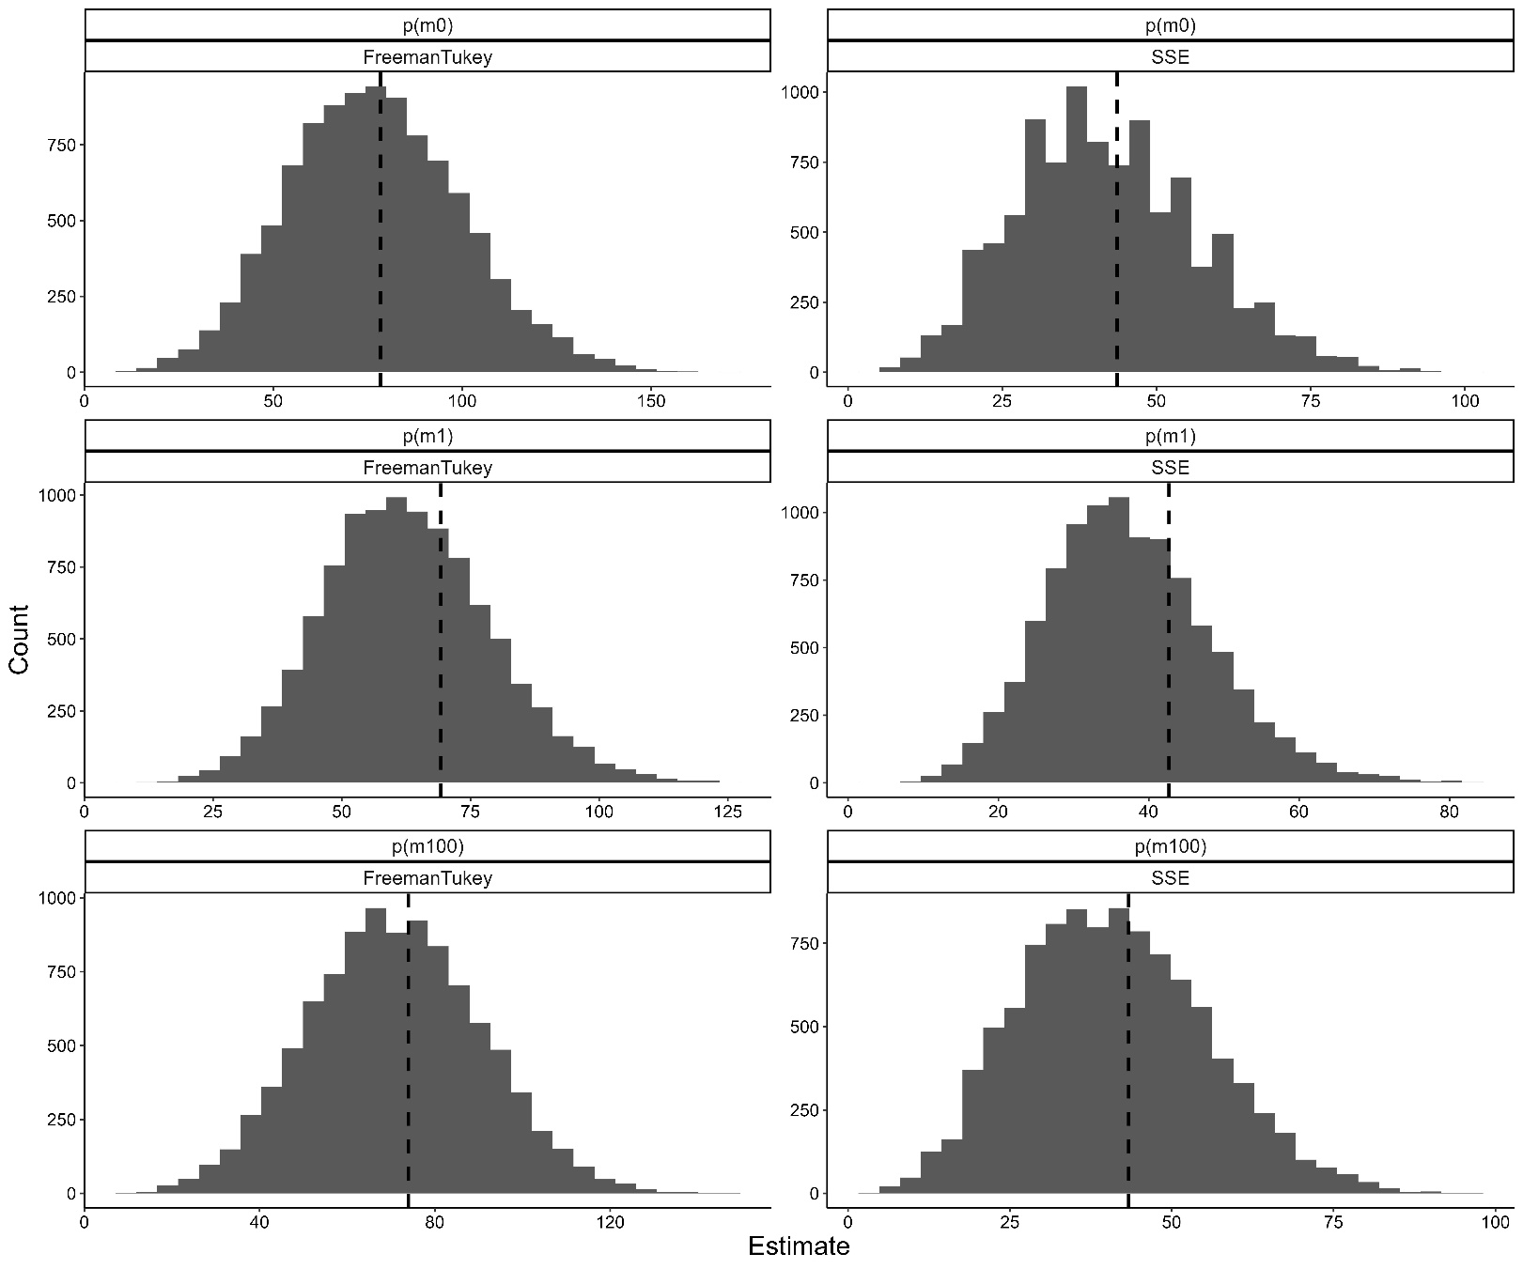

Table A6: Detection model selection statistics for the top ten models fitted to the occupancy data for Heleioporus australiacus australiacus. Akaike information criterion (AIC) are provided for each model, as is the distance to the top model (ΔAIC). Weight is derived from the Maximum Likelihood models.
Model | nPar | AIC | ΔAIC | Cumulative Weight
ρ _{(DTD + solar + rain1 + temp)} ψ_{(.)} | 6 | 390.00 | 0.00 | 0.15
ρ (DTD + solar + rain1 + RHMin + temp) ψ_{(.)} | 7 | 390.26 | 0.26 | 0.28
ρ (DTD + solar + rain1 + rain5 + temp) ψ_{(.)} | 7 | 390.61 | 0.61 | 0.39
ρ (DTD + JDate + solar + rain1 + temp) ψ_{(.)} | 7 | 390.73 | 0.73 | 0.50
ρ (DTD + solar + rain1 + rain5 + RHMin + temp) ψ_{(.)} | 8 | 390.86 | 0.86 | 0.59
ρ (DTD + moon + solar + rain1 + temp) ψ_{(.)} | 7 | 391.05 | 1.05 | 0.68
ρ (DTD + JDate + solar + rain1 + RHMin + temp) ψ_{(.)} | 8 | 391.14 | 1.13 | 0.77
ρ (DTD + JDate + moon + solar + rain1 + temp) ψ_{(.)} | 8 | 391.17 | 1.16 | 0.85
ρ (DTD + JDate + solar + rain1 + rain5 + temp) ψ_{(.)} | 8 | 391.40 | 1.39 | 0.93
ρ (DTD + moon + solar + rain1 + RHMin + temp) ψ_{(.)} | 8 | 391.41 | 1.41 | 1.00

Supplementary references
- Beranek, Chad T., Samantha Sanders, John Clulow, and Michael Mahony. 2022. "Factors influencing persistence of a threatened amphibian in restored wetlands despite severe population decline during climate change driven weather extremes.” Biodiversity and Conservation 31(4), pp.1267-1287. https://doi.org/10.1007/s10531-022-02387-9
- Gillespie, G.R., 1990. “Distribution, habitat, and conservation status of the giant burrowing frog (Heleioporus australiacus) in Victoria.” Victorian Naturalist, 107:144–153
- Kavanagh, Rodney P., & Garry A. Webb. 1998. “Effects of variable-intensity logging on mammals reptiles and amphibians at Waratah Creek, southeastern New South Wales.” Pacific Conservation Biology 4(4) :326–347. https://doi.org/10.1071/PC980326
- Lemckert, Francis, Traecey Brassil, & K. McCray. 1998. “Recent records of the giant burrowing frog (Heleioporus australiacus) from the far south coast of NSW.” Herpetofauna 28:32–39.
- Mahony, Michael J. 1993. “The status of frogs in the Watagan Mountains area of the Central Coast of New South Wales.” In: Lunney D, Ayers D (eds) Herpetology in Australia: a diverse discipline. Royal Zoological Society of NSW, Mosman, p 257–264
- Mahony, Michael J., Trent Penman, Terry Bertozzi, Francis Lemckert, Rohan Bilney, & Stephen C. Donnellan. 2021. “Taxonomic revision of south-eastern Australian giant burrowing frogs (Anura: Limnodynastidae: Heleioporus Gray).” Zootaxa 5016(4): 451-489. https://doi.org/10.11646/zootaxa.5016.4.1
- NSW National Parks and Wildlife Service, 2003. The Bioregions of New South Wales: their biodiversity, conservation and history. NSW National Parks and Wildlife Service, Hurstville.
- Penman, Trent D., Francis Lemckert, & Michael Mahony. 2004. “Two hundred and ten years looking for the Giant Burrowing Frog.” Australian Zoologist 32(4), 597-604. https://doi.org/10.7882/AZ.2004.005
- Penman, Trent, Francis Lemckert,, Chris Slade, & Michael Mahony. 2005a. “Nonbreeding habitat requirements of the giant burrowing frog, Heleioporus australiacus (Anura: Myobatrachidae) in south-eastern Australia.” Australian Zoology 33(2):251–257. https://doi.org/10.7882/AZ.2005.022
- Penman, Trent, Michael J. Mahony, A.L. Towerton, & Francis Lemckert. 2005b. “Bioclimatic analysis of disjunct populations of the giant burrowing frog, Heleioporus australiacus.” Journal of Biogeography 32: 397-405. https://doi.org/10.1111/j.1365-2699.2005.01205.x
- Penman, Trent, Francis Lemckert, & Michael Mahony. 2006a. “Meteorological effects on the activity of the giant burrowing frog (Heleioporus australiacus) in south-eastern Australia.” Wildlife Research 33(1): 35–40. https://doi.org/10.1071/WR04081
- Penman, Trent, Francis Lemckert, & Michael Mahony. 2008a. “Applied conservation management of a threatened forest dependent frog, Heleioporus australiacus.” Endangered Species Research 5(1): 45-53. https://doi.org/10.3354/esr00111

