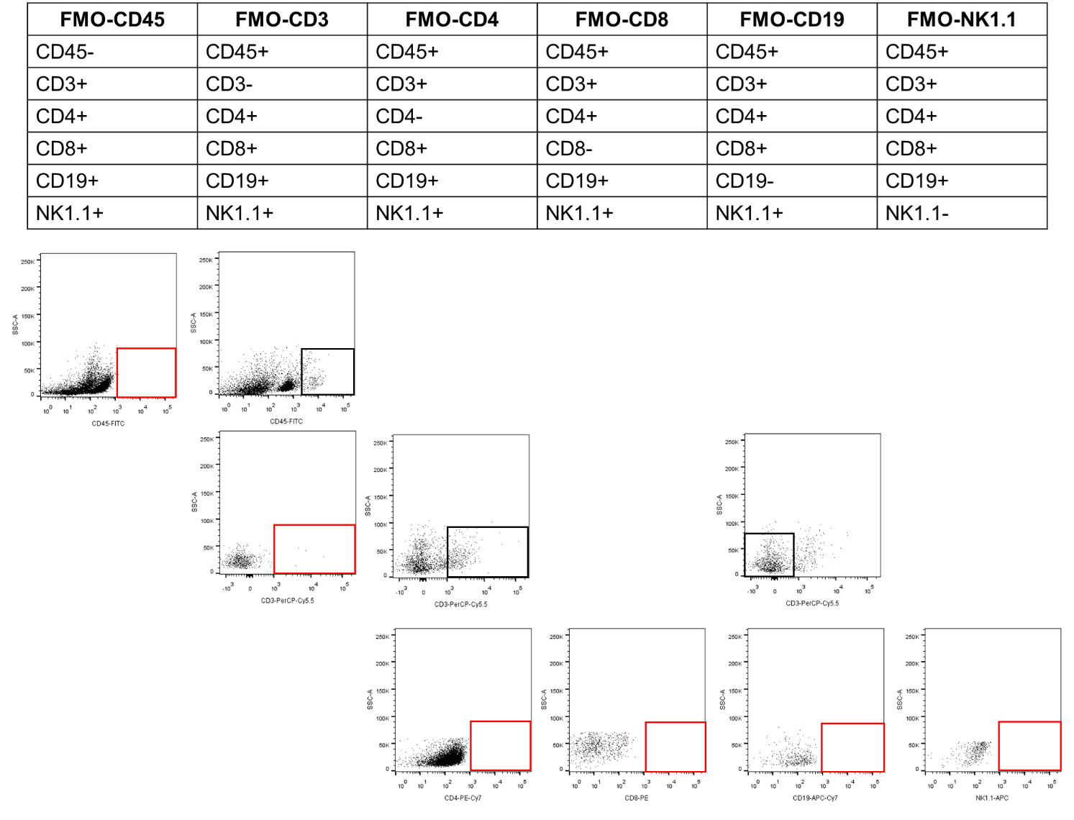
Supplementary Materials

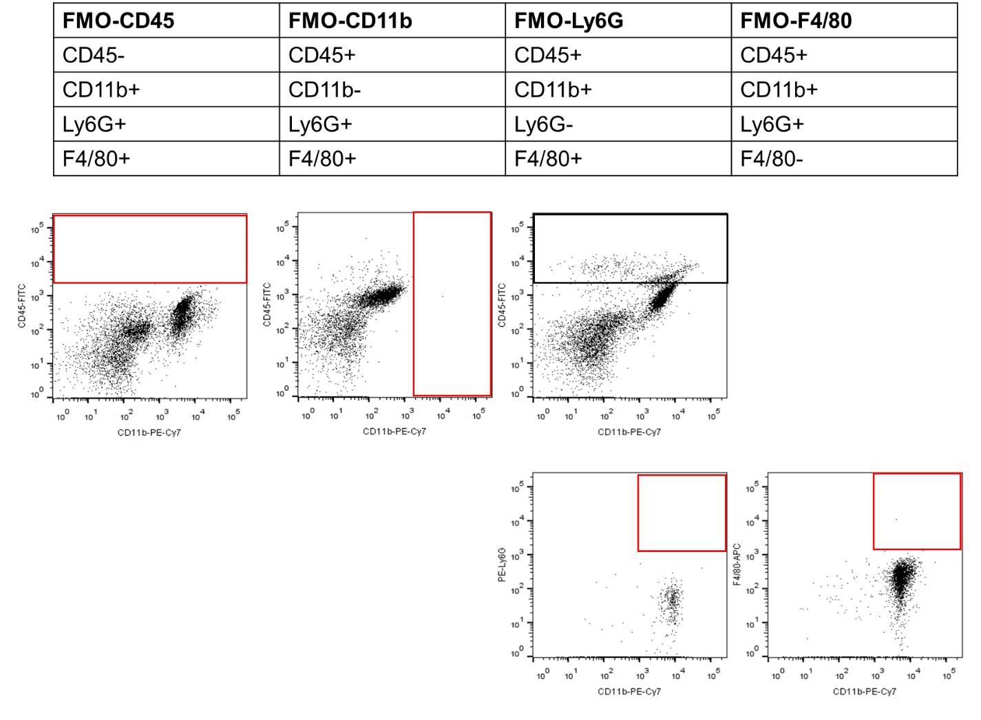
Figure S1. Fluorescence minus one (FMO) controls for the identification of immune cells.
Single cell suspensions were prepared from brain of C57BL/6 mice and stained with fluorochrome-conjugated antibodies.

Figure S2. Secukinumab may not directly act on neurons.
Cell viability was detected by CCK8 assay. All data are expressed as mean ± SEM; * p < 0.05, ** p < 0.01, #p<0.001 (MPP⁺ versus MPP⁺ + SEC or control)

