Hydrophilic and strength-softening characteristics of clay-rich rocks
Zongfang Han^{1, 2}, Mohua Bu⁴, Yuqiong Li^{1, 2,3}*, Manchao He⁴
1 Key Laboratory for Mechanics in Fluid Solid Coupling Systems, Institute of Mechanics, Chinese Academy of Sciences, Beijing 100190, China.
2 Guangdong Aerospace Research Academy, Guangzhou (Nan Sha) 511458, China
3 State Key Laboratory of Nonlinear Mechanics, Institute of Mechanics, Chinese Academy of Sciences, Beijing 100190, China
4 State Key Laboratory for Tunnel Engineering, China University of Mining and Technology, Beijing 100083, China
*Corresponding author. E-mail address: liyuqiong@imech.ac.cn

In this supplementary information, we provide additional details on certain aspects of the study reported in the manuscript.
Supplementary Note 1: Sample Preparation
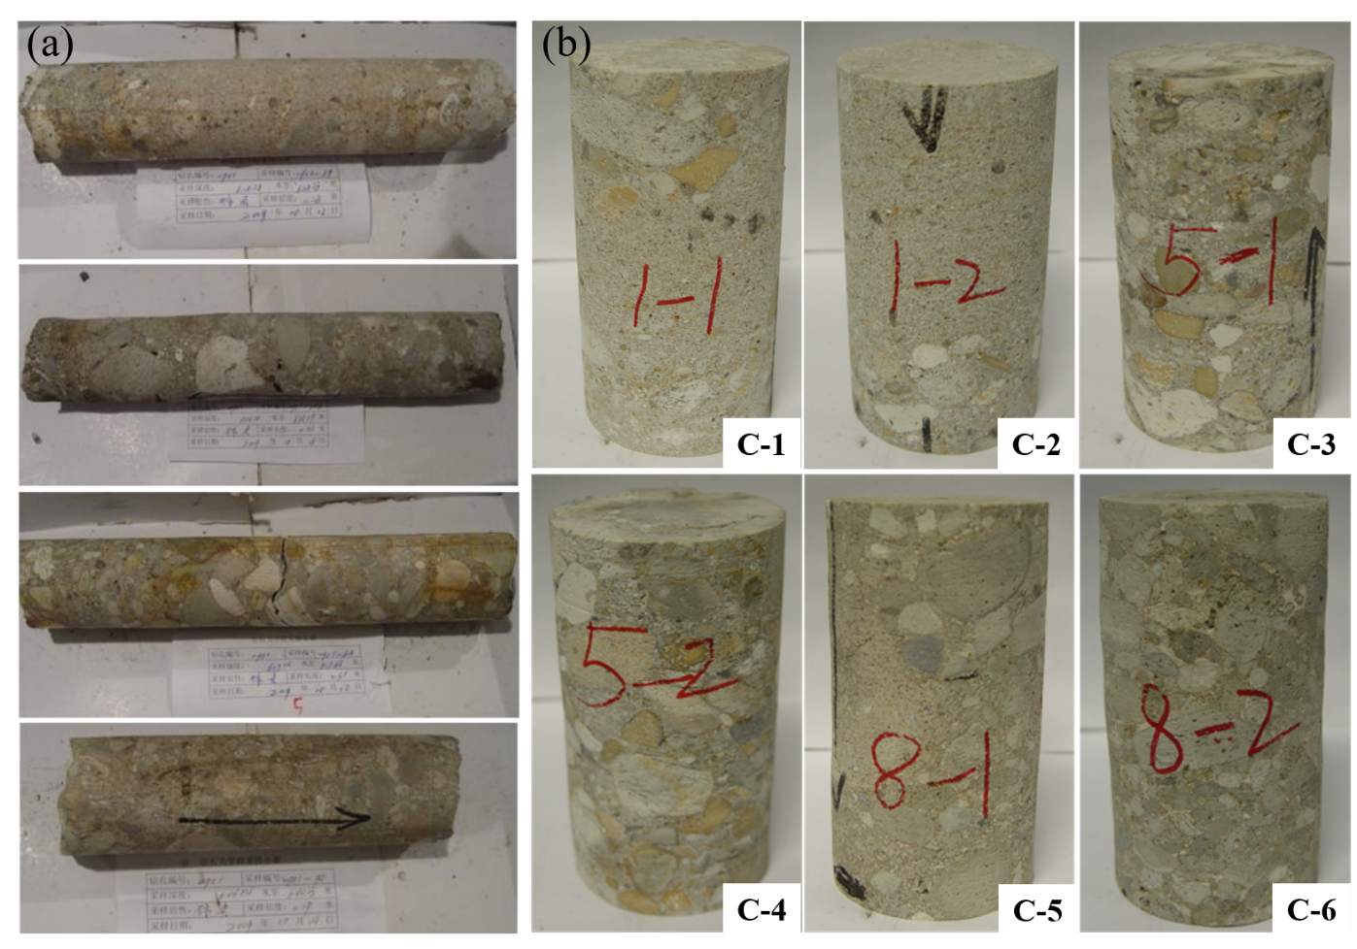
Fig. S1 (a) Initial cylindrical samples (b) Standard size rock samples after processing.
Supplementary Note 2: Apparatus and characterizations
Detailed test steps for gaseous water adsorption:
Step1: Check the electronic balance to ensure its accuracy. Inject distilled water into the water tank, and the water volume reaches more than half of the water tank capacity, to ensure that the water volume is sufficient throughout the experiment and not affect the experimental results due to water shortage.
Step2: Place the sample vertically on the plastic bar to ensure that there is no contact between the plastic bar and the side wall. First, the conglomerate is tested, then the fine sandstone, and finally the coarse sandstone.
Step3: Start the heating and humidification procedure, adjust the temperature and humidity to the set value, and the sample is in the setting value environment during the whole experiment. It is worth noting that in this study, the ambient temperature is 25 ℃ and the relative humidity is 100%, in order to simulate the mining environment with high humidity.
Step4: The variation curve of water absorption of rock samples with time can be seen in the data acquisition system. When the water absorption curve of rock samples tends to be smooth and stable, close the heating and humidification program and stop the experiment.
The uniaxial compression test equipment is XTR01 microcomputer servo tester. As shown in Fig. S2. The device can automatically collect the stress change and axial radial deformation of the rock during loading until the sample is crushed. Based on the collected data, the stress-strain curve was plotted to obtain the uniaxial compressive strength of the experimental sample.
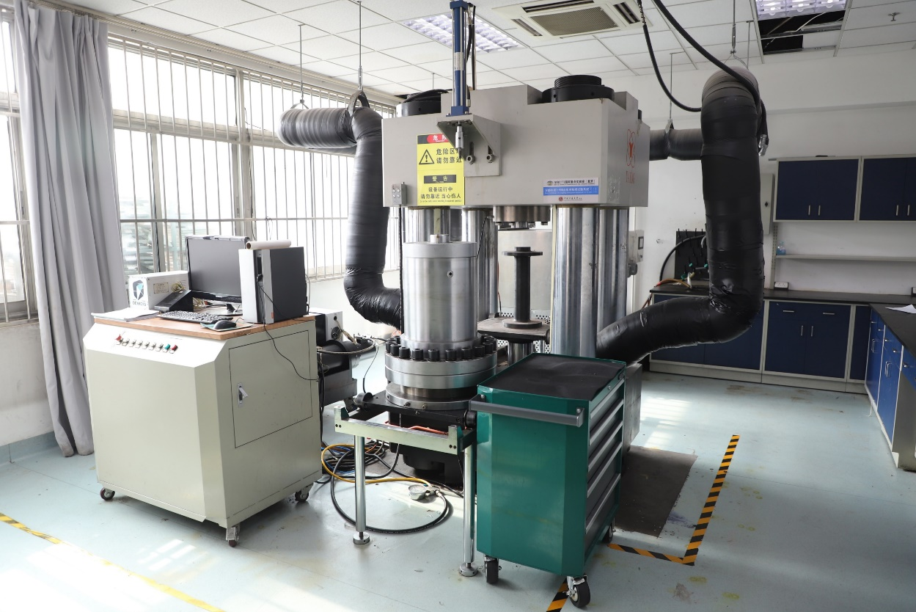
Fig.S2 XTR01 microcomputer servo tester.
Supplementary Note 3: Water absorption characteristic curves of clay-rich rocks
Table S1. Water vapor adsorption and curve regression fitting results of rock samples.
NO. | Water absorption /g | Water absorption rate/% | Fitting parameters
NO. | Water absorption /g | Water absorption rate/% | a | k | 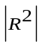
C-1 | 33.63 | 4.986 | 4.797 | 0.010 | 0.99
C-2 | 33.94 | 4.999 | 4.788 | 0.009 | 0.99
C-3 | 31.80 | 4.499 | 4.245 | 0.009 | 0.99
C-4 | 27.56 | 3.914 | 3.696 | 0.009 | 0.99
C-5 | 17.46 | 2.587 | 2.499 | 0.013 | 0.99
C-6 | 17.60 | 2.570 | 2.456 | 0.013 | 0.99

Table S1 shows that the saturated water absorption a obtained by fitting is very close to the experimental value, and the goodness of fit R² for all six clay samples is 0.99. The closer the value of R² is to 1, the better the curve fit is, which also indicates that the fitting function is accurate.
Supplementary Note 4: Effect of microscopic pore characteristics on water absorption
The SEM image is difficult to segment the pore structure effectively by general methods due to its special imaging mode. Image Pro Plus (IPP) is a graphical analysis software that integrates image acquisition, processing and measurement, which can provide quantitative statistics of pore size, area and other information in gray-scale processed SEM images. Firstly, the spatial scale of the IPP software was calibrated according to the scale on the SEM image, and the calibration unit was determined to be μm, and then the SEM image was binarized to obtain the pore characteristics of the rock, and the black area represented the pore area (Fig. S3). Finally, the accuracy of pore identification was further improved by eliminating interfering areas and segmenting image thresholds.
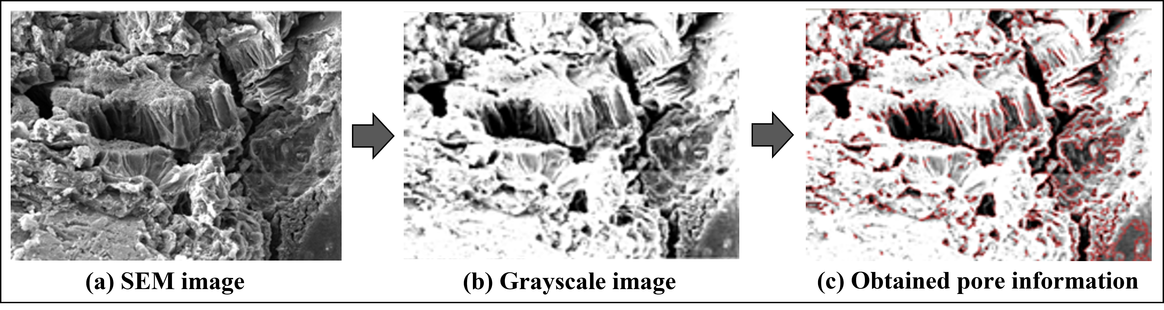
Fig.S3 Steps for processing SEM images by IPP software.

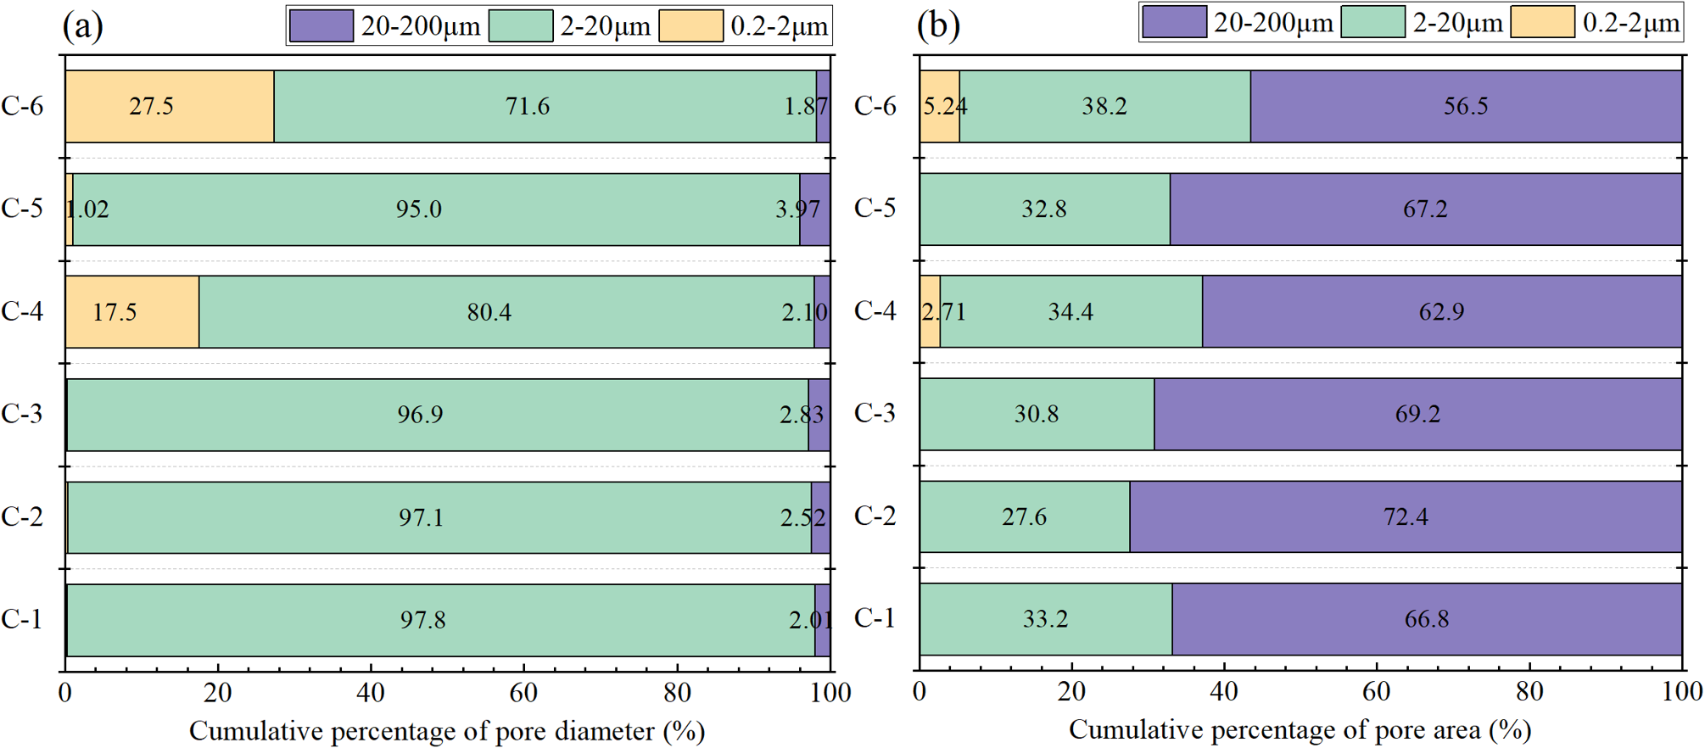
Fig.S4 Cumulative percentage of pore diameter and pore area.
As shown in Fig. S4, most pores in conglomerate have a diameter of 2~20μm (70.9%-97.8%). Although the number of pores in the range of 20-200 µm is very small, only 1.9%-4.0%, its pore area accounts for a relatively large proportion (56.5%-72.4%).

Supplementary Note 5: MD simulation model and simulation details
The Wyoming MMT model proposed by Skipper et al. (1995) was used to establish a 8a×4b×3c supercell model with Materials Studio software version 8.0, and the formula is Na_{0.75}(Si_{7.75}Al_{0.25})(Al_{3.5}Mg_{0.5})O₂₀(OH)₄. The monoclinic atomic structure of Wyoming sodium MMT considered in our study is based on the natural material with isomorphic substitution on pyrophyllite structure. The isomorphic substitution of MMT follows Lowenstein's rule and requires a 4a×2b×1c supercell model as a substitution unit, where two Si⁴⁺ are replaced by Al3⁺ in Si-O tetrahedra and four Al³⁺ are replaced by Mg²⁺ in Al-O octahedra, and the negative charge of the interlayer is balanced by six Na⁺ (Loewenstein 1954). Then, the energy optimized water molecules were randomly filled in the MMT interlayer domains (Fig. S5). Based on a previous study (Boek. 2014), we performed modeling calculations for the supercell model with interlayer containing 0 and 96 water molecules, corresponding to dry and saturated two-layer hydrate, respectively. The lattice parameters of unit cell are a = 5.23 Å, b = 9.06 Å. The parameter c depends on the hydration of MMT, it is 9.6 Å at the dry state. When there are two and three layers of water molecules, c takes the value of 15.5 Å and 18.5 Å respectively. Further, 𝛼 = 𝛾 = 90◦, 𝛽 = 99◦. The author's previous studies have shown that MMT interlayer cations differed and had an effect on its mechanical properties only under dry state (Han et al., 2022); therefore, only Na-MMT was selected here for the study of water absorption and softening.
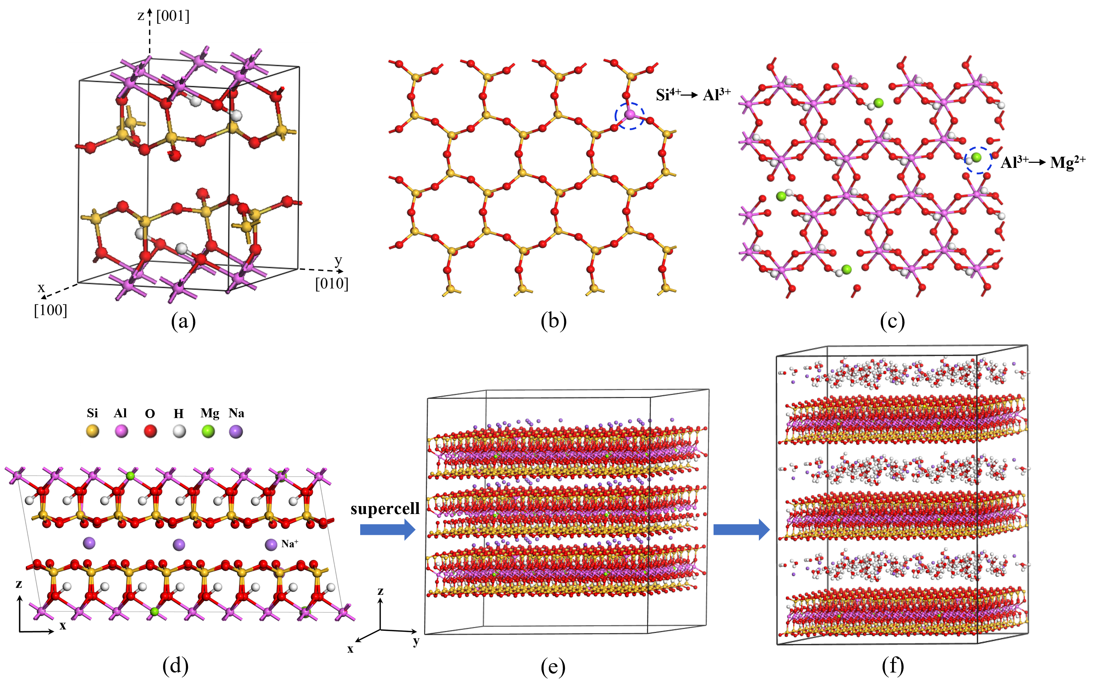
Fig S5. Model building process (a) 1×1×1 pyrophyllite unit cell, (b) isomorphic substitution in Si-O tetrahedra and (c) Al-O octahedra, (d) 4a × 2b × 1c model after isomorphic substitution, (e) 8a × 4b × 3c supercell model, (f) hydrated MMT model.
In this paper, the CLAYFF force field (Cygan et al., 2004) is used for molecular mechanical simulation, and the total energy is determined by evaluating the energy terms of the interaction between each atom in the system. In general, the total energy is contributed by Coulomb (electrostatic) interactions, short-range interactions (often referred to as van der Waals terms), and bonding interactions:
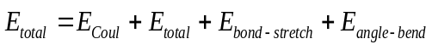 (1)
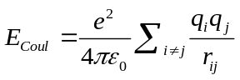 (2)
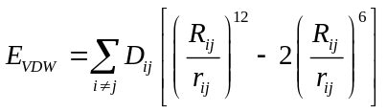 (3)
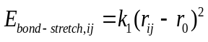 (4)
Where e is the electron charge (-1.6×10⁻¹² C), ɛ₀ is the dielectric permittivity of vacuum (8.85419×10⁻¹² F/m). r_{ij} is the distance between atoms i and j, $D_{0,ij}$ and $R_{0,ij}$ represent the distances between atoms i and j at the maximum attraction energy and maximum attraction, respectively, and are empirical parameters obtained by fitting the model to the observed structural physical data. Many experimental structures of simple oxides, hydroxides, and oxyhydroxides were used to derive optimal values for these parameters. Bonding terms include bond stretching and angle bending energy terms, which are represented as harmonic terms in the flexible SPC water model. Coulomb and VDW interactions do not include proximal intramolecular (binding) interactions, in which case only intermolecular O-O and O-H nonbonded interactions need to be evaluated.
Large-scale Atomic/Molecular Massively Parallel Simulator (LAMMPS) was used for MD (Plimpton 1995). Nose-Hoover barostat and thermostat were applied to control pressure and temperature, respectively (Hoover 1985) All simulations were conducted employing an isobaric-isothermal (NPT) ensemble at 𝑝=1 atm and 𝑇 = 300K. Three dimensional periodic boundary conditions with 10Å cut off for short-range interactions were used and Ewald summation method was employed to calculate electrostatic interactions. Atom movements were integrated using Verlet leapfrog algorithm and timestep was adjusted at 1 fs (Allen and Tildesley 1987). In order to keep the system in the equilibrium state with the lowest energy, the NPT ensemble was used to relax for 200 ps to obtain the equilibrium dynamic trajectory and the data required for analysis. Subsequently, by continuously increasing the deformation, the MMT model was subjected to uniaxial compression simulation along x,y and z directions (Fig. S6), compressed to a strain of 20% at a loading rate of 1.0×10⁷ s⁻¹, and the trajectory files of the deformation and failure process of the system were obtained.
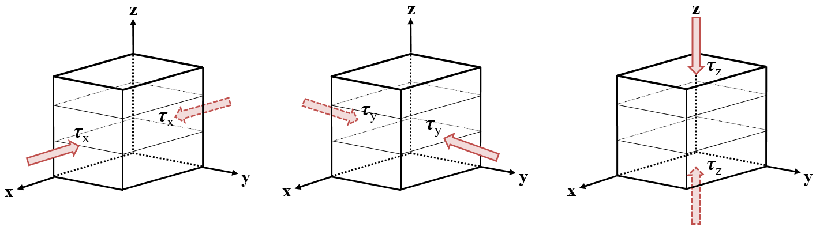
Fig S6. Loading diagram along x, y, z directions.
Reference：
Skipper, N.T., Chang, F.R.C., Sposito, G., Monte Carlo simulation of interlayer molecular structure in swelling clay minerals; 1, methodology. Clay Clay Min. 1995, 43: 285-293.
Loewenstein, W., 1954. The distribution of aluminum in the tetrahedra of silicates and aluminates. Am Mineral 39:92-96.
Boek, E.S., 2014 MD simulations of interlayer structure and mobility in hydrated Li-, Na- and K-MMT clays. Molecular Physics, 112(9-10): 1472-1483.
Han, Z.F., Yang, H., Bu, M.H., He, M.C., 2022. A MD study on the structural and mechanical properties of pyrophyllite and M-MMTs (M = Na, K, Ca, and Ba). Chem. Phys. Lett. 803:139848.
Cygan, R.T., Liang, J.J., Kalinichev, A.G., 2004. Molecular Models of Hydroxide, Oxyhydroxide, and Clay Phases and the Development of a General Force Field. J. Phys Chem B. 108:1255-1266.
Plimpton, S., 1995. Fast parallel algorithms for short-range MD. J Comput Phys 117:1-19.
Hoover, W.G., 1985. Canonical dynamics: Equilibrium phase-space distributions. Phys Rev A 31:1695-1697.
Allen, M.P., Tildesley, D.J., 1987. Computer Simulation of Liquids. Clarendon Press, Oxford, pp 78-81.

