The novel amino-artemisinin derivative WHN-11 disrupts mitochondria and protein homeostasis, and induces autophagy and apoptosis in cancer cells

Deborah Kajewole¹, Ho Ning Wong², Alexander von Kriegsheim³, Richard K. Haynes^{2,4}, Jo-Anne de la Mare¹, Adrienne Lesley Edkins^{1,}*

¹Biomedical Biotechnology Research Unit (BioBRU), Department of Biochemistry and Microbiology, Rhodes University, Makhanda 6139, South Africa
²Rural Health Research Institute, Charles Sturt University, Orange, New South Wales 2800, Australia.
³Institute of Genetics and Cancer, University of Edinburgh, Scotland, UK
⁴Centre of Excellence for Pharmaceutical Sciences, Faculty of Health Sciences, North-West University, Potchefstroom 2531, South Africa

*Correspondence: a.edkins@ru.ac.za

Supplementary Materials and Methods

Preparation and purification of the piperazinyl ureas WHN-10 and WHN-11, and the piperazinyl amides WHN-14 and WHN-15 are described in detail elsewhere [1]. The highly crystalline DHA-piperazine dimer WHN-27 is prepared from DHA and piperazine and has been structurally characterized by X-ray crystallography [2]. The geranyl- and farnesyl-piperazine derivatives WHN-296 and WHN-298, respectively, are readily obtained by alkylation of DHA-piperazine as described in detail elsewhere [3].

1.1. Syntheses of DHA-1-(2-aminoethyl) piperazine WHN-00 and DHA-Piperazine, 1,1'-(1,2-ethanediyl)bis dimer WHN-26.
Bulk solvents, magnesium sulfate and sodium hydrogen carbonate were from ACE Chemicals, Johannesburg, South Africa. Dihydroartemisinin (DHA) was obtained either from the Kunming Pharmaceutical Corporation, Kunming, China, or from Haphacen, Hanoi College of Pharmacy, Vietnam. 1,1'-(1,2-ethanediyl)bis-piperazine, 96% pure, was purchased from Alfa Chemicals, and used as supplied. Dichloromethane was distilled, dried over calcium carbonate and stored over 3Å molecular sieves. Diethyl ether and tetrahydrofuran (THF) were dried over sodium, and distilled before use. ¹H and ¹³C NMR spectra were recorded on a Bruker Avance III spectrometer as solutions in CDCl₃. Chemical shifts (δ) are reported in parts per million (ppm) and ¹H chemical shifts are reported downfield of tetramethylsilane (TMS) with internal reference to the residual proton in CDCl₃ (δ 7.25 ppm). ¹³C chemical shifts were referenced to the CDCl₃ resonances (δ = 77.00 ppm). The splitting patterns are abbreviated as follows: s (singlet), d (doublet), dd (doublet of doublets), t (triplet) and m (multiplet). The coupling constant J are reported in Hz. Spectra were analyzed with MestReNova Software, version 5.3.2–4936. High resolution mass spectrometry (HRMS) was recorded on a Bruker MicroTOF Q II mass spectrometer, equipped with an ESI source set at 180 °C using Bruker Compass DataAnalysis 4.0 software. Infrared (IR) spectra were recorded on a Bruker Alpha-P FTIR instrument. Column chromatography was performed using high-purity-grade silica gel (pore size: 60 Å, 70–230 mesh, 63–200 µm) from Sigma–Aldrich and thin-layer chromatography (TLC) was performed with silica gel plates (60 F254) from Merck. For HPLC analyses, an Agilent 1100 series instrument equipped with a gradient pump, autosampler, Diode Array UV detector and OpenLab CDS Chemstation Rev.C.01.07 SR3 data acquisition and analysis software, and a Venusil XBP C18(2) column, 150 x 4.6 mm, 5 µm spherical particles, 100 Å pore size (Agela Technologies, Newark, DE, USA) were used. The mobile phase consisted of acetonitrile and 0.1% orthophosphoric acid in water with a linear gradient from 30% acetonitrile to 85% after five minutes and holding until 15 minutes before equilibrating with 30% acetonitrile to 20 minutes; for the derivatives, UV detection at UV at 210 nm was used. All compounds submitted for screening were demonstrated to be ≥95% pure.
a. Preparation of DHA-1-(2-aminoethyl) piperazine (WHN-00)
Dimethyl sulfoxide (DMSO) (25.1 µL, 0.1 equiv.) was added to a stirred solution of DHA (1.0 g, 3.517 mmol) in toluene (10 mL) at room temperature under nitrogen. Oxalyl chloride (0.35 mL, 1.15 equiv.) was slowly added and the resulting mixture was stirred for 1 hour. This was then transferred by cannula into a stirred solution of 1-(2-aminoethyl) piperazine (2.33 mL, 5 equiv.) in dichloromethane (10 mL) and stirred overnight. The mixture was then quenched with saturated sodium bicarbonate solution (20 mL), extracted with ethyl acetate (4 x 30 mL), and the extracts were combined and washed with brine (2 x 25 mL),and then dried over anhydrous magnesium sulfate. The solution was filtered, and the filtrate evaporated under reduced pressure to leave a residue solvent was evaporated to leave the crude product mixture as an amber coloured gum. According to the previously described method [18,19], this was analysed by ¹H NMR spectroscopy which indicated the ratio of the product WHN-00 to the known glycal was about 1:1, indicating approximately 1.17 mmol of the desired product was present (ca. 50% yield). The crude product mixture was submitted to column chromatography with silica gel. Elution with 30% ethyl acetate in hexane followed by 10% methanol in dichloromethane removed the non-polar glycal and other products. Final elution with 20% methanol in dichloromethane containing 1% triethylamine followed by evaporation of the eluate gave the crystalline product WHN-00 (478 mg, 34%), m.p. 119.6 °C. ¹H NMR: δ = 0.78-0.79 (3H, d, J = 7.3 Hz, 9 Me), 0.92-0.93 (3H, d, J = 6.5 Hz, 6 Me), 0.96-1.02 (1H, m), 1.18-1.24 (2H, m), 1.28-1.35 (2H, m), 1.36 (3H, s, 3 Me), 1.42-1.53 (3H, m), 1.63-1.72 (4H, m), 1.81-1.86 (1H, m), 1.95-2.00 (1H, m), 2.30-2.35 (1H, m), 2.37-2.50 (4H, m), 2.53-2.57 (1H, m), 2.64-2.68 (2H, m), 2.76-2.78 (2H, t, J = 6.2 Hz, aminoethyl H), 2.84-2.92 (3H, m), 2.96-3.02 (4H, m, piperazine), 3.99-4.00 (1H, d, J = 10.3 Hz, H-10), 5.25 (1H, s, H-12). IR (film): v_{max} = 485, 511, 551, 745, 767, 826, 851, 879, 895, 925, 942, 979, 1013, 1040, 1085, 1100, 1130, 1160, 1179, 1200, 1227, 1279, 1300, 1351, 1375, 1415, 1449, 1642, 2810, 2870, 2925, 3244 cm⁻¹. MS: m/z: calcd for C₂₁H₃₈N₃O₄⁺: 396.2862 [M+H]⁺; found : 396.2857.
b. Preparation of DHA-piperazine 1,1'-(1,2-ethanediyl)bis dimer WHN-26
DMSO (25.1 µL, 0.1 equiv.) was added into a stirred solution of DHA (1.0 g, 3.517 mmol) in toluene (10 mL) at room temperature under nitrogen in a 2-necked flask. Oxalyl chloride (0.35 mL, 1.15 equiv.) was slowly added into the reaction mixture and the resulting mixture stirred for 1 hour. This was then transferred by cannula into a stirred solution of 1,1'-(1,2-ethanediyl)bis-piperazine, (3.487 g, 5 equiv.) in dichloromethane (20 mL) and stirred overnight. The reaction mixture was filtered through cotton wool, the filtrate was then quenched with saturated sodium bicarbonate solution (30 mL), extracted with ethyl acetate (3 x 30 mL). The extracts were combined and washed with brine (30 mL), and dried over anydrous magnesium sulfate. The reaction was repeated at the same scale, the crude products were combined and submitted to column chromatography. The product WHN-26 (438.9 mg, from 2 g DHA, 17.1%) was isolated by elution with 50% ethyl acetate in hexane followed by 10% methanol in dichloromethane as a fine crystalline solid, m.p. 107.1 °C. ¹H NMR: δ = 0.76-0.77 (6H, d, J = 7.1 Hz, 9 Me), 0.92-0.93 (6H, d, J = 6.3 Hz, 6 Me), 0.95-1.02 (2H, m), 1.17-1.26 (4H, m), 1.29-1.34 (2H, m), 1.35 (6H, s, 3 Me), 1.41-1.55 (4H, m), 1.61-1.77 (4H, m), 1.82-1.86 (2H, m), 1.96-2.01 (2H, m), 2.29-2.35 (2H, m), 2.50-2.56 (2H, m), 2.65-2.80 (16H, m H, piperazine), 3.00-3.05 (4H, m, H from the ethyl linker between piperazine rings), 4.01-4.02 (2H, d, J = 10.2 Hz, H-10), 5.25 (2H, s, H-12). IR (film): v_{max} = 485, 693, 746, 812, 825, 841, 851, 862, 880, 893, 924, 940, 956, 982, 1013, 1042, 1060, 1083, 1101, 1114, 1123, 1132, 1151, 1164, 1180, 1202, 1228, 1254, 1285, 1297, 1323, 1358, 1379, 1421, 1446, 2791, 2846, 2921, 2954 cm⁻¹. MS: m/z: calcd for C₄₀H₆₇N₄O₈⁺: 731.4959 [M+H]⁺; found : 731.4940.

1.2. Analysis of cell viability of treated cells in the presence of the ROS scavenger N-acetyl cysteine (NAC).
HCC1937 cells (5 × 10³ cells/well) pre-incubated for 30 minutes without or with 10 mM NAC were treated with the compounds at concentrations equivalent to their individual IC₅₀ values, or 0.1% (v/v) DMSO in culture medium for 72 hours. As described for the SRB assay, cells were fixed, stained with the dye and the absorbance measured.

1.3. Detection of ROS in treated cells using 2ʹ,7ʹ-dichlorodihydrofluorescein diacetate (DCFDA) dye
HCC1937 cells suspended in 2% (v/v) serum-containing media were seeded into a black-walled 96-well plate (2 × 10⁴ cells/well) until adherent. Cells were pre-incubated for 30 minutes with 5 µM DCFDA dye in phosphate-buffered saline (PBS). Afterwards, cells were treated with 0.1% (v/v) DMSO, 50 µM H₂O₂, artemisinin or WHN-11. Fluorescence was measured at Ex_{535nm} and Em_{485nm} for 6 hours at 30 min intervals.

1.4. NQO1 Luciferase Promoter Activity in treated HeLa cells
The plasmids, pGL4.10-NQO1⁺ and pGL4.10-NQO1 provided by Prof. Demetra Mavri-Damelin, School of Molecular and Cell Biology, University of the Witswatersrand, South Africa, contain the NAD(P)H:Quinone Oxidoreductase 1 (NQO1⁺) promoter sequence with a functional nuclear factor erythroid 2–related factor 2 (Nrf2) binding site and NQO1⁻, which has no Nrf2 binding site, respectively [4]. HeLa cells were seeded overnight in a sterile 6-well plate (5 × 10⁵ cells/well) and co-transfected for 30 hours with 2 µg of pLV-eGFP (Addgene: Plasmid #36083; transfection efficiency control) and 2 µg pGL4.17 (backbone control lacking a promoter), pGL4.10-NQO1⁺ or pGL4.10-NQO1⁻ plasmids using a 1:1 ratio of the transfection reagent (µL) to DNA (µg). Cells were lifted and reseeded at equal density in 12-well plates and treated for 8 hours with either 0.1% (v/v) DMSO, 250 nM elesclomol or 5 - 10 µM WHN-11. Lysates were measured for eGFP at Em_{485nm} and Ex_{535nm}, and luminescence following the addition of firefly luciferase assay reagent (FLAR - 100 µM EDTA, 200 mM Tricine, 2.67 mM MgSO₄, 17 mM DTT, 250 µM ATP and 250 µM D-luciferin) [5]. NQO1 promoter activity was calculated as the ratio of the relative luminescence units (RLU) to GFP.

1.5. Quantitative Polymerase Chain Reaction (qPCR)
Total RNA from treated HCC1937 cells was isolated using the Direct-Zol RNA miniprep kit (Zymo-research, ZR2052). Complementary DNA (cDNA) was synthesized from equal amounts of RNA (400 ng) with the ProtoScript first strand cDNA synthesis kit [New England Biolabs (NEB), E6560L]. The levels of Hsp70 mRNA in treated cells were quantified using a Luna Universal qPCR mix (NEB M3003E) on a Bio-Rad CFX Connect Real-Time PCR System (Bio-Rad, USA).

1.6. Detection of LC3-I lipidation in stable HeLa cell line
HeLa cells, stably transfected with pBABE-puro-mCherry-EGFP-LC3B plasmid, were seeded on coverslips, and treated overnight with compounds or for 4 hours with HBSS. Cells were briefly fixed with 4% (w/v) aqueous paraformaldehyde (PFA), stained with Hoechst 33342, and washed with PBS (pH 7.4). Coverslips were mounted on to slides with DAKO and the images captured using laser wavelengths of Ex_{561nm}/Em_{637nm} for mCherry signals and Ex_{488nm}/Em_{539nm} for EGFP signals on a Zeiss LSM 780 confocal microscope. Colocalization of puncta was analysed by Pearson’s correlation coefficient using ImageJ 1.51j8 JACoP freeware (NIH, USA), as previously described [6].

Supplementary Figures
Supplementary Figure 1. a. Artemisinin and the current clinical derivatives dihydroartemisinin (DHA), artemether and artesunate; b the amino-artemisinins artemiside and artemisone. The current clinical derivatives are used for treatment of malaria. Artemether and artesunate are rapidly converted into DHA in vivo via facile metabolism or hydrolysis respectively. The amino-artemisinins artemiside and artemisone differ in possessing a nitrogen atom at C-10 that enhances biological activities, and blocks metabolism to DHA, an important feature for selection of amino-artemisinins for drug development campaigns targeting diseases other than malaria wherein relatively large amounts of drug will be required for effective dose regimens.

Supplementary Figure 2. Amino-artemisinins examined in the current work. The piperazinyl ureas WHN-10 and WHN-11, the piperazinyl amides WHN-14 and WHN-15 [1], the DHA-piperazine dimer WHN-27 [7], the geranyl- and farnesyl-piperazine derivatives WHN-296 and WHN-298 [8] have been prepared previously. The aminoethylpiperazine derivative WHN-00 and the dimer WHN-26 are reported here for the first time; details of their preparation and spectroscopic data are given in the Materials and Methods section.

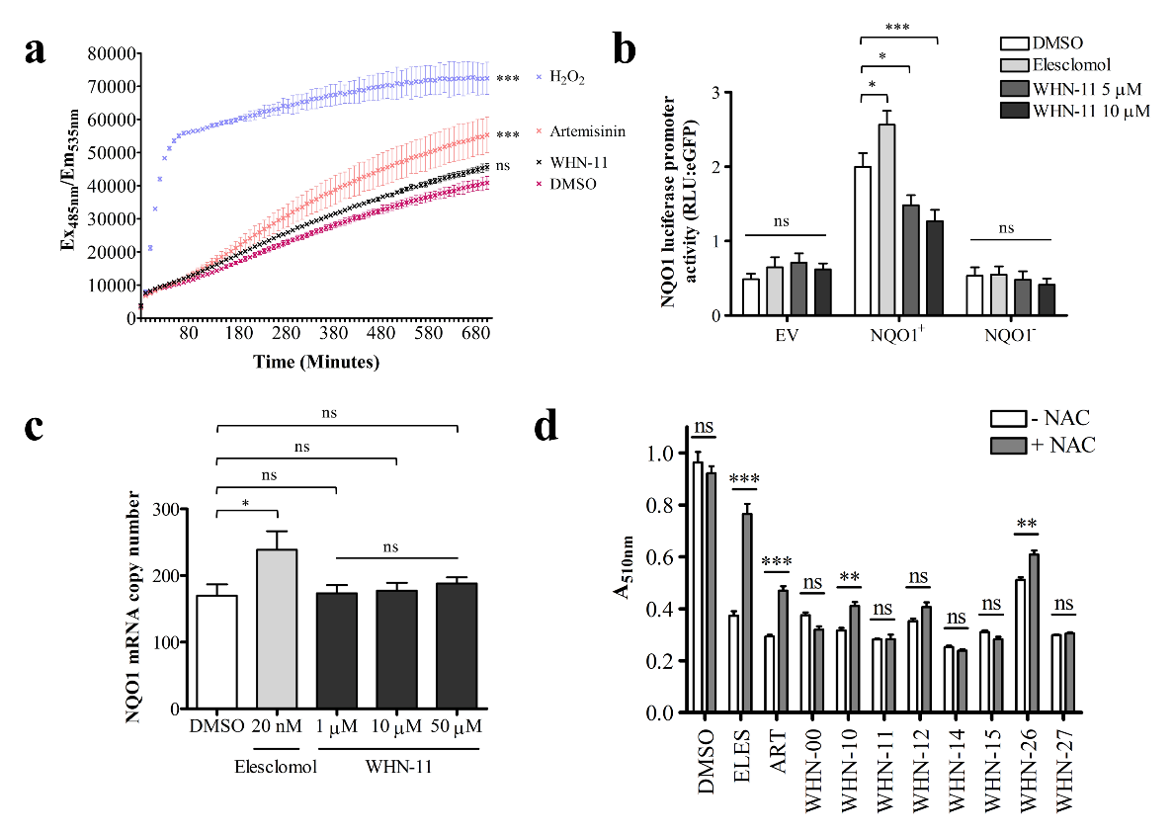
Supplementary Figure 3: WHN-11 cytotoxicity does not require ROS production. (a) ROS detection using DCFDA where fluorescence values are shown as averages ± SEM (n = 3), where *** p < 0.001 and ns - not significant using a One-Way ANOVA Bonferroni's multiple comparison test comparing the treated samples to the DMSO. (b) NADP(H):quinone oxidoreductase 1 (NQO1) luciferase promoter activity in treated HeLa cells co-transfected with pLV-eGFP and EV - pGL4.17, pGL4.10-NQO1+ or pGL4.10-NQO1-. ROS-induced promoter activity was reported as RLU:EGFP, averages ± SEM (n = 3) and * p < 0.05, *** p < 0.001 and ns – not significant using two-Way ANOVA with Bonferroni post-tests. (c) Average NQO1 mRNA copy number ± SEM (n = 6) in treated HCC1937 cells. (d) Viability of HCC1937 cells measured by SRB assay after treatment with compound in the absence (-) or presence (+) of antioxidant NAC. Data shown are averages ± SEM (n = 4), where ** p < 0.01, *** p < 0.001 and ns – not significant by a Two-Way ANOVA, Bonferroni post-tests. H₂O₂ and Elesclomol were positive controls.

Supplementary Figure 4: Proteomic analysis of WHN-11 treated HCC1937 cells. Volcano plot showing the unique proteins identified by mass spectrometry analysis in treated cells. Dashed lines represent cut-off values for significantly regulated proteins in WHN-11 treated samples relative to DMSO treated control. Total identified proteins were 3,629: ● proteins that were not significantly altered (n = 3,494), ● significantly upregulated proteins (-Log₁₀ p-value > 1.3, Log₂ FC ≥ 1; n = 51) and ● significantly downregulated proteins (-Log₁₀ p-value > 1.3, Log₂ FC ≤ -1; n = 84).

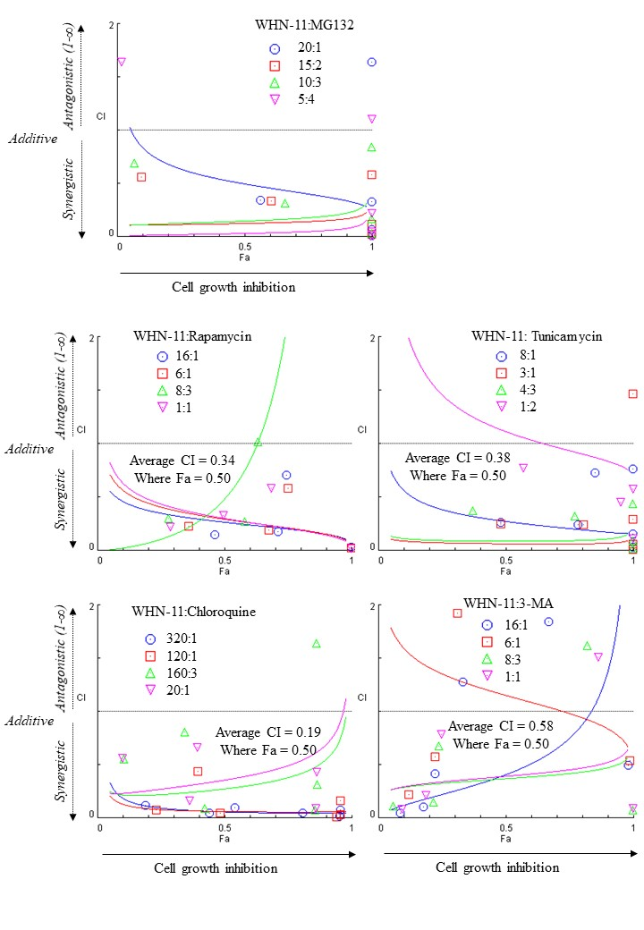
Supplementary Figure 5: Synergistic relationships between WHN-11 and autophagy inducers or inhibitors in HCC1937 cells. Combinations of WHN-11 with MG132 (constant ratios:20:1, 15:2, 10:3, 5:4); rapamycin (constant ratios of 16:1, 6:1, 8:3, 1:1); tunicamycin (constant ratios of 8:1, 3:1, 4:3, 1:2), chloroquine (constant ratios of 320:1, 120:1, 160:3, 20:1) and 3-methyladenine (3-MA) (constant ratios of 16:1, 6:1, 8:3, 1:1). Cells treated for 72 hours with compounds dose-dependently in combination or single drug treatments were subjected to an MTT cell viability assay. Graphs were developed for each combination point using CompuSyn software, version 1.0 showing the combination index (CI) versus Fractions of cell growth affected (Fa) as indicated. Relationships were defined as synergistic (CI < 1), additive (CI = 1) or antagonistic (CI > 1). Representative data shown (n = 2).

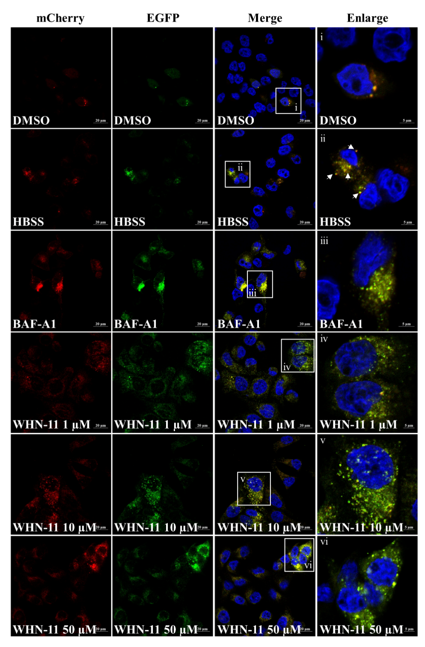

Supplementary Figure 6. Autophagy induction by WHN11 in HeLa cell line overexpressing LC3B autophagy marker. Confocal analysis of autophagic vesicles in HeLa cell line stably expressing mCherry-EGFP-LC3 treated overnight with 0.1% DMSO, 20 nM bafilomycin-A1 (Baf-A1), 1 - 50 µM WHN-11 or for 4 hours with Hanks’ Balanced Salt Solution (HBSS). Representative images shown (n = 2).

Supplementary Table 1: Cell culture conditions.
Cell line | Medium*
HCC1937 | RPMI-1640, 0.25% (v/v) sodium bicarbonate, 10% (v/v) FBS, 1% (v/v) 100 U/mL PSA and 1% (v/v) GlutaMAXTM
HCC70
501 melanoma
MDA-MB-231 | DMEM, 10% (v/v) FBS, 1% (v/v) 100 U/mL PSA and 1% (v/v) GlutaMAXTM
HeLa
U-87
HCT116 | DMEM, 1% (v/v) sodium pyruvate, 10% (v/v) FBS, 1% (v/v) 100 U/mL PSA and 1% (v/v) GlutaMAXTM
HEK293T | DMEM, 10% (v/v) FBS, 1% (v/v) 100 U/mL PSA and 1% (v/v) GlutaMAXTM, 1 mM sodium pyruvate, 0.1 mM NEAA, 500 µg/ml G418
MCF-12A | DMEM/Ham’s F-12, 10% (v/v) FBS, 1% (v/v) PSA, 20 ng/mL human epidermal growth factor, 100 ng/mL cholera toxin, 500 ng/mL hydrocortisone and 10 µg/mL insulin

Supplementary Table 2: IC₅₀ values and selectivity indices (SI) of artemisinins
Compounds | IC₅₀ µM±SEM (n=3)
Compounds | HCC1937 | HCC70 | MDA-MB-231 | HeLa | U87 | 501 Mel | HCT116 | MCF-12A | HEK293T
Artemisinin | 389.33 ± 92.70  SI_{12A}: 0.26  SI_{HEK}: 0.15 | 202.90 ± 1.30  SI_{12A}: 0.50 SI_{HEK}: 0.28 | 214.10 ± 1.14  SI_{12A}: 0.48 SI_{HEK}: 0.27 | 158.10 ± 1.53  SI_{12A}: 0.64 SI_{HEK}: 0.36 | 314.40 ± 0.01  SI_{12A}: 0.32 SI_{HEK}: 0.18 | 109.90 ± 1.24  SI_{12A}: 0.93 SI_{HEK}: 0.52 | 161.00 ± 1.50  SI_{12A}: 0.63 SI_{HEK}: 0.36 | 101.80 ± 1.34 | 57.53 ± 1.18
Dihydro-  Artemisinin (DHA) | 23.72 ± 15.49  SI_{12A}: 0.38  SI_{HEK}: 0.02 | 56.09 ± 1.28  SI_{12A}: 0.16  SI_{HEK}: 0.01 | 21.67 ± 1.17  SI_{12A}: 0.42  SI_{HEK}: 0.02 | 15.03 ± 1.18  SI_{12A}: 0.60  SI_{HEK}: 0.03 | 17.40 ± 1.34  SI_{12A}: 0.52  SI_{HEK}: 0.02 | 2.10 ± 1.12  SI_{12A}: 4.30  SI_{HEK}: 0.19 | 6.53 ± 1.12  SI_{12A}: 1.38  SI_{HEK}: 0.06 | 9.01 ± 1.15 | 0.40 ± 1.19
Artemether | 262.90 ± 25.03  SI_{12A}: 0.99 | ND | ND | 83.64 ± 2.54  SI_{12A}: 3.10 | 158.90 ± 1.00  SI_{12A}: 1.63 | 159.30 ± 1.45  SI_{12A}: 1.63 | 87.43 ± 1.68  SI_{12A}: 2.96 | 259.20 ± 1.11 | ND
Artesunate | 17.02 ± 6.02  SI_{12A}: 0.13 | ND | ND | 16.61 ± 1.61  SI_{12A}: 0.13 | 18.68 ± 1.34  SI_{12A}: 0.12 | 3.44 ± 1.17  SI_{12A}: 0.63 | 5.04 ± 1.16  SI_{12A}: 0.43 | 2.18 ± 1.16 | ND
Artemiside | 73.54 ± 1.37  SI_{12A}: 0.03 | ND | ND | ND | ND | ND | ND | 2.06 ± 1.22 | ND
Artemisone | 21.05 ± 4.08  SI_{12A}: 0.22 | ND | ND | ND | ND | ND | ND | 4.60 ± 1.27 | ND
WHN-00 | 153.98 ± 75.33  SI_{12A}: 0.13  SI_{HEK}: 0.02 | 70.77 ± 1.39  SI_{12A}: 0.29 SI_{HEK}: 0.03 | 21.14 ± 1.26  SI_{12A}: 0.97 SI_{HEK}: 0.11 | 49.46 ± 1.23  SI: 0.41  SI_{HEK}: 0.05 | 49.67 ± 1.41  SI: 0.41  SI_{HEK}: 0.05 | 4.24 ± 1.09  SI: 4.82  SI_{HEK}: 0.55 | 14.35 ± 1.27  SI_{12A}: 1.42  SI_{HEK}: 0.16 | 20.42 ± 1.31 | 2.33 ± 1.14
WHN-10 | 38.92 ± 35.70  SI_{12A}: 0.23 | 32.30 ± 1.54  SI_{12A}: 0.29 | 11.99 ± 1.29  SI_{12A}: 0.75 | 0.71 ± 1.21  SI_{12A}: 12.68 | 3.69 ± 0.0  SI_{12A}: 2.44 | 5.98 ± 1.28  SI_{12A}: 1.51 | 1.45 ± 1.70  SI_{12A}: 6.21 | 9.00 ± 1.63 | ND
WHN-11 | 0.74 ± 0.40  SI_{12A}: 0.30  SI_{HEK}: 3.23 | 0.19 ± 1.52  SI_{12A}: 1.16  SI_{HEK}: 12.58 | 0.50 ± 1.36  SI_{12A}: 0.44  SI_{HEK}: 4.78 | 0.84 ± 1.51  SI_{12A}: 0.26  SI_{HEK}: 2.85 | 6.57 ± 1.56  SI_{12A}: 0.03  SI_{HEK}: 0.36 | 0.20 ± 1.26  SI_{12A}: 1.10  SI_{HEK}: 11.95 | 0.44 ± 1.35  SI_{12A}: 0.50  SI_{HEK}: 5.43 | 0.22 ± 0.11 | 2.39 ± 1.07
WHN-12 | 38.37 ± 21.86  SI_{12A}: 0.03 | 13.76 ± 1.31  SI_{12A}: 0.08 | 24.38 ± 1.17  SI: 0.04 | 1.61 ± 1.10  SI_{12A}: 0.67 | 5.72 ± 1.66  SI_{12A}: 0.19 | 0.89 ± 1.28  SI_{12A}: 1.21 | 0.98 ± 1.34  SI_{12A}: 1.10 | 1.08 ± 1.43 | ND
WHN-14 | 41.61 ± 22.61  SI_{12A}: 0.01 | 10.40 ± 1.33  SI_{12A}: 0.05 | 22.18 ± 1.32  SI: 0.03 | 2.10 ± 1.43  SI_{12A}: 0.27 | 3.49 ± 1.55  SI_{12A}: 0.16 | 2.13 ± 1.36  SI_{12A}: 0.28 | 2.26 ± 1.31  SI_{12A}: 0.25 | 0.56 ± 1.34 | ND
WHN-15 | 10.76 ± 8.29  SI_{12A}: 0.02 | 6.80 ± 1.49  SI_{12A}: 0.03 | 3.79 ± 1.22  SI_{12A}: 0.05 | 0.48 ± 1.64  SI_{12A}: 0.38 | 6.72 ± 1.47  SI_{12A}: 0.03 | 0.56 ± 1.31  SI_{12A}: 0.32 | 0.15 ± 1.44  SI_{12A}: 1.2 | 0.18 ± 1.80 | ND
WHN-26 | 5.60 ± 3.28  SI_{12A}: 0.67 | 1.01 ± 1.15  SI_{12A}: 3.70 | 50.79 ± 1.30  SI_{12A}: 0.07 | 0.57 ± 1.30  SI_{12A}: 6.56 | 18.76 ± 1.38  SI_{12A}: 0.20 | 6.08 ± 1.31  SI_{12A}: 0.62 | 1.36 ± 1.20  SI_{12A}: 2.75 | 3.74 ± 1.29 | ND
WHN-27 | 35.06 ± 3.72  SI_{12A}: 0.01 | 0.38 ± 1.26  SI_{12A}: 1.03 | 9.02 ± 1.29  SI_{12A}: 0.04 | 1.15 ± 1.54  SI_{12A}: 0.34 | 7.40 ± 1.51  SI_{12A}: 0.05 | 2.93 ± 1.13  SI_{12A}: 0.13 | 0.98 ± 1.17  SI_{12A}: 0.40 | 0.39 ± 1.56 | ND
WHN-296 | 395.00 ± 164.04  SI_{12A}: 0.10 | ND | ND | ND | ND | ND | ND | 39.54 ± 1.28 | ND
WHN-298 | 136.60 ± 134.07  SI_{12A}: 0.15 | ND | ND | ND | ND | ND | ND | 20.06 ± 1.28 | ND

Full Western blot Figures

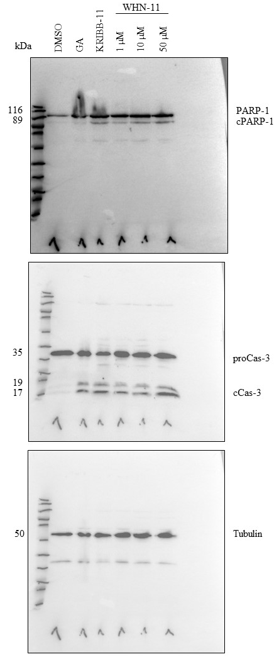
F1. Western blot analysis of PARP-1 and caspase-3 activation in treated HCC1937 cells. GA: geldanamycin.

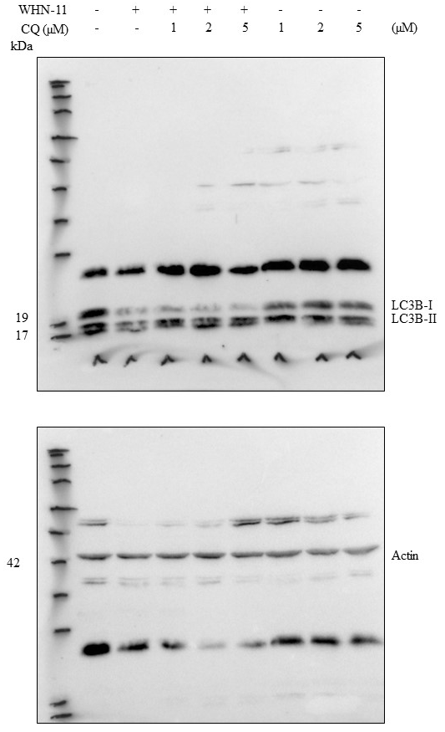
F2. Western blot analysis of LC3B lipidation in HCC1937 cells treated overnight with 10 µM WHN-11 and for 4 hours with 2 µM chloroquine (CQ).

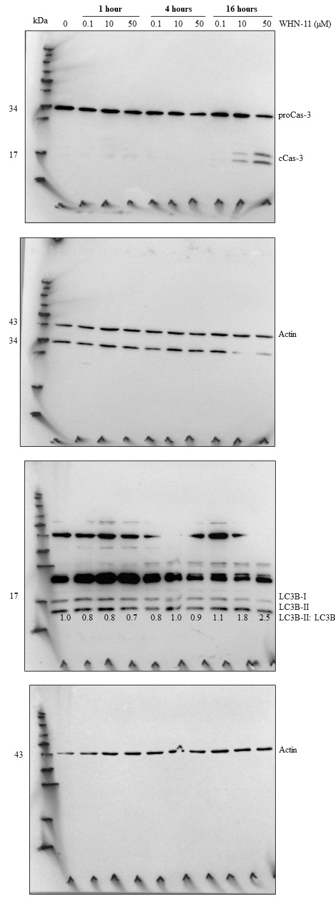
F3. Time-dependent treatment of HCC1937 cells with 0.1% DMSO or WHN-11 for caspase-3 and LC3B activation.

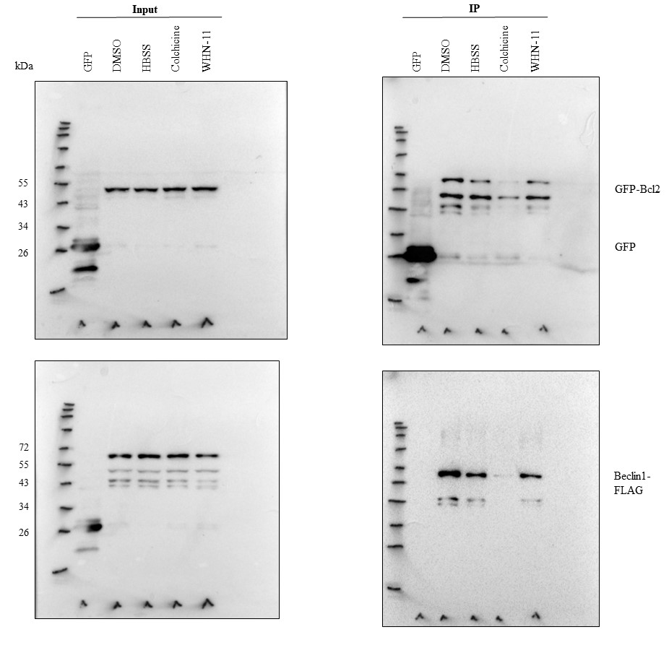
F4. Immunoprecipitation of GFP or GFP-Bcl2 complexes in lysates (input) for HEK293T cells transfected with pLV-eGFP (untreated control) or GFP-Bcl2 and Beclin1-FLAG for 48 hours and treated for 3 hours with 0.1% DMSO, Hanks’ Balanced Salt Solution (HBSS), 5 µM colchicine or 10 µM WHN-11.

References
1. Watson DJ, Laing L, Gibhard L, et al (2021) Toward new transmission-blocking combination therapies: Pharmacokinetics of 10-amino-artemisinins and 11-aza-artemisinin and comparison with dihydroartemisinin and artemether. Antimicrob Agents Chemother 65:. https://doi.org/10.1128/AAC.00990-21/SUPPL_FILE/AAC00990-21_SUPP_S1_SEQ2.PDF
2. Wu Y, Parapini S, Williams ID, et al (2018) Facile Preparation of N-Glycosylated 10-Piperazinyl Artemisinin Derivatives and Evaluation of Their Antimalarial and Cytotoxic Activities. Molecules 23:. https://doi.org/10.3390/MOLECULES23071713
3. Wong HN, Lewies A, Haigh M, et al (2020) Anti-Melanoma Activities of Artemisone and Prenylated Amino-Artemisinins in Combination With Known Anticancer Drugs. Front Pharmacol 11:. https://doi.org/10.3389/fphar.2020.558894
4. Hanmer KL, Mavri-Damelin D (2018) Peroxidasin is a novel target of the redox-sensitive transcription factor Nrf2. Gene 674:104–114. https://doi.org/10.1016/j.gene.2018.06.076
5. Siebring-Van Olst E, Vermeulen C, De Menezes RX, et al (2013) Affordable luciferase reporter assay for cell-based high-throughput screening. J Biomol Screen 18:453–461. https://doi.org/10.1177/1087057112465184
6. Bolte S, Cordelières FP (2006) A guided tour into subcellular colocalization analysis in light microscopy. J Microsc 224:213–232. https://doi.org/10.1111/j.1365-2818.2006.01706.x
7. Augustin Y, Staines HM, Krishna S (2020) Artemisinins as a novel anti-cancer therapy: Targeting a global cancer pandemic through drug repurposing. Pharmacol Ther 216:. https://doi.org/10.1016/J.PHARMTHERA.2020.107706
8. Yang X, Zheng Y, Liu L, et al (2021) Progress on the study of the anticancer effects of artesunate. Oncol Lett 22:. https://doi.org/10.3892/OL.2021.13011

