Supplementary material

2.2 Data pre-processing for text-mining
Text preprocessing includes removing extra spaces, numbers, punctuation, correcting spelling errors and nouns, translating from English to Korean, tokenization, stopping word removal, and synonym processing. Due to the unique structure of the Korean language, where affixes form words and various verb derivations are common, expressions are often modified to nouns to reduce ambiguity. For instance, the phrase ‘I’m having a hard time with back pain’ is converted into ‘lumbago.’ In addition, if symptoms were reported as improved rather than as an adverse reaction, the response was removed. Initial analysis indicated similarities between terms related to injection site reactions and systemic adverse reactions, leading to their combined analysis in subsequent stages. The refined data from preprocessing facilitated word frequency analysis, calculation of daily reporting rates for prevalent terms, and semantic network analysis.

2.3 Data analysis
2.3.2 Word frequencies
In word-frequency analysis, to prevent exaggeration from individuals who responded multiple times (either across multiple days or within the same day), duplicate terms in an individual’s response were treated as omissions, and ‘injection’ was designated as a stop word. This approach allowed for the calculation of reporting percentages for 1,864 respondents. Among the extracted terms, those related to adverse reactions reported by >1% of all respondents (frequency > 20 times) were ranked according to frequency. Furthermore, word frequency analysis was performed taking into consideration factors such as the coadministration of the influenza vaccine, sex, and age groups (<65 years, 65–74 years, and ≥75 years). The daily adverse reaction reporting percentage was calculated to deduce when and for how long adverse reactions occurred after vaccination. Analysis was conducted for each day (from day 0–7) during the survey period. If a respondent reported the same term multiple times within a day, it was considered a duplicate term and treated as missing, and word frequency was calculated accordingly. Results, focusing on the top 10 most frequently reported terms daily, were organized and visualized for clear insight into the trends of adverse reactions.
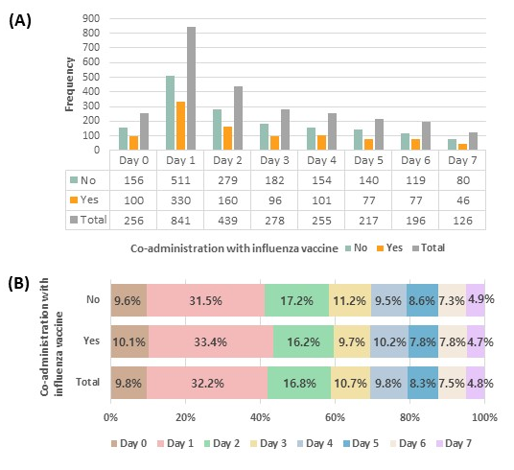
Supplemental Figure 1. Frequency and of reporting of text-based adverse reactions during the first 7 days following mRNA COVID-19 vaccination (October 19, 2023 to November 6, 2023), according to whether the COVID-19 vaccine and seasonal influenza vaccine were administered at same time: (A) Frequency of reports by day after vaccination and (B) Percentage of reports by day after vaccination

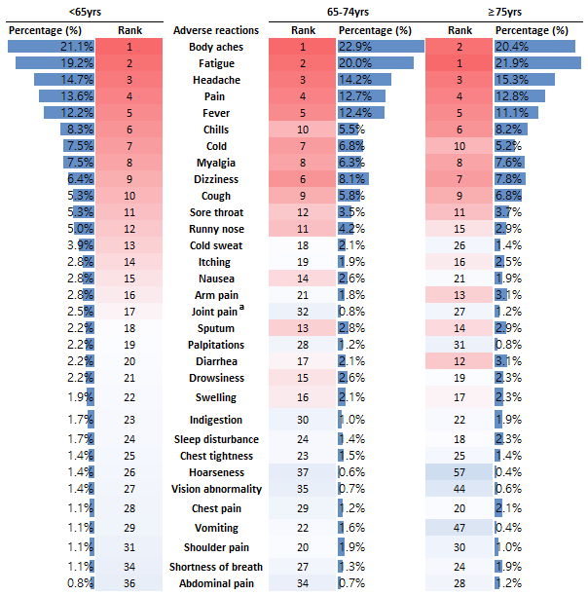

Supplemental Figure 1. Differences of frequent terms for adverse reactions reported via text during the first 7 days following mRNA COVID-19 vaccination (October 19, 2023 to November 6, 2023), according to age groups
The superscript letter 'a' indicates a statistical difference (Bonferroni adjusted p<0.05) between the group under 65 years of age and the group 65-74 years of age.

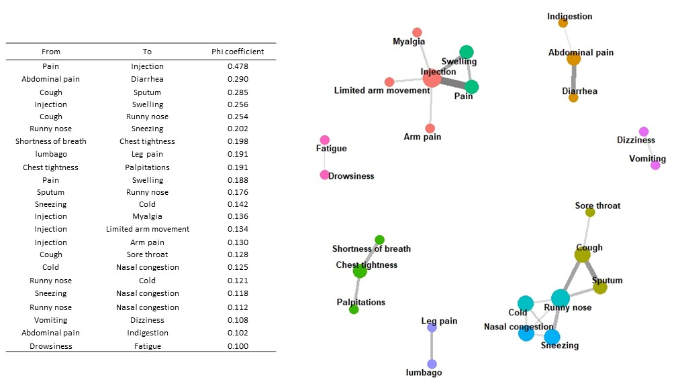
Supplemental Figure 3. Phi-coefficient network diagram for terms related to adverse reactions reported via text during the first 7 days following mRNA COVID-19 vaccination (October 19, 2023 to November 6, 2023)
Node size indicates centrality and edge thickness indicates the phi-coefficient of term pairs. It was organized around key terms pairs that reported a phi-coefficient > 0.1.

Supplemental Table 1. Terms (below 1%) reported as adverse reactions during the first 7 days following mRNA COVID-19 vaccination (October 19, 2023 to November 6, 2023)
Category | Adverse reactions | Frequency | Percentage (%)
Uncommon  (≥ 0.1% to < 1.0%) | Abdominal pain | 16 | 0.9
Uncommon  (≥ 0.1% to < 1.0%) | Vision abnormality | 15 | 0.8
Uncommon  (≥ 0.1% to < 1.0%) | Hoarseness | 13 | 0.7
Uncommon  (≥ 0.1% to < 1.0%) | Nasal congestion | 13 | 0.7
Uncommon  (≥ 0.1% to < 1.0%) | Leg pain | 12 | 0.6
Uncommon  (≥ 0.1% to < 1.0%) | Discomfort in arm movement | 12 | 0.6
Uncommon  (≥ 0.1% to < 1.0%) | Shoulder muscle pain | 11 | 0.6
Uncommon  (≥ 0.1% to < 1.0%) | Blushing | 11 | 0.6
Uncommon  (≥ 0.1% to < 1.0%) | Sneezing | 10 | 0.5
Uncommon  (≥ 0.1% to < 1.0%) | Whole body | 9 | 0.5
Uncommon  (≥ 0.1% to < 1.0%) | Rib pain | 8 | 0.4
Uncommon  (≥ 0.1% to < 1.0%) | Numbness in legs | 8 | 0.4
Uncommon  (≥ 0.1% to < 1.0%) | Brain fog | 8 | 0.4
Uncommon  (≥ 0.1% to < 1.0%) | Knee pain | 8 | 0.4
Uncommon  (≥ 0.1% to < 1.0%) | Inconvenience | 8 | 0.4
Uncommon  (≥ 0.1% to < 1.0%) | Finger pain | 8 | 0.4
Uncommon  (≥ 0.1% to < 1.0%) | Tinnitus | 8 | 0.4
Uncommon  (≥ 0.1% to < 1.0%) | Leg muscle pain | 7 | 0.4
Uncommon  (≥ 0.1% to < 1.0%) | Leg weakness | 7 | 0.4
Uncommon  (≥ 0.1% to < 1.0%) | Knee | 7 | 0.4
Uncommon  (≥ 0.1% to < 1.0%) | Eye pain | 7 | 0.4
Uncommon  (≥ 0.1% to < 1.0%) | Increased blood pressure | 7 | 0.4
Uncommon  (≥ 0.1% to < 1.0%) | Earache | 6 | 0.3
Uncommon  (≥ 0.1% to < 1.0%) | Eye congestion | 6 | 0.3
Uncommon  (≥ 0.1% to < 1.0%) | Bone joint | 6 | 0.3
Uncommon  (≥ 0.1% to < 1.0%) | Facial edema' | 6 | 0.3
Uncommon  (≥ 0.1% to < 1.0%) | Difficulty moving | 5 | 0.3
Uncommon  (≥ 0.1% to < 1.0%) | Bruise | 5 | 0.3
Uncommon  (≥ 0.1% to < 1.0%) | Loss of taste | 5 | 0.3
Uncommon  (≥ 0.1% to < 1.0%) | Eye discomfort | 5 | 0.3
Uncommon  (≥ 0.1% to < 1.0%) | Nosebleed | 5 | 0.3
Uncommon  (≥ 0.1% to < 1.0%) | Waist | 5 | 0.3
Uncommon  (≥ 0.1% to < 1.0%) | Thighs | 5 | 0.3
Uncommon  (≥ 0.1% to < 1.0%) | Armpit pain | 4 | 0.2
Uncommon  (≥ 0.1% to < 1.0%) | Stomatitis | 4 | 0.2
Uncommon  (≥ 0.1% to < 1.0%) | Neck discomfort | 4 | 0.2
Uncommon  (≥ 0.1% to < 1.0%) | Heaviness | 4 | 0.2
Uncommon  (≥ 0.1% to < 1.0%) | Menstruation | 4 | 0.2
Uncommon  (≥ 0.1% to < 1.0%) | Itchy face | 4 | 0.2
Uncommon  (≥ 0.1% to < 1.0%) | Side | 4 | 0.2
Uncommon  (≥ 0.1% to < 1.0%) | Gum pain | 4 | 0.2
Uncommon  (≥ 0.1% to < 1.0%) | Memory impairments | 3 | 0.2
Uncommon  (≥ 0.1% to < 1.0%) | Tear | 3 | 0.2
Uncommon  (≥ 0.1% to < 1.0%) | Hives | 3 | 0.2
Uncommon  (≥ 0.1% to < 1.0%) | Itchy scalp | 3 | 0.2
Uncommon  (≥ 0.1% to < 1.0%) | Motion Sickness | 3 | 0.2
Uncommon  (≥ 0.1% to < 1.0%) | Neck pain | 3 | 0.2
Uncommon  (≥ 0.1% to < 1.0%) | Toe pain | 3 | 0.2
Uncommon  (≥ 0.1% to < 1.0%) | Rash | 3 | 0.2
Uncommon  (≥ 0.1% to < 1.0%) | Abdominal distension | 3 | 0.2
Uncommon  (≥ 0.1% to < 1.0%) | Red spot | 3 | 0.2
Uncommon  (≥ 0.1% to < 1.0%) | Irregular menstruation | 3 | 0.2
Uncommon  (≥ 0.1% to < 1.0%) | Hot eye | 3 | 0.2
Uncommon  (≥ 0.1% to < 1.0%) | Shoulder | 3 | 0.2
Uncommon  (≥ 0.1% to < 1.0%) | Shoulder joint pain | 3 | 0.2
Uncommon  (≥ 0.1% to < 1.0%) | Shoulder heavy | 3 | 0.2
Uncommon  (≥ 0.1% to < 1.0%) | Ear fullness | 3 | 0.2
Uncommon  (≥ 0.1% to < 1.0%) | Dry mouth | 3 | 0.2
Uncommon  (≥ 0.1% to < 1.0%) | Back muscle pain | 3 | 0.2
Uncommon  (≥ 0.1% to < 1.0%) | Numbness | 2 | 0.1
Uncommon  (≥ 0.1% to < 1.0%) | Armpit itching | 2 | 0.1
Uncommon  (≥ 0.1% to < 1.0%) | Earache | 2 | 0.1
Uncommon  (≥ 0.1% to < 1.0%) | Leg | 2 | 0.1
Uncommon  (≥ 0.1% to < 1.0%) | Difficulty moving | 2 | 0.1
Uncommon  (≥ 0.1% to < 1.0%) | Leg swelling | 2 | 0.1
Uncommon  (≥ 0.1% to < 1.0%) | Stuffy | 2 | 0.1
Uncommon  (≥ 0.1% to < 1.0%) | Back muscle pain | 2 | 0.1
Uncommon  (≥ 0.1% to < 1.0%) | Neck muscle pain | 2 | 0.1
Uncommon  (≥ 0.1% to < 1.0%) | Ankle pain | 2 | 0.1
Uncommon  (≥ 0.1% to < 1.0%) | Sole pain | 2 | 0.1
Uncommon  (≥ 0.1% to < 1.0%) | Unrest | 2 | 0.1
Uncommon  (≥ 0.1% to < 1.0%) | Upper body itching | 2 | 0.1
Uncommon  (≥ 0.1% to < 1.0%) | Wrist pain | 2 | 0.1
Uncommon  (≥ 0.1% to < 1.0%) | Shoulder discomfort | 2 | 0.1
Uncommon  (≥ 0.1% to < 1.0%) | Hip | 2 | 0.1
Uncommon  (≥ 0.1% to < 1.0%) | Dead skin cells on lips | 2 | 0.1
Uncommon  (≥ 0.1% to < 1.0%) | Lip blisters | 2 | 0.1
Uncommon  (≥ 0.1% to < 1.0%) | Gum swelling | 2 | 0.1
Uncommon  (≥ 0.1% to < 1.0%) | Tooth pain | 2 | 0.1
Uncommon  (≥ 0.1% to < 1.0%) | Itchy arms | 2 | 0.1
Uncommon  (≥ 0.1% to < 1.0%) | Elbow | 2 | 0.1
Uncommon  (≥ 0.1% to < 1.0%) | Tonsil edema | 2 | 0.1
 | Tonsil | 2 | 0.1
If an individual reported the same adverse reaction repeatedly over several days, it was treated as a single event. Percentage (%) was calculated for 1,864 subjects.

