Supplementary Material

REST Study Design and Population
The multisite study named REST (Recovery Optimisation in Emergency Medicine addressing Stress Adaptation Techniques) was a stepped-wedge, cluster-randomised controlled trial using computer-generated sequence randomisation for a block of eight EHPs each time with EnnovClinical® Software (Ennov, Paris, France) in nine calendar-time blocks. Data collection occurred in two university hospital's emergency departments in Lyon, France. The shift system requires nurses to rotate 12-hour day and night shifts and physicians to rotate between 10.5-hour dayshifts and 14-hour night shifts. The study has been approved by the ethics committee for the protection of individuals, the “Comité de Protection des Personnes” (CPP: an independent committee approved by the Health Ministry) (2021-A03171-40) and was preregistered on ClinicalTrials.gov (Identifier: NCT05251246).
Inclusion criteria were full-time staff (or at least 80%) as a physician or nurse, staff that had worked more than a year in an ED and that signed the consent statement. Participants were not remunerated and did solely benefit from personalised behavioural sleep training as part of the protocol. Exclusion criteria were vacations longer than three weeks and pregnant or lactating women. Data collection occurred between February and November 2022. A total of 72 participants volunteered.
The procedure consisted of a delayed intervention design spanning six non-consecutive weeks: three for baseline sleep measurements, two for a personalised recovery program, and one for post-intervention assessment (Figure 1). Participants in the RECOVERY group, assigned through cluster randomisation, participated in the earliest possible workshop and training session based on logistical feasibility. The CONTROL group did not engage in any additional activities until the post-measurement phase. A battery of questionnaires about baseline characteristics and health profiles were given at inclusion

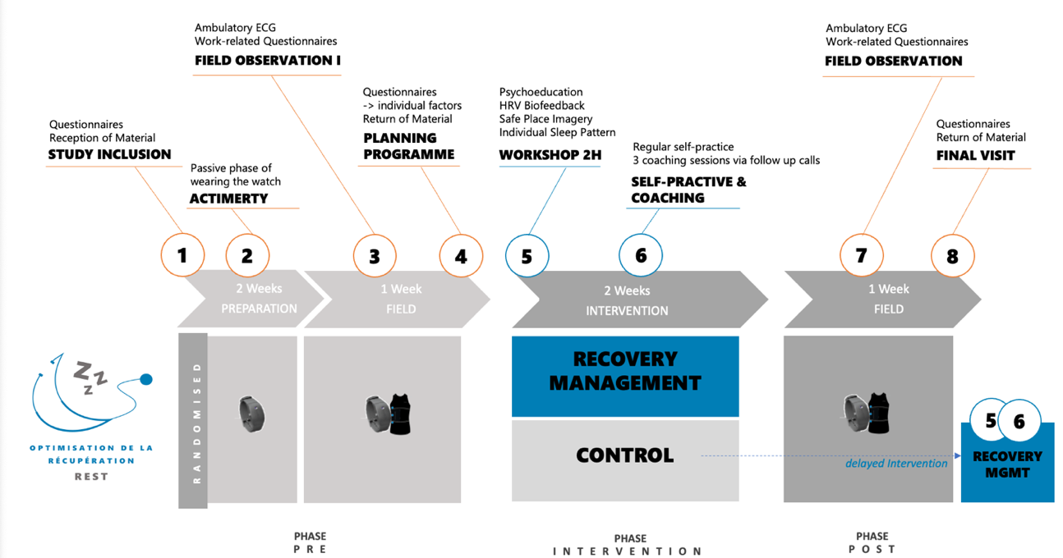
Supplemental Figure SF1.
REST Study Design: 6 non-consecutive weeks for a delayed intervention design rolled out in a stepped-wedge, cluster randomised control trial.

Figure SF2.
Exemplary process and visualisation of Shift Load Index (SLI) calculation:
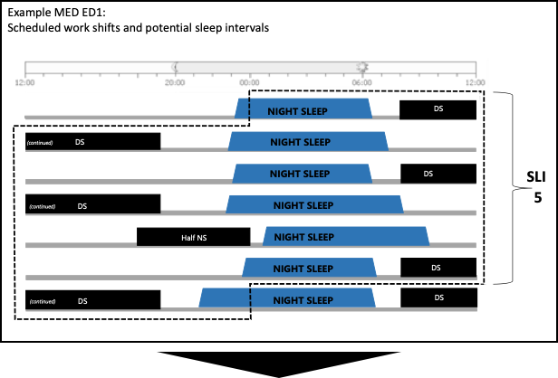

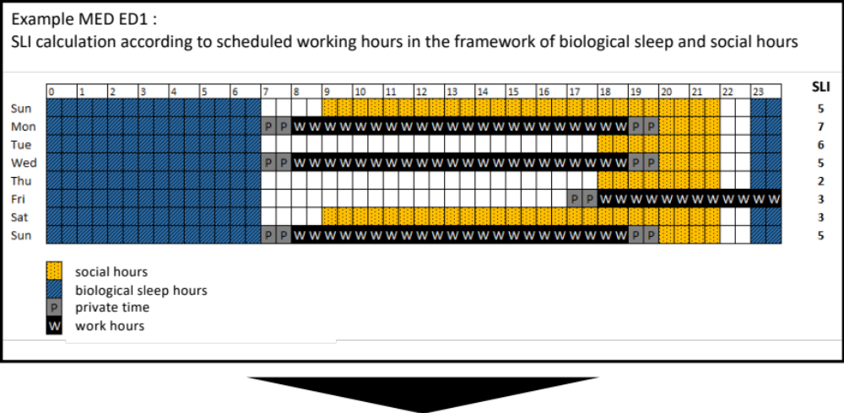

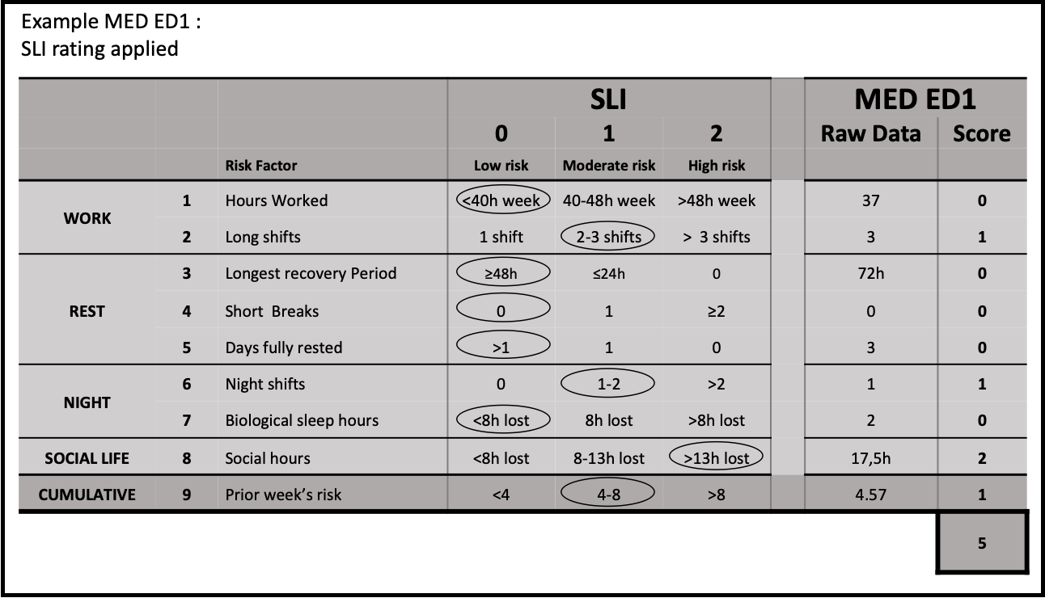

Table ST1.
Items of the Shift Load Index (SLI) compared to original items from Gander’s research team.
 |  |  |  |  | Shift Load Index |  |  |  | Gander Rating Matrix
 |  |  |  |  | 0 | 1 | 2 |  | 0 | 1 | 2
 |  |  | Risk Factor |  | Low  risk | Moderate  risk | High  risk |  | Low  risk | Moderate  risk | High  risk
WORK | 1 |  | Hours Worked |  | <40h  week | 40-48h week | >48h  week |  | <50h  week | 50-70h week | >70h  week
WORK | 2 |  | Long shifts |  | 1 shift | 2-3 shifts | >3 shifts |  | 0 shift  all < 10h | 1 shift  > 14h | ≥2 shifts  > 14h
REST | 3 |  | Longest Recovery Period |  | ≥48h | ≤24h | 0 |  | ≥48h | ≤24h | 0
REST | 4 |  | Short Breaks |  | 0 | 1 | ≥2 |  | 0 | 1 | ≥2
REST | 5 |  | Days fully rested |  | >1 | 1 | 0 |  | >1 | 1 | 0
NIGHT | 6 |  | Night shifts |  | 0 | 1-2 | >2 |  | 0 | 1-2 | >2
NIGHT | 7 |  | Biological sleep hours |  | <8h lost | 8h lost | >8h lost |  | 6-7 complete nights | 4-5 complete nights | 0-3 complete nights
SOCIAL LIFE | 8 |  | Social hours |  | <8h lost | 8-13h lost | >13h lost |  | / | / | /
CUMULATIVE | 9 |  | Prior week’s risk score  (optional) |  | <4 SLI | 4-8 SLI | >8 SLI |  | / | / | /
Note. SLI rating: Long shifts >10h. Longest recovery period assesses the consecutive time to disconnect and recover, similar to a typical weekend period. Short breaks <11h. Biological sleep hours assumes one complete night of biological sleep amounts to 8h between 23:00 – 7:00; hours lost refers to the cumulated hours of night time sleep duration during one week below 56h (7 nights * 8h), 8h lost ≈ 1 complete night. Social hours are assumed to occur between 18:00 and 22:00 on weekday evenings and between 9:00 and 22:00 on weekends; hours lost refers to cumulated social hours below 46h, 8h lost ≈ two social evenings, 13h lost ≈ a weekend day. Prior week’s risk score maximum across eight items is 16, more than half that score indicated heightened risk in the prior week and a quarter a low risk in the prior week.

Table ST2.
Comparison of raw values of Shift Load Index items between professions.
 |  | Nurse |  |  | Physician
 |  | M | SD |  | M | SD |  | p
1 | Working Hours | 36.7 | 10.9 |  | 40.0 | 12.6 |  | 0.166
2 | Long shifts | 3.0 | 0.9 |  | 3.1 | 1.1 |  | 0.776
3 | Longest Recovery Period¹ | 4.3 | 1.2 |  | 3.6 | 1.2 |  | < 0.001 | ***
4 | Short Breaks | 0.0 | 0.0 |  | 0.1 | 0.2 |  | 0.028 | *
5 | Day fully rested¹ | 3.1 | 1.2 |  | 2.5 | 1.4 |  | 0.019 | *
6 | Night Shifts | 1.5 | 1.1 |  | 1.3 | 0.8 |  | 0.381
7 | Biological Sleep Hours | 12.6 | 8.1 |  | 10.5 | 6.5 |  | 0.018 | *
8 | Social Hours | 13.6 | 8.0 |  | 12.9 | 7.1 |  | 0.812
9 | Week Cumulation | 4.9 | 2.6 |  | 5.3 | 3.1 |  | 0.518
Note. Group comparison between profession with Mann Whitney U Test.
¹Items with higher scores indicating less risk

