Supplementary data
Supplementary data 1: Comparison of simple models for estimating leaf dry weight vs. leaf area E. standleyana
Model type | r.squared | adj.r.squared | sigma | Statistic | P.value | df | logLik | AIC | BIC | deviance | df.residual | nobs
Linear | 0.972 | 0.972 | 0.239 | 2462.571 | 7.38E-57 | 1 | 1.845 | 2.311 | 9.182 | 4.063 | 71 | 73
Logarithmic | 0.783 | 0.780 | 0.666 | 255.771 | 3.09E-25 | 1 | -72.912 | 151.824 | 158.695 | 31.506 | 71 | 73
Exponential | 0.836 | 0.833 | 0.432 | 360.658 | 1.53E-29 | 1 | -41.254 | 88.508 | 95.380 | 13.235 | 71 | 73
Potential | 0.992 | 0.992 | 0.094 | 9065.788 | 1.22E-76 | 1 | 70.159 | -134.319 | -127.448 | 0.625 | 71 | 73

Supplementary data 2: Potential model parameters for estimating leaf dry weight E. standleyana
Term | Estimate | Std.error | Statistic | P.value
(Intercept) | -5.049587948 | 0.061247906 | -82.44507143 | 3.08E-72
log(Leaf area) | 1.29702164 | 0.013622112 | 95.21443071 | 1.22E-76
Supplementary data 3: Validation tests of the potential model for estimating leaf dry weight in E. standleyana
 | Test | Statistic | Value | P.value
Residuals normality | Shapiro-Wilk | W | 0.56164 | 0.8919
Homoscedasticity of residuals | Breusch-Pagan | BP | 3.2008 | 0.0736
Autocorrelation of residuals | Durbin-Watson | D-W | 2.1136 | 0.6575
Supplementary data 4: Graphical representation of the validations leaf dry weight vs leaf area model E. standleyana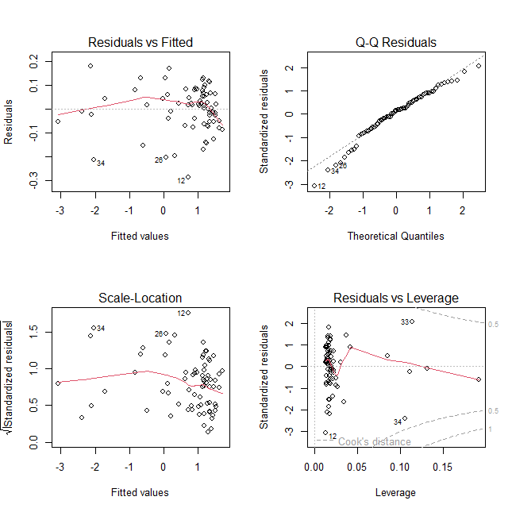

Supplementary data 5: Comparison of simple models for estimating leaf dry weight vs. leaf area E. santanderensis.
Model type | r.squared | adj.r.squared | sigma | Statistic | P.value | df | logLik | AIC | BIC | deviance | df.residual | nobs
Linear | 0.86 | 0.86 | 0.04 | 404.13 | 7.66E-30 | 1 | 130.96 | -255.93 | -249.27 | 0.08 | 66 | 68
Logarithmic | 0.77 | 0.77 | 0.05 | 221.18 | 9.36E-23 | 1 | 114.20 | -222.41 | -215.75 | 0.14 | 66 | 68
Exponential | 0.77 | 0.77 | 0.21 | 225.17 | 5.92E-23 | 1 | 9.85 | -13.70 | -7.04 | 2.98 | 66 | 68
Potential | 0.87 | 0.87 | 0.16 | 459.32 | 1.95E-31 | 1 | 29.91 | -53.82 | -47.16 | 1.65 | 66 | 68

Supplementary data 6: Linear model parameters for estimating leaf dry weight E. santanderensis
Term | Estimate | Std.error | Statistic | P.value
(Intercept) | -0.00122505 | 0.01297394 | -0.09442395 | 0.92505847
`Leaf area` | 0.02075864 | 0.00103261 | 20.1030066 | 7.66E-30

Supplementary data 7: Validation tests of the potential model for estimating leaf dry weight in E. santanderensis
 | Test | Statistic | Value | P.value
Residuals normality | Shapiro-Wilk | W | 0.57353 | 0.8696
Homoscedasticity of residuals | Breusch-Pagan | BP | 3.3999 | 0.0652
Autocorrelation of residuals | Durbin-Watson | D-W | 1.6485 | 0.0669
Supplementary data 8: Graphical representation of the validations leaf dry weight vs leaf area model in E. santanderensis
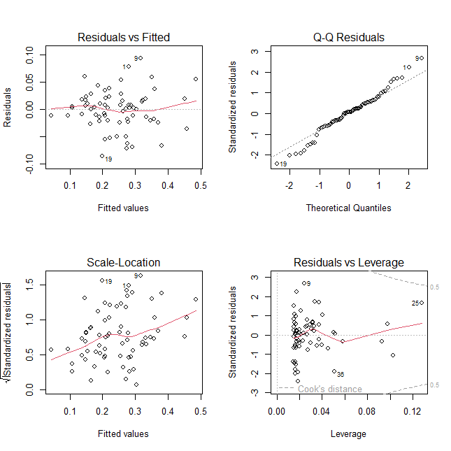
Supplementary data 9: Validation model leaf biomass E. standleyana.
r.squared | adj.r.squared | sigma | Statistic | P.value | df | logLik | AIC | BIC | deviance | df.residual | nobs
0.992 | 0.992 | 14.5 | 1718 | 2.41E-28 | 2 | -117 | 242 | 248 | 5451 | 26 | 29

Supplementary data 10: Multiple linear model parameters for estimating leaf biomass E. standleyana
Term | Estimate | Std.error | Statistic | P.value
(Intercept) | -78.9 | 7.64 | -10.3 | 1.09E-10
LAI | 242 | 5.48 | 44.2 | 5.45E-26
DWmean | 39.7 | 2.7 | 14.7 | 4.19E-14

Supplementary data 11: Validation tests of the potential model for estimating leaf biomass in E. standleyana
 | Test | Statistic | Value | P.value
Residuals normality | Shapiro-Wilk | W | 0.93925 | 0.09584
Homoscedasticity of residuals | Breusch-Pagan | B-P | 0.041 | 0.3447
Autocorrelation of residuals | Durbin-Watson | D-W | 2.0007 | 0.4702

Supplementary data 12: Collinearity Diagnostics Part 1
Eigenvalue | Condition Index | intercept | LAI | Dry Weight
2.81217727 | 1 | 0.0147351 | 0.01327822 | 0.0196138
0.11728418 | 4.896679 | 0.2764514 | 0.07837848 | 0.93974766
0.07053855 | 6.314051 | 0.7088135 | 0.9083433 | 0.04063854

Supplementary data 12: Collinearity Diagnostics Part 2
Variables | Tolerance | VIF
LAI | 0.7998441 | 1.250244
DWmean | 0.7998441 | 1.250244
Supplementary data 13: Graphical representation of the validations leaf biomass vs leaf area index and mean dry weight model E. standleyana
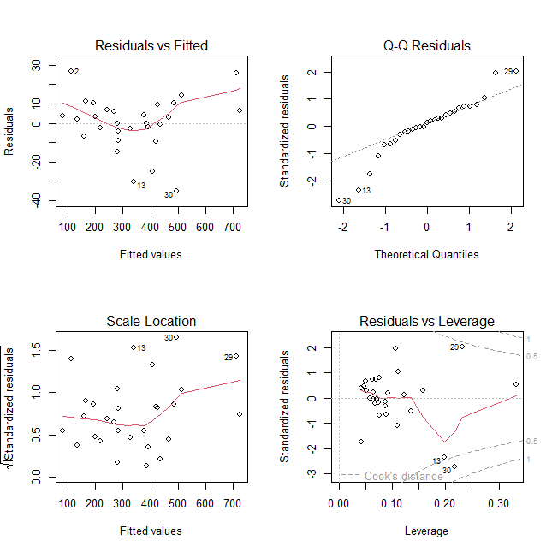
Supplementary data 14: Validation model leaf biomass E. santanderensis
r.squared | adj.r.squared | sigma | Statistic | P.value | df | logLik | AIC | BIC | deviance | df.residual | nobs
0.998 | 0.998 | 4.934 | 17255.888 | 1.99E-39 | 1 | -86.399 | 178.798 | 182.900 | 657.182 | 27 | 29

Supplementary data 15: Linear model parameters for estimating leaf dry weight E. standleyana. en E. santanderensis.
Term | Estimate | Std.error | Statistic | P.value
(Intercept) | 0.934 | 0.908 | 1.03 | 3.12E-01
LAI | 182 | 0.736 | 247 | 2.81E-48

Supplementary data 16: Validation tests of the potential model for estimating leaf biomass in E. santanderensis
 | Test | Statistic | Value | P.value
Residuals normality | Shapiro-Wilk | W | 0.94626 | 0.1737
Homoscedasticity of residuals | Breusch-Pagan | BP | 1.9284 | 0.1649
Autocorrelation of residuals | Durbin-Watson | D-W | 2.5884 | 0.9381
Supplementary data 17: Graphical representation of the validations leaf biomass vs leaf area index model E. santanderensis
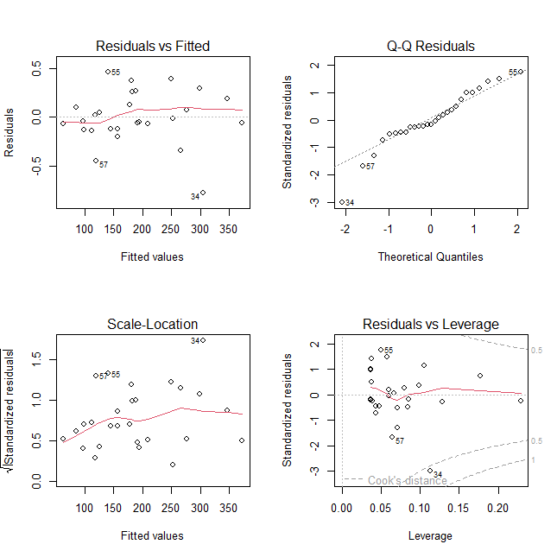
Supplementary data 17: Comparisons test all variables
Especie | Variable | Mean ± SDM | Comparison test | Probability
E. standleyana | Rosette height | 82.1±6.455 cm | -10.344 tW | 2.136e-11
E. santanderensis | Rosette height | 14.7±0.81 cm | -10.344 tW | 2.136e-11
E. standleyana | Rosette cover | 1431.1±161.08 cm² | -5.7442 tW | 1.64e-06
E. santanderensis | Rosette cover | 457.06±53.16 cm² | -5.7442 tW | 1.64e-06
E. standleyana | Rosette diameter | 40.3±2.63 cm | -5.8645 tW | 6.309e-07
E. santanderensis | Rosette diameter | 23.13±1.27 cm | -5.8645 tW | 6.309e-07
E. standleyana | Rosette leaf area | 2130.2±278.71 cm² | -5.6585 tW | 3.175e-06
E. santanderensis | Rosette leaf area | 465.47±56.56 cm² | -5.6585 tW | 3.175e-06
E. standleyana | Rosette leaf dry weight | 53.5±8.32 g | -5.3211 tW | -5.6585
E. santanderensis | Rosette leaf dry weight | 10.25±1.29 g | -5.3211 tW | -5.6585
E. standleyana | Leaf fresh weight | 8.1±0.79 g | -9.503 tW | 1.872e-10
E. santanderensis | Leaf fresh weight | 0.57±0.056 g | -9.503 tW | 1.872e-10
E. standleyana | Leaf dry weight | 2.3±0.22 g | -8.7624 tW | 9.444e-10
E. santanderensis | Leaf dry weight | 0.30±0.02 g | -8.7624 tW | 9.444e-10
E. standleyana | Leaf area | 94.5±7.36 cm² | -11.222 tW | 3.672e-12
E. santanderensis | Leaf area | 10.32±0.61 cm² | -11.222 tW | 3.672e-12
E. standleyana | Leaf length | 24.2±0.94cm | -12.487 tW | 4.605e-16
E. santanderensis | Leaf length | 11.82±0.72 cm | -12.487 tW | 4.605e-16
E. standleyana | Leaf width | 46±0.22 cm | -15.062 tW | 1.13e-15
E. santanderensis | Leaf width | 1.3±0.042 cm | -15.062 tW | 1.13e-15
E. standleyana | Number of leaves | 20.233±1.32 | 5.8234 tW | 1.133e-06
E. santanderensis | Number of leaves | 42.63±3.61 | 5.8234 tW | 1.133e-06
E. standleyana | % sclerophylly | 43.401±1.26 % | 6.3489 tS | 3.6e-08
E. santanderensis | % sclerophylly | 34.5±0.64 % | 6.3489 tS | 3.6e-08
E. standleyana | Specific leaf area | 47.67±1.82 g.cm⁻² | 596 w | 0.03074
E. santanderensis | Specific leaf area | 43.8±1.6 g.cm⁻² | 596 w | 0.03074
E. standleyana | Leaf water content | 5.4±0.55g | -9.1468 tW | 4.401e-10
E. santanderensis | Leaf water content | 0.33±0.038 g | -9.1468 tW | 4.401e-10
E. standleyana | % leaf wáter content | 65.5±0.64% | -6.3489 tS | 3.6e-08
E. santanderensis | % leaf wáter content | 56.6±1.26 % | -6.3489 tS | 3.6e-08
E. standleyana | Leaf área index | 1.6±0.13m².m⁻² | -2.0683 tS | 0.04308
E. santanderensis | Leaf área index | 1.11±0.1 m².m⁻² | -2.0683 tS | 0.04308
E. standleyana | Leaf biomass | 376.9±33.1 g.m⁻² | -4.101tW | 0.0001614
E. santanderensis | Leaf biomass | 242.35±22.53 g.m⁻² | -4.101tW | 0.0001614
E. standleyana | Vascular bundle length | 321.72±5.01 µm | 4.2213 tW | 0.001981
E. santanderensis | Vascular bundle length | 192.19±30.27 µm | 4.2213 tW | 0.001981
E. standleyana | Vascular bundle width | 103.74±3.3 µm | 5.4495 tW | 0.0003333
E. santanderensis | Vascular bundle width | 211.48±19.49 µm | 5.4495 tW | 0.0003333
E. standleyana | Stomatal crypt Depth | 117.28±13.36 µm | -2.4374 tS | 0.04073
E. santanderensis | Stomatal crypt Depth | 80.70±6.81 µm | -2.4374 tS | 0.04073
E. standleyana | Stomatal crypt width (µm) | 130.27±8.66 µm | 1.9985 tS | 0.0807
E. santanderensis | Stomatal crypt width (µm) | 158.80±11.34 µm | 1.9985 tS | 0.0807
E. standleyana | Mesophyll thickness | 46.87±2.73 µm | -2.3499 tS | 0.4033
E. santanderensis | Mesophyll thickness | 38.28±3.83 µm | -2.3499 tS | 0.4033
E. standleyana | Xylem vessels diameter | 6.22±0.2 µm | -16.23 tS | <2.2 e-16
E. santanderensis | Xylem vessels diameter | 12.47±0.15 µm | -16.23 tS | <2.2 e-16
E. standleyana | Soil water content | 53.50±1.4 (%) | 12.162 | 4.066e-10
E. santanderensis | Soil water content | 33.27±0.9 (%) | 12.162 | 4.066e-10
E. standleyana | Soil organic matter | 30.06±1.53(%) | 6.7629 | 2.455e-06
E. santanderensis | Soil organic matter | 18.03±0.9(%) | 6.7629 | 2.455e-06
E. standleyana | Soil pH | 3.9±0.03 | -9.1932 | 3.206e-08
E. santanderensis | Soil pH | 4.5±0.05 | -9.1932 | 3.206e-08
SDM= standard deviation of the mean
tS= t de Student´s test
tW= t Welch´s test
W= Wilcoxon-Mann-Whitney´s test

