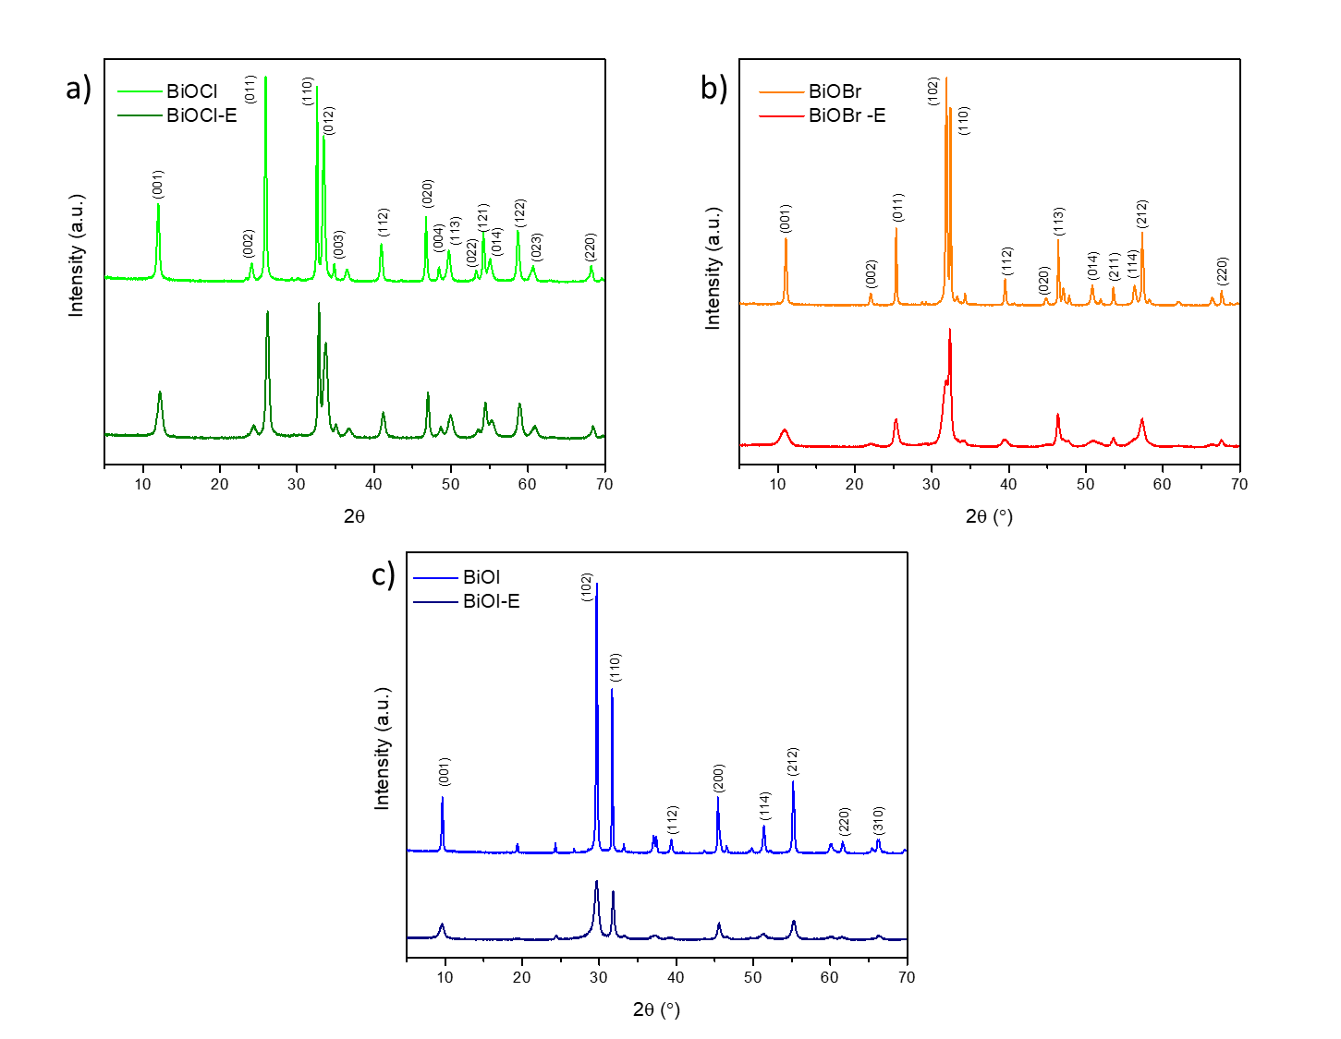
Fig. 1 XRD patterns of materials a) BiOBr b) BiOCl c) BiOI with and without EDTA.

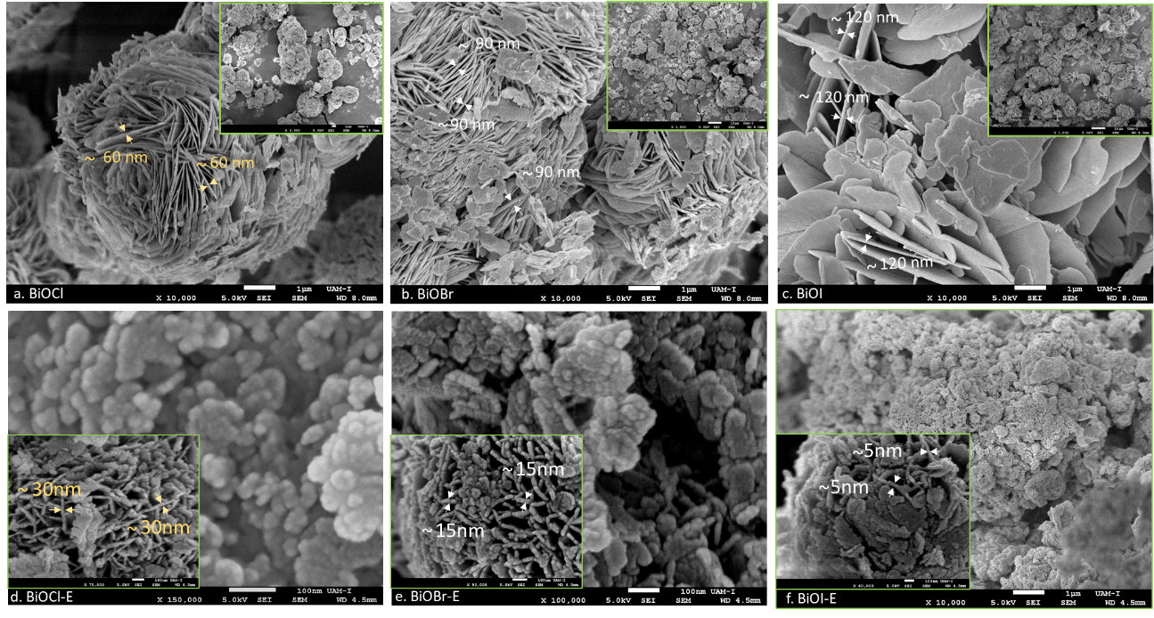
Fig. 2 Images of materials a) BiOBr b) BiOCl c) BiOI with and without EDTA.
Fig. 3 Adsorption-desorption isotherms of N2 of BiOX (X=Cl,Br,Cl) with and without EDTA.
Fig. 4 FTIR spectra of BiOX (X=Cl,Br,Cl) with and without EDTA.
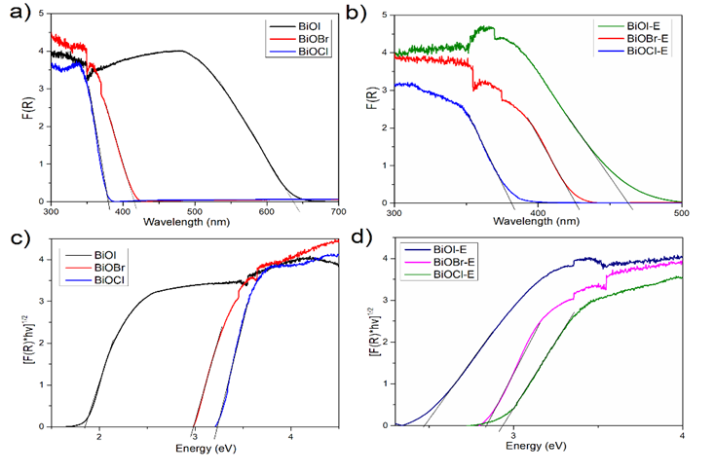
Fig. 5 a,b) DRS UV-Vis spectra, and c,d) Modified Kubelka-Munk spectra of all materials.
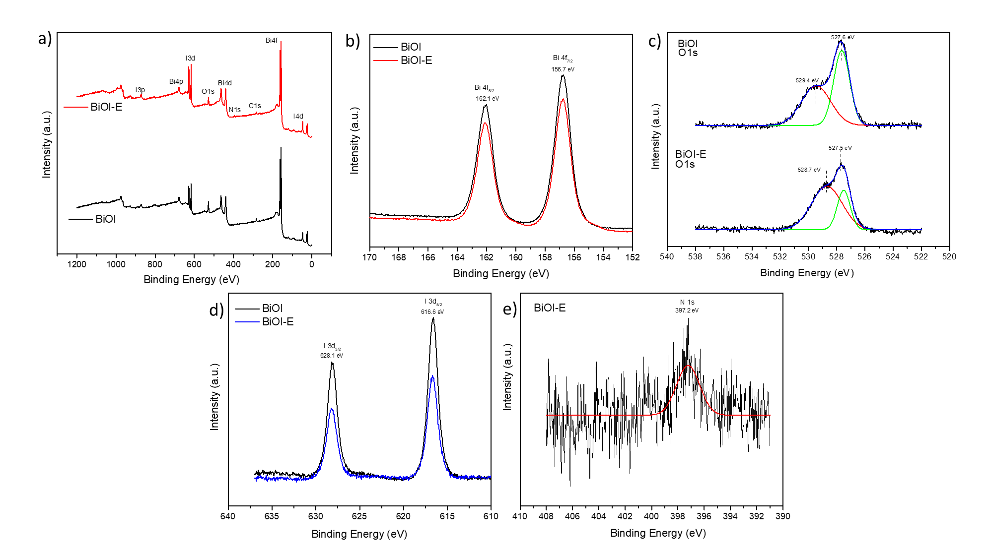
Fig. 6 XPS spectrum of a) BiOI and BiOI-E, High-resolution XPS spectra of b) Bi 4f, c) O 1s, d) I 3d and e) N 1s.

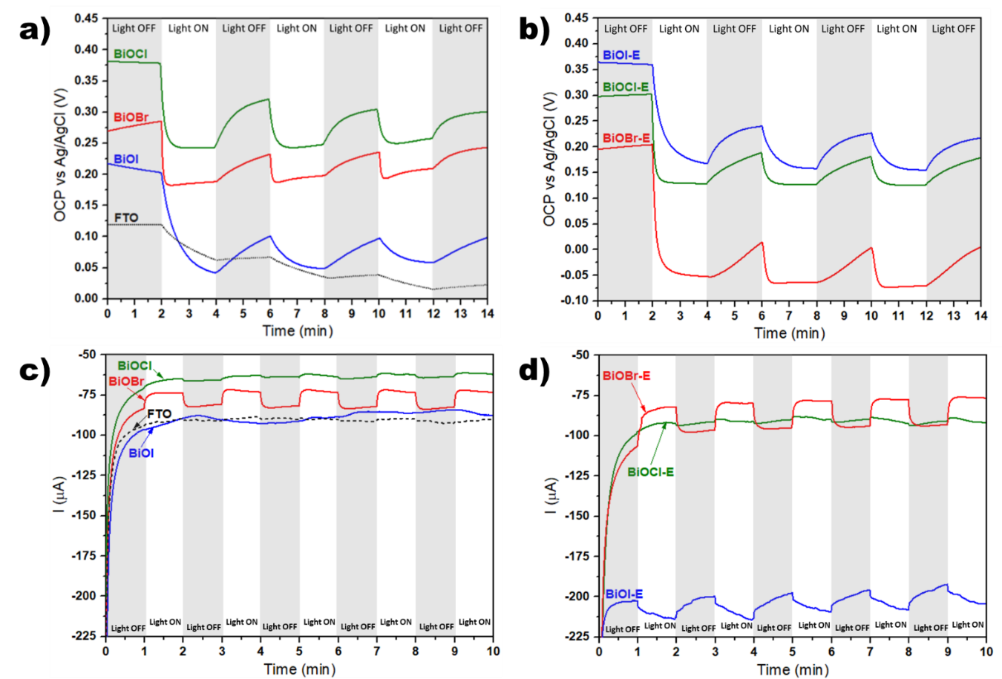
Fig. 7 a, b) OCP vs time plots; c, d) Current transients obtained at -1 V vs Ag/AgCl; acquired under dark and light conditions, for the samples indicated in the figures.
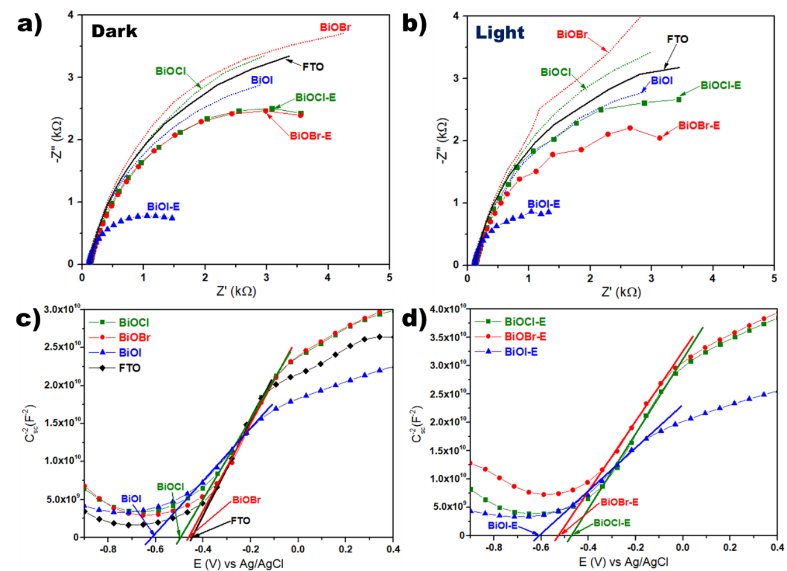
Fig. 8 a, b) Nyquist plots obtained at -1 V vs Ag/AgCl under dark and light conditions; c, d); Mott-Schottky plots measured at 500 Hz; for the samples indicated in the figures.
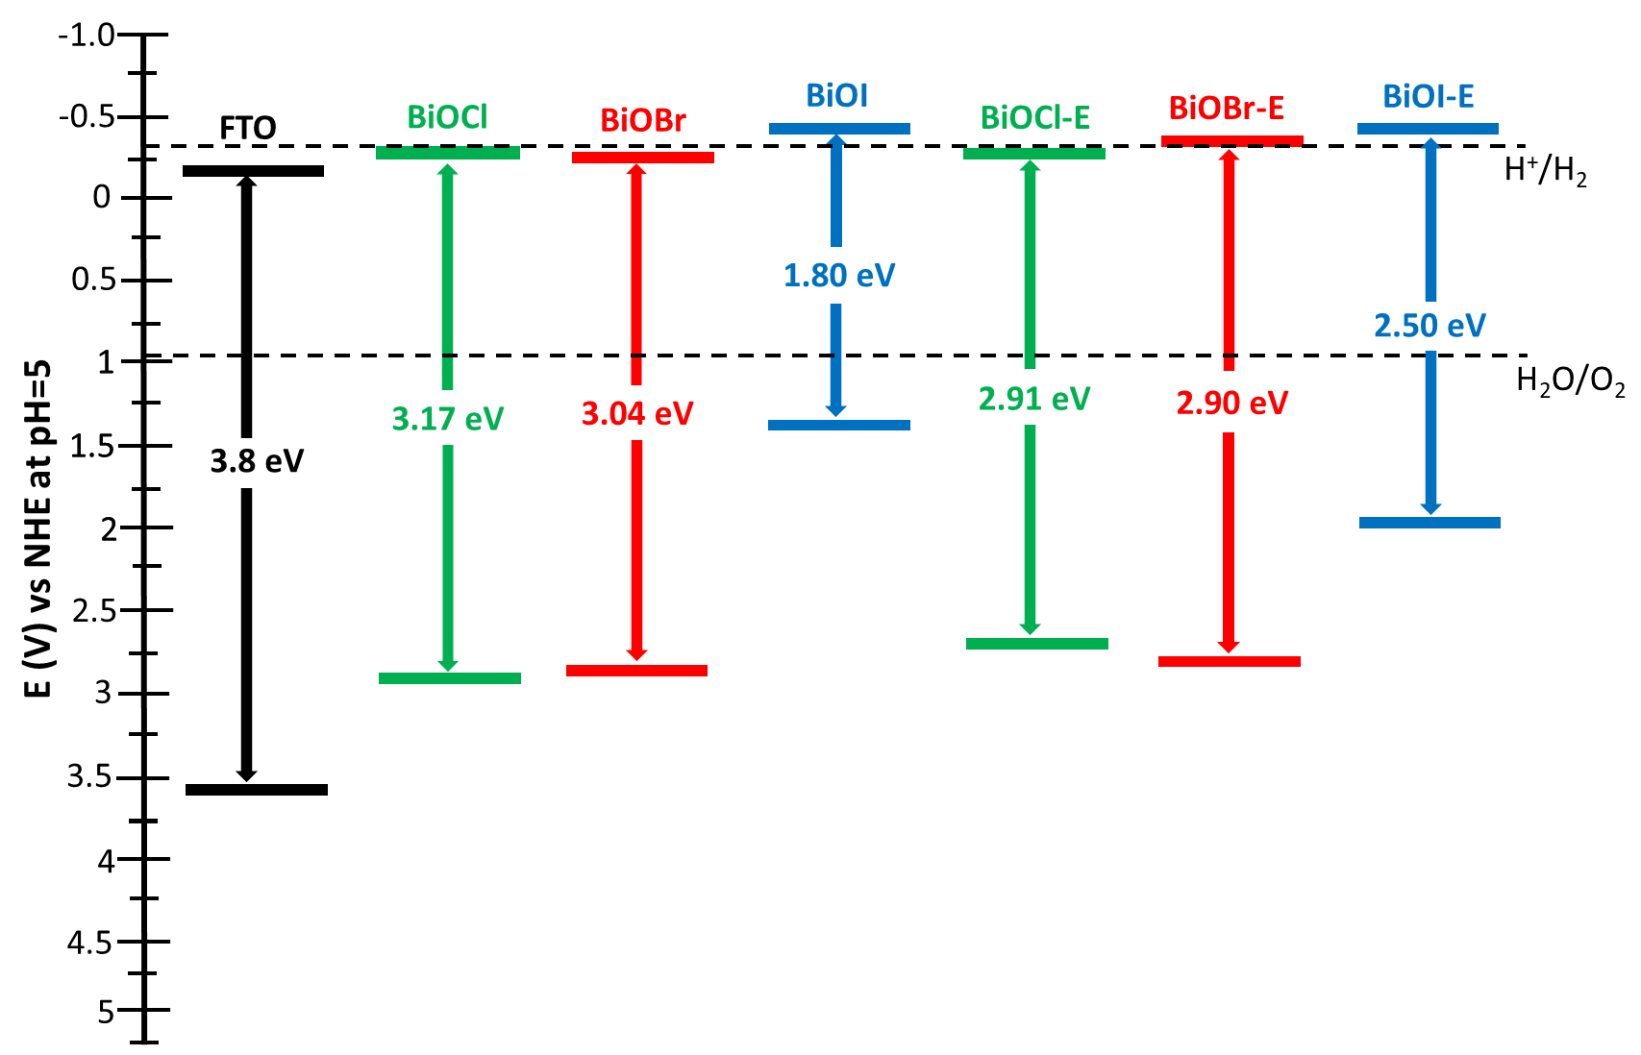
Fig. 9 Energy band diagram for the samples indicated in the figure, estimated from band gaps obtained through Tauc plots and CB position calculated from Mott-Schottky plots.
Fig. 10 Hydrogen production of all materials without sacrificial molecule methanol.
Fig. 11 Hydrogen production of all materials with sacrificial molecule methanol.

