Integrative morphological, phytochemical, and molecular identification of three invasive and medicinal Reynoutria species.

Marta Stafiniak¹, Monika Bielecka¹*, Krzysztof Kujawa², Anna Jezierska-Domaradzaka¹, Bartosz Pencakowski¹, Aleksander Basiak³, Adam Matkowski¹, Izabela Nawrot-Hadzik¹

¹Department of Pharmaceutical Biology and Biotechnology, Wroclaw Medical University, Wroclaw, Poland
²Statistical Analysis Centre, Wroclaw Medical University, Wroclaw, Poland
³Department of Pediatrics, Endocrinology, Diabetology and Metabolic Diseases, Wroclaw Medical University, Wroclaw, Poland
*monika.bielecka@umw.edu.pl
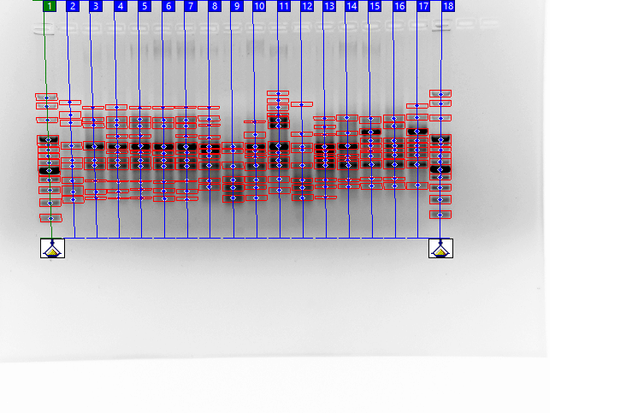
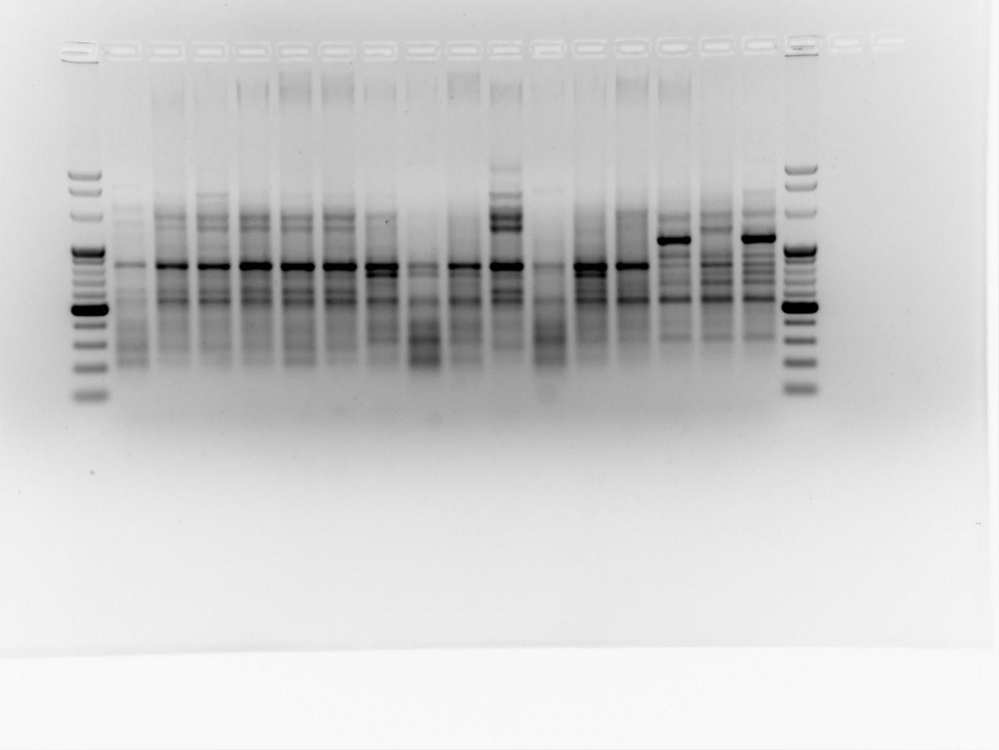
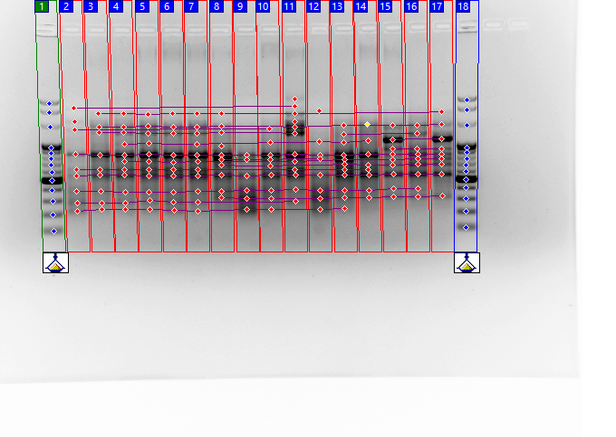
A
B
C
Supplementary Figure 1 Band analysis workflow. Amplification profile of SCoT1 marker in Reynoutria populations (A); Bands detection with Cliqs v1.5 software (Total Lab, UK) (B); Aligning visible bands and matrix creation (C); Left and right-most lane – Perfect™ 100 bp DNA Ladder (EURx). Lanes 2 to 7 (locations RJ2, RJ5, RJ6, RJ8, RJ10, RJ31) – R. japonica; lanes 8 to 14 (locations RB12, RB13, RB14, RB15, RB17, RB18, RB20) – R. x bohemica, lanes 14 to 16 (locations RS21, RS22, RS23) – R. sachalinensis (RS).

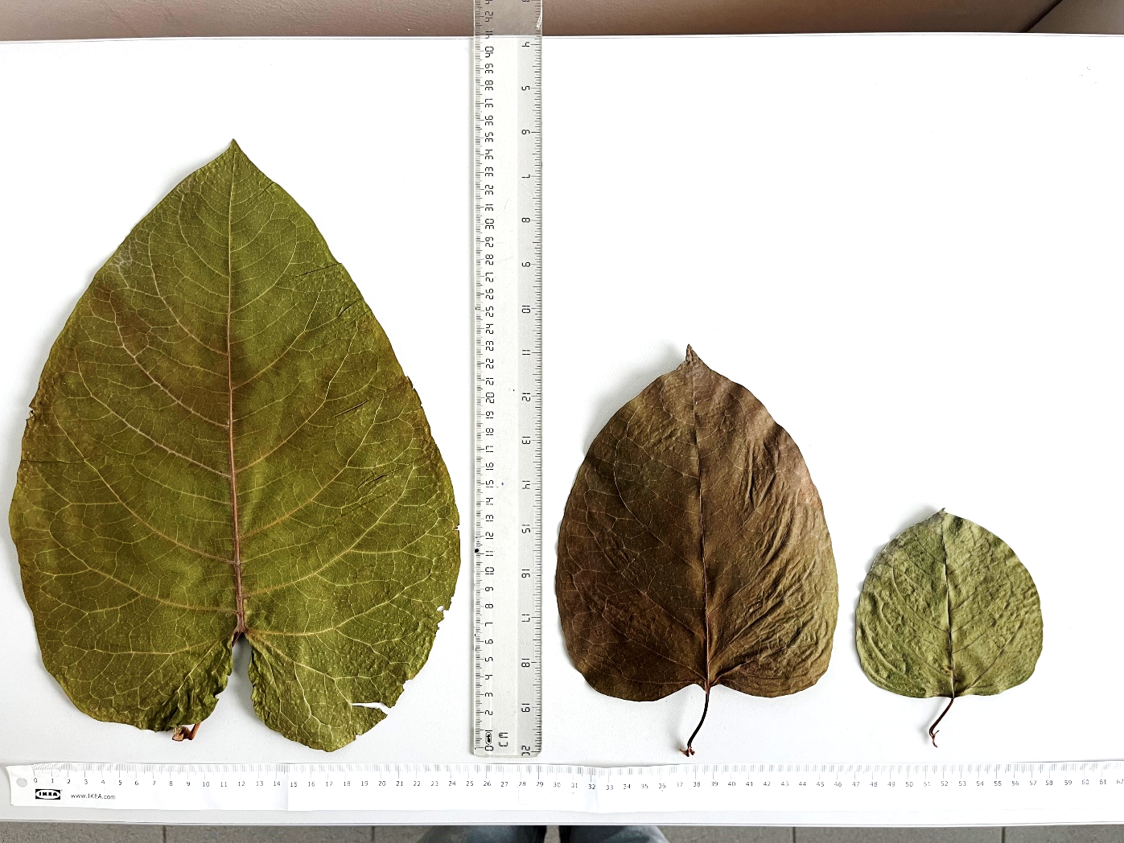
C
A
B
Supplementary Figure 2 Variation of leaves size and morphology in typical representatives of R. sachalinensis (A), R. x bohemica (B), R. japonica (C).

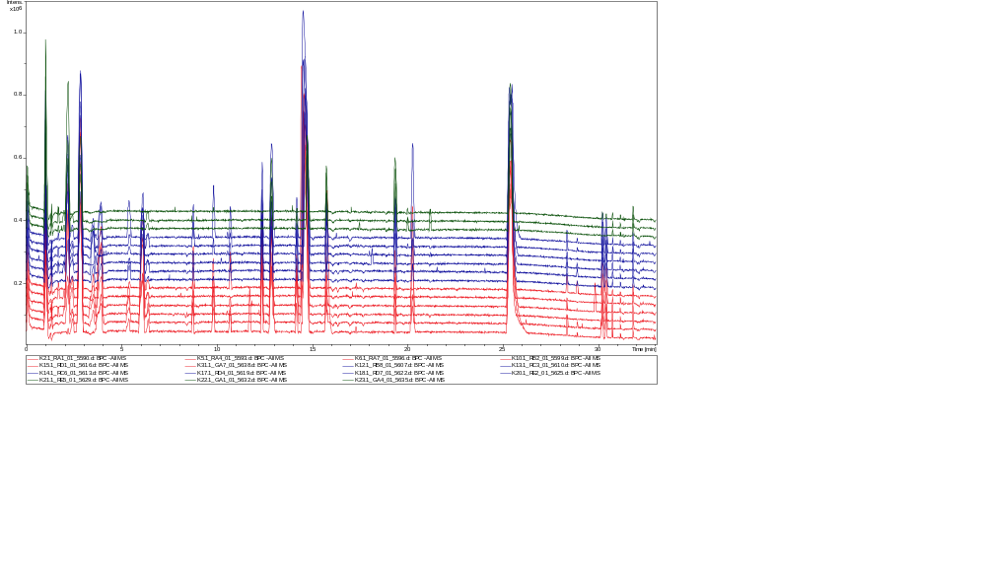
Supplementary Figure 3 Chromatograms of extracts obtained from samples from different locations, as specified in Table 6 – R. japonica (red), R. x bohemica (blue), R. sachalinensis (green).

