Supplemental information
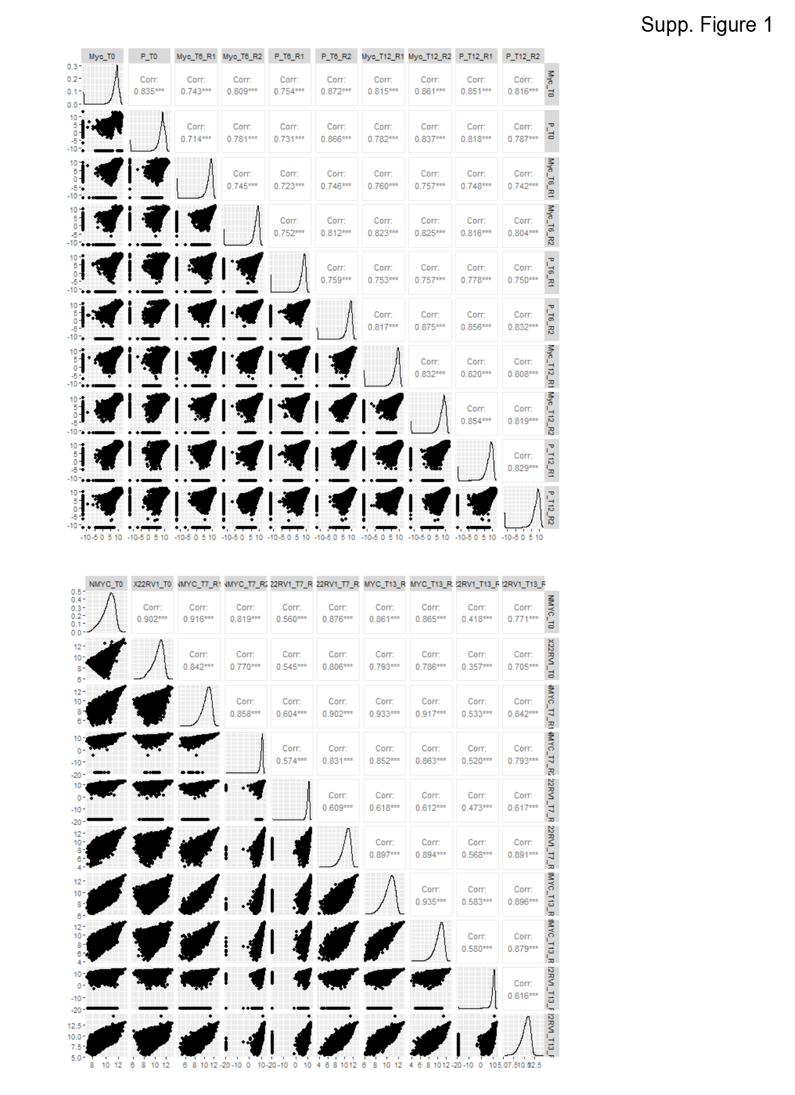
Supplementary Figure S1: Correlation of replicates in shRNA (top) and CRISPR screens (bottom).
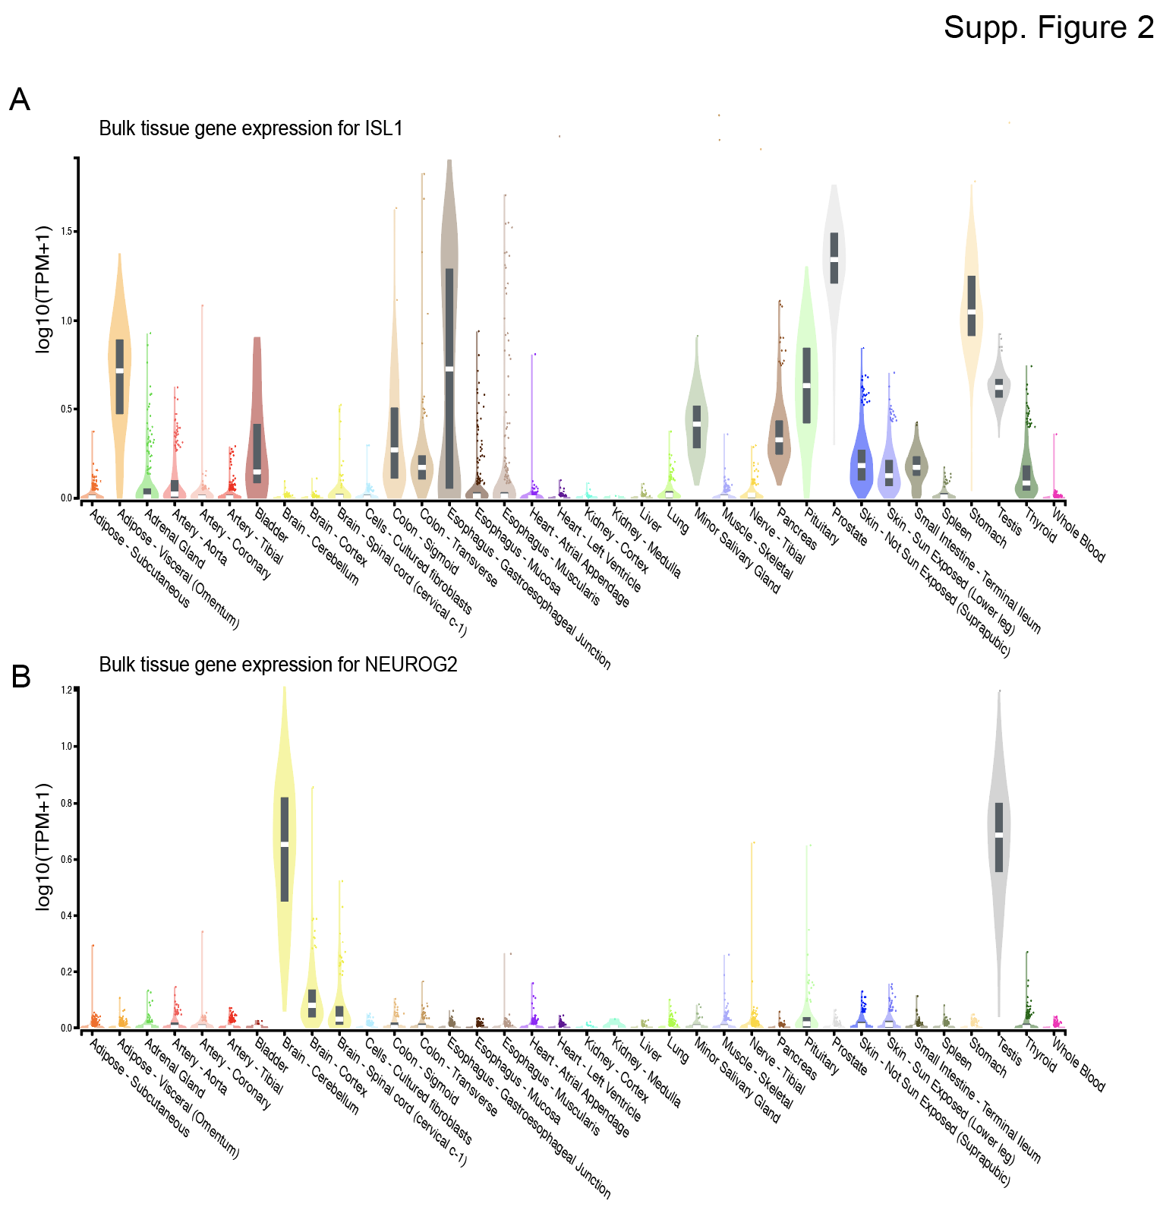
Supplementary Figure S2: Gene expression data of ISL1 (A) and NEUROG2 (B) in normal human tissues derived from GTEx portal.
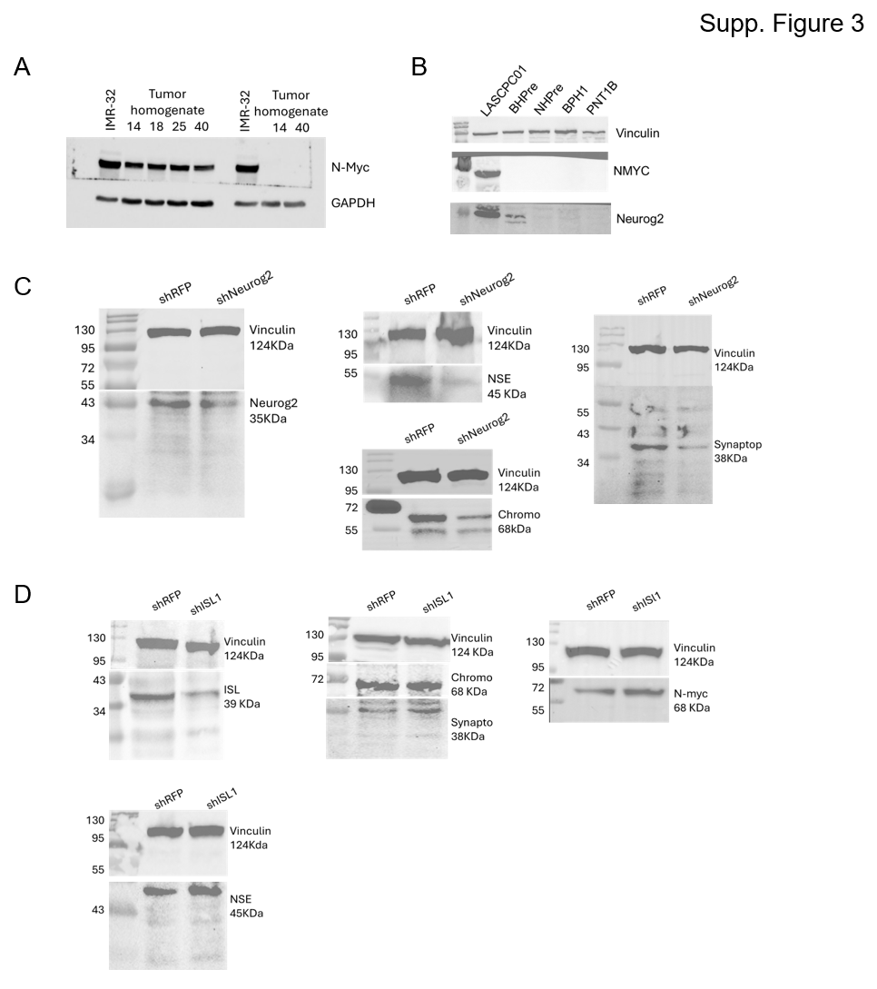
Supplementary Figure S3: Original Western blots relating to Figure 1 (A), Figure 3 (B) and Figure 4 (C and D).
Supplementary Table S1: qPCR Primers
Supplementary Table S2: List of 553 genes that are SDL to NMYC identified from CRISPR/Cas9 screen

