Supplementary table 1. ​Sequences of siRNA used in RNA interference
Gene | ​Sequences（5′-3′）
Grin2a | forward GGAAGUUUGUCAAGAUCAACATT
 | Reverse UGUUGAUCUUGACAAACUUCCTT
Grin2b | Forward GCGACUCUAAGAUCCAGAATT
 | Reverse UUCUGGAUCUUAGAGUCGCTT

The protein expression levels of NMDAR2A, NMDAR2B, and NMDAR1 in BV2 microglia from each experimental group were assessed by western blot analysis. The findings indicated that neither LPS nor Esketamine had a significant impact on the expression levels of NMDAR2A, NMDAR2B, and NMDAR1 in BV2 microglia cells
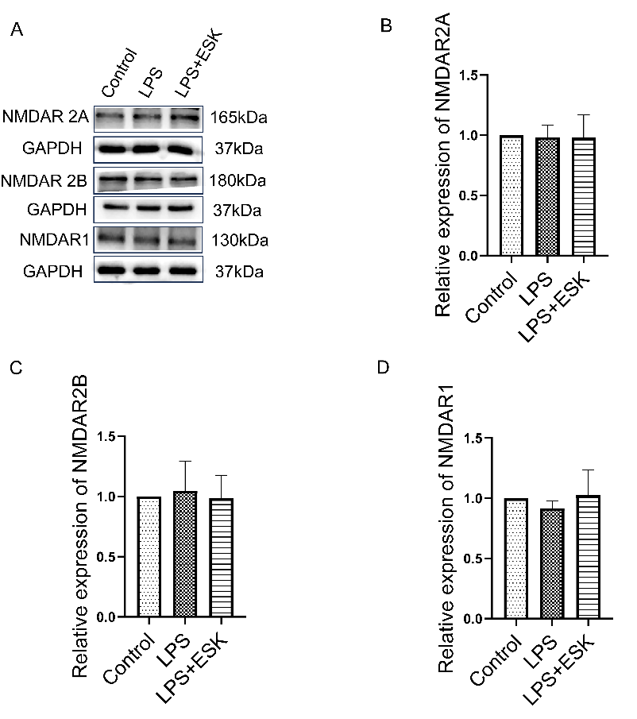
Supplementary Fig. 1. Esketamine did not affect NMDAR subtype protein expression in LPS-induced BV2 microglia. (A) Representative images of protein expression levels of NMDAR2A, NMDAR2B, and NMDAR1 in different groups of BV2 microglia cells. (B-D) Quantitative analysis of NMDAR2A, NMDAR2B and NMDAR1 protein expression levels in different groups of BV2 microglia cells (n=4) .

The transfection efficiency of Grin2a was verified by Western blot

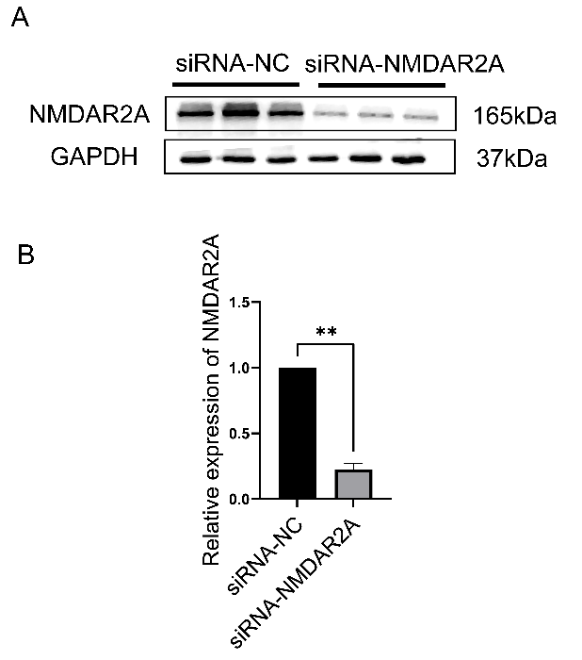
Supplementary Fig. 2. To verify the efficiency of siRNA interference with NMDAR2A. (A) Representative images of NMDAR2A protein expression levels in different groups of BV2 cells. (B) Quantitative analysis of NMDAR2A protein expression in different groups of BV2 cells (n=3), Results are presented as means ±SEMs (*P < 0.05; **P < 0.01).

The transfection efficiency of Grin2b was verified by Western blot

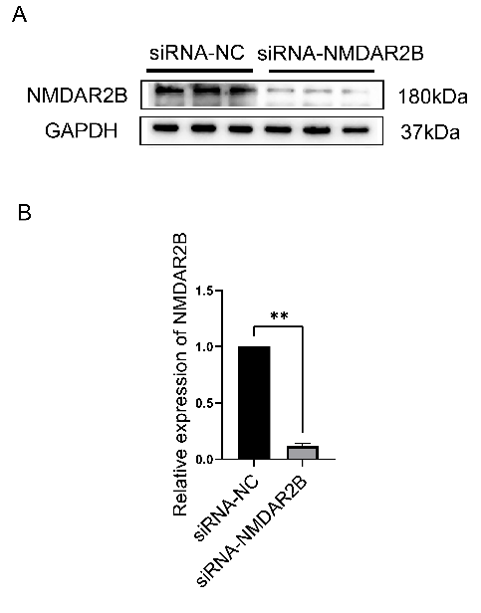
Supplementary Fig. 3. To verify the efficiency of siRNA interference with NMDAR2B. (A) Representative images of NMDAR2B protein expression levels in different groups of BV2 cells. (B) Quantitative analysis of NMDAR2B protein expression in different groups of BV2 cells (n=3), Results are presented as means ±SEMs (*P < 0.05; **P < 0.01).

The levels of IL-4 and TNF-α in BV2 microglia cell culture medium were quantified using Elisa. In the LPS-induced inflammatory model of BV2 microglia, Esketamine was found to significantly increase the expression of IL-4 in the cell culture medium, while siRNA-Grin2b did not demonstrate any significant impact on the expression of IL-4 protein, additionally, siRNA interference with NMDAR2B did not alter the effects of Esketamine (Supplementary Fig. 5A). Furthermore, in the same inflammatory model, the expression of TNF-α in the cell culture medium was up-regulated, and Esketamine was able to down-regulate the expression of TNF-α, with siRNA-Grin2b showing no significant effect on TNF-α expression, moreover, siRNA interference with NMDAR2B did not affect the effect of Esketamine (Supplementary Fig. 5B). Western blot analysis was utilized to assess the levels of CD32 and ARG-1 proteins in BV2 cells across different experimental groups. The results indicated a significant up-regulation of CD32 protein expression in BV2 cells subjected to LPS-induced inflammation. Treatment with Esketamine led to a down-regulation of CD32 protein expression, while siRNA-Grin2b did not have a significant impact on CD32 protein expression. Furthermore, the effect of Esketamine remained unchanged following siRNA interference with NMDAR2B (Supplementary Fig. 5C-D). In the LPS-induced inflammatory model of BV2 microglia, Esketamine demonstrated a significant up-regulation of ARG-1 protein expression, while siRNA-Grin2b did not exhibit a significant impact on ARG-1 protein expression. Furthermore, the influence of Esketamine on ARG-1 remained unaffected following siRNA interference (Supplementary Fig. 5C, E).
Supplementary Fig. 4. Esketamine does not attenuate microglial M1 proinflammatory polarization via NMDAR2B. (A) The levels of IL-4 in cell culture medium in different groups (n=5). (B) The levels of TNF-α in cell culture medium in different groups (n=5). (C) Representative images of protein expression levels of CD32 and ARG-1 in different groups of BV2 microglia. (D-E) Quantitative analysis of CD32 and ARG-1 protein expression levels in different groups of BV2 microglia (n=4). n.s., non-significant difference (p ≥ 0.05). Results are presented as means ±SEMs (ns: no significant difference. *P < 0.05; **P < 0.01).

The protein expression levels of mTOR, p-mTOR, BDNF, TrkB, and p-TrkB in BV2 microglia were assessed via western blot analysis in each experimental group. The p-mTOR/mTOR ratio was found to be significantly decreased in the BV2 cells treated with LPS to induce inflammation, while Esketamine treatment resulted in an upregulation of the p-mTOR/mTOR ratio, however, siRNA-grin2b did not have a significant impact on the ratio, and the effects of Esketamine were not altered when administered after siRNA interference with NMDAR2B (Supplementary Fig. 6A-C). In the LPS-induced inflammatory model of BV2 cells, a significant decrease in the expression of BDNF protein was observed. Esketamine demonstrated the ability to up-regulate the expression of BDNF, while siRNA-Grin2b did not have a significant effect on the expression of BDNF protein. Furthermore, the impact of Esketamine remained unaffected after siRNA interference with NMDAR2B (Supplementary Fig. 6A, D). In the LPS-induced inflammatory model of BV2 microglia, a significant decrease in the expression of TrkB and p-TrkB protein was observed. Esketamine was found to significantly up-regulate the expression of TrkB and p-TrkB protein, while siRNA-Grin2b did not have a significant effect on the expression of TrkB and p-TrkB protein. Furthermore, the impact of Esketamine on TrkB and p-TrkB protein expression remained unaffected following siRNA interference with NMDAR2B (Supplementary Fig. 6A, E-F).
Supplementary Fig. 5. Esketamine does not regulate the expression of mTOR and BDNF-TrkB proteins via NMDAR2B. (A) Representative images of protein expression levels of mTOR, p-mTOR, BDNF, TrkB and p-TrkB in different groups of BV2 microglia. (B-F) Quantitative analysis of mTOR, mTOR/mTOR ratio, BDNF, TrkB, p-TrkB protein expression levels in different groups of BV2 microglia (n=4). n.s., non-significant difference (p≥0.05). Asterisks indicate statistically significant difference. Results are presented as means ±SEMs (ns: no significant difference. *P < 0.05; **P < 0.01).

