Description of SEYMOUR participatory workshops
Participant selection and recruitment
The process of participant selection and recruitment was structured, pre-planned (1) and guided by Hyder et al’s (2) framework by systematically considering a range of stakeholder categories and factors that could influence stakeholder involvement including levels of power/influence, the potential to strengthen but also weaken support for the model (3), drivers for involvement and potential challenges. The research team worked closely with the NWMPHN to identify and engage expert stakeholders for inclusion in the participatory workshops. Purposive sampling was used to ensure maximum variation in the perspectives, cases and expertise recruited in the stakeholder group, including: i) young people aged 12-25 years with lived/living experience of self-harm and/or suicidal behaviour; ii) family members/carers of young people aged 12-25 with lived experience of self-harm and/or suicidal behaviour; iii) primary care and allied health professionals, youth mental health clinicians; iv) health department policy makers and policy officers and v) service planners and commissioners. Snowballing sampling was also used whereby existing stakeholders identified further stakeholders for inclusion in the workshops. A member of the research team met either online or face to face with potential participants for an initial discussion about the project, what their participation would involve and time commitment. Those interested were provided with a link to the study information sheet, consent form and a short demographic information sheet for completion prior to the first workshop.
Procedure
Workshop 1
The research team introduced the basic principles of systems modelling and explained the advantages of using a participatory approach. Following this, a participatory mapping exercise took place whereby stakeholders conceptualised and mapped the pathways for the development of self-harm and suicidal behaviour in young people and mapped young people’s help-seeking journey considering both informal (e.g., peers, family) and formal (e.g., GP, emergency department) sources of help-seeking including community and (mental) health service pathways and the factors that influence the flow of the population along these pathways. This exercise took place as a small group discussion using a simple diagram (Figure 1) followed by a larger facilitated discussion using butcher’s paper (Figure 2) with participants using different coloured post-it notes depending on the stakeholder category (e.g., young people, health professionals) they identified with. This allowed the research team to identify and map the contributions of each stakeholder category without specific input being ascribed to specific participants.

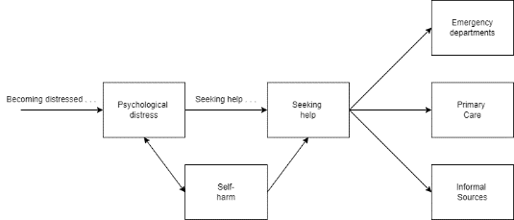

Figure 1. Initial diagram used in small group discussions.

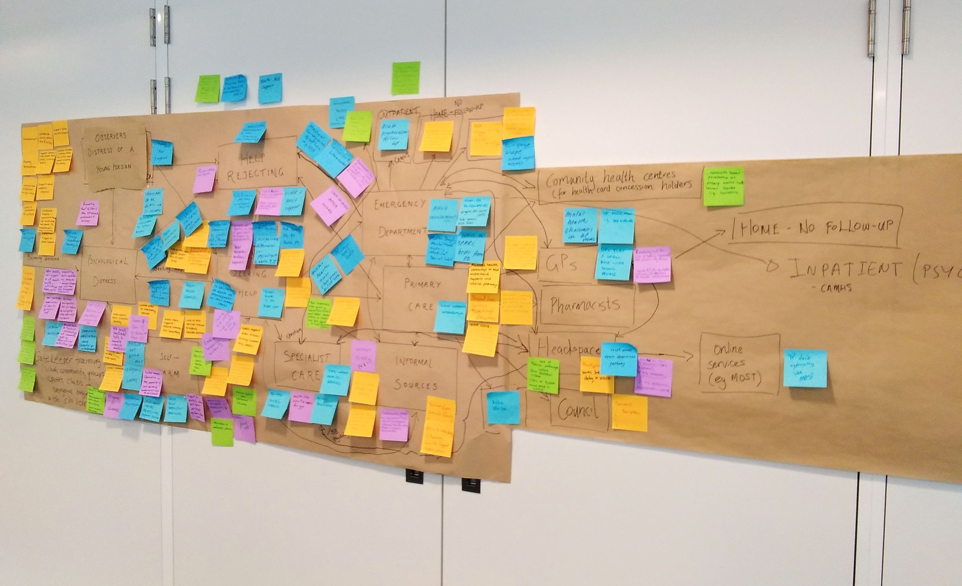
Figure 2. Model conceptualisation
Following the participatory mapping exercise, the expert stakeholder group was asked to brainstorm potential interventions, policies or programs of interest that they would like to see included in the model to capture their effects. Each participant provided a list of interventions including those already implemented in the real world and hypothetical scenarios using coloured post-it notes assigned to their stakeholder category.
By the end of the first workshop, the expert stakeholder group had co-designed a draft conceptual map of the youth mental health system structure in North-West Melbourne along with a list of interventions or policy initiatives of interest.
Workshop 2
Between workshop 1 and 2, the research team used the conceptual map to create a draft stock and flow diagram using Stella Architect (Version 3.1.1). The draft model structure and logic was presented to the expert stakeholder group explaining each model component and how they relate to each other. Stakeholders were split into small groups and using printed copies of the stock and flow diagram, reviewed and refined the structure and logic of the model based on their experience. Participants were asked to identify weaknesses in the system (i.e., leverage points) where one could intervene to improve model behaviour. The identification and prioritisation of interventions or policies, aiming to optimise the structure of the system and how it works, ran as a facilitated discussion and voting exercise (4). The research team presented a slide showing a list of potential interventions based on the current evidence-base (e.g., Cochrane systematic reviews) and those brainstormed by participants at workshop 1. Stakeholders were asked to suggest additional/alternative interventions based on local knowledge and needs by placing sticky notes on butchers paper. The research team then presented a slide with the combined interventions grouped based on the following themes: 1) suicide-specific interventions, 2) mental health service delivery interventions and 3) mental health interventions. The list of interventions was also presented on butchers paper and participants were given sticky dots and asked to choose the interventions they would like to prioritise to address the identified weaknesses in the model. The higher the number of sticky dots placed against an intervention indicated its importance.
Workshop 3
The research team revised the stock and flow diagram between workshop 2 and 3 and a revised draft was presented to the expert stakeholder group seeking further feedback on model structure and logic. The research team also presented the findings of the voting exercise which were the top three interventions or policies of interest (see Results). Participants were split into three mixed groups and each group was allocated one intervention to work on. This activity had two aims:
- Each group had to clearly define and describe the intervention by working through a list of questions (Supplementary Material 3).
- Each group had to identify where each intervention is likely to have its effect in the model structure.
Upon completion, the research team explained the next steps which would include finalising and validating the model before inviting back the expert stakeholder group to test the prioritised set of interventions or policy initiatives to understand the effects generated by the model as well as trade-offs between different scenarios.

References
- van Bruggen A, Nikolic I, Kwakkel J. Modeling with stakeholders for transformative change. Sustainability 2019; 11(3):825. https://doi.org/10.3390/su11030825
- Hyder A, Syed S, Puvanachandra P, Bloom G, Sundaram S, Mahmood S, Iqbal M, Hongwen Z, Ravichandran N, Oladepo O, Pariyo G, Peters D. Stakeholder analysis for health research: case studies from low- and middle-income countries. Public Health. 2010 Mar;124(3):159-66. https://doi.org/10.1016/j.puhe.2009.12.006
- Crosby B. Stakeholder analysis: a vital tool for strategic managers. Washington, DC: USAID; 1991
- Freebairn L, Occhipinti J, Huntley S. Participatory methods for systems modelling of youth mental health: An implementation protocol. JIMR Res Protoc 2022;11 (2):e32988.

