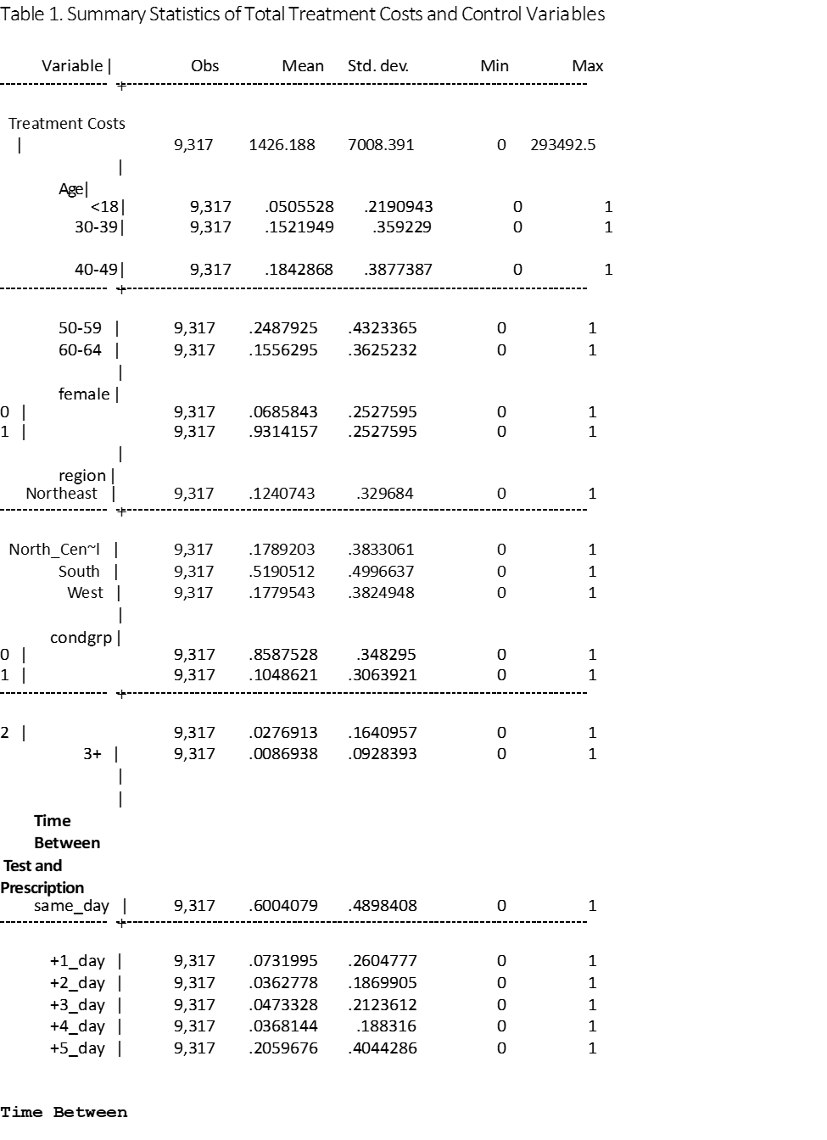

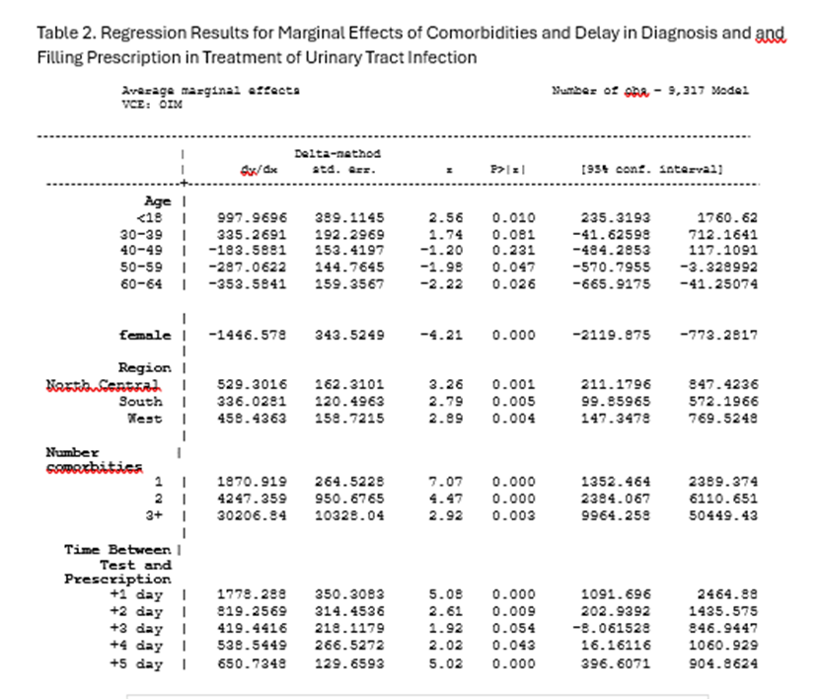

Table 3. Costs of Treating Urinary Tract Infection Episode as a Function of Time
Between Test and Diagnosis
Number of obs = 13,950
--------------------------------------------------------------------------------
| Delta-method
| dy/dx std. err. P>|z| [95% conf. interval]
---------------+----------------------------------------------------------------
Age |
<18 | 1831.93 543.1131 3.37 0.001 767.4476 2896.412
30-39 | 147.7138 209.0626 0.71 0.480 -262.0413 557.4689
40-49 | -115.3934 185.6463 -0.62 0.534 -479.2534 248.4666
50-59 | -359.9215 170.242 -2.11 0.035 -693.5896 -26.25337
60-64 | -470.7864 183.348 -2.57 0.010 -830.1418 -111.4309
|
female | -1749.154 409.246 -4.27 0.000 -2551.262 -947.0467
|
Region |
North_Central | 615.8407 191.5748 3.21 0.001 240.361 991.3204
South | 415.9062 148.6963 2.80 0.005 124.4669 707.3455
West | 153.6014 166.4434 0.92 0.356 -172.6216 479.8243
|
Number
Comorbid Conditions |
1 | 2591.771 341.4799 7.59 0.000 1922.483 3261.06
2 | 6710.493 1391.668 4.82 0.000 3982.874 9438.112
3+ | 22604.49 7102.127 3.18 0.001 8684.579 36524.4
|
Time from Test
To Diagnosis |
+1_day | 2821.58 1613.539 1.75 0.080 -340.8982 5984.058
+2_day | 2072.661 1550.851 1.34 0.181 -966.9508 5112.273
+3_day | 1009.543 1104.354 0.91 0.361 -1154.952 3174.038
+4_day | 3271.234 2229.586 1.47 0.142 -1098.674 7641.142
+5_day | 986.3784 171.4342 5.75 0.000 650.3736 1322.383
--------------------------------------------------------------------------------
Note: dy/dx for factor levels is the discrete change from the base level.

Table 4. Percent of Urinary Tract Infection Patients Hospitals by Days of Test Turnaround

Days Between Test Days to Days to
Prescription Diagnosis
% hospitalized % hospitalized
Same day results | 0.6% | 1.8%
1 | 2.0% | 20.2%
2 | 5.9% | 13.2%
3 | 4.0% | 14.3%
4 | 4.1% | 15.0%
5 | 5.7% | 5.5%

