Supporting Information
Catalysis in Motion: Large-Scale Domain Alternation Enables Co(III)-C Bond Homolysis in Lysine 5,6-Aminomutase
Khai Pham^{1#}, Peter Voss^{1#}, Andrew T. Poore^{1#}, Mingxin Liu¹, Eli C. Zuercher¹, Caitlin Birthright¹, David Toba¹, Natasha Das¹, Stephen C. Yachuw¹, Christian Denault¹, Maggie Kim¹, Thomas Klose^{2,3}, Christopher Uyeda¹, Shiliang Tian^{1*}
¹Department of Chemistry, Purdue University, 560 Oval Drive, West Lafayette, Indiana 47907
²Department of Biological Sciences, Purdue University, West Lafayette, IN 47907
³Purdue Institute of Inflammation, Immunology, and Infectious Disease, Purdue University, West Lafayette, IN 47907
#These authors contributed equally
*e-mail: sltian@purdue.edu
General. Water was purified using a MilliQ IQ 7000 Lab Water System with a resistivity of 18.2 MΩ•cm.
Chemicals. GelCode blue stain reagent, GeneRuler 1 kb Plus DNA ladder, Ni-NTA (nitriloacetic acid) Superflow agarose, adenosylcobalamin (AdoCbl), 4-(2-Hydroxyethyl)-1-piperazinepropanesulfonic acid (EPPS), and glycerol were purchased from Thermo Scientific. ACS grade α-toluenesulfonyl fluoride (PMSF), and ACS reagent grade ninhydrin were purchased from Alfa Aesar. ACS grade sodium chloride, ACS grade potassium phosphate dibasic anhydrous, ACS grade potassium phosphate monobasic, tryptone, yeast extract, and ACS grade ammonium acetate purchased from Fisher Chemical. Rosetta™ 2(DE3)pLysS Competent Cells, pyridoxal-5’-phosphate hydrate (PLP), L-lysine monohydrochloride, and S-(2-aminoethyl)-L-cysteine hydrochloride, were purchased from Millipore Sigma. ACS grade sodium citrate was purchased from LabChem. D-lysine hydrochloride and imidazole were purchased from Acros Organics. Kanamycin monosulfate, DL-Dithiothreitol (DTT), and Isopropyl-ß-D-thiogalactopyranoside (IPTG) were purchased from GoldBio. Phenyl isothiocyanate (PITC) was purchased from TCI. 2,5-diaminohexanoic acid (DAH) was purchased from Chem-Impex. ¹³C-labeled Na₂ATP was purchased from Santa Cruz Biotechnology. Hydroxycobalamin was purchased from Spectrum Chemicals. C₁₈ Sep-Pack cartridges were purchased from Waters.
Thermoanaerobacter tengcongensis Lysine 5,6-Aminomutase (TtLAM) Purification and Characterization. The pCOLADuet-1 plasmid containing both the alpha- and beta-subunits of TtLAM was obtained from Dr. Kurihara at Kyoto University.¹ The plasmid construct was confirmed to contain both subunits of TtLAM via Sanger sequencing. The plasmid was transformed into Rosetta™ 2(DE3)pLysS Competent Cells. Rosetta™ 2(DE3)pLysS containing the TtLAM vector were grown in Luria Bertani media containing 30 mg/L Kanamycin and 0.1 mM IPTG for 24 hours. Cells were harvested and resuspended in a lysis buffer containing 10 mM EPPS, 300 mM NaCl, 5 mM Imidazole, 1.0 mM DTT, 0.6 mM PMSF at pH = 8.0 and sonicated on ice for 7 minutes at 70% amplification in cycles of 15s on, 30s off. TtLAM was incubated with equilibrated Ni-NTA resin for 45 minutes and purified via Ni-NTA affinity chromatography. Elute was collected and exchanged into no salt phosphate buffer (10 mM mM KH₂PO₄, pH = 7.0) using 50 kDa MWCO VivaSpin concentrators. TtLAM was purified via a HiFlow Q anion exchange column pre-equilibrated in 10 mM KH₂PO₄ pH = 7.0 eluted with a 0 – 500 mM KCl gradient. Fractions containing active both subunits of TtLAM were incubated with 1.25 molar equivalents of both AdoCbl and PLP for 30 minutes under stirring at 25 in the dark to prevent cofactor photobleaching, and holo-TtLAM concentration assessed via UV-vis. Holo-TtLAM was used immediately, or flash frozen in liquid nitrogen and stored at -80 ºC. Concentration of apo-TtLAM was estimated via UV-vis absorption at 280 nm with a molar absorptivity coefficient of 55,495 M⁻¹cm⁻¹ per active site.
Temperature Dependent Activity Assays. Utilizing a modified procedure from Dr. Ke, steady-state kinetic experiments for the reaction of TtLAM with D-lysine were conducted via HPLC using the PITC-derivatized substrate D-lysine and product DAH.² The variable temperature assays contained 20 μM LAM, 25 μM AdoCbl, 25 μM PLP in 25 mM pH 8.5 NH₄ EPPS buffer and were initiated with various concentrations of D-lysine (6, 8, 10, 15, 25, 50, 75, and 150 mM). The reaction was allowed to proceed for varying amounts of time correlated to temperature before quenching with 2N HClO₄ (180s at 30°C or 30s at 60°C). The ratio of the area of the peak for 2,5-DAH-PITC to the area of the sum of the peaks for D-lysine-PITC and 2,5-DAH PITC was calculated and multiplied by the concentration of D-lysine present in the sample to calculate conversion to 2,5-DAH. An initial rate independent of enzyme concentration was obtained by dividing by both the time point and enzyme concentration for each sample.
Tobacco Etch Virus Protease (TEV) Expression and Purification. TEV plasmid was purchased from AddGene (Plasmid #125194) with a pTH24 vector backbone. TEV was expressed and purified as previously described.³ In brief, cells were cultured in LB media containing 100 μg/mL ampicillin at 37 ºC until OD₆₀₀ = 0.6. Cells were induced with 1 mM IPTG at 20 ºC for 24 hours. TEV was purified with Ni-NTA affinity chromatography and the elute was concentrated for size exclusion chromatography. Following a Cytiva HiPrep 16/60 Sephacryl S-100 HR size-exclusion column, protein was flash frozen in liquid nitrogen and stored at -80 ºC. Protein concentration was estimated via UV-vis at 280 nm with an extinction coefficient of 36,130 M⁻¹ cm⁻¹.
ATP:Co(I)rrinoid Adeosyltransferase (CobA) Expression and Purification. CobA was expressed and purified according to previously described protocol.⁴ In brief, CobA was grown in E. coli BL21(DE3) cells and induced for 24 hours at 18 ºC. Cells were lysed in 25 mM Tris, 500 mM NaCl, pH = 8.0, 1 mM PMSF via sonication. Supernatant was further purified with NiNTA affinity chromatography. Elute was dialyzed against a 25 mM Tris, 250 mM NaCl, pH = 8.0 to remove excess imidazole from solution. During a second round of dialysis, TEV was added to cleave His-tagged CobA in a 1:100 molar equivalence. An additional Ni-NTA column was used to separate CobA from TEV. CobA was further purified via a Cytiva HiPrep 16/60 Sephacryl S-100 HR size exclusion column. Fractions were either flash frozen and stored at -80 ºC or used directly following SEC. Protein concentration was estimated via UV-vis absorption at 280 nm with a molar extinction coefficient of 23,950 M⁻¹cm⁻¹.
Synthesis of [Adenine-¹³C-10]Adenosylcobalamin. ¹³C-labeled AdoCbl was synthesized using a previously described protocol.² The following chemicals were mixed in an amber vial in the dark: 1.1 mg hydroxycobalamin, 10 mg KBH₄, and 5 mg MgCl₂ 6H₂O. Contents of the vial were transferred into a COY Type B vinyl anaerobic chamber with oxygen content monitored by a CAM-12 monitor and dissolved in 2.5 mL of anaerobic buffer (100 mM Tris, pH = 8.0). 1 mg ¹³C-labeled Na₂ATP and 480 μL of 200 μM CobA was added to the vial under stirring and allowed to incubate for 2.5 hours. At the 2.5-hour mark, an additional 5 mg KBH₄ and 240 μL of 200 μM CobA were added to the mixture and allowed to incubate for an additional 2.5 hours. At 5 hours, 5 mg KBH₄ and 240 μL CobA (200 μM) were again added to the reaction mixture and allowed to incubate for an additional 30 minutes. The reaction mixture was removed from the anaerobic chamber and O₂ (g) was slowly bubbled into solution to oxidize any cob(I)alamin present and subsequently spun down and filtered with a 0.22 μm syringe filter. A methanol-activated Sep-Pack cartridge was used to remove any salts and buffering molecules present in the filtrate. The cartridge was washed with MilliQ water followed by a 0.02% TFA/10% methanol solution. A 0.02% TFA/40% methanol solution was used to remove the ¹³C labelled AdoCbl (¹³C-AdoCbl) from the cartridge. Solvent was evaporated from the eluted ¹³C-AdoCbl using a Savant SpeedVac SPD120 Vacuum Concentrator. Solid was redissolved in 250 μL MilliQ.
EPR Conditions. 400 μM holo-TtLAM was allowed to stir under anaerobic conditions for 30 minutes in the dark. A stock of 0.5 M Thialysine was prepared at a final concentration of 60 mM, mixed with holo-TtLAM, and rapidly frozen at ~30s to obtain EPR sample. All samples were flash-frozen and stored in liquid nitrogen before analysis. EPR spectra were recorded on a Bruker EMXplus EPR instrument equipped with a ColdEdge Stinger closed-cycle flow system with the following conditions: temperature 20 K, modulation amplitude 4 G, microwave power 2.0 mW, and microwave frequency ∼9.46 GHz. The EPR spectra were simulated by EasySpin.⁵

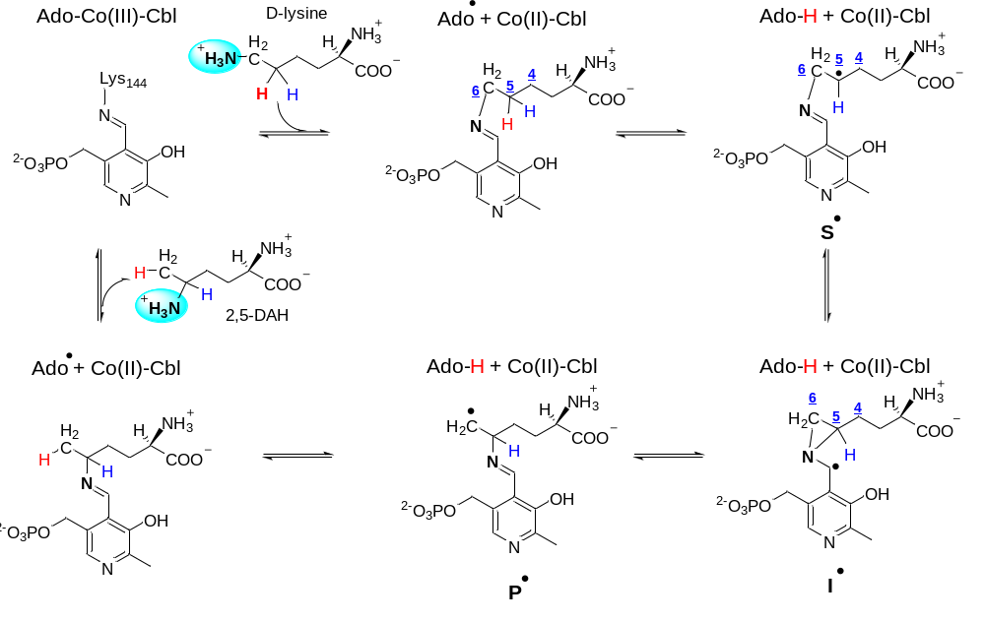
Fig. S1. Proposed mechanism of Lysine 5,6-aminomutase (LAM). In the absence of substrate, the PLP cofactor is covalently linked to Lys144β via an internal imine bond. Upon substrate introduction, D-lysine forms an external imine with the PLP cofactor, releasing Lys144β. The adenosyl radical (Ado•), generated by the homolysis of the Co(III)-C bond in adenosylcobalamin, abstracts a hydrogen atom from C5 of the PLP-lysine adduct, creating a substrate radical (S•) and Ado-H. Rearrangement of S• leads to the formation of the aziridinylcarbinyl radical (I•). The ring-opening of the aziridine facilitates the amine group’s shift from C6 to C5 on the lysine substrate, relocating the radical to C6 of the PLP-lysine adduct (P•). P• abstracts a hydrogen atom from the 5’-C of Ado-H, reforming Ado•. Recombination of Ado• with Co(II)-cobalamin restores adenosylcobalamin, and transimination reforms the imine bond with Lys144β, releasing the product, 2,5-diaminohexanoic acid (2,5-DAH).
Fig. S2. SDS-PAGE gel electrophoresis of purified apo TtLAM. The gel shows that the purified apo TtLAM consists of both the α (59.8 kDa) and β (29.8 kDa) subunits.
Fig. S3. UV-vis absorption spectra of holo-TtLAM. The absorption spectra of holo-TtLAM reveals the presence of both PLP and AdoCbl cofactors.
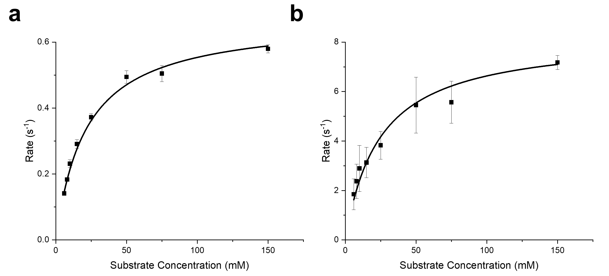
Fig. S4. Variable temperature Michaelis-Menton kinetics. Reaction assays were conducted to determine the activity of TtLAM at various temperatures. Reaction conditions for each assay were 20 μM TtLAM, 25 μM AdoCbl, 25 μM PLP, 2 mM β-mercaptoethanol in 100 mM NH₄EPPS pH=8.5. Each assay consisted of 8 different substrate concentrations (6, 8, 10, 15, 25, 50, 75, and 150 mM). a) Reaction at 30°C in triplicate averaged with standard deviation error. Data can be fit using a Michealis-Menton curve with the following parameters: V_{max} = 0.67 + 0.02 s⁻¹, K_{m} = 21.5 + 1.02 M. b) Reaction at 60°C in triplicate averaged with standard deviation error. Data can be fit using a Michealis-Menton curve with the following parameters: V_{max} = 8.3 + 0.3 s⁻¹, K_{m} = 24.5 + 3.01 M.

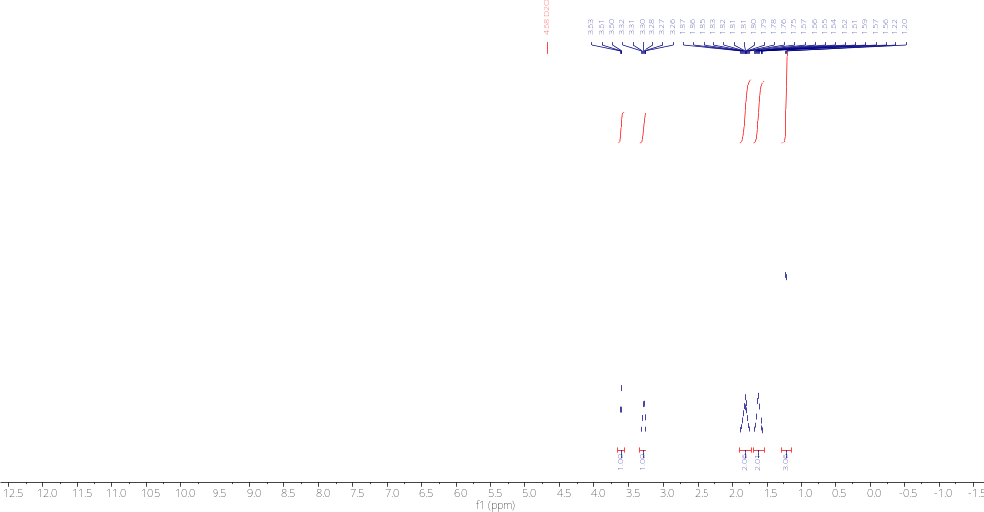
Fig. S5. ¹H NMR of 2,5-diaminohexanoic acid. ¹H NMR of 2,5-diaminohexanoic acid (2,5-DAH) (500 MHz, D₂O, 298 K) δ 3.61 (t, J = 5.8 Hz, 1H), 3.29 (h, J = 6.4 Hz, 1H), 1.87–1.75 (m, 2H), 1.67–1.56 (m, 2H), 1.21 (d, J = 6.6 Hz, 3H).

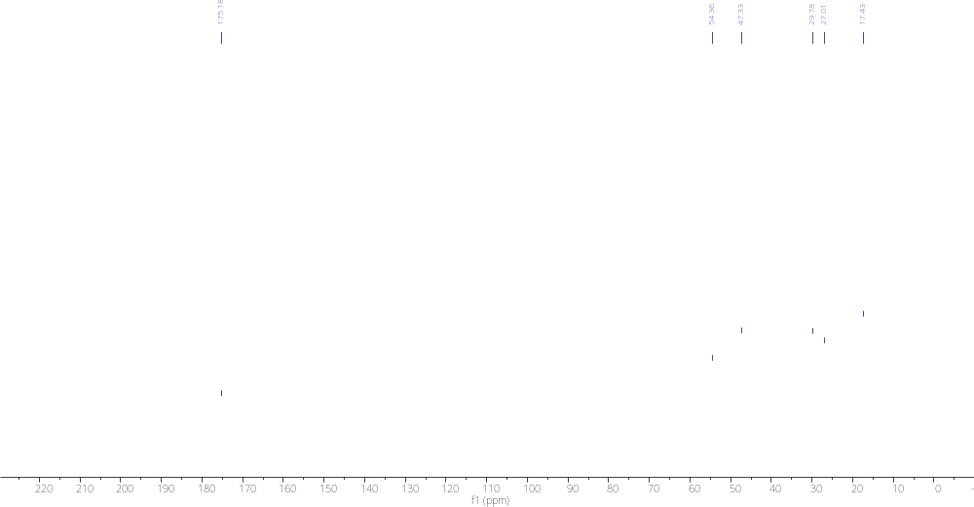
Fig. S6. ¹³C NMR of 2,5-diaminohexanoic acid. ¹³C NMR of 2,5-diaminohexanoic acid (2,5-DAH) (126 MHz, D₂O, 298 K) δ 175.2, 54.4, 47.3, 29.8, 27.0, 17.4.
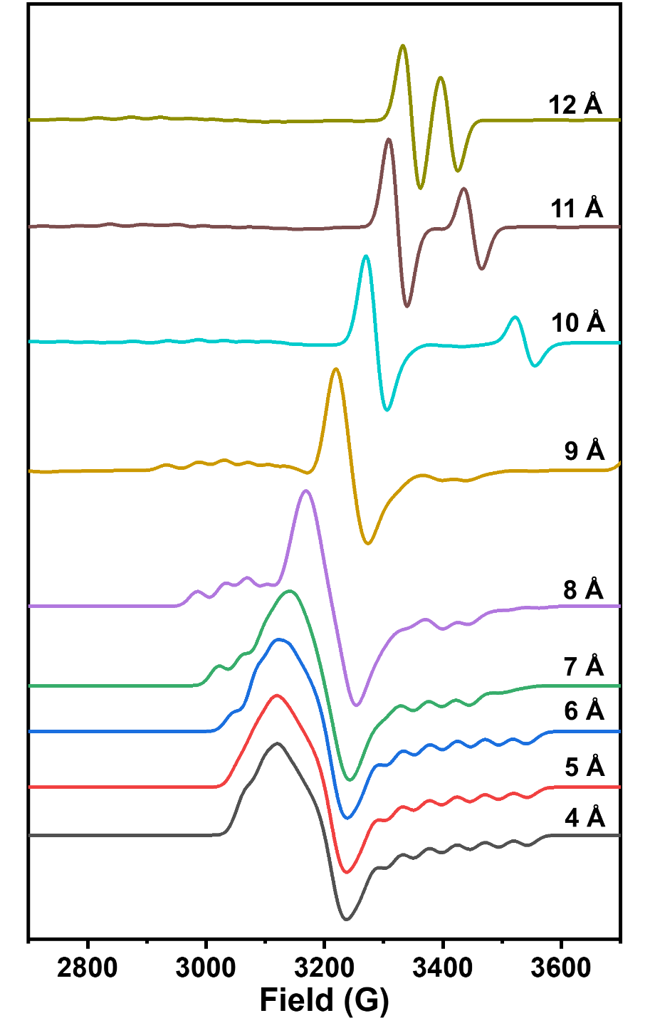
Fig. S7. Influence of inter-spin distance on EPR spectra. Theoretical EPR simulations were performed using Easyspin. All simulations represent an axial Co(II) species (g_{┴Co} = 2.27, g_{//Co} = 2.0, A_{//Co} = 100 G) coupled to an isotropic organic radical (g_{iso,C} = 2.003), based on the AdoCbl and thialysine paired transient radical. The inter-spin distance was varied from 4 to 12 Å in 1 Å increments, with corresponding changes in D and J. The parameter E was adjusted to maintain a consistent E/D ratio of 0.14.

Cryo-EM Sample Preparation and Data Collection. Apo TtLAM for cryo-EM samples were prepared with an additional Superdex S200 size-exclusion column equilibrated with 25 mM NH4 EPPS buffer, pH = 8.5.
‘Open’ form. Apo-TtLAM was mixed with 5 molar equivalents of adenosylcobalamin (AdoCbl) and pyridoxal-5’-phosphate (PLP) and incubated for 30 minutes in 25mM EPPS, pH 8.5, at a final protein concentration of 17.1uM. 3.5µl of freshly prepared samples were applied to Quantifoil R1.2/1.3 400 mesh holey carbon grids that were glow discharged for 60s at 25mA using an EasiGlow (PELCO) glow discharger. The protein was incubated on the grids for 15s and 100% RH, blotted for 4s with a blot force of 2, and then plunged into liquid ethane using a FEI Vitrobot Mark IV. Grids were screened on a Talos F200C operated by the Purdue Cryo-EM Facility. The full data set was collected on a FEI Titan Krios G4 equipped with a Gatan Energy Filter and a K3 and imaged at a nominal magnification of 81,000x in super-resolution mode, resulting in a pixel size of 0.527Å. The energy filter was set to slit width of 20eV. A total of 5524 movies were acquired with an exposure time of 3.21s and fractioned into 40 frames with a total dose of 57.8e/Å2 and a defocus range of -0.6µm to 1.8µm using EPU (TFS).
‘Close’ form. TtLAM was mixed with 5 molar equivalents of adenosylcobalamin (AdoCbl) and pyridoxal-5’-phosphate (PLP) and incubated for 30 minutes in 25mM EPPS, 2mM β-mercaptoethanol, pH 8.5, at a final protein concentration of 15.2 uM. Subsequently, thialysine was introduced at 2.5 molar equivalents relative to the protein. 3.5µl of freshly prepared samples were applied to Quantifoil R1.2/1.3 400 mesh holey carbon grids that were glow discharged for 60s at 25mA using an EasiGlow (PELCO) glow discharger. The protein was incubated on the grids for 10 s and 100% RH, blotted for 1s with a blot force of 2, and then plunged into liquid ethane using a FEI Vitrobot Mark IV. Grids were screened on a Talos F200C operated by the Purdue Cryo-EM Facility. The full data set was collected on a FEI Titan Krios G1 equipped with a Gatan Energy Filter and a K3 and imaged at a nominal magnification of 81,000x in super-resolution mode, resulting in a pixel size of 0.539Å. The energy filter was set to slit width of 20eV. A total of 3802 movies were acquired with an exposure time of 3.21s and fractioned into 40 frames with a total dose of 55.2e/Å2 and a defocus range of -0.6µm to 1.8µm.
Cryo-EM Data Processing. Both datasets were processed using cryoSPARC V4.2.0+23020 for all steps. After initial patch motion correction and CTF estimation, particles were picked using a blob-based picker with a minimum and maximum particle diameter of 100Å and 200Å, respectively. The resulting picks were used for an initial round of 2D classification and well resolved 2D classes were selected for template-based particle picking using a particle diameter of 200Å.
For the ‘Open’ form, this resulted in 3,683,376 particles for the apo dataset of which 2,933,314 good particles were selected after several rounds of 2D classification. These particles were used to generate three initial models, and all particles were then refined against these three models using the Heterogonous Refinement workflow and C1 symmetry. The class with the best resolution and visible features contained 1,482,472 particles which were then used for non-uniform refinement to a final resolution of 3.1Å.
For the ‘Closed’ form, the same general approach was used, with 2,786,751 particles picked from all micrographs using a template-based picker. Of these, 1,956,367 good particles were selected after several rounds of 2D classification. These particles were then again used to generate three initial models, and all particles were then refined against these three models using the Heterogonous Refinement workflow and C1 symmetry. The class with the best resolution and visible features contained 1,060,403 particles when were then used for non-uniform refinement to a final resolution of 3Å.
Cryo-EM Model Building and Refinement. ModelAngelo was used to place amino acids and generate an initial model by identifying the densest regions corresponding to atomic positions, effectively translating the electron density data into a preliminary structural model.⁶ Cofactors, ligands, and manual adjustments were incorporated to address inaccuracies such as misplaced atoms, incorrect side-chain orientations, unrealistic bond angles and lengths, and missing amino acids, using Coot.⁷ After refining the model in Coot, Phenix was employed for further refinement, optimizing atomic positions, B-factors, and overall geometry to minimize discrepancies between the model and the EM density map.⁸
Table S1: Cryo-EM data collection and processing for Opened-LAM
(a) Sample details
Sample | Opened state of lysine 5,6-aminomutase
Organism name | Thermoanaerobacter tengcongensis
Expression system | Escherichia coli
Freezing method (cryogen) | FEI Vitrobot Mark IV (ethane)
Grid support | Quantifoil r1.2/1.3 copper mesh
Concentration | 17.1 uM
Buffer condition | 25mM EPPS, pH 8.5
(b) Data Collection and Processing Statistics
Microscope | FEI Titan Krios G4
Accelarating voltage (keV) | 300 KeV
Defocus range (μm) | -0.6µm - 1.8µm
Energy Filter (eV) | 20eV
Detector | Gatan K3
Micrograph movies: collected (used) | 5524
Physical Pixel size (Å) | 0.527Å
Total dose (e-/Å2) | 57.8e/Å2
Particle box size: pixels (Å) | 320
Particles: initial (final) | 3,683,376 (2,933,314)
Consensus map resolution, FSC=0.143/0.5 (Å) | 3.06Å

Table S2: Cryo-EM data collection and processing for Closed-LAM
(a) Sample details
Sample | Closed state of lysine 5,6-aminomutase
Organism name | Thermoanaerobacter tengcongensis
Expression system | Escherichia coli
Freezing method (cryogen) | FEI Vitrobot Mark IV (ethane)
Grid support | Quantifoil r1.2/1.3 copper mesh
Concentration | 15.2 uM
Buffer condition | 25mM EPPS, 2mM β-mercaptoethanol, pH 8.5
(b) Data Collection and Processing Statistics
Microscope | FEI Titan Krios G1
Accelarating voltage (keV) | 300 KeV
Defocus range (μm) | -0.6µm - 1.8µm
Energy Filter (eV) | 20eV
Detector | Gatan K3
Micrograph movies: collected (used) | 3802
Physical Pixel size (Å) | 0.539Å
Total dose (e-/Å2) | 55.2e/Å2
Particle box size: pixels (Å) | 320
Particles: initial (final) | 2786751 (1956367)
Consensus map resolution, FSC=0.143/0.5 (Å) | 3.00Å

Table S3: Cryo-EM model Opened-LAM
Model and model/map statistics
Residues modeled | 1547
Atoms (no hydrogens) | 12571
Cofactors | 3
Ligand | 0
Resolution, map/model FSC = 0.5 (Å) | 3.06Å
MolProbity | 4.02b-467
Bonds (RMSD)
Length (Å) (# > 4σ) | 0.003 (0)
Angles (o) (# > 4σ) | 0.634 (0)
Clashscore | 37
Ramachandran plot (%)
Favored | 96
Allowed | 60
Outliers | 5
Rotamer outliers (%) | 6
Cβ outliers (%) | 0.0
CaBLAM outliers (%) | 0.0
Cis proline/general | 0.0/0.0
Twisted proline/general | 0.0/0.0
ADP (B-factors)
Protein (min/max/mean) | 43.19/201.84/91.96
CC (mask) | 0.85
CC (box) | 0.84
CC (volume) | 0.85

Table S4: Cryo-EM model Closed-LAM
Model and model/map statistics
Residues modeled | 1373
Atoms (no hydrogens) | 11011
Cofactors | 3
Ligand | 1
Resolution, map/model FSC = 0.5 (Å) | 3.00Å
MolProbity score | 4.02b-467
Bonds (RMSD)
Length (Å) (# > 4σ) | 0.006 (6)
Angles (o) (# > 4σ) | 1.081 (7)
Clashscore | 24
Ramachandran plot (%)
Favored | 97.51
Allowed | 2.49
Outliers | 0.00
Rotamer outliers (%) | 4
Cβ outliers (%) | 0.0
CaBLAM outliers (%) | 0.0
Cis proline/general | 0.0/0.0
Twisted proline/general | 0.0/0.0
ADP (B-factors)
Protein (min/max/mean) | 17.79/114.63/52.95
Ligand (min/max/mean) | 20.00/20.00/20.00
CC (mask) | 0.80
CC (box) | 0.80
CC (volume) | 0.80

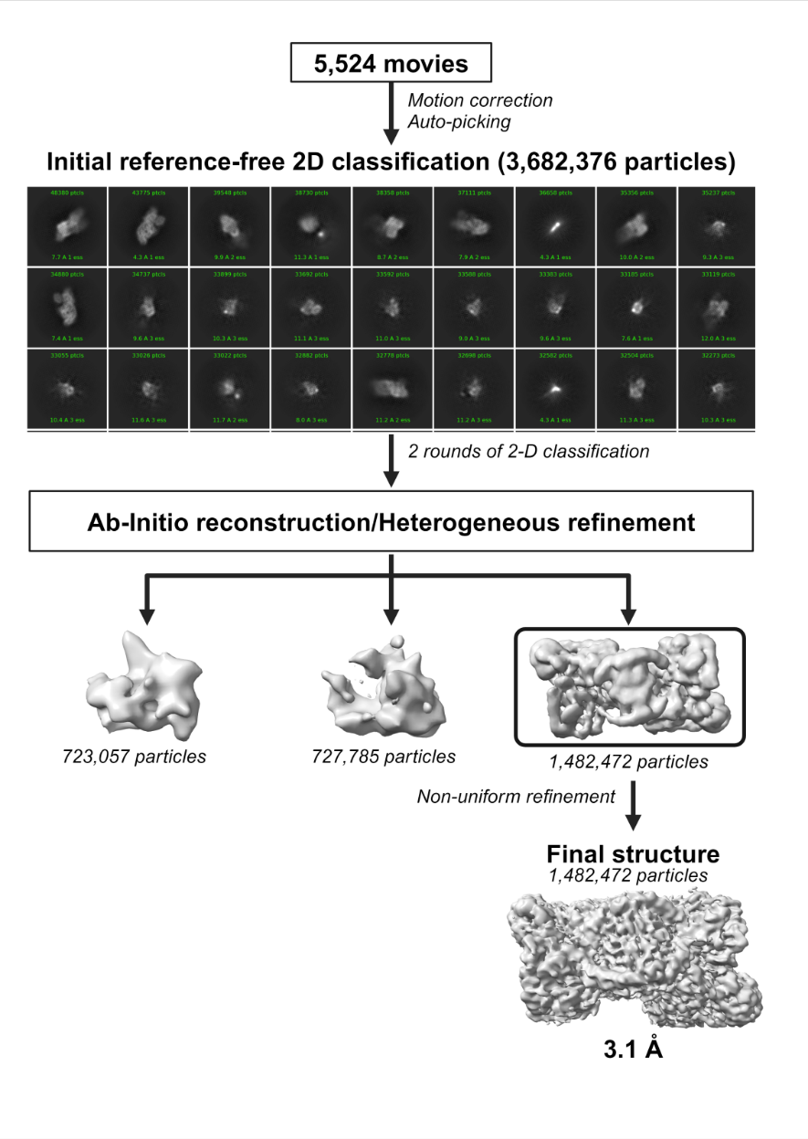
Fig. S8. Visualizing the opened state of 5,6-Lysine Aminomutase Protein Structure via Cryo-EM and CryoSPARC Processing. CryoSPARC was used to process Cryo-EM data to elucidate the structure of the 5,6-lysine aminomutase protein. Starting with 5,524 movies, motion correction and auto-picking are applied, resulting in an initial pool of 3,682,376 particles. These particles undergo two successive rounds of reference-free 2D classification to discriminate between well-defined particle projections and ambiguous or distorted ones. Subsequently, the dataset is categorized into three classes through ab-initio reconstruction and heterogeneous refinement: two classes were dentified as junk or highly heterogeneous averages, and a class containing structure of interest. These latter two classes are not pursued further. The remaining class, encompassing 1,482,472 particles, is advanced to non-uniform refinement, which adjusts for non-uniform resolution across the protein and minimizes the influence of heterogeneity. This step culminates in the final 3D structure at a resolution of 3.1 Å, reflecting the intact and correctly folded state of the 5,6-lysine aminomutase enzyme.
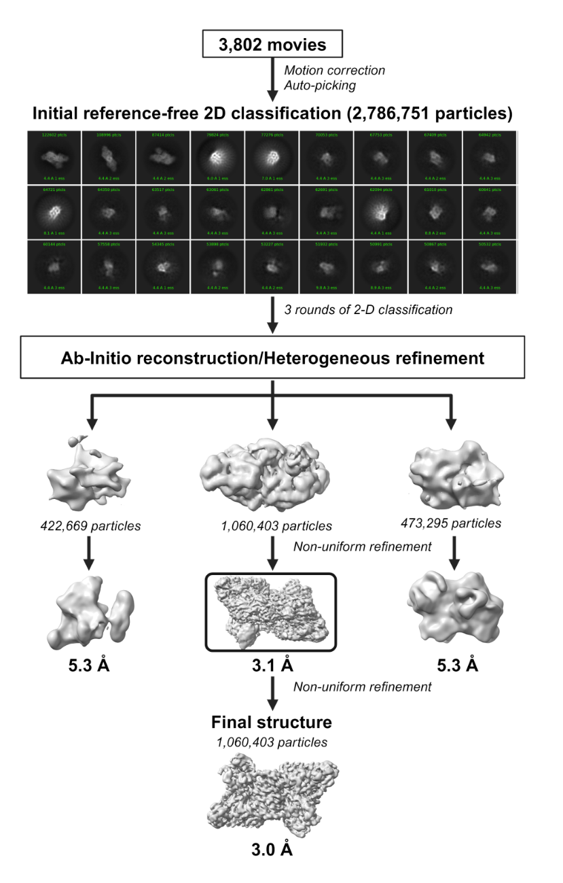
Fig. S9. Visualizing the closed state of 5,6-Lysine Aminomutase Protein Structure via Cryo-EM and CryoSPARC Processing. Starting from 3,802 collected movies, the procedure begins with motion correction to mitigate the effects of electron beam-induced movement, followed by auto-picking, which identifies potential particles resulting in a dataset of 2,786,751 particles. These particles are subjected to three rounds of reference-free 2D classification, effectively filtering out noise and aberrant particles. Following classification, the particles are allocated to ab-initio reconstruction and heterogeneous refinement paths, segregating them into three main classes: one with resolution of 5.3 Å, another with resolution of 3.1 Å, and a third also at resolution of 5.3 Å. The class with 1,060,403 particles, representing the protein of interest, is subjected to non-uniform refinement, a process that adjusts for variable resolution across the structure, thereby enhancing the detail and clarity of the model. This refinement step produces a detailed structure at an improved resolution of 3.0 Å, revealing the intricate atomic configuration of the ligand-bound 5,6-lysine aminomutase. The other two classes are not further refined, as they likely represent different conformational or partial denaturation states that are not the focus of the current study.

References

1 Fukuyama, S. et al. Characterization of a thermostable 2,4-diaminopentanoate dehydrogenase from Fervidobacterium nodosum Rt17-B1. J. Biosci. Bioeng. 117, 551-556, (2014).
2 Tang, K.-H., Chang, C. H. & Frey, P. A. Electron Transfer in the Substrate-Dependent Suicide Inactivation of Lysine 5,6-Aminomutase. Biochemistry 40, 5190-5199, (2001).
3 van den Berg, S., Löfdahl, P.-Å., Härd, T. & Berglund, H. Improved solubility of TEV protease by directed evolution. J. Biotechnol. 121, 291-298, (2006).
4 Moore, T. C., Newmister, S. A., Rayment, I. & Escalante-Semerena, J. C. Structural Insights into the Mechanism of Four-Coordinate Cob(II)alamin Formation in the Active Site of the Salmonella enterica ATP:Co(I)rrinoid Adenosyltransferase Enzyme: Critical Role of Residues Phe91 and Trp93. Biochemistry 51, 9647-9657, (2012).
5 Stoll, S. & Schweiger, A. EasySpin, a comprehensive software package for spectral simulation and analysis in EPR. J. Magn. Reson. 178, 42-55, (2006).
6 Jamali, K. et al. Automated model building and protein identification in cryo-EM maps. Nature 628, 450-457, (2024).
7 Emsley, P. & Cowtan, K. Coot: model-building tools for molecular graphics. Acta Crystallogr. D 60, 2126-2132, (2004).
8 Adams, P. D. et al. PHENIX: a comprehensive Python-based system for macromolecular structure solution. Acta Crystallogr. D 66, 213-221, (2010).

