Supplementary Material

Starting values for the parameters |  |  | Model output
t_{c} -start | a-start | τ-start | t_{c} | A | τ
2.1 | 6 | 5 | 2.24 (2.66; 0.84; 0.40) | 5.97 (3.26; 1.83; 0.07) | 4.83 (0.57; 8.37; <0.0001)
10 | 6 | 5 | 2.24 (2.65; 0.85; 0.40) | 5.99 (3.27; 1.83; 0.07) | 4.82 (0.58; 8.38; <0.0001)
19 | 6 | 5 | 2.30 (2.03; 1.13; 0.26) | 5.91 (2.46; 2.41; 0.02) | 4.83 (0.58; 8.34; <0.0001)
2.2 | 1 | 5 | 2.30 (2.03; 1.13; 0.26) | 5.91 (2.46; 2.40; 0.17) | 4.83 (0.58; 8.34; <0.0001)
2.2 | 10 | 5 | 2.24 (2.66; 0.84; 0.40) | 5.98 (3.27; 1.83; 0.07) | 4.83 (0.58; 8.37; <0.0001)
2.2 | 19 | 5 | 2.30 (2.03; 1.13; 0.26) | 5.91 (2.46; 2.41; 0.02) | 4.83 (0.58; 8.34; <0.0001)
2.2 | 6 | 1 | 2.24 (2.66; 0.84; 0.40) | 5.97 (3.27; 1.83; 0.07) | 4.83 (0.58; 8.37; <0.0001)
2.2 | 6 | 10 | 2.30 (2.03; 1.13; 0.26) | 5.90 (2.46; 2.40; 0.02) | 4.83 (0.58; 8.34; <0.0001)
2.2 | 6 | 19 | 2.25 (2.67; 0.84; 0.40) | 5.97 (3.27; 1.83; 0.07) | 4.84 (0.58; 8.36; <0.0001)
6 | 6 | 6 | 2.29 (2.02; 1.13; 0.26) | 5.92 (2.46; 2.41; 0.02) | 4.83 (0.58; 8.34; <0.0001)
11 | 11 | 11 | 2.29 (2.03; 1.31; 0.26) | 5.92 (2.46; 2.41; 0.02) | 4.83 (0.58; 8.34; <0.0001)
19 | 19 | 19 | 2.24 (2.66; 0.84; 0.40) | 5.97 (3.27; 1.83; 0.07) | 4.83 (0.58; 8.36; <0.0001)
Table S1. The ASD group: examples of starting values for the nlsLM model parameters and their corresponding output results. The nlsLM function is sensitive to the choice of starting values for the model parameters. This sensitivity can result in differences in the model results for the same dataset, or a complete failure to fit the model. The nlsLM model converged with 65% of starting values: t_{c} starting value ranged from 2 to 19 years; a starting value ranged from 1 to 19 MSEC units per year; τ starting value ranged from 1 to 19 year. Modeling output results are presented as: Estimate (Std.Error; t-value; p-value).

Starting values for the parameters |  |  | Model output
t_{c} -start | a-start | τ-start | t_{c} | A | τ
2.15 | 6 | 5 | 2.28 (2.15; 1.06; 0.29) | 5.80 (2.51; 2.33; 0.02) | 4.98 (0.61; 8.20; <0.0001)
2.2 | 6 | 5 | 2.28 (2.15; 1.06; 0.29) | 5.90 (2.51; 2.35; 0.02) | 4.99 (0.60; 8.28; <0.0001)
2.2 | 6 | 4.75 | 2.28 (2.15; 1.06; 0.29) | 5.90 (2.63; 2.24; 0.02) | 4.75 (0.57; 8.32; <0.0001)
2.2 | 6 | 19 | 2.29 (2.10; 1.09; 0.27) | 5.86 (2.51; 2.34; 0.02) | 4.84 (0.59; 8.26; <0.0001)
2.2 | 8 | 5 | 2.24 (2.71; 0.83; 0.41) | 5.92 (3.27; 1.81; 0.07) | 4.87 (0.59; 8.28; <0.0001)
Table S2. The ASD group: examples of starting values for the nlme model parameters and their corresponding output results. The nlme function is also sensitive to the choice of starting values for the model parameters. This sensitivity can result in differences in the model outcomes for the same dataset, or a complete failure to fit the model. The nlme model converged with 10% of starting values: t_{c} starting value ranged from 2 to 19 years; a starting value ranged from 1 to 19 MSEC units per year; τ starting value ranged from 1 to 19 year. Modeling output results are presented as: Estimate (Std.Error; t-value; p-value).

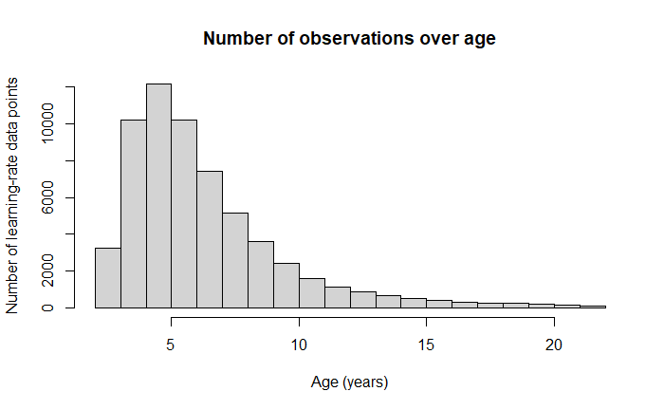
Figure S1. The ASD group: histogram of learning-rate data points over age.

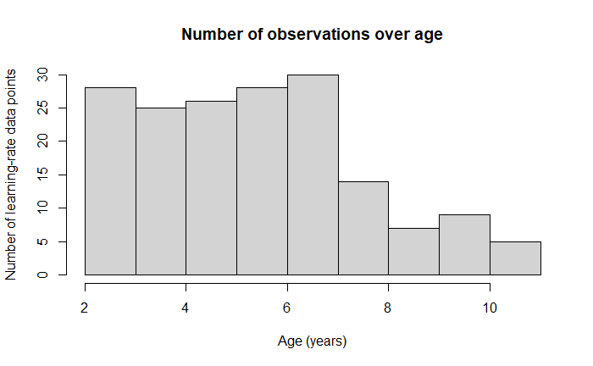
Figure S2. The neurotypical group: histogram of learning-rate data points over age.

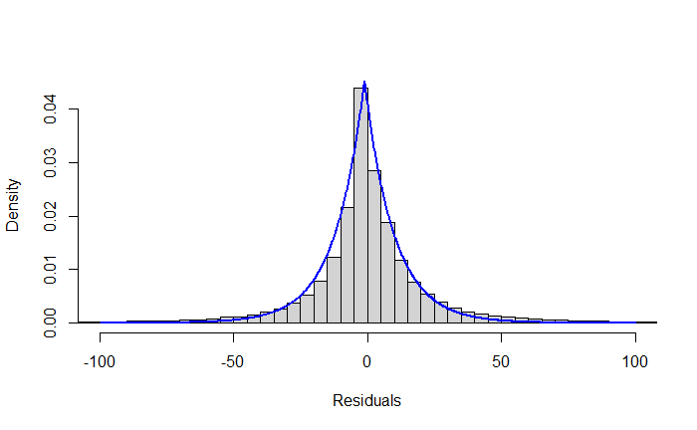
Figure S3. The ASD group: density histogram of residuals from the nlsLM model. Blue line: LaPlace distribution.

Figure S4. The ASD group: density histogram of residuals from the nlme model. Blue line: LaPlace distribution.
Starting values | Model output
t_{c} -start | Mild ASD t_{c} | Moderate ASD t_{c} | Severe ASD t_{c}
1 | 3.15 (0.27; 11.5; <0.0001) | 2.00 (0.30; 6.63; <0.0001) | 1.35 (0.43; 3.11; 0.002)
2 | 3.15 (0.27; 11.5; <0.0001) | 2.00 (0.30; 6.63; <0.0001) | 1.35 (0.43; 3.11; 0.002)
3 | 3.15 (0.27; 11.5; <0.0001) | 2.00 (0.30; 6.63; <0.0001) | 1.35 (0.43; 3.11; 0.002)
4 | 3.15 (0.27; 11.5; <0.0001) | 2.00 (0.30; 6.63; <0.0001) | 1.35 (0.43; 3.11; 0.002)
5 | 3.15 (0.27; 11.5; <0.0001) | 2.00 (0.30; 6.63; <0.0001) | 1.35 (0.43; 3.11; 0.002)
6 | 3.15 (0.27; 11.5; <0.0001) | 2.00 (0.30; 6.63; <0.0001) | 1.35 (0.43; 3.11; 0.002)
7 | 3.15 (0.27; 11.5; <0.0001) | 2.00 (0.30; 6.63; <0.0001) | 1.35 (0.43; 3.11; 0.002)
8 | 3.15 (0.27; 11.5; <0.0001) | 2.00 (0.30; 6.63; <0.0001) | 1.35 (0.43; 3.11; 0.002)
9 | 3.15 (0.27; 11.5; <0.0001) | 2.00 (0.30; 6.63; <0.0001) | 1.35 (0.43; 3.11; 0.002)
10 | 3.15 (0.27; 11.5; <0.0001) | 2.00 (0.30; 6.63; <0.0001) | 1.35 (0.43; 3.11; 0.002)
11 | 3.15 (0.27; 11.5; <0.0001) | 2.00 (0.30; 6.63; <0.0001) | 1.35 (0.43; 3.11; 0.002)
12 | 3.15 (0.27; 11.5; <0.0001) | 2.00 (0.30; 6.63; <0.0001) | 1.35 (0.43; 3.11; 0.002)
13 | 3.15 (0.27; 11.5; <0.0001) | 2.00 (0.30; 6.63; <0.0001) | 1.35 (0.43; 3.11; 0.002)
14 | 3.15 (0.27; 11.5; <0.0001) | 2.00 (0.30; 6.63; <0.0001) | 1.35 (0.43; 3.11; 0.002)
15 | 3.15 (0.27; 11.5; <0.0001) | 2.00 (0.30; 6.63; <0.0001) | 1.35 (0.43; 3.11; 0.002)
16 | 3.15 (0.27; 11.5; <0.0001) | 2.00 (0.30; 6.63; <0.0001) | 1.35 (0.43; 3.11; 0.002)
17 | 3.15 (0.27; 11.5; <0.0001) | 2.00 (0.30; 6.63; <0.0001) | 1.35 (0.43; 3.11; 0.002)
18 | 3.15 (0.27; 11.5; <0.0001) | 2.00 (0.30; 6.63; <0.0001) | 1.35 (0.43; 3.11; 0.002)
19 | 3.15 (0.27; 11.5; <0.0001) | 2.00 (0.30; 6.63; <0.0001) | 1.35 (0.43; 3.11; 0.002)
Table S3. Starting values for the nlsLM model parameter t_{c} and corresponding output results in mild (level 1), moderate (level 2), or severe (level 3) ASD. To make an unambiguous comparison, the number of the model parameters was reduced to one, the critical inflection point t_{c}. Starting values for t_{c} ranged from 1 to 19 years; a was set to 5.9 MSEC units per year; τ was set to 4.9 years. The nlsLM model converged with 100% of starting values. Modeling output results are presented as: Estimate (Std.Error; t-value; p-value).

Starting values | Model output
t_{c} -start | Mild ASD t_{c} | Moderate ASD t_{c} | Severe ASD t_{c}
1 | 3.13 (0.27; 11.4; <0.0001) | 2.00 (0.30; 6.64; <0.0001) | 1.36 (0.43; 3.15; 0.002)
2 | 3.17 (0.27; 11.6; <0.0001) | 2.00 (0.30; 6.64; <0.0001) | 1.35 (0.43; 3.11; 0.002)
3 | 3.15 (0.27; 11.5; <0.0001) | 2.00 (0.30; 6.64; <0.0001) | 1.35 (0.43; 3.11; 0.002)
4 | 3.17 (0.27; 11.6; <0.0001) | 2.00 (0.30; 6.71; <0.0001) | 1.38 (0.43; 3.20; 0.014)
5 | 3.15 (0.27; 11.5; <0.0001) | 2.00 (0.30; 6.63; <0.0001) | 1.35 (0.43; 3.11; 0.002)
6 | 3.17 (0.27; 11.6; <0.0001) | 1.98 (0.30; 6.56; <0.0001) | 1.35 (0.43; 3.11; 0.002)
7 | 3.15 (0.27; 11.5; <0.0001) | 2.00 (0.30; 6.67; <0.0001) | 1.35 (0.43; 3.12; 0.002)
8 | 3.17 (0.27; 11.6; <0.0001) | 2.00 (0.30; 6.63; <0.0001) | 1.36 (0.43; 3.15; 0.002)
9 | 3.15 (0.27; 11.5; <0.0001) | 1.99 (0.3; 6.58; <0.0001) | 1.35 (0.43; 3.11; 0.002)
10 | 3.15 (0.27; 11.5; <0.0001) | 2.00 (0.30; 6.63; <0.0001) | 1.35 (0.43; 3.10; 0.002)
11 | 3.16 (0.27; 11.5; <0.0001) | 2.00 (0.30; 6.63; <0.0001) | 1.35 (0.43; 3.11; 0.002)
12 | 3.15 (0.27; 11.5; <0.0001) | 2.00 (0.30; 6.64; <0.0001) | 1.37 (0.43; 3.18; 0.002)
13 | 3.17 (0.27; 11.6; <0.0001) | 2.01 (0.30; 6.70; <0.0001) | 1.35 (0.43; 3.11; 0.002)
14 | 3.15 (0.27; 11.5; <0.0001) | 2.00 (0.30; 6.63; <0.0001) | 1.35 (0.43; 3.11; 0.002)
15 | 3.15 (0.27; 11.5; <0.0001) | 2.00 (0.30; 6.64; <0.0001) | 1.34 (0.43; 3.09; 0.002)
16 | 3.16 (0.27; 11.6; <0.0001) | 1.98 (0.31; 6.54; <0.0001) | 1.37 (0.43; 3.18; 0.002)
17 | 3.20 (0.27; 11.7; <0.0001) | 2.00 (0.30; 6.63; <0.0001) | 1.33 (0.43; 3.06; 0.002)
18 | 3.15 (0.27; 11.5; <0.0001) | 2.00 (0.30; 6.64; <0.0001) | 1.34 (0.43; 3.09; 0.002)
19 | 3.15 (0.27; 11.5; <0.0001) | 1.99 (0.3; 6.58; <0.0001) | 1.36 (0.43; 3.15; 0.002)
Table S4. Starting values for the nlme model parameter t_{c} and corresponding output results in mild (level 1), moderate (level 2), or severe (level 3) ASD. To make an unambiguous comparison, the number of the model parameters was reduced to one, the critical inflection point t_{c}. Starting values for t_{c} ranged from 1 to 19 years; a was set to 5.9 MSEC units per year; τ was set to 4.9 years. The nlme model converged with 100% of starting values. Modeling output results are presented as: Estimate (Std.Error; t-value; p-value).

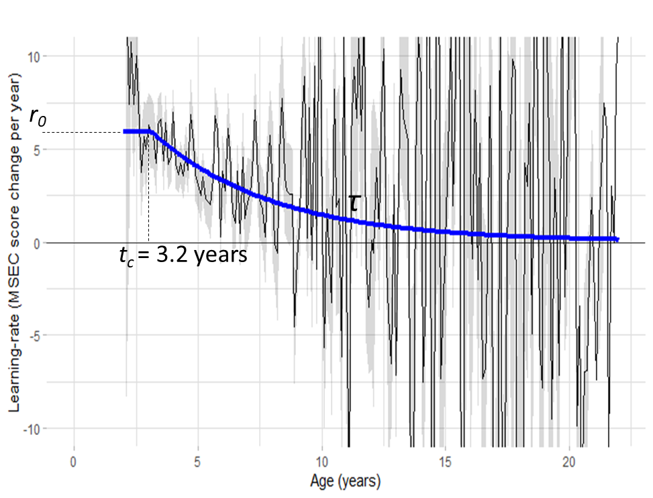
Figure S5. Analysis of participants diagnosed with mild ASD (level 1 ASD). Thin black line: learning-rate averaged in 0.1-year bins, measured as MSEC score change per year (positive MSEC score change indicates improvement; the grey shaded area represents the 95% confidence interval). Thick blue line: graphical representation of modeling results.

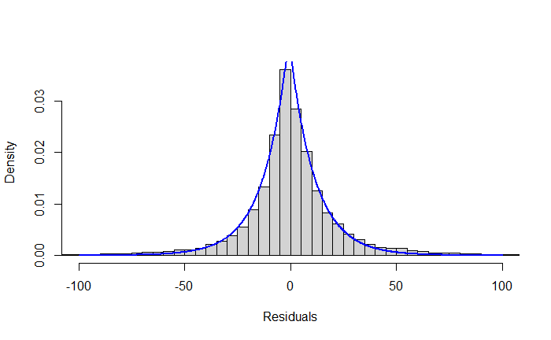
Figure S6. Density histogram of residuals from the nlsLM model in participants diagnosed with mild ASD. Blue line: LaPlace distribution.

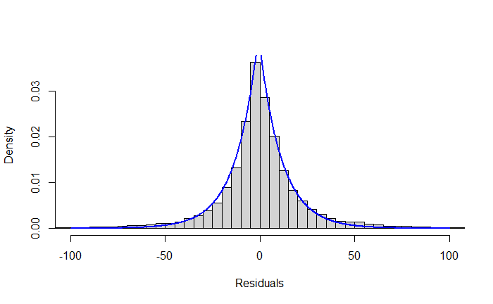
Figure S7. Density histogram of residuals from the nlme model in participants diagnosed with mild ASD. Blue line: LaPlace distribution.

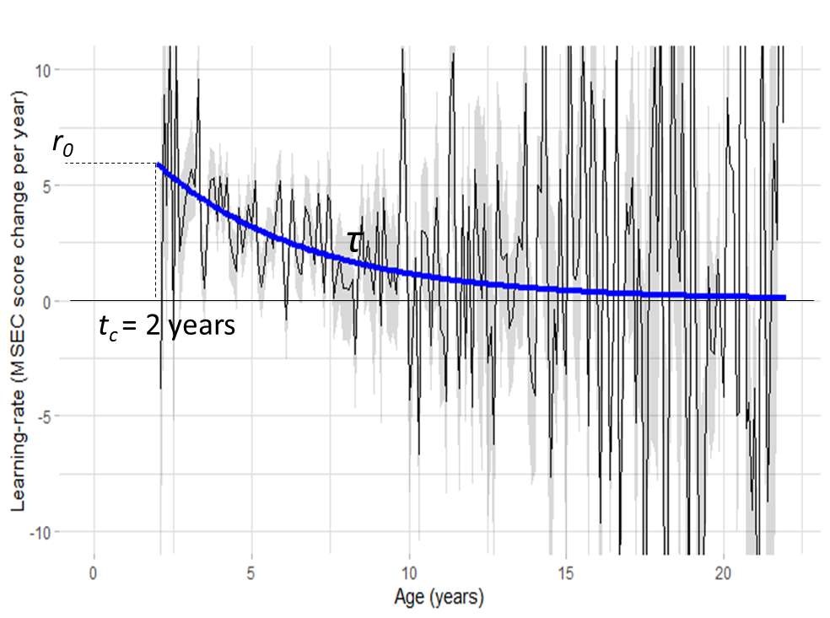
Figure S8. Analysis of participants diagnosed with moderate ASD (level 2 ASD). Thin black line: learning-rate averaged in 0.1-year bins, measured as MSEC score change per year (positive MSEC score change indicates improvement; the grey shaded area represents the 95% confidence interval). Thick blue line: graphical representation of modeling results.

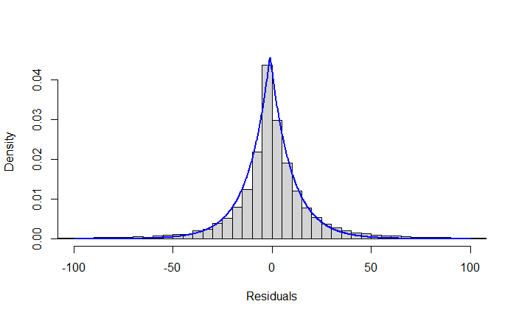
Figure S9. Density histogram of residuals from the nlsLM model in participants diagnosed with moderate ASD. Blue line: LaPlace distribution.

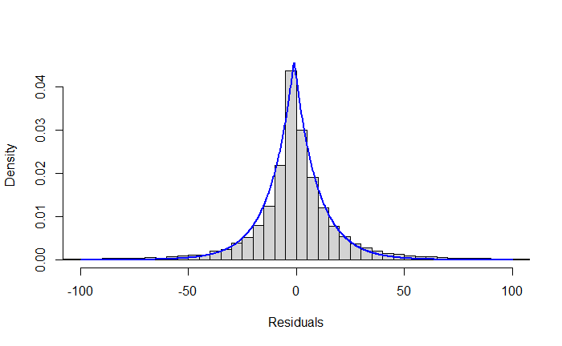
Figure S10. Density histogram of residuals from the nlme model in participants diagnosed with moderate ASD. Blue line: LaPlace distribution.

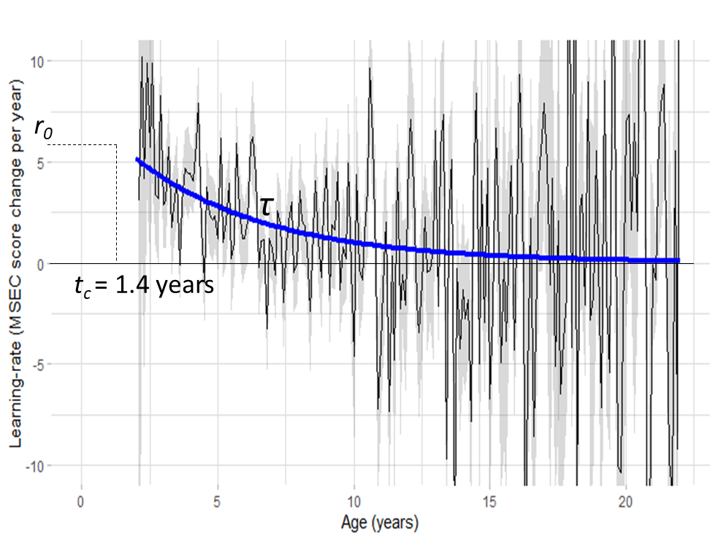
Figure S11. Analysis of participants diagnosed with severe ASD (level 3 ASD). Thin black line: learning-rate averaged in 0.1-year bins, measured as MSEC score change per year (positive MSEC score change indicates improvement; the grey shaded area represents the 95% confidence interval). Thick blue line: graphical representation of modeling results.

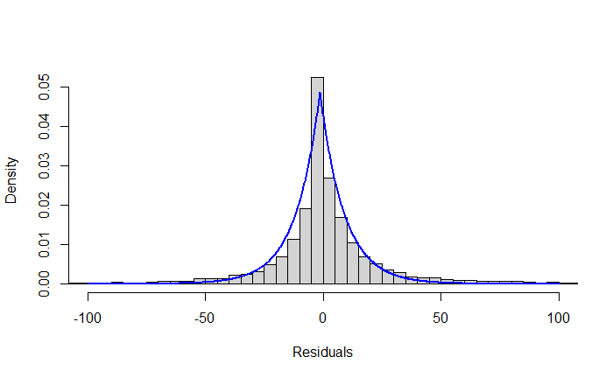
Figure S12. Density histogram of residuals from the nlsLM model in participants diagnosed with severe ASD. Blue line: LaPlace distribution.

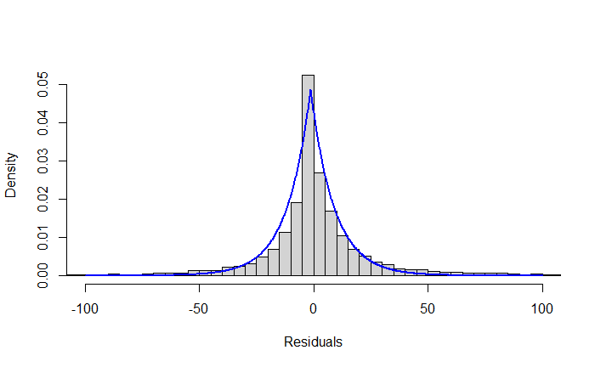
Figure S13. Density histogram of residuals from the nlme model in participants diagnosed with severe ASD. Blue line: LaPlace distribution.

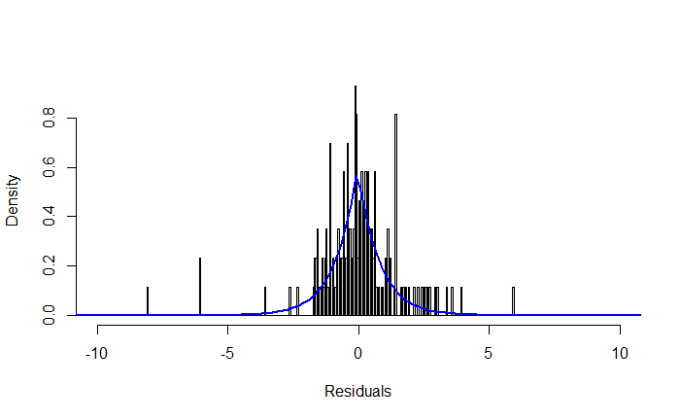
Figure S14. The neurotypical group: density histogram of residuals from the nlsLM model. Blue line: LaPlace distribution.

