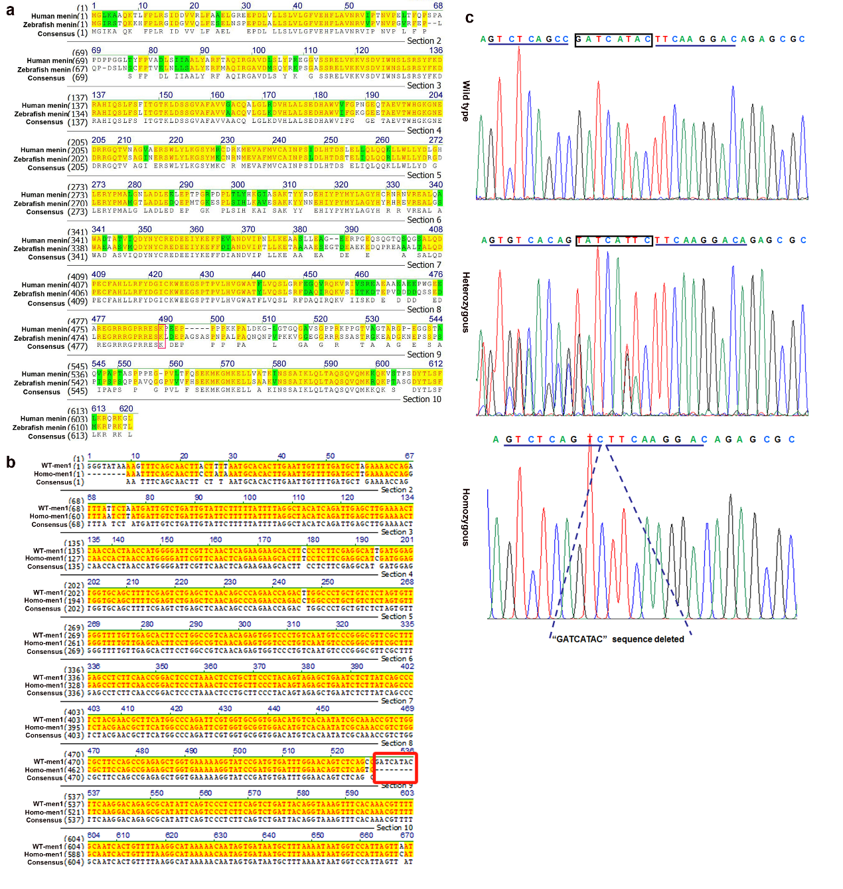
Supplementary Fig.1 The PTC individuals of F2 generation of zebrafish with men1 frameshift was constructed successfully using CAS9 technology.
a Protein sequence alignment analysis indicated that there was 66% homology between human MEN1 and zebrafish men1. The Lysine residue 488 of human MEN1 and the Lysine residue 487 of zebrafish men1 were framed in red. b Sequence alignment of wild type men1 of zebrafish with homozygous mutated men1. The sequences of wild type men1 were aligned with homozygous mutated men1. using DNAMAN software (version 9). The sequences highlighted in yellow were the consensus sequence, and the “GATCATAC” sequences framed in red are those to be deleted using CAS9 technology to generate the frameshift mutation and premature translational-termination codon (PTC). c Sanger sequencing was performed to for genotype identification. Sequence chromatograms indicated that the intended deleted “GATCATAC” sequences in zebrafish of wild type men1 gene are framed. According to the coding sequence of men1（NM_130953），c.1459A of wild type men1was mutated into T to generate “TAA” terminal codon by the deletion of “GATCATAC” sequences using CAS9 technology. Sequence chromatograms showed that ， in zebrafish of heterozygous men1 mutation， the “GATCATAC” sequences of wild type men1 were mutated into “TATCATTC” ones and the flanking “GTCTCAGCC” sequences of wild type men1 were mutated into “GTGTCACAG” ones，which were marked by box and horizontal lines. Sequence chromatograms showed that the “GATCATAC” sequences in zebrafish of homozygous men1 mutation could not be detected and indicated by dashed lines .

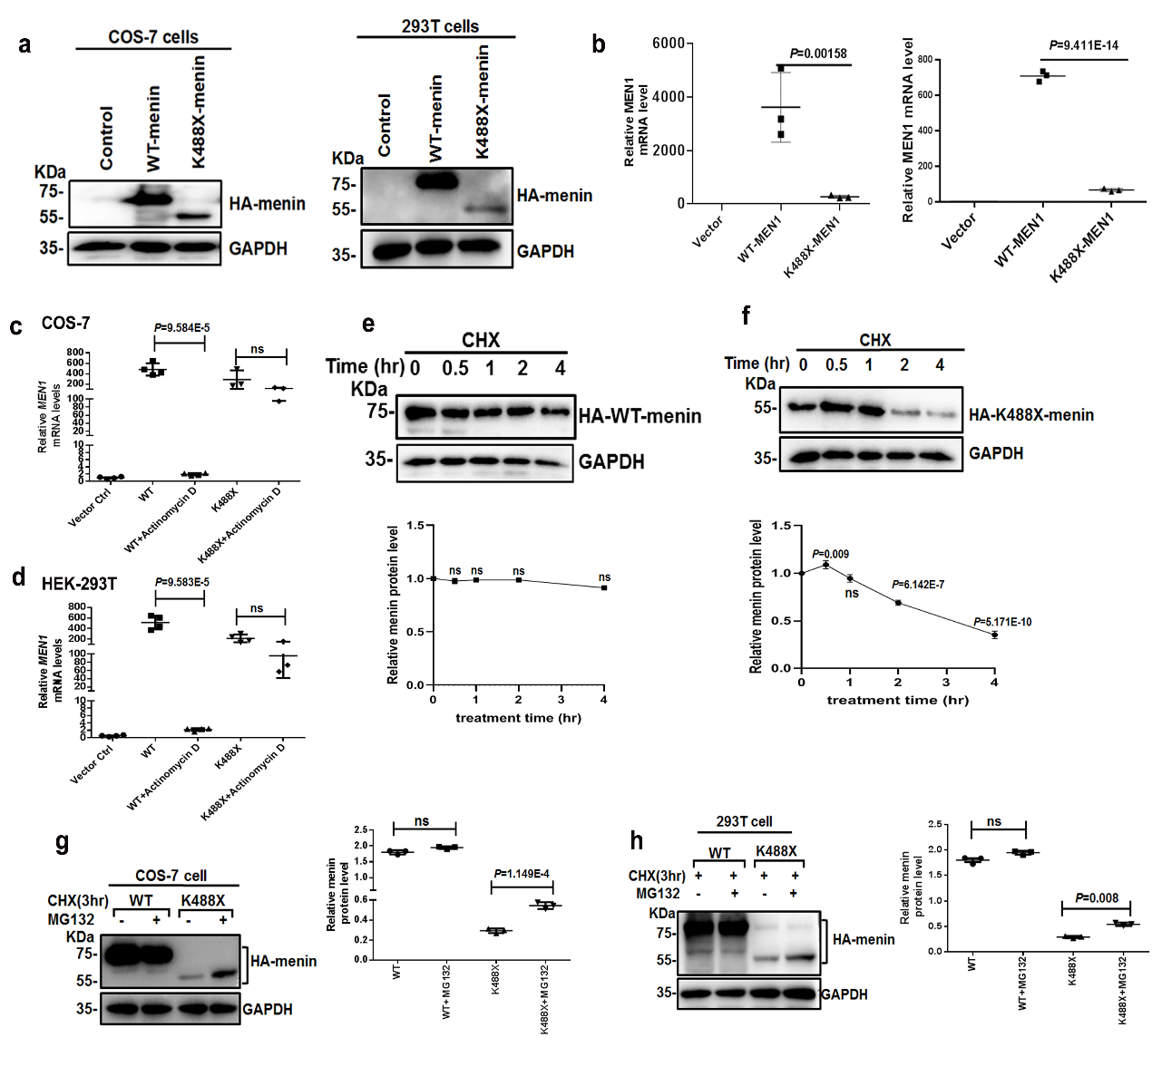
Supplementary Fig. 2 Instability of K488X−menin is mediated by the ubiquitin−proteasome pathway.
a The MEN1^{K488X} variant reduced menin levels. The 293T and COS−7 cells were transfected with HA−tagged wild−type and mutant type MEN1. At 48 hr after transfection, the cells were lysed and analyzed using western blot. b Down- regulation of MEN1 at the transcriptional level was induced by the MEN1^{K488X} variant， as indicated by qRT−PCR. HA−tagged wild type and mutant type MEN1 were introduced into HEK-293T and COS−7 cells. At 24 hr after transfection, four replicate wells of transfected cells in six-well plates from each group were lysed and analyzed using qRT−PCR. c and d The stability of K488X-MEN1 mRNA can not be affected by the treatment of actinomycin D(the transcription inhibitor).
The wild-type and K488X−MEN1 were transfected into COS-7 and HEK-293T cells and at 30hr after transfection，cells were treated with 20 nM concentration of actinomycin D for 17hr. Then， qRT–PCR was performed to compare the MEN1 mRNA differences in expression. Transfected cells from three replicate wells in 12−well plates for each group were lysed for RNA extraction and qRT-PCR. e and f K488X−affected menin protein is less stable than wild-type menin. Wild−type and mutant MEN1 were introduced into COS−7 cells. After 48 hr of transfection, the cells were treated with CHX (20 μg/ml) for the indicated times and analyzed using western blotting. g and h The proteasome inhibitor MG132 increased the level of K488X-menin after CHX treatment. The wild−type menin was unaffected by MG132. The wild-type and K488X-MEN1 cells were transfected into COS-7 and HEK-293T cells, and at 48 hr after transfection, the cells were treated with 20 μg/ml CHX for 3 hr. MG132 (25 μM) was then added to the transfected cells, which were then treated for another 3 hr. The cells were lysed in SDS loading buffer and analyzed using western blotting. Statistical results are displayed as the mean±SEM. Significance of Supplementary Figure 2b, 2c, 2d, 2g and 2h was assessed via One-Samples T test. Significance of Supplementary Figure 2e-2f was assessed via one-way ANOVA.

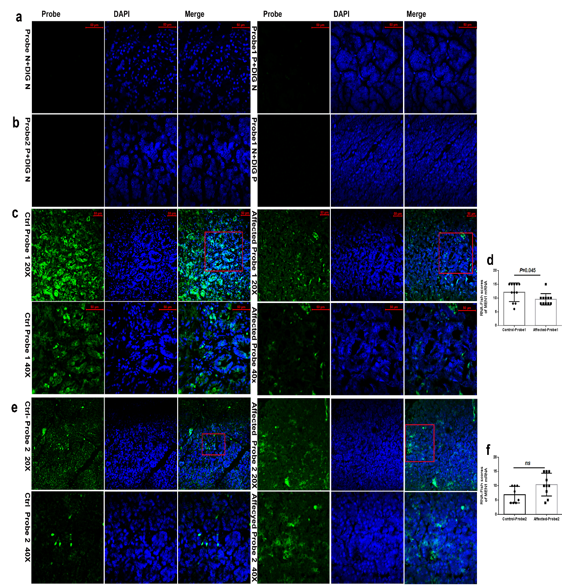
Supplementary Fig. 3 No significantly downregulated MEN1 mRNA was detected in the pancreatic tissues of the proband.
a No fluorescence was detected in the double−negative control (probe and digoxin (DIG) double−negative controls) in the left panel. Probe−negative and DIG−negative controls were used to exclude nonspecific staining in the pancreatic tissues of non−MEN1 individuals; probe and DIG fluorescent primary antibodies were omitted for tissue RNA hybridization and the binding of DIG−labeled probes and tissue RNA in tissue sections. No fluorescence was detected in the Probe 1-negative controls in the right panel. At the final concentration (0.8 μg/ml) of Probe 1, no DIG fluorescent primary antibody was added to the proband’s pancreatic tissues to exclude nonspecific staining. Magnification: 400×. P: positive and N: negative. Bars: 50 μm. b No fluorescence was detected in the probe−negative controls in the left panel; 0.8 μg/ml (final concentration) Probe 2 was added, and the DIG fluorescent primary antibody was omitted from non−MEN1 individuals’ pancreatic tissues to exclude nonspecific staining. No fluorescence was detected in the Probe 2−negative controls in the right panel. DIG fluorescent primary antibody was incubated; however, no probe was added to the proband’s pancreatic tissues to exclude nonspecific staining caused by the DIG fluorescent primary antibody. c and d Slight downregulation of MEN1 mRNA was detected in the pancreatic tissues of the proband compared with that in the non−MEN1 pancreatic tissues. The pancreatic tissues of the proband and the non−MEN1 individual were incubated with 0.8 μg/ml (final concentration) Probe 1 to measure the expression of MEN1 mRNA. Typical characteristic areas of RNA–FISH staining are framed in red and magnified in the bottom panels (400×). Eleven fields of view at 200× magnification were photographed. The intensity and percentage of RNA staining were evaluated, and the RNA−FISH staining score was calculated and statistically analyzed. Bar: 50 μm. e and f No downregulation of MEN1 mRNA was detected in the pancreatic tissues of the proband in comparison with that in non−MEN1 pancreatic tissues. The pancreatic tissues of the proband and the non−MEN1 individual were incubated with 0.8 μg/ml (final concentration) Probe 2 to measure MEN1 mRNA. Typical characteristic areas of RNA–FISH staining are framed in red and magnified in the bottom panel. Eight fields (200× magnification) of non−MEN1 individual tissues and 10 fields of the proband’s tissues were photographed. The RNA–FISH staining score was calculated and statistically analyzed. Bar: 50 μm. Statistical results are showed as the mean ±SEM. Significance in Supplementary Figure 3d and 3f was assessed via One-Samples T test.

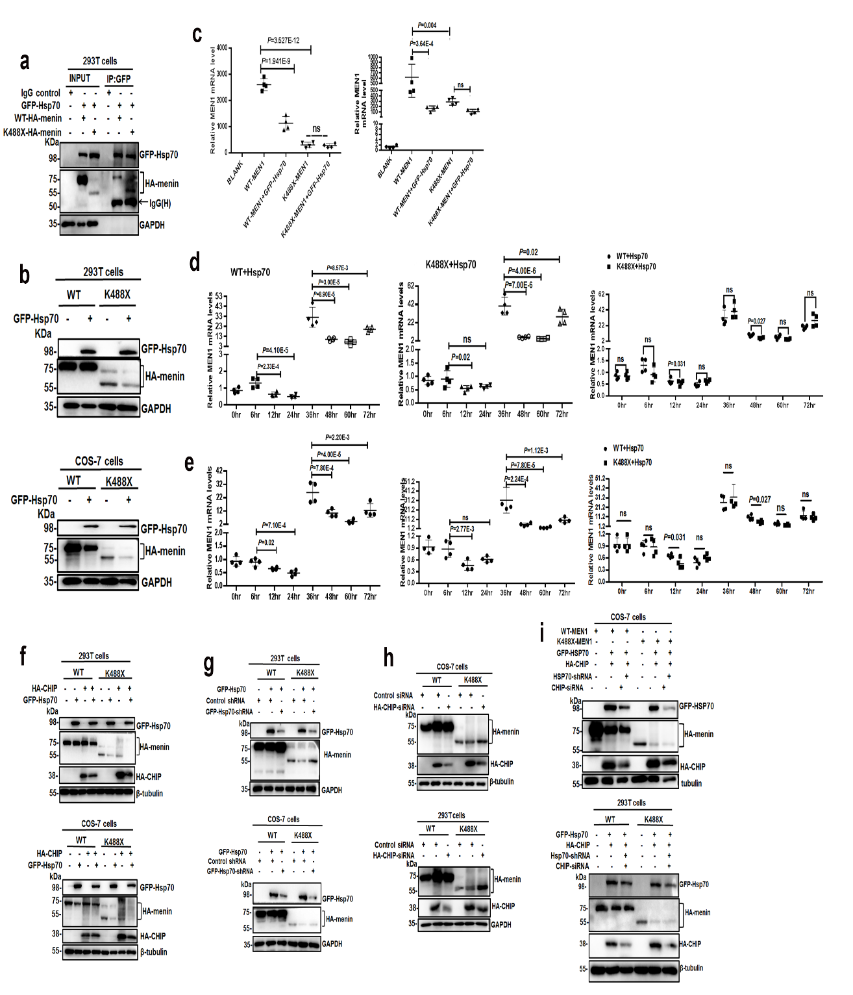
Supplementary Fig.4 Stabilization of K488X−menin is mediated by Hsp70 and CHIP.
a Wild−type menin and K488X−menin mutants were associated with Hsp70. HA−tagged wild−type and mutant MEN1 and GFP−tagged Hsp70 were transfected into HEK−293T cells with different combinations of agents. At 48 hr after transfection, the cells were lysed, GFP-Hsp70 was immunoprecipitated with an anti-GFP antibody, and the associated HA−menin was measured using immunoblotting. b A decrease in K488X−menin but not in wild−type menin was induced by Hsp70. HA−tagged wild−type and mutant MEN1 and GFP−tagged Hsp70 were transfected into HEK−293T and COS−7 cells as indicated by the different combinations. At 48 hr after transfection, the cells were lysed and analyzed using western blotting. c Hsp70 induced downregulation of wild−type MEN1 but not K488X−MEN1 at the transcriptional level. HA−tagged wild−type and mutant MEN1 and GFP-tagged Hsp70 were simultaneously introduced into HEK-293T and COS-7 cells in different combinations. At 24 hr after transfection, the cells were lysed and analyzed using qRT‒PCR (n = 4/group). d Hsp70 induced downregulation of wild−type MEN1 but not K488X−MEN1 in the early stages of expression in HEK−293T cells, but both were downregulated in the late stage of expression (left and middle panels). However, there was no difference in expression between the wild−type and K488X−MEN1 cells at different time points (right panels). HA−tagged wild−type and mutant MEN1 and GFP−tagged Hsp70 were simultaneously introduced into HEK−293T cells at different time points. Transfected cells were lysed and analyzed using qRT‒PCR (n = 4/group). e Hsp70 induced downregulation of wild−type MEN1 but not K488X−MEN1 in the early stages of expression in COS-7 cells, but both were induced in the late stage of expression (left and middle panels). However, there was no difference in expression between the wild−type and K488X−MEN1 cells at different time points (right panels). Statistical results of are displayed as the mean ±SEM. Significance of supplementary Figure 4c was assessed via one-way ANOVA. Significance of supplementary Figure 4d-4e was assessed via One-Samples T test. f Hsp70 or CHIP overexpression downregulated K488X−menin, and K488X−menin downregulation was aggravated by co−overexpressing Hsp70 and CHIP. HA−tagged wild−type and mutant MEN1, GFP−tagged Hsp70, and HA-tagged CHIP were transfected into HEK−293T and COS-7 cells in different combinations. At 48 hr after transfection, the cells were lysed and analyzed using western blotting. g The downregulation of K488X−menin induced by Hsp70 overexpression was reversed by Hsp70 silencing. HA−tagged wild−type and mutant MEN1, GFP−tagged Hsp70, and Hsp70−specific shRNAs were transfected into COS-7 and HEK-293T cells in different combinations. After 48 hr, the cells were lysed and analyzed using western blotting. h The decrease in K488X−menin induced by CHIP overexpression was reversed by CHIP silencing. HA−tagged wild−type and mutant MEN1 and HA−tagged CHIP were transfected into COS-7 and HEK-293T cells, followed by transfection of CHIP-specific siRNAs in different combinations. After 48 hr, the cells were lysed and analyzed using western blotting. i The co-induced downregulation of K488X-menin by co-overexpression of CHIP and Hsp70 could not be reversed by cosilencing of CHIP and Hsp70.

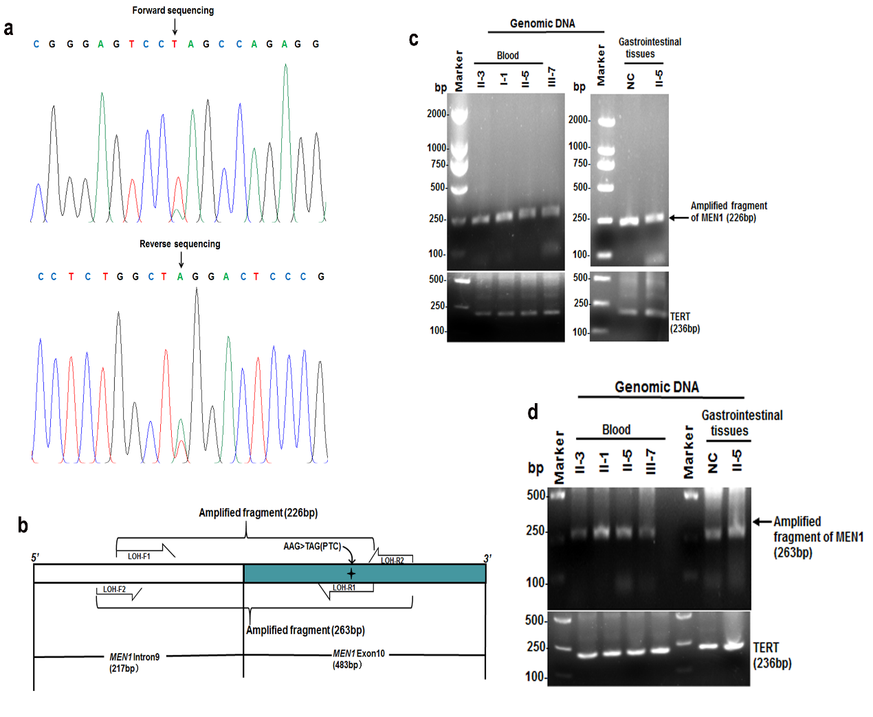
Supplementary Fig.5 LOH of wild type MEN1 allele is not detected in the MEN1 patients in the family.
a The c.1462A>T mutation on exon 10 was also detected in the proband’s gastric mucosa’ DNA from the proband. The forward and reverse sequencing chromatogram demonstrate the c.1462A>T mutation. The arrow indicates the location of the MEN1 gene variant. b The schematic view to demonstrate that the amplified fragments in the intron 9 and exon 10 of MEN1 using the primers containing the c.1462A mutation site or at the 3-terminal of the c.1462A mutation site may reveal the LOH of wild type MEN1 allele caused by the c.1462A>T mutation. c Loss of the wild-type allele was not consistently observed in the amplified fragments of intron9+exon10 of MEN1 using the blood and/or the gastric mucosa’s DNA from the proband and the III-7 patient as template and the primers containing the c.1462A mutation site. d Loss of the wild-type allele was not consistently observed in the amplified fragments of intron9+exon10 of MEN1 using the blood and/or the gastric mucosa’s DNA from the proband and the III-7 patient as template and the primers containing at the 3-terminal of the c.1462A mutation site.

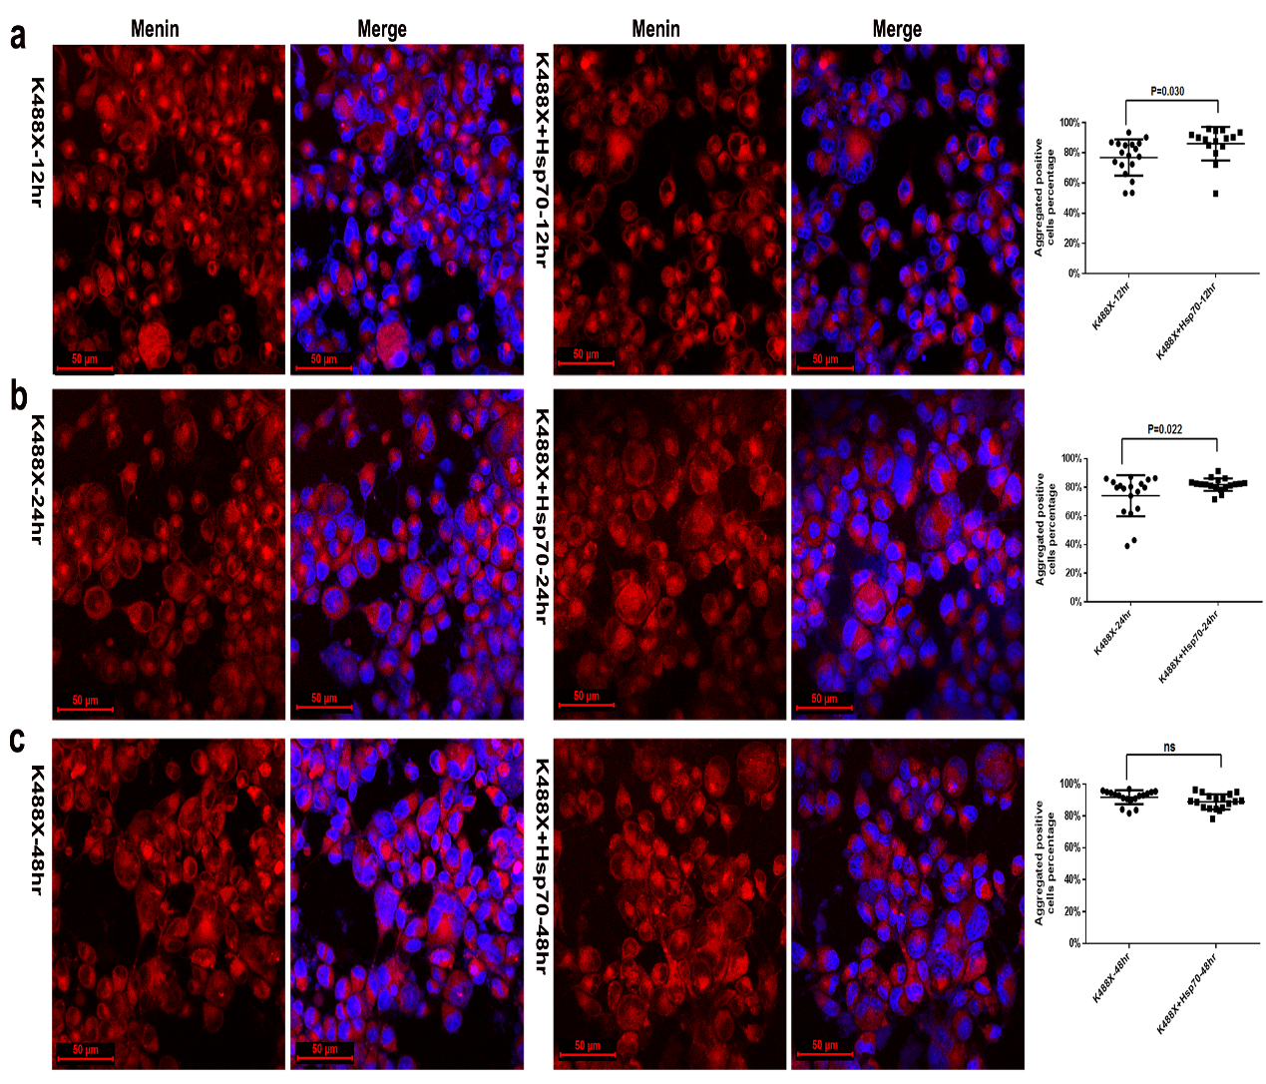
Supplementary Fig.6 The aggregation speed of K488X-menin exceeds the speed recognized by Hsp70 for K488X-menin.
a Aggregated K488X-menin was slightly recognized by Hsp70 in COS-7 cells at early expression stage of K488X-menin and Hsp70. K488X-MEN1 or/and GFP-Hsp70 were transfected into COS-7 cells and at 12hr after the transfection of K488X-MEN1 or/and GFP-Hsp70，cells were subjected to FPC detection. The percentage of aggregated K488X-menin positive cells in each view field was calculated and statistically analyzed. b Aggregated K488X-menin was slightly recognized by Hsp70 in COS-7 cells at the metaphase of K488X-menin and Hsp70. K488X-MEN1 or/and GFP-Hsp70 were transfected into COS-7 cells and at 24hr after the transfection of K488X-MEN1 or/and GFP-Hsp70，cells were subjected to FPC detection. c Aggregated K488X-menin was NOT recognized by Hsp70 in COS-7 cells at the late expression stage of K488X-menin and Hsp70. K488X-MEN1 or/and GFP-Hsp70 were transfected into COS-7 cells and at 48hr after the transfection of K488X-MEN1 or/and GFP-Hsp70，cells were subjected to FPC detection. Statistical results in supplementary Figure 6 are displayed as the mean ±SEM. Significance was assessed via One-Samples T test.

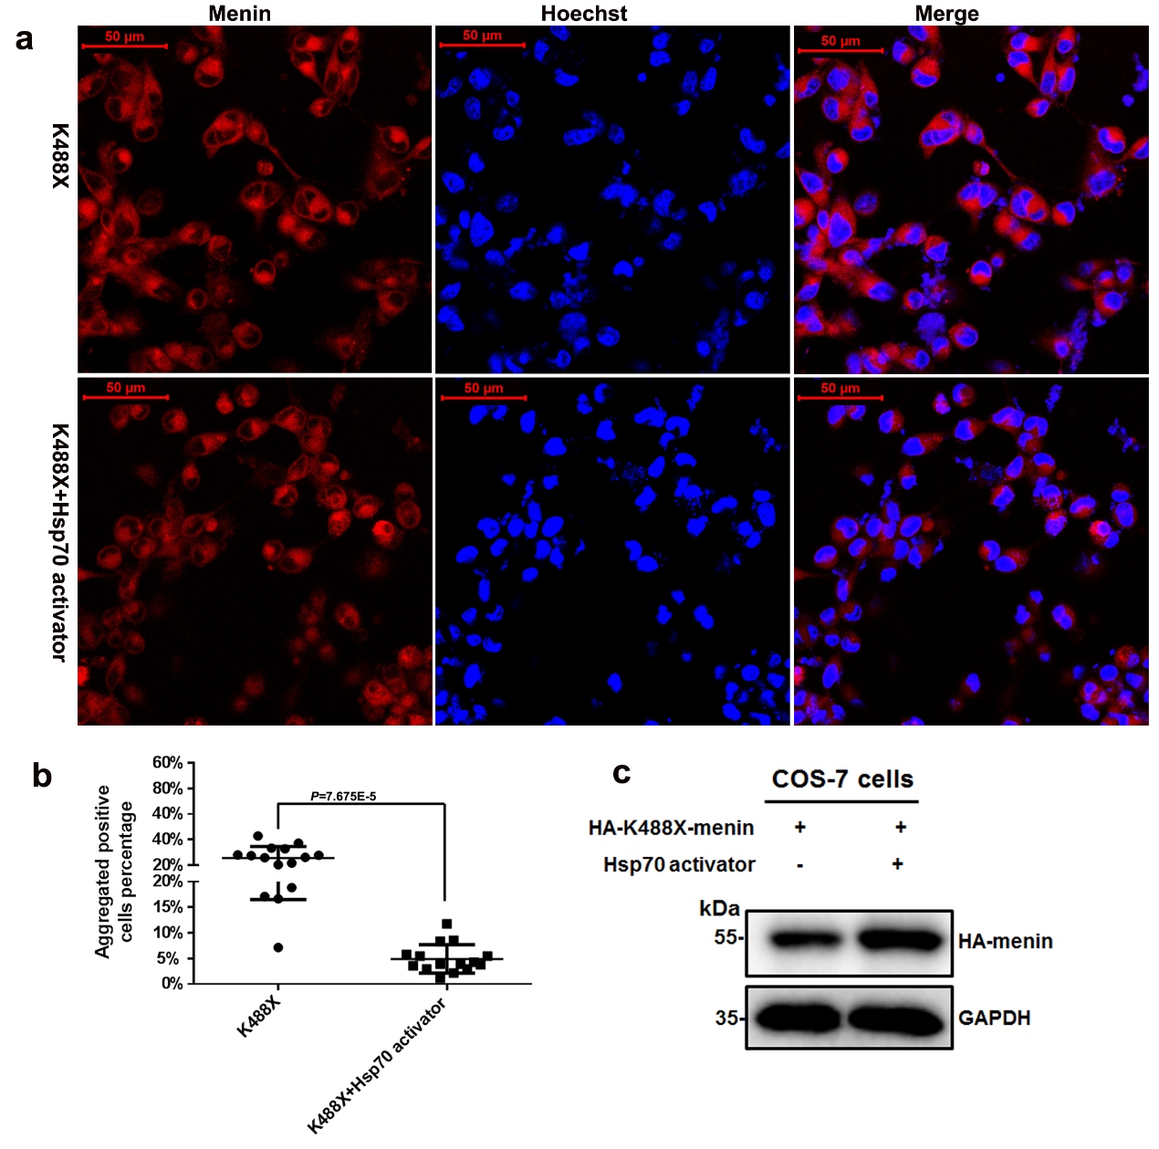
Supplementary Fig.7 Hsp70 activator treatment disaggregates the aggregated K488X-menin in vitro.
a The disaggregation of K488X−menin was induced by Hsp70 activator treatment. Halo−tagged K488X−MEN1 was transfected into COS−7 cells, and at 24 hr after transfection, ML346 (an Hsp70 activator, final concentration: 10 μM) was added to the COS−7−transfected cells for 24 hr of treatment, after which the cells were subjected to FPS detection. The total cell number and number of cells containing aggregated K488X−menin in 15 and 16 fields of view in the K488X and K488X+Hsp70-activator groups were calculated, respectively. b The percentage of aggregated K488X-menin cells was statistically analyzed. Statistical results in supplemental Figure 7b are displayed as the mean±SEM. Significance was assessed via One-Samples T test. c The upregulation of K488X-menin was induced by ML346 treatment. HA−tagged K488X−MEN1 was transfected into COS−7 cells, and at 24 hr after transfection,10 μM of ML346 was added to the COS−7−transfected cells for 24 hr of treatment, after which the cells were subjected to immunoblotting.

