Supplementary Material

Emergence of human infections with the novel avian influenza in Zhejiang Province, China post COVID-19 pandemic: An epidemiological analysis

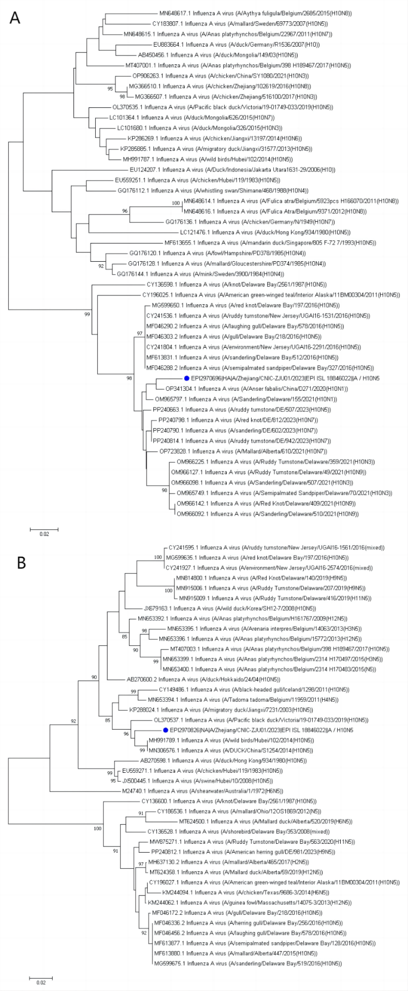
Supplementary Figure 1. Figure 2. Phylogenetic trees of the full-length of H10N5 avian influenza virus (A) haemagglutinin and (B) neuraminidase genes of H10 and N5 subtype influenza viruses.

