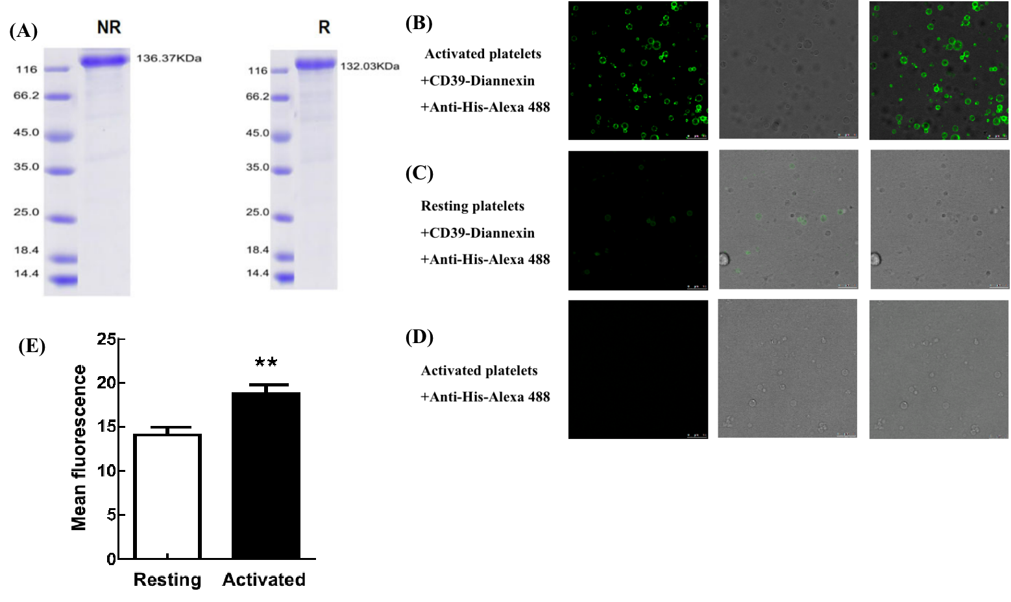
Figure 1 The characterizations of CD39-Diannexin. (A) The protein’s molecular weight in non-reducing state is 136.37kDa, and in reducing state, the molecular weight is 132.03kDa. The protein is stained with Coomassie bright blue. (B-D) We used activated platelets [(D) Platelets were activated by calcium ionophore A23187, which can lead phosphatidylserine (PS) exposed to the outer face], resting platelets [(E) PS mainly locates in the inner face of membrane] to test whether the recombinant protein CD39-Diannexin can specifically bind with PS. We can clearly see that after activation, platelets show high green fluorescence while in resting state, the green fluorescence is weak. (E) The quantitative analysis for the mean fluorescence intensity in activated and resting state.
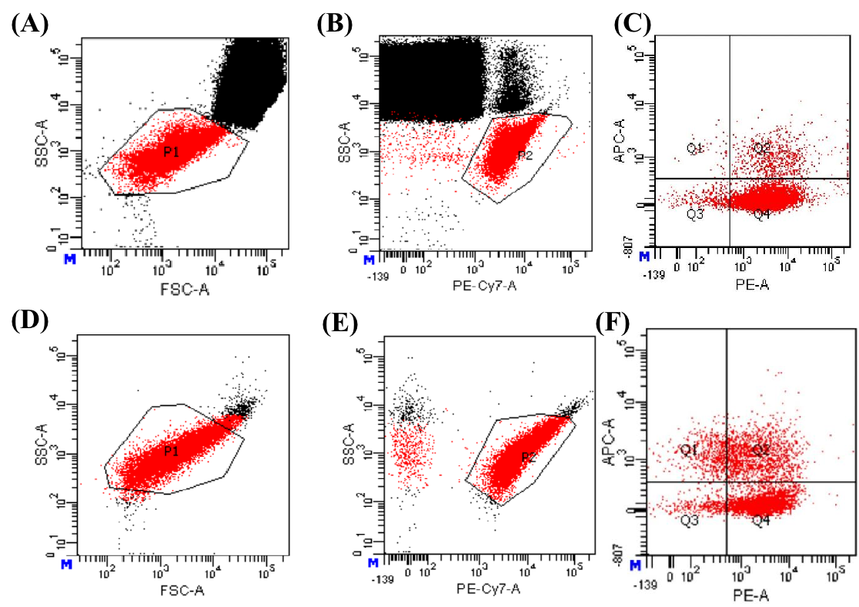
Figure 2 Measurement procedure of procoagulant platelets by using FCM. (A-C) The results of using whole blood in measuring procoagulant platelets (PPs). (A) Platelets locate in P1 gate. (B) CD41a positive platelets locate in P2 gate. (C) PPs locate in Q2 area. (D-F) The results of using washed platelets in measuring PPs. (D) Platelets locate in P1 gate. (E) CD41a positive platelets locate in P2 gate. (F) PPs located in Q2 area. FSC, forward scatter channel; SSC, side scatter channel. CD41a is a specific marker for platelets.

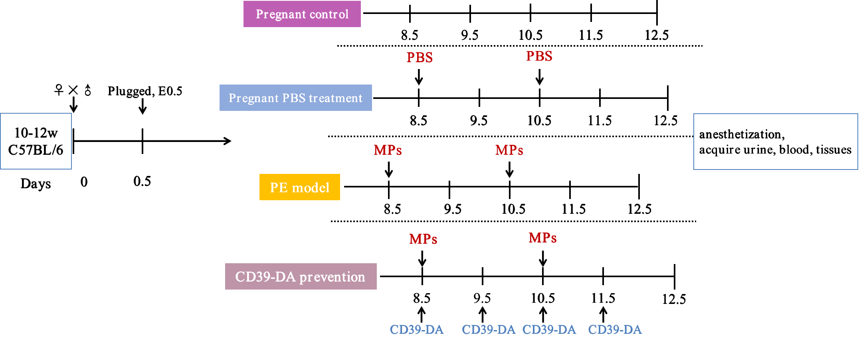
Figure 3 The treatment of four groups. The pregnant control group, pregnant PBS treatment group, PE model group and CD39-Diannexin prevention group were set, respectively. 10-12 week’s C57BL/6 mice were matched in a 1:1 ratio. Each group was treated by the above reagents. On E12.5, mice were anesthetized and urine, blood were acquired. Placentas were separated. CD39-DA: CD39-Diannexin.

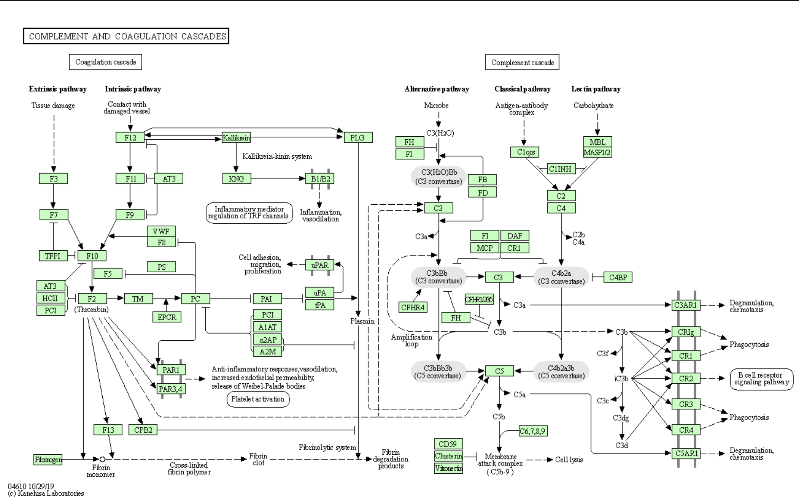
Figure 4 Complement and coagulation cascades. Kininogen and complement C3, which were both detected in our proteomics analysis are both the elements in the complement and coagulation cascades.

