Supplementary materials

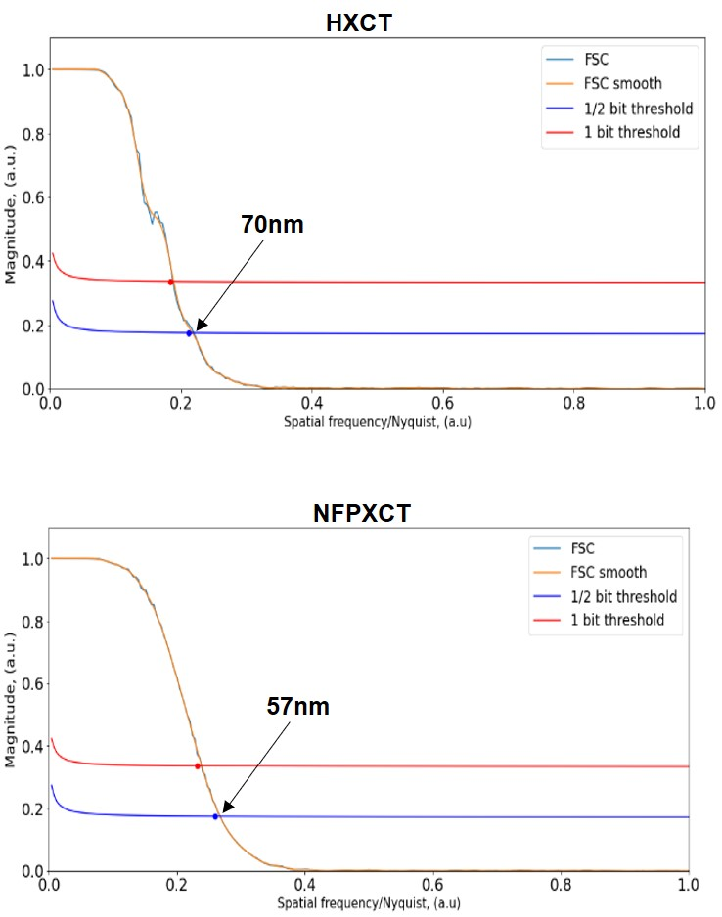
Fig. S 1. Fourier shell correlation estimation of HXCT (top) and NFPXCT (bottom) volumes. The evaluation was done using a region of (500)³ pixels in the center of the volumes from each technique.

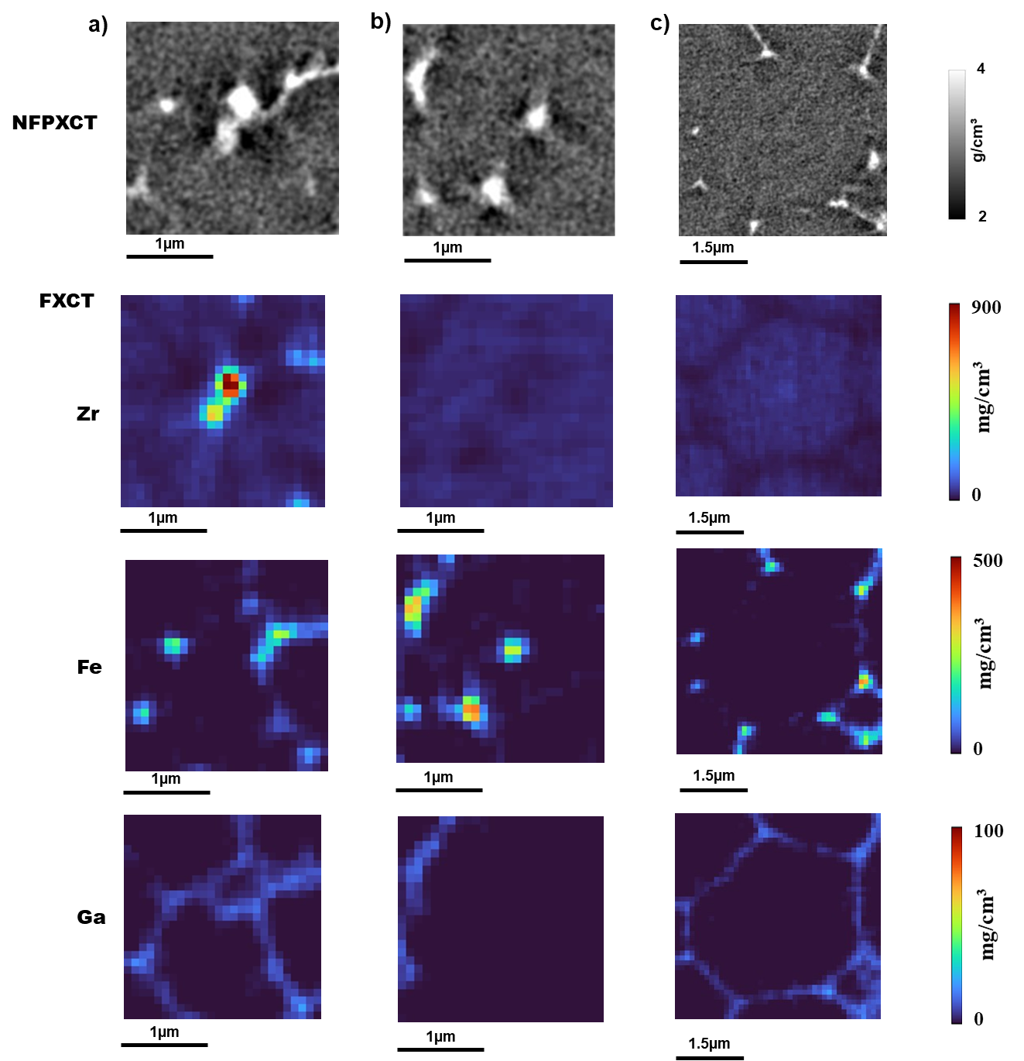
Fig. S 2. Direct comparison of the enlarged regions of interest from NFPXCT and the corresponding regions from FXCT for the different elements.

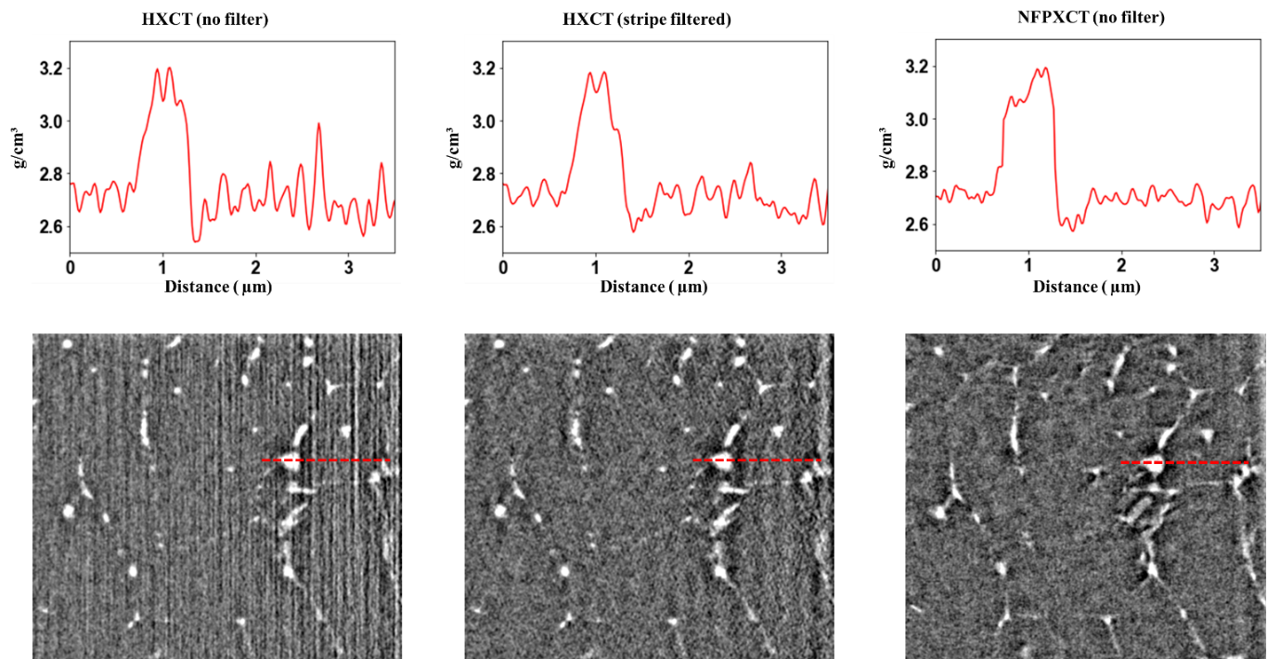
Fig. S 3. Comparison of an x-z slice from HXCT volumes before and after applying the stripes filter. The same region of interest from NFPXCT volume is shown.

