Tables
Table 1. Beetle species and number of the specimens per forest type included in the study along with information related to their origin and main fungal structures.
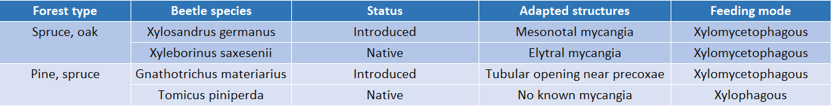

Table 2. Overview of the GLM analysis results, showing the significant p values, the percentage of explained variance and the F parameter for every factor included in the model.
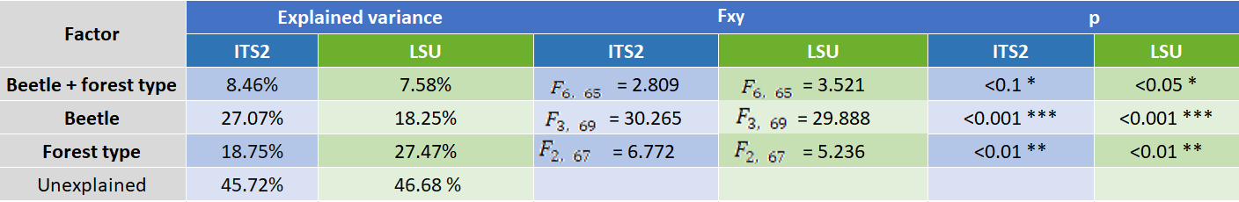

Table 3: Net relatedness index (NRI), nearest taxon index (NTI), and number of OTUs recovered for LSU and ITS2 across all clustering thresholds. “Mixed” refers to a clustering threshold of 99% for LSU and 98% for ITS2. Reference sequences were included when building the trees used, though pruned (leaving only OTUs in the tree) for the above calculations.
