Environmental Sciences Europe
Supplementary information

Ecotoxicological data of selected antiviral drugs acting against SARS-CoV-2: Aliivibrio fischeri bioluminescence inhibition, Daphnia magna immobilization, and comparison with in silico predictions

Indra Bartels ^{a,b,f}, Nazmun Nahar ^{c,d,g}, Esther Smollich ^{c,h}, Sonja Zimmermann ^{c,d,i}, Torsten C. Schmidt ^{b,d,j}, Martin Jaeger ^{a,k,*}, Bernd Sures ^{c,d,e,l}
ª Department of Chemistry and ILOC, Niederrhein University of Applied Sciences, Frankenring 20, D-47798 Krefeld, Germany; ^{b} Faculty of Chemistry, University Duisburg-Essen, Universitätsstraße 5, D-45141 Essen, Germany; ^{c} Aquatic Ecology, Faculty of Biology, University Duisburg-Essen, Universitätsstraße 5, D-45141 Essen, Germany; ^{d} Centre for Water and Environmental Research, University of Duisburg-Essen, Universitätsstr. 5, 45141 Essen, Germany; ^{e} Research Center One Health Ruhr, Research Alliance Ruhr, University Duisburg-Essen, Universitätsstraße 5, D-45141 Essen, Germany; ORCID ID: ^{f} 0000-0001-7245-443X; ^{g} 0000-0001-6377-3906; ^{h} 0000-0003-2679-5860, ^{i} 0000-0001-6929-7541; ^{j} 0000-0003-1107-4403; ^{k} 0000-0002-7709-2869; ^{l} 0000-0001-6865-6186;
* corresponding author: martin.jaeger@hs-niederrhein.de

Table A. 1: Abbreviations and structural formulas for favipiravir, remdesivir, GS-441524, molnupiravir and EIDD-1931 as used in the main paper
analyte | abbreviation | structural formula
favipiravir | FAV
remdesivir | REM
GS-441524  (active metabolite of remdesivir) | GS
molnupiravir | MOL
EIDD-1931  (active metabolite of molnupiravir) | EIDD

Table A. 2: Chemicals required for the bioluminescence inhibition test on A. fischeri, stating their concentration, temperature and time of the respective incubation and dilution on the microplate regarding DIN EN ISO 11348
Chemicals and steps | Parameters/ properties and description
positive control: potassium dichromate (K₂Cr₂O₇) | c= 22.6 mg∙L⁻¹
positive control: zinc sulfate heptahydrate (ZnSO₄ × 7 H₂O). | c= 219.8 mg∙L⁻¹
test solutions | T= 15°C
100 µL A. fischeri suspension | 2500 ± 500 formazine absorbing units (FAU); diluted in 0.5 mL of 20 g∙L⁻¹ sodium chloride
Incubation of A. fischeri solution | T= 15°C for 15 minutes
After incubation of A. fischeri | 11.5 mL of 20 g∙L⁻¹ sodium chloride solution was added and homogenized with the aid of a vortex homogenizer
microplate | 0.5 mL of the test substance solution or control was added to 0.5 mL bacteria suspension per well
negative control: sodium chloride solution | pH= 6.4.

Table A.3: Measured pH values of stock solutions of FAV, REM and GS and their resulting test solutions prior to the investigation of bioluminescence inhibition using Aliivibrio fischeri
FAV |  | REM |  | GS
c / mg∙L⁻¹ | pH value | c / mg∙L⁻¹ | pH value | c / mg∙L⁻¹ | pH value
1000 | 6.4 | 19.3 | 6.4 | 7.7 | 6.4
500 | 6.3 | 6.5 | 6.4 | 3.8 | 6.4
100 | 6.4 | 1.7 | 6.4 | 0.7 | 6.4
50 | 6.4 | 0.6 | 6.4 | 0.4 | 6.4
10 | 6.3 | 0.1 | 6.4 | 0.1 | 6.4
5.0 | 6.3 | 0.0 | 6.4 | 0.0 | 6.4
1.0 | 6.4 | - | - | - | -
0.5 | 6.3 | - | - | - | -

Table A.4: Measured pH values of stock solutions of MOL and EIDD and their resulting test solutions prior to the investigation of bioluminescence inhibition using Aliivibrio fischeri
MOL |  | EIDD
c / mg∙L⁻¹ | pH value | c / mg∙L⁻¹ | pH value
1500 | 6.4 | 1500 | 7.0
1000 | 6.4 | 1000 | 6.7
500 | 6.4 | 500 | 6.7
100 | 6.7 | 100 | 6.7
50 | 6.4 | 50 | 6.7
10 | 6.4 | 10 | 6.7
5 | 6.4 | 5 | 6.7

Table A. 5: Chemicals required for the acute immobilization test on D. magna, stating their concentration, temperature and time of the respective incubation and dilution regarding OECD guideline
Chemicals and steps | Parameters/ properties and description
synthetic sea salt | c= 19.9 g∙60 L⁻¹
CaCl₂ x 2H₂O | 138 mL∙60 L⁻¹ of 117.6 g∙L⁻¹
NaHCO₃ | 132 mL∙60 L⁻¹ of 25.2 g∙L⁻¹
SeO₂ | 6 mL∙60 L⁻¹ of 0.07 g∙L⁻¹
aeration of the artificial medium | t= 16 to 18 h
pH values of the artificial medium | adjusted between pH= 6 to 8

Table A.6: pH values and dissolved oxygen (mg∙L⁻¹) in the exposure media with different concentrations of K₂Cr₂O₇ directly before (t=0 h) and after (t=48 h) the exposure to Daphnia magna
c / mg∙L⁻¹ | pH values |  | dissolved oxygen / mg∙L⁻¹
c / mg∙L⁻¹ | t=0 h | t=48 h | t=0 h | t=48 h
3.2 | 6.6 | 7.2 | 5.0 | 4.5
1.8 | 6.6 | 7.2 | 5 | 4.1
1.0 | 6.6 | 7.2 | 5.1 | 4.1
0.6 | 6.7 | 7.5 | 5.1 | 3.9
0.3 | 6.7 | 7.1 | 5.1 | 4.2
Control | 6.7 | 7.3 | 5.1 | 4.5

Table A.7: pH values and dissolved oxygen (mg∙L⁻¹) in the exposure media with different concentrations of FAV directly before (t=0 h) and after (t=48 h) the exposure to Daphnia magna
c / mg∙L⁻¹ | pH values |  | dissolved oxygen / mg∙L⁻¹
c / mg∙L⁻¹ | t=0 h | t=48 h | t=0 h | t=48 h
850 | 6.8 | 6.3 | 5.5 | 5.0
500 | 6.6 | 6.1 | 4.8 | 4.2
300 | 6.7 | 6.4 | 5.1 | 4.7
175 | 6.8 | 6.6 | 5.3 | 4.8
100 | 7.2 | 6.9 | 5.3 | 4.7
Control | 6.7 | 6.9 | 5.1 | 4.5

Table A.8: pH values and dissolved oxygen (mg∙L⁻¹) in the exposure media with different concentrations of REM directly before (t=0 h) and after (t=48 h) the exposure to Daphnia magna
c / mg∙L⁻¹ | pH values |  | dissolved oxygen / mg∙L⁻¹
c / mg∙L⁻¹ | t=0 h | t=48 h | t=0 h | t=48 h
79.9 | 7.3 | 6.1 | 5.1 | 4.6
42.3 | 6.4 | 6.5 | 4.7 | 4.2
39.4 | 6.6 | 6.4 | 5.0 | 4.4
34.8 | 6.7 | 6.7 | 5.2 | 4.7
32.0 | 6.7 | 6.7 | 5.4 | 4.9
Control | 6.8 | 6.3 | 5.1 | 4.5

Table A.9: pH values and dissolved oxygen (mg∙L⁻¹) in the exposure media with different concentrations of GS directly before (t=0 h) and after (t=48 h) the exposure to Daphnia magna
c / mg∙L⁻¹ | pH values |  | dissolved oxygen / mg∙L⁻¹
c / mg∙L⁻¹ | t=0 h | t=48 h | t=0 h | t=48 h
>850-10 | 6.3-7.4 | 6.0-6.9 | 5.0-5.4 | 5.2-5.3
Control | 7.0 | 6.9 | 5.5 | 4.7

Table A.10: pH values and dissolved oxygen (mg∙L⁻¹) in the exposure media with different concentrations of MOL directly before (t=0 h) and after (t=48 h) the exposure to Daphnia magna
c / mg∙L⁻¹ | pH values |  | dissolved oxygen / mg∙L⁻¹
c / mg∙L⁻¹ | t=0 h | t=48 h | t=0 h | t=48 h
1400 | 6.7 | 7.3 | 5.6 | 5.5
1200 | 6.7 | 7.2 | 5.6 | 5.2
1000 | 6.7 | 7.3 | 5.0 | 4.9
800 | 6.7 | 7.4 | 4.9 | 4.8
600 | 6.7 | 7.3 | 4.9 | 4.6
Control | 6.7 | 7.4 | 5.0 | 4.9

Table A.11: pH values and dissolved oxygen (mg∙L⁻¹) in the exposure media with different concentrations of EIDD directly before (t=0 h) and after (t=48 h) the exposure to Daphnia magna
c / mg∙L⁻¹ | pH values |  | dissolved oxygen / mg∙L⁻¹
c / mg∙L⁻¹ | t=0 h | t=48 h | t=0 h | t=48 h
1400 | 6.4 | 7.1 | 5.4 | 4.4
1000 | 6.4 | 7.0 | 4.9 | 4.1
600 | 6.5 | 7.3 | 4.9 | 4.2
300 | 6.6 | 7.3 | 4.9 | 2.2
150 | 6.6 | 7.2 | 5.2 | 4.4
Control | 6.8 | 7.0 | 5.5 | 4.9

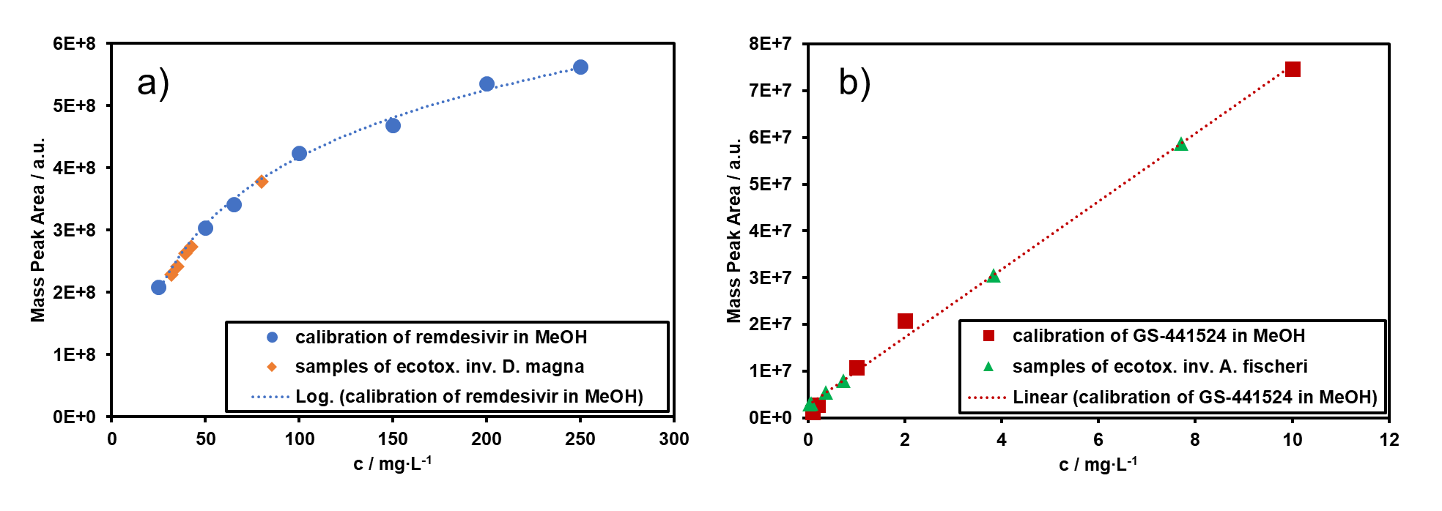
Figure A.1: Calibration of REM (a) in MeOH and samples of the ecotoxicological investigation using Daphnia magna and calibration of GS (b) in MeOH and samples of the ecotoxicological investigation using Aliivibrio fischeri.

Table A. 12: Determination of the actual concentration (c_{actual} / mg∙L⁻¹) using HPLS-HRMS with deviation (%) to the nominal concentration (c_{nominal} / mg∙L⁻¹), indicating the solubility (%) of FAV, REM, GS, MOL and EIDD during the bioluminescence inhibition test on Aliivibrio fischeri.
Test substance | c_{nominal} / mg∙L⁻¹ | c_{actual} / mg∙L⁻¹ | deviation / % | solubility / %
FAV | 0.5 | 0.5 | 1.4 | 98.6
FAV | 1.0 | 1.0 | 2.1 | 97.9
FAV | 5.0 | 5.0 | 0.9 | 99.1
FAV | 10.0 | 9.8 | 2.2 | 97.8
FAV | 50.0 | 48.8 | 2.4 | 97.6
FAV | 100.0 | 97.4 | 2.6 | 97.4
FAV | 500.0 | 494.2 | 1.2 | 98.8
FAV | 1000.0 | 988.1 | 1.2 | 98.8
REM | 0.5 | 0.0 | 94.9 | 5.1
REM | 1.0 | 0.1 | 94.5 | 5.5
REM | 5.0 | 0.6 | 88.4 | 11.6
REM | 10.0 | 1.6 | 83.5 | 16.5
REM | 50.0 | 6.5 | 87.0 | 13.0
REM | 100.0 | 19.3 | 80.7 | 19.3
GS | 0.05 | 0.03 | 35.8 | 64.2
GS | 0.10 | 0.06 | 41.8 | 58.2
GS | 0.50 | 0.37 | 26.6 | 73.4
GS | 1.00 | 0.73 | 27.3 | 72.7
GS | 5.00 | 3.83 | 23.5 | 76.5
GS | 10.00 | 7.71 | 22.9 | 77.1

Table A. 12 continued
Test substance | c_{nominal} / mg∙L⁻¹ | c_{actual} / mg∙L⁻¹ | deviation / % | stability / %
MOL | 5.0 | 4.9 | 1.4 | 98.6
MOL | 10.0 | 10.0 | 0.03 | 100.0
MOL | 50.0 | 49.9 | 0.3 | 99.7
MOL | 100.0 | 99.4 | 0.6 | 99.4
MOL | 500.0 | 495.8 | 0.8 | 99.2
MOL | 1000.0 | 986.2 | 1.4 | 98.6
MOL | 1500.0 | 1479.3 | 1.4 | 98.6
EIDD | 5.0 | 4.9 | 1.1 | 98.9
EIDD | 10.0 | 9.8 | 2.2 | 97.8
EIDD | 50.0 | 49.4 | 1.1 | 98.9
EIDD | 100.0 | 96.9 | 3.1 | 96.9
EIDD | 500.0 | 488.0 | 2.4 | 97.6
EIDD | 1000.0 | 993.9 | 0.6 | 99.4
EIDD | 1500.0 | 1492.3 | 0.5 | 99.5

Table A. 13: Determination of the actual concentration (c_{actual} / mg∙L⁻¹) using HPLS-HRMS with deviation (%) to the nominal concentration (c_{nominal} / mg∙L⁻¹) depending on the exposure time of FAV, REM, MOL and EIDD on Daphnia magna
 | exposure time / h
Test substance |  | 0 |  | 24 |  |  | 48
Test substance | c_{nominal} / mg∙L⁻¹ | c_{actual} / mg∙L⁻¹ | deviation / % | c_{actual} / mg∙L⁻¹ | deviation / % | stability  / % | c_{actual} / mg∙L⁻¹ | deviation / % | stability / %
FAV | 100.0 | 98.6 | 1.4 | 97.8 | 2.2 | 99.2 | 96.9 | 3.1 |  | 98.2
FAV | 175.0 | 172.4 | 1.5 | 172.2 | 1.6 | 99.9 | 170.8 | 2.4 |  | 99.1
FAV | 300.0 | 297.5 | 0.8 | 289.0 | 3.7 | 97.1 | 293.4 | 2.2 |  | 98.6
FAV | 500.0 | 496.6 | 0.7 | 491.3 | 1.7 | 98.9 | 479.1 | 4.2 |  | 96.5
FAV | 850.0 | 843.5 | 0.8 | 826.3 | 2.8 | 98.0 | 834.2 | 1.9 |  | 98.9
REM | 65.0 | 32.0 | 50.8 | 29.1 | 55.2 | 90.9 | 30.7 | 52.8 |  | 95.9
REM | 100.0 | 34.8 | 65.2 | 34.7 | 65.3 | 99.6 | 34.3 | 65.7 |  | 98.6
REM | 150.0 | 39.4 | 73.7 | 38.5 | 74.3 | 97.7 | 38.7 | 74.2 |  | 98.2
REM | 200.0 | 42.3 | 78.9 | 41.5 | 79.2 | 98.2 | 40.9 | 79.5 |  | 96.8
REM | 250.0 | 79.9 | 68.0 | 78.6 | 68.6 | 98.4 | 79.3 | 68.3 |  | 99.2

Table A. 13 continued
 | exposure time / h
Test substance |  | 0 |  | 24 |  |  | 48
Test substance | c_{nominal} / mg∙L⁻¹ | c_{actual} / mg∙L⁻¹ | deviation / % | c_{actual} / mg∙L⁻¹ | deviation / % | stability  / % | c_{actual}  / mg∙L⁻¹ | deviation / % | stability  / %
MOL | 600.0 | 597.8 | 0.4 | 592.8 | 1.2 | 99.2 | 594.3 | 1.0 | 99.4
MOL | 800.0 | 797.2 | 0.4 | 786.2 | 1.7 | 98.6 | 797.0 | 0.4 | 100.0
MOL | 1000.0 | 998.4 | 0.2 | 998.1 | 0.2 | 100.0 | 991.9 | 0.8 | 99.3
MOL | 1200.0 | 1196.7 | 0.3 | 1193.7 | 0.5 | 99.7 | 1186.5 | 1.1 | 99.2
MOL | 1400.0 | 1392.6 | 0.5 | 1383.6 | 1.2 | 99.4 | 1387.9 | 0.9 | 99.7
EIDD | 150.0 | 147.0 | 2.0 | 143.1 | 4.6 | 97.3 | 146.9 | 2.1 | 99.9
EIDD | 300.0 | 297.0 | 1.0 | 294.6 | 1.8 | 99.2 | 296.5 | 1.2 | 99.8
EIDD | 600.0 | 586.0 | 2.3 | 585.3 | 2.5 | 99.9 | 585.2 | 2.5 | 99.9
EIDD | 1000.0 | 966.0 | 3.4 | 965.2 | 3.5 | 99.9 | 965.4 | 3.5 | 99.9
EIDD | 1400.0 | 1376.0 | 1.7 | 1372.3 | 2.0 | 99.7 | 1371.5 | 2.0 | 99.7

Table A.14: Mean adjustment factor (MAF) and standard deviations of the adjustment factor (sdAF) of three replicates for MOL and EIDD on the corresponding microtiter plate after different inhibition periods (t_{bioluminescence inhibition}) during the bioluminescence inhibition test using Aliivibrio fischeri
t_{bioluminescence inhibition} / min | MOL, calculated for the concentrations 10-1000 mg∙L⁻¹ |  | MOL and EIDD, calculated for the concentrations 5, 1500 mg∙L⁻¹ |  | EIDD, calculated for the concentrations 10-1000 mg∙L⁻¹
t_{bioluminescence inhibition} / min | MAF | sdAF | MAF | sdAF | MAF | sdAF
0 | 1.00 | 0.00 | 1.00 | 0.00 | 1.00 | 0.00
5 | 1.12 | 0.03 | 1.16 | 0.01 | 1.16 | 0.02
15 | 1.11 | 0.04 | 1.15 | 0.01 | 1.14 | 0.02
30 | 1.15 | 0.05 | 1.10 | 0.03 | 1.12 | 0.04

Table A.15: Mean adjustment factor (MAF) and standard deviations of the adjustment factor (sdAF) of three replicates for REM and GS on the corresponding microtiter plate after different inhibition periods (t_{bioluminescence inhibition}) during the bioluminescence inhibition test using Aliivibrio fischeri
t_{bioluminescence inhibition} / min | REM calculated for the concentrations 0.06-6.52 mg∙L⁻¹ |  | REM calculated for the concentrations 0.03, 19.32; GS 0.03, 7.71 mg∙L⁻¹ |  | GS calculated for the concentrations 0.06 -3.83 mg∙L⁻¹
t_{bioluminescence inhibition} / min | MAF | sdAF | MAF | sdAF | MAF | sdAF
0 | 1.00 | 0.00 | 1.00 | 0.00 | 1.00 | 0.00
5 | 1.17 | 0.01 | 1.20 | 0.02 | 1.13 | 0.04
15 | 1.14 | 0.02 | 1.23 | 0.02 | 1.10 | 0.04
30 | 1.09 | 0.04 | 1.26 | 0.04 | 1.07 | 0.06

Table A.16: Mean adjustment factor (MAF) and standard deviations of the adjustment factor (sdAF) of three replicates for FAV on the corresponding microtiter plate after different inhibition periods (t_{bioluminescence inhibition}) during the bioluminescence inhibition test using Aliivibrio fischeri
t_{bioluminescence inhibition} / min | FAV calculated for the concentrations 1-100 mg∙L⁻¹ |  | FAV calculated for the concentrations 0.5, 500, 1000 mg∙L⁻¹
t_{bioluminescence inhibition} / min | MAF | sdAF | MAF | sdAF
0 | 1.00 | 0.00 | 1.00 | 0.00
5 | 1.18 | 0.02 | 1.14 | 0.03
15 | 1.18 | 0.02 | 1.11 | 0.03
30 | 1.19 | 0.03 | 1.07 | 0.05

Table A.17: Deviation (as absolute, %) of the adjustment factor of each individual replicate from the mean value of the control of the corresponding microtiter plate during the bioluminescence inhibition test using Aliivibrio fischeri.
t_{bioluminescence inhibition} /  min for each analyte | deviation of the individual adjustment factors from mean of the control in %
MOL 10-1000 mg∙L⁻¹ | A | B | C
0 | 0.00 | 0.00 | 0.00
5 | 3.23 | 0.42 | 2.81
15 | 3.18 | 0.03 | 3.15
30 | 3.90 | 0.12 | 4.03
MOL and EIDD: 5 and 1500 mg∙L⁻¹
0 | 0.00 | 0.00 | 0.00
5 | 0.64 | 0.01 | 0.65
15 | 0.64 | 0.10 | 0.54
30 | 2.54 | 0.54 | 3.08

Table A.17 continued
t_{bioluminescence inhibition} / min for each analyte | deviation of the individual adjustment factors from mean of  the control in %
EIDD 10 - 1000 mg∙L⁻¹
0 |  | 0.00 | 0.00 | 0.00
5 |  | 1.14 | 0.55 | 1.69
15 |  | 1.55 | 0.43 | 1.99
30 |  | 2.70 | 1.25 | 3.95
REM 0.06 - 6.5 mg∙L⁻¹
0 |  | 0.00 | 0.00 | 0.00
5 |  | 0.46 | 0.44 | 0.91
15 |  | 1.41 | 0.84 | 2.25
30 |  | 1.86 | 2.13 | 3.99
REM 0.03, 19.3; GS 0.03, 7.7 mg∙L⁻¹
0 |  | 0.00 | 0.00 | 0.00
5 |  | 0.95 | 1.34 | 2.28
15 |  | 0.76 | 1.29 | 2.05
30 |  | 1.79 | 1.72 | 3.51
GS 0.06 -3.8 mg∙L⁻¹
0 |  | 0.00 | 0.00 | 0.00
5 |  | 2.42 | 1.42 | 3.84
15 |  | 3.28 | 1.29 | 4.57
30 |  | 4.02 | 2.14 | 6.16

Table A.17 continued
t_{bioluminescence inhibition} / min for each analyte | deviation of the individual adjustment factors from mean of  the control in %
FAV 1-100 mg∙L⁻¹
0 |  | 0.00 | 0.00 | 0.00
5 |  | 1.31 | 0.54 | 1.86
15 |  | 1.76 | 0.16 | 1.92
30 |  | 2.06 | 1.18 | 3.24
FAV 0.5, 500, 1000 mg∙L⁻¹
0 |  | 0.00 | 0.00 | 0.00
5 |  | 1.99 | 1.01 | 2.99
15 |  | 2.70 | 0.71 | 3.41
30 |  | 4.42 | 0.89 | 5.31

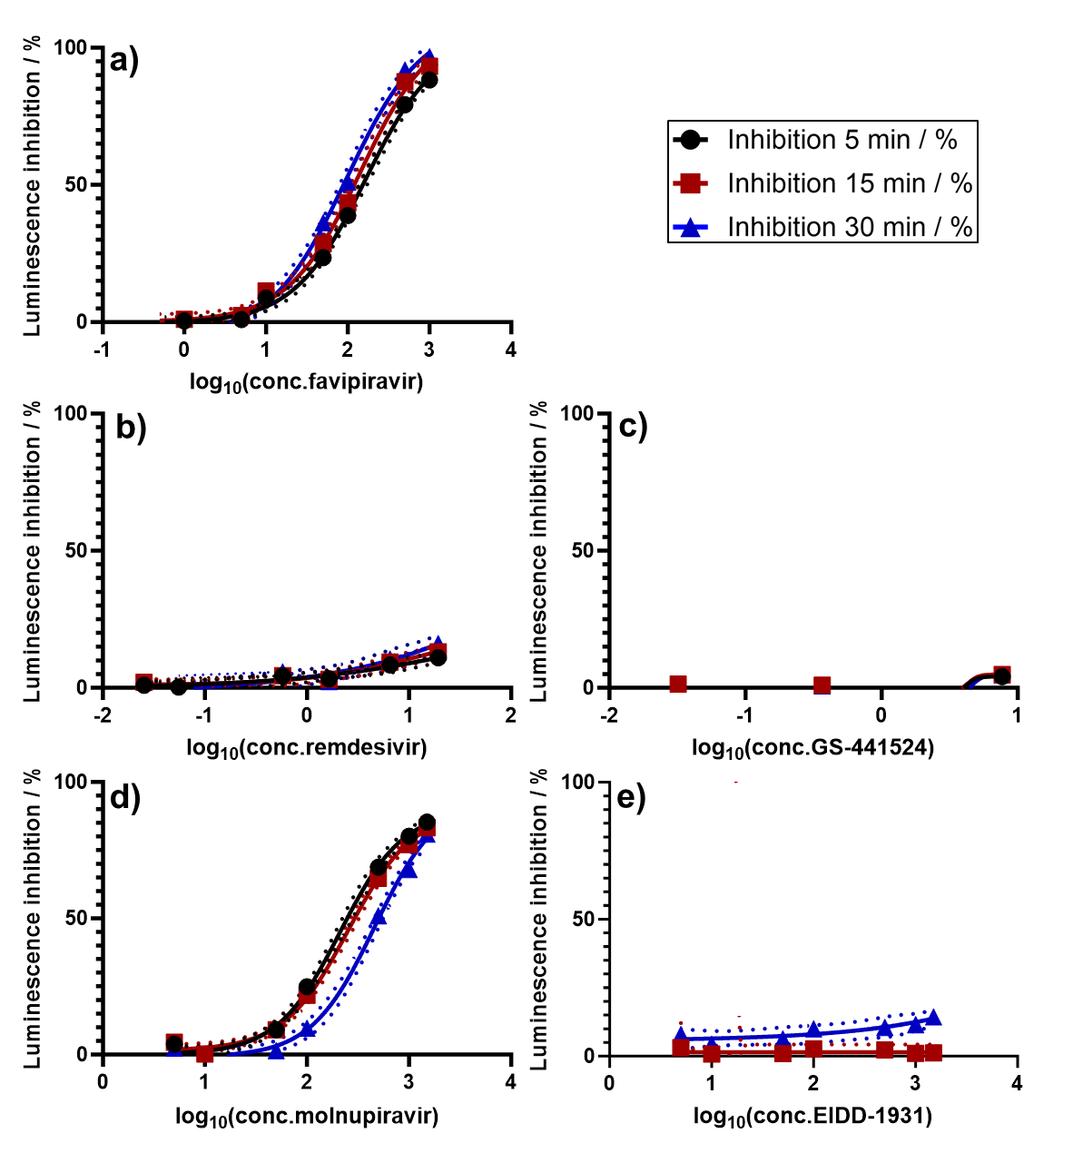
Figure A.2: Logarithmic plot of the actual concentration (c_{actual}) of each substance versus the mean bioluminescence inhibition (%) of favipiravir (FAV a), remdesivir (REM b), GS-441524 (GS c), molnupiravir (MOL d) and EIDD-1931 (EIDD e) in A. fischeri (n= 4). The non-linear model was used to calculate EC₁₀ with 95% confidence intervals (CIs) indicated as dashed lines. CIs are not illustrated if they corresponded to too wide a range. Figure keys for all partial illustrations are shown at the top right.
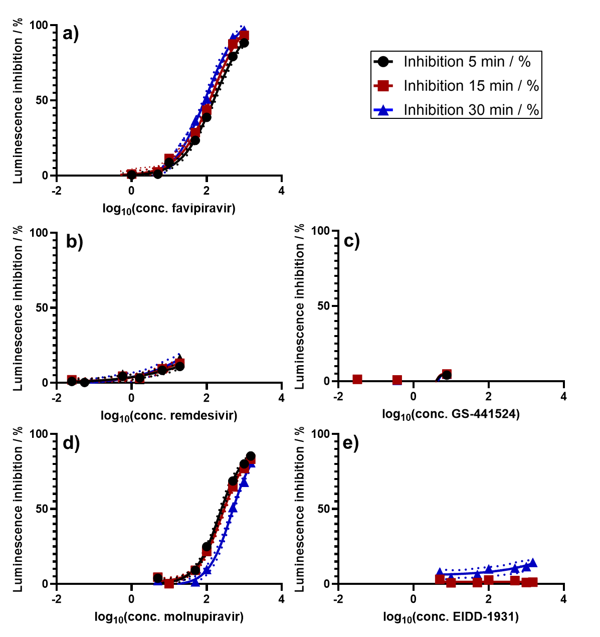
Figure A.3: Logarithmic plot of the actual concentration (c_{actual}) of each substance versus the mean bioluminescence inhibition (%) of favipiravir (FAV a), remdesivir (REM b), GS-441524 (GS c), molnupiravir (MOL d) and EIDD-1931 (EIDD e) in A. fischeri (n= 4). The non-linear model was used to calculate EC₂₀ with 95% confidence intervals (CIs) indicated as dashed lines. CIs are not illustrated if they corresponded to too wide a range. Figure keys for all partial illustrations are shown at the top right.

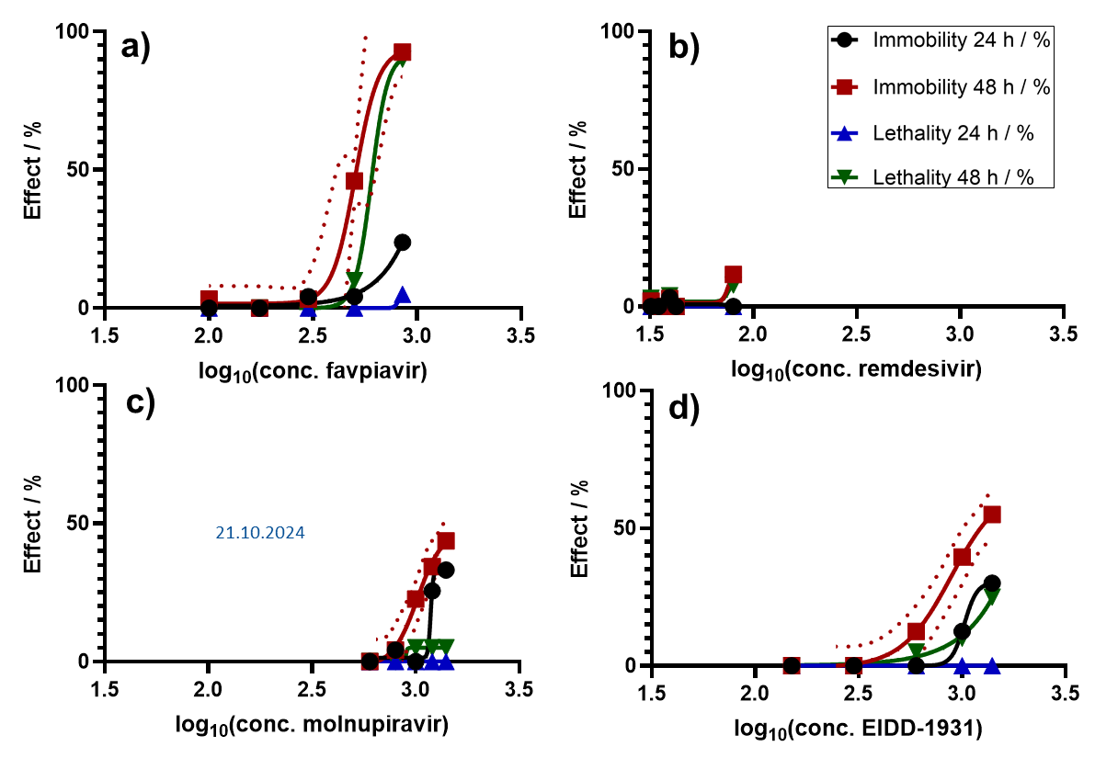
Figure A. 4: Logarithmic plot of the actual concentration (c_{actual}) of each substance versus the respective effect (%) of favipiravir (FAV a), remdesivir (REM b), molnupiravir (MOL c) and EIDD-1931 (EIDD d) in D. magna (n= 20). The non-linear model was used to calculate EC₂₀/LC₂₀ with 95 % confidence intervals (CIs) indicated as dashed lines. CIs are not illustrated if they corresponded to too wide a range. Figure keys for all partial illustrations are shown at the top right.

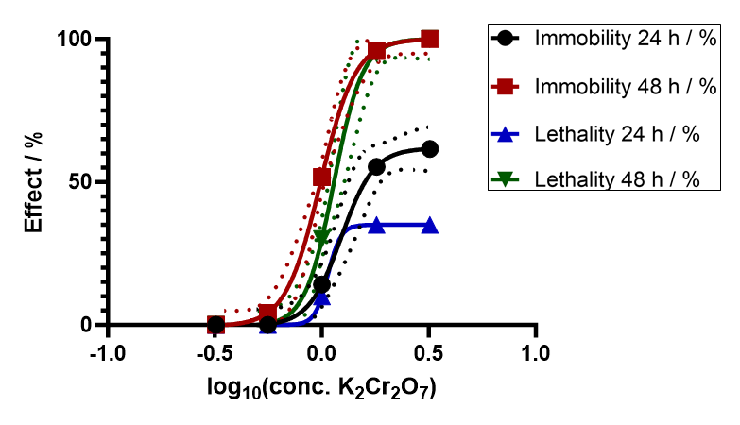
Figure A.5: Logarithmic plot of the actual concentration (c_{actual}) versus the mean effect (%) of K₂Cr₂O₇ on D. magna (n= 20). The different colors denote immobilization (EC₁₀) after 24h (black circles) and 48h (red squares) as well as lethality (LC₁₀) after 24h (blue triangle up) and 48h (green triangle down), with confidence intervals (CIs, 95%, dashed lines in corresponding color). CIs are not illustrated if they corresponded to too wide a range.

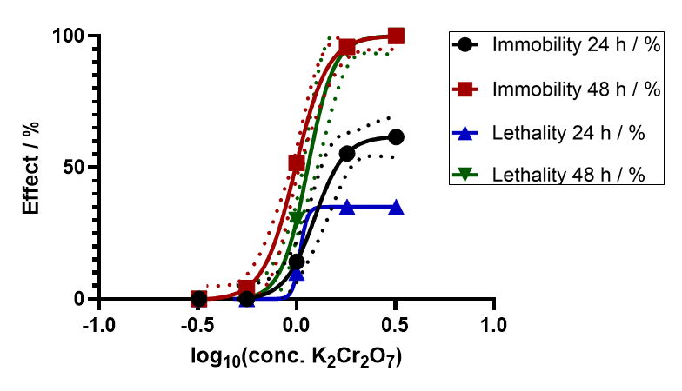
Figure A.6: Logarithmic plot of the actual concentration (c_{actual}) versus the mean effect (%) of K₂Cr₂O₇ on D. magna (n= 20). The different colors denote immobilization (EC₂₀) after 24h (black circles) and 48h (red squares) as well as lethality (LC₂₀) after 24h (blue triangle up) and 48h (green triangle down), with confidence intervals (CIs, 95%, dashed lines in corresponding color). CIs are not illustrated if they corresponded to too wide a range.

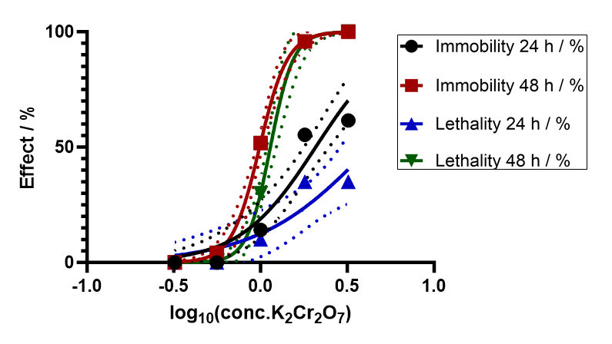
Figure A.7: Logarithmic plot of the actual concentration (c_{actual}) versus the mean effect (%) of K₂Cr₂O₇ on D. magna (n= 20). The different colors denote immobilization (EC₅₀) after 24h (black circles) and 48h (red squares) as well as lethality (LC₅₀) after 24h (blue triangle up) and 48h (green triangle down), with confidence intervals (CIs, 95%, dashed lines in corresponding color). CIs are not illustrated if they corresponded to too wide a range.
Table A.18: Observations of alive, immobile and dead individuals in each replicate of the control for each tested substance after 48 hours of exposure to Daphnia magna
Test substance | Replicate No. | observation in control after 48 h
Test substance | Replicate No. | alive | immobile | dead
K₂Cr₂O₇ | 1 | 5 | - | -
 | 2 | 5 | - | -
 | 3 | 5 | - | -
 | 4 | 5 | - | -
FAV | 1 | 5 | - | -
 | 2 | 5 | - | -
 | 3 | 5 | - | -
 | 4 | 5 | 1 | -
REM | 1 | 5 | - | -
 | 2 | 4 | 1 | 1
 | 3 | 5 | - | -
 | 4 | 5 | 1 | -
K₂Cr₂O₇ | 1 | 5 | - | -
 | 2 | 5 | - | -
 | 3 | 5 | - | -
 | 4 | 5 | - | -

Table A.18 continued
Test substance | Replicate No. | observation in control after 48 h
Test substance | Replicate No. | alive | immobile | dead
MOL | 1 | 5 | - | -
 | 2 | 5 | - | -
 | 3 | 5 | - | -
 | 4 | 5 | - | -
EIDD | 1 | 5 | - | -
 | 2 | 5 | - | -
 | 3 | 5 | - | -
 | 4 | 5 | - | -

Table A.19: Effective (EC) and lethal concentration (LC) values regarding 10, 20 and 50% effect (mg∙L⁻¹) and their confidence intervals (CI, 95%) for K₂Cr₂O₇ from the acute immobilization test using Daphnia magna
effect | immobility |  | lethality 24 h / %
 | 24 h | 48 h | 24 h | 48 h
EC₁₀ & LC₁₀ / mg∙L⁻¹ (95% CI) | 0.84  (0.64 - 1.03) | 0.65  (0.54 - n.a.) | 9.14  (n.a) | 0.81  (0.70 - n.a.)
EC₂₀ & LC₂₀ / mg∙L⁻¹ (95% CI) | 0.97  (0.80 - 1.16) | 0,76  (0.66 - n.a.) | 0.98  (n.a.) | 0.92  (0.84 - 0.98)
EC₅₀ & LC₅₀ / mg∙L⁻¹ (95% CI) | 2.08  (1.77 - 2.50) | 0.99  (0.95 - 1.03) | 4.29  (2.85 - 14.11) | 1.14  (n.a. - 1.21)

