Fig S1. Forest plot illustrating the causal effects between immune cell traits and CRC as determined by IVW analyses.
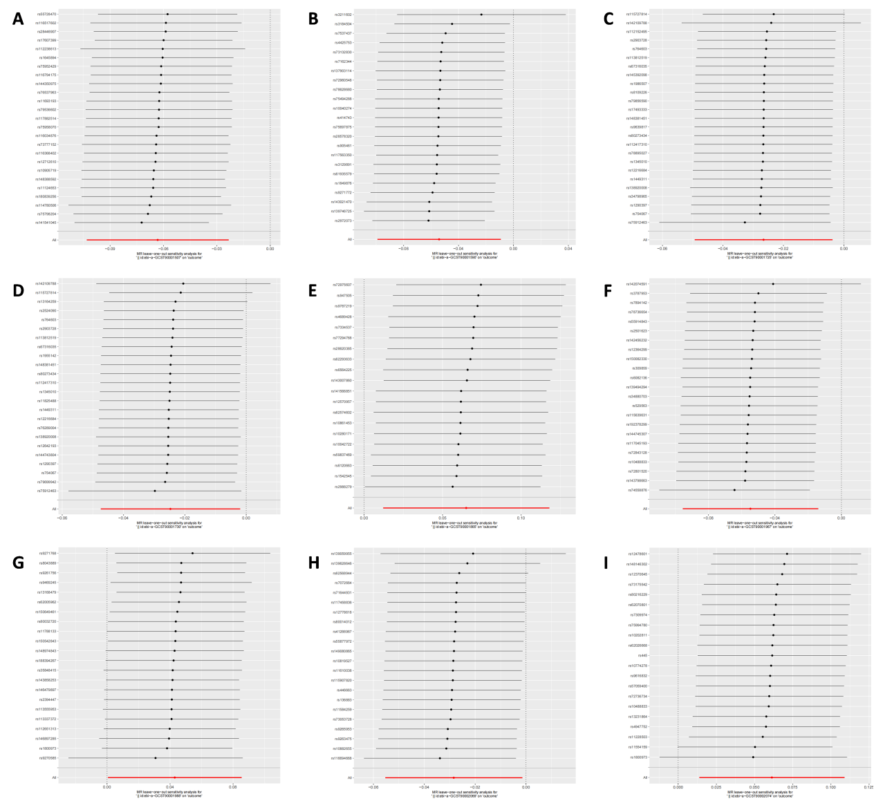
Figure S2. Forest plots showing causal effect of significant immune cells on CRC.
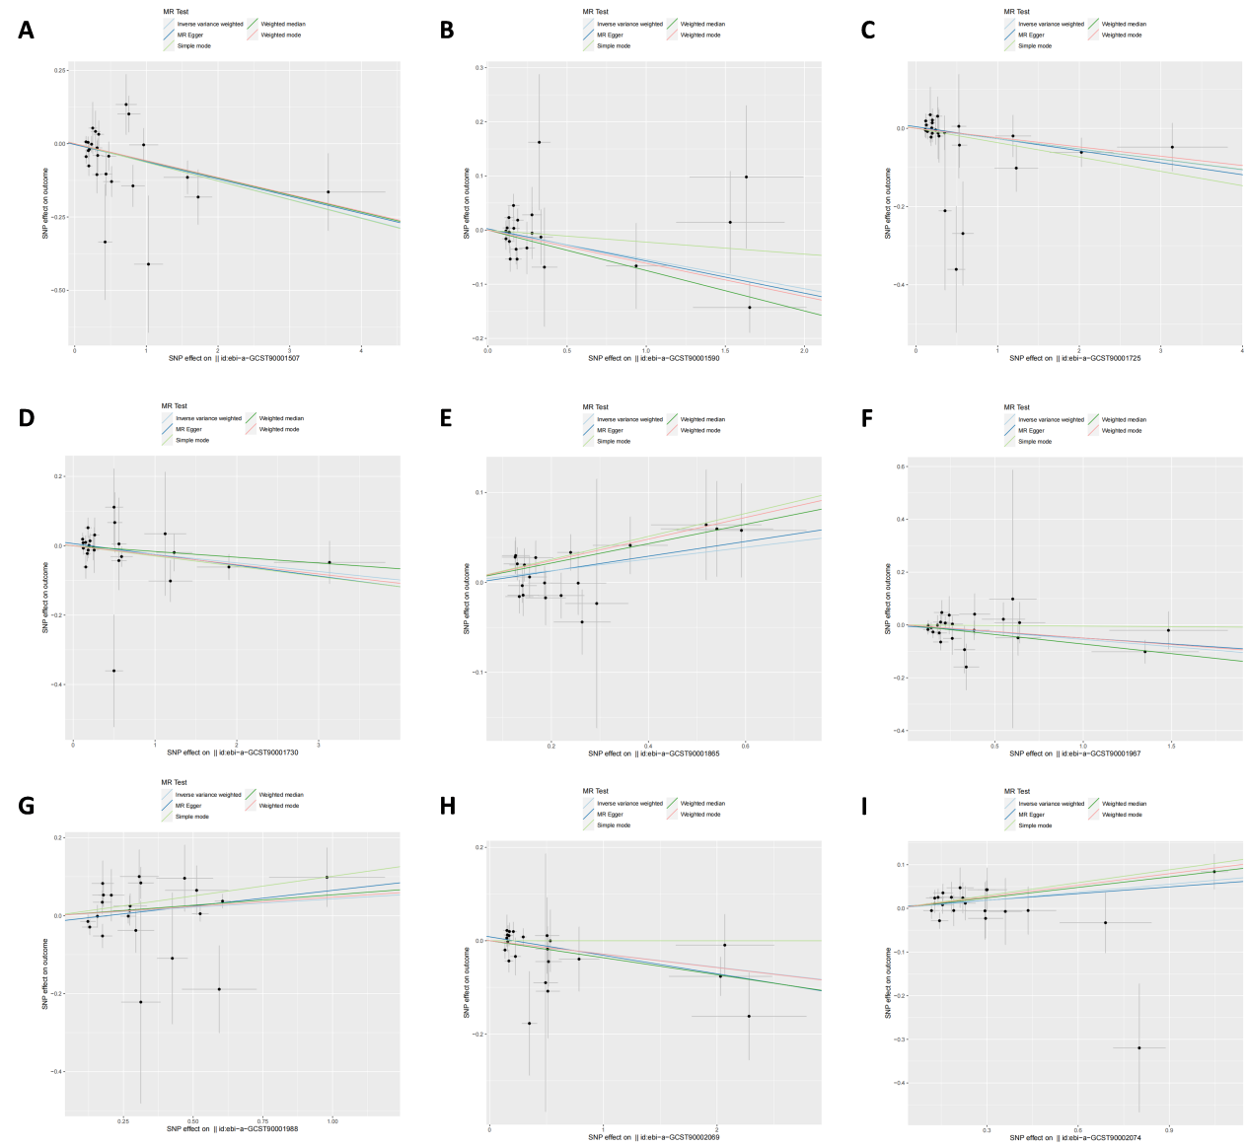
Figure S3. Scatter plot showing the association between significant immune cells on CRC using five Mendelian randomization models. The plot includes the regression line for MR-egger, weighted median, IVW, simple mode, and weighted mode.

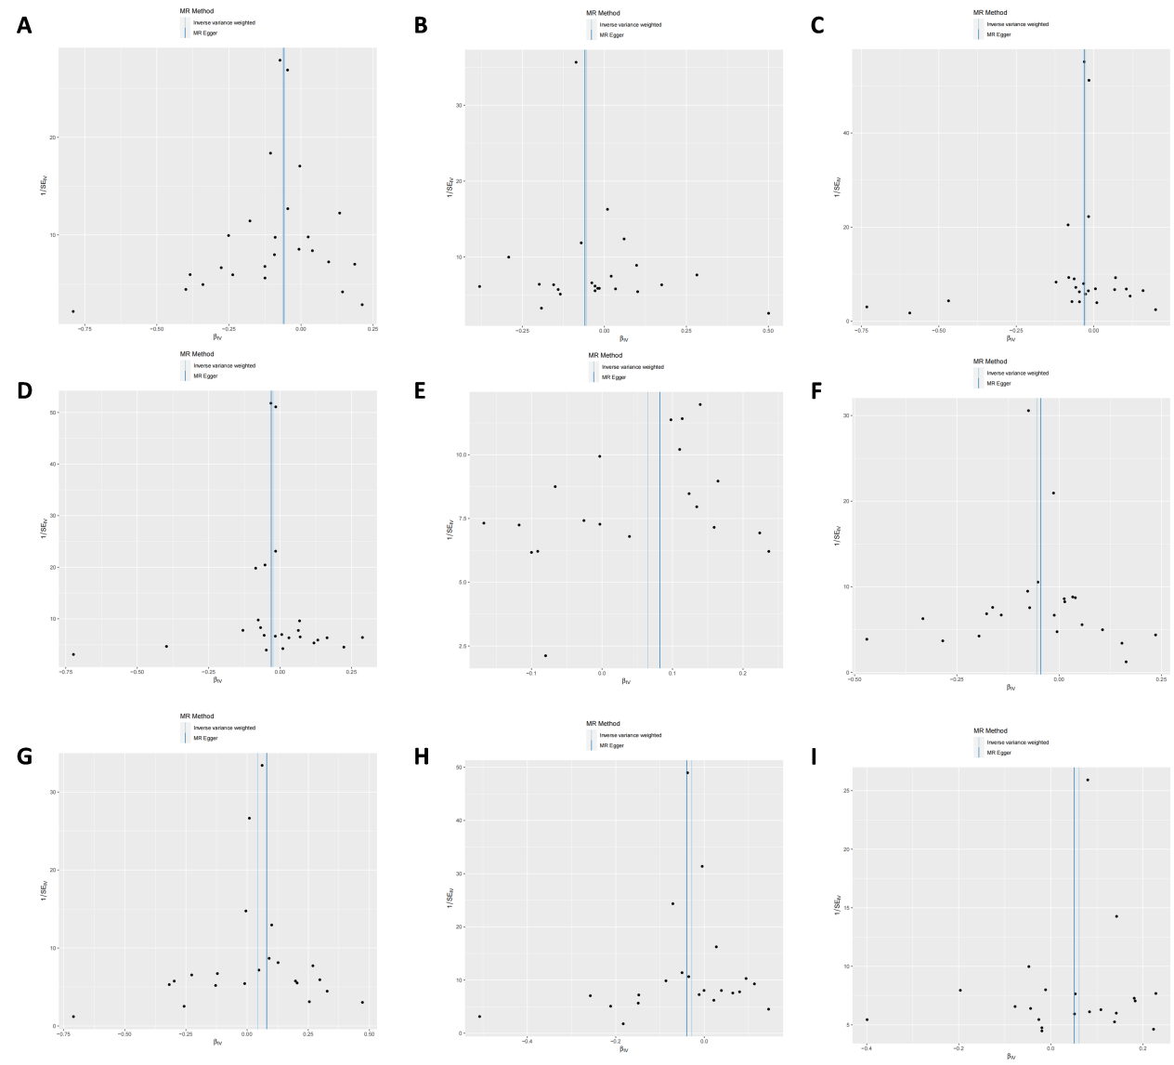
Figure S4. Funnel plot detecting heterogeneity of significant Mendelian randomization results using the MR-Egger regression and IVW methods (the causal effects of immune cells on CRC).

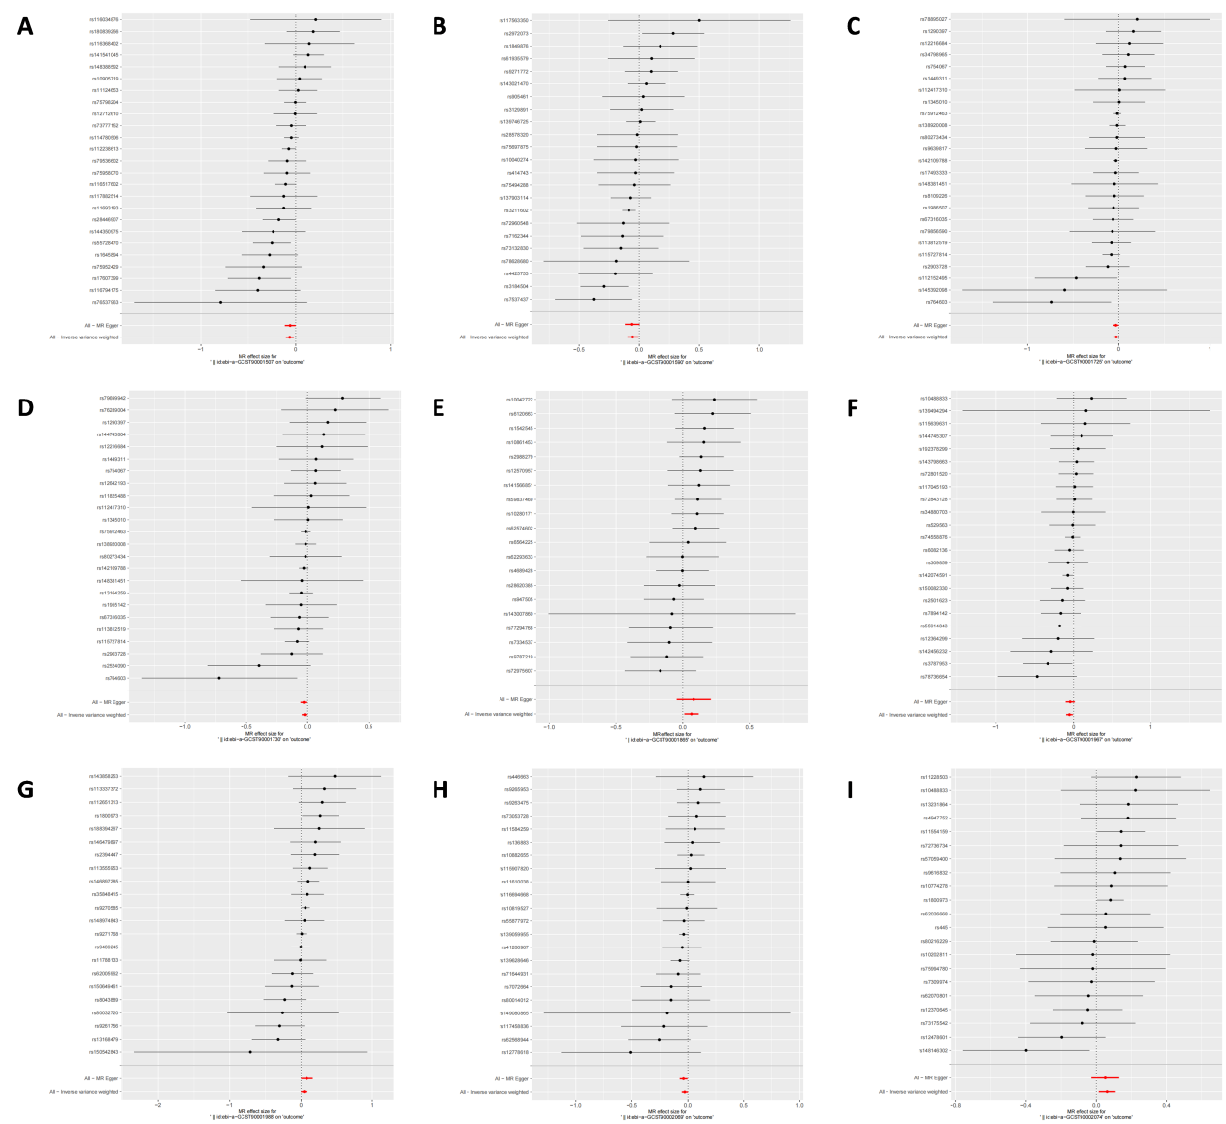
Figure S5. Presentation of the leave-one-out sensitivity analysis for the effect of immune cells increasing SNPs on CRC risk in the context of MR. The dot and bar indicate the estimate and 95% CI when a specific SNP is removed.

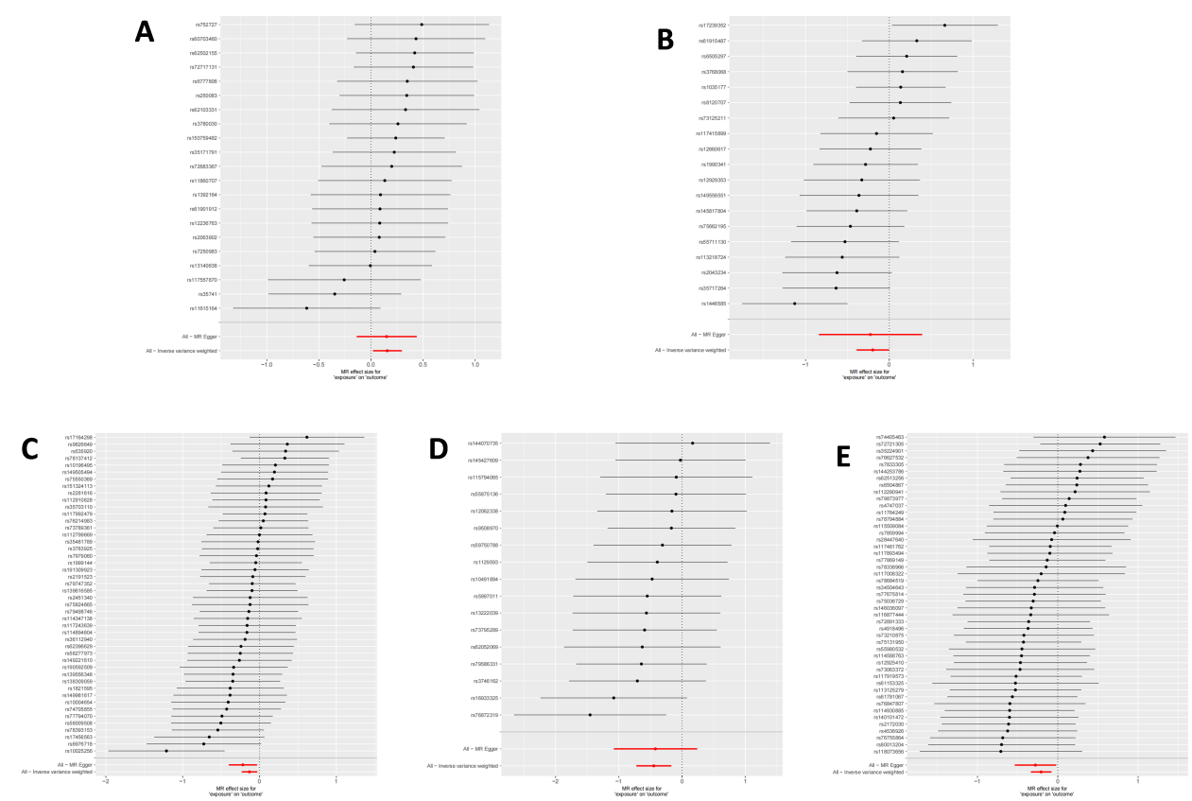
Figure S6. Forest plots showing causal effect of significant GM traits on CRC.

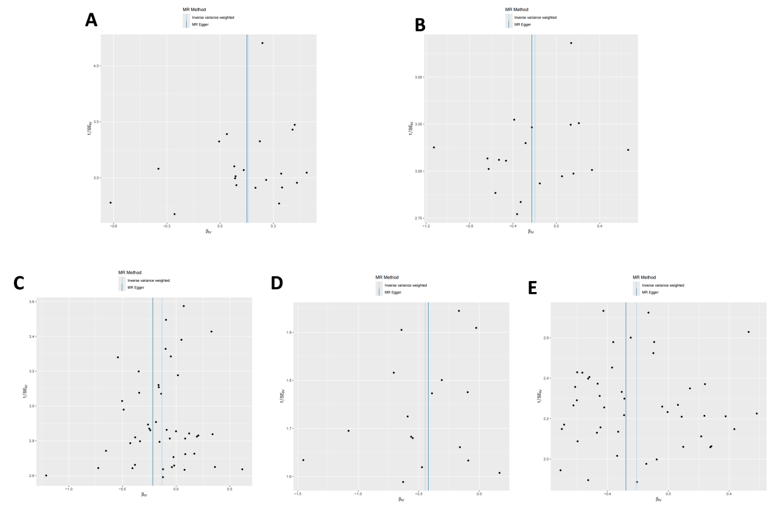
Figure S7. Scatter plot showing the association between significant GM traits on CRC using five Mendelian randomization models. The plot includes the regression line for MR-egger, weighted median, IVW, simple mode, and weighted mode.

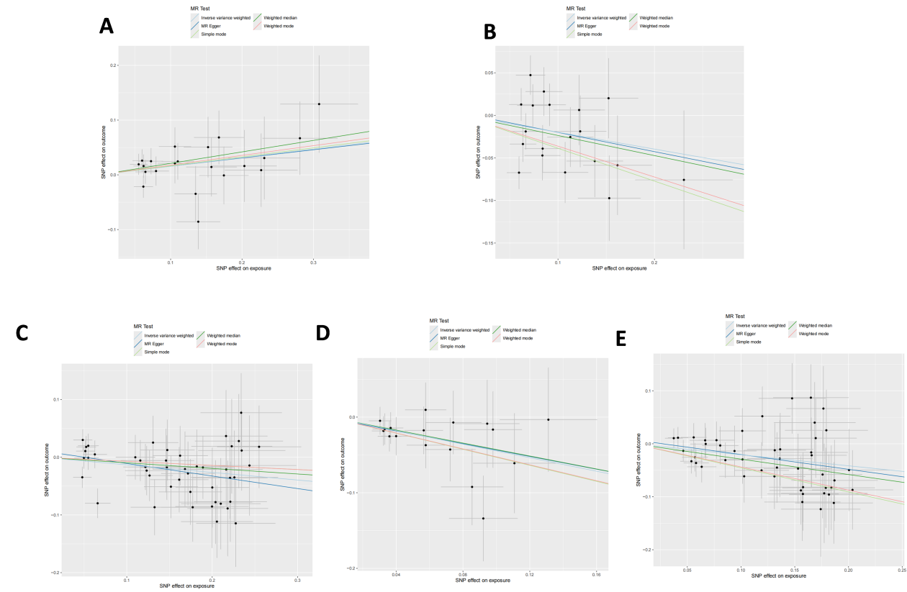
Figure S8. Funnel plot detecting heterogeneity of significant Mendelian randomization results using the MR-Egger regression and IVW methods (the causal effects of significant GM traits on CRC).

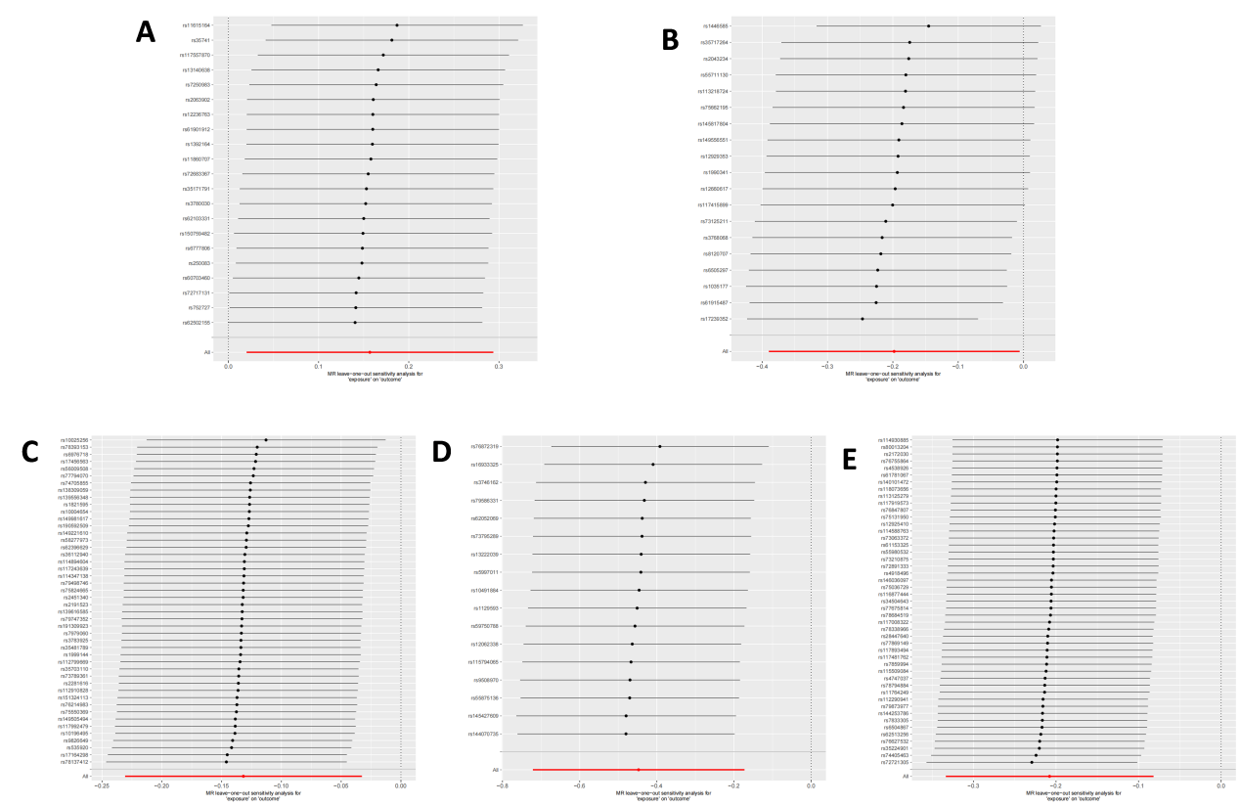
Figure S9. Presentation of the leave-one-out sensitivity analysis for the effect of significant GM traits increasing SNPs on CRC risk in the context of MR. The dot and bar indicate the estimate and 95% CI when a specific SNP is removed.

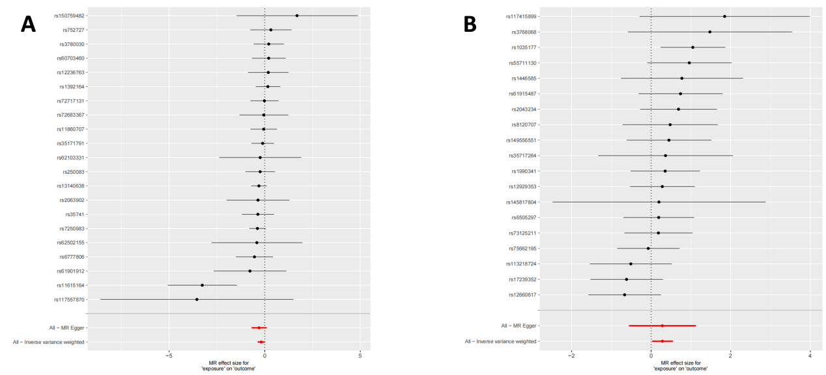
Figure S10. Forest plots showing causal effect of significant GM traits on immune cells.

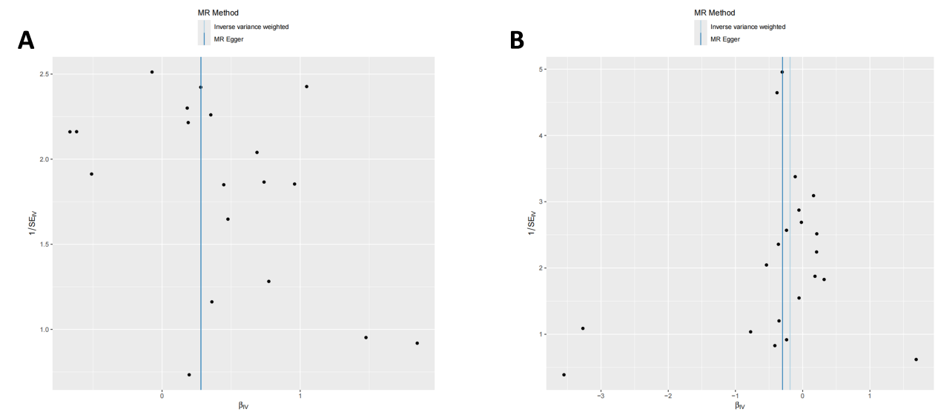
Figure S11. Scatter plot showing the association between significant GM traits on immune cells using five Mendelian randomization models. The plot includes the regression line for MR-egger, weighted median, IVW, simple mode, and weighted mode.

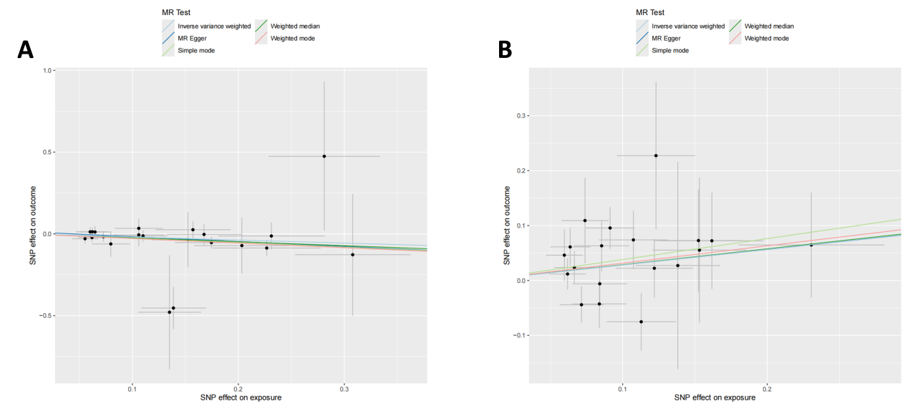
Figure S12. Funnel plot detecting heterogeneity of significant Mendelian randomization results using the MR-Egger regression and IVW methods (the causal effects of significant GM traits on immune cells).

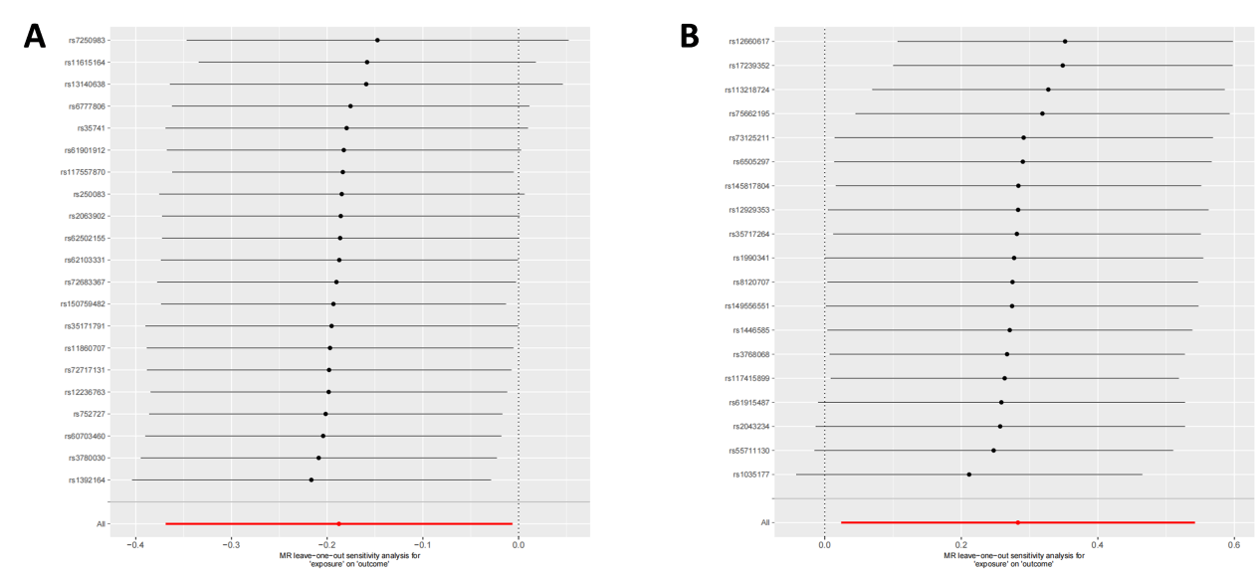
Figure S13. Presentation of the leave-one-out sensitivity analysis for the effect of significant GM traits increasing SNPs on immune cells in the context of MR. The dot and bar indicate the estimate and 95% CI when a specific SNP is removed.

