A meta-study of the microbiome and related dysfunction of the brain reveals distinct microbial signatures in the microbiota-gut-brain axis
Yaru Liu ¹, Shitao Li¹, Tiantian Liu², Penghui Deng³, Jiyang Dong ^{1*}, Xiangnan Xu ^{4*}

- Department of Electronic Science, National Institute for Data Science in Health and Medicine, Xiamen University, Xiamen 361005, China
- Research Center of Biostatistics and Computational Pharmacy, China Pharmaceutical University, 639 Longmian Dadao, 211198, Jiangsu, China
- Institute of Cell Biology and Neurobiology, Charité-Universitätsmedizin Berlin, Charitéplatz 1, 10117, Berlin, Germany.
- School of Business and Economics, Humboldt-Universitat zu Berlin, Berlin 10099, Germany
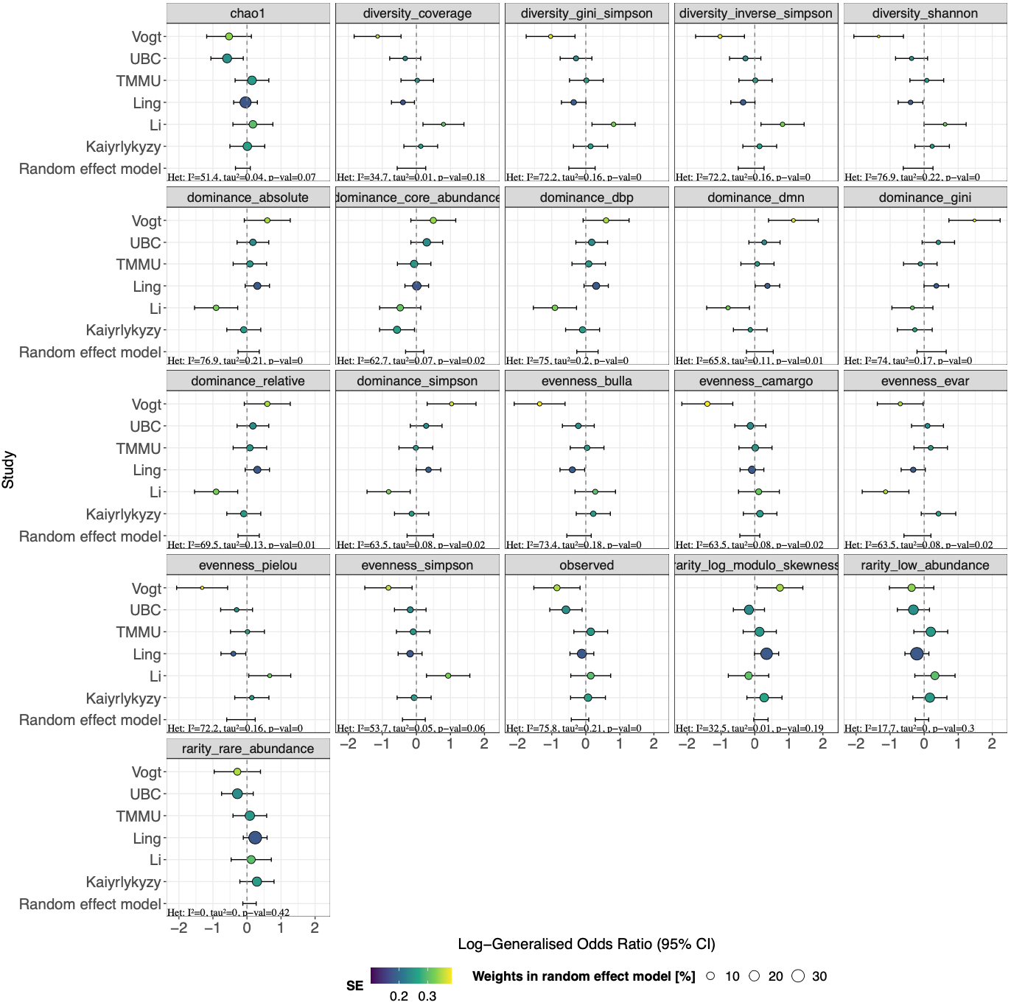
Supplementary Figure 1. Meta-analysis of alpha diversity indices in Alzheimer's disease studies. This forest plot illustrates the comparison of 21 alpha diversity measures between AD patients and healthy controls across six independent studies. For each study, effect sizes were calculated using log-generalized odds ratios, which were subsequently combined using a random-effects meta-analysis model. The vertical line at zero represents no difference between AD and control groups. Points to the left of this line indicate higher values in controls, while points to the right suggest higher values in AD patients. The size of each point corresponds to the weight assigned to that study in the meta-analysis, with larger points having greater influence on the pooled estimate.

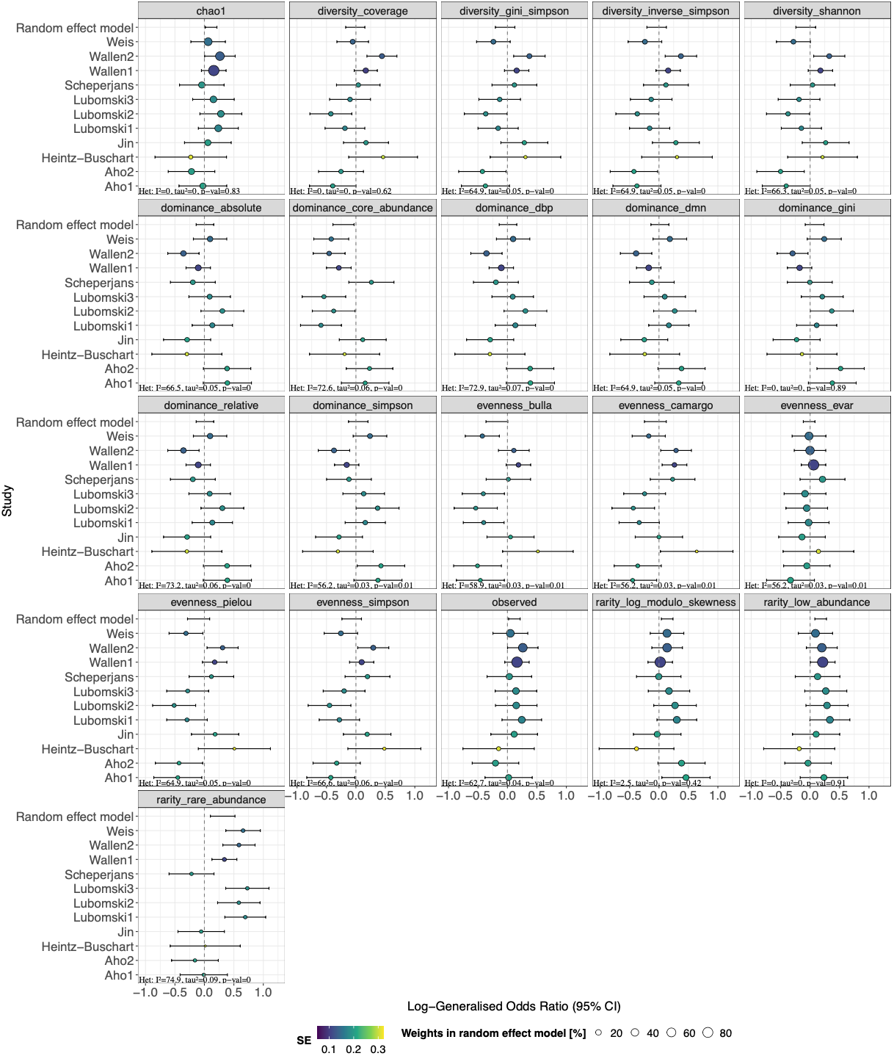
Supplementary Figure 2. Meta-analysis of alpha diversity indices in Parkinson's disease studies.
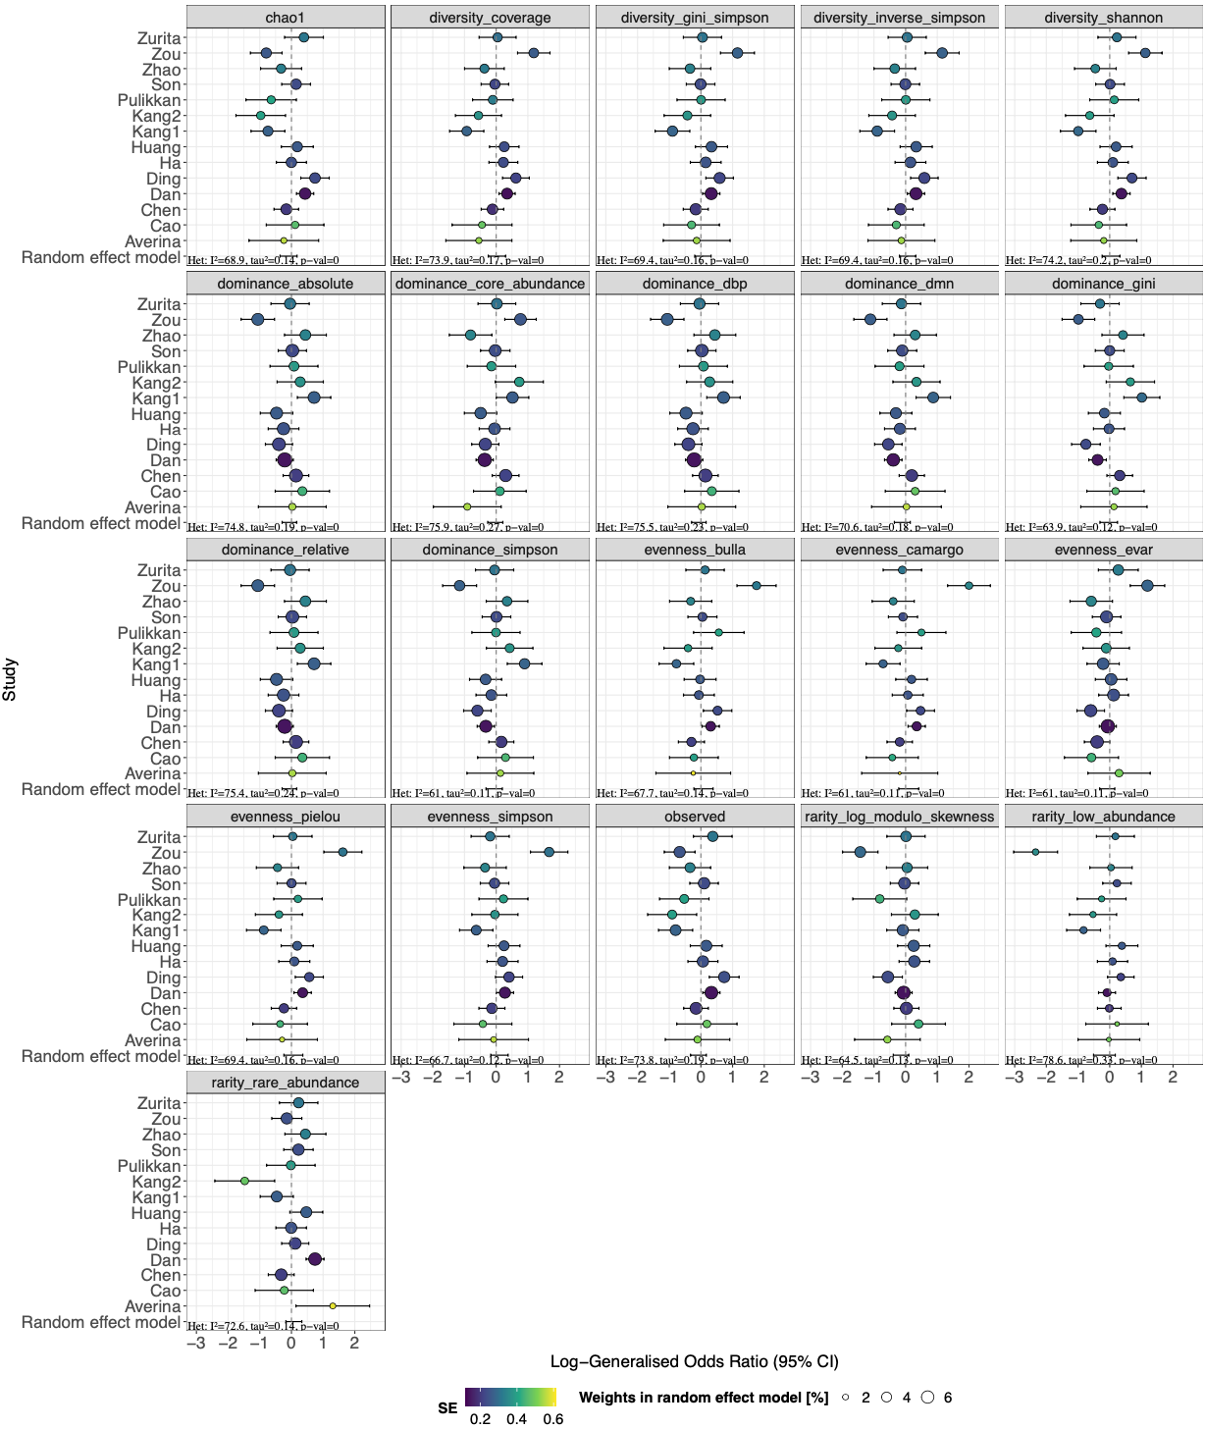
Supplementary Figure 3. Meta-analysis of alpha diversity indices in Autism Spectrum Disorder studies.
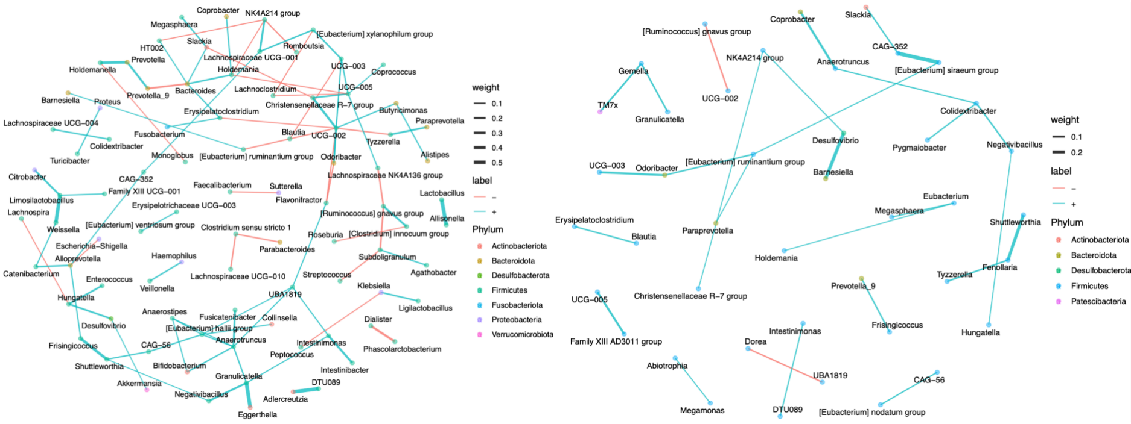
Supplementary Figure 4. Microbial co-abundance network in Alzheimer's disease based on the Li dataset. The figure shows the control group's network on the left and the AD group's network on the right. In both networks, each node represents a bacterial genus, with node colors indicating different phyla. The size of each node corresponds to its degree of connectivity within the network. Edges connecting the nodes represent significant co-abundance relationships between genera. Blue edges indicate positive correlations (genera that tend to increase or decrease in abundance together), while red edges represent negative correlations (genera with inverse abundance patterns). The thickness of each edge reflects the strength of the co-abundance relationship.
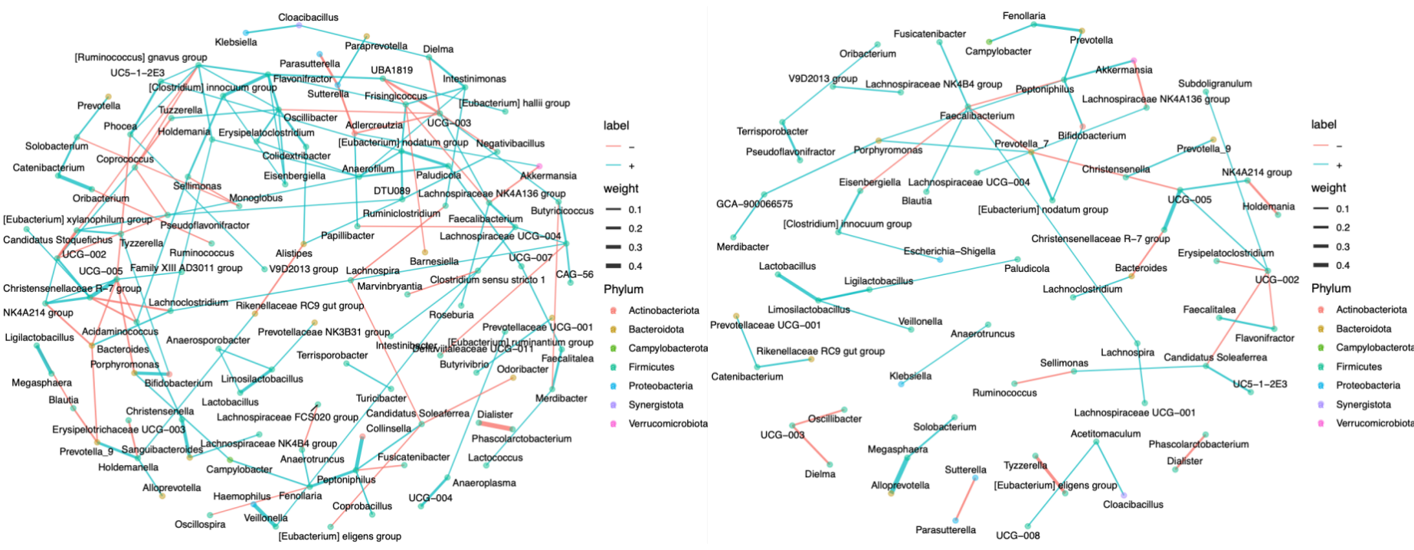
Supplementary Figure 5. Microbial co-abundance network in Parkinson's disease based on the Scheperjans dataset.
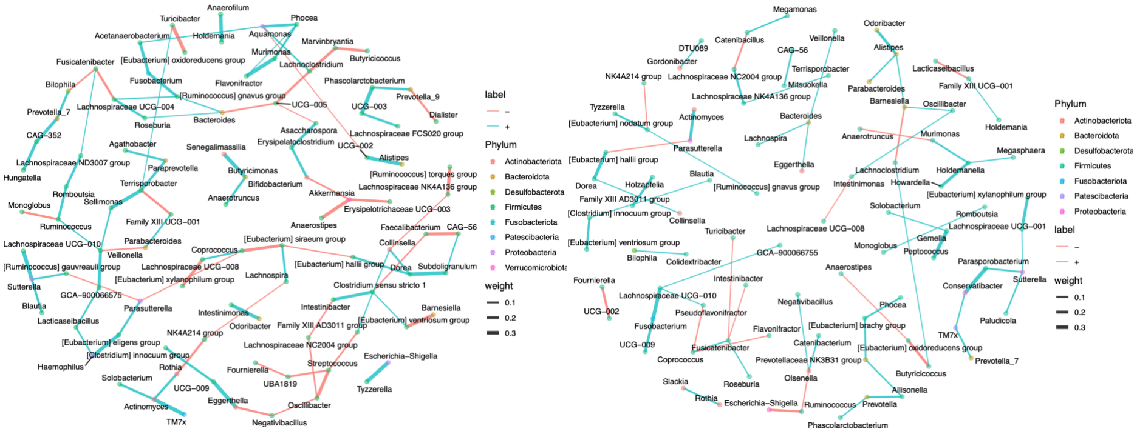
Supplementary Figure 6. Microbial co-abundance network in Autism Spectrum Disorder based on the Averina dataset.

Supplementary Table 1. Overview of microbiome datasets for Alzheimer's disease (AD), Parkinson's disease (PD), and Autism Spectrum Disorder (ASD). The table provides details on each study, including authors, Digital Object Identifier (DOI), project number (PRJ), disease investigated, sequencing method (targeted or shotgun), country of origin, publication year, and number of sequencing runs.
Study | DOI | PRJ | Disease | Targeted | National | Year | Runs
Vogt | https://doi.org/10.1038/s41598-017-13601-y | PRJEB51982 | AD | V4 | USA | 2022 | 50
Li | https://doi.org/10.1016/j.jalz.2019.07.002 | PRJNA489760 | AD | V3-V4 | China | 2018 | 180
Third Military Medical University(TMMU) |  | PRJNA554111 | AD |  | China | 2019 | 86
Ling | https://doi.org/10.3389/fcell.2020.634069 | PRJNA633959 | AD | V3-V4 | China | 2020 | 171
Kaiyrlykyzy | https://doi.org/10.1038/s41598-022-19393-0 | PRJNA811324 | AD |  | Kazakhstan | 2019 | 84
University of British Columbia(UBC) |  | PRJNA770746 | AD |  | Canada | 2020 | 198
Aho | https://doi.org/10.1016/j.ebiom.2019.05.064 | PRJEB27564 | PD | V3-V4 | Finland | 2019 | 300
Scheperjans | https://doi.org/10.1002/mds.26069 | PRJEB4927 | PD | V1-V3 | Finland | 2014 | 148
Heintz‐Buschart | https://doi.org/10.1002/mds.27105 | PRJNA381395 | PD | V4 | Germany | 2017 | 378
Jin | https://doi.org/10.3389/fnins.2019.01184 | PRJEB588834 | PD | V3-V4 | China | 2019 | 133
Weis | https://doi.org/10.1038/s41531-019-0100-x | PRJEB30615 | PD | V4-V5 | Germany | 2019 | 260
Lubomski | https://doi.org/10.3389/fnagi.2022.881872 | PRJNA808166 | PD | V3-V4 | Australia | 2020 | 148
Wallen1 | https://doi.org/10.1038/s41531-020-0112-6 | PRJNA601994 | PD | V4 | USA | 2020 | 507
Wallen2 | https://doi.org/10.1038/s41531-020-0112-6 | PRJNA601994 | PD | V4 | USA | 2020 | 333
Cao | https://doi.org/10.3389/fnins.2021.635925 | PRJNA642975 | ASD | V4 | China | 2020 | 86
Pulikkan | https://doi.org/10.1007/s00248-018-1176-2 | PRJNA355023 | ASD | V3 | India | 2016 | 54
Kang | https://doi.org/10.1016/j.anaerobe.2017.12.007 | PRJNA533120 | ASD | V2-V3 | USA | 2019 | 82
Kang | https://doi.org/10.1371/journal.pone.0068322 | PRJNA168470 | ASD | V2-V3 | USA | 2012 | 40
Dan | https://doi.org/10.1080/19490976.2020.1747329 | PRJNA453621 | ASD | V4 | China | 2018 | 286
Zou | https://doi.org/10.1002/aur.2358 | PRJNA578223 | ASD | V3-V4 | China | 2019 | 96
Ha | https://doi.org/10.3390/nu13103300 | PRJEB45948 | ASD | V3-V4 | Korean | 2021 | 92
Chen | https://doi.org/10.3389/fpsyt.2021.789864 | PRJNA769228 | ASD | V3-V4 | China | 2021 | 261
Zurita | https://doi.org/10.1080/19490976.2019.1662260 | PRJEB27306 | ASD | V4 | Ecuador | 2019 | 58
Son | https://doi.org/10.1371/journal.pone.0137725 | PRJNA282013 | ASD | V1-V2 & V1V3 | USA | 2015 | 103
Huang | https://doi.org/10.3389/fpsyt.2021.682454 | PRJNA687773 | ASD | V4-V5 | China | 2020 | 119
Averina | https://doi.org/10.1099/jmm.0.001178 | PRJNA516054 | ASD |  | Russia | 2019 | 98
Zhao | https://doi.org/10.7499/j.issn.1008-8830.2019.07.009 | PRJNA624252 | ASD | V3-V4 | China | 2020 | 50
Ding | https://doi.org/10.1016/j.jpsychires.2020.06.032 | PRJNA589343 | ASD | V4 | China | 2019 | 127

