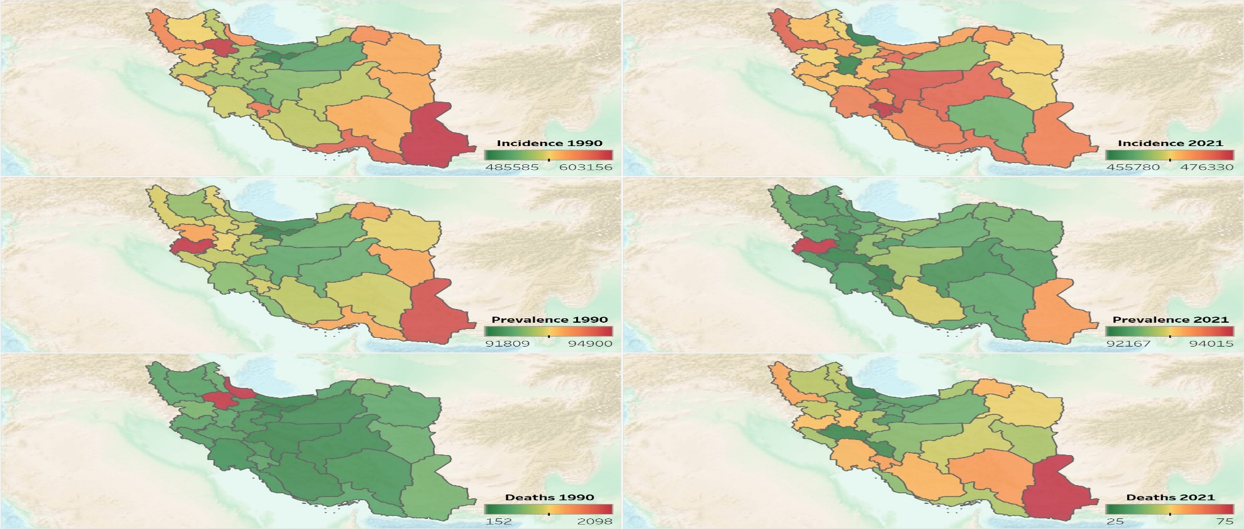
Figure S1. Geographical distribution of rate of incidence, prevalence, and mortality of child and adolescents causes of death among females in 1990 and 2021 in Iran. Imagery reproduced from the GEBCO_2022 Grid, GEBCO Compilation Group (2022) GEBCO 2022 Grid (doi:10.5285/e0f0bb80-ab44-2739-e053-6c86abc0289c)

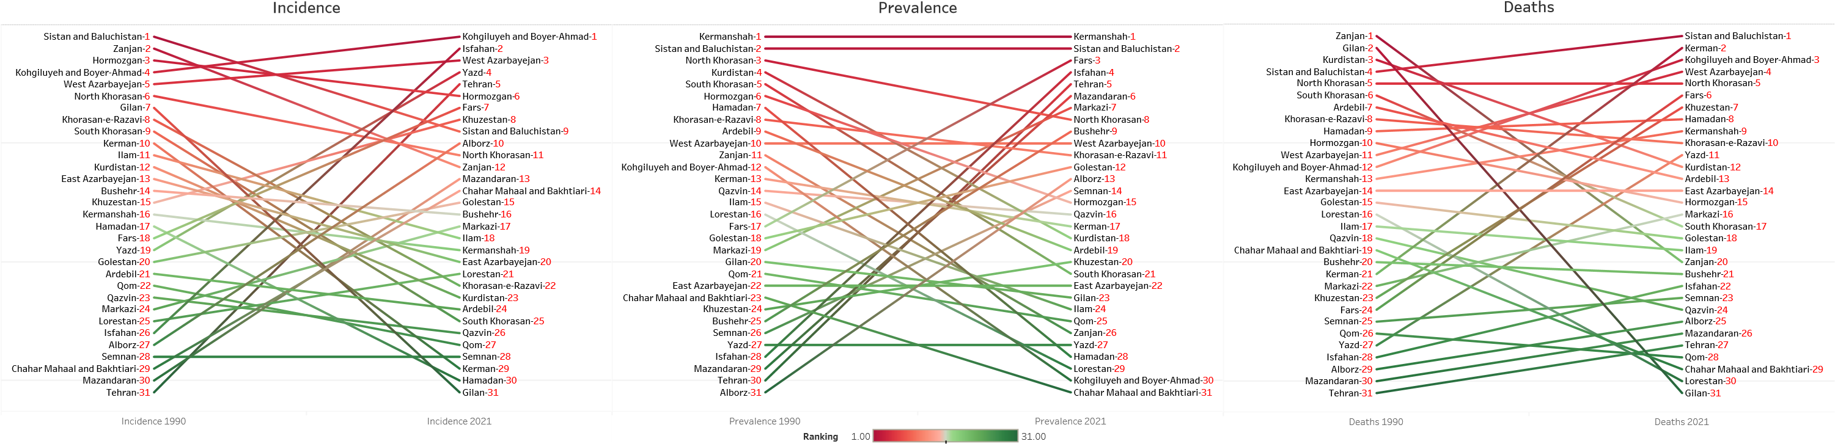
Figure S2. Ranking of rate of incidence, prevalence, and mortality of child and adolescents causes of death among females in 1990 and 2021 in Iran

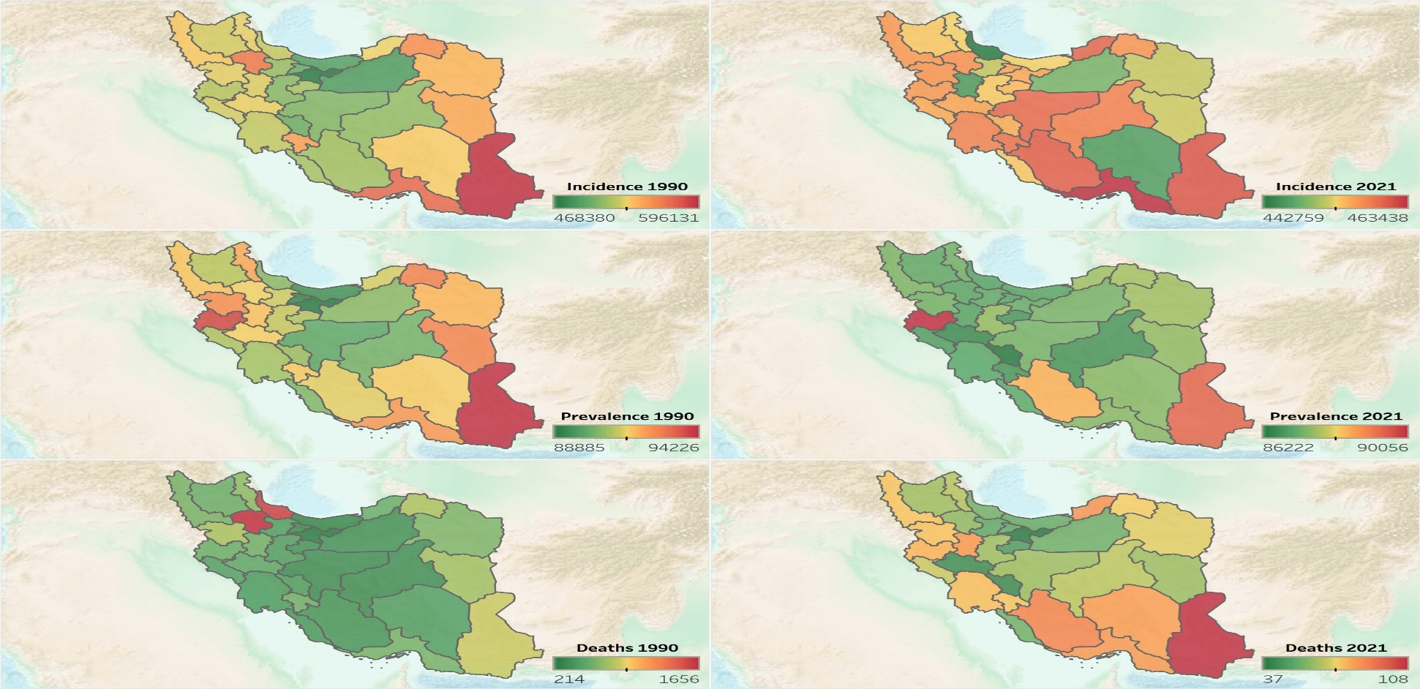
Figure S3. Geographical distribution of rate of incidence, prevalence, and mortality of child and adolescents causes of death among males in 1990 and 2021 in Iran. Imagery reproduced from the GEBCO_2022 Grid, GEBCO Compilation Group (2022) GEBCO 2022 Grid (doi:10.5285/e0f0bb80-ab44-2739-e053-6c86abc0289c)

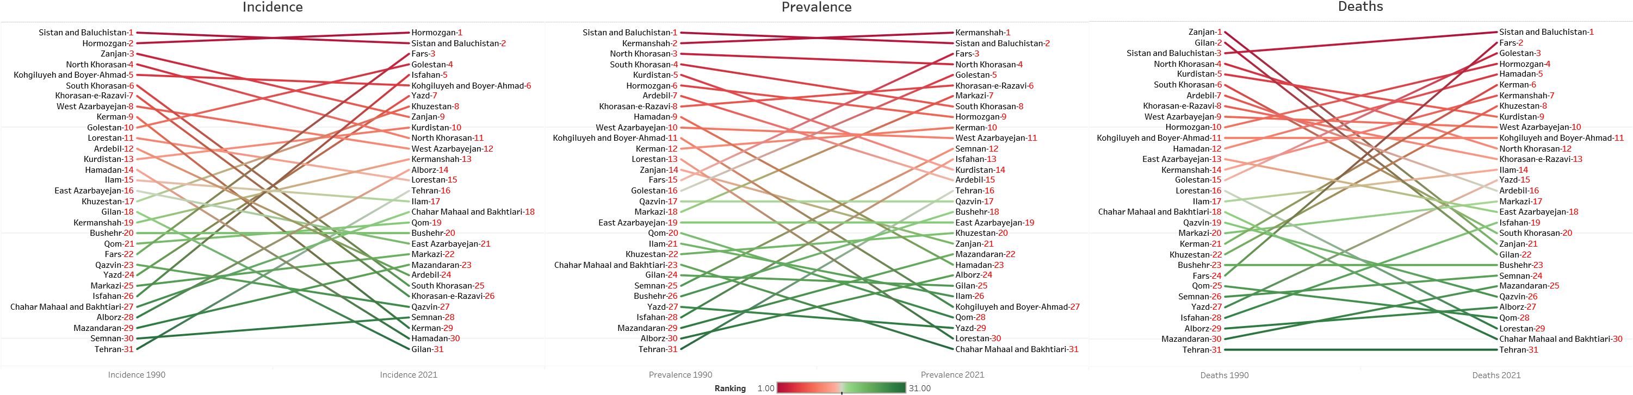
Figure S4. Ranking of rate of incidence, prevalence, and mortality of child and adolescents causes of death among males in 1990 and 2021 in Iran

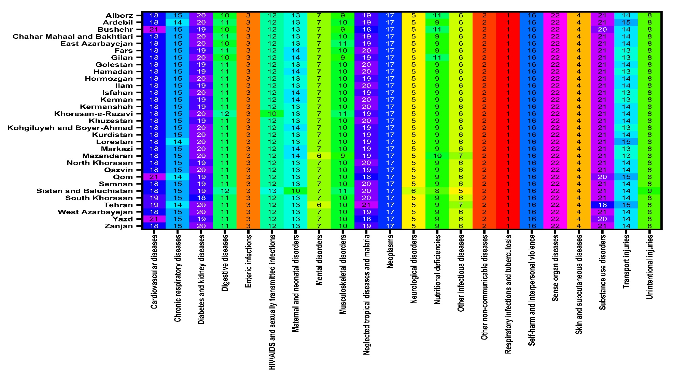
Figure S5. Ranking of rate of incidence of child and adolescents causes of death among females in 2021 in Iran

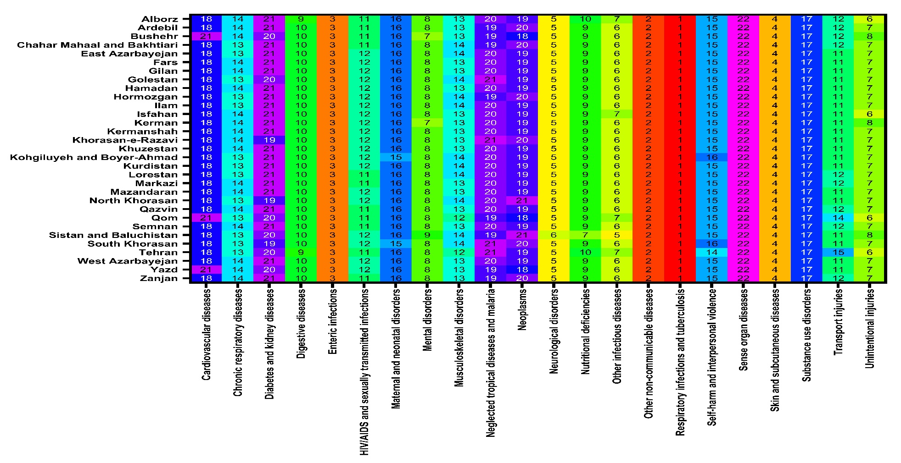
Figure S6. Ranking of rate of incidence of child and adolescents causes of death among males in 2021 in Iran

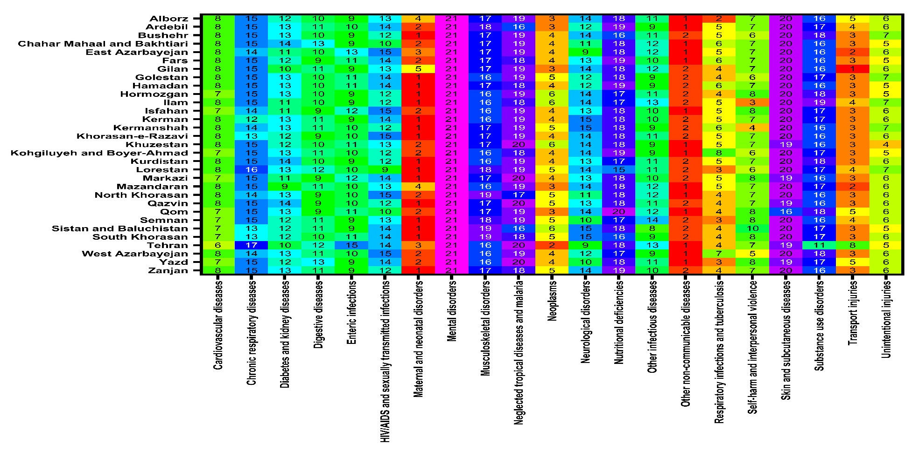
Figure S7. Ranking of rate of mortality of child and adolescents causes of death among females in 2021 in Iran

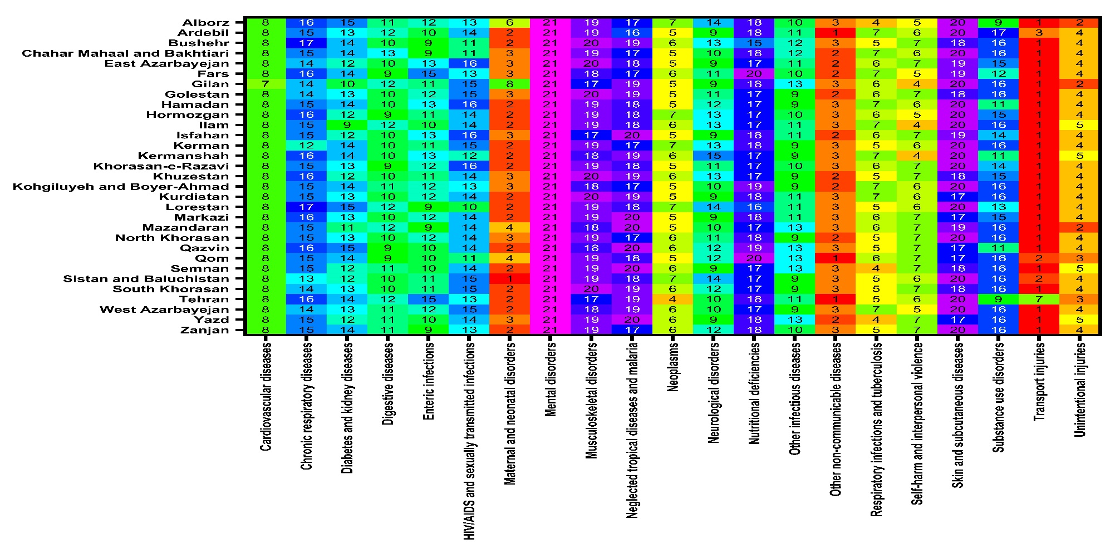
Figure S8. Ranking of rate of mortality of child and adolescents causes of death among males in 2021 in Iran

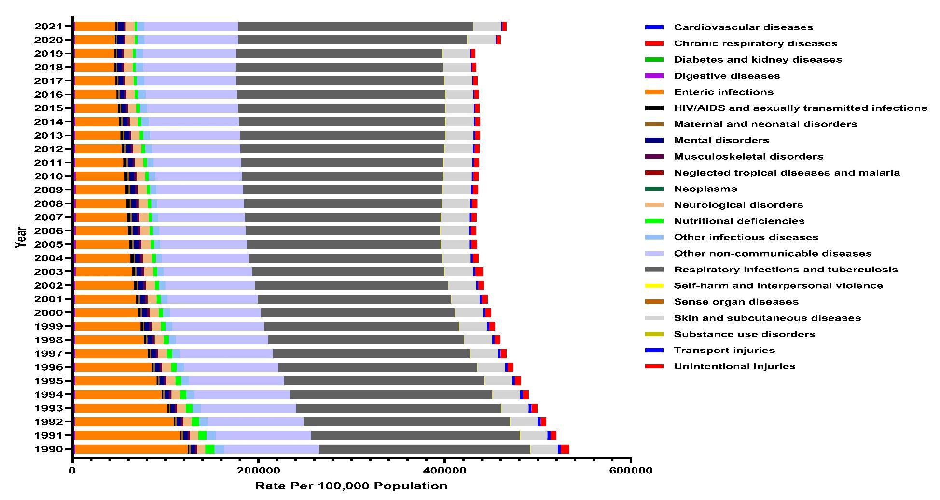
Figure S9. Time trend of rate of incidence of child and adolescents causes of death among females in 1990-2021 in Iran

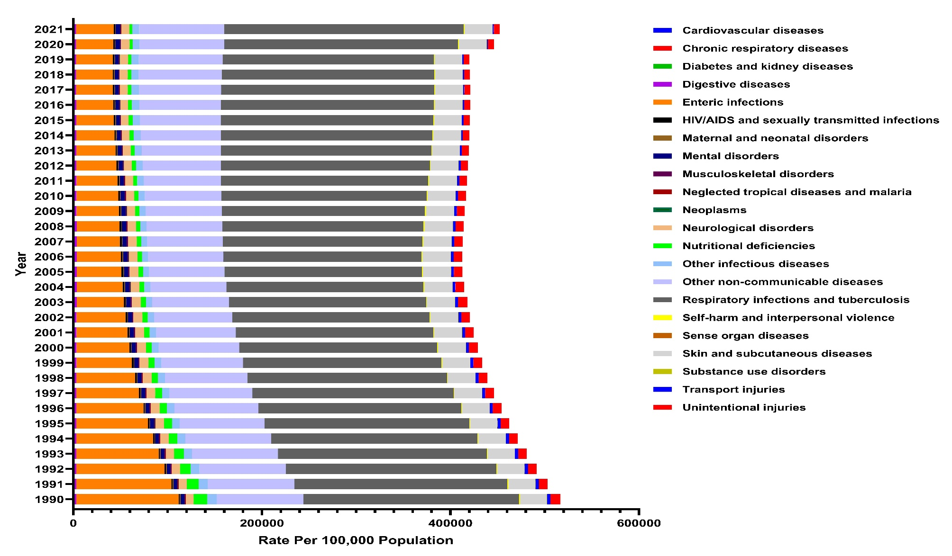
Figure S10. Time trend of rate of incidence of child and adolescents causes of death among males in 1990-2021 in Iran

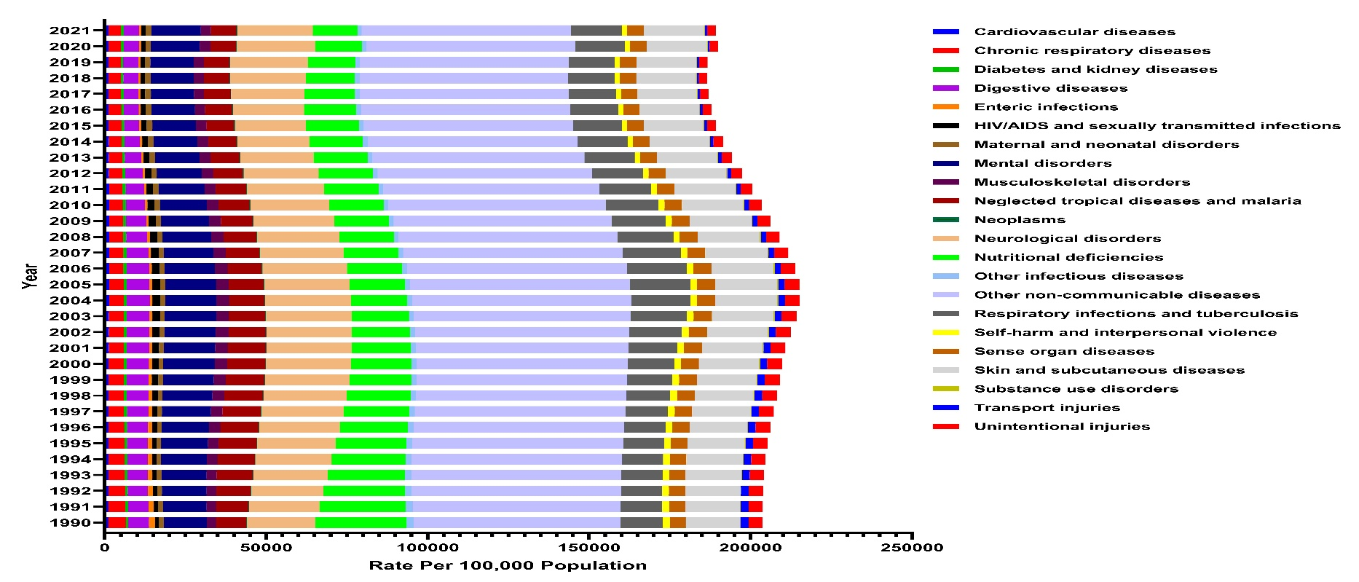
Figure S11. Time trend of rate of prevalence of child and adolescents causes of death among both sexes in 1990-2021 in Iran

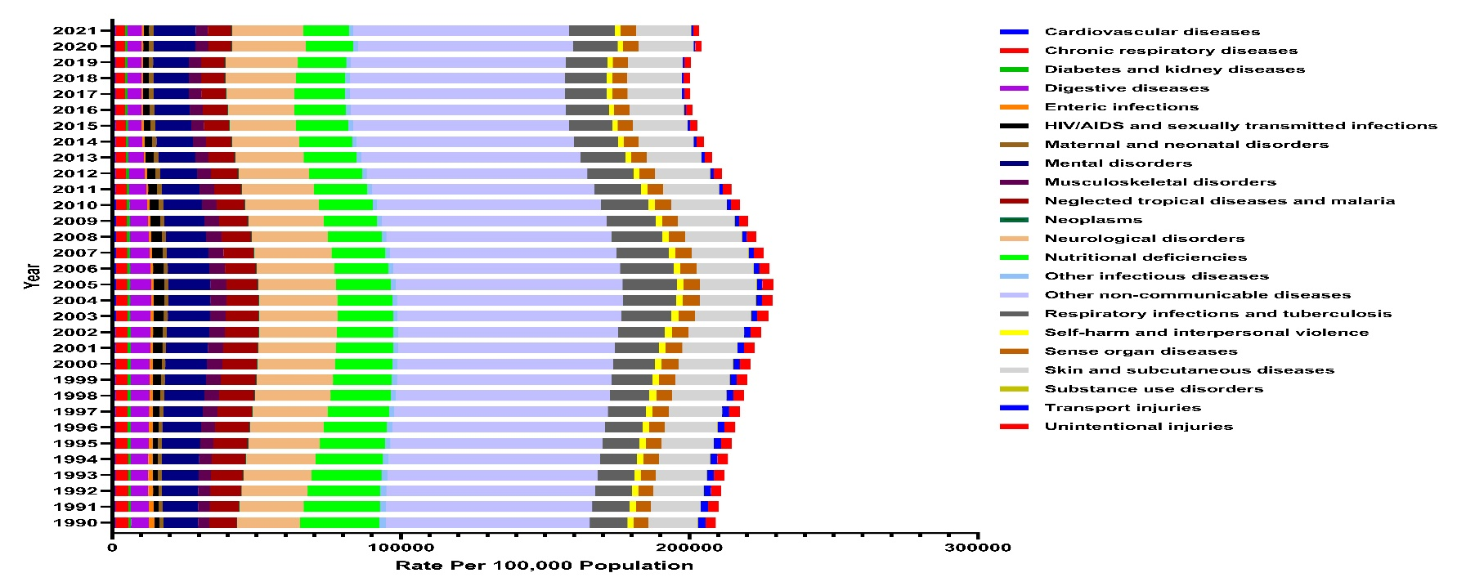
Figure S12. Time trend of rate of prevalence of child and adolescents causes of death among females in 1990-2021 in Iran

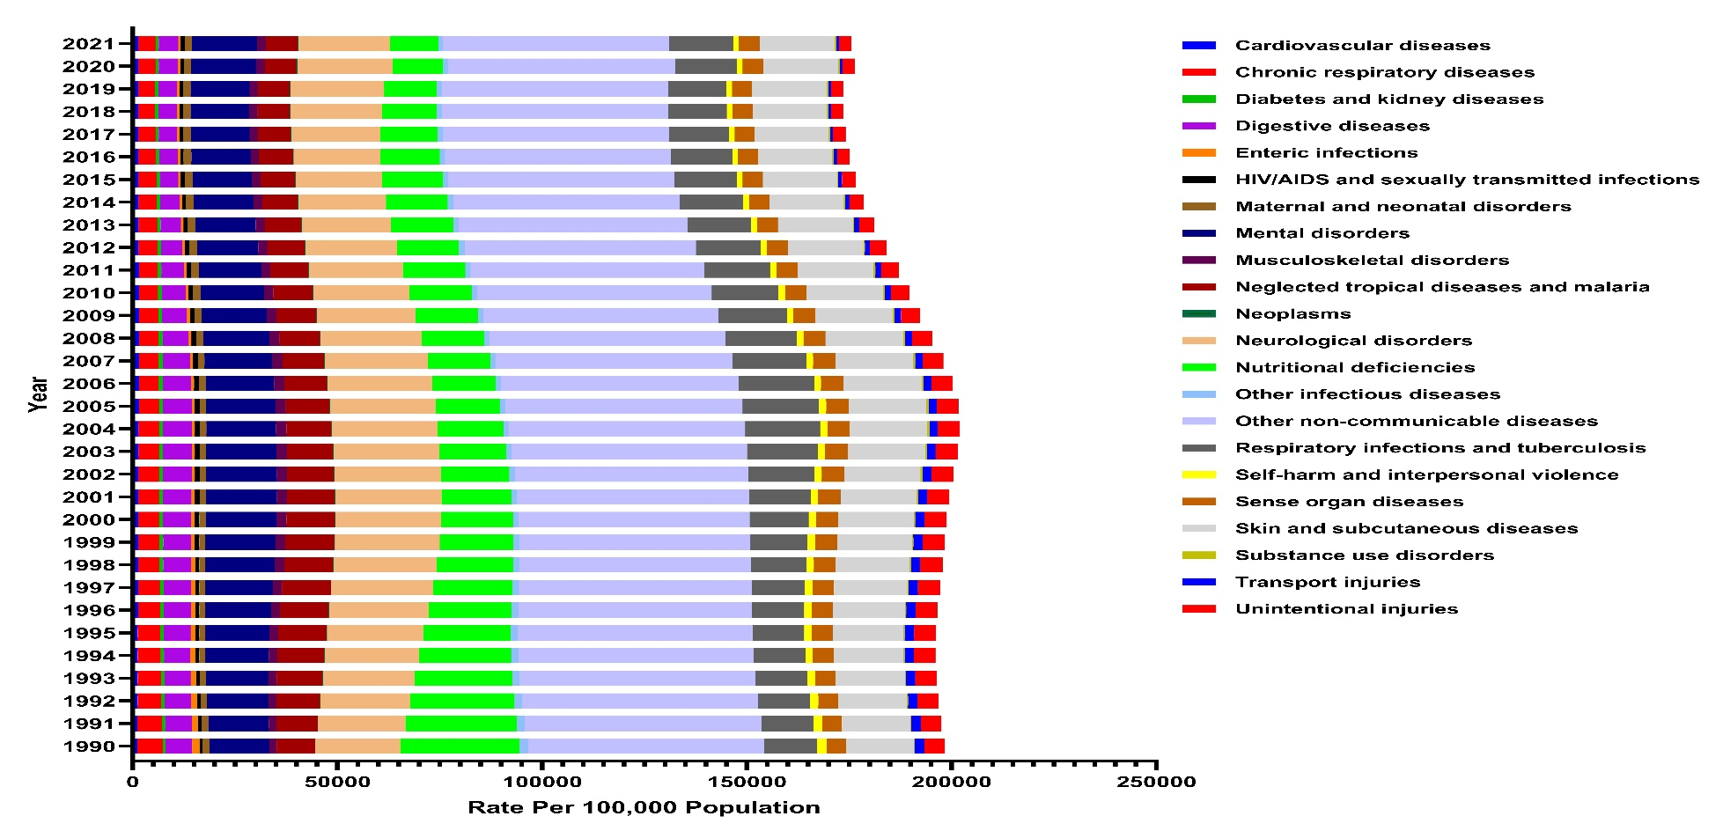
Figure S13. Time trend of rate of prevalence of child and adolescents causes of death among males in 1990-2021 in Iran

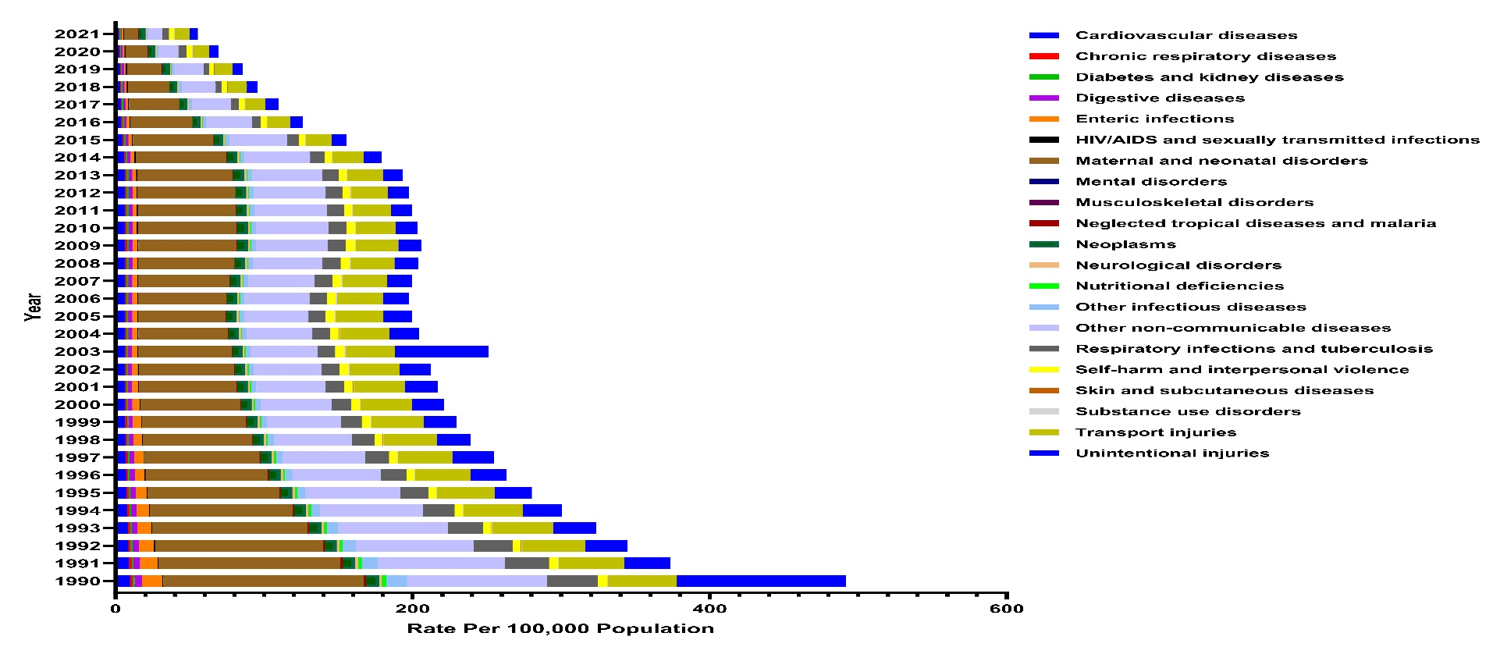
Figure S14. Time trend of rate of mortality of child and adolescents causes of death among both sexes in 1990-2021 in Iran

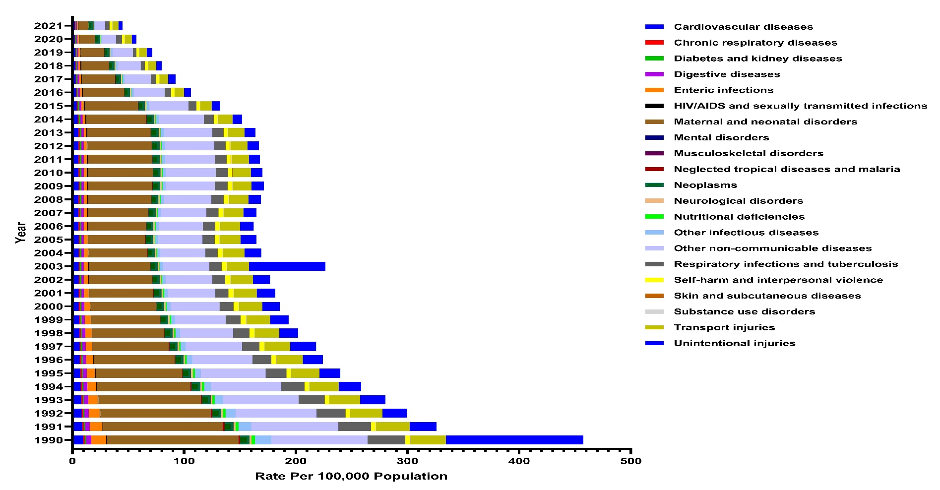
Figure S15. Time trend of rate of mortality of child and adolescents causes of death among females in 1990-2021 in Iran

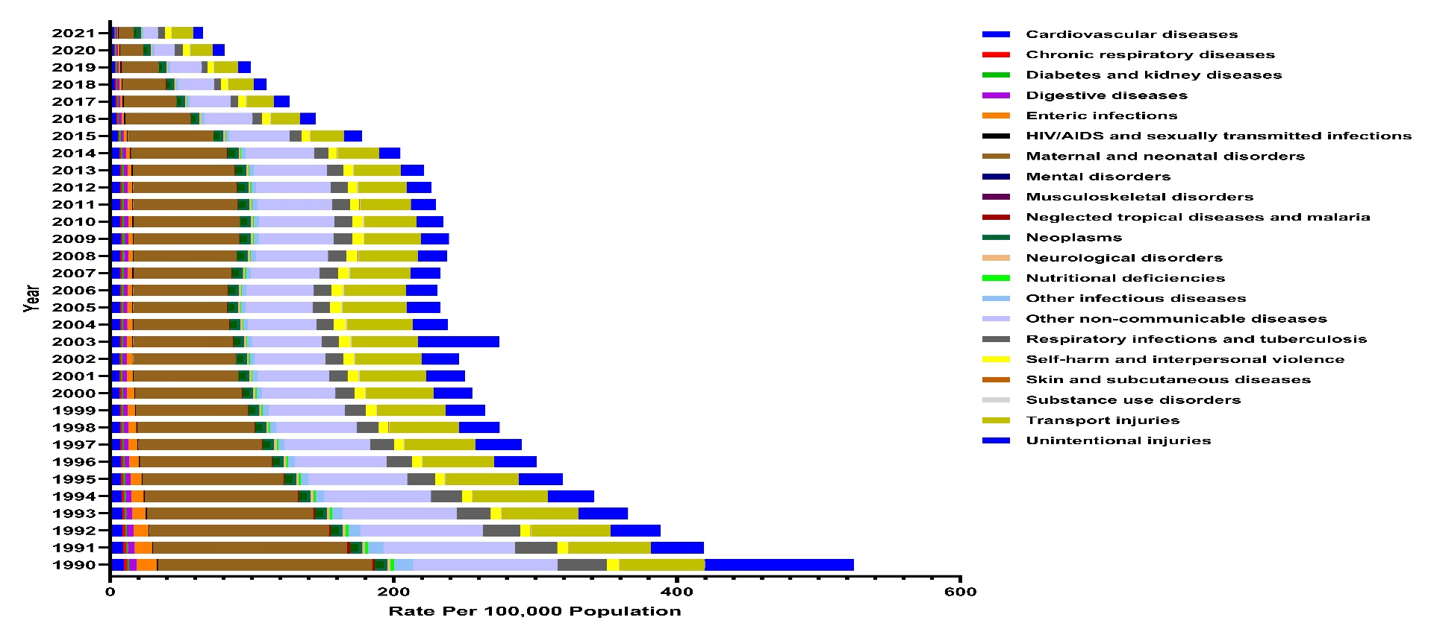
Figure S16. Time trend of rate of mortality of child and adolescents causes of death among males in 1990-2021 in Iran

