Supplementary Figure 1: Patient Workflow and Schedule at the STHR
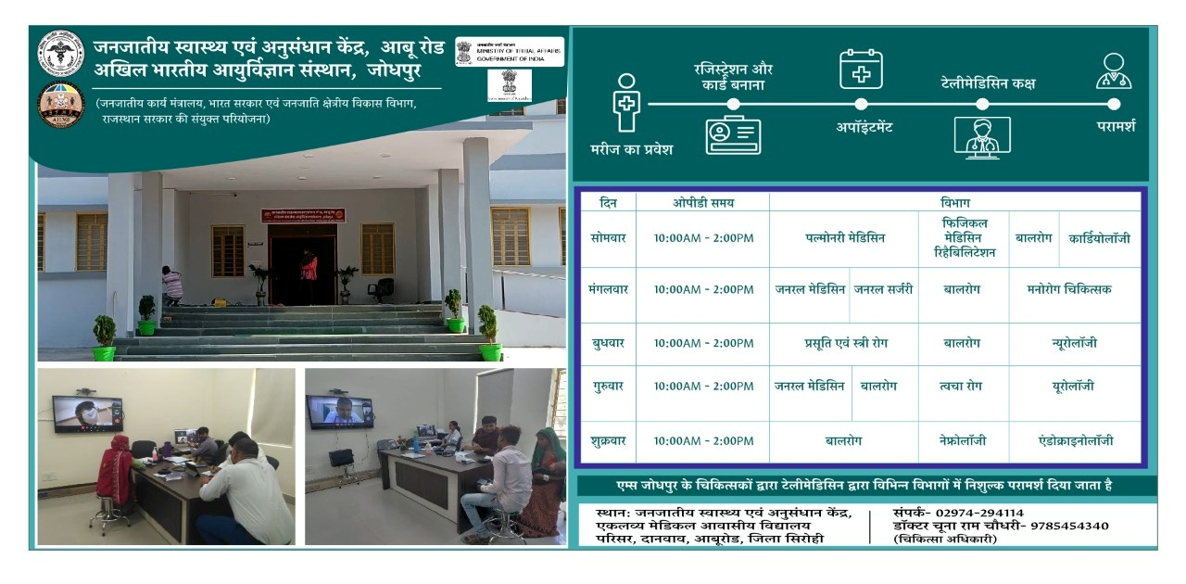

Supplementary Table 1: Socio-demographic Characteristics of the Population Visiting STHR (N=16,38)
Parameter | Frequency | Percentage (%)
Age  0-15 years  16-30 years  31-45 years  46-60 years  61 years & above | 246  461  374  370  187 | 15  28.1  22.8  22.6  11.5
Gender  Male  Female | 885  753 | 54  46
Religion  Hindu  Muslim | 1,424  216 | 86.9  13.1
Marital status  Married  Unmarried | 1145  493 | 69.9  30.1
Education  Illiterate  Primary education  Secondary education  Graduation and above | 630  297  575  137 | 38.4  18.1  35.1  8.4

Supplementary Table 2: Sources of Information About STHR for the Population (N=1,638)
Question: Where did you learn about this centre? | Frequency | Percentage (%)
- Heard from peer group | 274 | 16.7
- Referred from CHC/PHC | 1,150 | 70.2
- Referred from private hospital | 9 | 0.6
- Saw Advertisement/newspaper/TV | 0 | 0
- ASHA/ANM/Sarpanch | 9 | 0.6
- Camps | 196 | 12

Supplementary Table 3: Department-wise Distribution of Patients Visiting STHR (N=1,638)
Department | Frequency | Percentage (%)
Cardiology | 23 | 1.4
Dermatology | 488 | 29.8
Endocrinology | 37 | 2.2
General Medicine | 495 | 30.2
General Surgery | 18 | 1.1
Obstetrics and Gynaecology | 50 | 3.1
Nephrology | 5 | 0.3
Neurology | 9 | 0.6
Pediatrics | 249 | 15.2
PMR | 214 | 13.1
Psychiatry | 18 | 1.1
Pulmonary medicine | 18 | 1.1
Urology | 14 | 0.8

Supplementary Table 4: Number of Visits by Patients to STHR (N=1,638)

Number of visits | Frequency | Percentage (%)
First | 1566 | 95.5
Second | 47 | 2.9
Third | 15 | 1.0
Fourth | 11 | 0.6

Supplementary Table 5: Duration Before Seeking First Medical Care at STHR After Illness (N=1,638)
When did you first seek medical care for this illness? | Frequency | Percentage (%)
Within a week | 28 | 1.6
Within a month | 306 | 18.6
1-3 months | 365 | 22.2
3-6 months | 407 | 25
6-12 months | 138 | 8.5
>1 year | 394 | 24.1

Supplementary Table 6: Alternative Healthcare Options if STHR Was Not Available (N=1,638)
S. No | Where would you have gone for treatment if you had not come to this centre? | Frequency | Percentage (%)
 | Sirohi Govt. hospital | 265 | 16.2
 | Sirohi Private Hospital | 160 | 9.7
 | Palanpur Govt. hospital | 119 | 7.2
 | Palanpur Private Hospital | 329 | 20.1
 | Udaipur Govt. hospital | 18 | 1.1
 | Udaipur Private Hospital | 14 | 0.8
 | Ahmedabad Govt. hospital | 73 | 4.5
 | Ahmedabad Private Hospital | 187 | 11.4
 | Abu Road Govt. hospital | 237 | 14.5
 | Abu Road Private Hospital | 196 | 12
 | Jodhpur Govt. hospital | 5 | 0.3
 | Jodhpur Private Hospital | 5 | 0.3
 | Mehsana Private Hospital | 5 | 0.3
 | Pindwada Govt. hospital | 18 | 1.1
 | Mumbai Private Hospital | 5 | 0.3
 | Punjab Govt. hospital | 5 | 0.3

Supplementary Table 7: Modes of Transportation Used by Patients Visiting STHR (N=1,638)
If you have gone somewhere else, what transportation would you take? | Frequency | Percentage (%)
Public transport | 1,442 | 88
Private transport | 141 | 8.6
Own vehicle | 55 | 3.3

Supplementary Table 8: Socio-demographic Characteristics of the Population Visiting CHC/PHCs at Abu Road (N=1,013)
Parameter | Frequency | Percentage (%)
Age  0-15 years  16-30 years  31-45 years  46-60 years  61 years & above | 7  183  263  332  228 | 0.7  18.1  26  32.8  22.5
Gender  Male  Female | 524  489 | 51.7  48.3
Religion  Hindu  Muslim | 917  96 | 90.5  9.5
Marital status  Married  Unmarried  Widow/widower | 981  24  8 | 96.8  2.4  0.8
Education  Illiterate  Primary education  Secondary education  Graduation and above | 153  621  208  31 | 15.1  61.3  20.5  3.1
Occupation  Agriculture/ Labour  Govt/private job  Skilled/Unskilled worker  Businessman  Housewife  Unemployed/student  Retired | 287  50  3  76  474  54  69 | 28.3  4.9  0.3  7.5  46.8  5.3  6.8

Supplementary Table 9: Department-wise Distribution of Patients Visiting CHC/PHCs at Abu Road (N=1,013)
Department | Frequency | Percentage (%)
Cardiology | 349 | 34.5
Dermatology | 10 | 1
General Medicine | 517 | 51
General Surgery | 69 | 6.8
Gynaecology | 60 | 5.9
Neurology | 1 | 0.1
Psychiatry | 4 | 0.4
Urology | 3 | 0.3

Supplementary Table 10: Number of Visits by Patients CHC/PHCs at Abu Road (N=1,013)
Number of visits | Frequency | Percentage (%)
First | 321 | 31.7
Second | 245 | 24.2
Third | 76 | 7.5
Fourth | 15 | 1.5
More than 4 visits | 356 | 35.1

Supplementary Table 11: Duration Before Seeking First Medical Care at CHC/PHCs at Abu Road (N=1,013)
When did you first seek medical care for this illness? | Frequency | Percentage (%)
Within a week | 633 | 62.5
Within a month | 301 | 29.7
1-3 months | 46 | 4.5
3-6 months | 18 | 1.8
6-12 months | 12 | 1.2
>1 year | 3 | 0.3

Supplementary Table 12: Proportion of Patients Taking Follow-up from CHC/PHC Itself (N=1,013)

Patients coming for follow-up to CHC/PHC | 918 (90.6%)
Patients referred from CHC/PHC to another centre | 95 (9.4%)

Supplementary Table 13: Proportion of Patients' Choice for Referral to Different Health Facilities Visiting CHC/PHCs at Abu Road (N=1,013)
Health facility | Frequency | Percentage (%)
STHR AIIMS Jodhpur Telemedicine | 923 | 91.12
Sirohi govt hospital | 33 | 3.25
Sirohi private hospital | 14 | 1.38
Palanpur govt hospital | 9 | 0.88
Palanpur private hospital | 19 | 1.87
Udaipur govt hospital | 2 | 0.19
Udaipur private hospital | 6 | 0.59
Ahmedabad govt hospital | 1 | 0.09
Ahmedabad private hospital | 3 | 0.29
Abu Road Private Hospital | 3 | 0.29

Supplementary Table 14: Mode of Transportation Options by Patients Visiting CHC/PHCs at Abu Road (N=1,013)
If you have gone somewhere else, what transportation would you take? | Frequency | Percentage (%)
Public transport | 384 | 37.9
Private transport | 204 | 20.1
Personal vehicle | 323 | 31.9
Others | 102 | 10.1

Supplementary Table 15: Estimated Monthly and Annual Costs for Operating the STHR Telemedicine Centre
Details | Cost ₹ | Cost ₹ (Monthly) | Cost ₹ (Yearly)
Rent of the room providing teleconsultations (Monthly) | 2500 | 2500 | 30000
1 Bed* | 5000 | 83.33333333 | 1000
1 Curtain* | 1000 | 16.66666667 | 200
2 Table* | 21060 | 351 | 4212
2 Chairs Revolving* | 10873.5 | 181.225 | 2174.7
Laptop 1* | 65000 | 1083.333333 | 13000
1 Screen* | 10000 | 166.6666667 | 2000
BP Hb Machine* | 6000 | 100 | 1200
Weighing machine* | 1000 | 16.66666667 | 200
Speaker* | 3000 | 50 | 600
Salary 1 Medical, 1 Nursing officer and 1 MSW** | 118500 | 59250 | 711000
Internet System Cost yearly | 7500 | 625 | 7500
Electricity bill of STHR yearly | 30000 | 2500 | 30000
PHeD Bill (Water Dept.) yearly | 9000 | 750 | 9000
Cost of stationery used yearly | 15000 | 1250 | 15000
Cost of Advertisement yearly | 1500 | 125 | 1500
Maintenance charges yearly | 15000 | 1250 | 15000
Miscellaneous yearly | 6000 | 500 | 6000
Total Cost |  | ₹70799 | ₹849587
*Assume that the average life of the product is five years. ** The current teleconsultation utilizes 50% of the staff, and the following staff members were involved in other activities of consultation centres.

Supplementary Table 16: Patient Satisfaction Based on Questionnaire at STHR (N=1638)
Questionnaire | Frequency (Yes) | Percentage (%)
Was it easy to use telemedicine? | 1291 | 78.8
Could you easily talk to a clinician using a telehealth system? | 1282 | 78.3
Were the visits provided over the telehealth system the same as in-person visits? | 1287 | 78.6
Will you use telehealth services again? | 1273 | 77.7
Do you find telemedicine an acceptable way to receive health care services? | 1296 | 79.1
Did the telemedicine services help you to improve your health? | 1278 | 78

Questionnaire for assessing telemedicine services
Name:
Age:
Gender:
Current Address:
Marital address:
Religion:
Education:
Occupation:
Monthly family income:

- Date of first visit to this centre-
- From where did you get to know about this centre?
- Heard from peer group
- Referred from CHC/PHC
- Referred from private hospital
- Saw Advertisement/newspaper/TV
- Others- (Specify)
- What was the main reason of visiting this centre?
- Number of visits-
- What is the duration of illness (no. in days)?
- When did you first seek medical care for this illness (no. in days)?
- Where would you have gone for treatment if you had not come to this centre?
- Sirohi govt hospital
- Sirohi private hospital
- Palanpur govt hospital
- Palanpur Private Hospital
- Udaipur govt hospital
- Udaipur Private Hospital
- Ahmedabad govt hospital
- Ahmedabad Private Hospital
- Abu Road govt hospital
- Abu Road Private Hospital
- Others - (Specify)
- If you have gone somewhere else, what mode of transportation would you take?
- Public transport
- Private transport
- Own vehicle
- Others - (Specify)
- Was it easy to use telemedicine?
- Yes
- No
- Could you easily talk to a clinician using a telehealth system?
(a)Yes
(b) No
- Were the visits provided over the telehealth system the same as in-person visits?
- Yes
- No
- Will you use telehealth services again?
- Yes
- No
- Do you find telemedicine an acceptable way to receive health care services?
- Yes
- No
- Did the telemedicine services help you to improve your health?
- Yes
- No

Questionnaire for PHC
Name: Age: Gender:
Address:
Marital status: Religion: Education:
Occupation: Monthly family income:

- Date of first visit to this centre-
- What was the main reason of visiting this centre?
- Number of visits-
- What is the duration of illness (no. in days)?
- When did you first seek medical care for this illness (no. in days)?
- Where would you have gone for treatment if you had not come to this centre?
- AIIMS telemedicine centre, Sirohi / STHR
- Sirohi govt hospital
- Sirohi Private Hospital
- Palanpur govt hospital
- Palanpur Private Hospital
- Udaipur govt hospital
- Udaipur Private Hospital
- Ahmedabad govt hospital
- Ahmedabad Private Hospital
- Abu Road govt hospital
- Abu Road Private Hospital
- Others - (Specify)

- If you have gone somewhere else, what mode of transportation would you take?
- Public transport
- Private transport
- Own vehicle
- Others - (Specify)

