A Carbazole Acrylonitrile Substituted Turn-On Fluorescence Chemosensors for Cyanide Ion and its Application to Real Sample Analysis
Jayapriya Sengottaiyan^{a,b}, K.Parvathi ^{c}, A. Franklin Ebenaze ª, N. Sampathkumar ª, Jegathalaprathaban Rajesh ^{d}, Gurusamy Rajagopal ^{e}
ª Post-Graduate and Research Department of Chemistry, Chikkanna Government Arts College, Tiruppur 641 602, Tamil Nadu, India.
^{b} Department of Chemistry, Sri Shakthi Institute of Engineering and Technology, Coimbatore 641 062, Tamil Nadu, India.
^{c} Department of Chemistry, L R G Government Arts College for Women, Tirupur, Tamil Nadu, India.
^{d} Department of Chemistry, Saveetha School of Engineering, Saveetha Institute of Medical and Technical Science, (Saveetha University), Chennai 602 105, Tamil Nadu, India.
^{e} Post-Graduate and Research Department of Chemistry, Government Arts College (Autonomous), Coimbatore 641 018, Tamil Nadu, India
* Corresponding Author: rajagopal18@yahoo.com
Fig. 1S. FTIR spectrum of CZ-Et
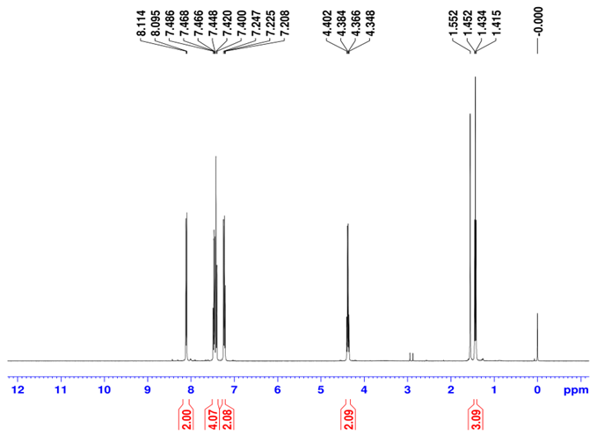
Fig. 2S. ¹H NMR spectrum of CZ-Et
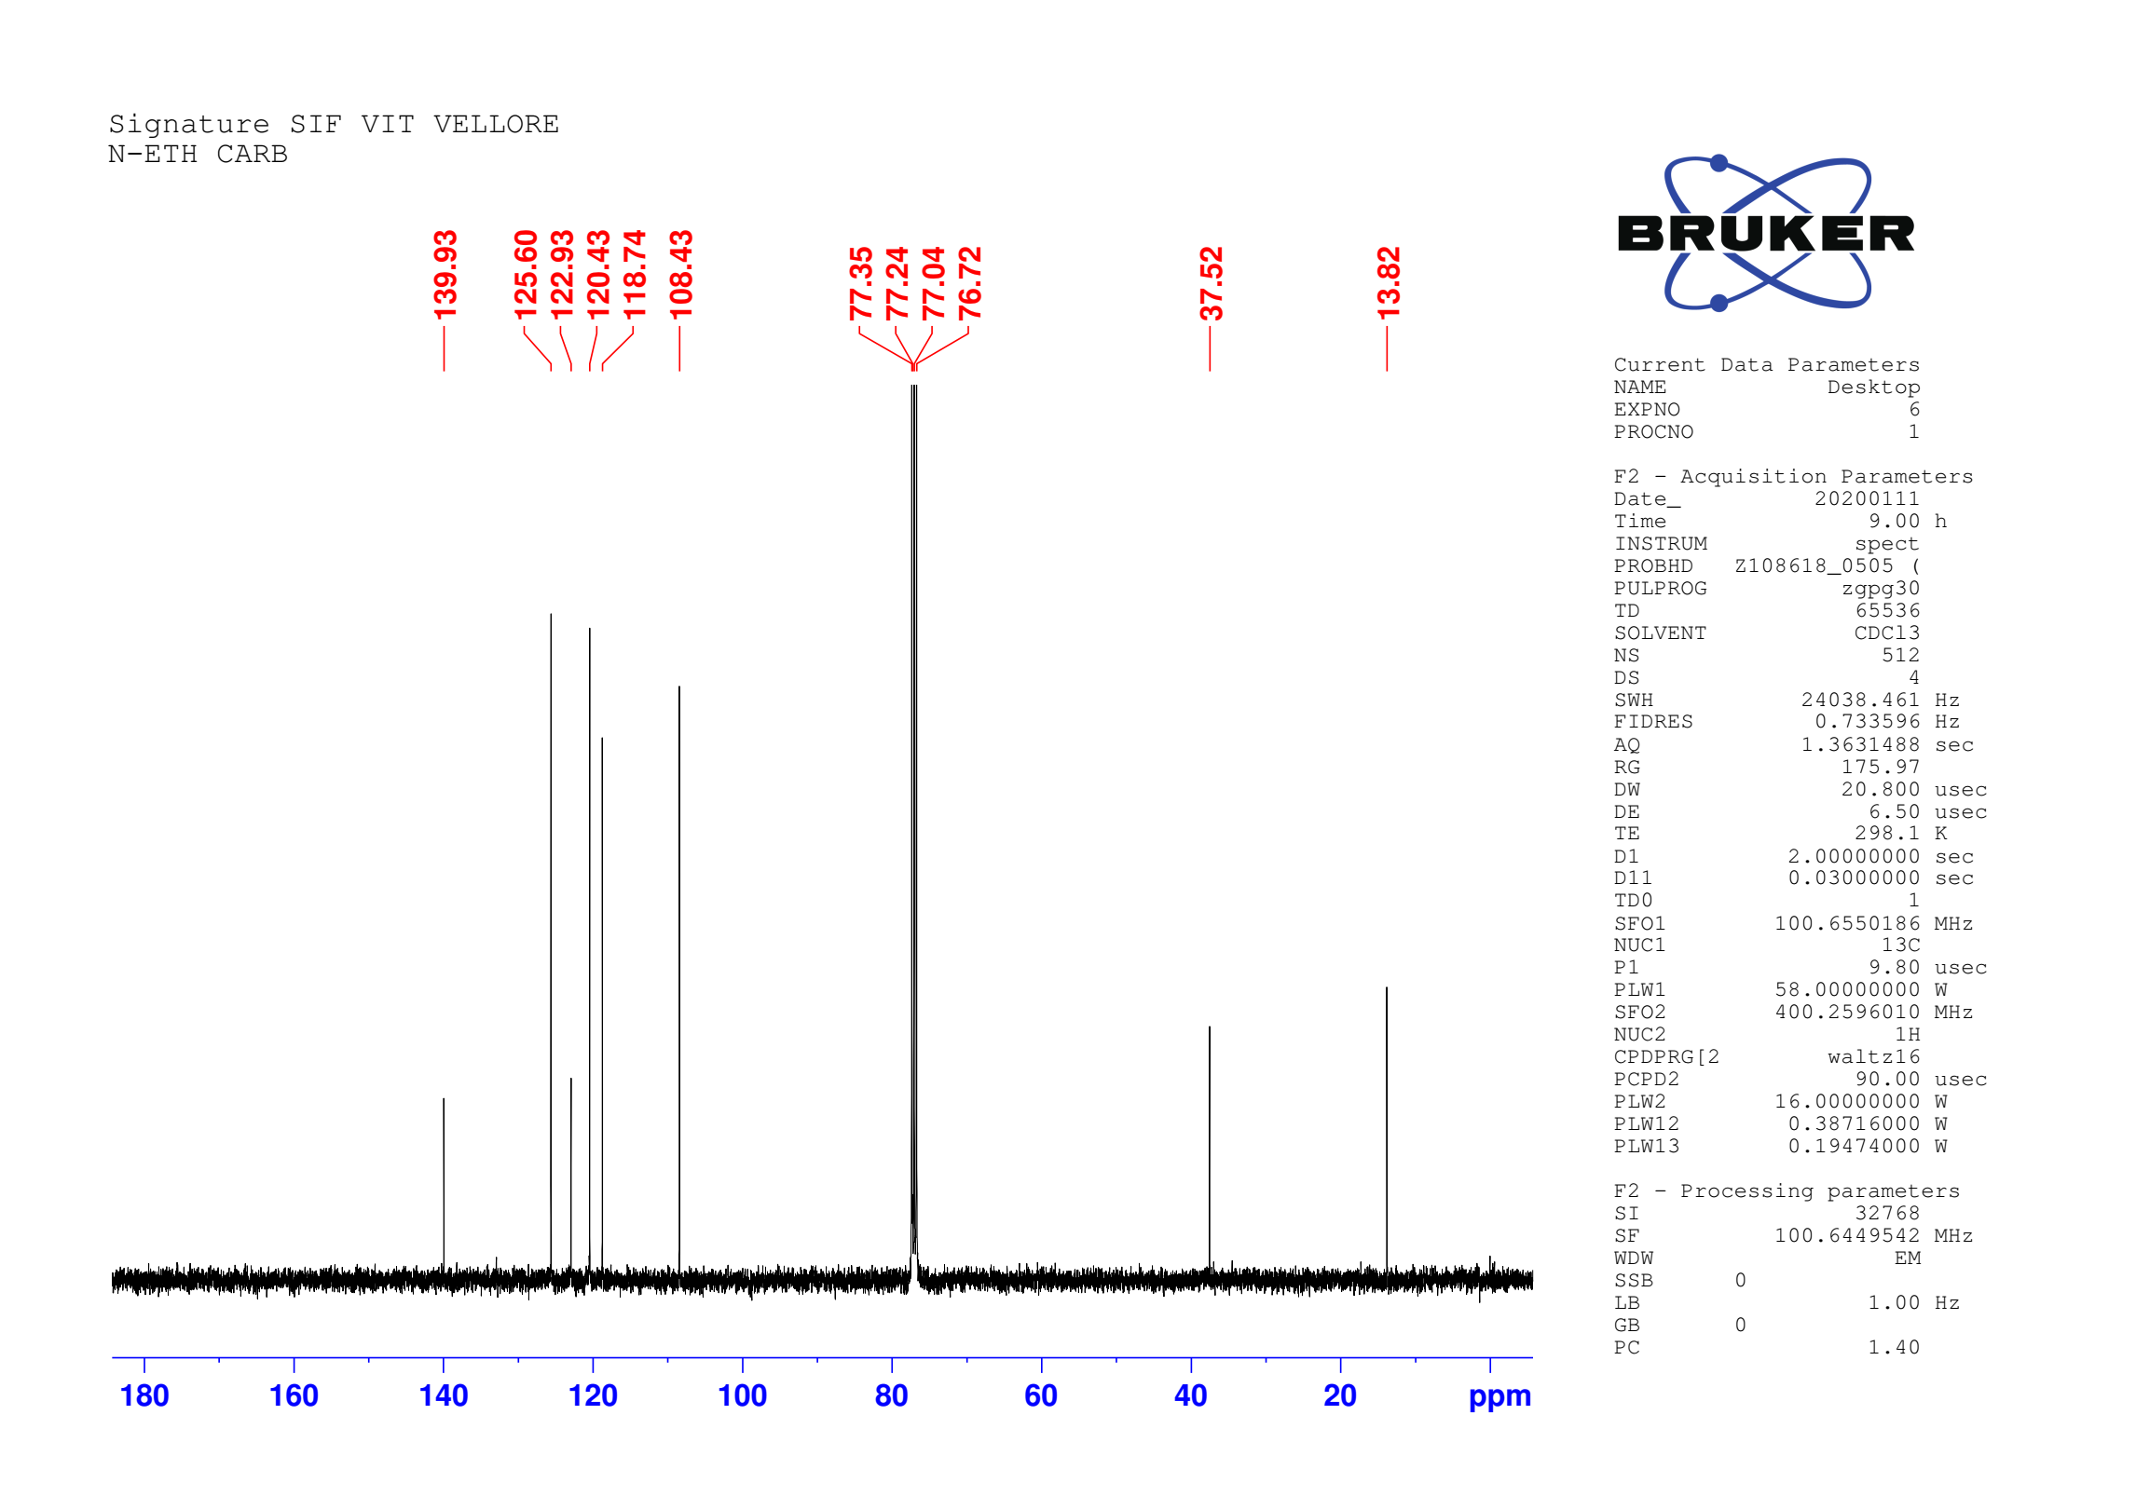
Fig. 3S.¹³C NMR spectrum of CZ-Et
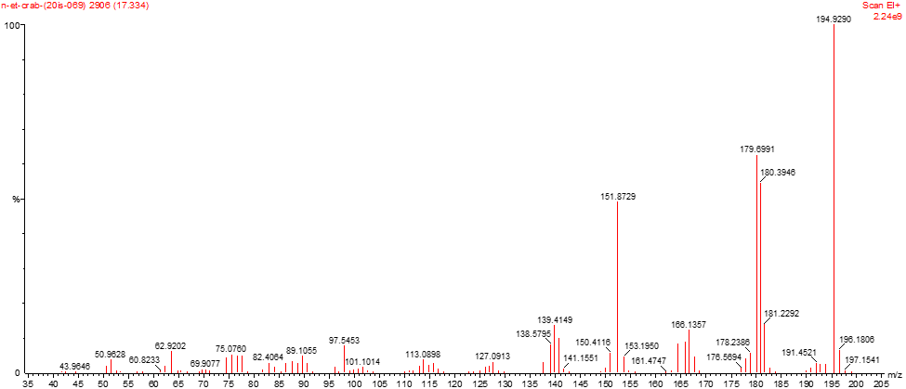
Fig. 4S. GC-Mass spectrum of CZ-Et
Fig. 5S. FTIR spectrum of CZ-Et-CHO
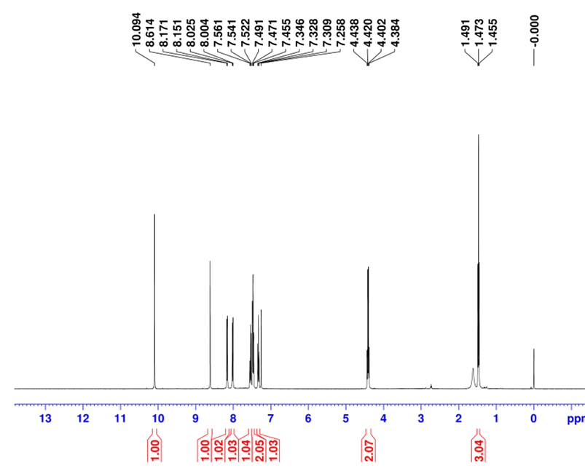
Fig. 6S. 1H NMR spectrum of CZ-Et-CHO
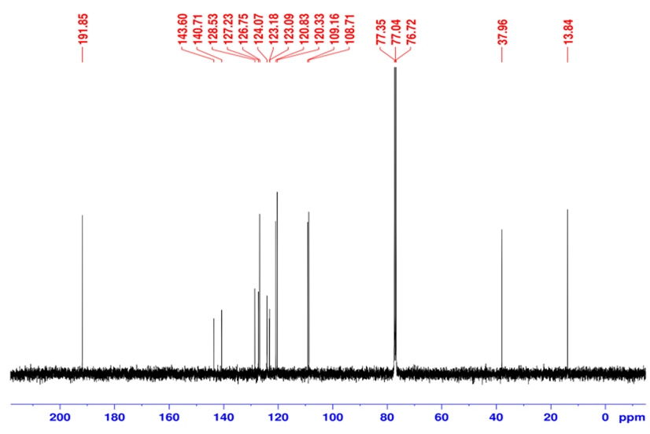
Fig. 7S. ¹³C spectrum of CZ-Et-CHO
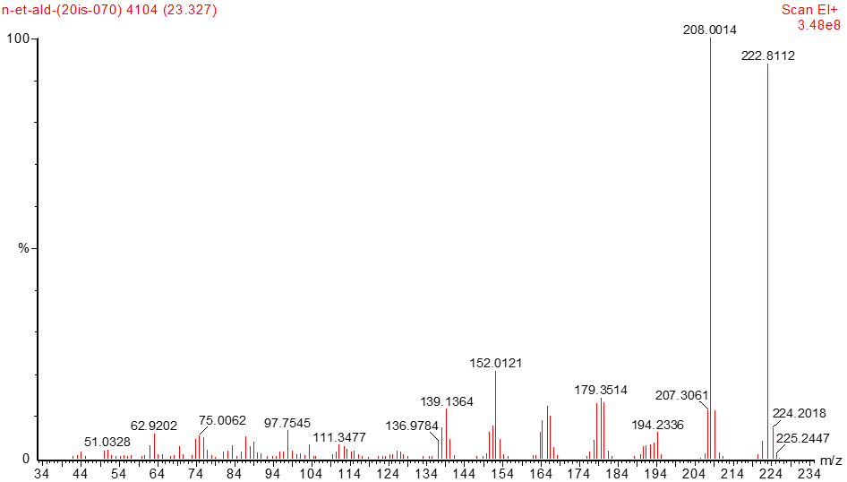
Fig. 8S. GC-Mass spectrum of CZ-Et-CHO

Fig. 9S. FTIR spectrum of probe CZ-BTZ

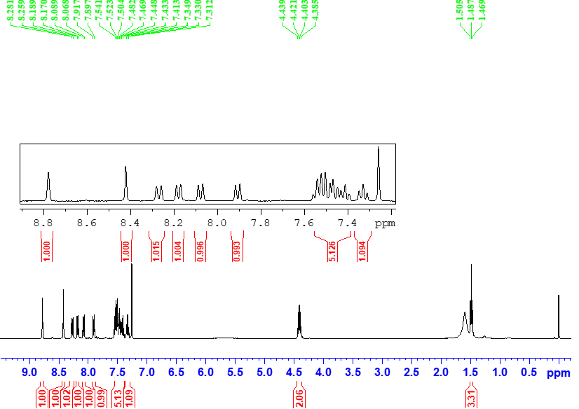
Fig. 10S. ¹H NMR spectrum of probe CZ-BTZ

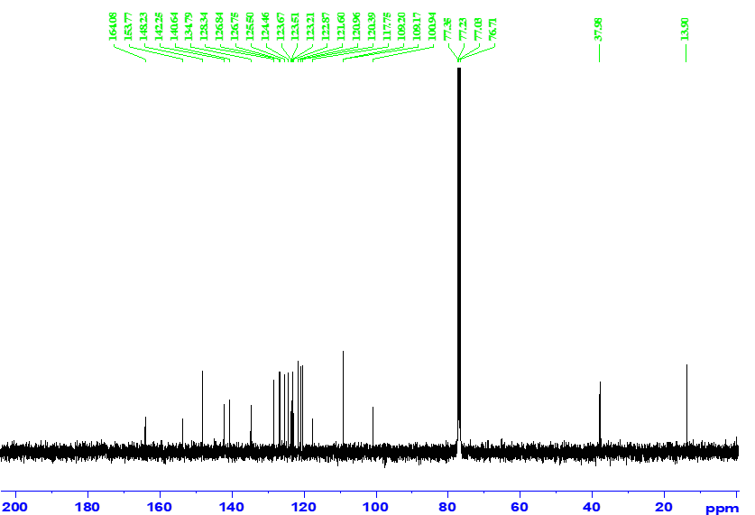
Fig. 11S. ¹³C NMR spectrum of probe CZ-BTZ
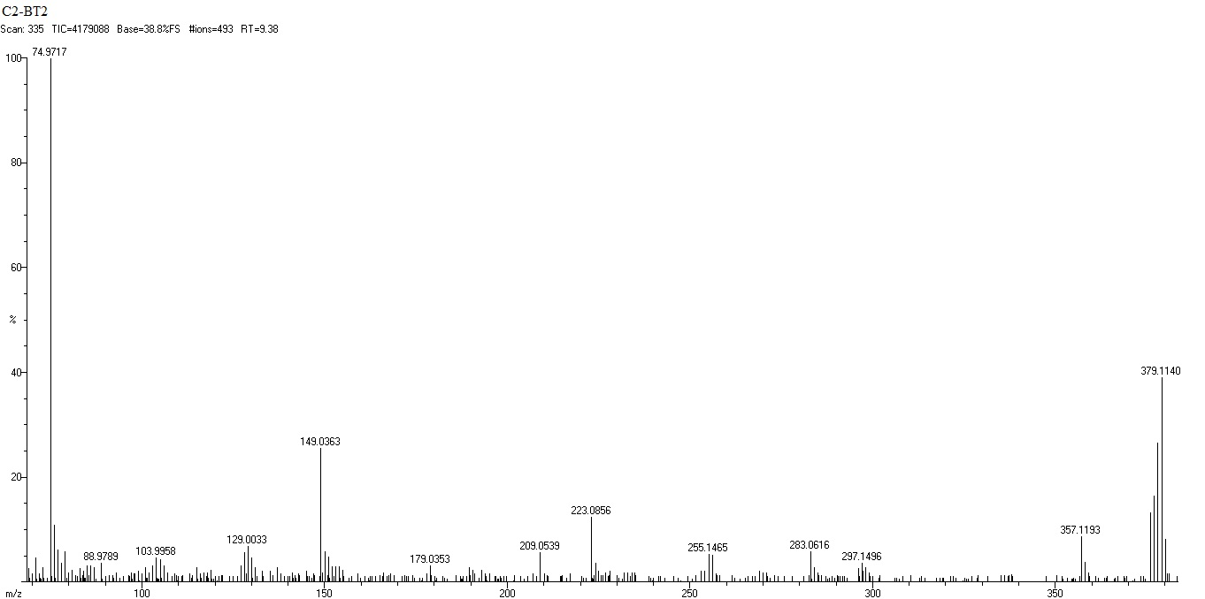
Fig. 12S. HR-Mass spectrum of probe CZ-BTZ
Fig. S13. FTIR spectra of CZ-BTZ-CN⁻ adduct
Table. 1S. Experiment and theoretical UV-Vis absorbance characteristic of CZ-BTZ and CZ-BTZ-CN⁻ adduct.
Compound | Experimental |  | Theoretical
Compound | λ_{abs}  (nm) | ε  (LM⁻¹cm⁻¹) | λ_{ext}  (nm) | ƒ | State Involved | Orbital Contribution
CZ-BTZ | 411 | 27044 | 411.31 | 0.9396 | S₀→S₁ | 96% H→L
CZ-BTZ | 324 | 16425 | 328.31 | 0.2849 | S₀→S₄ | 66% H-3→L, 18% H→L+1
CZ-BTZ -CN⁻ | 350 | 43465 | 343.57 | 0.2943 | S₀→S₈ | 36% H→L+5, 29% H→L+3, 18% H→L+8
*H- HOMO, L-LUMO

