SUPPORTING INFORMATION

Pen direct writing of Multiplex-LFIA for detection of thiamphenicol and tylosin in milk
Alida Russo ª, Simone Cavalera ^{b}, Richard Murray ª, Aidan J. Quinn ª, Laura Anfossi^{b} , Daniela Iacopino ^{a*}
ª Tyndall National Institute, University College Cork, Dyke Parade, Cork, Ireland
^{b} Department of Chemistry, University of Turin, Via P. Giuria 5, 10125, Turin, Italy
*Corresponding author: daniela.iacopino@tyndall.ie

Synthesis of the antigen Thiam-HS-BSA
Some molecules, like the antibiotics, are too small to generate an immune response, therefore it is necessary to couple them to a carrier protein such as bovine serum albumin (BSA) to obtain antigenic conjugates. Similarly, small molecules-protein antigenic conjugates are needed in competitive immunoassays, to be deposited in the nitrocellulose membranes [1].
For this research, the antigen was produced by conjugation of the thiamphenicol hemisuccinate (Thiam-HS) to bovine serum albumin (BSA). The Thiam-HS was synthesized starting from the thiamphenicol (Figure SI1a) through the reaction with succinic anhydride and the formation of the hemisuccinate derivative (Figure SI1b). Briefly, 25 mg of thiamphenicol (0.07 mmol, 1 eq) were dissolved in 1.5 mL of anhydrous pyridine into a dark glass vial. After complete dissolving, 1.12 mL of a 10 mg mL⁻¹ solution of succinic anhydride in pyridine, supplemented by 1 mg ml⁻¹ of 4-dimethylaminopyridine (dmap) (0.112 mmol, 1.6 eq) were added and the solution was let reacting for 72 h at room temperature under stirring. Then, 10 mL of milliQ water were added to the solution containing the synthesized Thiam-HS and was acidified by adding HCl dropwise until pH 2-3. Rapidly, the solution was extracted three times with ethyl acetate, reduced into few millilitres with rotary evaporator, and transferred into a glass vial for exhaustive drying under vacuum. 36mg were recovered after drying. Subsequently, the Thiam-HS was activated transforming it into a N-hydroxy succinimide ester (Figure SI1c). Briefly, 31.2 mg of Thiam-HS were dissolved in 840.6 µL of anhydrous dimethylformamide (DMF) (0.068 mmol, 1 eq). Then, 286.7 µL of a freshly prepared 30 mg mL⁻¹ solution in anhydrous DMF of N-hydroxy succinimide (NHS) (0.075 mmol, 1.1 eq), and 11.7 µL of N,N'-diisopropylcarbodiimide (DIC) (0.075 mmol, 1.1 eq), were added and the solution was let reacting at 4 °C for 2 h. The so-obtained hapten Thiam-HS-NHS was conjugated to BSA with a molar excess ratio of 200 (Figure SI1d). To this purpose, 5 mg of BSA were dissolved into a dark glass vial with 2.5 ml of bicarbonate buffer 150 mM, pH 8.5. Then 151.6 µL of Thiam-HS-NHS active solution was added and the mixture was let reacting at room temperature under stirring overnight. Finally, the solution was purified through size exclusion chromatography by means of a Sephadex G26 (MWCO 6000 Da) eluting with PBS [2].

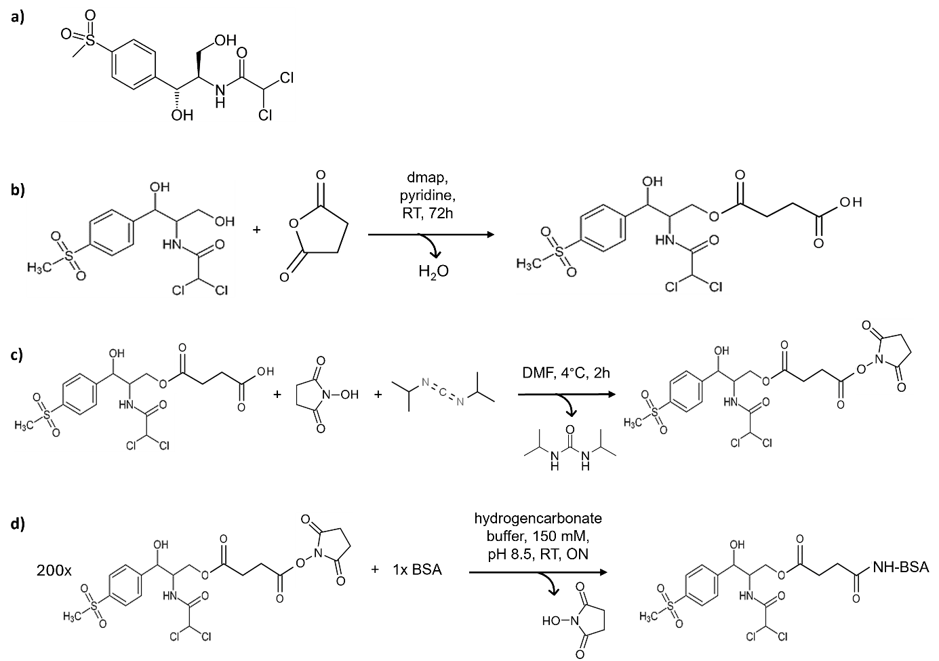
Figure SI1: a) Chemical structures of Thiamphenicol; b) scheme of the synthesis of the hapten Thiam-HS; c) activation of the Thiam-HS hapten to Thiam-HS-NHS; d) synthesis of the antigen Thiam-HS-BSA.

ELISA evaluation of the antigen-antibody pair
The antigens (Thiam-HS-BSA, Spi-BSA) were preliminary tested for their binding and competition capacity by means of a screening indirect competitive ELISA (cELISA). Briefly, this cELISA format was carried out with the immobilized antigen and indirect antibody detection. Microplate wells were coated with 150 µL per well of antigen solution in coating buffer by overnight incubation at 4°C. Plates were rinsed three times with washing solution (milliQ water with 0.05% v/v Tween 20) after each incubation step. The wells were coated with 300 µL per well of buffer solution supplemented of 0.5% w/v BSA by 1 h incubation at room temperature (RT). The competitive immunochemical reaction was performed by mixing 100 µL per well of antibiotic solution in PBS with 100 µL per well of the antibody solution in PBS-T (PBS containing 0.05% v/v Tween 20). The mixture was incubated for 1 h at RT and, after that, the plates were washed. The fraction of bound antibody was detected by adding 200 µL per well of a 1/5000 dilution in PBS-T of peroxidase labelled rabbit anti-sheep immunoglobulin polyclonal antibody (RAS-HRP). The plates were incubated at RT for 1 h, and after washing as before, the signal was generated by adding 200 mL per well of N,N,N’N’-tetramethylbenzidine/substrate solution. The enzymatic reaction was stopped after 30 min at RT in the dark by adding 50 µL of 2 M H₂SO₄ per well. The absorbance was immediately read at 450 nm. For both the pairs, Thiam-HS-BSA/antiThiam antibody and Spi-BSA/antiTyl antibody, the binding and competition was verified (Figure SI2).
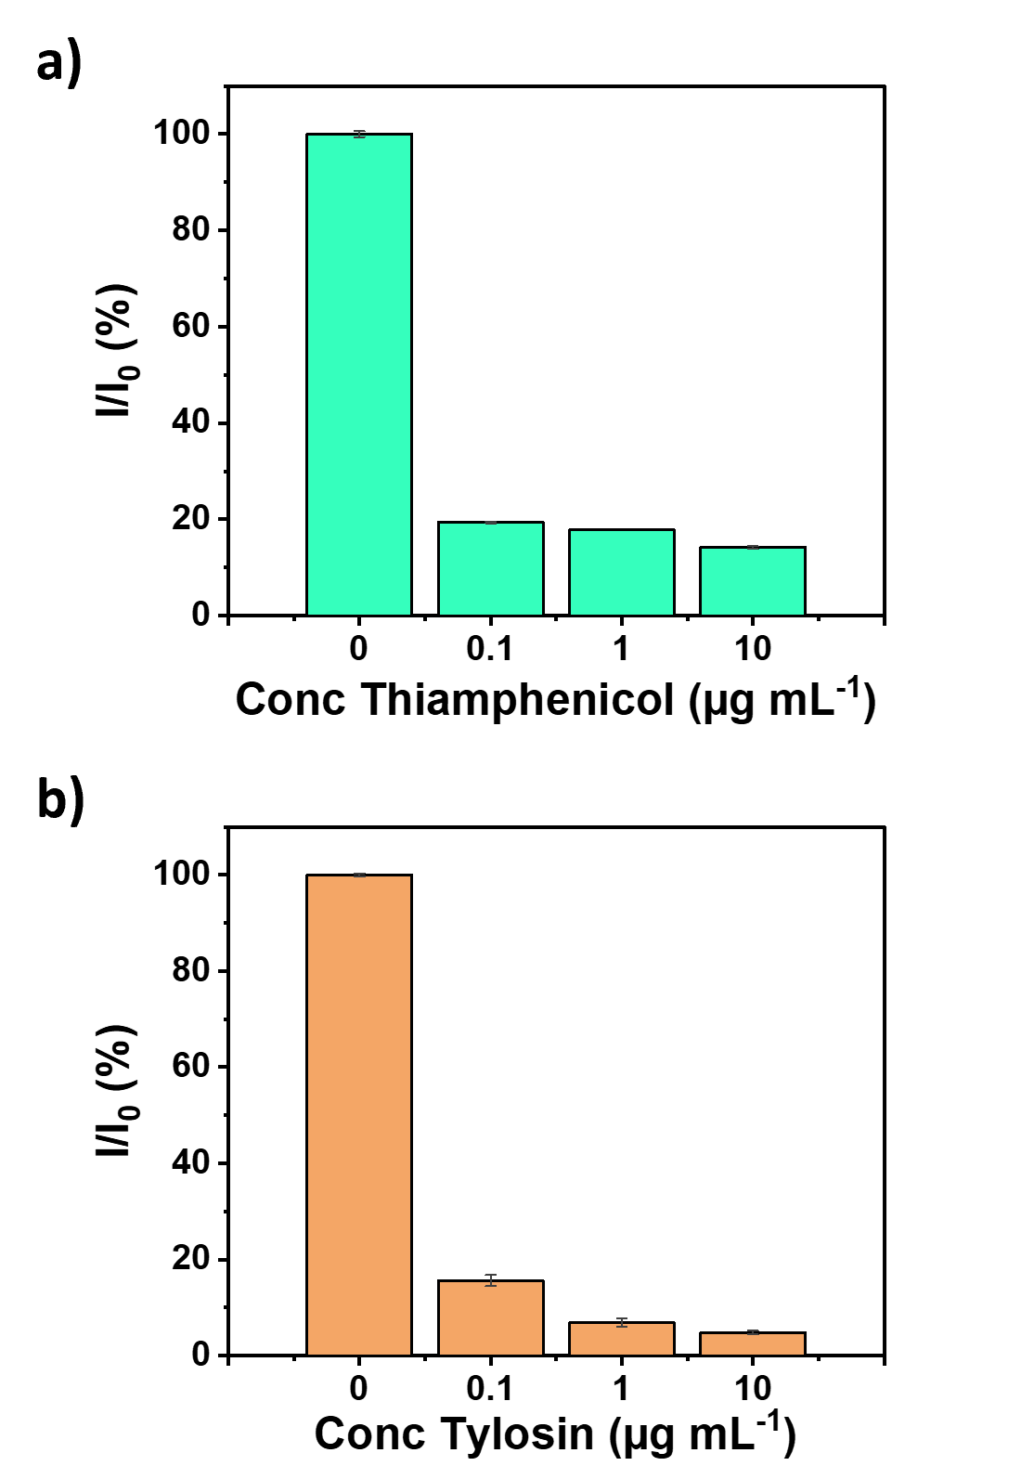
Figure SI2: cELISA binding and competition results for the antibody-antigen pairs: a) Thiam-HS-BSA/antiThiam; b) Spi-BSA/antiTyl.
LFIAs for detection of Thiamphenicol and Tylosin
Prior to the development of the multiplex-LFIA the two antibiotics were tested separately. Figure SI3 and SI4 show results obtained in buffer and milk for the detection of thiamphenicol and tylosin, respectively. The two antibiotics were tested at increasing concentrations both in buffer (PB in presence of 0.2% v/v Tween20) and spiked in milk.
For the development of the LFIA for detection of thiamphenicol, the test and control line were written onto the nitrocellulose with 0.3 mg mL⁻¹ Thiam-HS-BSA and 0.2 mg mL⁻¹ secondary antibody, respectively. The conjugate pad was dispensed per saturation with Au NPs-antiThiam OD 3.
For the detection of tylosin, test and control line were written using 0.25 mg mL⁻¹ of both Spi-BSA and secondary antibody, respectively. The conjugate pad was dispensed with Au NPs-antiTyl OD 3 per saturation.
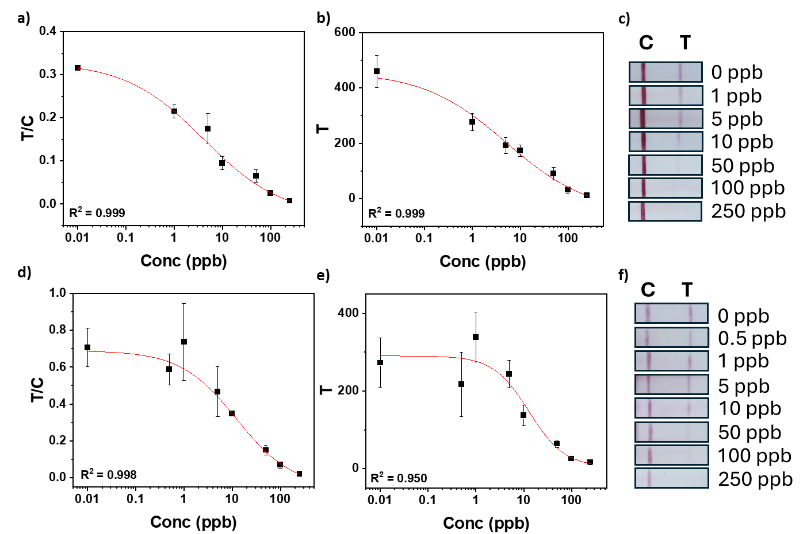
Figure SI3: a) Calibration curve obtained considering the ratio between the intensities of the lines T and C as a function of thiamphenicol concentration in buffer; b) calibration curve obtained considering the intensity of the T line as function of thiamphenicol concentration in buffer; c) visual readout of the strips at different levels of thiamphenicol in buffer; d) calibration curve got from the ratio of the T and C line intensities as function of thiamphenicol concentration in milk; e) calibration curve obtained considering the intensity of the T line as function of thiamphenicol concentration in milk; f) visual readout of the strips at different levels of thiamphenicol in milk. The measurements in buffer were obtained with two replicates, the measurements in milk were in three replicates.
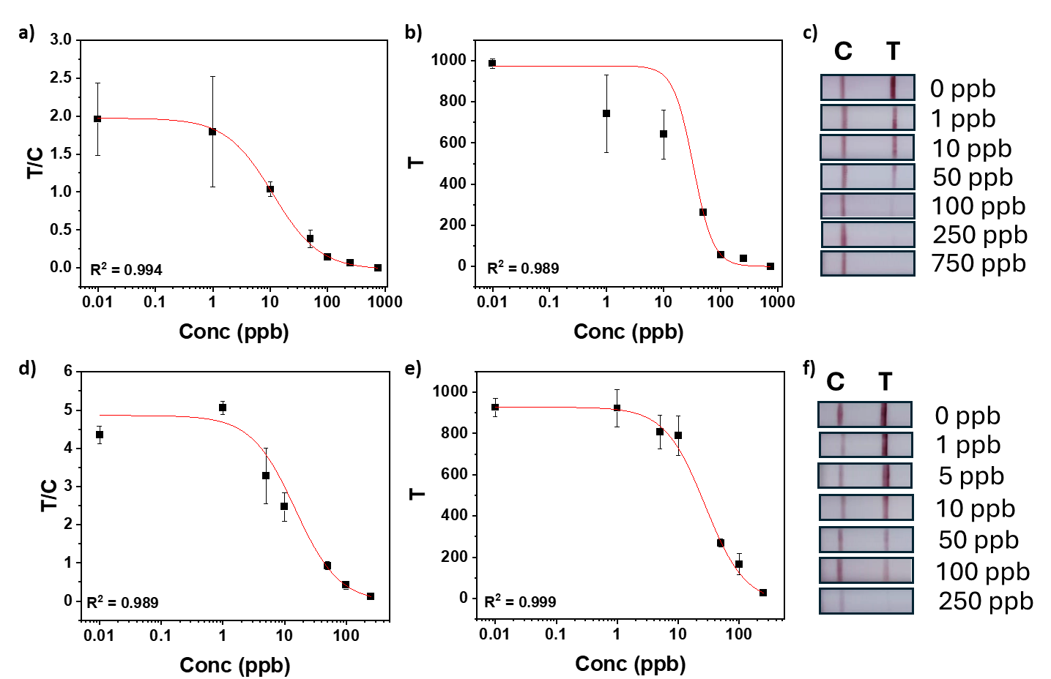
Figure SI4: a) Calibration curve obtained considering the ratio between the intensities of the lines T and C as a function of tylosin concentration in buffer; b) calibration curve obtained considering the intensity of the T line as function of tylosin concentration in buffer; c) visual readout of the strips at different levels of tylosin in buffer; d) calibration curve got from the ratio of the T and C line intensities as function of tylosin concentration in milk; e) calibration curve attained considering the intensity of the T line as function of tylosin concentration in milk; f) visual readout of the strips at different levels of tylosin in milk. The measurements in buffer were done two replicates, the ones in milk three replicates.

Cross-reactivity measurements
For the development of a selective multiplex-LFIA, it was necessary to prove that antibodies and antibiotics did not interact with each other. Therefore, two sets of experiments were designed to investigate the cross-reactivity of the two target antibiotics. The first experiment consisted in using the single-test line sensor of one antibiotic in presence of the other antibiotic spiked in milk (Figure SI5a,c), which needed to give the same result as a negative test. The second experiment consisted of using non-spiked milk samples into single-test line sensors using opposite conjugate pads (Figure SI5b,d). The aim was to investigate the interaction between the antigen of one antibiotic and the antibodies against the other, which should result in just a coloured control line. The results excluded a possible cross-reactivity among the two antibiotics.
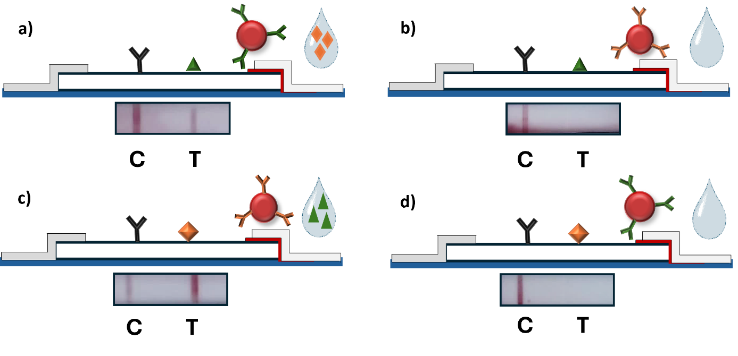
Figure SI5: Schematic and digital picture results of cross-reactivity tests on single-test line assays: a) thiamphenicol-LFIA using conjugate Au NPs-antiThiam OD 3 in presence of tylosin in milk; b) thiamphenicol-LFIA using conjugate Au NPs-antiTyl OD 3 in milk; c) tylosin-LFIA using conjugate Au NPs-antiTyl OD 3 in presence of thiamphenicol in milk; d) tylosin-LFIA using conjugate Au NPs-antiThiam OD 3 in milk.

Double conjugate test
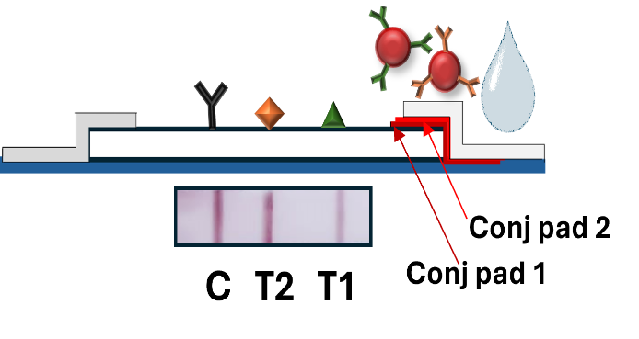
Figure SI6: Schematic and digital picture of the negative result (1+1: milk + running buffer) obtained using two separate conjugate pads for the two-types modified nanoparticles. In particular, ‘conj pad 1’ is referred to Au NPs-antiThiam OD 3, while ‘conj pad 2’ is referred to Au NPs-antiTyl OD 3. All the rest of the components were maintained constant.

Calibration curves for Thiamphenicol and Tylosin
Table SI1: Calibration curves parameters for Figure 5 and 6.
Intensity | Curve | IC₅₀ | Dynamic range  (IC₁₀-IC₉₀)
Thiamphenicol T₁/C | Fig. 5b | 2.8 ± 2.7 | 0.2-46.2
Thiamphenicol T₁ | Fig. 5c | 5.0 ± 4.4 | 0.3-86.9
Tylosin T₂/C | Fig. 5e | 5.2 ± 6.1 | 0.3-90.6
Tylosin T₂ | Fig. 5f | 13.1 ± 7.7 | 0.9-186.4
Thiamphenicol T₁/C | Fig. 6b | 8.1 ± 4.7 | 0.3-254.4
Thiamphenicol T₁ | Fig. 6c | 10.8 ± 1.3 | 0.7-167.7
Tylosin T₂/C | Fig. 6d | 7.9 ± 2.0 | 1.5-41.1
Tylosin T₂ | Fig. 6e | 6.9 ± 1.0 | 1.5-31.6

Stability
The stability of the multiplex-LFIA was evaluated at room temperature in a month time in three different days (day 1-7-30) at three different concentration levels (0-10-100 ppb) for both antibiotics: thiamphenicol (Figure SI7a) and tylosin (Figure SI7b).
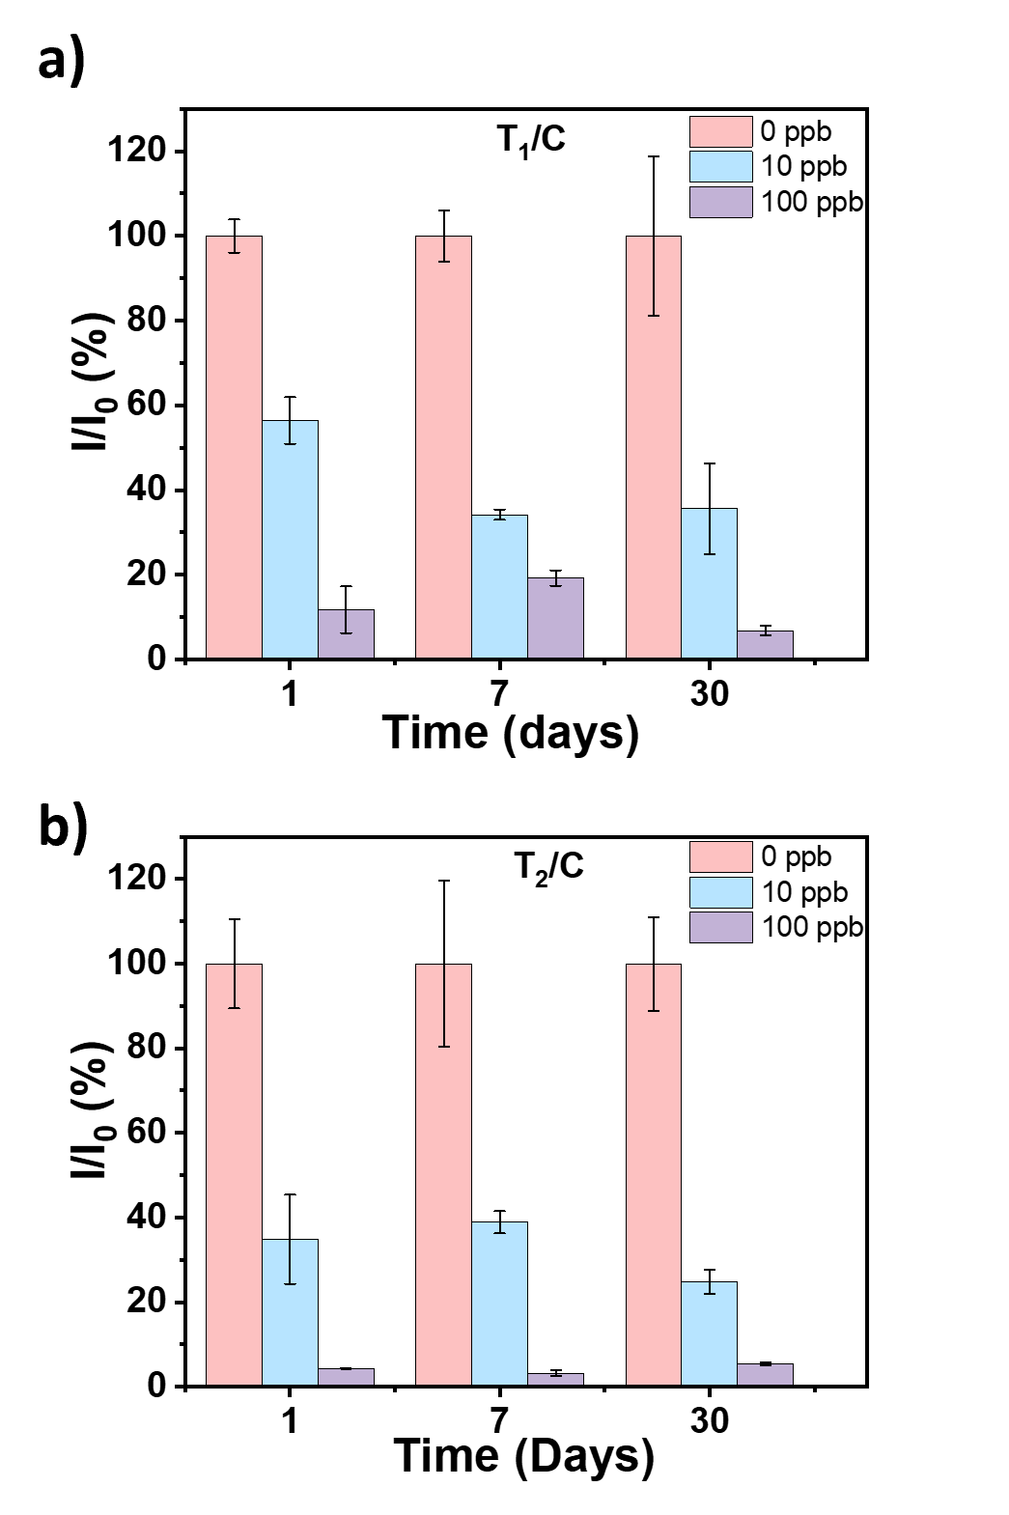
Figure SI7: Stability of the multiplex-LFIA developed at room temperature at three concentrations of antibiotics: a) thiamphenicol; b) tylosin. The measurements were done in milk on two replicates at day 1, day 7 and day 30.

References

[1] S. Thompson, ‘Small-Molecule-Protein Conjugation Procedures’, in Molecular Diagnosis of Infectious Diseases, J. Decler and U. Reischl, Eds., Totowa, NJ: Humana Press, 2004, pp. 255–265. doi: 10.1385/1-59259-679-7:255.
[2] G. T. Hermanson, Bioconjugate Techniques. Academic Press, 2010.

