Supplementary Table 1. PCR primers used in the study
Target gene | Primer name | Sequence
Amplification of RNAi fragment
OsFatB1 | Rte1 | CTCTAGAGTCATGGCTGGTTCTCTTGCGGC
OsFatB1 | Rte2 | CTCTAGAACCATCACCTAAGAGACCAGCAGT
OsFatB1 | RteSac5 | CGAGCTCGTCATGGCTGGTTCTCTTGCGGC
OsFatB1 | RteBam3 | CTCTAGAACCATCACCAGACCAGCAGT
Genotyping makers
OsFatB1^{KO} | PEL7 | ATTGTTAGGTTGCAAGTTAGTTAAGA
OsFatB1^{KO} | PEL8 | CACCAGCAAAATGAATG ACG
OsFatB1^{KO} | PEL9 | GCAGTGTTTGGGTGATGATG
RNAi cassette | Ubi_F | CCCTGCCTTCATACGCTATT
RNAi cassette | FATB_dup_R | TGTCTTCGGAGCAGTGTACG
RT-PCR
OsFatB1 | P0399F2 | CGCTGCTACCAAACAATTCA
OsFatB1 | P0399R2 | TTCTGTGTTGCCATCATCG
OsFatB2 | P5291_F2 | CAGGAAATAAAGTTGGTGATGATG
OsFatB2 | P8870R | CTTCACAATATCAGCTCCTGACTC
OsFatB3 | P5291_F2 | CTGCTTGATTGGAAGCCG
OsFatB3 | P5291R | CGACCCATGTGTCAACTTGAACCA
OsFatB4 | P4236F2 | ACAGGCCTGACTCCACGAT
OsFatB4 | P4236R2 | GGCAAGAGGTGTTAGCAAGG
Ostuba1 | OSTUBA1_F | TACCCACTCCCTCCTTGAGC
Ostuba1 | OSTUBA1_R | AGGCACTGTTGGTGATCTCG

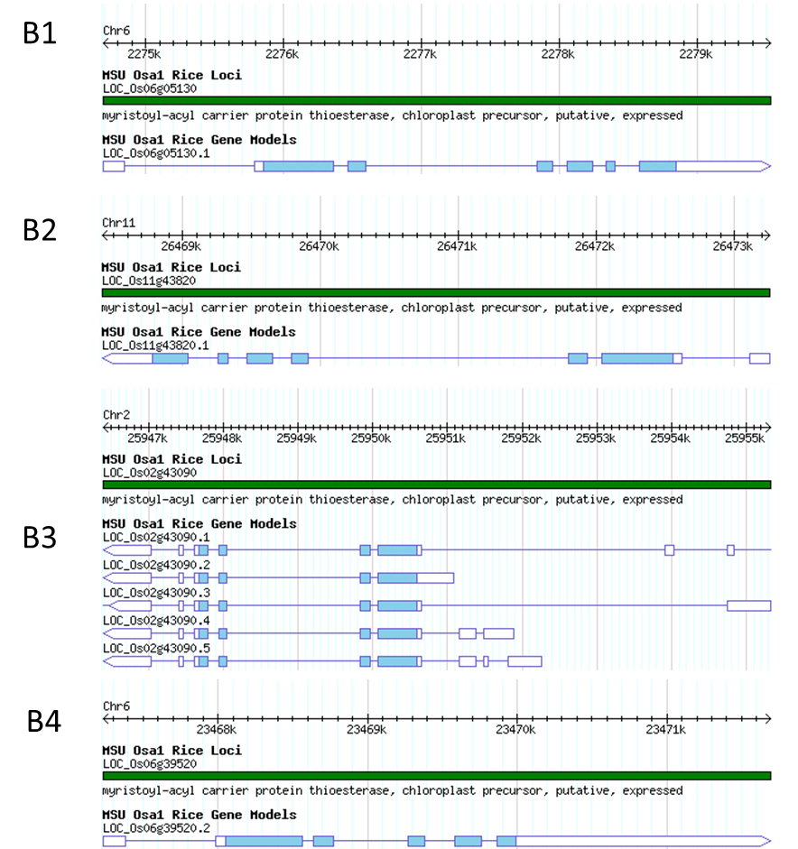
OsFatB3
OsFatB4
OsFatB1
OsFatB2
Supplementary figure 1. Gene structure and localization of OsFatBs in the rice genome. The figures were downloaded and adapted from the Rice Genome Annotation Project Database. The corresponding gene identity is indicated on the right side of each panel. The chromosome names are labelled on the top of each panel. The introns and exons of each gene are presented at the bottom of each panel.

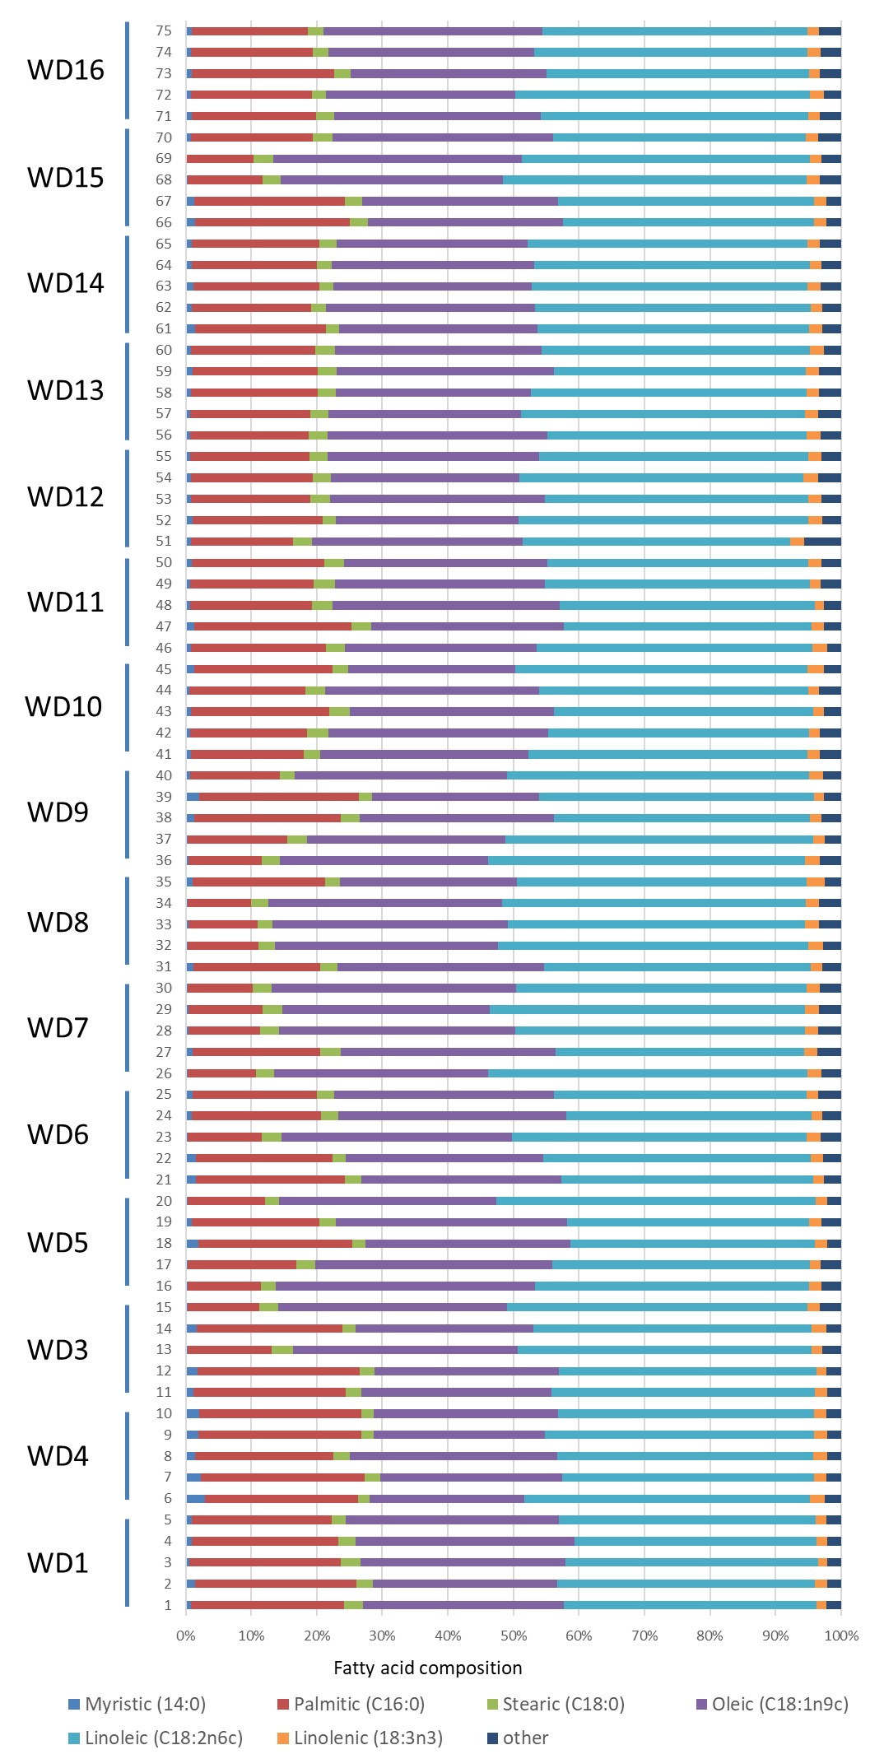
Supplementary figure 2. Fatty acid compositions of a half seed of the OsFatB^{DR} lines. The total fatty acid compositions were from individual seeds. Five seeds were selected randomly from each transgenic line.

