EXTENDED DATA

Extended Data Fig. 1 TREM2 effect on cognitive decline stratified by TREM2 mutation carriers compared to non-carriers.
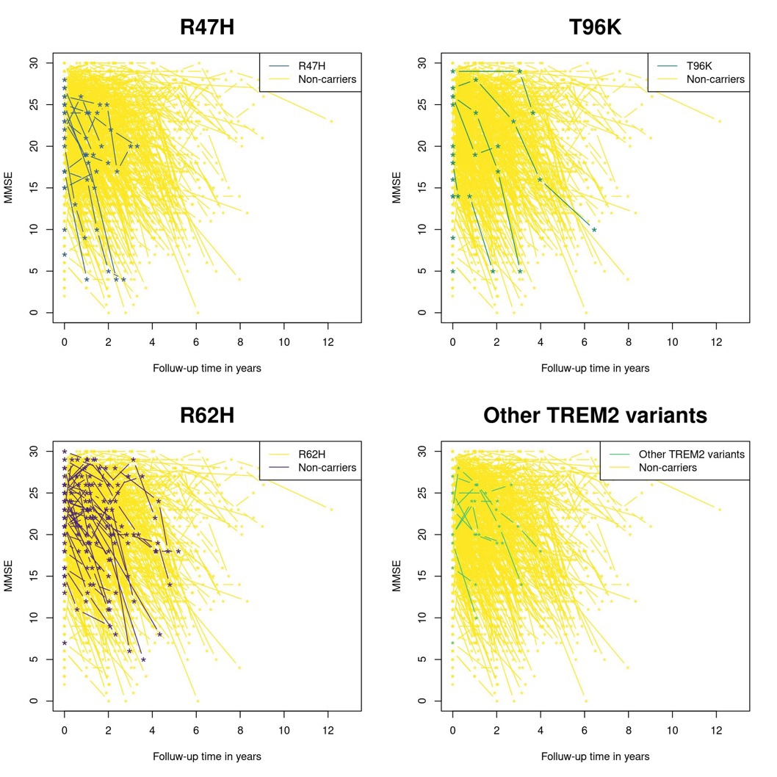
Shown here are MMSE values per individual over time, unadjusted.
Other TREM2 variants include: D87N, G58A, Q33X, C51Y, R47G, R31F, and A105V.
Abbrev.: MMSE = Mini-Mental State Examination; R47H = p.Arg47His; R62H = p.Arg62His; T96K = p.Thr96Lys; TREM2 = Triggering Receptor Expressed on Myeloid Cells 2.
SUPPLEMENTARY MATERIAL

Supplementary Fig. 1: TREM2 effect on time between diagnosis of symptomatic AD and death compared to non-carriers.
(a) 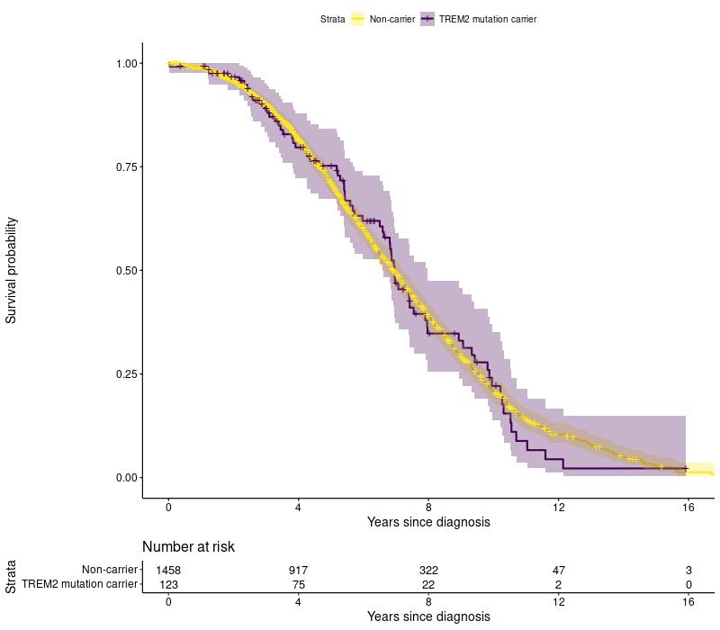 (b) 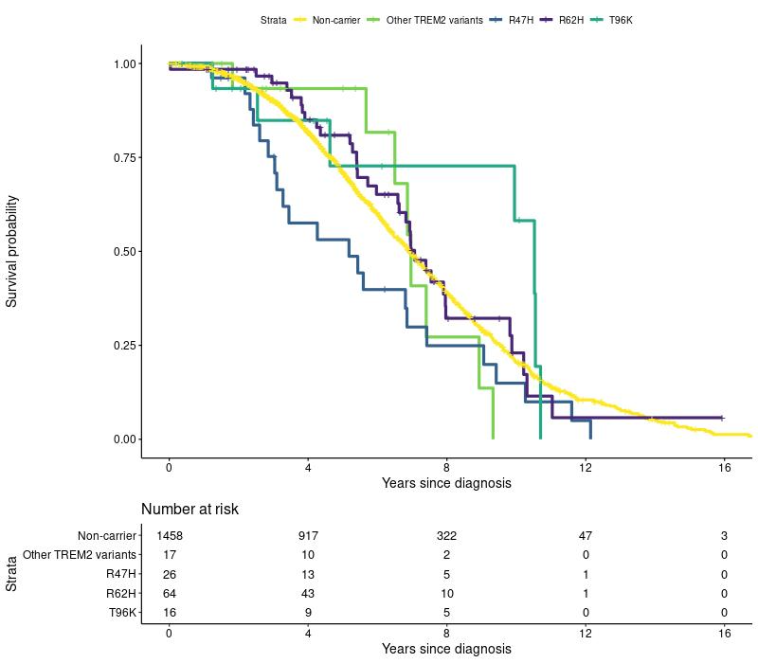
Shown here are unadjusted Kaplan Meijer curves of the time between diagnosis and death.
(a) TREM2 mutation carriers vs. non-carriers. (b) TREM2-mutation carriers stratified by mutation vs. non-carriers.
Other TREM2 variants include: D87N, G58A, Q33X, C51Y, R47G, R31F, and A105V.
Abbreviations: R47H = p.Arg47His; R62H = p.Arg62His; T96K = p.Thr96Lys; TREM2 = Triggering Receptor Expressed on Myeloid Cells 2.

Supplementary Table 1: Cohort characteristics per endophenotype.
 | Main analysis |  |  |  |  |  |  |  | Exploratory analysis
 | Total | Neuropsych.  Domains | MRI clinical  ratings | CSF | CSF-NfL | EEG | Time Diagnosis  to Death | MMSE  over Time | MRI structural | Tau-PET
Total | 1582 (100) | 1519 (96) | 1210 (76) | 1522 (96) | 164 (10) | 1304 (82) | 1582 (100) | 1564 (99) | 1069 (68) | 67 (4)
Female | 824 (52) | 789 (52) | 637 (53) | 791 (52) | 94 (57) | 679 (52) | 824 (52) | 814 (52) | 558 (52) | 33 (49)
Age at diagnosis, mean ±SD | 64.4 ±7 | 64.4 ±7 | 64.8 ±7 | 64.4 ±7 | 63.4 ±7 | 64.4 ±7.1 | 64.4 ±7 | 64.4 ±7 | 64.6 ±7 | 63 ±7
Education, median (IQR) | 1 (0-2) | 1 (0-2) | 1 (0-2) | 1 (0-2) | 1 (0-2) | 1 (0-2) | 1 (0-2) | 1 (0-2) | 1 (0-2) | 2 (1-2)
Positive family historyª | 691 (44) | 670 (44) | 524 (43) | 660 (43) | 78 (48) | 565 (43) | 691 (44) | 688 (44) | 466 (44) | 35 (52)
ApoE-ε4 carrier | 1076 (68) | 1044 (69) | 842 (70) | 1038 (68) | 115 (70) | 899 (69) | 1076 (68) | 1064 (68) | 743 (70) | 46 (69)
Died | 949 (60) | 894 (59) | 747 (62) | 924 (61) | 102 (62) | 811 (62) | 949 (60) | 934 (60) | 657 (61) | 35 (52)
Age at death | 71 ±8 | 71.1 ±8 | 71.5 ±8 | 71.1 ±7.7 | 69.2 ±8 | 71.2 ±8 | 71 ±8 | 71 ±8 | 71.2 ±8 | 69.4 ±7
TREM2 mutation carriers | 123 (8) | 118 (8) | 99 (8) | 117 (8) | 10 (6) | 105 (8) | 123 (8) | 120 (8) | 95 (9) | 4 (6)
R62H | 66 (54) | 64 (54) | 54 (55) | 61 (52) | 4 (40) | 57 (54) | 66 (54) | 66 (55) | 53 (56) | 1 (25)
R47H | 26 (21) | 25 (21) | 18 (18) | 26 (22) | 3 (30) | 23 (22) | 26 (21) | 24 (20) | 18 (19) | 1 (25)
T96K | 16 (13) | 14 (12) | 15 (15) | 16 (14) | 2 (20) | 12 (11) | 16 (13) | 15 (12) | 11 (12) | 0 (0)
Other variants* | 17 (14) | 17 (14) | 13 (13) | 16 (14) | 1 (10) | 15 (14) | 17 (14) | 17 (14) | 14 (15) | 2 (50)
Table shows n (%) unless otherwise specified.
*Other TREM2 variants include: D87N, G58A, Q33X, C51Y, R47G, R31F, and A105V.
a) Positive family history = affected first degree relative.
Abbreviations: AD = Alzheimer’s Disease; ApoE = Apolipoprotein E; CSF = cerebrospinal fluid; Diag. = Diagnosis; EEG = Electroencephalography; IQR = Interquartile Range; MMSE = Mini-Mental State Examination; MRI = Magnetic Resonance Imaging; n = number; NfL = Neurofilament Light; Neuropsych. = Neuropsychological; PET = Positron Emission Tomography; R47H = p.Arg47His; R62H = p.Arg62His; T96K = p.Thr96Lys; SD = Standard Deviation; TREM2 = Triggering Receptor Expressed on Myeloid Cells 2.
Supplementary Table 2: Effect of TREM2 variants on clinical measures in AD comparing TREM2 mutation carriers vs. non-carriers, scaled.
 | Main analysis |  | Exploratory analysis
 | All TREM2 variants combined |  | R62H |  | R47H |  | T96K |  | Other TREM2 variants
 | stdβ ± SE | p-value✦ | stdβ ± SE | p-value | stdβ ± SE | p-value | stdβ ± SE | p-value | stdβ ± SE | p-value
MMSE at baseline | -0.00 ±0.08 | 0.962 | 0.07 ±0.11 | 0.544 | -0.11 ±0.18 | 0.54 | -0.19 ±0.20 | 0.339 | 0.08 ±0.22 | 0.724
Neuropsychological domains
Memory | -0.14 ±0.07 | 0.247 | -0.10 ±0.10 | 0.327 | -0.27 ±0.16 | 0.097 | -0.42 ±0.18 | 0.018* | 0.13 ±0.19 | 0.487
Executive functioning | 0.07 ±0.16 | 0.816 | 0.21 ±0.21 | 0.316 | -0.69 ±0.35 | 0.053 | -0.36 ±0.37 | 0.331 | 0.63 ±0.39 | 0.110
Attention and speed | 0.12 ±0.10 | 0.667 | 0.28 ±0.14 | 0.042* | -0.40 ±0.22 | 0.072 | 0.18 ±0.25 | 0.463 | 0.07 ±0.25 | 0.774
Language | -0.03 ±0.08 | 0.816 | 0.18 ±0.10 | 0.075 | -0.38 ±0.17 | 0.027* | -0.37 ±0.18 | 0.034* | -0.00 ±0.19 | 0.996
Visuospatial functioning | 0.21 ±0.08 | 0.094✦ | 0.16 ±0.10 | 0.12 | 0.24 ±0.17 | 0.174 | 0.24 ±0.18 | 0.197 | 0.29 ±0.19 | 0.123
Global cognition | -0.04 ±0.07 | 0.816 | 0.02 ±0.08 | 0.824 | -0.56 ±0.16 | 0.0004*** | -0.15 ±0.15 | 0.329 | 0.28 ±0.16 | 0.076
Magnetic resonance imaging
Medial Temporal Atrophy | -0.06 ±0.10 | 0.816 | -0.26 ±0.13 | 0.052 | 0.07 ±0.23 | 0.771 | 0.31 ±0.21 | 0.144 | 0.09 ±0.27 | 0.731
Parietal Cortical Atrophy | -0.10 ±0.11 | 0.667 | 0.13 ±0.14 | 0.343 | -0.32 ±0.24 | 0.181 | -0.56 ±0.23 | 0.013* | -0.43 ±0.28 | 0.128
Fazekas score | -0.14 ±0.10 | 0.479 | -0.27 ±0.13 | 0.035* | 0.03 ±0.22 | 0.903 | 0.03 ±0.20 | 0.875 | 0.10 ±0.26 | 0.685
Cerebrospinal fluid
Aβ42 | -0.09 ±0.10 | 0.667 | -0.04 ±0.13 | 0.760 | 0.21 ±0.20 | 0.297 | -0.64 ±0.21 | 0.003** | -0.18 ±0.25 | 0.475
pTau-181 | 0.03 ±0.10 | 0.847 | 0.00 ±0.13 | 0.994 | 0.60 ±0.20 | 0.003** | -0.50 ±0.21 | 0.019* | -0.04 ±0.25 | 0.877
t-Tau | 0.05 ±0.10 | 0.816 | 0.08 ±0.13 | 0.557 | 0.47 ±0.20 | 0.018* | -0.45 ±0.21 | 0.035* | -0.05 ±0.25 | 0.833
Neurofilament Light | 0.08 ±0.32 | 0.797 | -0.02 ±0.51 | 0.963 | 0.35 ±0.59 | 0.556 | 0.51 ±0.71 | 0.475 | -1.05 ±1.00 | 0.297
 | β ± SE | p-value✦ | β ± SE | p-value | β ± SE | p-value | β ± SE | p-value | β ± SE | p-value
EEG abnormality^{log} | -0.44 ±0.21 | 0.227 | -0.38 ±0.29 | 0.195 | -0.21 ±0.43 | 0.633 | -0.62 ±0.55 | 0.369 | -0.96 ±0.60 | 0.133
Time diagnosis-death^{cox} | 0.12 ±0.13 | 0.667 | 0.05 ±0.18 | 0.759 | 0.47 ±0.22 | 0.034* | -0.42 ±0.41 | 0.311 | 0.13 ±0.36 | 0.706
Cognitive decline^{lmm} | -0.63 ±0.25 | 0.094✦ | -0.54 ±0.31 | 0.085 | -1.40 ±0.61 | 0.021* | -1.75 ±0.74 | 0.018* | 0.58 ±0.62 | 0.350
Shown here are standardized betas of linear regression models adjusted for age and sex; MMSE at baseline and neuropsychological domains are also adjusted for education level and disease stage. Also shown here are betas of logistic regression models (log), cox proportional hazards models (cox), and linear mixed models (lmm) adjusted for age, sex, education level, and disease stage; cox regression models are also adjusted for MMSE at baseline.
✦ FDR-corrected p<0.10, *p<0.05, **p<0.01.
Other TREM2 variants include: D87N, G58A, Q33X, C51Y, R47G, R31F, and A105V.
Abbreviations: Aβ42 = Beta-Amyloid 42; CI = confidence interval; EEG = Electroencephalography; EF = Executive Functioning; FDR = False Discovery Rate; MMSE = Mini-Mental State Examination; pTau-181 = Phosphorylated Tau-181; R47H = p.Arg47His; R62H = p.Arg62His; SE = Standard Error; stdβ = standardized beta; T96K = p.Thr96Lys; TREM2 = Triggering Receptor Expressed On Myeloid Cells 2.

Supplementary Table 3: Effect of TREM2 variants on time between diagnosis and death.
 | Hazard Ratio [95%-Confidence Interval] | p-value | p-value FDR-corrected
Model 1
All TREM2 variants | 1.12 [0.9-1.4] | 0.353 | 0.667
Model 2
R62H | 1.06 [0.8-1.5] | 0.759 | NA
R47H | 1.60 [1.0-2.5] | 0.034* | NA
T96K | 0.66 [0.3-1.5] | 0.311 | NA
Other TREM2 variants | 1.14 [0.6-2.3] | 0.706 | NA
Shown here are hazard ratios with 95% confidence interval, adjusted for age at diagnosis, sex, education level, disease stage (MCI/dementia), and MMSE at baseline.
*p<0.05
Other TREM2 variants include: D87N, G58A, Q33X, C51Y, R47G, R31F, and A105V.
Abbreviations: NA = Not Available; FDR = False Discovery Rate; R47H = p.Arg47His; R62H = p.Arg62His; T96K = p.Thr96Lys; TREM2 = Triggering Receptor Expressed on Myeloid Cells 2.

Supplementary Table 4: Summary statistics of quantitative image analysis of significant TREM2-associated cortical thickness regions and subcortical volumes based on Desikan Kiliany atlas.
 | Lobe | Brain region of interest | stdβ ± SE | p-value
All TREM2 variants | Subcortical | Amygdala | 0.19 ±0.10 | 0.047
R62H | Temporal | Temporal pole | 0.29 ±0.14 | 0.037
R47H | Occipital | Cuneus | 0.49 ±0.24 | 0.037
 |  | Lingual | 0.47 ±0.24 | 0.049
 | Subcortical | Amygdala | 0.69 ±0.21 | 0.001
 |  | Hippocampus | 0.49 ±0.20 | 0.016
T96K | Cingulate | Rostral anterior cingulate | -0.67 ±0.25 | 0.007
 | Frontal | Medial orbitofrontal | -0.50 ±0.25 | 0.047
 | Subcortical | Hippocampus | -0.64 ±0.22 | 0.003
 | NA | Insula | -0.55 ±0.25 | 0.029
Other TREM2 variants | Cingulate | Isthmus cingulate | -0.61 ±0.28 | 0.027
 | Frontal | Pars orbitalis | -0.59 ±0.27 | 0.033
 |  | Frontal pole | -0.56 ±0.28 | 0.042
Shown here are standardized betas with standard error, adjusted for age, sex and estimated intracranial volume. The betas represent the effect of TREM2 variants on cortical thickness (mm) and subcortical volumes (mm³) compared to non-carriers with symptomatic AD.
Other TREM2 variants include: D87N, G58A, Q33X, C51Y, R47G, R31F, and A105V.
Abbreviations: CI = confidence interval; R47H = p.Arg47His; T96K = p.Thr96Lys; SE = Standard Error; stdβ = standardized beta; TREM2 = Triggering Receptor Expressed on Myeloid Cells 2.

Supplementary Table 5: Sensitivity analyses of TREM2 effect on clinical measures in symptomatic Alzheimer’s disease, scaled.
Shown here are (standardized) betas of the sensitivity analyses. (a) Cohort descriptives per clinical measure. (b) Shown here are standardized betas of linear regression models are adjusted for age, sex, and three principal components. Neuropsychological domains are also adjusted for education level and disease stage (MCI/dementia). Also shown here are betas of logistic regression models (log), cox proportional hazards models (cox), and linear mixed models (lmm) adjusted for age, sex, education level, disease stage and three principal components; cox regression models are also adjusted for MMSE at baseline. (c) Cox regression models are adjusted for age at diagnosis, sex, education level, disease stage, MMSE at baseline, and three principal components. (d) Significant findings of linear regression models in quantitative image analysis adjusted for age, sex, estimated intracranial volume, and three principal components (p<0.05).
✦ FDR-corrected p<0.10, *p<0.05, **p<0.01, ***p<0.001.
Other TREM2 variants include: D87N, G58A, Q33X, C51Y, R31F.
Abbreviations: Aβ42 = Beta-Amyloid 42; AD = Alzheimer’s Disease; ApoE = Apolipoprotein E; CI = confidence interval; CSF = cerebrospinal fluid; EF = Executive Functioning; IQR = Interquartile Range; MMSE = Mini-Mental State Examination; MRI = Magnetic Resonance Imaging; MTA = Medial Temporal Lobe; n = number; NA = Not Applicable; NfL = Neurofilament Light; Neuropsych. = Neuropsychological; PCA = Posterior Cortical Atrophy; pTau-181 = Phosphorylated Tau-181; R47H = p.Arg47His; R62H = p.Arg62His; SD = Standard Deviation; SE = Standard Error; stdβ = standardized beta; T96K = p.Thr96Lys; TREM2 = Triggering Receptor Expressed on Myeloid Cells 2.

a)
 | Main analysis |  |  |  |  |  |  |  | Exploratory analysis
 | Total | Neuropsych.  Domains | MRI clinical  ratings | CSF | CSF-NfL | EEG | Time Diagnosis  to Death | MMSE  over Time | MRI structural | Tau-PET
Total | 1444 (100) | 1391 (96) | 1102 (76) | 1390 (96) | 150 (10) | 1189 (82) | 1444 (100) | 1431 (99) | 968 (67) | 63 (4)
Female | 747 (52) | 717 (52) | 572 (52) | 719 (52) | 85 (57) | 616 (52) | 747 (52) | 739 (52) | 496 (51) | 31 (49)
TREM2 mutation carriers | 103 (7) | 101 (7) | 84 (8) | 97 (7) | 8 (5) | 89 (7) | 103 (7) | 101 (7) | 83 (9) | 4 (6)
R62H | 60 (58) | 59 (58) | 51 (61) | 55 (57) | 4 (50) | 52 (58) | 60 (58) | 60 (59) | 50 (60) | 1 (25)
R47H | 26 (25) | 25 (25) | 18 (21) | 26 (27) | 3 (38) | 23 (26) | 26 (25) | 24 (24) | 18 (22) | 1 (25)
T96K | 3 (3) | 3 (3) | 3 (4) | 3 (3) | 0 (0) | 2 (2) | 3 (3) | 3 (3) | 2 (2) | 0 (0)
Other variants* | 16 (16) | 16 (16) | 13 (15) | 15 (15) | 1 (12) | 14 (16) | 16 (16) | 16 (16) | 14 (17) | 2 (50)
Table shows n (%).
b)
 | Main analysis |  | Exploratory analysis
 | All TREM2 variants combined |  | R62H |  | R47H |  | T96K |  | Other TREM2 variants
 | stdβ ± SE | p-value✦ | stdβ ± SE | p-value | stdβ ± SE | p-value | stdβ ± SE | p-value | stdβ ± SE | p-value
MMSE at baseline | 0.09 ±0.10 | 0.555 | 0.08 ±0.13 | 0.506 | -0.14 ±0.20 | 0.497 | 0.45 ±0.56 | 0.419 | 0.31 ±0.24 | 0.196
Neuropsychological domains
Memory | -0.08 ±0.08 | 0.555 | -0.08 ±0.10 | 0.443 | -0.29 ±0.17 | 0.079 | -0.43 ±0.45 | 0.340 | 0.22 ±0.20 | 0.270
Executive functioning | 0.16 ±0.17 | 0.555 | 0.26 ±0.22 | 0.233 | -0.69 ±0.35 | 0.052 | -0.46 ±0.91 | 0.612 | 0.81 ±0.40 | 0.046*
Attention and speed | 0.08 ±0.11 | 0.700 | 0.25 ±0.14 | 0.082 | -0.40 ±0.22 | 0.072 | 0.58 ±0.60 | 0.337 | 0.06 ±0.26 | 0.832
Language | -0.01 ±0.08 | 0.943 | 0.15 ±0.10 | 0.153 | -0.39 ±0.17 | 0.022* | -0.36 ±0.45 | 0.430 | 0.02 ±0.20 | 0.904
Visuospatial functioning | 0.22 ±0.08 | 0.136 | 0.19 ±0.11 | 0.072 | 0.23 ±0.17 | 0.188 | 0.20 ±0.41 | 0.629 | 0.30 ±0.19 | 0.122
Global cognition | -0.03 ±0.07 | 0.872 | 0.03 ±0.09 | 0.765 | -0.56 ±0.16 | 0.0004*** | -0.18 ±0.34 | 0.589 | 0.27 ±0.16 | 0.082
Magnetic resonance imaging
Medial Temporal Atrophy | -0.12 ±0.11 | 0.555 | -0.23 ±0.14 | 0.099 | 0.06 ±0.23 | 0.783 | 0.00 ±0.56 | 0.998 | 0.08 ±0.27 | 0.770
Parietal Cortical Atrophy | -0.02 ±0.11 | 0.943 | 0.19 ±0.14 | 0.189 | -0.34 ±0.24 | 0.150 | -0.45 ±0.71 | 0.525 | -0.44 ±0.28 | 0.116
Fazekas score | -0.18 ±0.11 | 0.353 | -0.30 ±0.13 | 0.025* | 0.02 ±0.22 | 0.914 | -0.58 ±0.54 | 0.281 | 0.08 ±0.26 | 0.755
Cerebrospinal fluid
Aβ42 | 0.02 ±0.10 | 0.943 | -0.00 ±0.14 | 0.994 | 0.22 ±0.20 | 0.273 | -0.52 ±0.57 | 0.365 | -0.17 ±0.26 | 0.498
pTau-181 | 0.11 ±0.10 | 0.555 | -0.00 ±0.14 | 0.989 | 0.60 ±0.20 | 0.003** | -0.63 ±0.58 | 0.276 | -0.05 ±0.26 | 0.839
t-Tau | 0.11 ±0.10 | 0.555 | 0.08 ±0.14 | 0.548 | 0.46 ±0.20 | 0.020* | -0.74 ±0.58 | 0.199 | -0.09 ±0.26 | 0.735
Neurofilament Light | -0.06 ±0.37 | 0.865 | -0.04 ±0.52 | 0.931 | 0.28 ±0.60 | 0.638 | NA | NA | NA | NA
 | β ± SE | p-value✦ | β ± SE | p-value | β ± SE | p-value | β ± SE | p-value | β ± SE | p-value
EEG abnormality^{log} | -0.49 ±0.23 | 0.249 | -0.37 ±0.30 | 0.205 | -0.21 ±0.43 | 0.631 | -12.9 ±NA | 0.969 | -1.2 ±0.67 | 0.065
Time diagnosis-death^{cox} | 0.14 ±0.13 | 0.555 | -0.01 ±0.18 | 0.951 | 0.46 ±0.22 | 0.038* | 0.08 ±1.0 | 0.934 | 0.08 ±0.38 | 0.844
Cognitive decline^{lmm} | -0.52 ±0.26 | 0.249 | -0.61 ±0.32 | 0.054 | -1.38 ±0.61 | 0.022* | 0.26 ±1.2 | 0.833 | 0.61 ±0.63 | 0.332

c)
 | Hazard Ratio [95% Confidence Interval] | p-value | p-value FDR-corrected
All TREM2 variants | 1.15 [0.9-1.5] | 0.289 | 0.555
R62H | 0.99 [0.7-1.4] | 0.951 | NA
R47H | 1.59 [1.0-2.5] | 0.038* | NA
T96K | 1.09 [0.1-7.8] | 0.934 | NA
Other TREM2 variants | 1.08 [0.5-2.3] | 0.844 | NA

d)
 | Lobe | Brain region of interest | stdβ ± SE | p-value
All TREM2 variants | Subcortical | Amygdala | 0.21 ±0.10 | 0.039
R47H | Occipital | Cuneus | 0.48 ±0.24 | 0.041
 | Subcortical | Amygdala | 0.70 ±0.21 | 0.001
 |  | Hippocampus | 0.47 ±0.20 | 0.023
T96K | Temporal | Parahippocampal | 1.55 ±0.69 | 0.025
Other TREM2 variants | Cingulate | Isthmus cingulate | -0.61 ±0.28 | 0.028
 | Frontal | Pars orbitalis | -0.55 ±0.28 | 0.046

