[Supplementary information]

Silicon nanocolumn-based disposable and flexible ultrasound patches

Dong-Hyun Kang^{1,†}, Seonghun Cho^{1,2,†}, Hae Youn Kim¹, Shinyong Shim¹, Dong Hun Kim¹, Baren Jeong³, Yoon Seong Lee³, Eun-Ah Park³, Whal Lee³, Hyungmin Kim¹, Butrus T. Khuri-Yakub⁴, Maesoon Im^{5,6,7}, Jae-Woong Jeong^{2,*}, and Byung Chul Lee^{1,6,7,*}

¹ Bionics Research Center, Korea Institute of Science and Technology, 5, Hwarang-ro 14-gil, Seongbuk-gu, Seoul 02792, Republic of Korea
² School of Electrical Engineering, Korea Advanced Institute of Science and Technology, 291, Daehak-ro, Yuseong-gu, Daejeon 34141, Republic of Korea
³ Department of Radiology, Seoul National University Hospital, 101, Daehak-ro, Jongno-gu, Seoul 03080, Republic of Korea
⁴ Department of Electrical Engineering, Stanford University, 350, Jane Stanford Way, Stanford, CA 94305, United States of America
⁵ Brain Science Institute, Korea Institute of Science and Technology, 5, Hwarang-ro 14-gil, Seongbuk-gu, Seoul 02792, Republic of Korea
⁶ Division of Bio-Medical Science and Technology, KIST School, Korea National University of Science and Technology, 5, Hwarang-ro 14-gil, Seongbuk-gu, Seoul 02792, Republic of Korea
⁷ KHU-KIST Department of Converging Science and Technology, Kyung Hee University, 24, Kyungheedae-ro, Dongdaemun-gu, Seoul 02453, Republic of Korea

† These authors contributed equally to this work: Dong-Hyun Kang, Seonghun Cho
* Corresponding author: jjeong1@kaist.ac.kr (J.-W. Jeong); bclee@kist.re.kr (B.C. Lee)

[Supplementary Table]
Supplementary Table 1. Production cost for conventional CMUT and snCMUT arrays in 8-inch wafer-level fabrication
Materials  & Processes | Unit Costs ¹⁾  (KRW) | Conventional CMUT |  | snCMUT
Materials  & Processes | Unit Costs ¹⁾  (KRW) | Process | Costs (KRW) | Process | Costs (KRW)
Si wafer  (8 inch) | 60,000 | 1 ea | 60,000 | - | -
SOI wafers  (8 inch) | 750,000 | 1 ea | 750,000 | 2 ea | 1,500,000
Dry oxidation | 20,400 ²⁾ | 3 times | 61,200 | 4 times | 81,600
Photolithography | 105,000 | 6 times | 630,000 | 9 times | 945,000
RIE | 100,000 | 6 times | 600,000 | 10 times | 1,000,000
DRIE | 200,000 | - | - | 3 times | 600,000
Metal deposition | 100,000 | 2 times | 100,000 | 1 time | 100,000
Wet etch & Cleaning | 120,000 | 8 times | 960,000 | 10 times | 1,200,000
Production cost (wafer level) |  | 3,261,200 |  | 5,426,600
64ch CMUT array per 8-inch wafer
: 192 ea
Production cost  per single array |  | 16,985 (KRW)  12 (USD) ³⁾ |  | 28,264 (KRW)  20 (USD) ³⁾
1) The unit cost of all fabrication processes is calculated based on the usage fee of The National Nanofab Center in Korea
2) The cost of dry oxidation is ₩510,000 for a single run of 25 wafers, and the price per wafer is calculated to be ₩20,400.
3) Exchange rate is 1,380 (KRW/USD)

Supplementary Table 2. Comparison of mechanical property, material, lead-containing, frequency, pitch, kerf, thickness, and resolution between this work and existing state-of-the-art.
Wearable ultrasound probes | Science (2022)⁴ | Nature Electronics (2023)⁵ | Nature Biomedical Engineering (2021)⁶ | Nature (2023)⁷ | Nature Communications (2024)⁸ | This work
Mechanical property | Rigid | Rigid | Stretchable | Stretchable | Flexible | Stretchable
Material | 1-3 composite | Sm/La-PMN-PT ceramic | 1-3 composite | 1-3 composite | P(VDF-TrFE) | snCMUT
Lead-containing | ○ | ○ | ○ | ○ | × | ×
Frequency (MHz) | 3, 7, 10 | 3.5 | 2 | 3 | 7.7 | 4.25
Working voltage (V_{PP}) | 40 | 50 | 25 | - | 95 | 8.9
Pitch  (µm) | 500 | 220 | 800 | 400 | 180 | 300
Kerf  (µm) | 100 | 50 | - | 200 | - | 15
Thickness  (mm) | 3 | 4.5 | 1 | 1 | 0.1 | 0.9
Axial resolution (mm) | 0.77 (3MHz)  0.23 (7 MHz)  0.19 (10MHz) ¹⁾ | 0.5 ²⁾ | 2.5 ²⁾ | 0.7 ²⁾ | 0.23 ²⁾ | 0.52 ²⁾
Lateral resolution (mm) | 1.79 (3MHz)  0.38 (7 MHz)  0.38 (10 MHz) ¹⁾ | 2.0 ²⁾ | - | 2 ²⁾ | 0.63 ²⁾ | 0.55 ²⁾
1) The axial and lateral resolutions of the 3-, 7-, and 10-MHz probes are measured by the pulse-echo tests and point spread functions, respectively.
2) The axial and lateral resolution is the full-width-half-maximum (FWHM) calculated from the point-spread function of ultrasound images in 100 µm nylon monofilament phantoms.

Supplementary Table 3. Comparative analysis of ultrasound transmits performance between commercial PZT probe, conventional CMUT, output pressure enhanced CMUTs, and this work.
 | Commercial PZT probe¹ | Conventional CMUT² | Piston CMUT² | Post-CMUT¹ | EP-CMUT³ | snCMUT  (This work)
Operating frequency  (MHz) | 2.00 | 2.50 | 2.50 | 1.85 | 1.51 | 4.7
Max. pressure (kPa) | 802  @ 60 V_{PP} |  |  | 1880  @ 90 V_{PP} | 10400  @ 170 V_{PP} | 1509  @ 6 V_{PP}
Transmission pressure efficiency (kPa/V) | 13.4 | 6.30 ¹⁾ | 11.5 ¹⁾ | 21.5 | 61.2 | 220
Average displacement efficiency (nm/V_{PP}) ²⁾ | 0.711 | 0.251 | 0.458 | 1.13 | 4.03 | 5.38
1) The transmission pressure efficiency related to the peak-to-peak driving voltage was estimated from the unit, kPa/V_{AC}, used in the reference.
2) Average displacement efficiency (nm/V_{PP}) is calculated by
$P=Re\left(Z_{m}V\right)=Re\left(Z_{m}\right)×ω×x$ (1)
where P is the output pressure, Z_{m} is the mechanical impedance of the medium, V is the velocity of the acoustic wave particle, ω is the operating frequency, and x is the average displacement amplitude of the acoustic wave particle, which is equivalent to the plate displacement.

[Supplementary Figures]
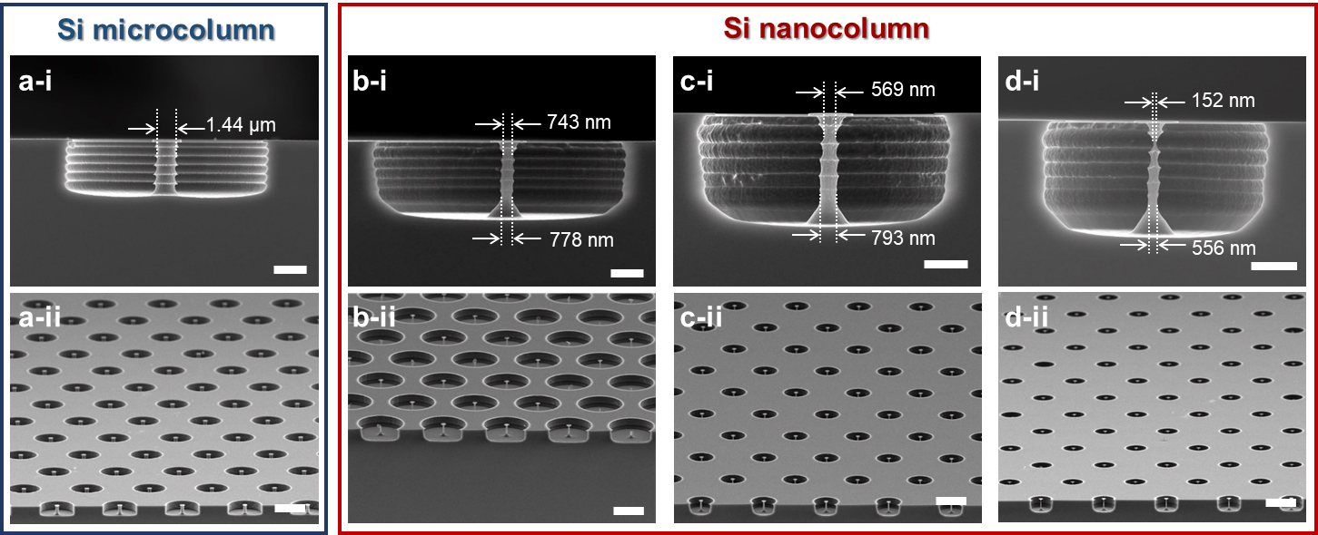
Supplementary Figure 1. a, SEM images of silicon microcolumn in cross-sectional (i) and bird-eye view (ii). The opening area was 7 µm. b-d, cross-sectional (i) and bird-eye view (ii) SEM images of silicon nanocolumns. Etch time and opening area of RIE in (b), (c), and (d) are 5, 6, and 8 min, and 10, 5, and 4 µm, respectively. The scale bar is 2 µm in (i) and 10 µm in (ii).

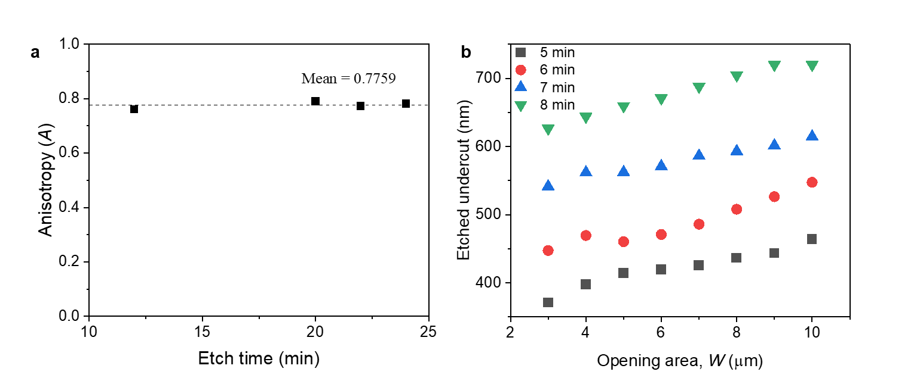
Supplementary Figure 2. a, The anisotropy (A) of silicon etching by RIE as etch time in this work. The anisotropy is defined as “horizontal etch depth/vertical etch depth.” The anisotropy in our works was 0.7759. b, The undercutting by RIE as opening area and etch time. The horizontal etch depth increased as the etch time and opening area increased.

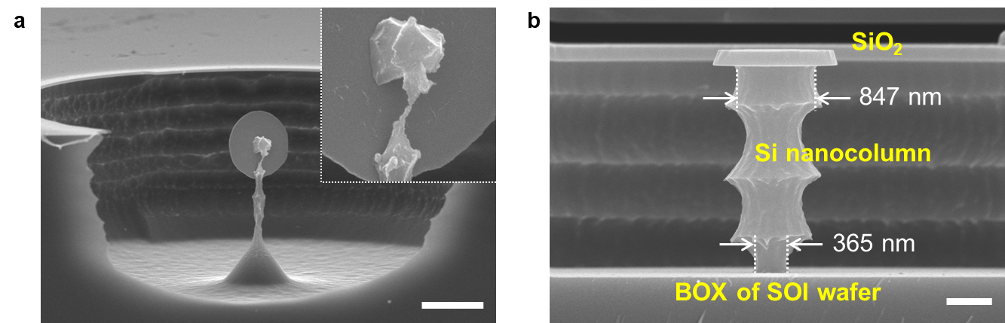
Supplementary Figure 3. a, SEM image of over-etched silicon nanocolumn with below 100 nm. Silicon nanocolumns with a minimum diameter (neck shape) below 100 nm revealed instability, leading to the collapse of the disc-shaped SiO₂ layer at the top. The scale bar is 2 µm. b, SEM image of fabricated silicon nanocolumn in SOI wafer. The BOX layer acted as an etch stop, resulting in smaller diameters at the bottom of the nanocolumns due to higher ion concentration. The scale bar is 500 nm.

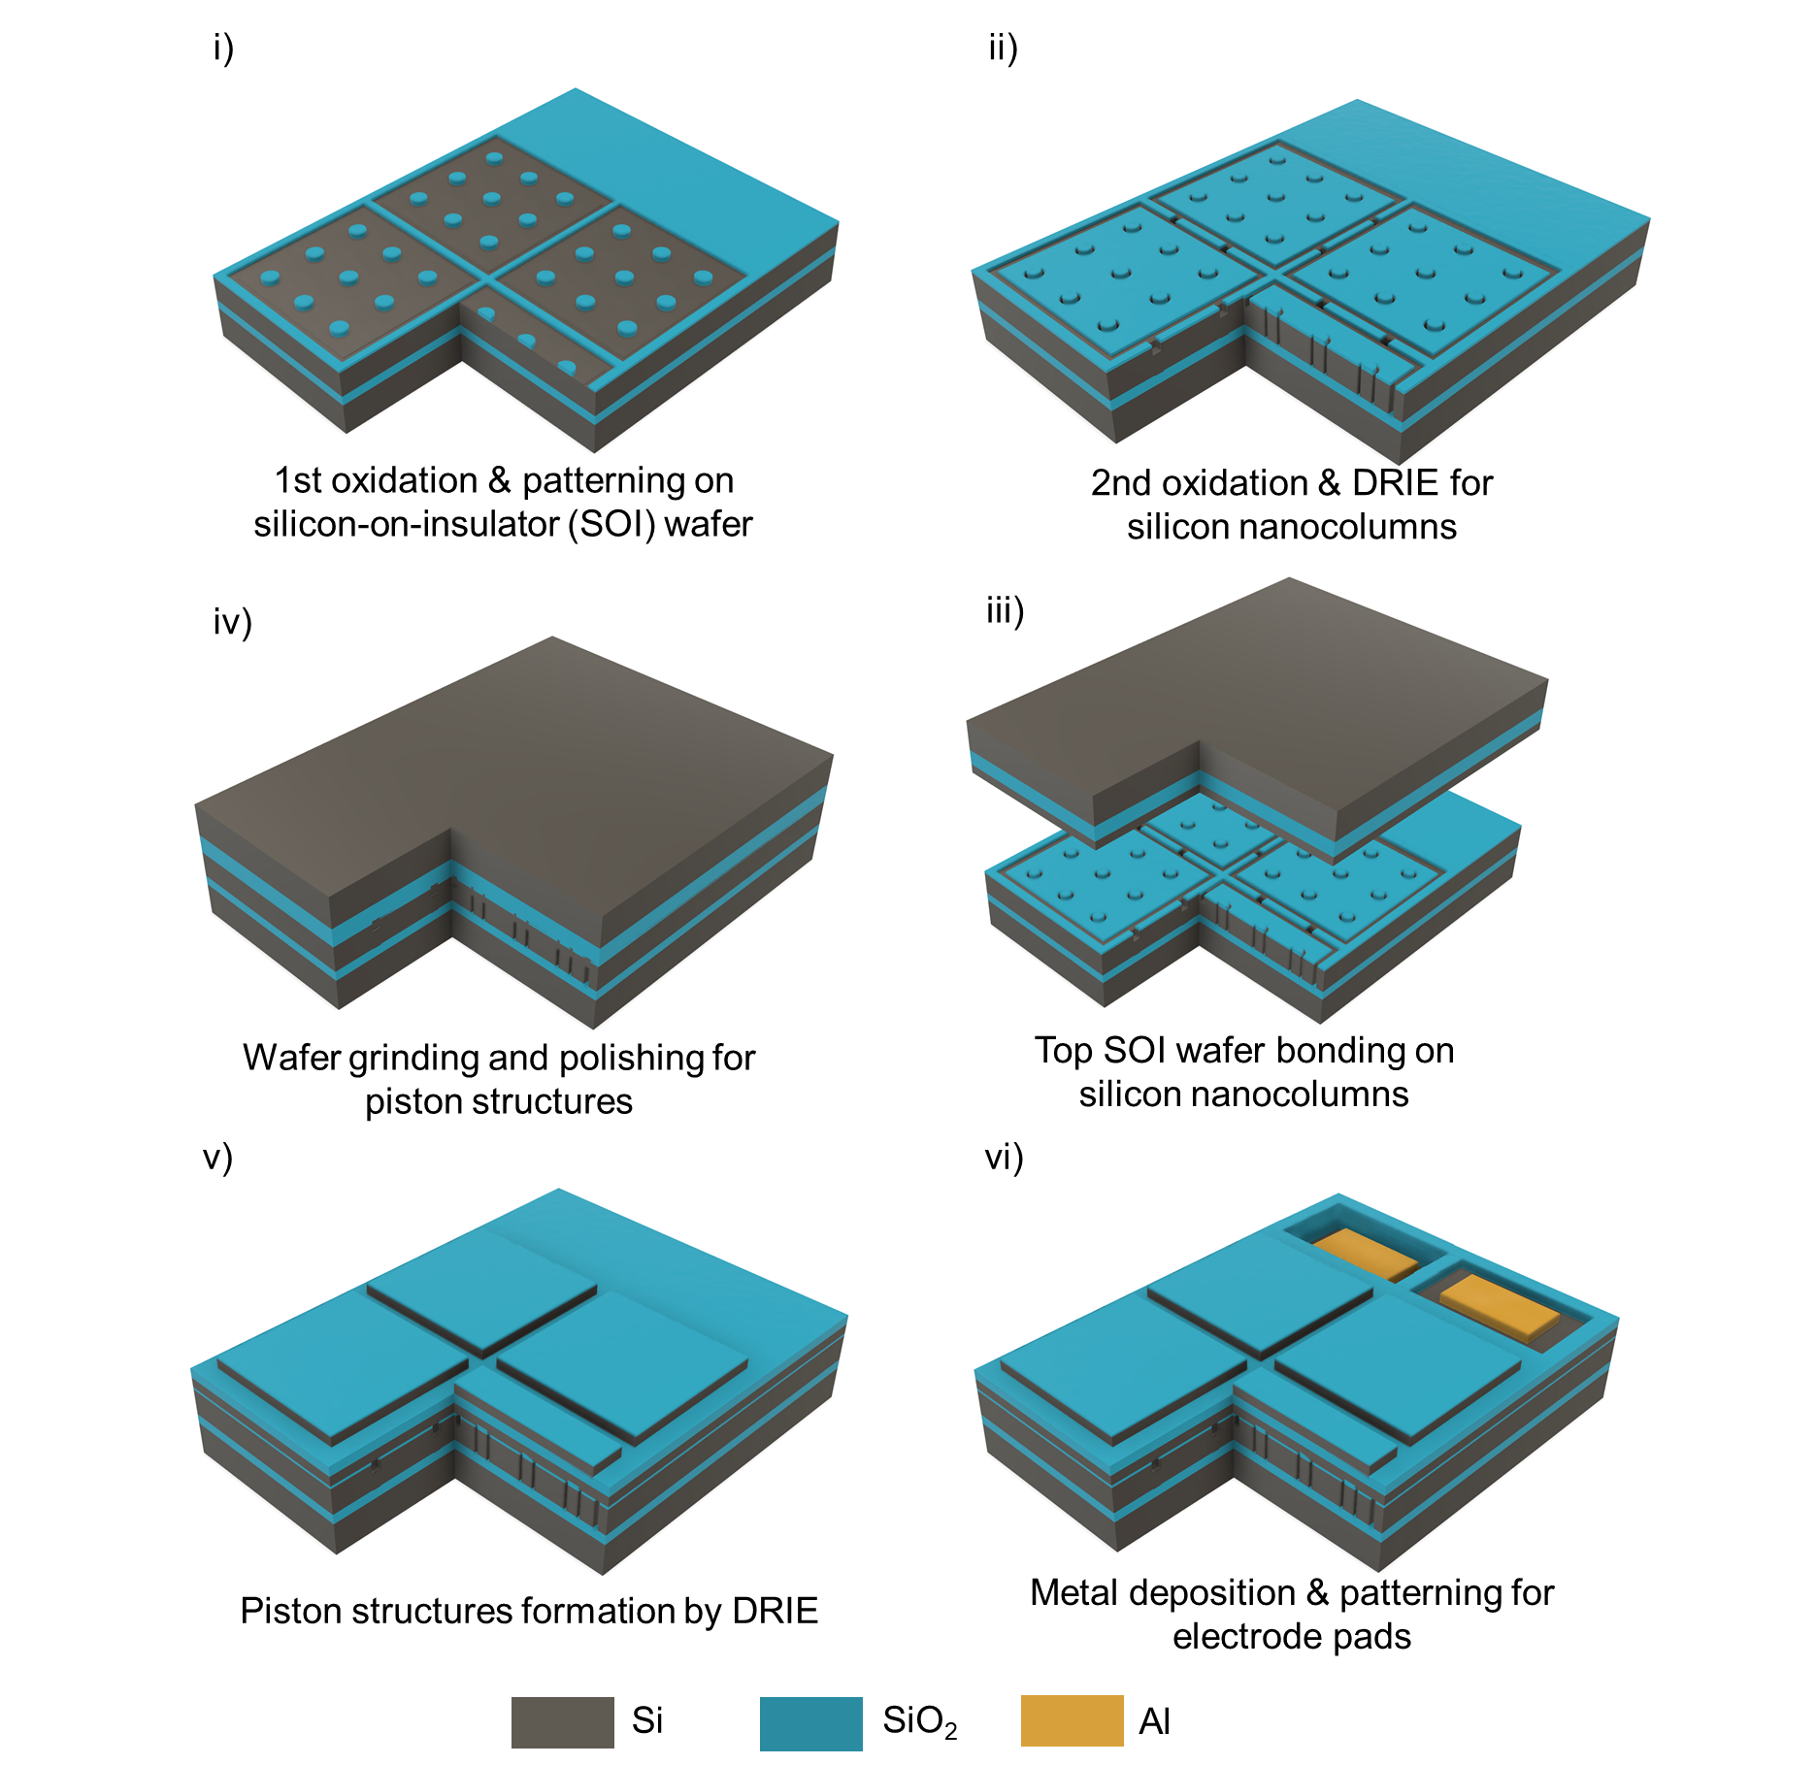
Supplementary Figure 4. The fabrication process flow of the Nanocolumn CMUT. i) 200 nm of silicon dioxide patterning for vacuum gap area; ii) Thermal oxidation for defining 180 nm of vacuum gap height and DRIE process step for defining CMUT cells and 9 silicon nanocolumns in each cell; iii) Direct wafer fusion bonding of the processed bottom SOI wafer and a top blank SOI wafer; iv) Wafer grinding and polishing for piston structures; v) Thermal oxidation and patterning for top plate mask and DRIE step for defining piston structures; vi) BOX layer of top SOI wafer opening for electrical contacts of moving plate of CMUT and silicon device layer of top SOI wafer and silicon dioxide layer of bottom SOI wafer etching for bottom electrode access; v) Metal deposition and patterning for electrodes.

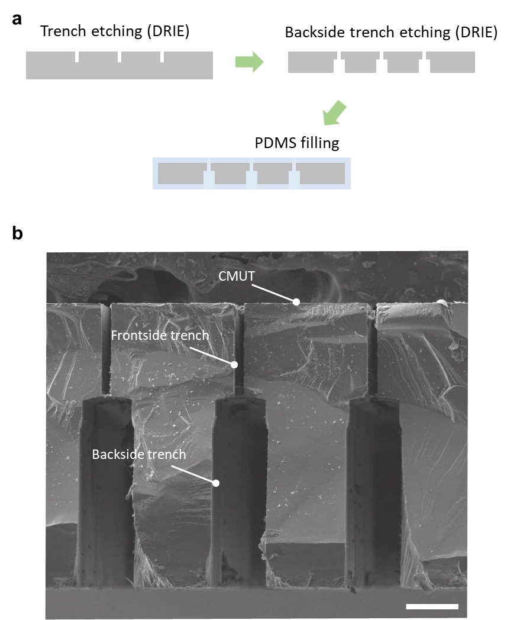
Supplementary Figure 5. a, Schematic illustrations of strategy to fabricate flexible and stretchable CMUT. Each CMUT element was singulated via frontside and backside trenches, and the trenches were filled with PDMS to realize flexible and stretchable snCMUT. b, SEM image after element singulation of snCMUT via fabrication of both-side trenches. The scale bar is 100 µm.

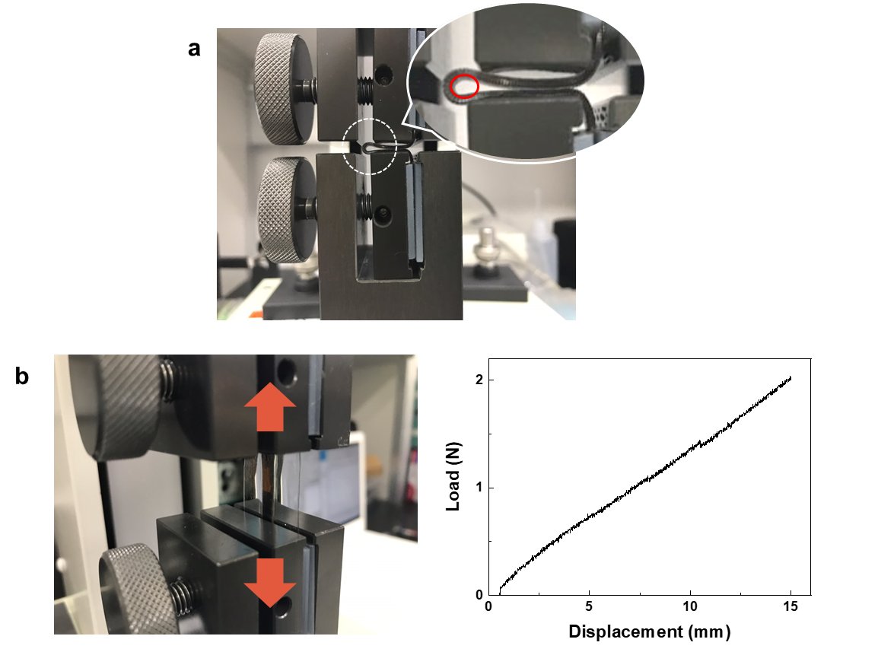
Supplementary Figure 6. a, Photograph of evaluation of bending characteristics of wearable nanocolumn CMUT using tensile-compression tester (radius of curvature: <1mm). b, Photograph (left) evaluating the elongation characteristics of wearable Nanocolumn CMUT using a tensile compression tester and their result (right).

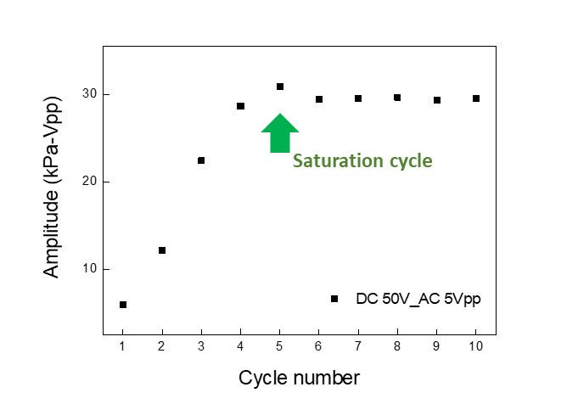
Supplementary Figure 7. Maximum peak-to-peak amplitude of pressure as pulse cycle. Due to fabrication variations in the silicon nanocolumns beneath the piston top plate, the differing spring constants of these nanocolumns result in asymmetric motion of the piston top plate. This asymmetry leads to smaller displacements and lower output pressures. However, as the pulse cycles increase, the piston top plate gradually achieves more symmetric motion, which enhances displacement and maximizes output pressure. This effect becomes saturated after five cycles.

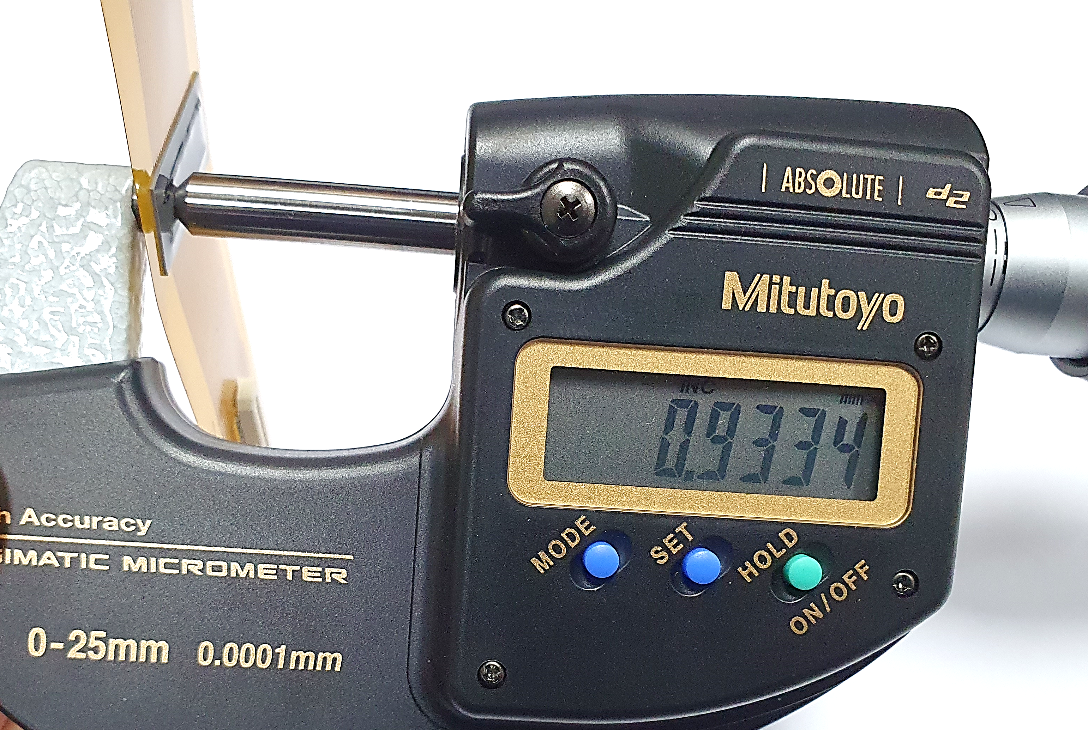
Supplementary Figure 8. The photographs of in-house designed FPCB and their packaging as a prototype disposable Nanocolumn CMUT patch. The prototype patch comprises a fabricated Nanocolumn CMUT and a covered PDMS lens. The thickness of a disposable Nanocolumn CMUT patch is only 933.4 µm, even fully packaged.

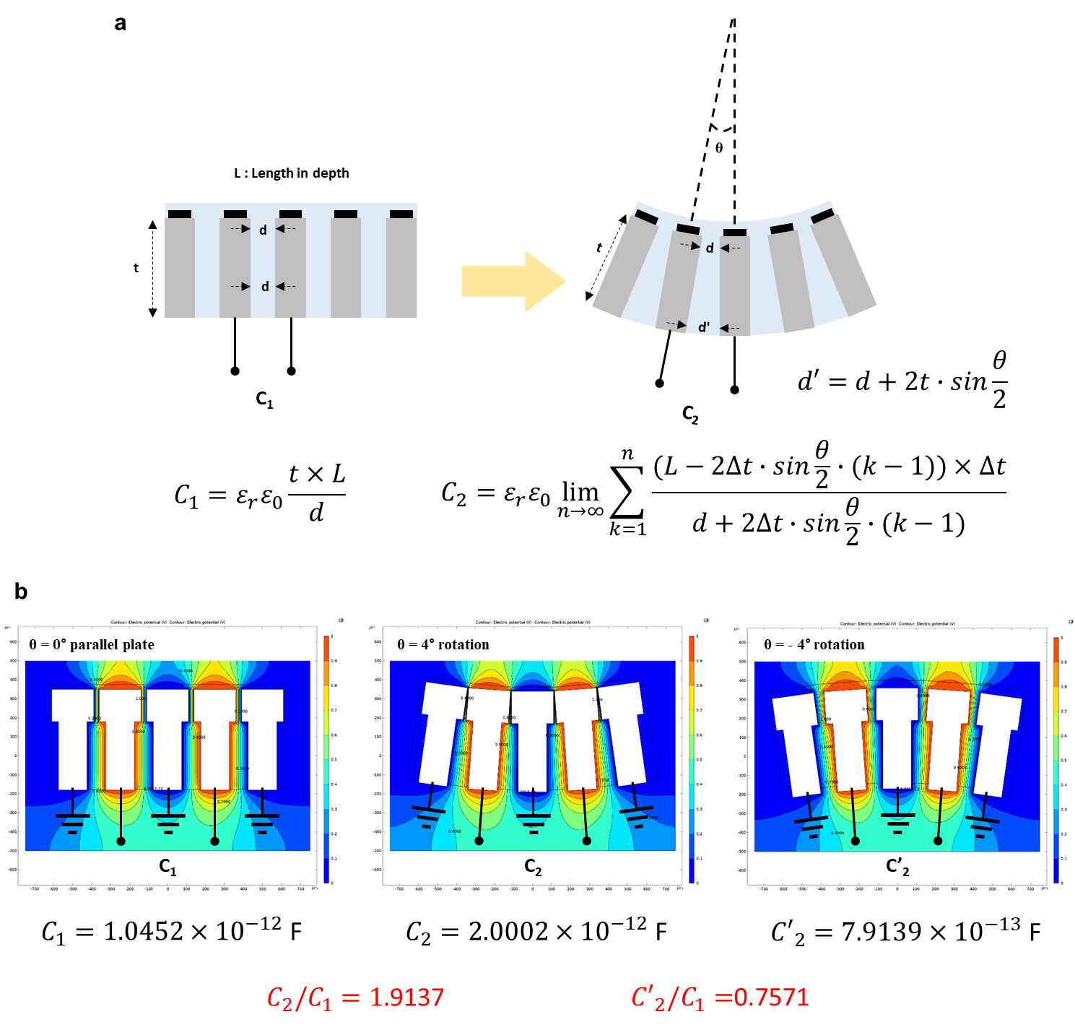
Supplementary Figure 9. a, Schematic illustrations of a change in capacitance caused by the substrate's deformation (stretching, bending) in the flexible array. After the substrate deformation, the distance between the adjacent arrays may be calculated by comparing the first capacitance C₁ with the second capacitance C₂. For all the elements of arrays, the relative position of each array relative to the others is determined by measuring a change in capacitance. b, The simulation of the capacitance changing depending on the bending direction of the substrate in the flexible array. When each array includes the first part and the second part having a smaller width than the first part, it can be seen that even though the extent of bending of the substrate is equal (θ = 4°), the capacitances C2, C2’ have different values depending on the bending direction of the substrate. Accordingly, the relative position between the arrays and the bending direction of the substrate are identified based on the change in the capacitance measurement value.

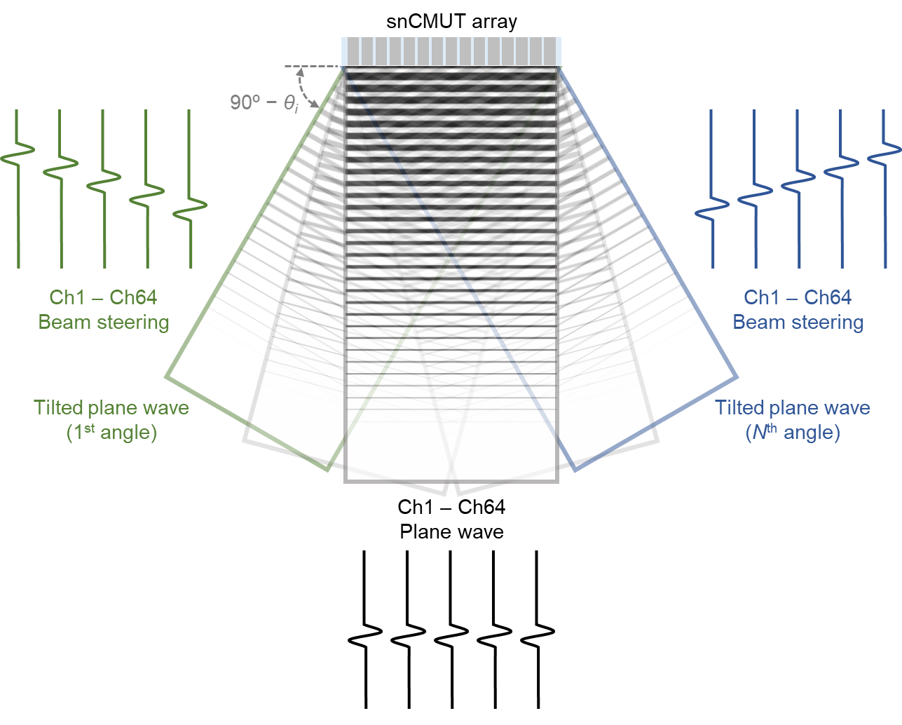
Supplementary Figure 10. Working principle of ultrasonic plane wave compounding imaging. The reduced ultrasound pressure resulting from the emission of an unfocused plane wave, rather than a focused beam used for sequential line or volume scanning, is compensated by coherently combining multiple views, N. These views are acquired successively, with the plane wave oriented at different θi angles to generate the corresponding frames. The received echoes are coherently compounded to increase the SNR.

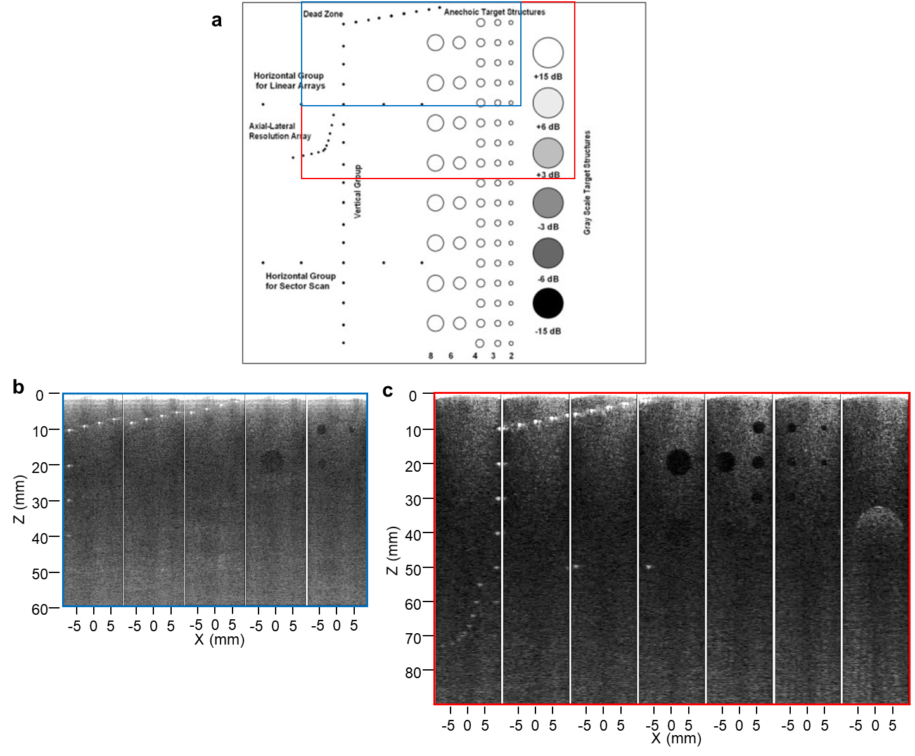
Supplementary Figure 11. a, Target diagram of the ATS 539 phantom. Material: Urethane rubber, Sound speed: 1450 m/s, Absorption: 0.5 dB/cm/MHz. On the left-hand side: Line Targets (Monofilament Nylon, Diameter: 0.12 mm). In the center section: Anechoic Targets (Cylindrical in shape filled with homogeneous, non-scattering material. Diameter: 2 to 8 mm). On the right-hand side: Gray Scale Targets (Cylindrical in shape filled with scattering material. Diameter: 10 mm. Contrast is backscatter relative to background material). b, Ultrasound images obtained with the conventional CMUT. The scanning area corresponds to the blue square outlined in the target diagram (a). The CMUT was operated with a DC bias voltage of 70 V, complemented by 30.6 V_{PP} and 6.25 MHz of AC wave. c, Ultrasound images obtained with the prototype disposable snCMUT patch. The scanning area corresponds to the red square outlined in the target diagram (a). The snCMUT was operated with a DC bias voltage of 40 V, complemented by 8.9 V_{PP} and 4.25 MHz of AC wave. Compared to the conventional CMUT probe, the proposed wearable patch, based on snCMUT, offers enhanced contrast and the ability to image deeper regions, thanks to its high output pressure efficiency.

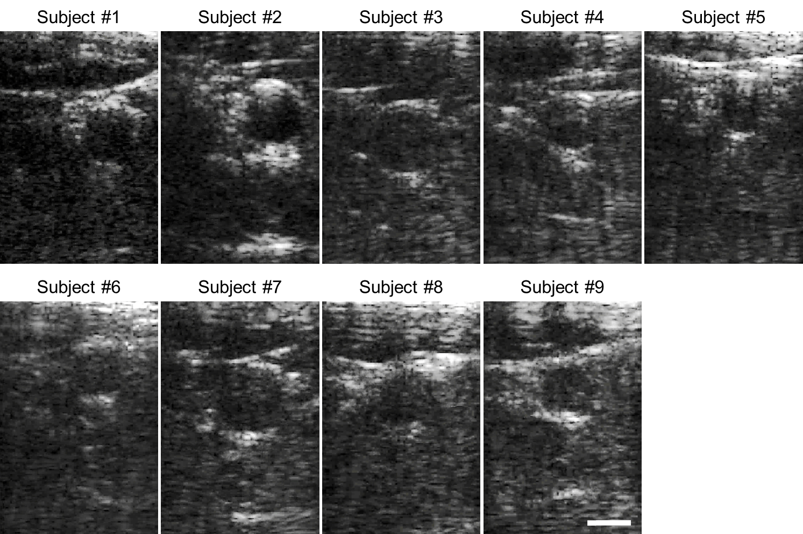
Supplementary Figure 12. Ultrasound B-mode images of the human carotid artery of 9 healthy volunteers from the disposable snCMUT patches. The scale bar is 5 mm.

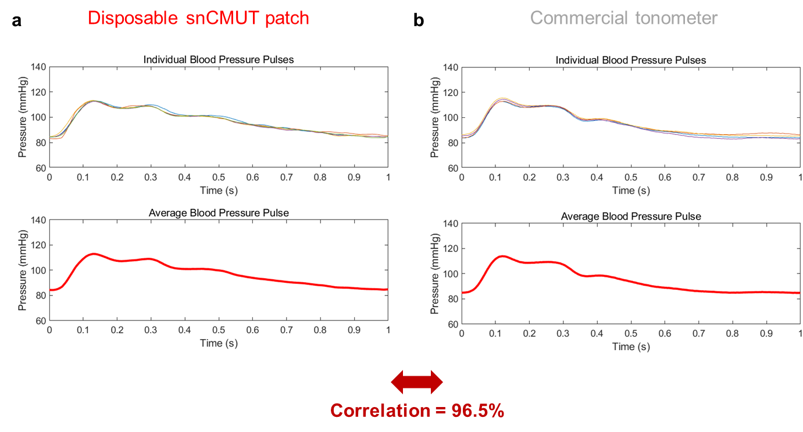
Supplementary Figure 13. a-b, Blood pressure pulses and the average blood pulse of each blood pressure pulse measured by disposable snCMUT patch (a) and commercial tonometer (b) for the exact position of the same subject in close succession, resulting in good correlation (96.5%).

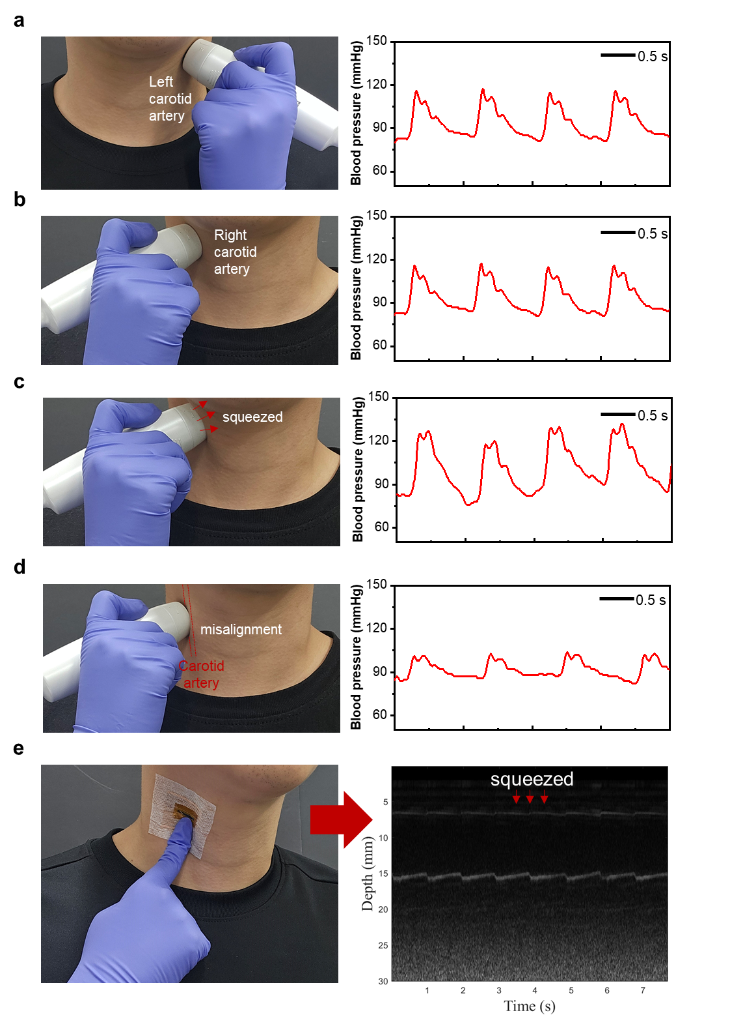
Supplementary Figure 14. a-d, Optical image of the blood pressure measurement and corresponding blood pressure pulses over time measured by commercial tonometer on the left carotid artery (a) and right carotid artery (b) with correct measurement condition and wrong measurement condition induced by vessel squeezing (c) and misalignment (d). e, M-mode image showing vessel squeezing due to excessive pressure applied on the ultrasound patch

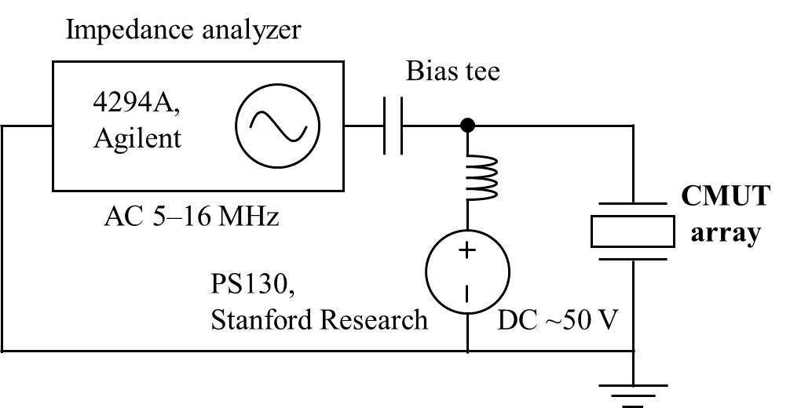
Supplementary Figure 15. Experimental setup to measure the electrical input impedance of the fabricated CMUT.

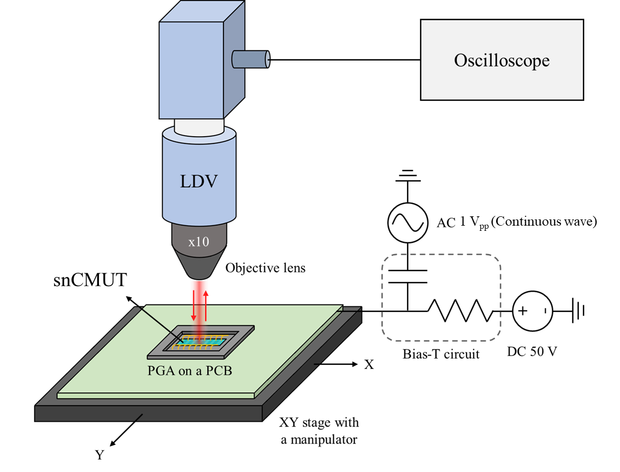
Supplementary Figure 16. Experimental setup for a laser Doppler vibrometer with an in-house custom-built microscopy.

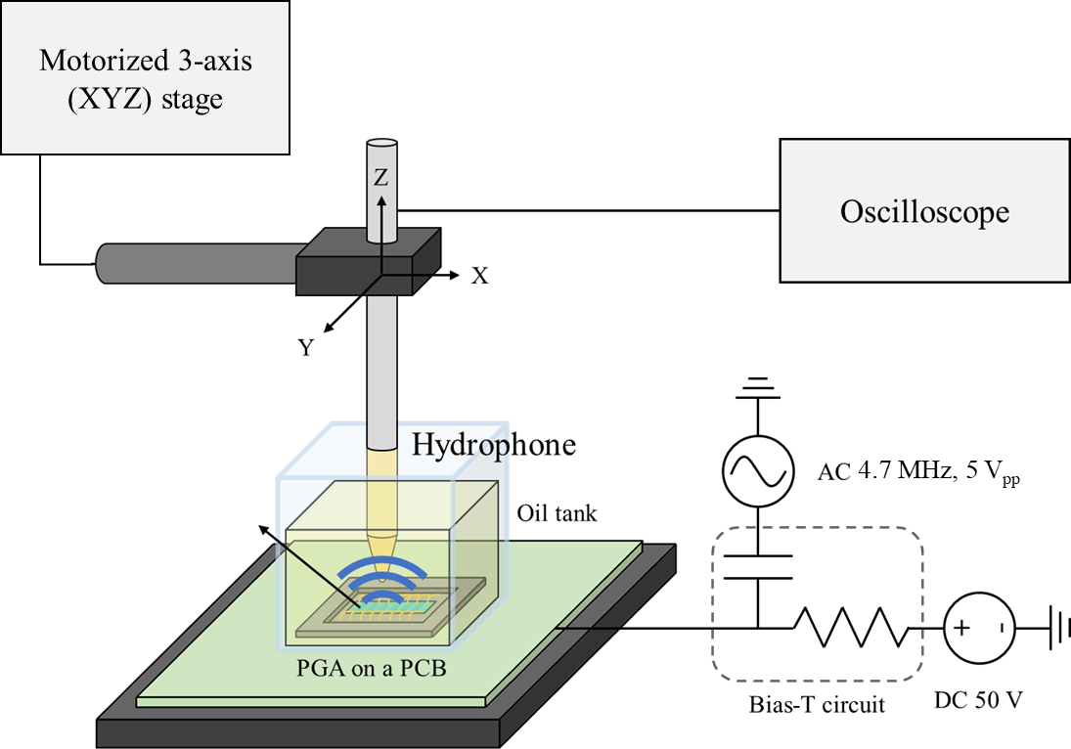
Supplementary Figure 17. Experimental setup to verify output pressure of the fabricated CMUT by hydrophone.

References
1. Lee, B. C., Nikoozadeh, A., Park, K. K. & Khuri-Yakub, B. T. High-Efficiency Output Pressure Performance Using Capacitive Micromachined Ultrasonic Transducers with Substrate-Embedded Springs. Sensors 18, 2520 (2018).
2. Huang, Y. et al. Capacitive micromachined ultrasonic transducers with piston-shaped membranes: fabrication and experimental characterization. IEEE Trans Ultrason Ferroelectr Freq Control 56, 136–145 (2009).
3. Dew, E. B., Kashani Ilkhechi, A., Maadi, M., Haven, N. J. M. & Zemp, R. J. Outperforming piezoelectric ultrasonics with high-reliability single-membrane CMUT array elements. Microsyst Nanoeng 8, 59 (2022).
4. Wang, C. et al. Bioadhesive ultrasound for long-term continuous imaging of diverse organs. Science (1979) 377, 517–523 (2022).
5. Zhang, L. et al. A conformable phased-array ultrasound patch for bladder volume monitoring. Nat Electron 7, 77–90 (2023).
6. Wang, C. et al. Continuous monitoring of deep-tissue haemodynamics with stretchable ultrasonic phased arrays. Nat Biomed Eng 5, 749–758 (2021).
7. Hu, H. et al. A wearable cardiac ultrasound imager. Nature 613, 667–675 (2023).
8. van Neer, P. L. M. J. et al. Flexible large-area ultrasound arrays for medical applications made using embossed polymer structures. Nat Commun 15, 2802 (2024).

