Title: Unique N-glycosylation signatures in Aβ oligomer- and lipopolysaccharide-activated human iPSC-derived microglia
Running title: AβO and LPS induce differential glycosylation changes in microglia
Xinyu Tang¹*, Ryan Lee Schindler²*, Jacopo Di Lucente³, Armin Oloumi², Jennyfer Tena², Danielle Harvey⁴, Carlito B. Lebrilla², Angela M. Zivkovic¹**, Lee-Way Jin³**, Izumi Maezawa³**
¹Department of Nutrition, University of California, Davis, California, USA.
²Department of Chemistry, University of California, Davis, California, USA.
³Department of Pathology and Laboratory Medicine and M.I.N.D. Institute, University of California Davis Medical Center, Sacramento, California, USA.
⁴Department of Public Health Sciences, University of California-Davis, Davis, CA, USA.
*Authors have equal contribution to the manuscript.
Address Correspondence to: Izumi Maezawa, Ph.D., Department of Pathology and Laboratory Medicine, University of California Davis Medical Center, Sacramento, CA 95817, USA, E-mail: imaezawa@ucdavis.edu, Lee-Way Jin, MD., PhD., Department of Pathology and Laboratory Medicine, University of California Davis Medical Center, Sacramento, CA 95817, USA, E-mail: lwjin@ucdavis.edu, Angela M. Zivkovic, PhD., Department of Nutrition, University of California, Davis, CA 95618, USA, E-mail: amzivkovic@ucdavis.edu.
Table of Contents
Supplementary figure 1 2
Supplementary figure 2 2
Supplementary figure 3 3

Supplementary figure 1

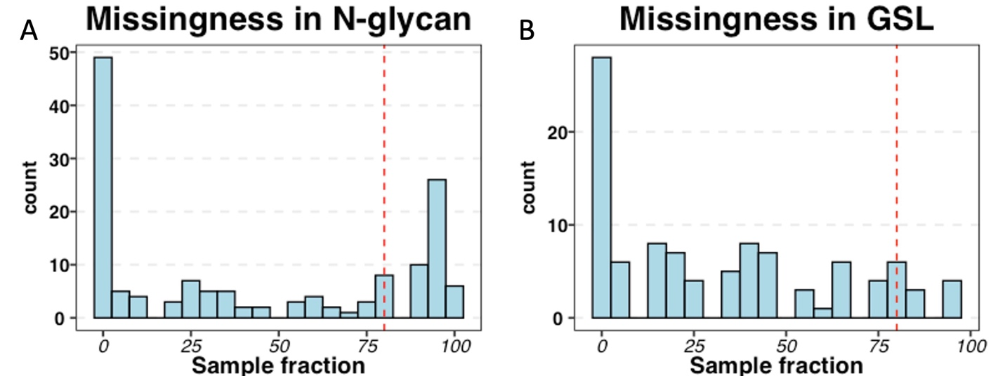

Supplementary figure 1. The missingness of N-glycans and GSL as the percentage of the number of samples. A) The missingness in N-glycan. B) The missingness in GSL. Red dash lines denote missingness of 80% across all samples.

Supplementary figure 2
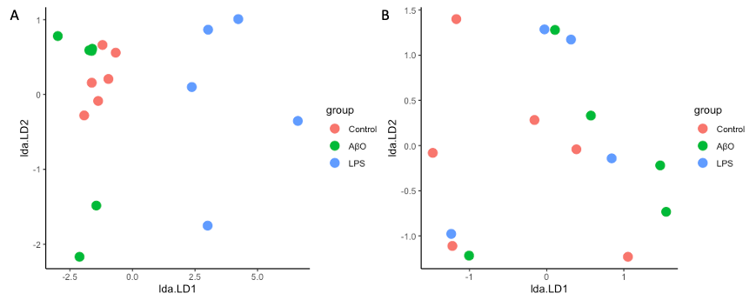
Supplementary figure 2: The scatter plot of the post-hoc linear discriminant analysis (LDA) of MANOVA for the PCA plots. A) The LDA scatter plot for N-glycan. According to the LDA scatter plot, LPS had the most significant impact on the group mean differences. B) The LDA scatter plot for GSL.

Supplementary figure 3

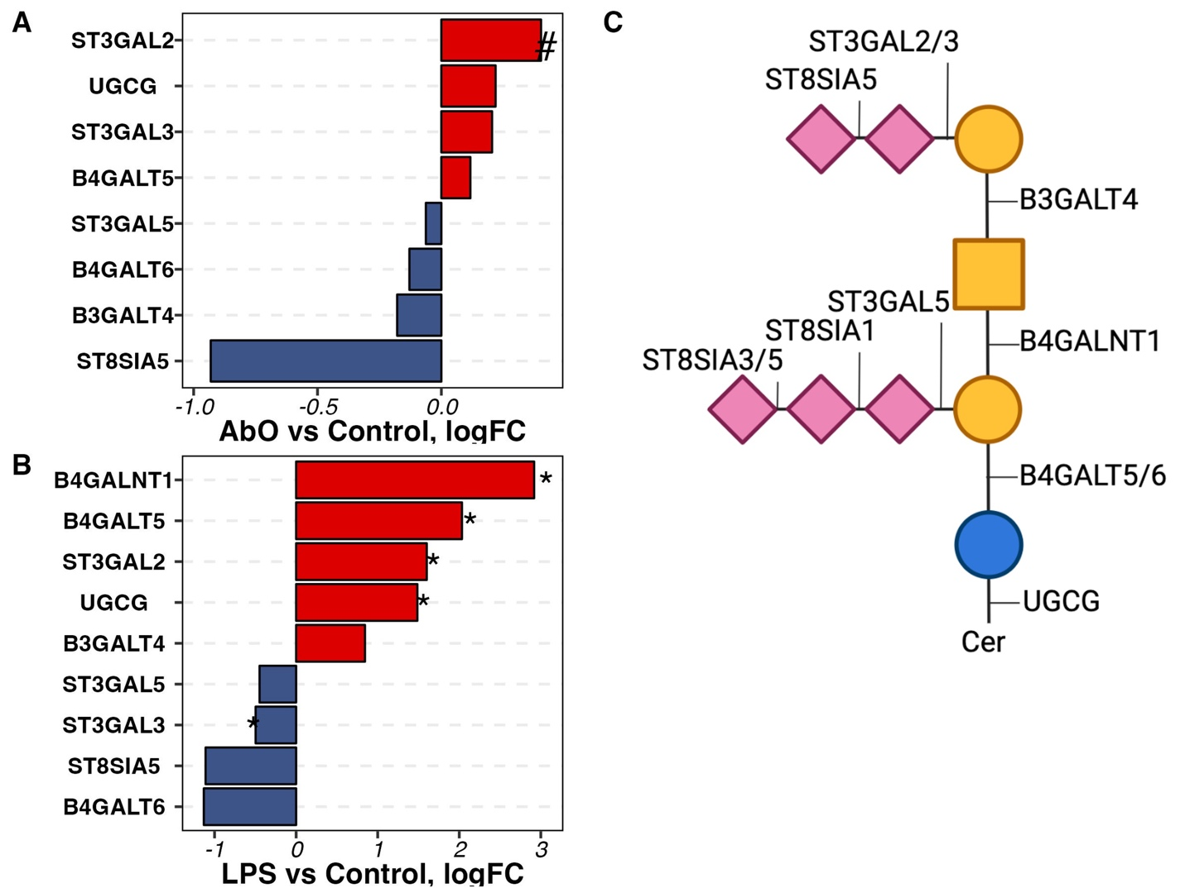

Supplementary figure 3. The differential expression of genes involved in GSL biosynthesis in AβO- and LPS-activated hiMG. A) The differential expression of genes involved in GSL biosynthesis in AβO-activated hiMG. B) The differential expression of genes involved in GSL biosynthesis in LPS-activated hiMG. C) The schematics of GSL structure and the corresponding enzymes. The pound (#) denotes genes with unadjusted p-value < 0.05 but FDP >0.05. The asterisk (*) denotes genes with FDP < 0.05.

