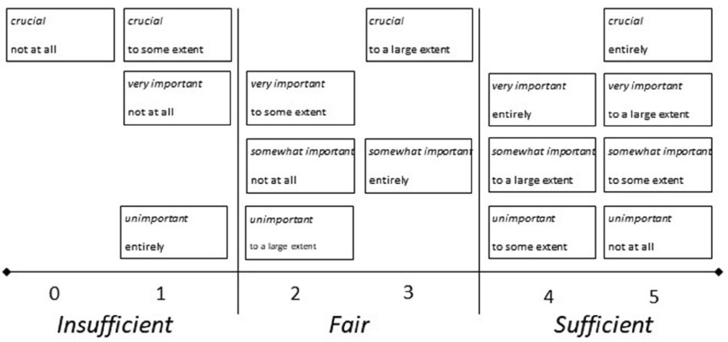

Supplementary Figure 1. Scores and levels of matches and mismatches between patient preferences (italicized text) and experiences of patient participation (unitalicized text). Originally published by Eldh et al. [22].

