Supplementary data for
Hyssopus cuspidatus Volatile oil: A potential treatment for steroid-resistant asthma via inhibition of neutrophil extracellular traps
Xu Wang^{1, a}, Hui-Ming Peng^{2, a}, Meng-Ru Zhang^{1, a}, Jing-Jing Li^{3, a}, Chuan-Peng Zhao¹, Ya-Li Zhang¹, Si-Yu Wang¹, Si-Ying Zhu¹, Jian-Kang Lu¹, Hai-Long Yin⁴, Qiang Yin⁴, and Jin-Bo Fang^{1, *}
Authors
1: School of Pharmacy, Hubei Key Laboratory of Natural Medicinal Chemistry and Resource Evaluation, Tongji Medical College, Huazhong University of Science and Technology, Wuhan 430030, China
2: Department of Anatomy, Tongji Medical College, Huazhong University of Science and Technology, Wuhan, 430030, China
3: Hubei Shizhen Laboratory, School of Basic Medicine, Hubei University of Chinese Medicine, Wuhan 430065, China
4: Xinjiang Uygur Pharmaceutical Co., Ltd, No. 2, Shenyang Street, Urumqi Economic and Technological Development Zone (Toutunhe District), Xinjiang Uygur Autonomous Region, Urumqi 830026, Xinjiang, China
ª Xu Wang, H. Peng, M. Zhang and J. Li contributed equally to this study.
*Corresponding author:
Jin-Bo Fang
Address: School of Pharmacy, Hubei Key Laboratory of Natural Medicinal Chemistry and Resource Evaluation, Tongji Medical College, Huazhong University of Science and Technology (HUST), Wuhan 430030, China
E-mail: fangjb@hust.edu.cn
Tel: 0086-27-83692482
Fax: 0086-27-83692482

Fig. S1. Extraction ion chromatogram (EIC) of some characteristic in vivo compounds of HVO analyzed by UPLC-QE-Orbitrap-MS. (A) EIC of part of prototypes. (B) EIC of part of Phase I metabolites. (C) EIC of part of Phase II metabolites.

Table S1. Characterization of prototypes in rat serum after administration of HVO by UPLC-QE-Orbitrap-MS
NO. | Identification | Formula | Selected ion | Calculated mass | Measured mass | Error（ppm） | T_{R}（min） | MS2
1 | 3-Furaldehyde | C₅H₄O₂ | [M+H^{]+} | 97.0284 | 97.0291 | 6.947 | 1.99 | 97.0289、79.0549、69.0343
2 | 3-Methoxy-4-hydroxy mandelonitrile | C₉H₉NO₃ | [M-H]⁻  [M+H]⁺ | 178.0499  180.0655 | 178.0504  180.0660 | 2.866  2.445 | 7.42  7.44 | 178.0502、134.0601、121.0284  180.0656、134.9563、105.0340、95.0497
3 | Pentanoic acid | C₅H₁₀O₂ | [M+H]⁺ | 103.0754 | 103.0760 | 6.538 | 9.88
4 | 2-methyl- Phenol | C₇H₈O | [M-H]⁻ | 107.0491 | 107.0490 | -1.788 | 10.75 | 107.0491、95.8866、63.8480
5 | p-(1-Propenyl)-toluene | C₁₀H₁₂ | [M+H]⁺ | 133.1012 | 133.1016 | 3.103 | 10.93
6 | 1,2,3,6-Tetrahydrobenzylalcohol acetate | C₉H₁₄O₂ | [M-H]⁻ | 153.0910 | 153.0912 | 1.462 | 11.10 | 153.0915、135.0079、109.0283
7 | cis-3-Hexenyl propionate | C₉H₁₆O₂ | [M+H]⁺ | 157.1223 | 157.1229 | 3.906 | 12.13 | 157.1221、129.0658、114.0553、97.1017、69.0707
8 | 2,3-dihydro- benzofuran | C₈H₈O | [M-H]⁻ | 119.0491 | 119.0490 | -1.356 | 12.40 | 119.0493、90.0336
9 | 2-hydroxy-2,6,6-trimethyl- Bicyclo[3.1.1]heptan-3-one | C₁₀H₁₆O₂ | [M+H]⁺ | 169.1223 | 169.1228 | 3.097 | 12.42
10 | 6-methyl-5-Hepten-2-one | C₈H₁₄O | [M+H]⁺ | 127.1117 | 127.1123 | 4.393 | 12.47
11 | 2,6,6-trimethyl-1-Cyclohexene-1-ethanol | C₁₁H₂₀O | [M+H]⁺ | 169.1587 | 169.1591 | 2.354 | 12.57
12 | Myrtenyl methyl ether | C₁₁H₁₈O | [M+H]⁺ | 167.1430 | 167.1435 | 2.861 | 12.57 | 167.1431、106.9641、79.0549
13 | 5-ethenyl-2-methoxy- Phenol | C₉H₁₀O₂ | [M+H]⁺ | 151.0754 | 151.0758 | 2.673 | 12.57
14 | Apiol | C₁₂H₁₄O₄ | [M-H]⁻ | 221.0808 | 221.0816 | 3.594 | 12.70 | 221.0820、177.0916、149.0960、134.0361、103.9190、91.9084、71.0489
15 | 3,3-dimethyl- Bicyclo[2.2.1]heptan-2-ol | C₉H₁₆O | [M+H]⁺ | 141.1274 | 141.1277 | 2.184 | 12.72
16 | Eugenol | C₁₀H₁₂O₂ | [M+H]⁺ | 165.0910 | 165.0913 | 2.022 | 12.97 | 165.0911、150.9689、137.0961、122.9743、104.9638
17 | Phenylethyl Alcohol | C₈H₁₀O | [M-H]⁻ | 121.0648 | 121.0647 | -1.003 | 13.09 | 121.0647、106.0413、94.0284
18 | 1,2-dihydro-1,1,6-trimethyl- Naphthalene | C₁₃H₁₆ | [M+H]⁺ | 173.1325 | 173.1330 | 2.847 | 13.26
19 | 3,3-dimethyl- Bicyclo[2.2.1]heptan-2-one | C₉H₁₄O | [M+H]⁺ | 139.1117 | 139.1121 | 2.432 | 13.26
20 | 2-(1-Cyclopent-1-enyl-1-methylethyl) cyclopentanone | C₁₃H₂₀O | [M+H]⁺ | 193.1587 | 193.1592 | 2.786 | 13.31 | 193.1588、175.1483、147.1169、133.1013、119.0859、109.1016、95.0862
21 | 1,2,3,4-tetrahydro-1,5,7-trimethyl- Naphthalene | C₁₃H₁₈ | [M+H]⁺ | 175.1481 | 175.1486 | 2.471 | 13.31 | 175.1482、147.1169、133.1013、105.0705、81.0706
22 | 4-methoxy-6-(2-propenyl)- 1,3-Benzodioxole | C₁₁H₁₂O₃ | [M+H]⁺ | 193.0859 | 193.0864 | 2.689 | 13.56 | 193.1588、175.1482、147.0554、133.1013、109.1016、95.0861
23 | cis-5-ethenyltetrahydro-α,α,5-trimethyl-2-Furanmethanol | C₁₀H₁₈O₂ | [M+H]⁺  [M-H]⁻ | 171.1380  169.1223 | 171.1382  169.1227 | 1.482  2.387 | 13.66  13.83 | 171.1377、139.1118、111.1172、69.0707  169.1226、139.2616、125.0234、113.9250、91.9125
24 | 4-(2,2,6-trimethyl-7-oxabicyclo[4.1.0]hept-1-yl)- 3-Buten-2-one | C₁₃H₂₀O₂  C₁₃H₂₀O₂ | [M+H]⁺  [M-H]⁻ | 209.1536  207.1380 | 209.1540  207.1387 | 1.643  3.687 | 13.66  13.68 | 209.1537、152.0706、95.0862  207.1385、165.9991、79.9560
25 | 4-methoxy- Benzoic acid methyl ester | C₉H₁₀O₃ | [M+H]⁺ | 167.0703 | 167.0707 | 2.330 | 13.85
26 | 1-Octen-3-ol | C₈H₁₆O | [M+H]⁺ | 129.1274 | 129.1277 | 2.542 | 14.05
27 | 1,1,4,7-Tetramethyldecahydro-1H-cyclopropa[e]azulene-4,7-diol | C₁₅H₂₆O₂ | [M-H]⁻ | 237.1849 | 237.1860 | 4.694 | 14.37 | 237.1855、195.1748、168.2530、91.9095
28 | Myrtenyl 2-methyl butyrate | C₁₅H₂₄O₂ | [M+H]⁺ | 237.1849 | 237.1853 | 1.870 | 15.82 | 237.1853、219.1749、201.1640、177.1638、163.1118、149.0962、121.1015、107.0860、95.0861、81.0706
29 | 2-methoxy-4-propyl- Phenol | C₁₀H₁₄O₂ | [M+H]⁺ | 167.1067 | 167.1069 | 1.758 | 15.82
30 | Methyleugenol | C₁₁H₁₄O₂ | [M+H]⁺ | 179.1067 | 179.1070 | 1.863 | 15.87
31 | 2,5-dimethyl-3-methylene-1,5-Hexadiene | C₉H₁₄ | [M+H]⁺ | 123.1168 | 123.1172 | 3.435 | 15.87
32 | cis-Calamenene | C₁₅H₂₂ | [M+H]⁺ | 203.1794 | 203.1799 | 2.277 | 15.97
33 | 4-(2,6,6-Trimethylcyclohexa-1,3-dienyl) but-3-en-2-one | C₁₃H₁₈O | [M+H]⁺ | 191.1430 | 191.1434 | 1.874 | 16.07
34 | (Z)-3-methyl-2-(2-pentenyl)- 2-Cyclopenten-1-one | C₁₁H₁₆O | [M+H]⁺ | 165.1274 | 165.1278 | 2.412 | 16.36
35 | (E)-6,10-dimethyl-5,9-Undecadien-2-one | C₁₃H₂₂O | [M+H]⁺ | 195.1743 | 195.1747 | 2.040 | 16.79
36 | Aristol-1(10)-en-9-yl isovalerate | C₂₀H₃₂O₂ | [M-H]⁻ | 303.2319 | 303.2333 | 4.793 | 17.01 | 303.2331、259.2434、205.1957、127.1099、59.0126
37 | (E)-1-(2,6,6-trimethyl-1,3-cyclohexadien-1-yl)- 2-Buten-1-one | C₁₃H₁₈O | [M+H]⁺ | 191.1430 | 191.1434 | 2.136 | 17.18
38 | 1,2,3,4-tetrahydro-1,1,6-trimethyl- Naphthalene | C₁₃H₁₈ | [M+H]⁺ | 175.1481 | 175.1484 | 1.444 | 17.18 | 175.1483、147.1166、133.1014、119.0859
39 | 6-methyl-5-(1-methylethylidene)- 6,8-Nonadien-2-one | C₁₃H₂₀O | [M+H]⁺ | 193.1587 | 193.1590 | 1.440 | 17.27 | 193.1590、175.1483、149.1325、133.1013、119.0858、109.1016、95.0862
40 | 1,3-diisopropenyl-6-methyl- Cyclohexene | C₁₃H₂₀ | [M+H]⁺ | 177.1638 | 177.1639 | 0.919 | 18.49
41 | 4-Hexen-1-ol | C₆H₁₂O | [M+H]⁺ | 101.0961 | 101.0968 | 7.205 | 21.03 | 101.0967、69.0707、59.0501

Table S2. Characterization of phase I metabolites in rat serum after administration of HVO by UPLC-QE-Orbitrap-MS.
NO. | Identification | Formula | Selected ion | Calculated mass | Measured mass | Error（ppm） | T_{R}（min） | MS2
1 | 4-Aminophenol | C₆H₇NO | [M+H]⁺ | 110.06 | 110.0606 | 4.902 | 1.38 | 110.0607、80.0503
2 | Hydro 3-Methoxy-4-hydroxy mandelonitrile | C₉H₁₁NO₃ | [M+H]⁺  [M-H]⁻ | 182.0812  180.0655 | 182.0817  180.066 | 2.912  2.889 | 2.38  2.6 | 182.0815、165.0547、136.0758、123.0443、72.0816  180.0659、163.0393、136.9088、92.9187
3 | Hydroxyl pentanoic acid | C₅H₁₀O₃ | [M-H]⁻ | 117.0546 | 117.0546 | 0.08 | 5.82 | 117.0545、71.0489
4 | Hydro 4-Hydroxybenzoic acid | C₇H₈O₃ | [M+H]⁺ | 141.0546 | 141.0550 | 2.973 | 6.45 | 141.0544、131.9746、113.9641、95.0497
5 | Hydroxyl 4-methoxy- Benzoic acid methyl ester | C₉H₁₀O₄ | [M-H]⁻ | 181.0495 | 181.0501 | 3.285 | 6.97 | 181.0499、163.0391、135.0441、119.0491、94.9158、72.9918
6 | Hydroxyl cis-3-Hexenyl propionate | C₉H₁₆O₃ | [M+H]⁺ | 173.1172 | 173.1159 | -7.399 | 7.14
7 | Hydroxyl Phenylethyl Alcohol | C₈H₁₀O₂ | [M+H]⁺ | 139.0754 | 139.0758 | 3.263 | 7.84
8 | Benzoic acid | C₇H₆O₂ | [M-H]⁻ | 121.0284 | 121.0284 | 0.281 | 8.07 | 121.0283、94.0285
9 | Demethyl 2-methyl- Phenol | C₆H₆O | [M-H]⁻ | 93.0335 | 93.0332 | -2.594 | 8.17 | 93.0333、69.2316
10 | Demethyl and hydro eugenol | C₉H₁₂O₂ | [M+H]⁺ | 153.0910 | 153.0914 | 2.442 | 9.28
11 | Hydroxyl 5-ethenyl-2-methoxy- Phenol | C₉H₁₀O₃ | [M-H]⁻ | 165.0546 | 165.055 | 2.359 | 9.45 | 165.0548、147.0442、121.0647、107.0490、72.9917
12 | Dehydroxyl 3-Methoxy-4-hydroxy mandelonitrile | C₉H₉NO₂ | [M-H]⁻ | 162.055 | 162.0553 | 2.005 | 9.9 | 162.0554、119.0491、73.0282
13 | 4-nitrophenol | C₆H₅NO₃ | [M-H]⁻ | 138.0186 | 138.0188 | 1.67 | 9.95 | 108.0187、108.0205、93.0333
14 | Demethyl Phenylethyl Alcohol | C₇H₈O | [M-H]⁻ | 107.0491 | 107.049 | -1.788 | 10.75 | 107.0491、95.8866、74.9904、63.8480
15 | 4-Hydroxybenzoic acid | C₇H₆O₃ | [M-H]⁻ | 137.0233 | 137.0235 | 1.383 | 10.9 | 137.0234、93.0333
16 | Dehydro cis-3-Hexenyl propionate | C₉H₁₄O₂ | [M+H]⁺ | 155.1067 | 155.107 | 2.41 | 11.13
17 | Hydroxyl 2-methoxy-4-propyl- Phenol | C₁₀H₁₄O₃ | [M+H]⁺ | 183.1016 | 183.1023 | 3.764 | 11.98 | 183.1025、165.0700、137.0962、123.0808、95.0861
18 | Hydroxyl 6-methyl- 5-Hepten-2-one | C₈H₁₄O₂ | [M+H]⁺ | 143.1067 | 143.1072 | 3.66 | 12.13 | 143.1068、111.0444、97.1018、73.0656、55.0552
19 | Hydroxyl 1-Octen-3-ol | C₈H₁₆O₂ | [M-H]⁻ | 143.1067 | 143.1068 | 1.074 | 12.15 | 143.1068、91.9117
20 | Hydroxyl styrene | C₈H₈O | [M-H]⁻ | 119.0491 | 119.049 | -1.356 | 12.4 | 119.0493、90.0336
21 | Hydroxyl 4-methoxy-6-(2-propenyl)- 1,3-Benzodioxole | C₁₁H₁₂O₄ | [M+H]⁺ | 209.0808 | 209.0815 | 3.179 | 12.52
22 | Hydroxyl (Z)-3-methyl-2-(2-pentenyl)- 2-Cyclopenten-1-one | C₁₁H₁₆O₂ | [M+H]⁺ | 181.1223 | 181.1228 | 2.726 | 12.52
23 | Hydroeugenol | C₁₀H₁₄O₂ | [M-H]⁻ | 165.091 | 165.0914 | 2.204 | 12.55 | 165.0912、136.9310、121.0282、79.9562
24 | Dehydro 2,6,6-trimethyl-1-Cyclohexene-1-ethanol | C₁₁H₁₈O | [M+H]⁺ | 167.143 | 167.1435 | 2.861 | 12.57 | 167.1431、106.9641、79.0549
25 | Demethyl 6-methyl-5-(1-methylethylidene)- 6,8-Nonadien-2-one | C₁₂H₁₈O | [M+H]⁺ | 179.143 | 179.1435 | 2.614 | 12.57 | 179.1432、161.1326、150.0268、133.1013、95.0861
26 | Demethyleugenol | C₉H₁₀O₂ | [M+H]⁺ | 151.0754 | 151.0758 | 2.673 | 12.57
27 | 4-methoxybenzoic acid | C₈H₈O₃ | [M-H]⁻ | 151.039 | 151.0392 | 1.32 | 12.89 | 151.0392、107.0491、66.2647
28 | Dehydro 2-methoxy-4-propyl- Phenol | C₁₀H₁₂O₂ | [M+H]⁺ | 165.091 | 165.0913 | 2.022 | 12.97 | 165.0911、137.0961、122.9743、104.9638
29 | Hydro 2,3-dihydro- Benzofuran | C₈H₁₀O | [M-H]⁻ | 121.0648 | 121.0647 | -1.003 | 13.09 | 121.0647、106.0413、94.0284
30 | Hydro 4-methoxy-6-(2-propenyl)- 1,3-Benzodioxole | C₁₁H₁₄O₃ | [M-H]⁻ | 193.0859 | 193.0866 | 3.414 | 13.19
31 | Hydroxyl 2,5-dimethyl-3-methylene-1,5-Hexadiene | C₉H₁₄O | [M+H]⁺ | 139.1117 | 139.1121 | 2.432 | 13.26
32 | Hydroxyl (E)-6,10-dimethyl-5,9-Undecadien-2-one | C₁₃H₂₂O₂ | [M+H]⁺ | 211.1693 | 211.1697 | 2.29 | 13.31 | 211.1690、193.1587、175.1484、133.1015、109.1019、95.0861
33 | Hydroxyl trimethyl-2-hydroxy-2,6,6- Bicyclo[3.1.1]heptan-3-one | C₁₀H₁₆O₃ | [M+H]⁺ | 185.1172 | 185.1177 | 2.642 | 13.31
34 | Hydro 1,2-dihydro-1,1,6-trimethyl- Naphthalene | C₁₃H₁₈ | [M+H]⁺ | 175.1481 | 175.1486 | 2.471 | 13.31 | 175.1482、133.1013、119.0858、105.0705
35 | Dehydro (E)-6,10-dimethyl-5,9-Undecadien-2-one | C₁₃H₂₀O | [M+H]⁺ | 193.1587 | 193.1592 | 2.786 | 13.31 | 193.1588、175.1483、147.1169、133.1013、119.0859、109.1016、95.0862
36 | Hydro cis-3-Hexenyl propionate | C₉H₁₈O₂ | [M-H]⁻ | 157.1223 | 157.1226 | 1.615 | 13.34 | 157.1225、89.0229
37 | Hydro 1,2,3,6-Tetrahydrobenzylalcohol acetate | C₉H₁₆O₂ | [M+H]⁺ | 157.1223 | 157.1227 | 2.697 | 13.36
38 | Hydroxyl 1,2,3,6-Tetrahydrobenzylalcohol acetate | C₉H₁₄O₃ | [M-H]⁻ | 169.0859 | 169.0862 | 1.651 | 13.38 | 169.0862、125.0960、91.9080
39 | Hydroxyl linalool | C₁₀H₁₈O₂ | [M+H]⁺  [M-H]⁻ | 171.138  169.1223 | 171.1382  169.1227 | 1.482  2.387 | 13.66  13.83 | 171.1377、139.1118、111.1172、69.0707  169.1226、125.0234、113.9250
40 | Hydroxyl 6-methyl-5-(1-methylethylidene)- 6,8-Nonadien-2-one | C₁₃H₂₀O₂ | [M+H]⁺  [M-H]⁻ | 209.1536  207.139 | 209.1539  207.1387 | 1.643  3.687 | 13.66  13.68 | 209.1537、152.0706、95.0862  207.1385、165.9991、79.9560
41 | Hydro cis- 5-ethenyltetrahydro-α,α,5-trimethyl-2-Furanmethanol | C₁₀H₂₀O₂ | [M-H]⁻ | 171.138 | 171.1384 | 2.651 | 13.68 | 171.1380、127.9561、115.9195、99.9246
42 | Hydroxyl methyleugenol | C₁₁H₁₄O₃ | [M+H]⁺ | 195.1016 | 195.1021 | 2.917 | 13.85
43 | Hydroxyl myrtenyl 2-methyl butyrate | C₁₅H₂₄O₃ | [M+H]⁺ | 253.1798 | 253.1803 | 2.049 | 13.95
44 | Hydroxyl (1S-cis)-1,2,3,4-tetrahydro-1,6-dimethyl-4-(1-methylethyl)- Naphthalene | C₁₅H₂₂O | [M+H]⁺ | 219.1743 | 219.1748 | 1.953 | 14
45 | Hydro 6-methyl-5-Hepten-2-one | C₈H₁₆O | [M+H]⁺ | 129.1274 | 129.1277 | 2.542 | 14.05
46 | Demethyl and dedihydroxyl eugenol | C9H10 | [M+H]⁺ | 119.0855 | 119.0858 | 2.293 | 14.10 | 119.0857、91.0848
47 | Hydroxyl p-(1-Propenyl)-toluene | C₁₀H₁₂O | [M+H]⁺ | 149.0961 | 149.0964 | 1.8 | 14.10
48 | Dehydroxyl 5-ethenyl-2-methoxy- Phenol | C₉H₁₀O | [M+H]⁺ | 135.0804 | 135.0806 | 1.247 | 14.10 | 135.0806、107.0860、95.0497
49 | Hydroxyl 2,6,6-trimethyl-1-Cyclohexene-1-ethanol | C₁₁H₂₀O₂ | [M+H]⁺ | 185.1536 | 185.154 | 2.072 | 14.15 | 185.1538、157.1225、139.1118、111.1173、97.1018、69.0707
50 | Hydroxyl 2,3-dihydro- Benzofuran | C₈H₈O₂ | [M+H]⁺ | 137.0597 | 137.0601 | 3.02 | 14.74
51 | Dehydromyrtenyl 2-methyl butyrate | C₁₅H₂₂O₂ | [M+H]⁺  [M-H]⁻ | 235.1693  233.1536 | 235.1699  233.1547 | 2.779  4.733 | 14.74  14.76 | 235.1692、172.1154、116.0531、89.0425  233.1544、99.9244
52 | Hydroxyl 3-benzyloxy-2-fluoro-4-methoxy- benzaldehyde | C₁₅H₁₃FO₄ | [M+H]⁺ | 277.087 | 277.0866 | 2.596 | 14.84
53 | Hydro methyleugenol | C₁₁H₁₆O₂ | [M+H]⁺ | 181.1223 | 181.1221 | -1.36 | 14.94 | 181.1224、163.0390、149.0235
54 | Dehydrated apiol | C₁₂H₁₂O₃ | [M+H]⁺ | 205.0859 | 205.0864 | 2.337 | 15.09 | 167.0339、149.0235、121.0285、57.0708
55 | Demethyl myrtenyl 2-methyl butyrate | C₁₄H₂₂O₂ | [M-H]⁻ | 221.1536 | 221.1546 | 4.312 | 15.26 | 221.1543、177.1275、91.9122、
56 | Hydroxyl eugenol | C₁₀H₁₂O₃ | [M+H]⁺ | 181.0859 | 181.0863 | 2.094 | 15.43 | 149.0235、107.0496、91.8904
57 | Dehydro 2-methyl- Phenol | C₇H₆O | [M+H]⁺ | 107.0491 | 107.0497 | 5.592 | 15.43 | 107.0496、93.0579
58 | Dehydrophenacylidene diacetate | C₁₂H₁₀O₅ | [M+H]⁺ | 235.0601 | 235.0593 | -3.275 | 15.48 | 235.0589、179.1067、57.0708
59 | Dehydroxyl methyleugenol |  | [M+H]⁺ | 163.1117 | 163.112 | 1.645 | 15.48 | 163.1117、133.0286、105.0340
60 | Demethyl [1ar-(1aα,4aα,7β,7aβ,7bα)]⁻ decahydro-1,1,7-trimethyl-4-methylene-1H-Cycloprop[e]azulen-7-ol | C₁₄H₂₂O | [M-H]⁻ | 205.1587 | 205.1595 | 3.939 | 15.6 | 205.1594、165.9993、129.6441、79.9561
61 | Hydroxyl (1S,3aR,4R,8R,8aS)-1-Isopropyl-3a-methyl-7-methylenedecahydro-4,8-epoxyazulene | C₁₅H₂₄O₂ | [M+H]⁺ | 237.1849 | 237.1853 | 1.87 | 15.82 | 237.1853、177.1638、149.0962、121.1015、81.0706
62 | Dehydro p-(1-Propenyl)-toluene | C₁₀H₁₀ | [M+H]⁺ | 131.0855 | 131.0859 | 2.541 | 15.82
63 | Dehydro (Z)- 3-methyl-2-(2-pentenyl)- 2-Cyclopenten-1-one | C₁₁H₁₄O | [M+H]⁺ | 163.1117 | 163.112 | 1.645 | 15.87 | 163.1117、105.0340
64 | Dehydro 6,10,14-trimethyl-2-Pentadecanone | C₁₈H₃₄O | [M+H]⁺ | 267.2682 | 267.2685 | 0.927 | 17.61 | 267.2688、171.9105、123.1172、109.1017、95.0861、81.0706、71.0863、57.0708
65 | Hydroxyl 6,10,14-trimethyl-2-Pentadecanone | C₁₈H₃₆O₂ | [M-H]⁻ | 283.2632 | 283.2646 | 5.059 | 18.32 | 283.2644、99.4546、75.8600

Table S3. Characterization of phase II metabolites in rat serum after administration of HVO.
NO. | Identification | Formula | Selected ion | Calculated mass | Measured mass | Error（ppm） | T_{R}（min） | MS2
1 | Methyl 4-Aminophenol | C₇H₉NO | [M+H]⁺ | 124.0757 | 124.0761 | 3.300 | 1.38 | 124.0759、107.0735、94.0656、79.0551
2 | Acetylated pyrrole | C₆H₇NO | [M+H]⁺ | 110.0600 | 110.0606 | 4.902 | 1.38 | 110.0607、80.0503
3 | Dimethyl 4-Aminophenol | C₈H₁₁NO | [M+H]⁺ | 138.0913 | 138.0916 | 2.096 | 1.43 | 138.0914、120.0811、94.0658、80.9486
4 | Trimethyl 4-Aminophenol | C₉H₁₃NO | [M+H]⁺ | 152.1070 | 152.1073 | 2.034 | 1.62 | 152.1071、134.0964、121.0889、94.0657、76.0763
5 | Methyl pyridine | C₆H₇N | [M+H]⁺ | 94.0651 | 94.0659 | 7.911 | 3.12 | 94.0657、67.0551、62.9908
6 | Glucuronide-conjugated 1-Octen-3-ol | C₁₄H₂₄O₇ | [M+H]⁺ | 305.1595 | 305.1579 | -5.078 | 7.49 | 305.1570、248.1755、163.1231、58.0660
7 | Methyl 3-Methoxy-4-hydroxy mandelonitrile | C₁₀H₁₁NO₃ | [M-H]⁻  [M+H]⁺ | 192.0655  194.0812 | 192.0662  194.0818 | 3.438  3.247 | 8.12  8.14 | 192.0661、102.9476、74.0234  194.0813、120.0811、91.0548、76.0401
8 | Glucuronide-conjugated 2-methyl- Phenol | C₁₃H₁₆O₇ | [M-H]⁻ | 283.0812 | 283.0826 | 4.984 | 9.25 | 283.0826、265.0701、175.0239、113.0232、85.0282
9 | Sulfate-conjugated 4-methoxy- Benzoic acid methyl ester | C₉H₁₀O₆S | [M-H]⁻ | 245.0114 | 245.0126 | 4.877 | 9.70 | 245.0124、203.0821、165.0549、116.0342、74.0234
10 | Methyl-3-Furaldehyde | C₆H₆O₂ | [M+H]⁺ | 111.0441 | 111.0446 | 5.169 | 10.48 | 111.0446、83.0498、79.0219、55.0552
11 | Glucuronide-conjugated 3-Benzyloxy-4-methoxybenzaldehyde | C₂₁H₂₂O₉ | [M-H]⁻ | 417.1180 | 417.1200 | 4.678 | 10.60 | 417.1197、348.6211、241.0869、175.0240、113.0233、85.0282
12 | Glucuronide-conjugated 2-hydroxy-2,6,6-trimethyl- Bicyclo[3.1.1]heptan-3-one | C₁₆H₂₄O₈ | [M-H]⁻ | 343.1387 | 343.1403 | 4.418 | 10.70 | 343.1403、297.1328、193.0350、163.0605、113.0232、75.0074
13 | Glucuronide-conjugated Phenylethyl Alcohol | C₁₄H₁₈O₇ | [M-H]⁻ | 297.0969 | 297.0984 | 5.186 | 10.75 | 297.0983、279.0873、219.5849、175.0240、113.0232、85.0282
14 | Sulfate-conjugated 2-methyl- Phenol | C₇H₈O₄S | [M-H]⁻ | 187.0060 | 187.0066 | 3.498 | 10.75 | 187.0065、142.1228、107.0490、79.9561
15 | Acetylated 3-Furaldehyde | C₇H₆O₃ | [M-H]⁻ | 137.0233 | 137.0235 | 1.383 | 10.90 | 137.0234、93.0333
16 | Trimethyl and hydro 4-Hydroxybenzoic acid | C₁₀H₁₄O₃ | [M+H]⁺ | 183.1016 | 183.1023 | 3.764 | 11.98 | 183.1025、123.0808、95.0861
17 | Acetylated 4-Hexen-1-ol | C₈H₁₄O₂ | [M+H]⁺ | 143.1067 | 143.1072 | 3.660 | 12.13 | 143.1068、111.0444、97.1018、73.0656、55.0552
18 | Acetylated 2-hydroxy-2,6,6-trimethyl- Bicyclo[3.1.1]heptan-3-one | C₁₂H₁₈O₃ | [M-H]⁻ | 209.1172 | 209.1180 | 3.869 | 12.15 | 209.1180、168.0154、79.9561、59.0125
19 | Acetylated (-)-Myrtenol | C₁₂H₁₈O₂ | [M+H]⁺ | 195.1380 | 195.1386 | 3.196 | 12.18 | 195.1384、135.1170、107.0860、93.0705
20 | Sulfate-conjugated 2,3-dihydro- Benzofuran | C₈H₈O₄S | [M-H]⁻ | 199.0060 | 199.0066 | 3.186 | 12.25 | 199.0065、156.1385、119.0491、79.9561
21 | Sulfate-conjugated 2-methoxy-4-propyl- Phenol | C₁₀H₁₄O₅S | [M-H]⁻ | 245.0478 | 245.0489 | 4.241 | 12.35 | 245.0489、187.0959、165.0912、143.1068、79.9561
22 | Acetylated cis- 5-ethenyltetrahydro-α,α,5-trimethyl-2-Furanmethanol | C₁₂H₂₀O₃ | [M-H]⁻ | 211.1329 | 211.1337 | 3.690 | 12.50 | 211.1335、167.0493、132.0444、80.9639
23 | Methyl (Z)- 3-methyl-2-(2-pentenyl)- 2-Cyclopenten-1-one | C₁₂H₁₈O | [M+H]⁺ | 179.1430 | 179.1435 | 2.614 | 12.57 | 179.1432、161.1326、150.0268、133.1013、119.0859、95.0861、81.0707
24 | Acetylated linalool | C₁₂H₂₀O₂ | [M+H]⁺ | 197.1536 | 197.1542 | 3.112 | 12.57 | 197.1536、161.1327、119.0858、95.0861
25 | Methyl 5-ethenyl-2-methoxy- Phenol | C₁₀H₁₂O₂ | [M+H]⁺ | 165.0910 | 165.0913 | 2.022 | 12.97 | 165.0911、137.0961、122.9743、104.9638、67.0550
26 | Methyl 2-methyl- phenol | C₈H₁₀O | [M-H]⁻ | 121.0648 | 121.0647 | -1.003 | 13.09 | 121.0647、106.0413、94.0284
27 | Sulfate-conjugated phenylethyl alcohol | C₈H₁₀O₄S | [M-H]⁻ | 201.0216 | 201.0224 | 3.701 | 13.09 | 201.0222、157.1225、121.0647、79.9561
28 | Sulfate-conjugated 3-Benzyloxy-4-methoxybenzaldehyde | C₁₅H₁₄O₆S | [M-H]⁻ | 321.0427 | 321.1442 | 4.438 | 13.14 | 321.0440、305.4681、241.0867、201.0224、135.0442、121.0284
29 | Acetylated 2,6,6-trimethyl-1-Cyclohexene-1-ethanol | C₁₃H₂₂O₂ | [M+H]⁺ | 211.1693 | 211.1697 | 2.290 | 13.31 | 211.1690、193.1587、175.1484、133.1015、109.1016、95.0861
30 | Acetylated 1,2,3,6-Tetrahydrobenzylalcohol acetate | C₁₁H₁₆O₃ | [M-H]⁻ | 195.1016 | 195.1022 | 3.481 | 13.38 | 195.1030、177.0919、151.1120、91.9118、69.0330
31 | Methyl cis-3-Hexenyl propionate | C₁₀H₁₈O₂ | [M+H]⁺  [M-H]⁻ | 171.1380  169.1223 | 171.1382  169.1227 | 1.482  2.387 | 13.66  13.83 | 171.1377、139.1118、111.1172、97.1017、69.0707  169.1226、125.0234、113.9250、91.9125
32 | Acetylated myrtenyl methyl ether | C₁₃H₂₀O₂ | [M+H]⁺  [M-H]⁻ | 209.1536  207.1380 | 209.1539  207.1387 | 1.643  3.687 | 13.66  13.68 | 209.1537、152.0706、95.0862  207.1385、165.9991、109.0280、79.9560
33 | Methyl 2,3-dihydro- Benzofuran | C₉H₁₀O | [M+H]⁺ | 135.0804 | 135.0806 | 1.247 | 14.10 | 135.0806、107.0860、95.0497
34 | Methyl cis-5-ethenyltetrahydro-α,α,5-trimethyl-2-Furanmethanol | C₁₁H₂₀O₂ | [M-H]⁻ | 185.1536 | 185.1540 | 2.072 | 14.15 | 185.1538、157.1225、139.1118、111.1173、69.0707
35 | Acetylated methyleugenol | C₁₃H₁₆O₃ | [M+H]⁺ | 221.1172 | 221.1177 | 2.076 | 14.69 | 221.1174、179.1068、57.0708
36 | Benzoic acid methyl ester | C₈H₈O₂ | [M+H]⁺ | 137.0597 | 137.0601 | 3.02 | 14.74
37 | Acetylated myrtenyl 2-methyl butyrate | C₁₇H₂₆O₃ | [M+H]⁺  [M-H]⁻ | 279.1955  277.1798 | 279.1962  277.1813 | 2.503  5.227 | 14.74  14.76 | 279.1954、223.0754、195.0806、149.0234  277.1810、233.1902、158.0960、91.9088、59.0125
38 | Acetylated 2-(1-Cyclopent-1-enyl-1-methylethyl)cyclopentanone | C₁₅H₂₂O₂ | [M+H]⁺  [M-H]⁻ | 235.1693  233.1536 | 235.1699  233.1547 | 2.779  4.733 | 14.74  14.76 | 235.1692、172.1154、116.0531、89.0425  233.1544、99.9244
39 | Acetylated (1S,3aR,4R,8R,8aS)-1-Isopropyl-3a-methyl-7-methylenedecahydro-4,8-epoxyazulene | C₁₇H₂₆O₂ | [M+H]⁺  [M-H]⁻ | 263.2006  261.1849 | 263.2012  261.1863 | 2.330  5.488 | 15.09  15.11 | 263.2006、245.1903、193.1224、133.1015  261.1865、217.1596、163.1483、91.9102
40 | Methyl 4-methoxy- Benzoic acid methyl ester | C₁₀H₁₂O₃ | [M+H]⁺ | 181.0859 | 181.0863 | 2.094 | 15.43 | 163.0390、149.0235、107.0496、91.8904
41 | Glucuronide-conjugated4-methyl-1-(1-methylethyl)- [1S-(1α,4β,5α)]⁻Bicyclo[3.1.0]hexan-3-one | C₁₆H₂₄O₇ | [M+H]⁺ | 329.1595 | 329.1602 | 2.250 | 15.58 | 259.1544、217.0343、185.0810、157.0133、129.0184、61.0293
42 | Methyl 2-(1-Cyclopent-1-enyl-1-methylethyl)cyclopentanone | C₁₄H₂₂O | [M-H]⁻ | 205.1587 | 205.1595 | 3.939 | 15.60 | 205.1594、165.9993、129.6441、79.9561
43 | Methyl methyleugenol | C₁₂H₁₆O₂ | [M+H]⁺ | 193.1223 | 193.1227 | 1.883 | 15.82
44 | Acetylated (E)- 6,10-dimethyl-5,9-Undecadien-2-one | C₁₅H₂₄O₂ | [M+H]⁺ | 237.1849 | 237.1853 | 1.870 | 15.82 | 237.1853、177.1638、149.0962、121.1015、81.0706
45 | Methyl myrtenyl 2-methyl butyrate | C₁₆H₂₆O₂ | [M-H]⁻ | 249.1849 | 249.1861 | 4.830 | 16.34 | 249.1857、205.1963、162.5447、112.9844
46 | Acetylated 6,10,14-trimethyl-2-Pentadecanone | C₂₀H₃₈O₂ | [M-H]⁻ | 309.2788 | 309.2801 | 4.343 | 18.32 | 309.2800、240.0256、172.5297、96.9588
47 | Sulfate-conjugated p-Cymen-7-ol | C₁₀H₁₄O₄S | [M-H]⁻ | 229.0529 | 229.0538 | 3.772 | 18.42 | 229.0536、196.9939、149.0961、116.9278、79.9561
48 | Sulfate-conjugated carvone | C₁₀H₁₄O₄S | [M-H]⁻ | 229.0529 | 229.0539 | 4.165 | 20.70 | 229.0536、196.9933、149.0961、91.9130、79.9561
49 | Methyl-1-Penten-3-ol | C₆H₁₂O | [M+H]⁺ | 101.0961 | 101.0968 | 7.205 | 21.03 | 101.0967、69.0707、59.0501
50 | Sulfate-conjugated pinocarvone | C₁₀H₁₄O₄S | [M-H]⁻ | 229.0529 | 229.0539 | 4.514 | 21.75 | 229.0539、196.9936、149.0962、79.9561

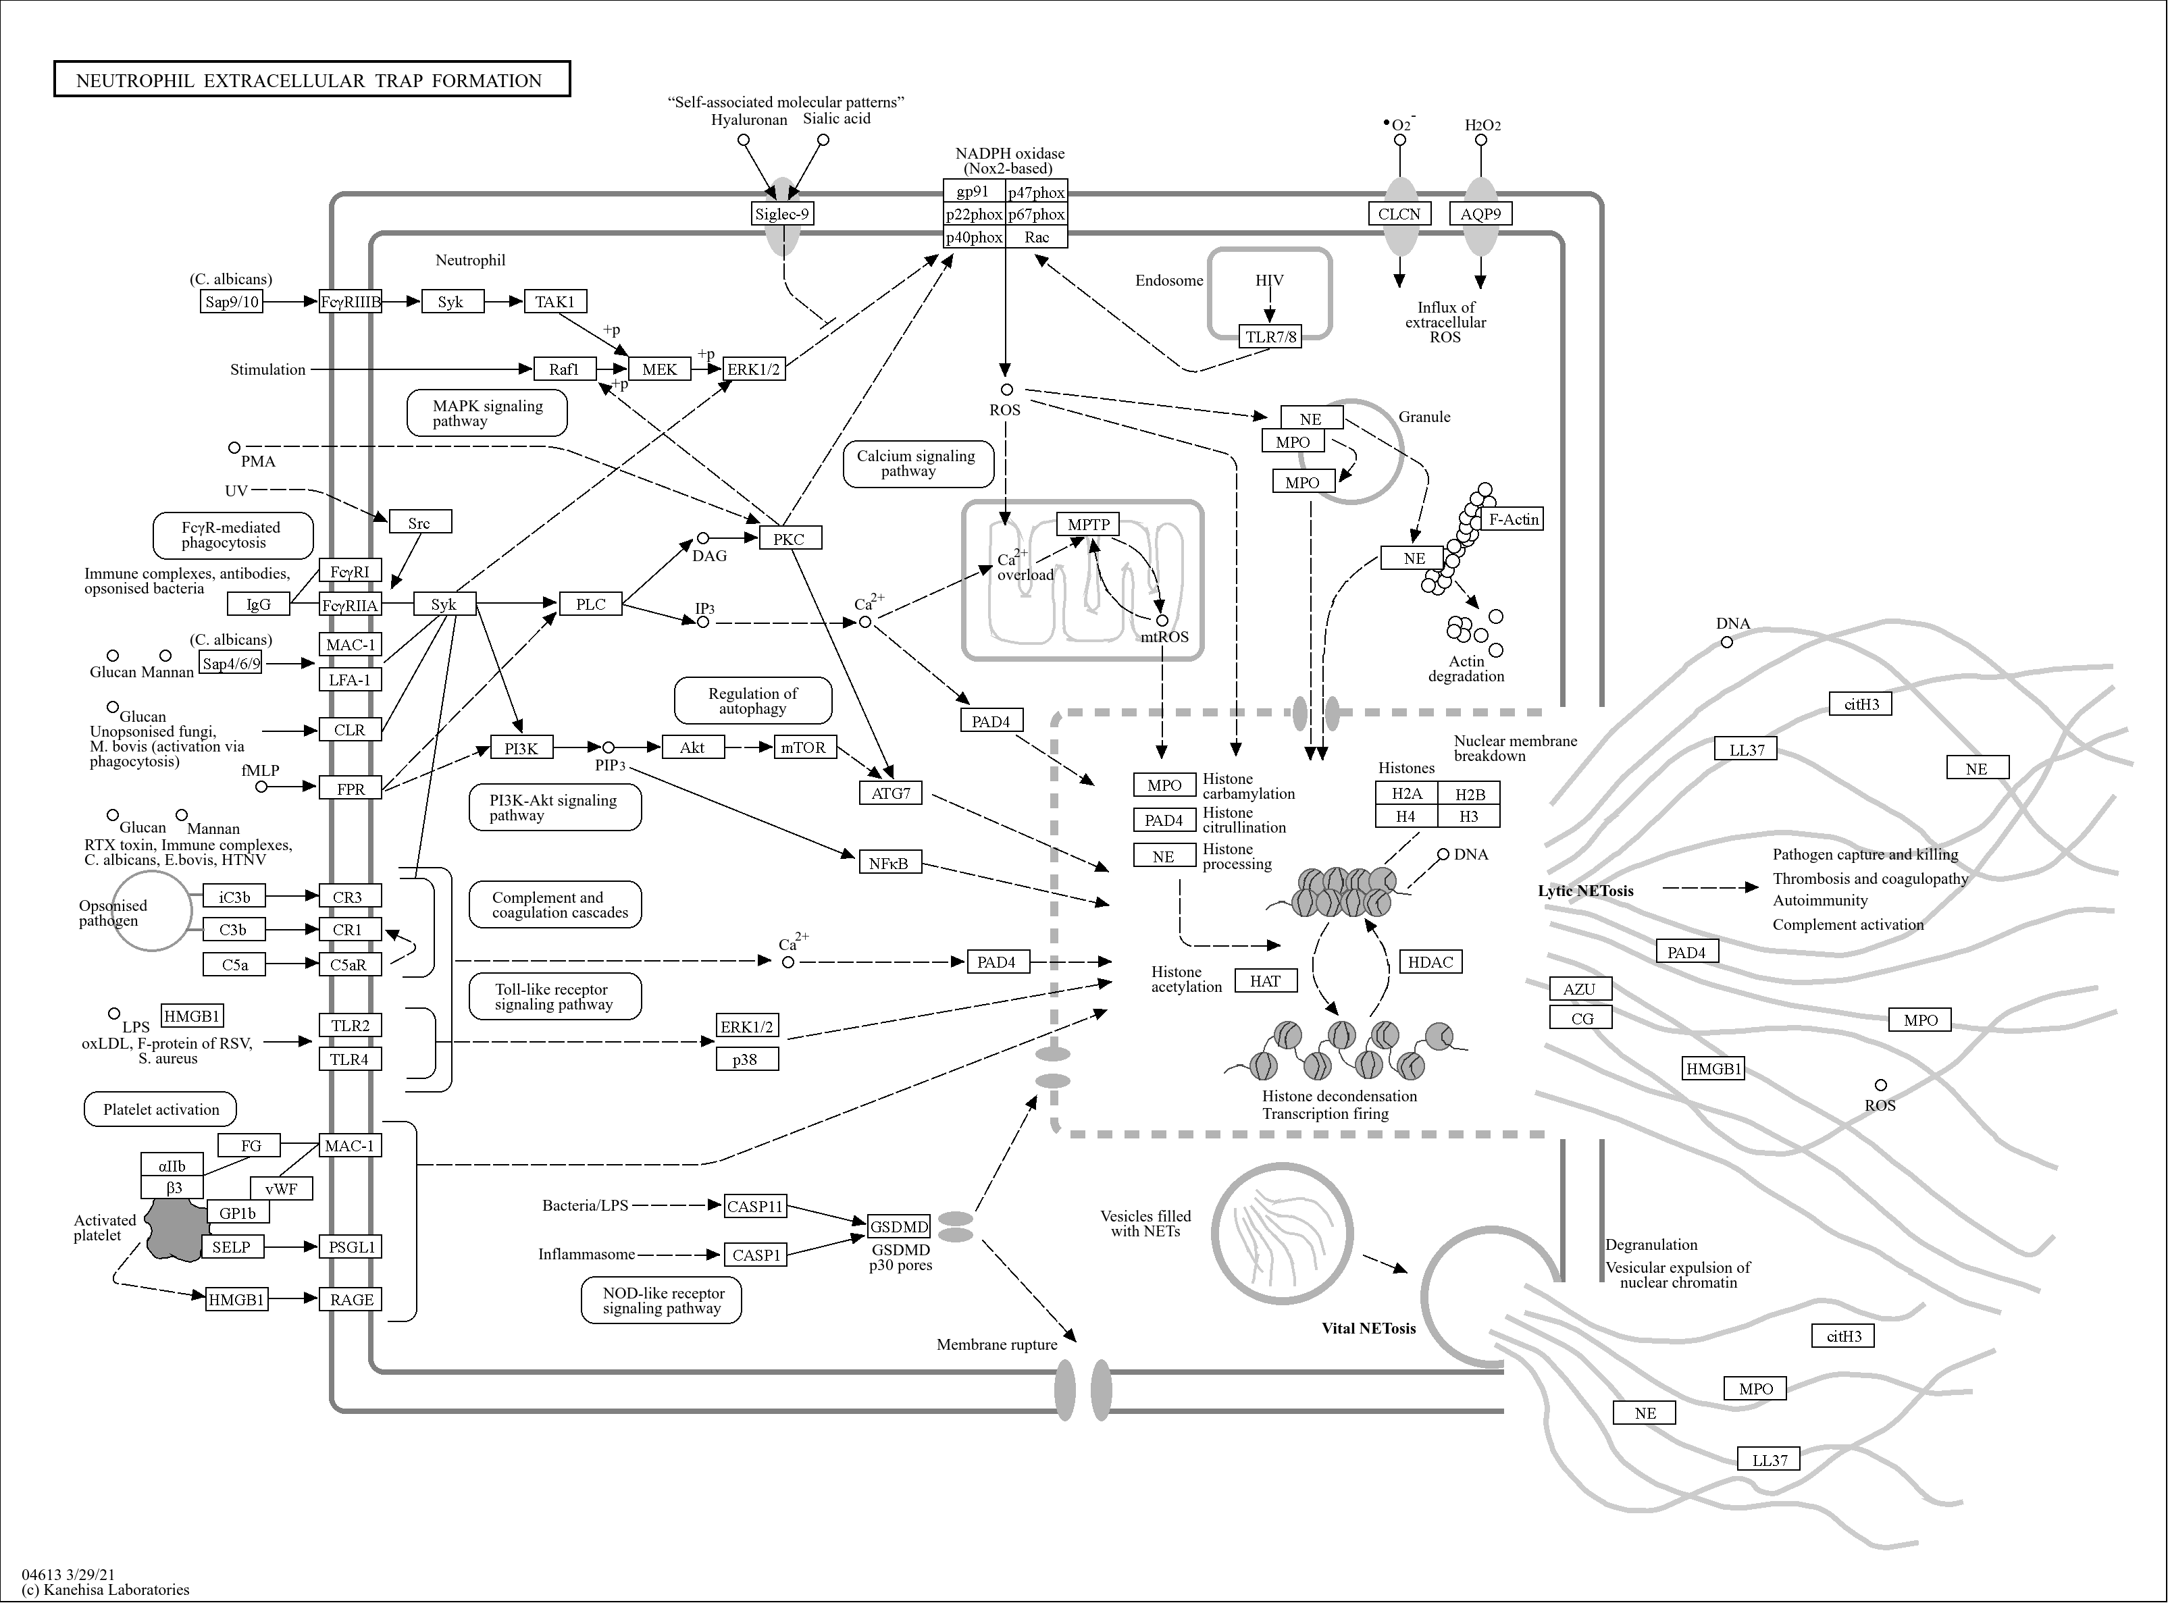
Fig. S2. The biological process of Neutrophil Extracellular Traps (NETs) formation by KEGG pathways enrichment in DAVID database.
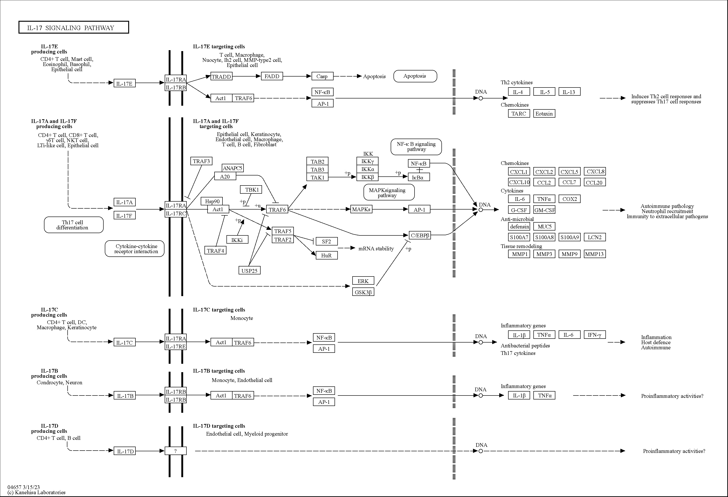
Fig. S3. The biological process of IL-17 signaling pathway by KEGG pathways enrichment in DAVID database. The cytokines and related proteins measured in this study were marked by red boxes.

