Supplementary Material

Highly efficient multifactory waste stabilization pond system: a survey on its abiotic properties and microbial community
By Silva Júnior et al.

Table S1. Monthly average rainfall from 2015-2021 from pluviometry stations in the neighbourhood of the Multifactory Wastewater Treatment Plant (MF-WWTP): station 268 (Barragem Duas Unas) and station 604 (Cidade da Copa).
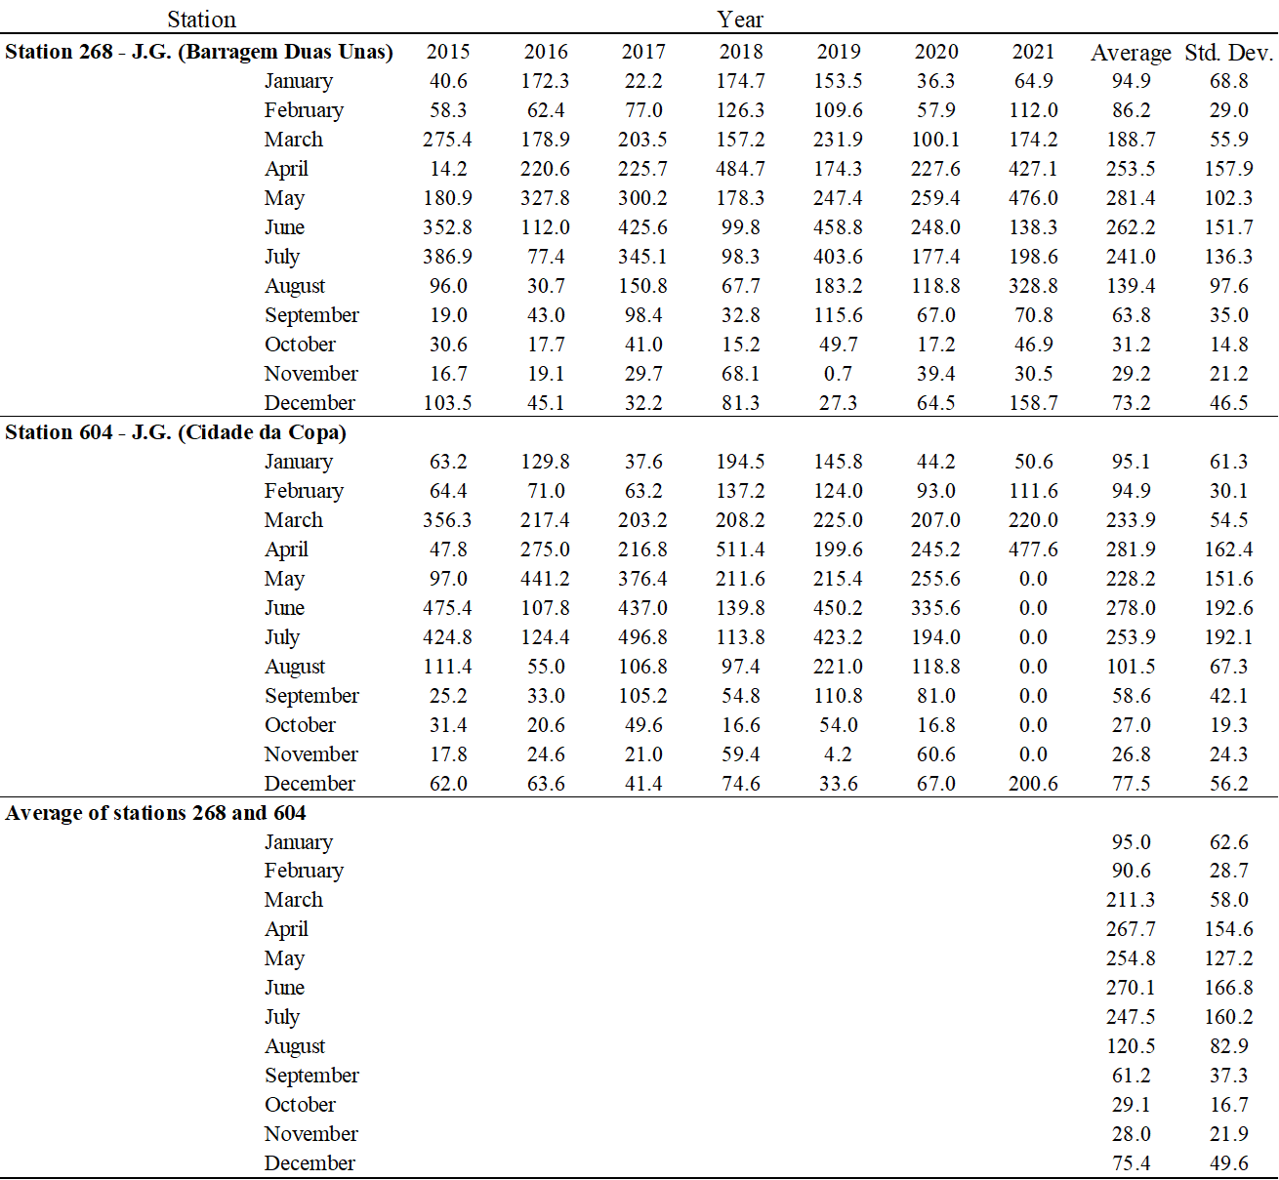
Source: data publicly available at APAC - Agência Pernambucana de Águas e Climas. Monitoramento pluviométrico, available at <http://old.apac.pe.gov.br/meteorologia/monitoramento-pluvio.php>. Last accessed: August 1st, 2023.

Volatile Fatty Acids (VFAs) Quantification Methodology
VFAs were quantified by gas chromatography (Agilent Technologies 7890A, Agilent Technologies Inc., Wilmington, DE, USA) coupled with a FID detector. Samples first received an ethyl ether organic acid extraction, following the protocol:

- Addition of 1 g of sodium chloride, in a 10 mL glass tube with a screw cap;
- Addition of reagents the glass tube:
  - 2 mL of sample;
  - 100 µL of crotonic acid as standard for evaluation of recovery;
  - 200 µL of sulfuric acid;
  - 600 µL of ethyl ether;
- Vortex at maximum speed for 2 minutes;
- Sample collection with syringe pre washed with ethyl ether.

The chromatographic conditions were as follows:

Injection volume: | 2 µL
Injection mode: | Split 1:10
Injector temperature: | 250 °C
Column: | J&W 122-7332: 260°C: 30 m x 250 μm x 0,25 μm
Temperature ramp: | 100 °C for 1 min, followed by a temperature increase ramp of 8 °C/min until 150 °C, kept for 1 min, followed by a temperature increase ramp of 35 °C/min until 200 °C, kept for for 1 min
Run time: | 10,7 minutes
Carrier gas: | N₂
Detector temperature: | 300 °C
Flow rate: | 1 mL/min
Detector: | Flame Ionization Detector (FID)

Table S2. Apparent and real colour of the untreated and treated wastewater collected on November 27, 2021.
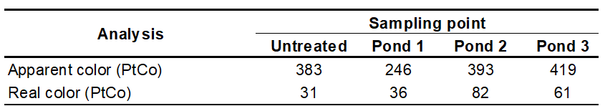

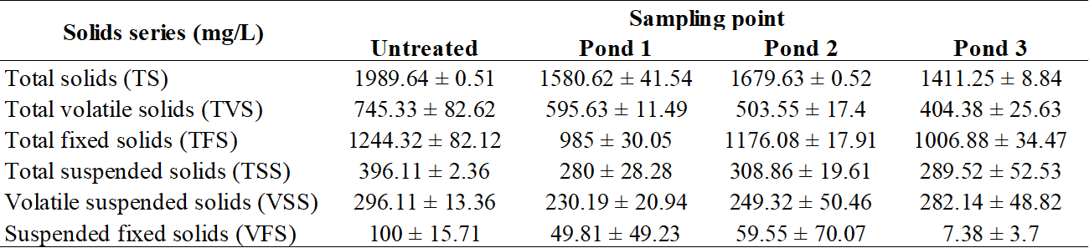
Table S3. Total and suspended solids series from untreated sample and from Ponds 1, 2 and 3 of the Multifactory Wastewater Treatment Plant.

Table S4. Analysis of acute toxicity to Aliivibrio fischeri (Beijerinck, 1889) Uranczyk et al., 2007 (synonym Vibrio fischeri) for samples from the Multifactory Wastewater Treatment Plant.
Parameter | Sample
Parameter | Untreated | Pond 1 | Pond 2 | Pond 3
TF | 64 | 512 | 64 | 512
TF: Toxicity factor, minimum dilution of the sample with no quantifiable inhibition of luminescence.
Table S5. Chromosomal alterations found in meristematic cells of Allium cepa L. after exposure to samples collected from the ponds of the Multifactory Wastewater Treatment Plant. Sampling points: untreated sample (SP13), pond 1 (SP14), pond 2 (SP15) and pond 3 (SP16).
Alteration | Sample
Alteration | CN | MMS | TRI | Untreated | P1 | P2 | P3
MN | 0 ± 0 | 0.38 ± 0.21* | 0.56 ± 0.41* | 0.18 ± 0.16* | 0.14 ± 0.18* | 0.19 ± 0.19* | 0.04 ± 0.08*
NB | 0.04 ± 0.07 | 0.08 ± 0.13 | 0.06 ± 0.09 | 0.06 ± 0.13 | 0.02 ± 0.06 | 0.04 ± 0.08 | 0.06 ± 0.12
CL | 0.10 ± 0.13 | 0.34 ± 0.18 | 0.36 ± 0.20 | 0.14 ± 0.15 | 0.31 ± 0.12 | 0.27 ± 0.25 | 0.59 ± 0.40*
CB | 0 ± 0 | 0.14 ± 0.18* | 0.10 ± 0.13* | 0.16 ± 0.19* | 0.19 ± 0.20* | 0.14 ± 0.31* | 0.21 ± 0.29*
CD | 0.04 ± 0.08 | 0.30 ± 0.64 | 0.10 ± 0.30 | 0.08 ± 0.13 | 0.04 ± 0.08 | 0.02 ± 0.06 | 0.02 ± 0.06
B | 0.13 ± 0.13 | 0.24 ± 0.20 | 0.20 ± 0.20 | 0.37 ± 0.39 | 0.39 ± 0.33 | 0.43 ± 0.41* | 0.9 ± 0.27*
CA | 0.10 ± 0.30 | 0.30 ± 0.64 | 0.20 ± 0.60 | 0.48 ± 0.88 | 0.57 ± 0.88 | 0.47 ± 0.75 | 0.30 ± 0.90
PC | 0.12 ± 0.10 | 0.22 ± 0.20 | 0.04 ± 0.08 | 0.33 ± 0.35 | 0.45 ± 0.48 | 0.26 ± 0.35 | 0.39 ± 0.38
CM | 0.10 ± 0.10 | 0.06 ± 0.09 | 0.04 ± 0.08 | 0.14 ± 0.18 | 0.10 ± 0.10 | 0.14 ± 0.18 | 0.06 ± 0.18*
NC = Negative Control; MMS = Methyl MethaneSulfonate; TRI = Trifluralin; MN = Micronucleus; BN = Nuclear Bud; CL = Chromosomal Loss; CB = Chromosomal Bridge; CD = Chromosomal Delay; B = Chromosomal Break; CA = Chromosomal Adhesion; CP = Polyploid Cell; CM = C-metaphase. Statistically significant values different from NC (p < 0.05) are followed by an asterisk in bold.
Fig S1. Sampling scheme in the three sequential stabilization ponds of the Multifactory Wastewater Treatment Plant (MF-WWTP), showing the collecting points for physicochemical and toxicity (blue), and biological (red) analysis in each pond. In the bottom, an amplification image shows the sampling approach using Van Dorn bottles.

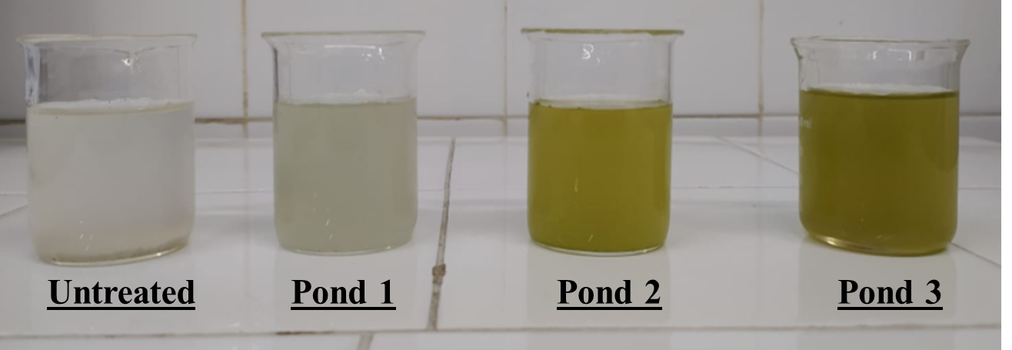
Fig S2. Samples for visual characterization from the first sampling campaign, on November 27, 2021.

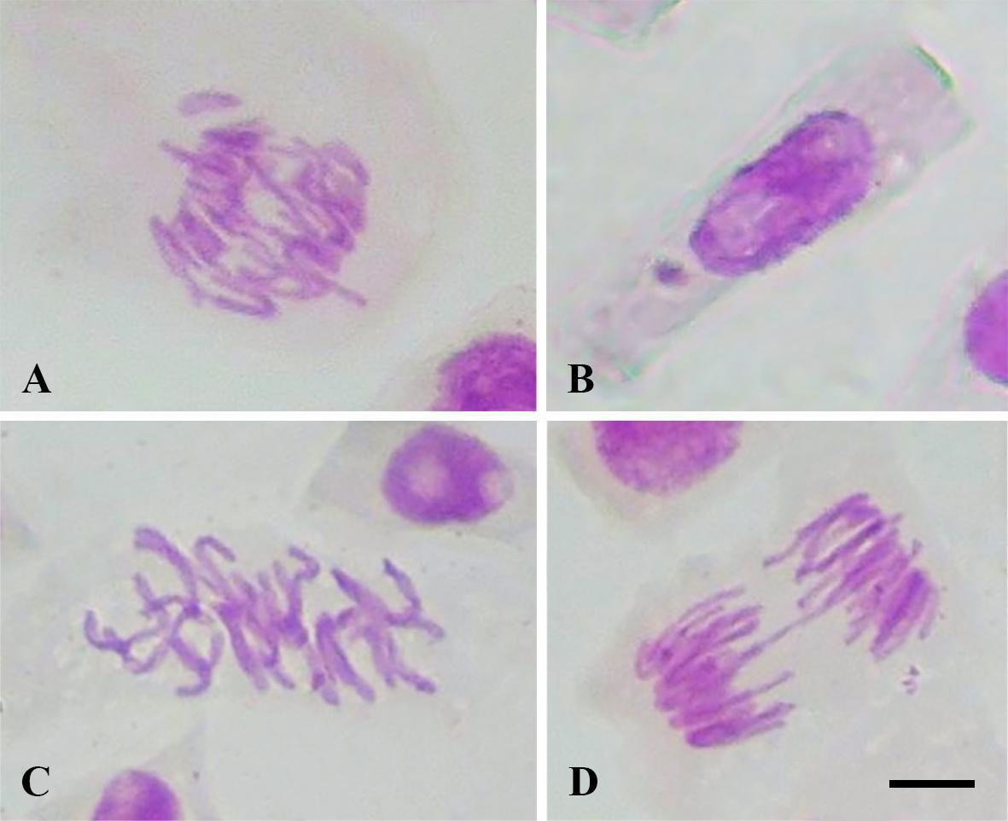
Fig S3: Chromosomal alterations found in meristematic cells of Allium cepa L. after exposure to samples from the Multifactory Wastewater Treatment Plant (MF-WWTP). (A) chromosomal loss (untreated sample); (B) Micronucleus (Pond 1); (C) C-metaphase (Pond 3); (D) chromosomal bridge (Pond 3). Bar in (D) corresponds to 10 µm.

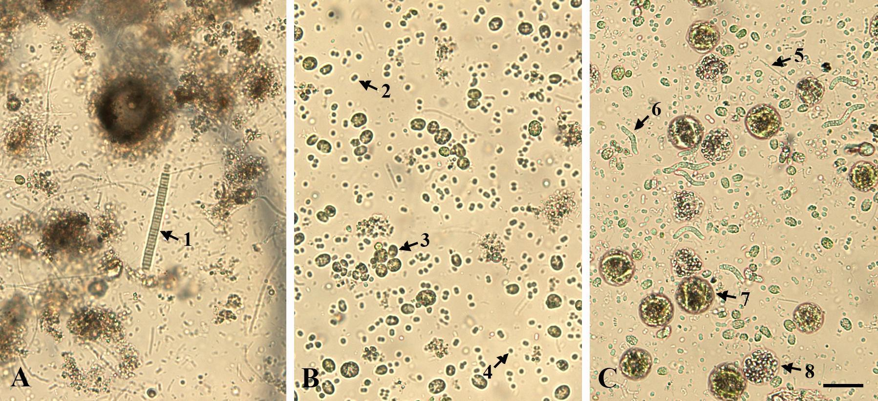
Fig S4: Images of the community of cyanobacteria and microalgae of the Ponds 1 (A), 2 (B), and 3 (C). Arrows indicate cyanobacteria: (1) Oscillatoria, (5) Geitlerinema, (6) Arthospira, (8) Merismopedia, and microalgae: (2) Chroococcus, (3) Choricystis, (4) Oocystis, (7) Chlorella. Bar in (C) corresponds to 50 µm.

