Supplementary Information for
Direction-Specific Diffusion of CO2 Augmented by Polygonal Rifling in Chiral Hexagonal Boron Nitride Nanotubes.
Manh-Thuong Nguyen,^{a*} David J. Heldebrant,^{a,b*}, Jian Liuª and Abhoyjit Bhown^{c}
[a] Pacific Northwest National Laboratory, Richland, Washington 99352, United States
[b] Pacific Northwest National Laboratory, Richland, Washington 99352, United States
Washington State University, Pullman, Washington 99164, United States
[c] Electric Power Research Institute, Palo Alto, California 94304, United States

S1. Methods
S1.1. Systems
We considered the h-BN nanotubes (BNNTs) of indices (5,5), (6,4), (7,3), (9,0), and (7,4), as generated using the TubeGen server. ¹
For binding energy screening, we used nanotubes/surfaces of which the chiral index and unit cell shown in Figure S1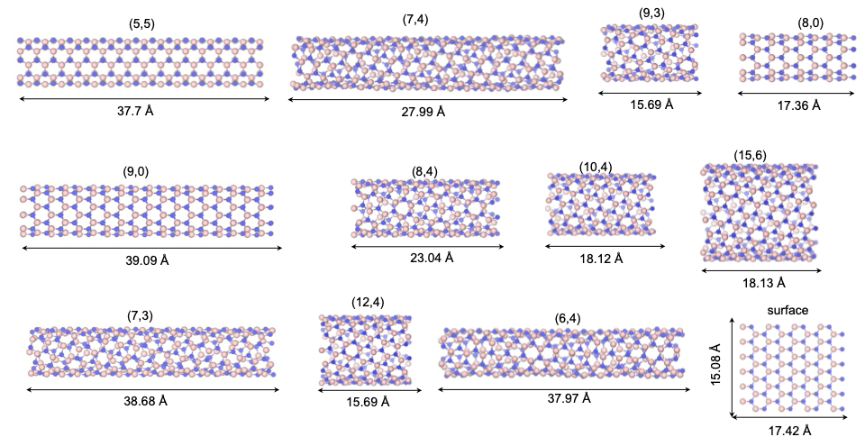
Figure S1. The unit cell size and chiral index of hBNNTs used for binding energy calculations.
S1.2. Static density functional calculations for binding energies
The binding energy of a (confined) X (X=CO2, N2) molecule a hBNNT was calculated as
$ΔE(X)=E\left({CO}_{2}-hBNNT\right)-E\left(X\right)-E\left(hBNNT\right)$,

in which the energy E of each system was calculated at the density functional level provided in Materials and Methods (main text).

S1.3. Diffusion coefficient (D)
D of CO2 along the tube direction (z), D_{z}, was calculated from the mean square displacement (MSD_{z})
$D_{z}=\frac{1}{2}\lim_{t→∞}{\frac{d}{dt}{MSD}_{z}(t)}$,
${MSD}_{z}(t)=〈{|r_{z}\left(t\right)-r_{z}(0)|}^{2}〉$,
in which r_{z} is the z component of the centroid coordinate of a CO2 molecule and the <> notation indicates the ensemble average.

S1.4. Adsorption free energy
At 1 atm, the free energy of X in hBNNTs (X= CO2, N2) was approximated as
$$∆G^{0}\left(X\right)≈∆E(X)- \tilde{μ}\left(T, p^{0},X\right),$$
in which $∆E$ is the calculated adsorption energy, and $\tilde{μ}\left(T, p^{0},X\right)$ is the chemical potential of molecule X at temperature T (T= room temperature in this study) and pressure p⁰ = 1 atm, as taken from NIST-JANAF Thermochemical Tables ².

S2. Results

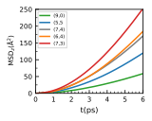
Figure S2. MSD_{z} of CO₂ in hBNNT from AIMD. The diffusion coefficient is calculated as the slope of the linear part from 4 to 6 ps.

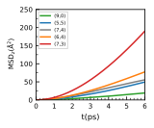
Figure S3. MSD_{z} of CO₂ in hBNNTs from xTB-MD.

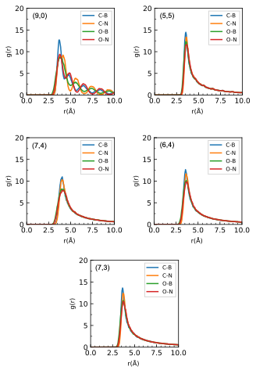
Figure S4. Radial distribution functions, g(r), of atom pairs, in which C and O are CO₂ atoms and B and N are hBNNT atoms.

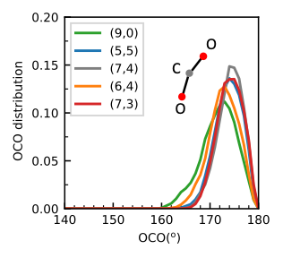
Figure S5. Distribution of the OCO angle.

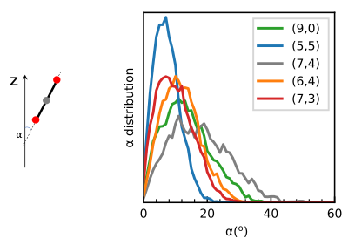
Figure S6. Angle ⍺ between the CO₂ molecule (OO direction) and the tube direction (z), and its distribution.

Uncategorized References
1. J. T. Frey and D. J. Doren Tw-i, http://turin.nss.udel.edu/research/tubegenonline.html), University of Delaware, Newark DE, 2011. TubeGen 3.4 (web-interface, http://turin.nss.udel.edu/research/tubegenonline.html), J. T. Frey and D. J. Doren, University of Delaware, Newark DE, 2011. [cited]Available from: TubeGen 3.4 (web-interface, http://turin.nss.udel.edu/research/tubegenonline.html), J. T. Frey and D. J. Doren, University of Delaware, Newark DE, 2011.

2. NIST. NIST-JANAF Thermochemical Tables, 2024.

