Supplementary materials
Synergistic interaction between microbial nitrogen fixation and iron reduction in the environment

Xiaohan Liu ^{1, 2}, Ping Li ^{1, 2 *}, Keman Bao ^{1, 2}, Yaqi Wang ^{1, 2}, Helin Wang ^{1, 2}, Yanhong Wang ^{1, 2}, Zhou Jiang ¹, Yi Yang³, Songhu Yuan^{1, 2}, Andreas Kappler^{4, 5}, Yanxin Wang^{1, 2}

¹ State Key Laboratory of Biogeology and Environmental Geology, China University of Geosciences, Wuhan, 430074, P.R. China
² Hubei Key Laboratory of Yangtze Catchment Environmental Aquatic Science, School of Environmental Studies, China University of Geosciences, Wuhan, 430074, P.R. China
³ College of Marine Science and Technology, China University of Geosciences, Wuhan, 430074, P.R. China
⁴ Department of Geosciences, University of Tübingen, Tübingen, Germany.
⁵ Cluster of Excellence: EXC 2124: Controlling Microbes to Fight Infection, Tübingen, Germany.

*Corresponding author: Ping Li, pli@cug.edu.cn

Contents of this file
Tables 6
Figures 14

Table S1 Primer pairs used in this study and correspondence RT-qPCR protocols.
Target gene | Primer pair |  |  | Sequences | Reaction conditions |  |  | Methods
Bacterial  16S rRNA |  | 27F  1492R | 5´- AGAGTTTGGATCMTGGCTCAG -3´  5´- CGGTTACCTTGTTACGACTT -3 |  |  | 95 °C for 5 min; 35 cycles of 30 s at 94 °C, 30 s at 55 °C, 2 min at 72 °C, and 7 min at 72 °C. | PCR
Bacterial  16S rRNA  (V4 region) |  | 515F  806R | 5´- GTGCCAGCMGCCGCGGTAA -3´  5′- GGACTACHVGGGTWTCTAAT -3′ |  |  | 94 °C for 3 min, 35 cycles of 45 s at 94 °C, 60 s at 50 °C, 90s at 72 °C and 10 min at 72 °C. | qPCR
nifH |  | PolF  PolR | 5´- TGCGAYCCSAARGCBGACTC -3´  5´- ATSGCCATCATYTCRCCGGA -3 |  |  | 95°C for 10 min, 40 cycles of 95°C for 15s, 56°C for 45 s, and 72°C for 45 s. | qPCR
Shewanella  16S rRNA |  | 640F  815R | 5’-RACTAGAGTC TTGTAGAGG-3’  5’-AAGDYACCA AAYTCCGAGT-3’ |  |  | 95 °C for 3 min; 40 cycles of 15 s at 95 °C, 30 s at 55 °C, and 30 s at 72 °C. | qPCR
Shewanella  cymA |  | CymA-F  CymA-R | 5’-GATGCGTTCTGTATGTCTTG-3’  5’-ACGGAAGTAAGCCAATGC-3’ |  |  | 95 °C for 30 s; 40 cycles of 5 s at 95 °C, and 60 s at 60°C. | qPCR
Shewanella  mtrA |  | MtrA-F  MtrA-R | 5’-AGCGTGAATGATACCTGTTA-3’  5’-ATGAACCTGACTATGGCAAT-3’ |  |  | 95 °C for 30 s; 40 cycles of 5 s at 95 °C, and 60 s at 60°C.
- PCR of 16S rRNA genes was performed in a total volume of 25 μL containing 2.5 μL PrimeScript buffer, 1 μL dNTP Mixture, 0.3 μL TaKaRa Ex Taq, 18.2 μL dd H₂O, 1 μL of each primer and 1μL DNA or RNA sample.
- qPCR was performed in a total volume of 15 μL containing 7.5 μL TB Green Premix Ex Taq Ⅱ, 1 μL forward and reverse primers, 0.3 μL ROX Reference Dye Ⅱ, 1 μL diluted template and 4.2 μL RNase-free water.

Table S2 Summary of transcriptome sequencing data and transcriptome assembly of strain Klebsiella sp. N7.
Sample Name | Raw reads | Raw Q20  (%) | Raw Q30  (%) | Clean Reads | Clean Q20  (%) | Clean Q30  (%)
Burk | 10938523 | 92.59 | 81.12 | 10399996 | 94.87 | 85.19
Burk | 11773693 | 92.61 | 81.03 | 11186067 | 94.89 | 85.13
Burk | 10851900 | 92.47 | 80.53 | 10272038 | 94.80 | 84.78
Burk+Fe | 11144068 | 92.50 | 80.89 | 10558610 | 94.89 | 85.18
Burk+Fe | 11047853 | 92.46 | 80.77 | 10490580 | 94.81 | 85.02
Burk+Fe | 10236657 | 91.66 | 78.79 | 9742101 | 93.99 | 82.95
Burk+Fe+Ar | 8683616 | 97.12 | 92.35 | 8437994 | 97.99 | 93.61
Burk+Fe+Ar | 8490047 | 97.18 | 92.56 | 8257889 | 98.07 | 93.83
Burk+Fe+Ar | 8167003 | 97.21 | 92.51 | 7928530 | 98.09 | 93.77

Table S3 Geochemical parameters of sediment/soil samples from different ecosystems used in microcosms.
 | Samples | Location | Depth (m) | ORP (mv) | DO  (mg L⁻¹) | Salinity | Temp (°C) | Fe  (mmol L⁻¹)
Aqufier sediment | X2 | 41.02 N,106.94 E | 20 | -86.4 | / | / | 12.2 | 0.94
Aqufier sediment | L2 | 40.96 N,107.00 E | 20 | -221.2 | / | / | 11.8 | 5.90
Soil | JH1 | 31.14 N,112.37 E | 0-0.1 | 197.5 | / | / | 17.3 | 7.82
Soil | XB5 | 28.34 N,121.45 E | 0.15-0.3 | / | / | / | / | 4.20
Hot spring sediment | DB-A-1 | 30.51 N,92.06 E | 0-0.1 | -301 | / | / | 63 | 2.12
Hot spring sediment | DB-A-3 | 30.51 N,92.06 E | 0-0.1 | -121 | / | / | 54 | 1.19
Hot spring sediment | DB-B-1 | 30.51 N,92.06 E | 0-0.1 | -298 | / | / | 61 | 7.79
Hot spring sediment | DB-B-3 | 30.51 N,92.06 E | 0-0.1 | -91 | / | / | 54 | 3.25
Marine sediment | A7-1 | 30.5 N,122.2 E | 10.2 | / | 3.6 | 19.2 | 26.4 | 10.76
Marine sediment | C4 | 31.2 N,121.8 E | 11.2 | / | 4.1 | 0.1 | 28.6 | 34.10

Table S4 Summary statistics for the assembly of metagenomic sequencing from various environmental samples.
 | Sample | Trimmed reads | Number of contigs | Contig N50
Groundwater | G1 | 2.44E+07 | 205,929 | 1161
Groundwater | G2 | 4.19E+07 | 561,917 | 1001
Groundwater | G27 | 2.97E+07 | 364,855 | 873
Groundwater | G30 | 3.78E+07 | 470,596 | 844
Aquifer sediment | X2 | 3.00E+07 | 388,016 | 834
Aquifer sediment | X4 | 3.91E+07 | 502,033 | 1007
Aquifer sediment | X6 | 2.36E+07 | 303,798 | 851
Aquifer sediment | L2 | 3.80E+07 | 443,302 | 1567
Aquifer sediment | L4 | 3.22E+07 | 158,153 | 1567
Aquifer sediment | L6 | 4.32E+07 | 601,614 | 748
Hot spring | DB | 6.52E+07 | 830,879 | 2362
Hot spring | DZ | 6.24E+07 | 222,303 | 3551
Hot spring | ZM | 4.82E+07 | 46,849 | 21399
Soil | S1 | 5.03E+07 | 875,960 | 693
Soil | S2 | 5.69E+07 | 868,266 | 698
Soil | S3 | 5.09E+07 | 715,607 | 688
Soil | S4 | 5.22E+07 | 1,068,941 | 762
Soil | S5 | 5.07E+07 | 1,054,347 | 756
Soil | S6 | 2.19E+07 | 395,549 | 623
Soil | S7 | 3.34E+07 | 630,252 | 735
Marine | M1 | 4.12E+07 | 254,880 | 2022
Marine | M2 | 3.67E+07 | 442,442 | 1153
Marine | M3 | 4.50E+07 | 773,162 | 1115
Marine | M4 | 4.14E+07 | 628,003 | 1271
Marine | M5 | 5.45E+07 | 737,986 | 692
Marine | M6 | 3.90E+07 | 485,928 | 1279
Marine | M7 | 4.85E+07 | 589,621 | 698
Marine | M8 | 5.15E+07 | 914,253 | 754

Table S5 Information on medium-quality metagenome-assembled genomes (MAGs) containing nitrogen fixation and ferric iron reduction genes in environmental samples.
Sample | Bin name |  | Completeness (%) | Contamination (%) |  |  | Classification
Groundwater | bin.16 | 68.59 |  |  | 1.41 | c__Thermodesulfovibrionia
Sediment | bin.26 | 67.35 |  |  | 5.37 | g__Azonexus
Sediment | bin.31 | 97.83 |  |  | 0.43 | c__Kapabacteria
Sediment | bin.126 | 64.05 |  |  | 13.15 | c__Gammaproteobacteria
Hot spring | Daba-bin.5 | 72.8 |  |  | 8.55 | k__Bacteria
Hot spring | Daba-bin.8 | 72.81 |  |  | 4.46 | p__Bacteroidota
Hot spring | Daba-bin.12 | 98.74 |  |  | 0.94 | k__Bacteria
Hot spring | Daba-bin.65 | 99.69 |  |  | 0.92 | k__Bacteria
Hot spring | Daba-bin.93 | 72.2 |  |  | 3.42 | o__Actinomycetales
Hot spring | Daba-bin.96 | 76.75 |  |  | 0.92 | c__Gammaproteobacteria
Hot spring | Daba-bin.118 | 67.5 |  |  | 3.24 | o__Actinomycetales
Hot spring | Daba-bin.146 | 98.18 |  |  | 6.36 | k__Bacteria
Hot spring | Dazuo-bin.13 | 73.13 |  |  | 1.07 | k__Bacteria
Hot spring | Dazuo-bin.46 | 98.09 |  |  | 1.14 | k__Bacteria
Hot spring | Dazuo-bin.47 | 59.88 |  |  | 8.36 | k__Bacteria
Hot spring | Dazuo-bin.59 | 64.08 |  |  | 2.27 | k__Bacteria
Hot spring | Dazuo-bin.78 | 95.33 |  |  | 0 | k__Bacteria
Soil | soil2.bin.12 | 98.28 |  |  | 2.89 | k__Bacteria
Soil | Soil4.bin.12 | 70.18 |  |  | 1.92 | k__Bacteria
Marine | sea2.bins.6 | 96.94 |  |  | 2.17 | o__Sphingomonadales
Marine | sea4.bins.36 | 55.52 |  |  | 1.72 | k__Bacteria
Marine | sea8.bins.14 | 98.32 |  |  | 4.15 | k__Bacteria
Marine | sea8.bins.19 | 77.05 |  |  | 1.01 | c__Gammaproteobacteria
Marine | sea8.bins.11 | 59.09 |  |  | 2.93 | k__Bacteria
Marine | sea8.bins.3 | 58.01 |  |  | 3.51 | k__Bacteria
Marine | sea8.bins.5 | 54.20 |  |  | 3.57 | p__Desulfobacterota

Table S6 Estimation of nitrogen fixation enhancement through ferric iron reduction in environmental sediments.
 | Samples | Fe(Ⅲ) addition in microcosm  (mmol L⁻¹) | Promoted nitrogenase activity (μmol L⁻¹ C₂H₄) | Converted N  (μmol L⁻¹) | Contribution (μmol N/mmol Fe)
Aquifer  sediments | X2 | 0.2 | 16.19 | 5.40 | 26.98
Aquifer  sediments | L2 | 0.2 | 6.68 | 2.23 | 11.13
Soils | JH1 | 0.2 | 9.56 | 3.18 | 15.92
Soils | XB5 | 0.2 | 45.35 | 15.12 | 75.58
Marine sediments | A7 | 0.2 | 3.75 | 1.25 | 6.25
Marine sediments | C4 | 0.2 | 0.85 | 0.28 | 1.42
- Values presented in the table represent mean values.
- To convert from C₂H₄ to N₂ fixation, a conversion factor of 3 C₂H₄ : 1 N₂ for the integrated concentrations was applied¹. This conversion factor is based on comparisons between the C₂H₂ reduction assay and ¹⁵N incubations.

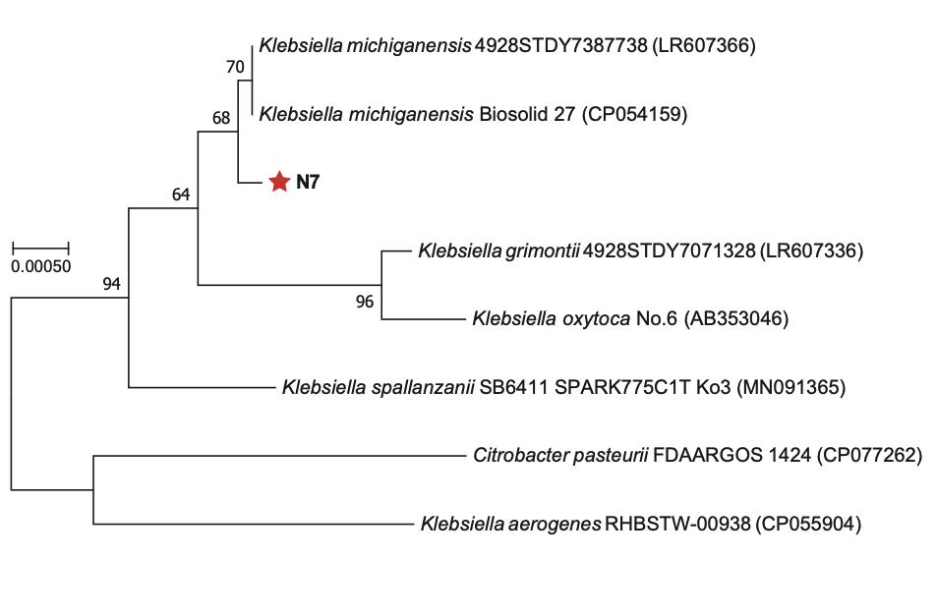
Fig. S1 Phylogenetic neighbor-joining dendrogram based on the 16S rRNA gene sequence of strain Klebsiella sp. N7 and known representative nitrogen-fixers.

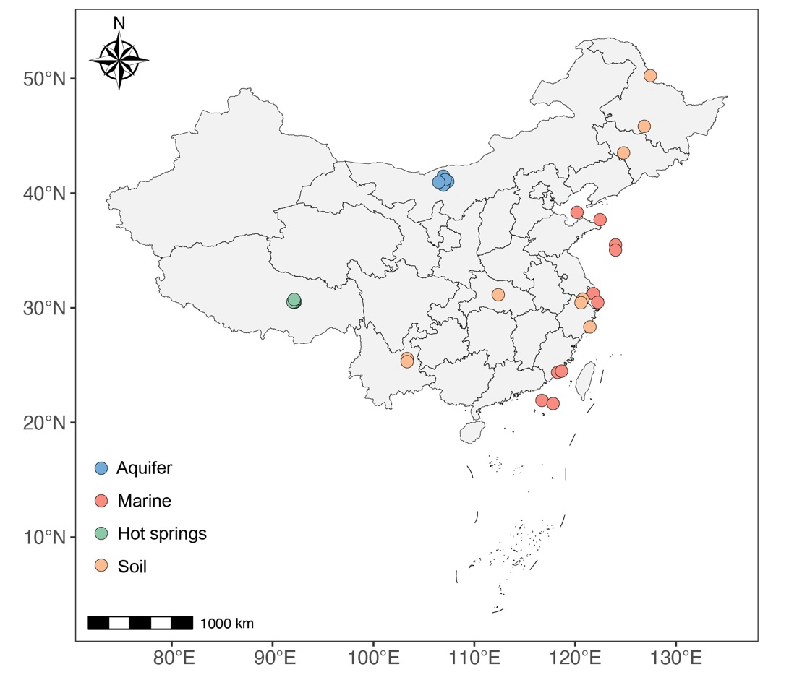
Fig. S2 Geographic distribution of environmental sampling sites in China, where microcosm and metagenomic data were collected. The samples were taken from aquifer waters/sediments (blue dots), marine sediments (red dots), hot spring sediments (green dots), and soils (orange dots).

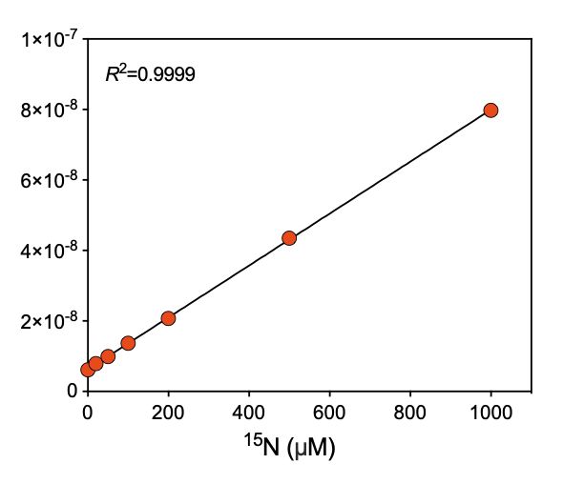
Fig. S3 Relationships between known ¹⁵NH₄⁺ concentrations and measured signal intensities of total ¹⁵N (²⁹N₂ +2× ³⁰N₂).

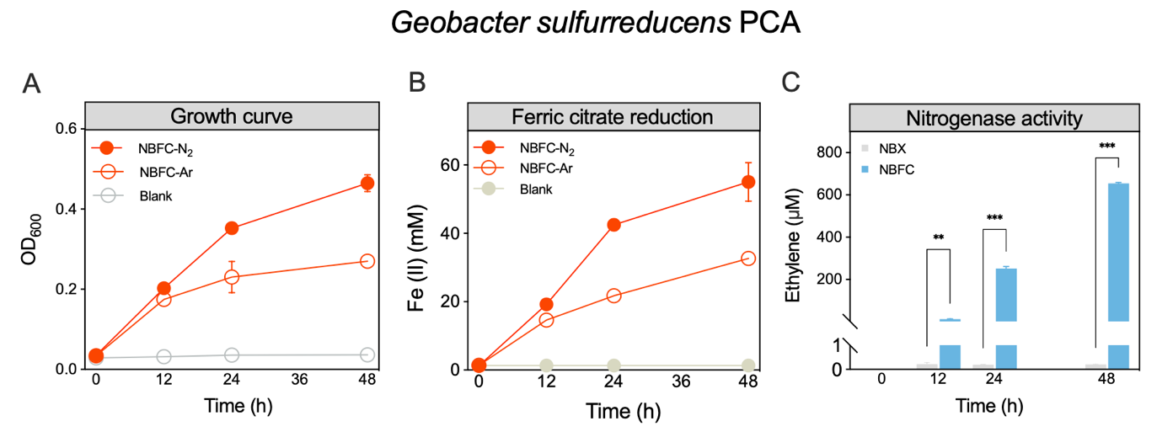
Fig. S4 Synergy between nitrogen fixation and Fe(Ⅲ) reduction in the respiratory-type diazotrophic iron-reducing bacterium Geobacter sulfurreducens PCA. (A) Growth, (B) Fe(Ⅲ)-citrate reduction, and (C) nitrogenase activities under different conditions.

Fig. S5 (A) Growth curve and (B) ferrihydrite reduction in strain Klebsiella sp. N7 under N₂ and Ar conditions. (C) Nitrogenase activity and (D) ¹⁵N products in strain Klebsiella sp. N7 with/without ferrihydrite. *, **, and *** represent p < 0.05, 0.01, and 0.001, respectively.

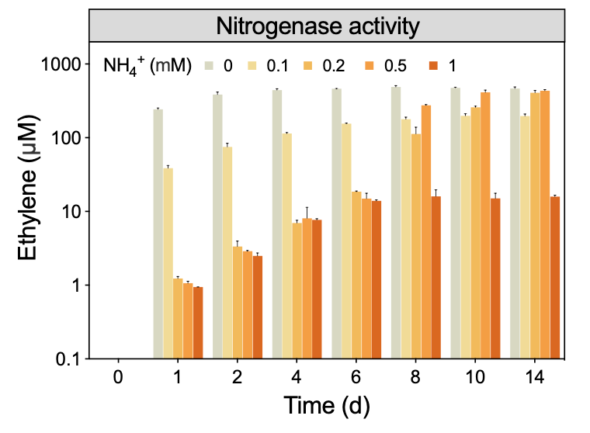
Fig. S6 Nitrogenase activity of strain Klebsiella sp. N7 at different concentrations of NH₄Cl, measured using the acetylene reduction assay.

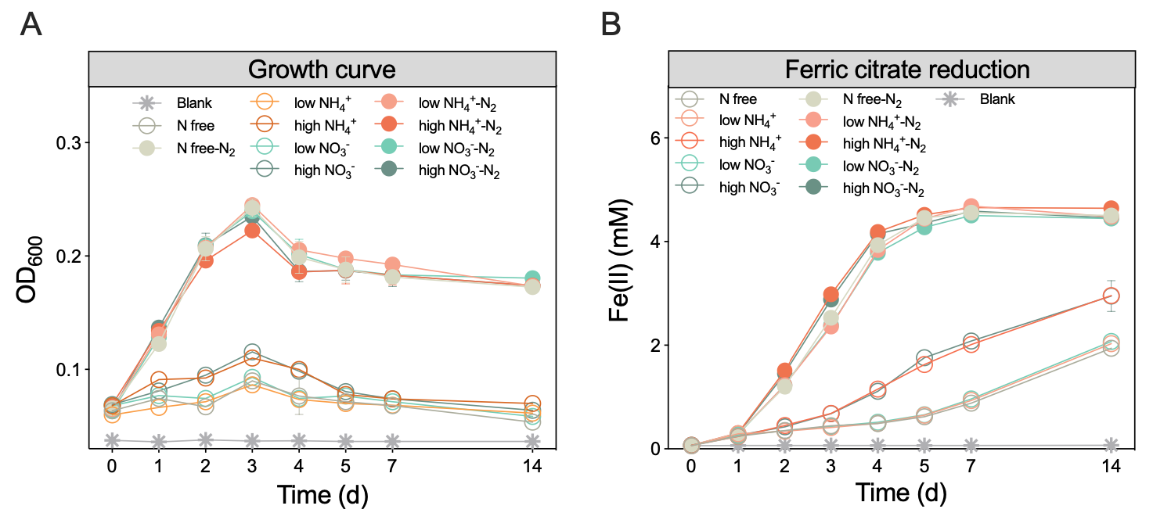
Fig. S7 Effects of nitrogen fixation on strain Klebsiella sp. N7 (A) growth and (B) ferric citrate reduction under different NH₄⁺/NO₃⁻ concentrations.

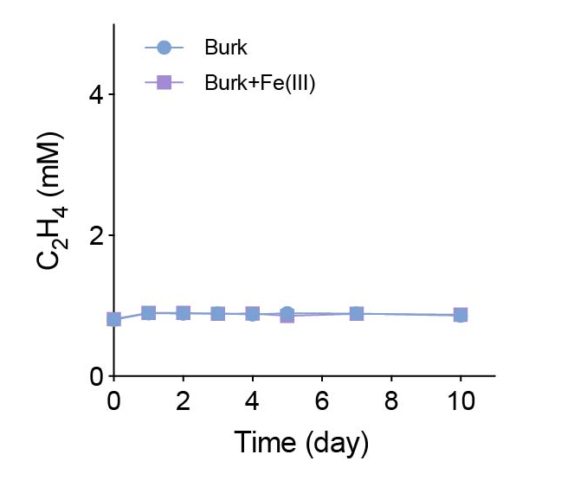
Fig. S8 Nitrogenase activity of strain Shewanella oneidensis MR-1 in nitrogen-free medium.

Fig. S9 Nitrogenase activity of strains Azospirillum humicireducens and Shewanella oneidensis MR-1 co-cultures under nitrogen and iron-free conditions.

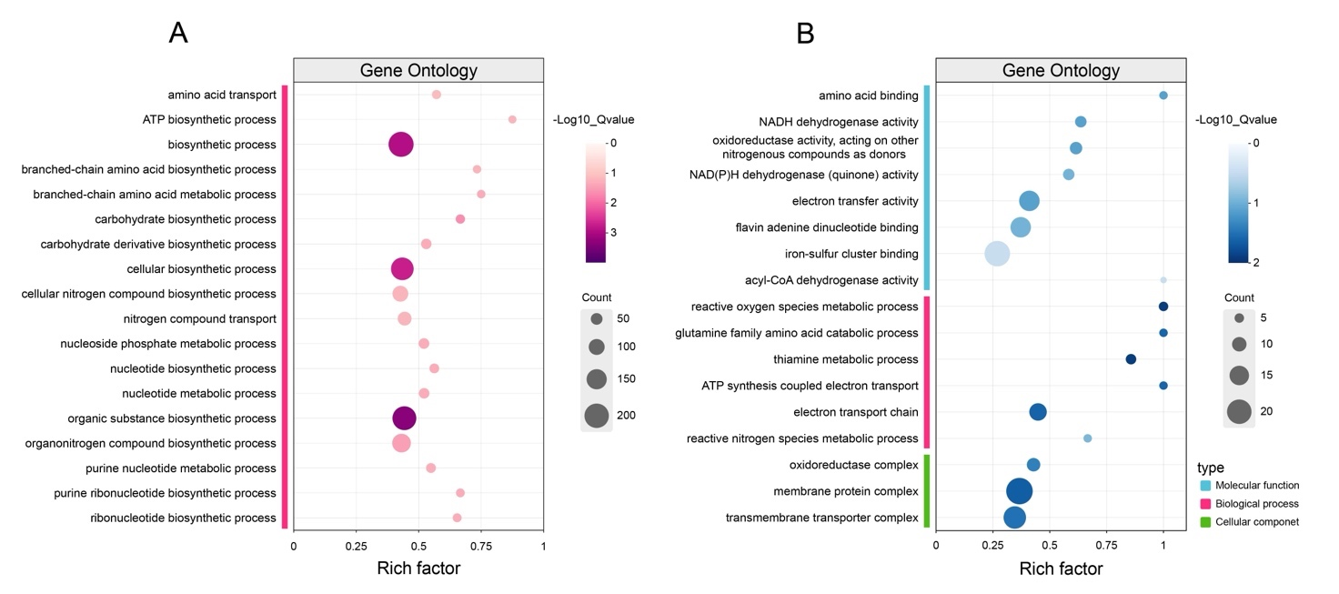
Fig. S10 Enrichment analysis of GO functional categories in strain Klebsiella sp. N7 under different conditions. (A) GO enrichment in strain Klebsiella sp. N7 under N₂ versus Ar conditions. (B) GO enrichment in strain Klebsiella sp. N7 with or without ferric iron addition.

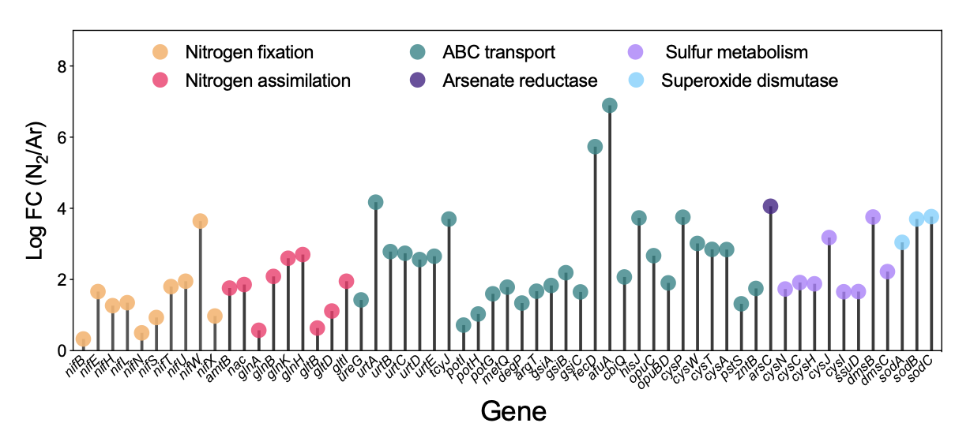
Fig. S11 Differentially expressed gene levels in strain Klebsiella sp. N7 with or without N₂ addition (P < 0.05).

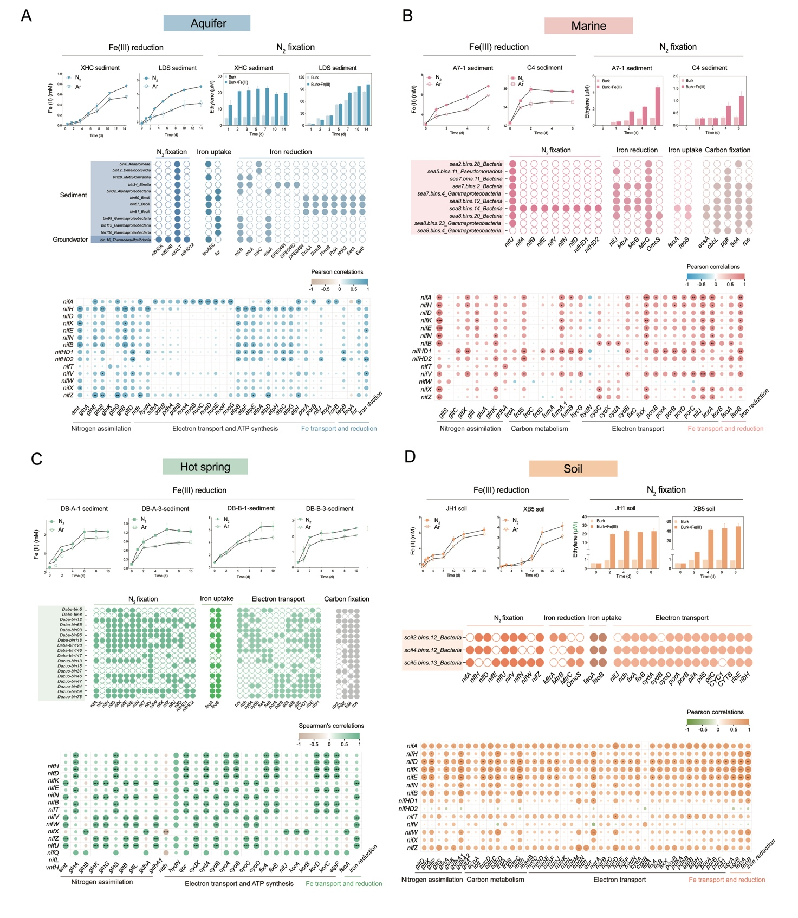
Fig. S12 Microcosm experiments and metagenomic analyses of environmental samples from (A) aquifer waters/sediments, (B) hot spring sediments, (C) soils, and (D) marine waters/sediments.

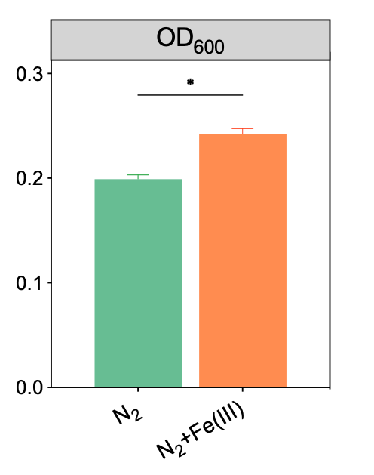
Fig. S13 OD₆₀₀ values of strain Klebsiella sp. N7 after 72 h of incubation with or without ferric citrate. * represents p < 0.05.

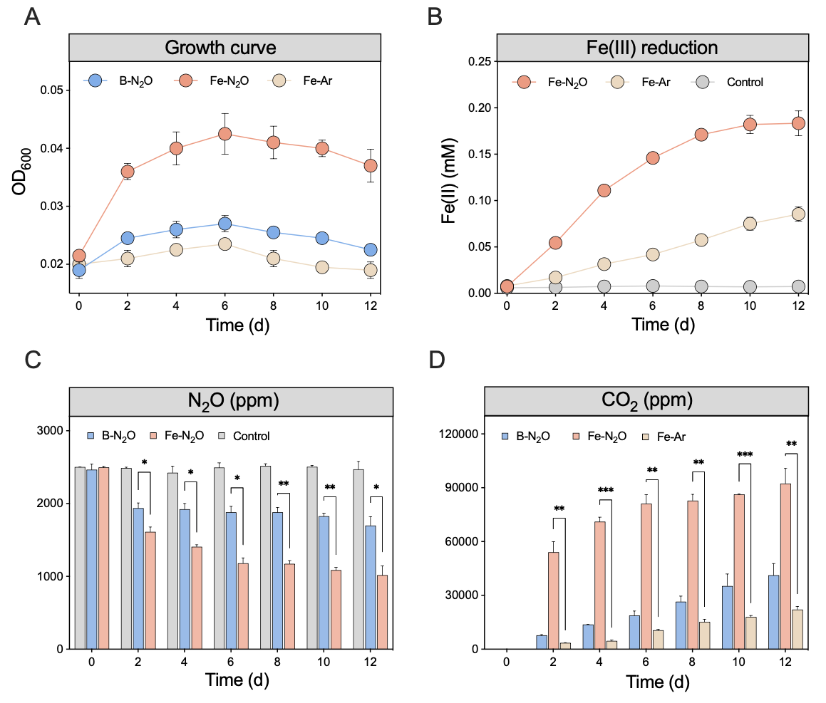
Fig. S14 Effects of N₂O fixation on (A) growth and (B) iron(Ⅲ) reduction in Klebsiella sp. N7 cultures. (C) N₂O consumption in Klebsiella sp. N7 with or without ferric citrate. (D) CO₂ production in Klebsiella sp. N7 under different conditions. *, **, and *** represent p < 0.05, 0.01, and 0.001, respectively.

Reference
1. Gier, J., Sommer, S., Löscher, C., Dale, A., Schmitz, R. & Treude, T. Nitrogen fixation in sediments along a depth transect through the Peruvian oxygen minimum zone. Biogeosciences 13, 4065-4080 (2016).

