Table S_1. Objective function value (OFV) differences between different disease progression models.
Number of parameters | Base model | OFV | ∆OFV | AIC  2P+∆OFV
6 | Linear  DS=BASE*(1+SLOPE*(TIME)) | -10293.625 | -
9 | Nonlinear  DS=BASE+((EMAX*(TIME**HILL))/((EC50**HILL)+(TIME**HILL))) - | -9966.541 | 327.84 | 345.84
6 | Exponential  DS=BASE*EXP(SLOPE*TIME) | -10313.308 | -19.683 | -7
Abbreviations: AIC; Akiake information criteria, variability, DS; disease status, EMAX; maximum level of amyloid plaque, EC50: the time at which accumulation reached to 50%, OFV: objective function value, ∆OFV: objective function value difference.
Figure S_1. Goodness-of-fit for the final developed DP model of amyloid plaque.
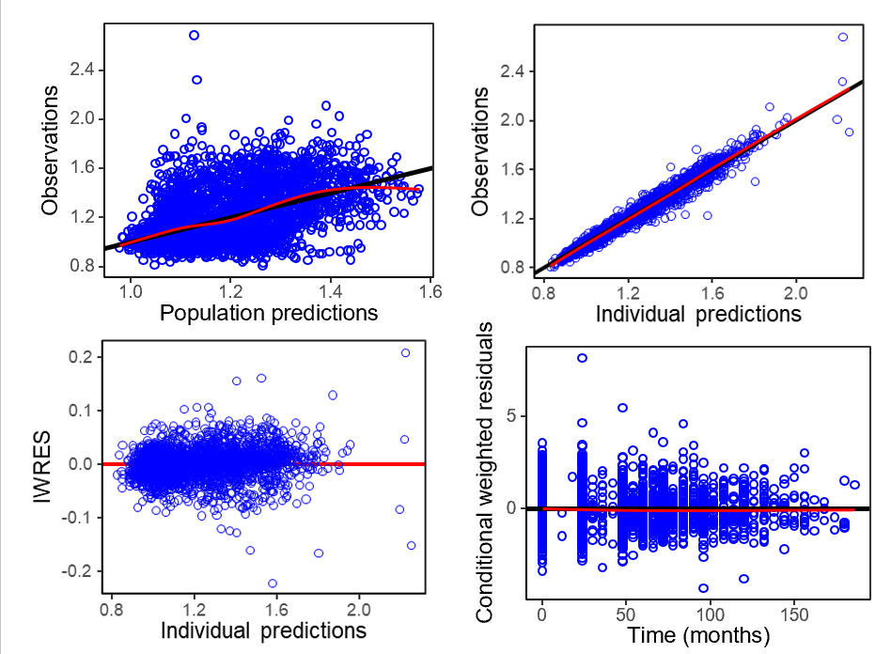
Goodness-of-fit for the final DP model of amyloid plaque, observed amyloid plaque versus population predicted amyloid plaque, observed amyloid plaque versus individual amyloid plaque, Individual weighted residuals (IWRES) versus individual prediction and conditional weighted residuals versus time (months). Abbreviations: IWRES; individual weighted residuals.

Figure S_2. Visual predictive checks of the amyloid plaque progression a) before and b) after dropout censoring.
a)
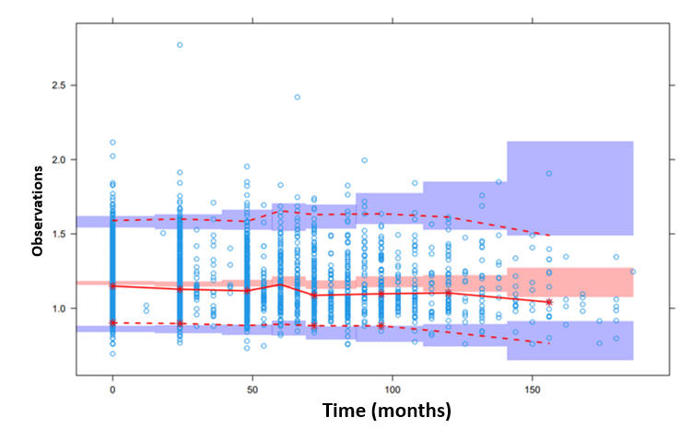
b)
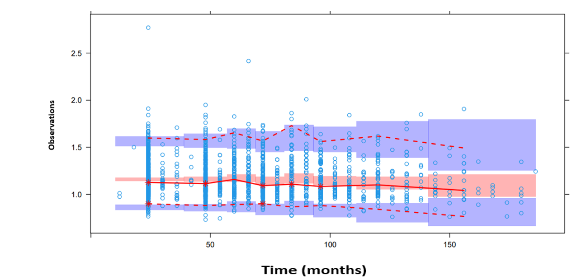
VPCs of the final amyloid plaque model with bins =8, while b) represents the final amyloid plaque model after considering dropouts censoring with bins =8. Solid red lines represent the median of observed data; dashed lines represent the 5th percentile (lower part) and 95th percentile (upper part) for observed data. Shaded areas are the 90% confidence interval for the 5th percentile (lower part) and 95th percentile (upper part) from 1000 simulated datasets. Bins=8.

Figure S_3. Dropout from the study based on diagnosis at baseline.
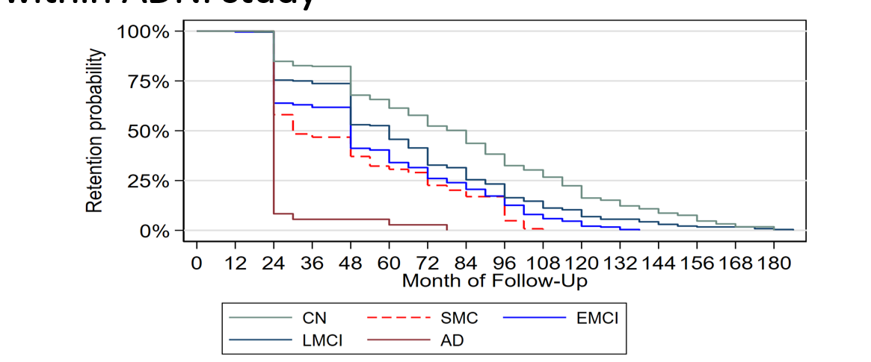
Plots of dropping out from the study according to diagnosis at baseline. Abbreviations: CN; cognitively normal, SMCs; subjective memory concerns, EMCI; early mild cognitive impairment, LMCI; late mild cognitive impairment, AD; Alzheimer disease.

