Supplementary Material
Agro-morphological characterization of Coffea canephora (Robusta) genotypes from the INERA Yangambi Coffee Collection, Democratic Republic of the Congo.
Robrecht Bollen, Jean-Léon Kambale, An-Sofie Tas, Benjamin Ntumba Katshela, Ebele Aaron Tshimi, Francis Wyffels, Filip Vandelook, Olivier Honnay, Piet Stoffelen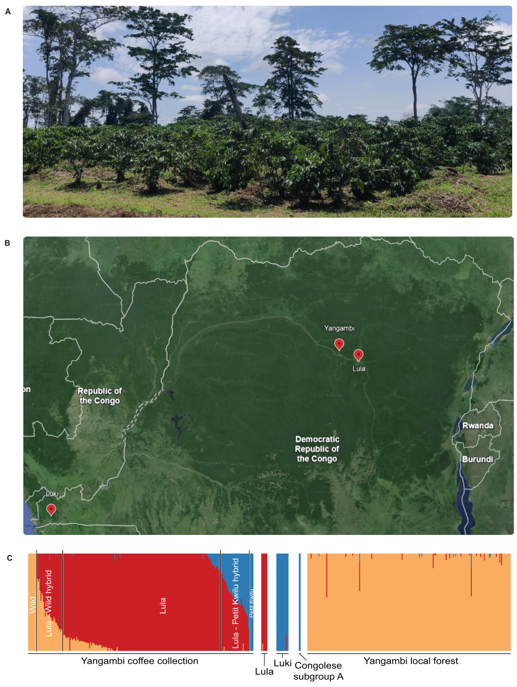
Supplementary Fig. S1 INERA Yangambi Coffee Collection. (A) C. canephora genotypes during the main harvest time. (B) Map locating the INERA Coffee Collection in Yangambi, the former INERA Lula breeding station, and the INERA Coffee Collection in Luki (Google Earth v10.49.0.0 (2023)). (C) Population genetic structure of the Yangambi Coffee Collection, INERA Luki reference material, Congolese subgroup A reference material, and the Yangambi local forest material. FastSTRUCTURE bar plot representing three clusters (K = 3). Colors define subpopulations: orange (Wild), blue (Congolese subgroup A), and red (‘Lula’ cultivars) (Verleysen et al., 2023).
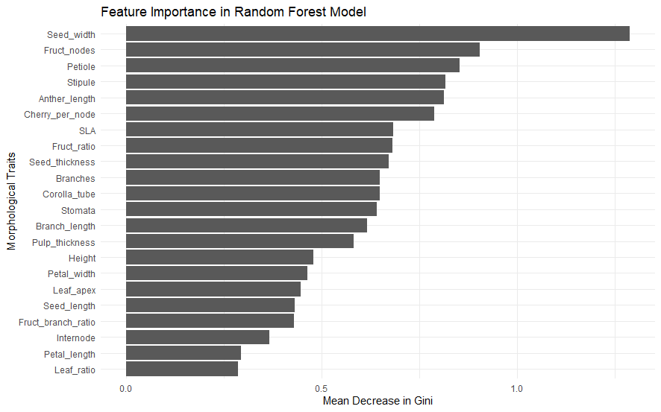
Supplementary Fig. S2 Morphological traits of importance in the random forest classification model of the selected Robusta genotypes with a Wild, ‘Lula’ and Congolese subgroup A identity. Genotypes with the highest ‘Lula’ genetic identity (n = 8), Wild genetic identity (n = 6), and Congolese subgroup A genetic identity (n = 8) were selected based on the population genetic structure analysis of Verleysen et al. (2023).

