Supporting Information for

The Fifth Generation Regional Climate Modeling System, RegCM5: the first Convection-Permitting European wide simulation and validation over the CORDEX-CORE domains

Coppola Erika¹, Filippo Giorgi¹, Graziano Giuliani¹, Emanuela Pichelli^{1,8}, James M. Ciarlo`^{1,5}, Francesca Raffaele¹, Rita Nogherotto^{1,7}, Michelle Simões Reboita^{1,2}, Chen Lu¹, Natalia Zazulie^{1,3}, Luiza Vargas-Heinz^{1,4}, Andressa Andrade Cardoso^{1,6}, Johannes de Leeuw^{1,7}

¹The Abdus Salam International Centre for Theoretical Physics, Trieste, Italy
²Federal University of Itajubá, Itajubá-MG, Brazil
³National Council of Scientific and Technical Research (CONICET), Buenos Aires, Argentina
⁴Università degli Studi di Trieste, Trieste, Italy
⁵University of Malta, Malta
⁶Departamento de Ciências Atmosféricas, Instituto de Astronomia, Geofísica e Ciências Atmosféricas, Universidade de São Paulo, São Paulo,SP, Brazil.
⁷The National Institute of Oceanography and Applied Geophysics, Trieste, Italy.
⁸ENEA - National Agency for new technologies, energy and sustainable economic development, Climate modeling and impacts laboratory (SSPT-MET-CLIM), Rome, Italy
Contents of this file

Figures S1 to S11

Introduction

This supporting information integrates the figures in the main article, showing the same metrics but for additional variables or pressure levels.

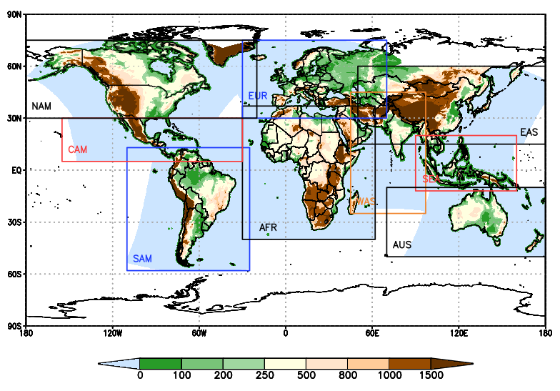

Figure S1: The CORDEX-CORE domains

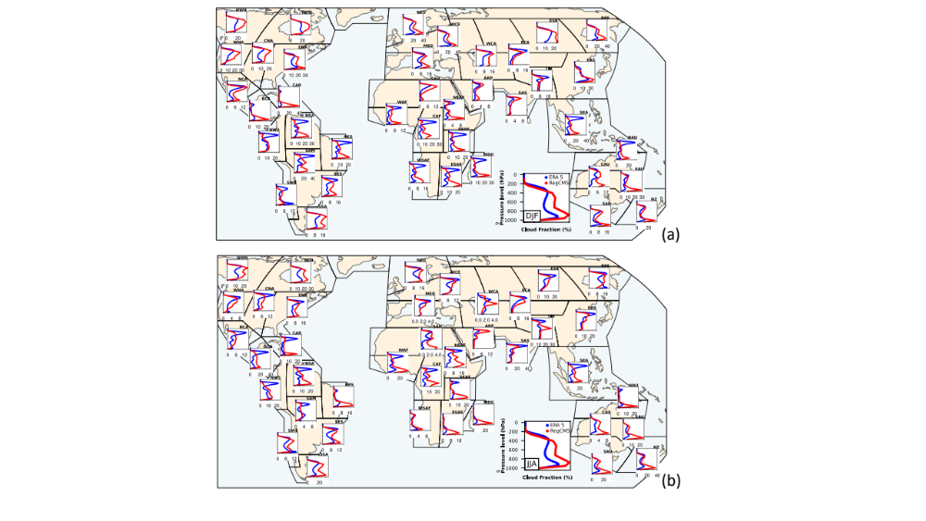

Figure S2: Cloud fraction vertical profiles for DJF (a) and JJA (b). The period covered is 2000-2009, except for the European domain (MED, WCE and NEU regions): 1980-2010.

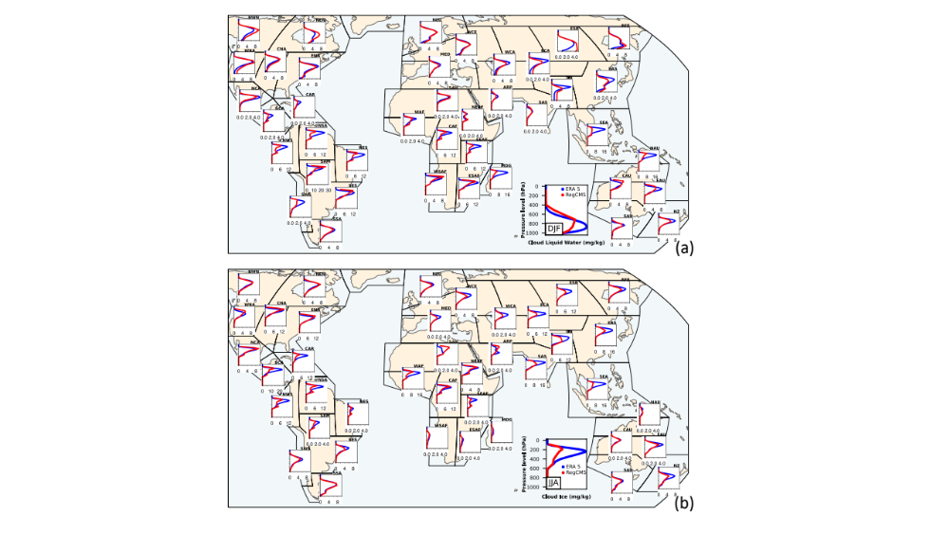

Figure S3: Cloud ice vertical profiles for DJF (a) and JJA (b). The period covered is 2000-2009, except for the European domain (MED, WCE and NEU regions): 1980-2010.

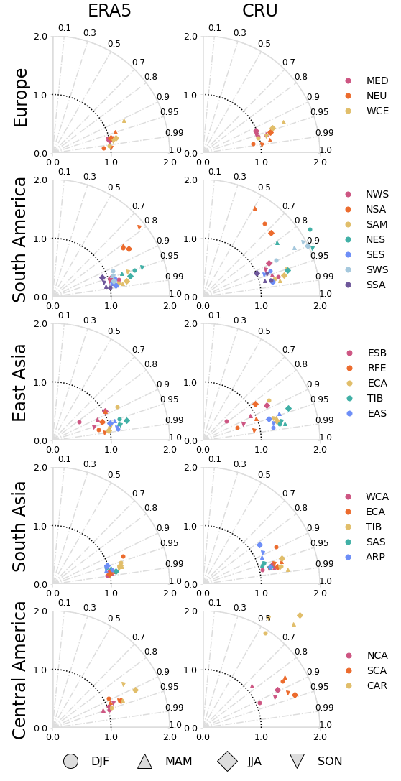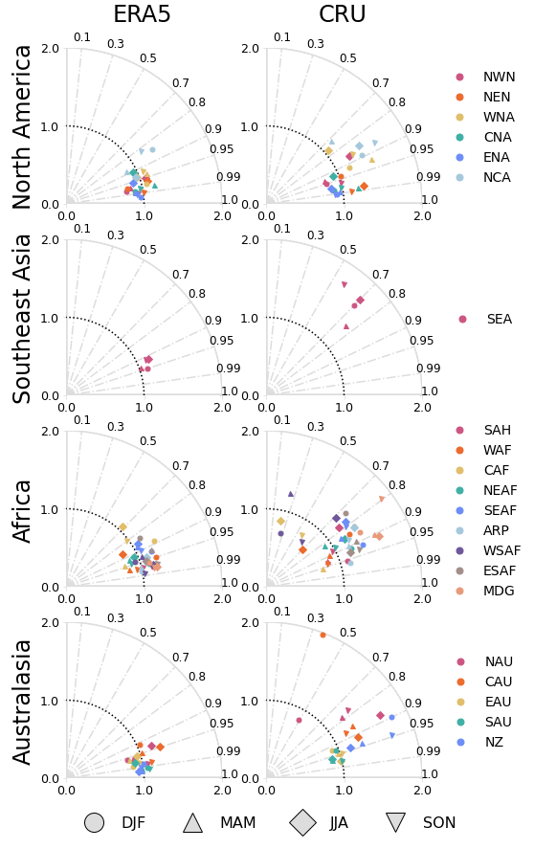

Figure S4: Taylor diagrams for the maximum temperature. Symbols represent seasons and colors are the subregions of a specific domain.

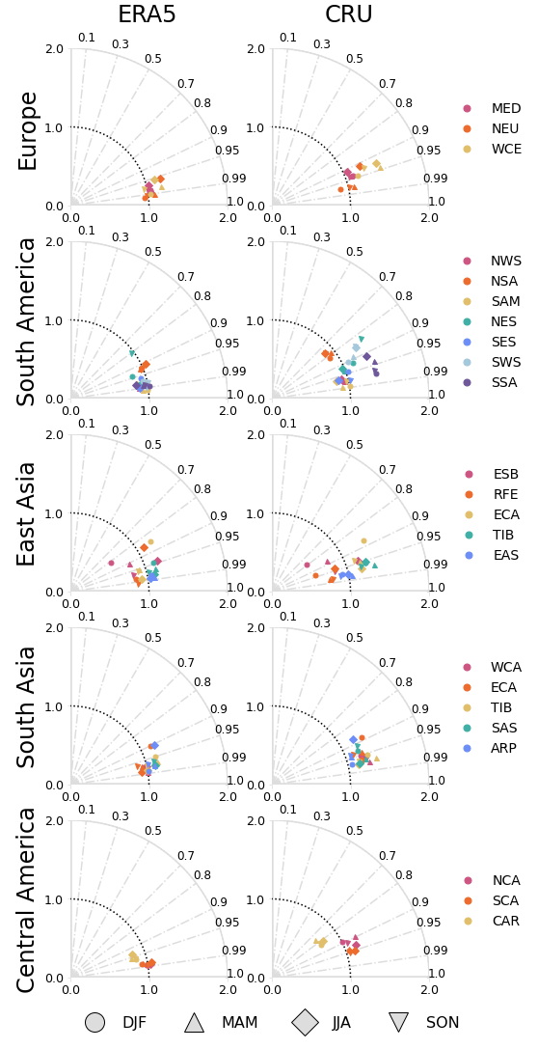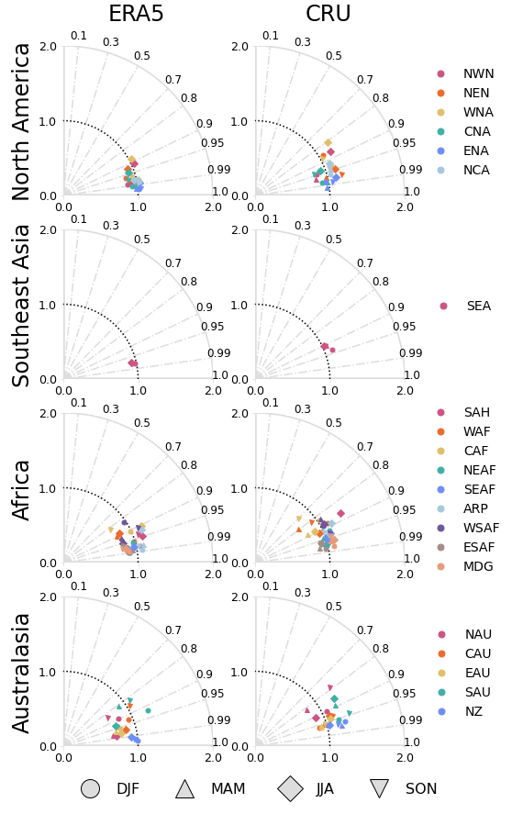

Figure S5: Taylor diagrams for the minimum temperature. Symbols represent seasons and colors are the subregions of a specific domain.

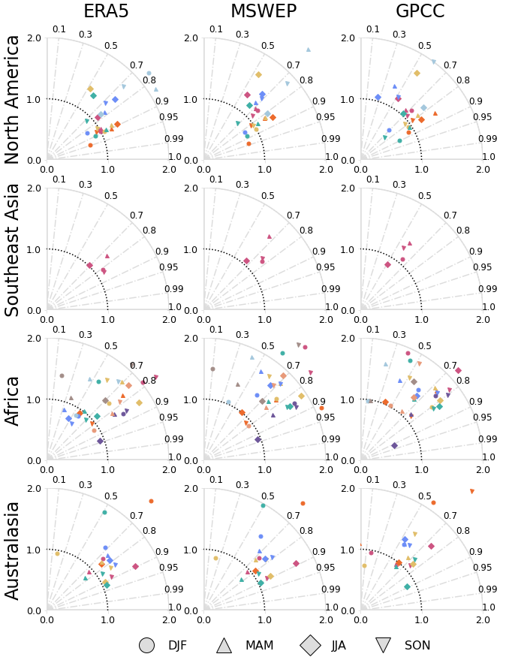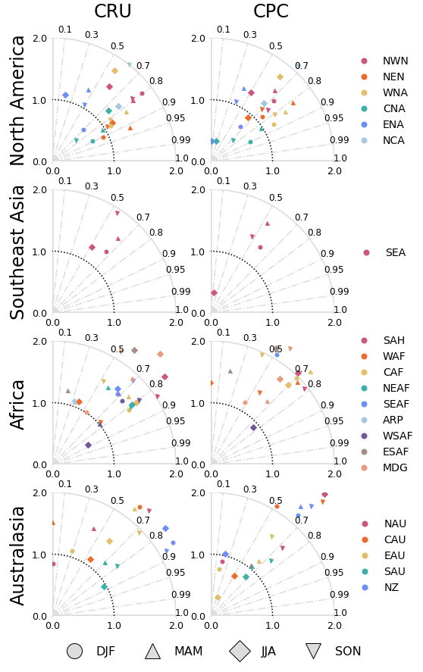(a)
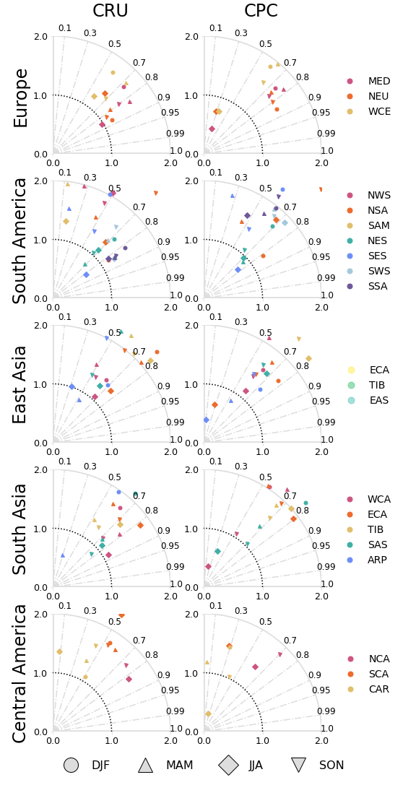
(b)

Figure S6: Taylor diagrams for precipitation for the remaining domains (panel a) and datasets (panel b). Symbols represent seasons and colors are the subregions of a specific domain.

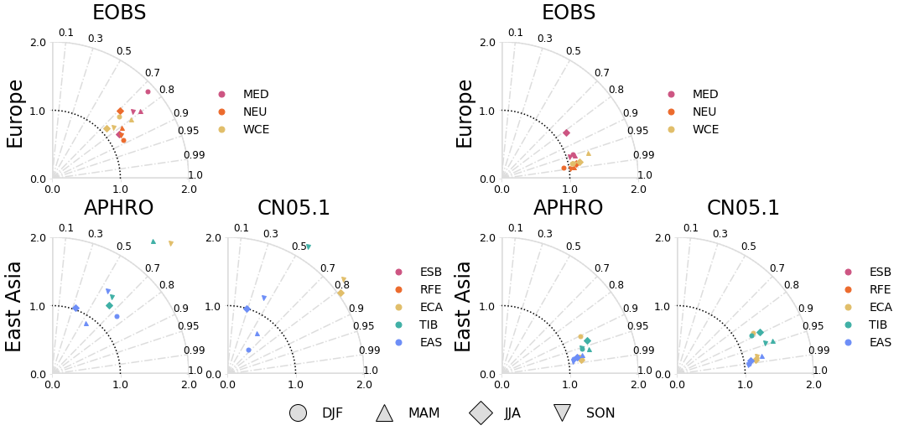

Figure S7: Taylor diagrams for precipitation (left panel) and temperature (right panel) with available regional datasets. (Note: For East Asia, results for RFE and ESB are not shown since APHORO and CN05.1 only cover a small portion of these subregions). Symbols represent seasons and colors are the subregions of a specific domain.

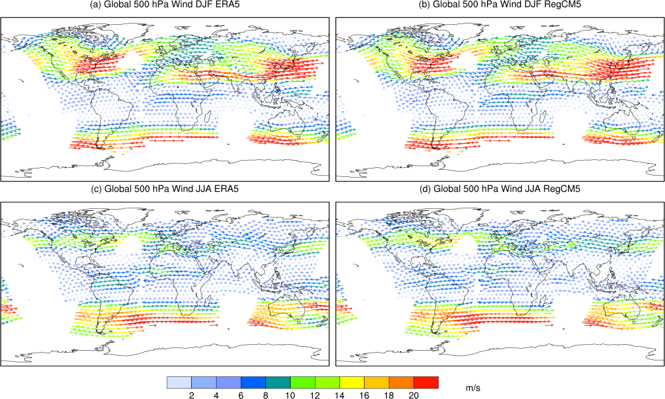(a)

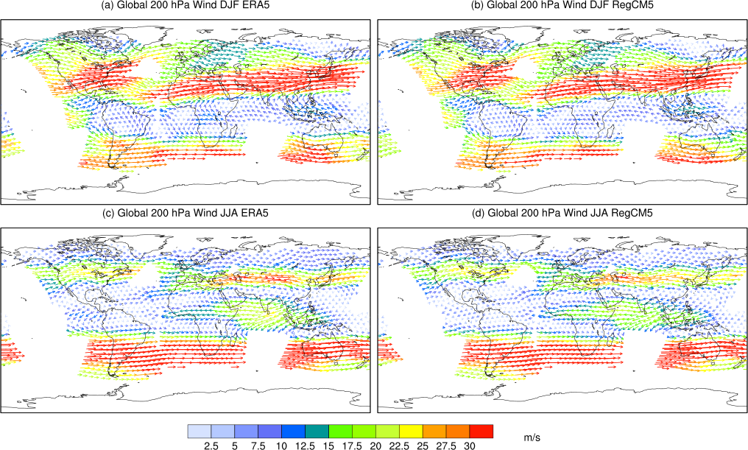(b)

Figure S8: Wind field at 500 hPa (upper panel) and 200 hPa (lower panel).

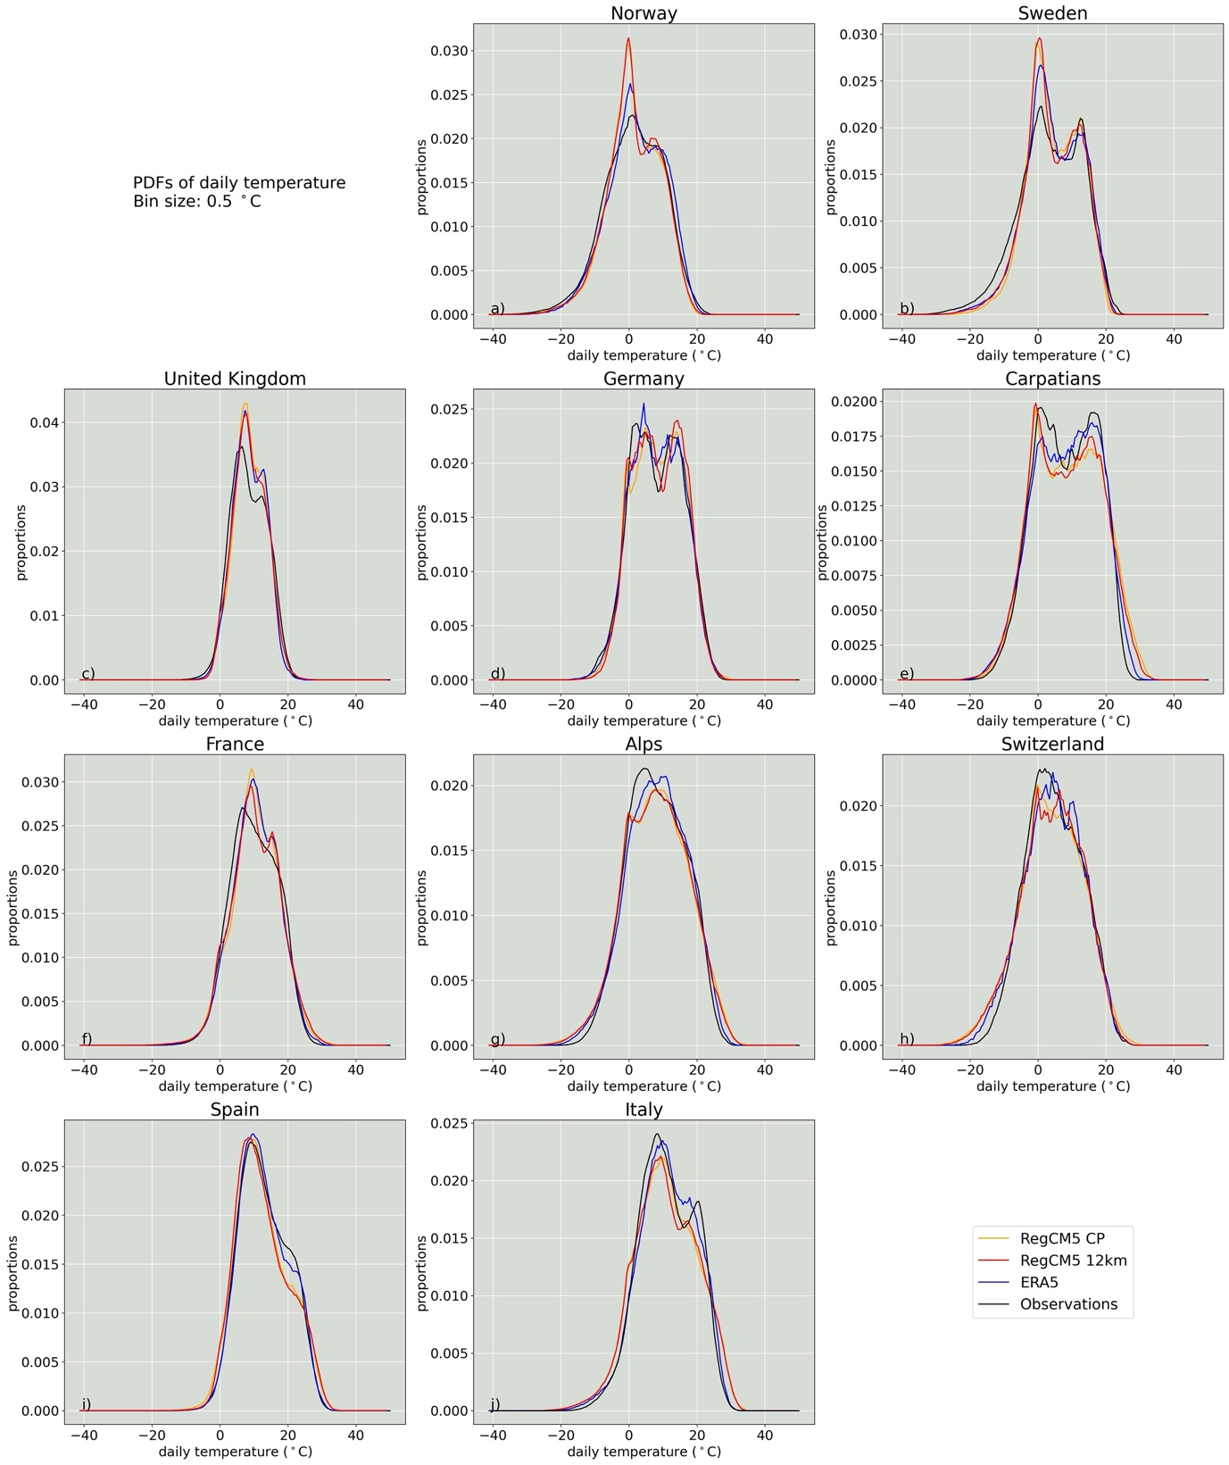

Figure S9: Probability density function distributions of the daily temperature [ºC] for the 10 regions investigated in the European domain. Each panel shows the distribution estimated from combining all available data for the years 2000-2004 for RegCM5 CP (orange), RegCM5 12km (red), ERA5 (blue) and observations (black). Details about the observational datasets for each region can be found in table 2.

Figure S10: Precipitation intensity, wet frequency and P99.9 seasonal bias for hourly REGCM5 CP (panel a) and REGCM5 12km (panel b) versus high resolution observations. The seasonal biases are the same as in Figure 10, but using 0.1 mm/hr as threshold for the minimum precipitation in the REGCM5 simulations.

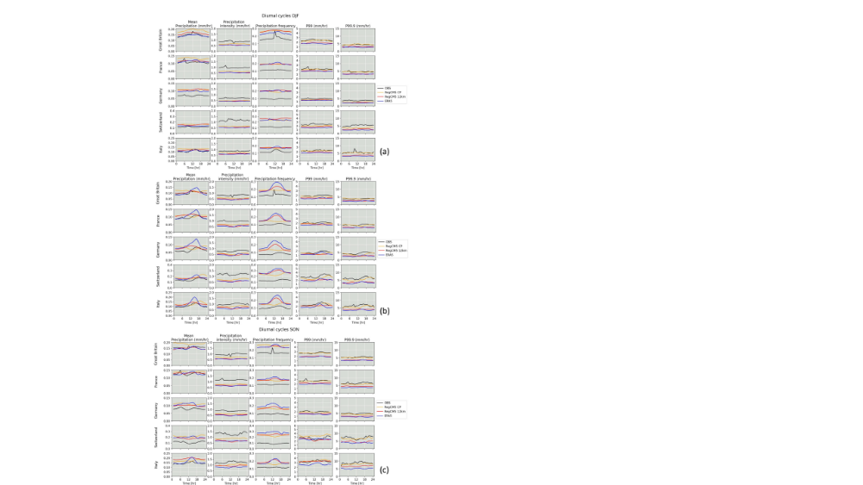

Figure S11: Diurnal cycles for mean precipitation (first column), precipitation intensity (second column), precipitation frequency (third column), p99 (fourth column) and p99.9 (fifth column) in DJF (panel a), MAM (panel b) and SON (panel c). In each panel, the results are shown for the following 5 regions in Europe: Great Britain (top row), France (second row), Germany (third row), Switzerland (fourth row) and Italy (bottom row).

