Additional file 2:
Spatiotemporal distribution and seismic interaction of very-low-frequency earthquakes in the northern Ryukyu Trench
Mamoru Nakamura¹, Ban-Yuan Kuo², Pei-Ying Patty Lin³, Shuichi Kodaira⁴, Yasushi Ishihara⁴
¹ Faculty of Science, University of the Ryukyus, Japan, mnaka@sci.u-ryukyu.ac.jp
² Institute of Earth Sciences, Academia Sinica, Taiwan
³ Pei-Ying Patty Lin, Department of Earth Sciences, National Taiwan Normal
⁴ Japan Agency for Marine-Earth Science and Technology
University, Taiwan

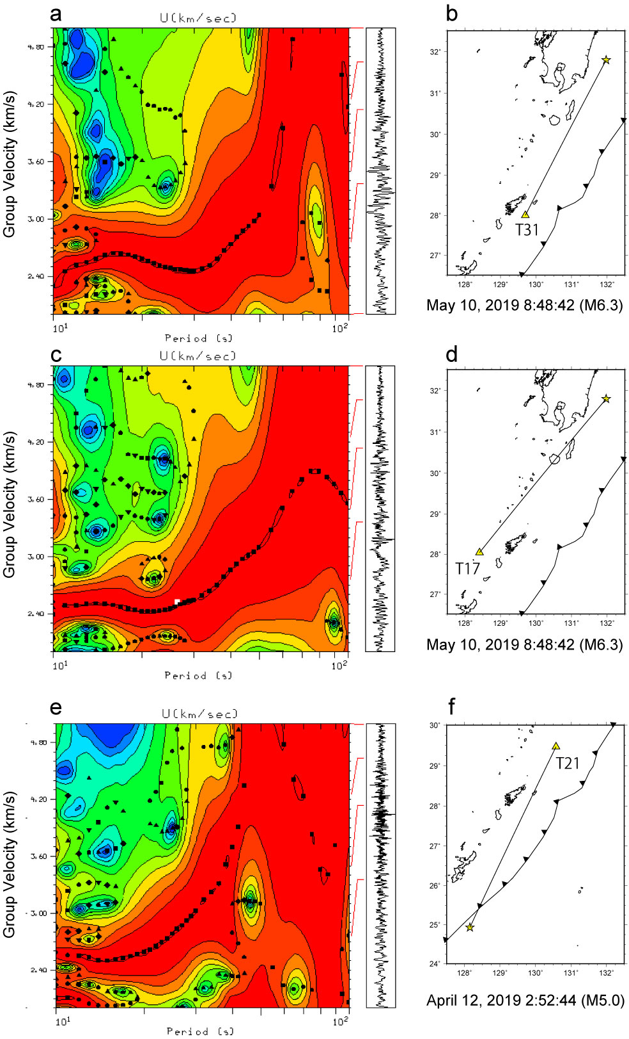
Figure S1. Vertical component group velocity of Rayleigh waves. (a) Group velocity of Rayleigh waves at T31 for the earthquake that occurred at 8:48:42 on May 10, 2019. (b) Raypath from the earthquake to T31. (c) Same as (a) but at T17. (d) Same as (b), but to T17. (e) Same as (a), but at T21 and the earthquake that occurred at 2:52:44 on April 12, 2019. (f) Raypath from the earthquake to T21.

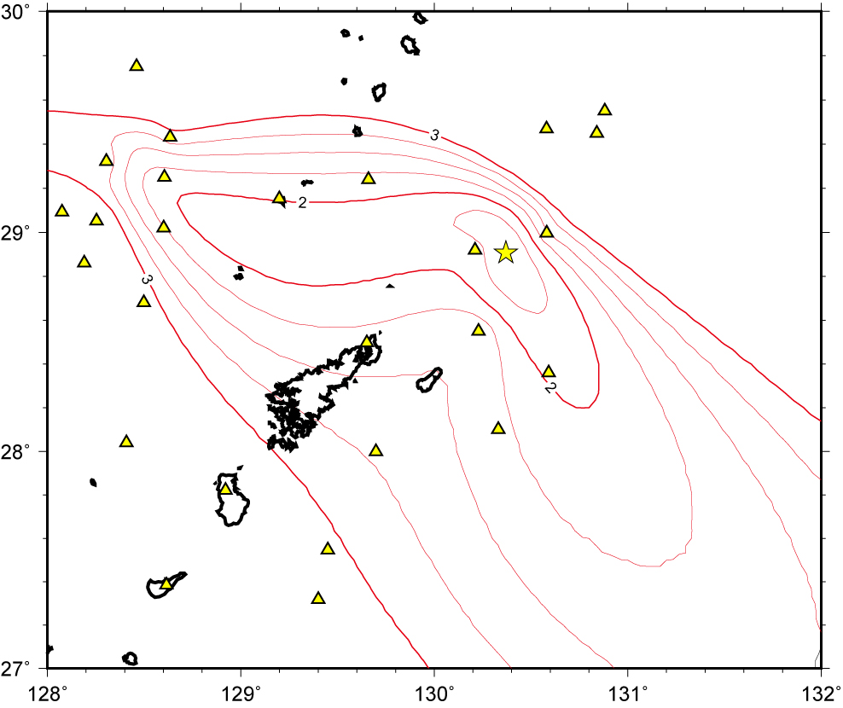
Figure S2. Error distribution in the determination of very-low-frequency earthquake (VLFE) epicenters. Triangles indicate observation stations, while the stars mark the VLFE epicenters. The VLFE event shown is from 08:26:20 on November 14, 2018.

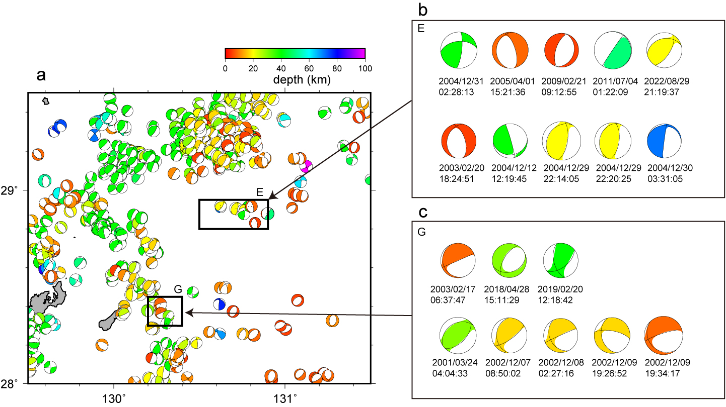
Figure S3. F-net centroid moment tensor (CMT) solutions northeast of Amami Island from January 2000 to December 2023. (a) F-net CMT solutions for earthquakes northeast of Amami Island from 2000 to 2023. (b) CMT solutions for earthquakes in Area E during the same period, with color coding by depth. (c) CMT solutions for earthquakes in Area G.

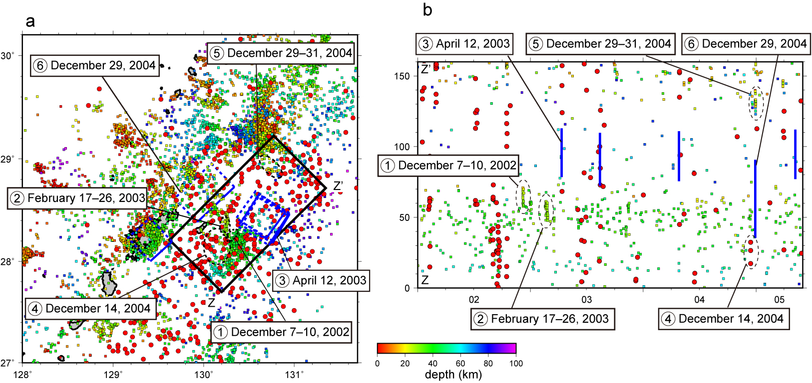

Figure S4. Seismic activity around Amami Island from January 2002 to June 2005. (a) Distribution of regular earthquakes, very-low-frequency earthquakes (VLFEs), and slow slip events (SSEs). Blue rectangles indicate SSE faults (Nishimura 2014). Squares represent the epicenters of earthquakes with magnitudes of 2 or higher. Red circles denote VLFEs (Nakamura and Sunagawa 2015). (b) Spatiotemporal distribution of regular earthquakes, VLFEs, and SSEs. Blue lines indicate SSEs.

