Supplementary information
TNMD in pan-cancer analysis: Exploring its impact on immune modulation and uncovering functional insights in colorectal cancer

Jingfeng Chen^{1,3}, Qin Hu¹, Cong Zhang², Bihua Guan¹, YiFan Wang¹, Min Zhang⁴, Xia Li¹, Biao Chen¹, Lulu Zeng¹, Minjiang Chen^{1,5}, Bing Wu⁶, Jianping Wang³***, Yang ^{1,5}**, and Jiansong Ji^{1,2,5}*
¹ Zhejiang Engineering Research Center of Interventional Medicine Engineering and Biotechnology, The Fifth Affiliated Hospital of Wenzhou Medical University, Lishui Central Hospital, Lishui 323000, China.
² Department of Radiology, School of Medicine, Lishui Hospital, Zhejiang University, Lishui Central Hospital, Lishui, 323000, China.
³ Anorectal surgery of The Fifth Affiliated Hospital of Wenzhou Medical University, Lishui, 323000, China.
⁴ Department, Pathology, The Fifth Affiliated Hospital of Wenzhou Medical University, Lishui, 323000, China.
⁵ Key Laboratory of Precision Medicine of Lishui, Lishui Central Hospital, Lishui 323000, China.
⁶ Department, Pharmacy, The Fifth Affiliated Hospital of Wenzhou Medical University, Lishui, 323000, China.
*: Correspondence should be addressed to the following authors:
Dr. J.S. Ji (Key Laboratory of Imaging Diagnosis and Minimally Invasive Intervention Research, The Fifth Affiliated Hospital of Wenzhou Medical University), Tel: +86-578-2285011; Fax: +86-578-2285011; E-mail: jjstcty@wmu.edu.cn
Dr. Y. Yang (Key Laboratory of Imaging Diagnosis and Minimally Invasive Intervention Research, The Fifth Affiliated Hospital of Wenzhou Medical University), Tel: +86-578-2285011; E-mail: yangyang_8668@163.com
Dr. J.P. Wang (Anorectal surgery of The Fifth Affiliated Hospital of Wenzhou Medical University, Lishui, 323000, China.), Tel: +86-578-2285215; E-mail: Wy705652899@163.com

Additional Fig.1. TNMD is associated with clinicopathologic staging in pan-cancer. a-d Correlation between the pathological T stage of BLCA, KIRC, OSCC and LUSC and TNMD expression. e-h Correlation between the pathological N stage of KICH, KIRC, OSCC and LUSC and TNMD expression. i-p Correlation between the pathological stage of BLCA, BRCA, KIRC, PAAD, TGCT, LUSC, THCA, and GBMLGG and TNMD expression.
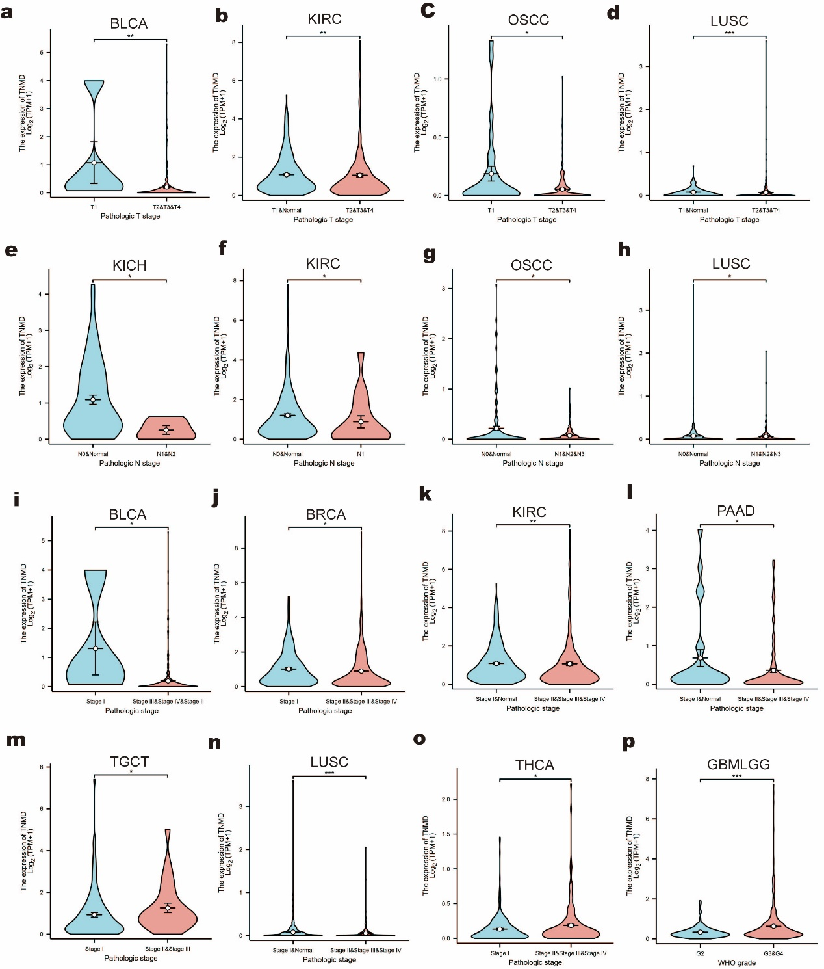
Additional Fig.2. Validation through TIDE analysis in GSE81986 database.
a The immunomatrix score of MSI-High group was significantly higher than that of MSS group (P<0.001). b Immunoinfiltration score of MSI-High group was higher than that of MSS group (P<0.001). c Higher TNMD expression was associated with improved immunotherapy outcomes (P=0.22). d Patients with elevated TNMD expression exhibited higher Merck18 scores (P=0.35).
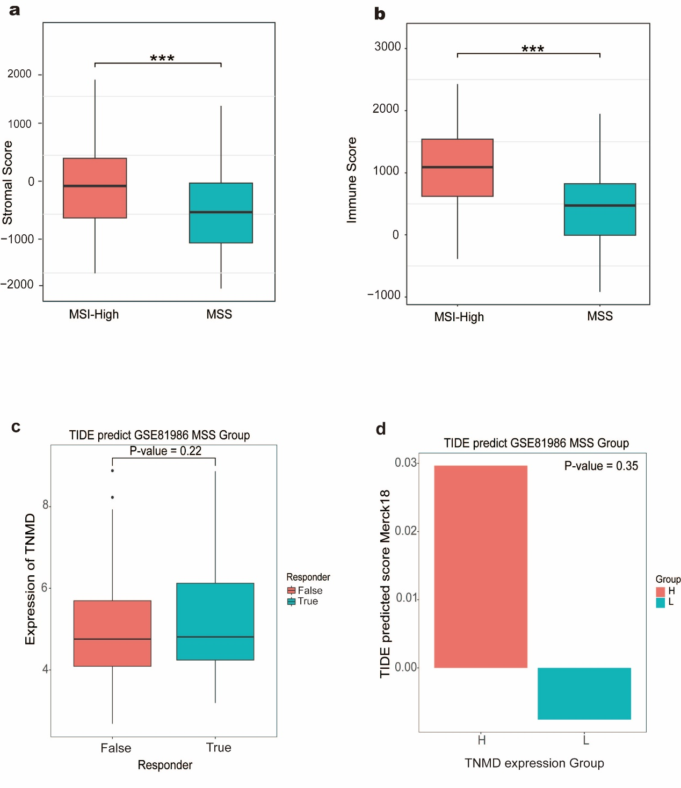

Additional Fig.3. Single cell sequencing analysis of GSE132465. a Post-correction, cells were classified into 24 cluster. b Bubble chart illustrating potential ligand-receptor pairs between TNMD+ epithelial subpopulations and macrophages, as well as TNMD- epithelial subpopulations and macrophages.

