Correlation between GLS and myocardial work variables on day 1 (pink shaded area represents normal range for myocardial work variable, purple shaded area represents normal range for GLS)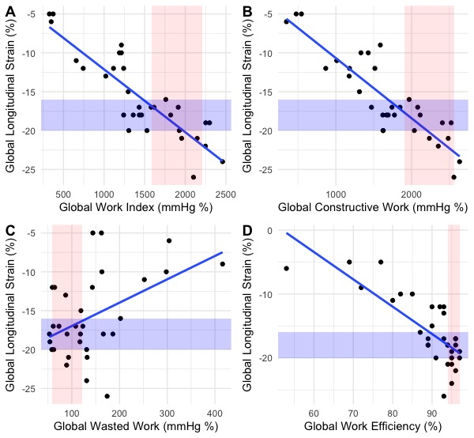

Correlation between GLS and myocardial work variables on day 3 (pink shaded area represents normal range for myocardial work variable, purple shaded area represents normal range for GLS)
