Supplementary Information

Application of novel triazolium-containing hydrogels to cotton fabrics: Evaluation of their flame retardancy and antibacterial properties
Nejmi Söyler¹; Eylen Sema Dalbaşı²; Hayati Türkmen^{3,*}
¹ Graduate School of Natural and Applied Sciences, Materials Science and Engineering, Ege University, 35100 Bornova, Izmir, Turkey
² Department of Textile Engineering, Ege University, 35100 Bornova, Izmir, Turkey
³ Department of Chemistry, Faculty of Science, Ege University, 35100 Bornova, Izmir, Turkey
* Corresponding author e-mail: hayati.turkmen@ege.edu.tr

Table S1. Chemicals used in the study 2

Figure S1. ¹H-NMR spectrum of 1-methyl-1,2,4 triazole 3
Figure S2. ¹³C-NMR spectrum of 1-methyl-1,2,4 triazole 3
Figure S3. ¹H-NMR spectrum of 1,2-Bis(1-methyl-1H-1,2,4 triazol-4-ium) ethane dibromide (DIL12) 4
Figure S4. ¹³C-NMR spectrum of 1,2-Bis(1-methyl-1H-1,2,4 triazol-4-ium) ethane dibromide (DIL12) 4
Figure S5. ¹H-NMR spectrum of 1,5-Bis(1-methyl-1H-1,2,4 triazol-4-ium) pentane dibromide (DIL15) 5
Figure S6. ¹³C-NMR spectrum of 1,5-Bis(1-methyl-1H-1,2,4 triazol-4-ium) pentane dibromide (DIL15) 5
Figure S7. ¹H-NMR spectrum of 1-methyl-4-pentyl-1H-1,2,4-triazol-4-ium bromide (IL15) 6
Figure S8. ¹³C-NMR spectrum of 1-methyl-4-pentyl-1H-1,2,4-triazol-4-ium bromide (IL15) 6
Figure S9. Calculation of activation energy for DIL12 using the KAS, OFW and STARINK methods 7
Figure S10. Calculation of activation energy for DIL15 using the KAS, OFW and STARINK methods 8
Figure S11. Calculation of activation energy for IL15 using the KAS, OFW and STARINK methods 9
Figure S12. TG graphs of PBIL15_10, PBDIL15_10, PBDIL12_10 at 20 °C/min heating rate 10

Table S1. Chemicals used in the study
Chemical Name | Molecular Structure | Molecular  Formula | CAS Number | Purity  (%)
1H-1,2,4-Triazole | 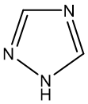 | C₂H₃N₃ | 288-88-0 | 99
1,2-Dibromoethane | 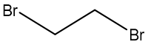 | C₂H₄Br₂ | 106-93-4 | 98
1,5-Dibromopentane | 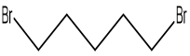 | C₅H₁₀Br₂ | 111-24-0 | 98
1-Bromopentane | 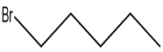 | C₅H₁₁Br | 110-53-2 | 98
Polyvinyl alcohol | 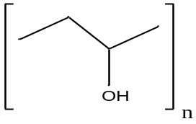 | [CH₂CH(OH)]_{n} | 9002-89-5 | 95
Borax (Sodium tetraborate) | 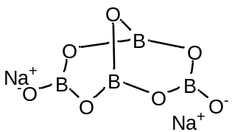 | Na₂B₄O₇ | 1333-73-9 | 99

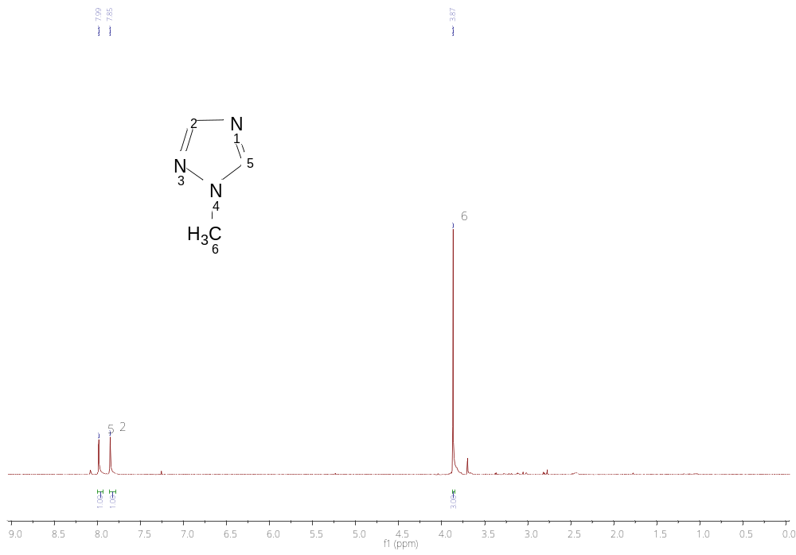
Figure S1. ¹H-NMR spectrum of 1-methyl-1,2,4 triazole

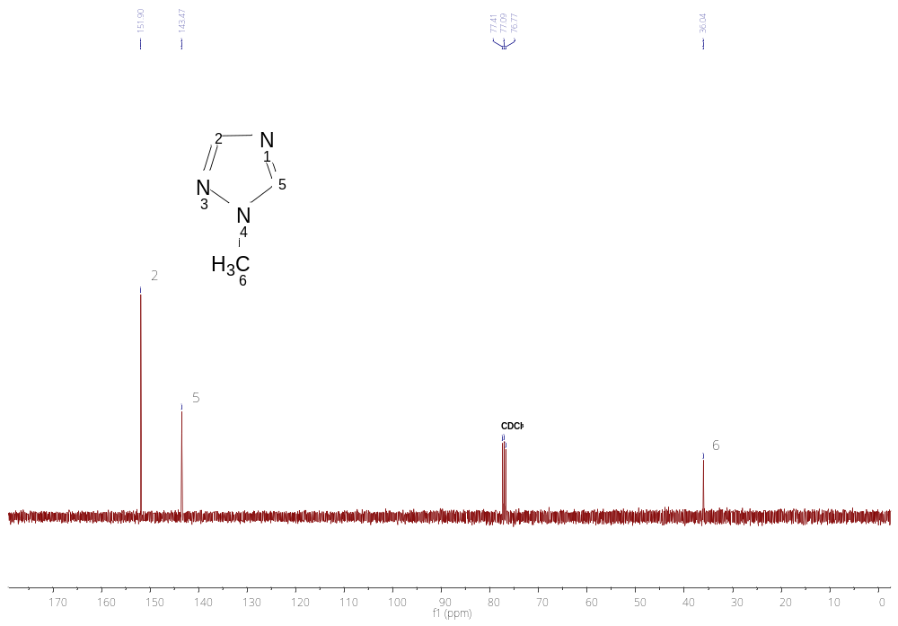
Figure S2. ¹³C-NMR spectrum of 1-methyl-1,2,4 triazole
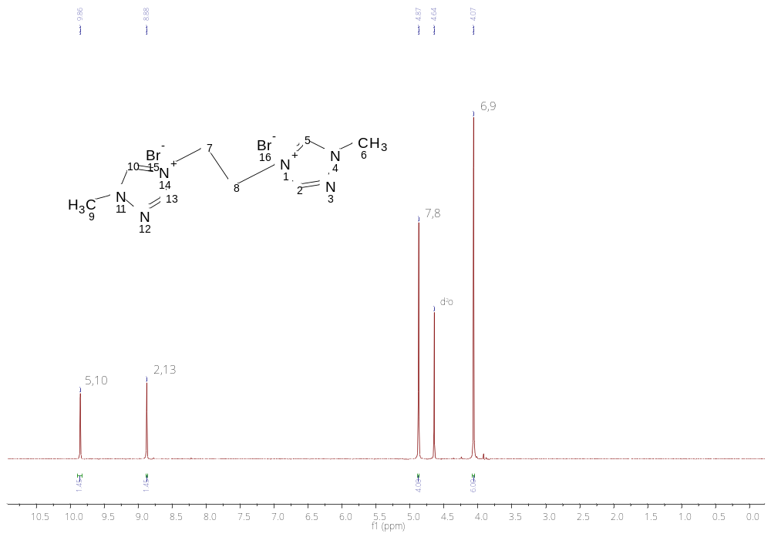
Figure S3. ¹H-NMR spectrum of 1,2-Bis(1-methyl-1H-1,2,4 triazol-4-ium) ethane dibromide (DIL12)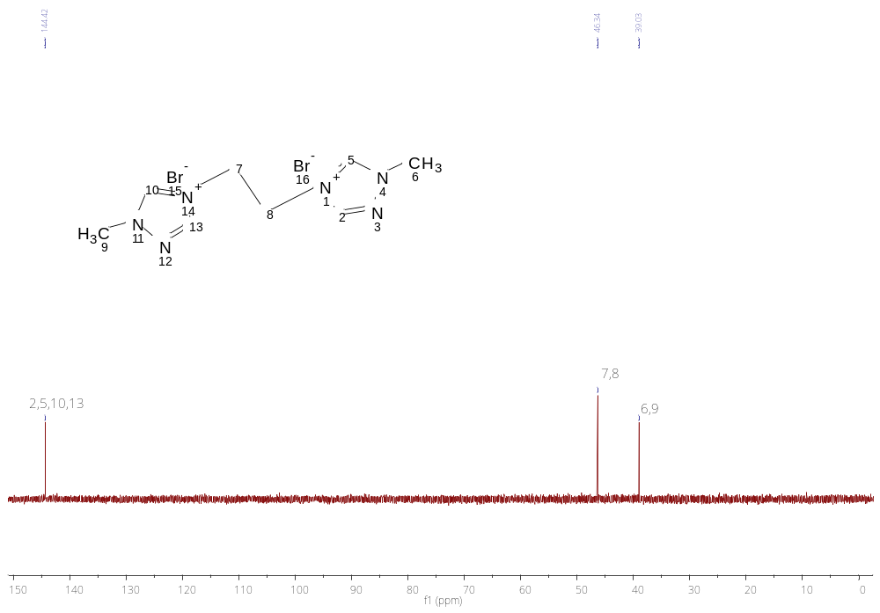
Figure S4. ¹³C-NMR spectrum of 1,2-Bis(1-methyl-1H-1,2,4 triazol-4-ium) ethane dibromide (DIL12)
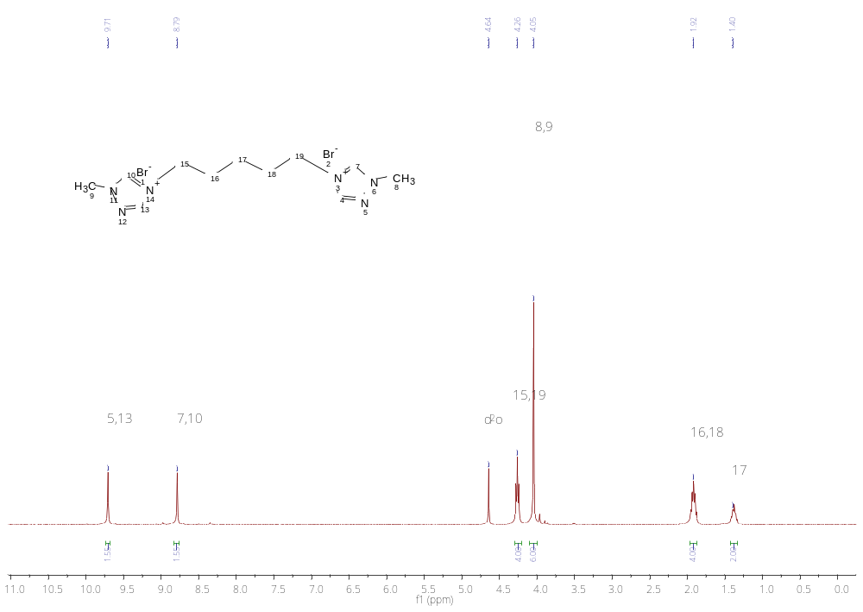
Figure S5. ¹H-NMR spectrum of 1,5-Bis(1-methyl-1H-1,2,4 triazol-4-ium) pentane dibromide (DIL15)
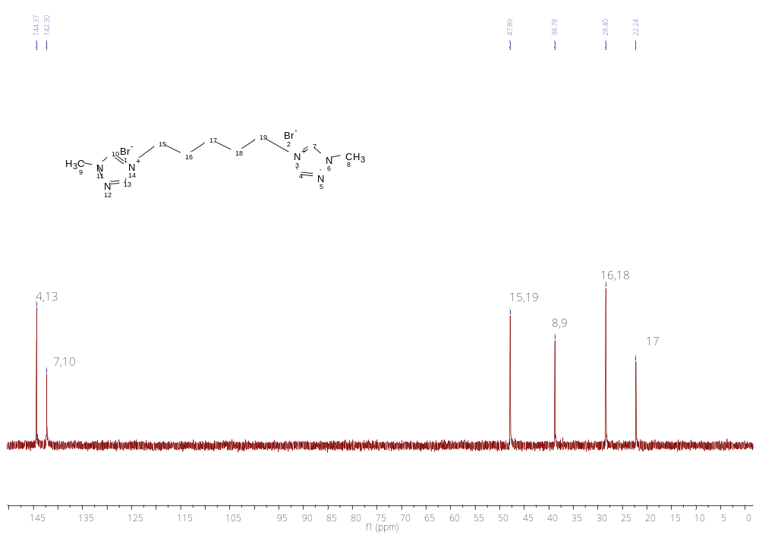
Figure S6. ¹³C-NMR spectrum of 1,5-Bis(1-methyl-1H-1,2,4 triazol-4-ium) pentane dibromide (DIL15)

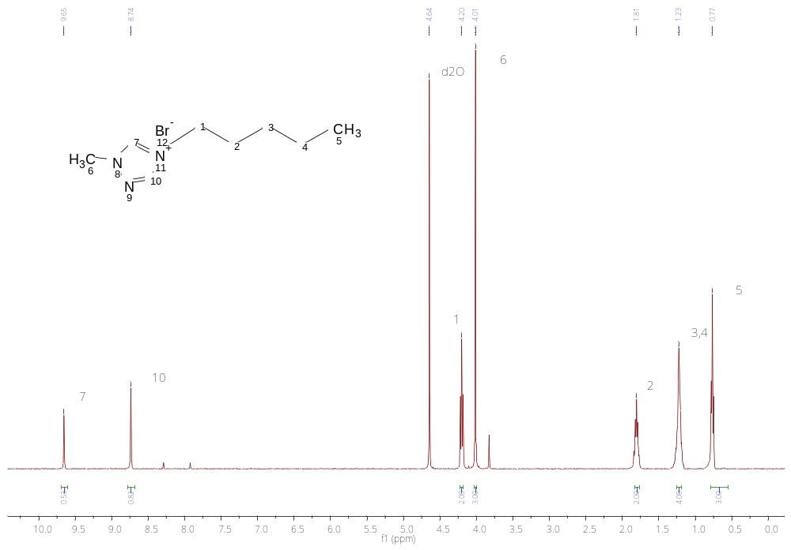
Figure S7. ¹H-NMR spectrum of 1-methyl-4-pentyl-1H-1,2,4-triazol-4-ium bromide (IL15)
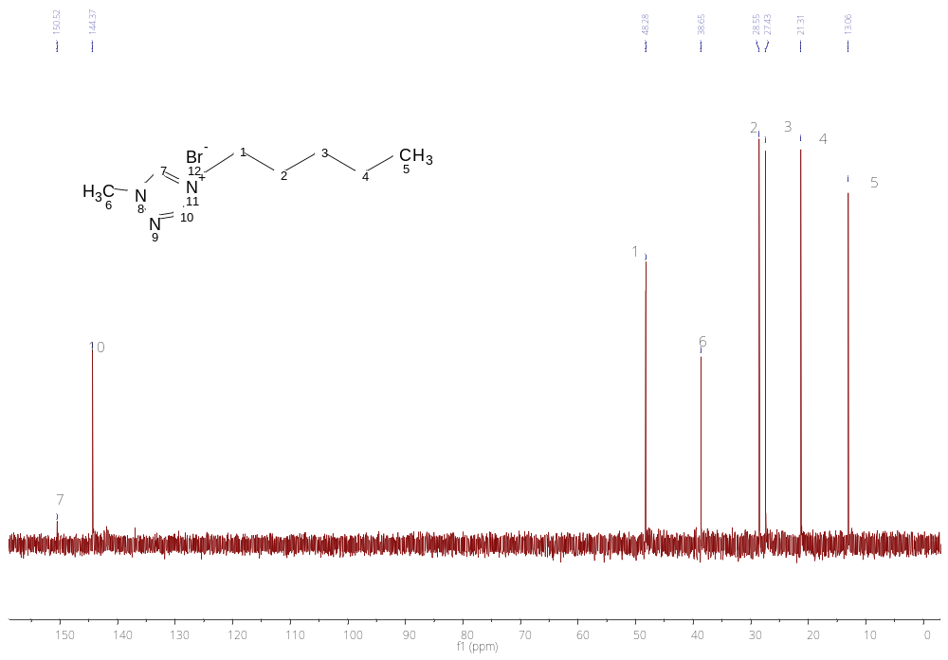
Figure S8. ¹³C-NMR spectrum of 1-methyl-4-pentyl-1H-1,2,4-triazol-4-ium bromide (IL15)

Figure S9. Calculation of activation energy for DIL12 using the KAS, OFW and STARINK methods

Figure S10. Calculation of activation energy for DIL15 using the KAS, OFW and STARINK methods

Figure S11. Calculation of activation energy for IL15 using the KAS, OFW and STARINK methods
PBIL15_10
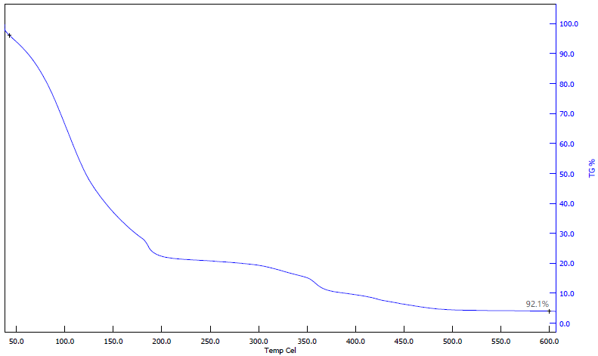
PBDIL15_10
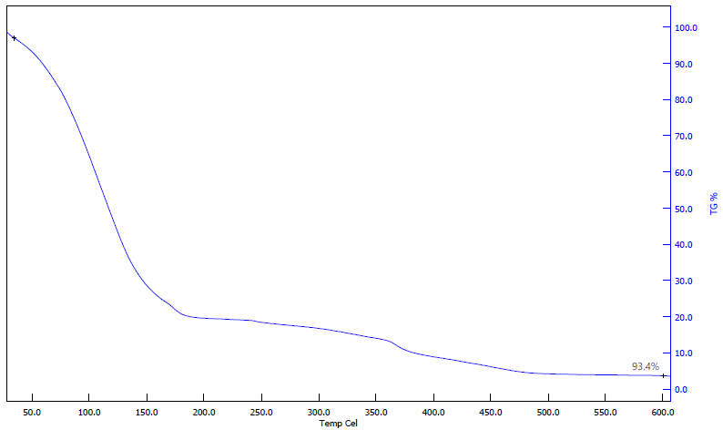
PBDIL12_10
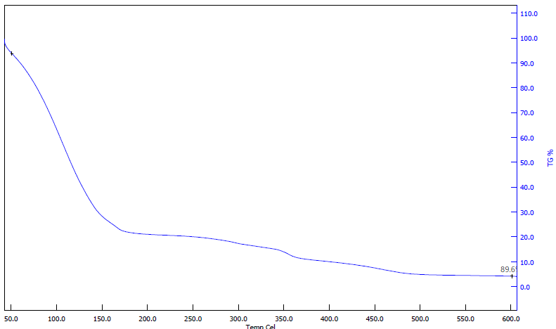

Figure S12. TG graphs of PBIL15_10, PBDIL15_10, PBDIL12_10 at 20 °C/min heating rate

