Supplementary information for

Multilayered modular microfluidic platform for 3D vascularized organ-on-a-chip application
Chenyang Zhou¹, Zhangjie Li¹, Jiaqi Xu¹, Dingyuan Yu¹, Lian Xuan², Xiaolin Wang¹²³*
1 Department of Micro/Nano Electronics, School of Electronic Information and Electrical Engineering, Shanghai Jiao Tong University, Shanghai, 200240, China.
2 Institute of Medical Robotics, Shanghai Jiao Tong University，Shanghai, 200240, China.
3 National Key Laboratory of Advanced Micro and Nano Manufacture Technology, Shanghai Jiao Tong University, Shanghai, 200240, China.

Corresponding author
Xiaolin Wang: Email: xlwang83@sjtu.edu.cn; Tel: 86-021-34206683.

This file includes:
Fig. S1 to S5
Other Supplementary Material for this manuscript includes the following:
Movies S1

Fig. S1 Parametric optimization of the entrance width of tissue chamber. a Images of hydrogel filling at different entrance width of tissue chambers. b The hydrogel-filled area and the rate of hydrogel-filled area varies with the entrance width.

Fig. S2 Sample curve based on the experimental results of the decrease of the hydrostatic pressure difference over 24 hours.
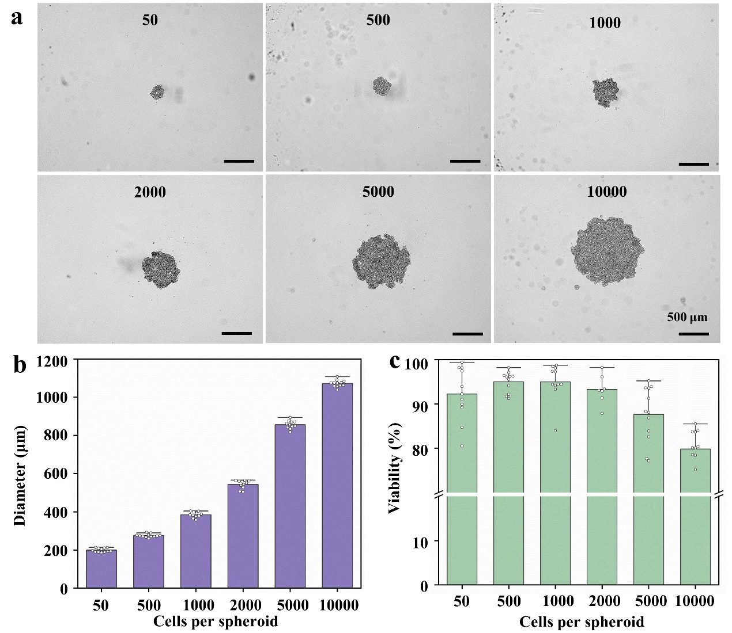
Fig. S3 Production and characterization of tumor spheroids. a Bright field images of tumor spheroid with different seeding density from 50 cells/well to 10000 cells/well, scale bar = 500 μm. Quantification of the relationship between seeding density and b spheroid diameters, and c the spheroid viability.

Fig. S4 Sorafenib treatment inhibited the tumor spheroids size. a Bright images of tumor spheroids after the sorafenib treatment from day 1 to day 5, scale bar = 500 μm. b Quantification of the tumor spheroid size with the culture time.

Fig. S5 Sorafenib treatment promoted the death of tumor spheroids. a Fluorescent images of tumor spheroids with calcein-AM (green) and PI (red), scale bar = 500 μm. b Quantification of the cells morality rate.

