Novel Cu-II Complexes of 2-Hydroxy 4-Methoxy Benzylidene 2-Hydroxy Benzhydrazide: Synthesis, Spectral Characterization Thermal, Antimicrobial, Antioxidant and Catalytic activity Study.
Sangeeta Korane^{1,*}, Babasaheb Bhosale ²
^{1*}Department of Chemistry, Rajarshi Chhatrapati Shahu College, Kolhapur, Maharashtra, India
²Department of Chemistry, Rajaram College, Kolhapur, Maharashtra, India
*Corresponding author (e- mail: (koranesangeeta9@gmail.com)

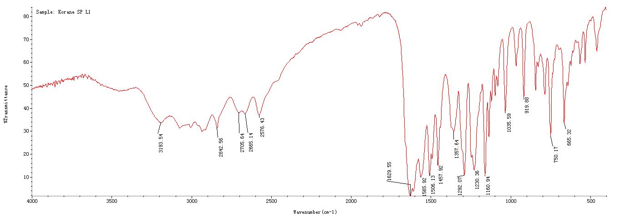

Fig 1.FT-IR Spectra of HL

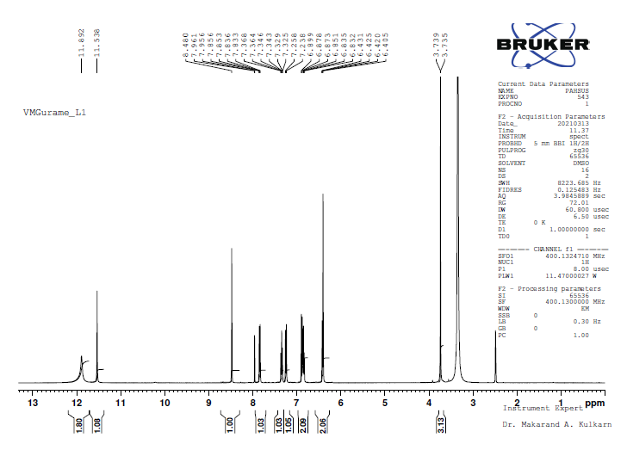

Fig 2.¹HNMR spectra of HL
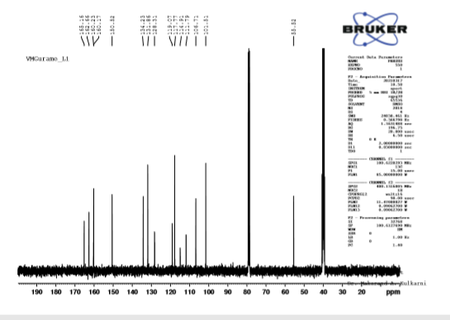
Fig 3.¹³C-NMR spectra of HL

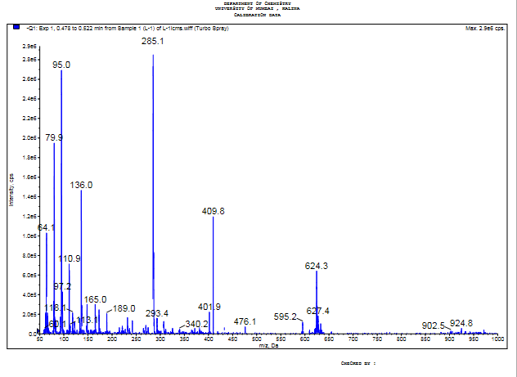
Fig 4.Mass spectra of HL

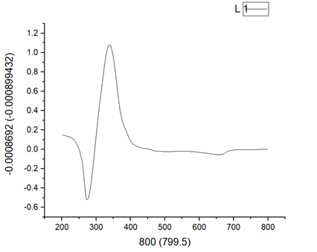
Fig 5.UV-Visible spectrum of HL
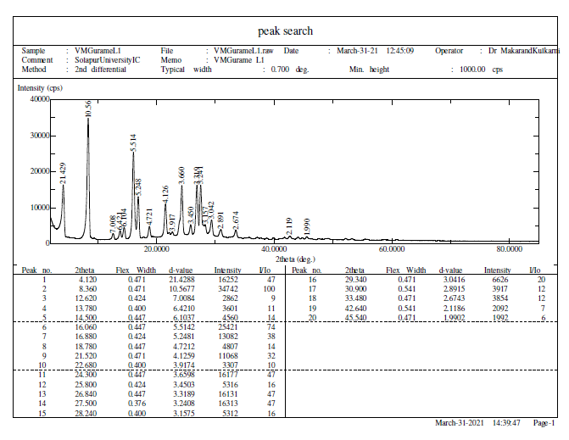
Fig 6.PXRD spectrum of HL

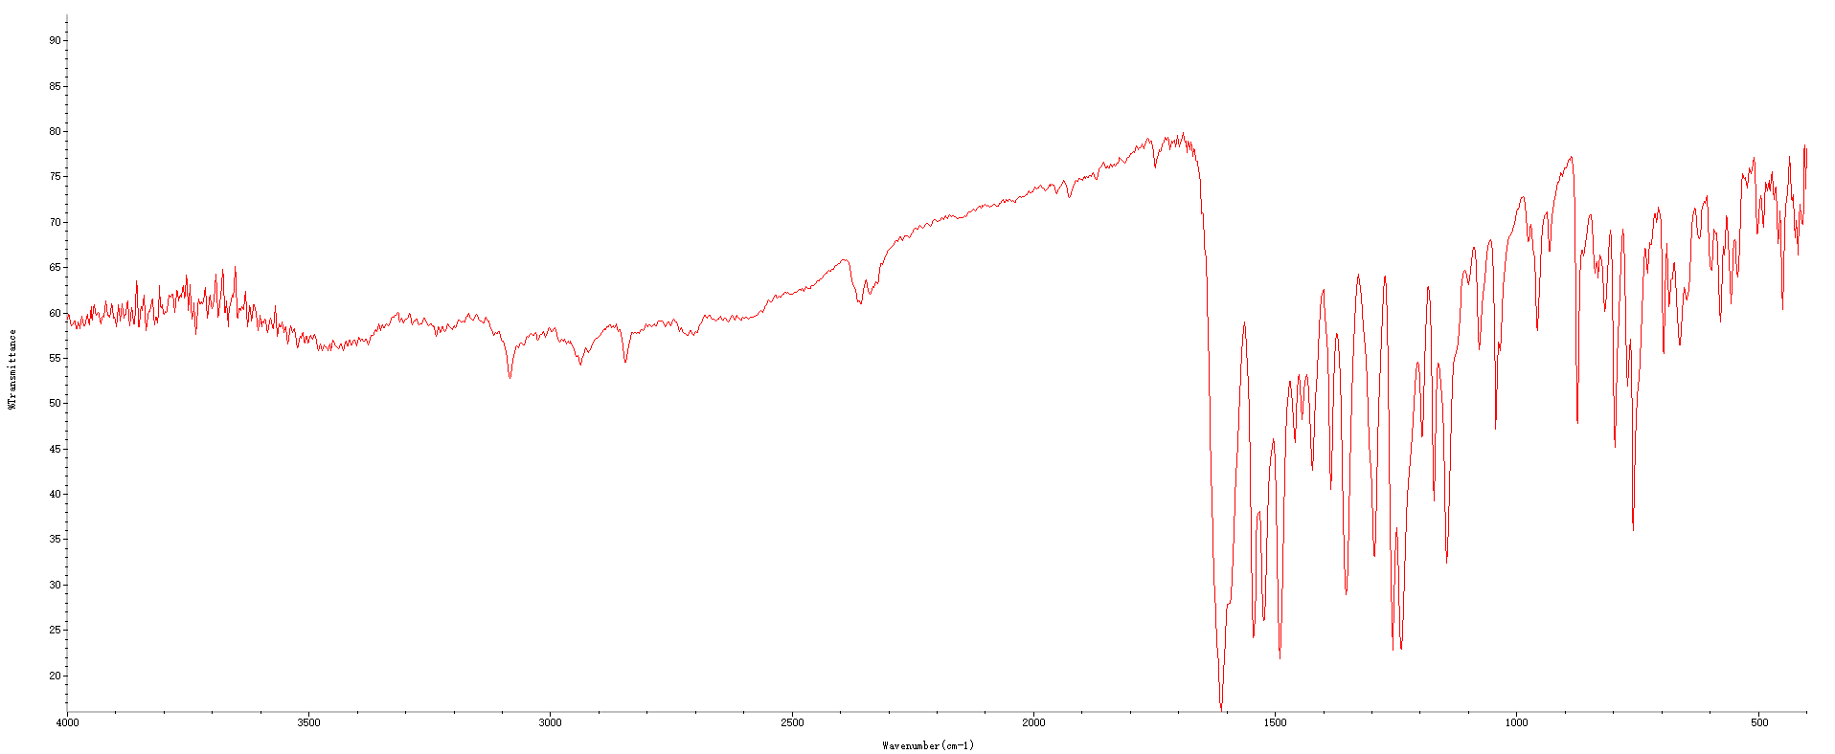
Fig 7.IR spectrum of [Cu (HL) (NO₃)])].$\frac{1}{3}$H₂O (1a)

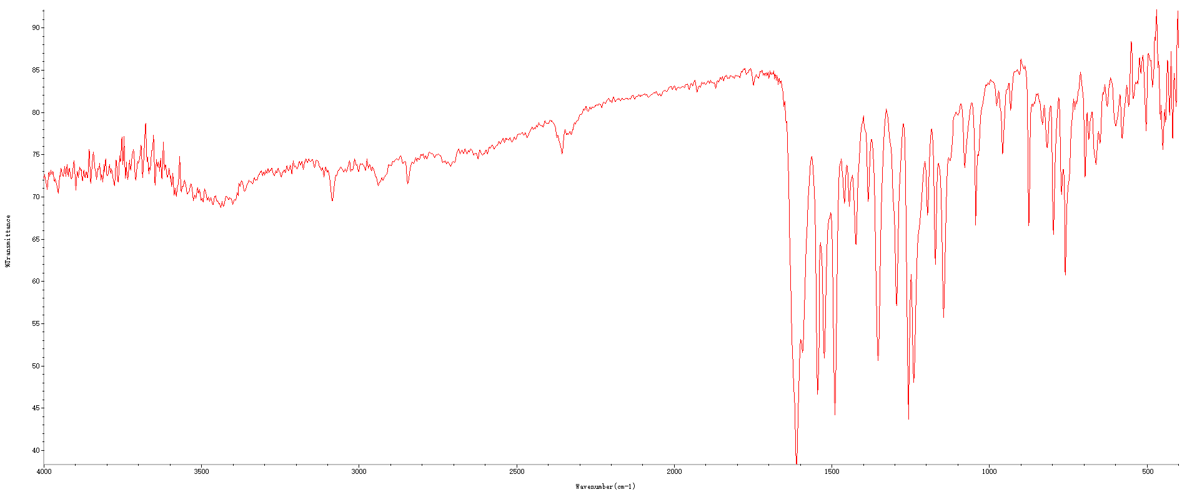
Fig 8.IR spectrum of [{Cu (HL)} ₂(μ-SO₄)] .1 $\frac{2}{3}$ H₂O (2a)

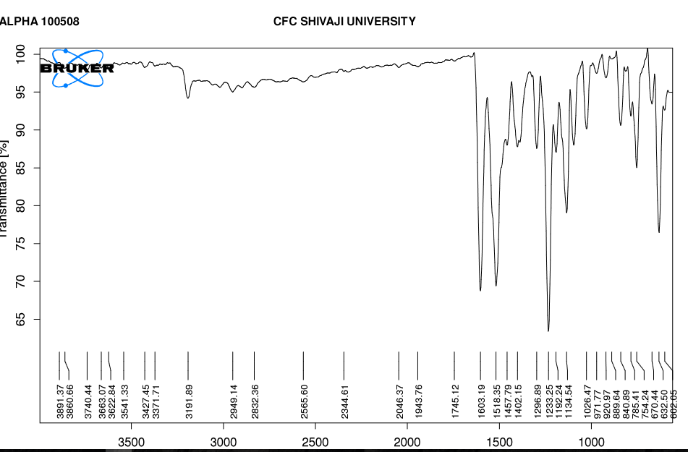
Fig 9.IR spectrum of [Cu (HL) (Cl ) (H₂O)] .(3a)

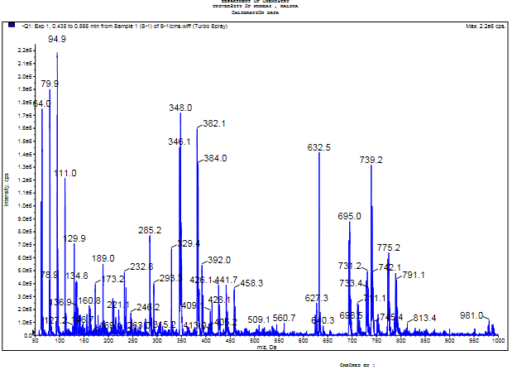
Fig 10.Mass spectrum of [Cu (HL) (NO₃)])].$\frac{1}{3}$H₂O (1a)

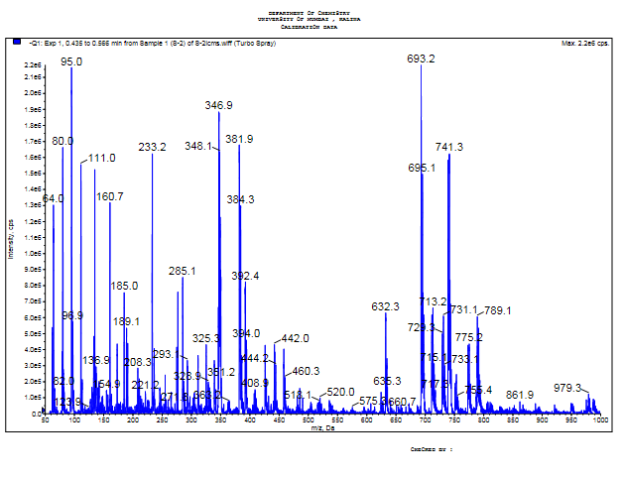
Fig 11.Mass spectrum of [{Cu (HL)} ₂(μ-SO₄)] .1 $\frac{2}{3}$ H₂O (2a)

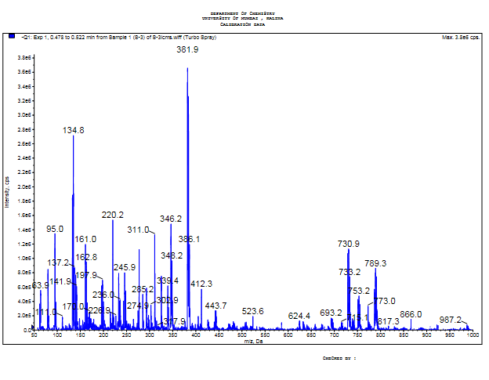Fig 12.Mass spectrum of [Cu (HL) (Cl ) (H₂O)] .(3a)

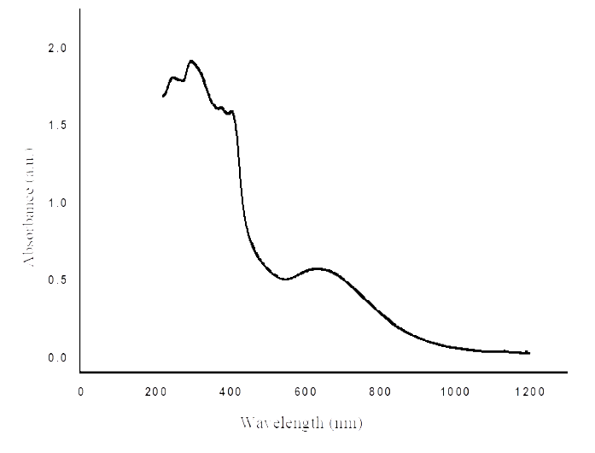
Fig 13.UV-Visible spectrum of [Cu (HL) (NO₃)])].$\frac{1}{3}$H₂O (1a)

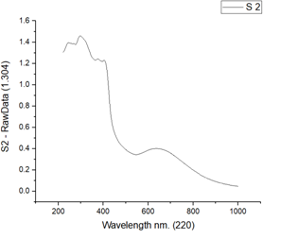
Fig 14.UV-Visible spectrum of [{Cu (HL)} ₂(μ-SO₄)] .1 $\frac{2}{3}$ H₂O (2a)

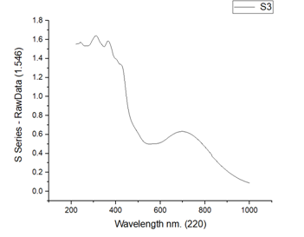
Fig 15.UV-Visible spectrum of [Cu (HL) (Cl ) (H₂O)] .(3a)

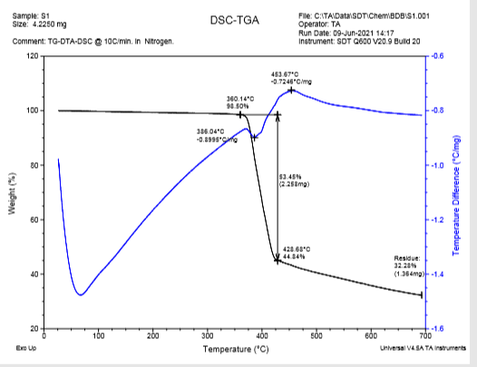

Fig. 16 TG-DTA Curves of [Cu (HL) (NO₃)])].$\frac{1}{3}$H₂O (1a)

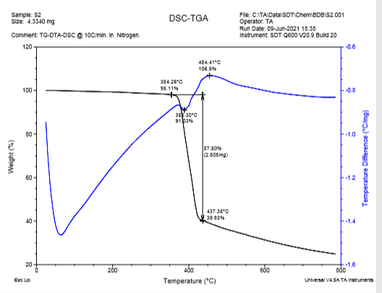

Fig. 17 TG-DTA curves of [{Cu (HL)} ₂(μ-SO₄)] .1 $\frac{2}{3}$ H₂O (2a)

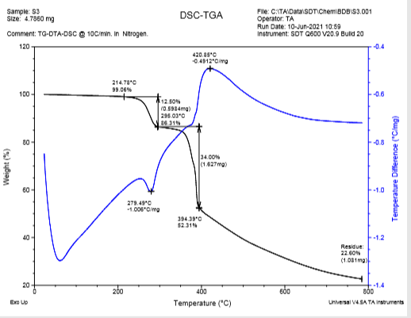

Fig. 18 TG-DTA curves of [Cu (HL) (Cl ) (H₂O)] .(3a)

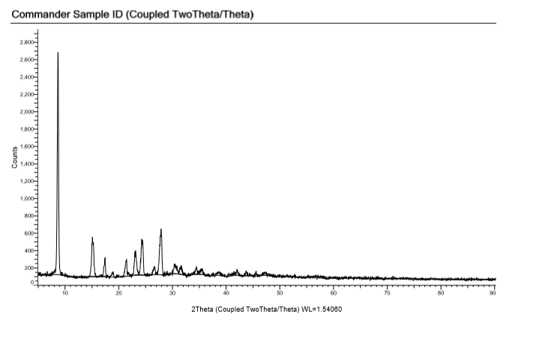
Fig 19.PXRD spectrum of [Cu (HL) (NO₃)])].$\frac{1}{3}$H₂O (1a)

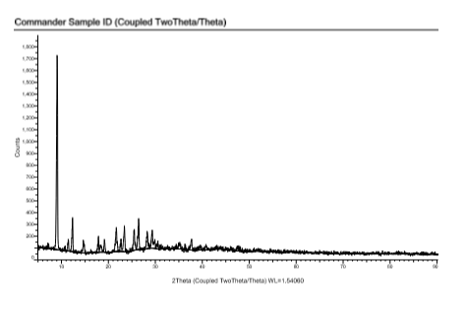
Fig 20.PXRD spectrum of [{Cu (HL)} ₂(μ-SO₄)] .1 $\frac{2}{3}$ H₂O (2a)

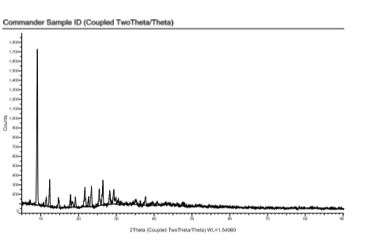
Fig 21.PXRD spectrum of [Cu (HL) (Cl ) (H₂O)].(3a)

