Dual-Targeting of PDPN-Expressing Synovial Fibroblasts and Macrophages via CLEC-2-Engineered Exosomes for Osteoarthritis Therapy
Bo Yu#, Rui Peng#, Zitao Liu#, Shanchuang Chen, Nanjun Xu, Qingjun Yang, Zhengang, Zha, Bolai Chen*, Tao Jiang*, Songwei Huan*, Tao Gui*
B. Yu, R. Peng, Z. Zha, S. Huan
Department of Bone and Joint Surgery, The First Affiliated Hospital, Jinan University, Guangzhou, Guangdong, China
E-mail: huansw@jnu.edu.cn
Z. Liu, S. Chen, N. Xu, X. Zeng, B. Chen, T. Jiang, T. Gui
Department of Orthopaedics, The Second Affiliated Hospital of Guangzhou University of Chinese Medicine, Guangzhou, Guangdong, China
E-mail: chenbolai@gzucm.edu.cn, homejiangtao@gzucm.edu.cn, guitao@jnu.edu.cn
Q. Yang
Peking University Shenzhen Hospital, Shenzhen 518000, Guangdong, China.
# These authors contribute equally to this work.
*Corresponding author: Tao Gui, Songwei Huan, Tao Jiang, Bolai Chen

Supplementary data
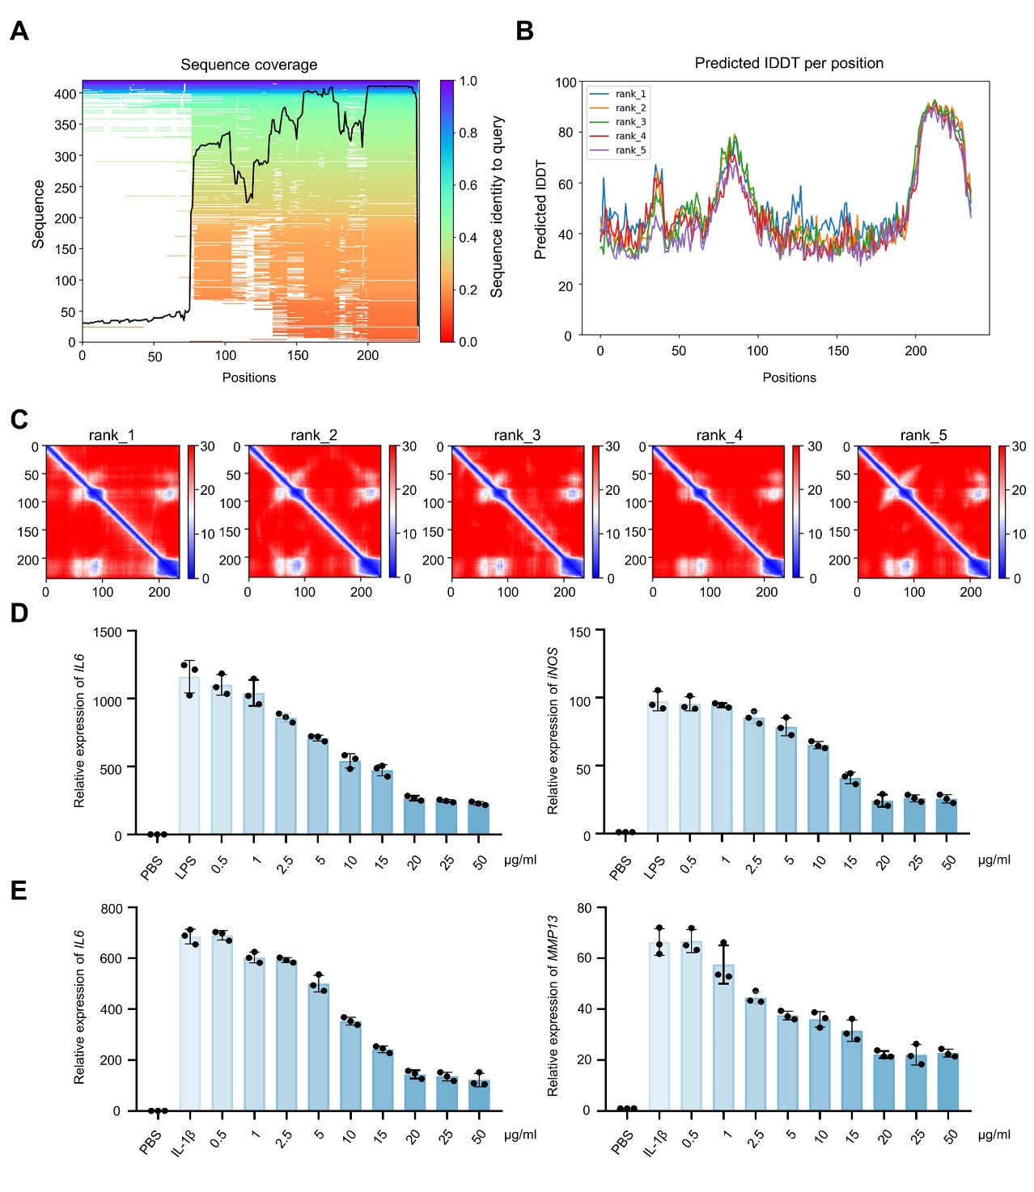
Figure S1. Network pharmacology-based predictions of PDPN-interacting small molecules.
A) Peak plot delineating the predicted sequence coverage of the PDPN protein.
B) Graphical representation of confidence indicators (plDDT) for PDPN protein pocket prediction.
C) Predicted Aligned Error (PAE) matrix for quantitative assessment of PDPN protein structural prediction errors.
D) The mRNA expression levels of IL6 and iNOS in RAW 264.7 cells treated with varying concentrations of LIQ under LPS stimulation.
E) The mRNA expression levels of IL6 and MMP13 in fibroblasts treated with varying concentrations of LIQ under IL-1β stimulation.

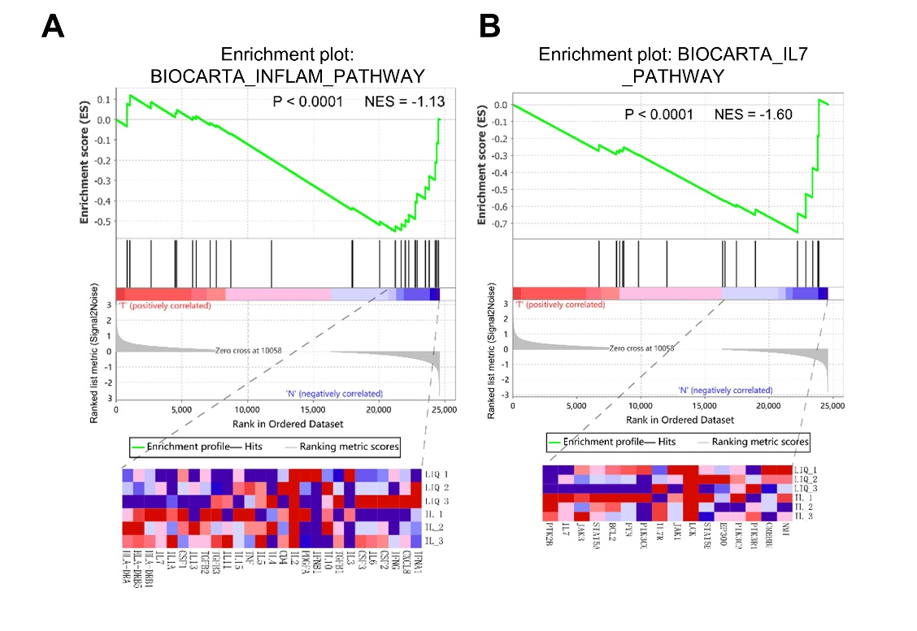
Figure S2. Two Gene Set Enrichment Analysis (GSEA) plots related to inflammation for Bulk RNA sequencing of fibroblasts treated with LIQ (20 µg/mL) in response to IL-1β stimulation.

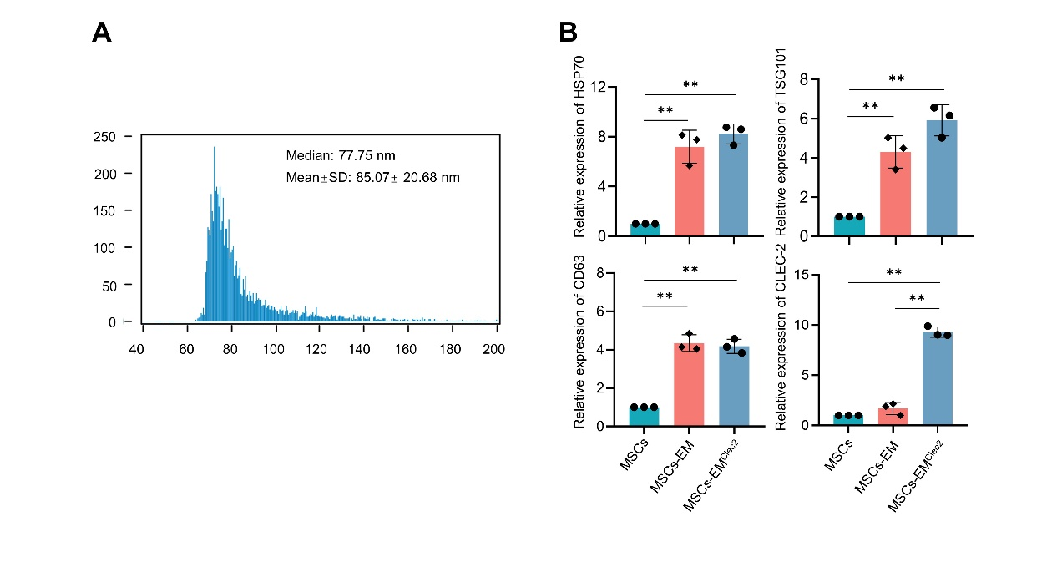
Figure S3. Synthesis and characterization of EMPL.
A) High-sensitivity flow cytometric analysis of MSC-derived exosomes at the nanoparticle level.
B) Quantitative protein expressions of HSP70, TSG101, CD63, and CLEC-2.

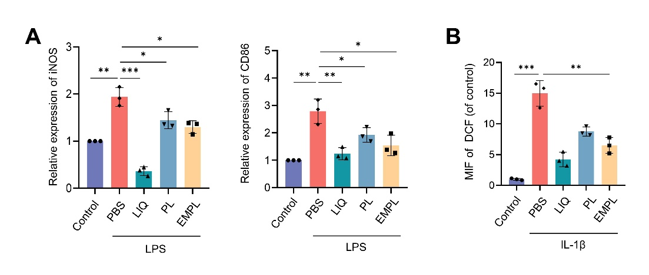
Figure S4. EMPL-mediated inhibition of inflammation in LPS-stimulated RAW 264.7 cells and IL-1β- stimulated fibroblasts.
- Quantitative protein expressions of iNOS and CD86 in RAW 264.7 cells.
- Statistical analysis of DCF fluorescence intensity in fibroblasts.

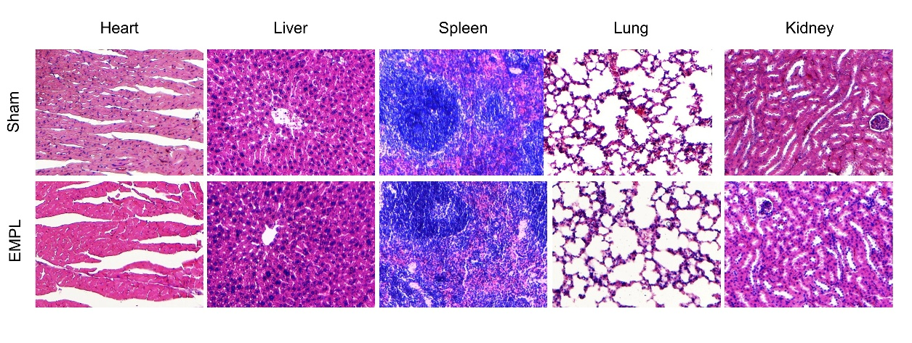
Figure S5. HE staining of heart, liver, spleen, lung, and kidney tissues from Sham and EMPL treatment groups.
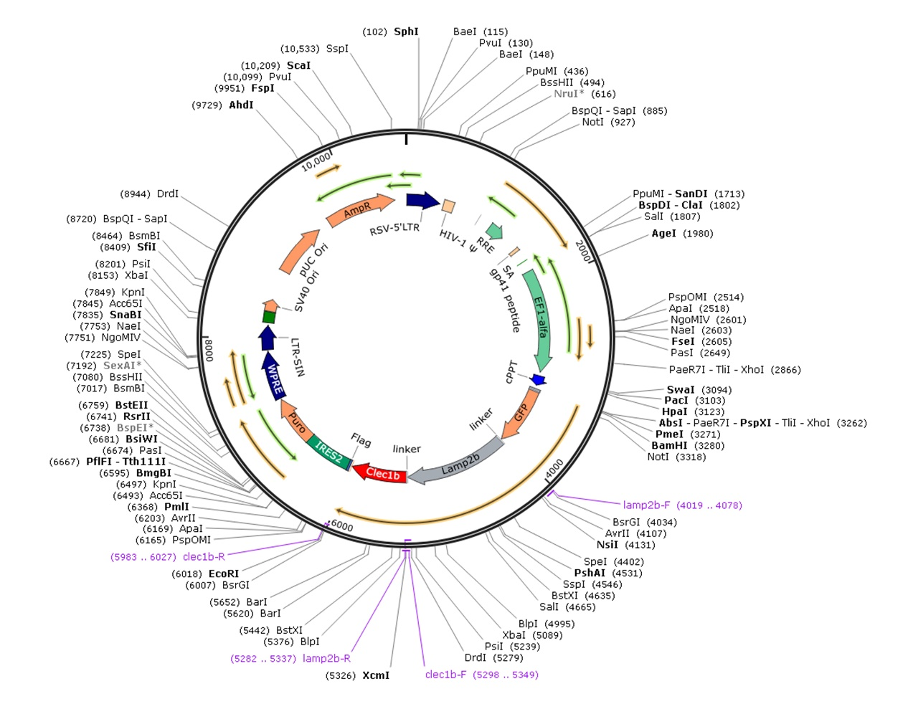
Figure S6. Schematic representation of the plasmid construction encoding the Lamp2-CLEC-2 fusion protein.

Table S1. Table of pocket information for the structure of PDPN protein.
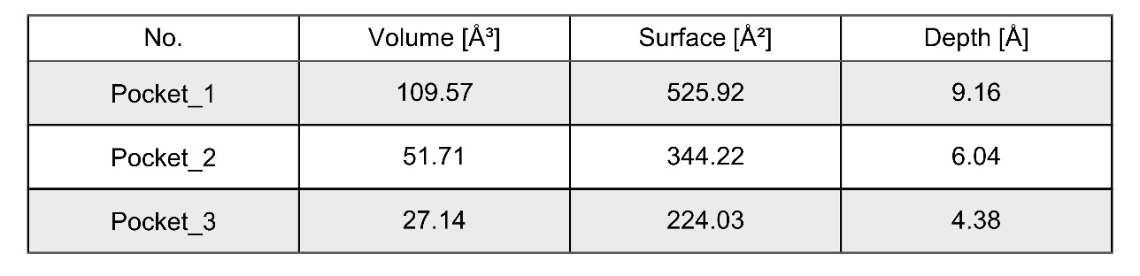

Table S2. Table of docking information for network pharmacology analysis.
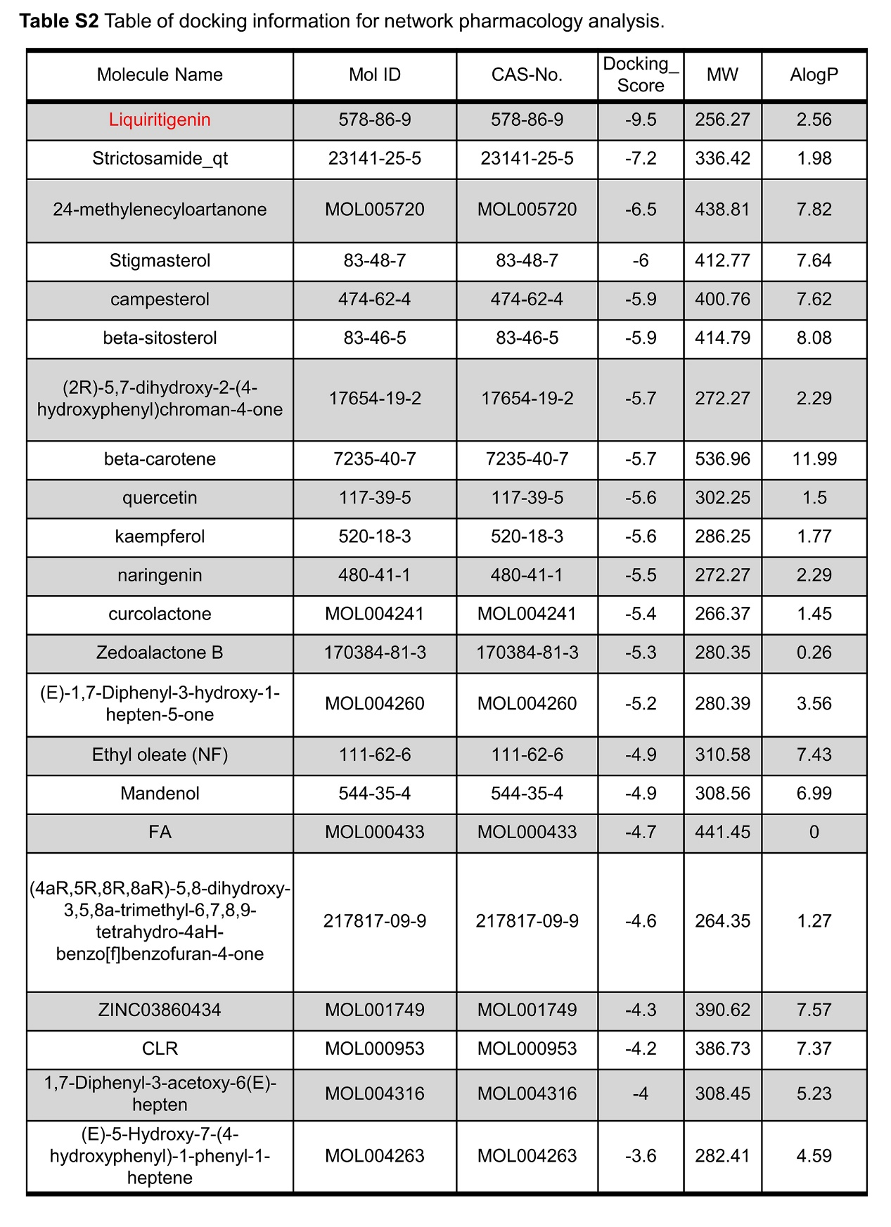

Table S3. RT-PCR primers were used in this study.
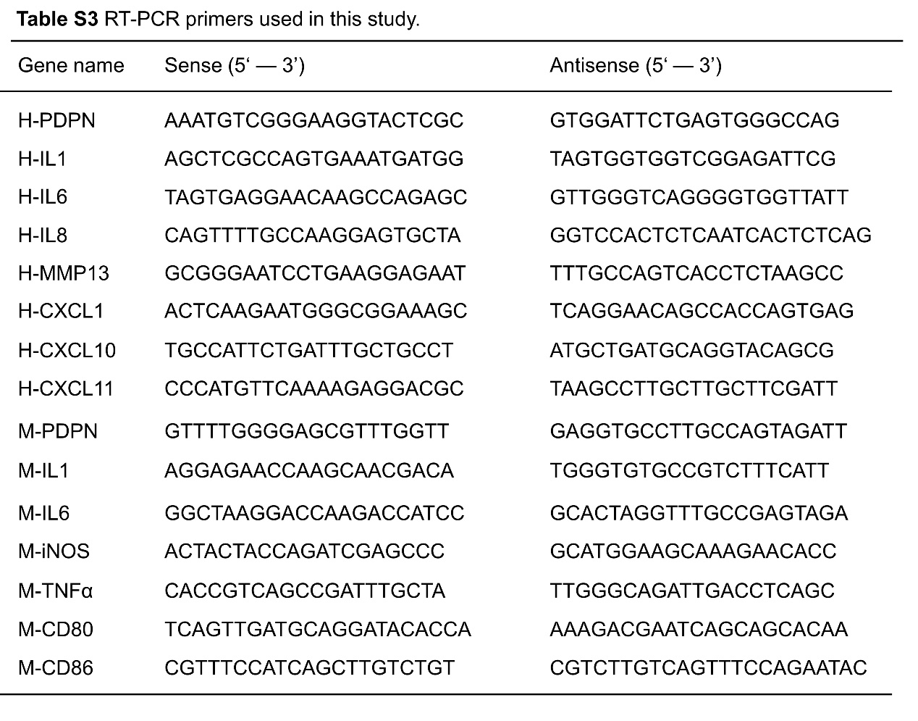

Table S4. The sequence of siPDPN was used in this study.
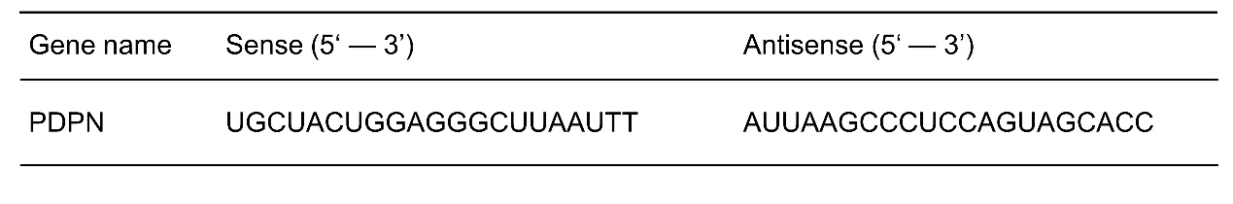

Table S5. PCR primers are used to construct plasmids.
