Supplementary
- Tables
Supplementary Table 1: Variables used for pharmacokinetic modelling
Variable | Unit | Explanation
D | mg | Amount of drug infused
T | h | Time of infusion
x₁ | mg | Amount of drug in central compartment
x₂ | mg | Amount of drug in first peripheral compartment
x₃ | mg | Amount of drug in second peripheral compartment
V₁ | l | Volume of central compartment
V₂ | l | Volume of first peripheral compartment
V₃ | l | Volume of second peripheral compartment
Q₁ | l/h | Intercompartmental Clearance between central and first peripheral compartment
Q₂ | l/h | Intercompartmental Clearance between central and second peripheral compartment
Cl | l/h | Clearance from central compartment
e | mg | Amount of drug excreted
V_{max} | mg/h | Maximum speed of elimination
K_{m} | mg/l | Michaelis-Menten Constant

Supplementary Table 2: Pharmacokinetic models used for calculation of tissue concentrations
Chemotherapeutic | Number of compartments | Distribution kinetic | Elimination kinetic
5-Flurorouracil | 2 | Linear | Saturable
Folic acid | 1 | - | Linear
Oxaliplatin | 2 and 3 | Linear | Linear
SN-38 | 3 for irinotecan  2 for SN-38 | Linear | Linear
Gemcitabine | 2 | Linear | Linear
Paclitaxel | 3 | Linear | Linear

Supplementary Table 3: Overview of in-vitro approaches toward combination drug therapy for PDAC
Publication | Regimen | Combination based on | Maximum concentrations of chemotherapeutic agents
Peschke et al.  [1] | FOLFIRINOX | c_{max/plasma} | 16.9 µM Irinotecan  37.6 µM 5-FU  7.9 µM Oxaliplatin
Bachir et al.  [2] | FOLFIRINOX | Pharmacokinetic equilibrium to estimate c_{max/tissue} | 12.5 nM SN-38  4 µM 5-FU  0.5 µM Oxaliplatin
Hennig et al.  [3] | FOLFIRINOX and gemcitabine/nab-paclitaxel | IC₅₀ values | 10 μM Irinotecan  35 μM Oxaliplatin  35 μM 5-FU  14 nM Gemcitabine  9 nM Paclitaxel
Farshadi et al.  [4] | FOLFIRINOX | IC₂₅ values | 5nM SN-38  30 µM 5-FU  10 µM Oxaliplatin

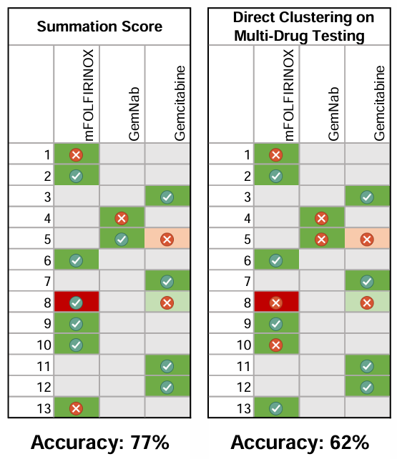
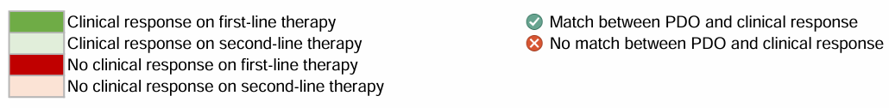
- Figures
Supplementary Figure 1: Overview of logIC₅₀]-based scores

1. Peschke K, Jakubowsky H, Schafer A, Maurer C, Lange S, Orben F, Bernad R, Harder FN, Eiber M, Ollinger R et al: Identification of treatment-induced vulnerabilities in pancreatic cancer patients using functional model systems. EMBO Mol Med 2022, 14:4.
2. Hadj Bachir E, Poiraud C, Paget S, Stoup N, El Moghrabi S, Duchene B, Jouy N, Bongiovanni A, Tardivel M, Weiswald LB et al: A new pancreatic adenocarcinoma-derived organoid model of acquired chemoresistance to FOLFIRINOX: First insight of the underlying mechanisms. Biol Cell 2022, 114:1.
3. Hennig A, Baenke F, Klimova A, Drukewitz S, Jahnke B, Brückmann S, Secci R, Winter C, Schmäche T, Seidlitz T et al: Detecting drug resistance in pancreatic cancer organoids guides optimized chemotherapy treatment. The Journal of Pathology 2022, 257:5.
4. Farshadi EA, Chang J, Sampadi B, Doukas M, Van 't Land F, van der Sijde F, Vietsch EE, Pothof J, Koerkamp BG, van Eijck CHJ: Organoids Derived from Neoadjuvant FOLFIRINOX Patients Recapitulate Therapy Resistance in Pancreatic Ductal Adenocarcinoma. Clinical Cancer Research 2021, 27:23.

