Supplementary Material
Fig 1 Geographical location of Eucalyptus urophylla seed orchards, Selvíria, Mato Grosso do Sul, Brazil
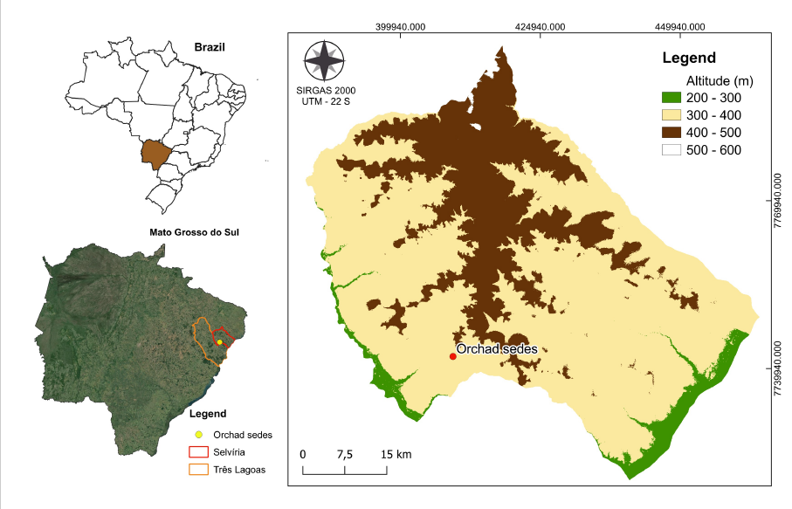

Table S1 Number of progenies (N) and bulks evaluated by island and origin in the provenance and progeny test (PPT) of Eucalyptus urophylla S.T. Blake, established in 2006 in the municipality of Selvíria, Mato Grosso do Sul, Brazil
Island | Origins | PPT I |  | PPT II |  | PPT III |  | PPT IV
Island | Origins | Prog | N | Prog | N | Prog | 432 | Prog | N
Adonara | Dua_Muda | 8 | 384 | 8 | 384 | -- | -- | -- | --
Adonara | Gonehama | 7 | 336 | 8 | 384 | -- | -- | -- | --
Adonara | Lamahela | 7 | 336 | 8 | 384 | Bulk | 48 | -- | --
Adonara | Kawela | -- | -- | -- | -- | 8 | 384 | 8 | 384
Adonara | Lamalota_Barat | -- | -- | 5 | 240 | -- | -- | -- | --
Adonara | Watololong | 7 | 336 | 7 | 336
Lembata | Bunga_Muda | Bulk | 48 | Bulk | 48 | Bulk | 48 | Bulk | 48
Lembata | Ille_Kerbau | Bulk | 48 | Bulk | 48 | Bulk | 48 | Bulk | 48
Timor | Bonmuti | Bulk | 48 | Bulk | 48 | Bulk | 48 | Bulk | 48
Wetar | Alasannaru | -- | -- | -- | -- | 7 | 336 | 7 | 336
Wetar | Elun_Kripas | -- | -- | -- | -- | 8 | 384 | 8 | 384
Wetar | Nakana_Ulam | -- | -- | -- | -- | 7 | 336 | 8 | 384
Wetar | Nesunhuhun | -- | -- | -- | -- | 7 | 336 | 7 | 336
Wetar | Ketur | 5 | 240 | 7 | 336 | -- | -- | -- | --
Wetar | Puaanan | 5 | 240 | 7 | 336 | -- | -- | -- | --
Wetar | Remamea | 8 | 384 | 8 | 384 | -- | -- | -- | --
Wetar | Tatianan | 11 | 528 |  | -- | -- | -- | -- | --
Clones | Control 1 |  | 48 |  | 48 |  | 48 |  | 48
Clones | Control 2 |  | 48 |  | 48 |  | 48 |  | 48
Clones | Control 3 |  | 48 |  | 48 |  | 48 |  | 48
Progenies |  | 58 |  | 58 |  | 37 |  | 38
Bulk |  | 3 |  | 3 |  | 4 |  | 3
Total |  |  | 3072 |  | 3072 |  | 2112 |  | 2112

Table S2 Hierarchical levels ($F_{ST}$, $F_{IS}$ e $F_{IT}$) among islands and among populations within islands of Eucalyptus urophylla S.T. Blake.
 |  | Adonara |  | Lembata |  | Timor |  | Wetar
Adonara |  | -0.2431 |  | 0.0112  (0.0104-0.0120) |  | 0.0259  (0.0240-0.0279) |  | 0.0538  (0.05140-0.0564)
Lembata |  |  |  | -0.2370 |  | 0.0246  (0.0115-0.0269) |  | 0.0532  (0.0502-0.0562)
Timor |  | - 0.22 |  |  |  | -0.2242 |  | 0.0278  (0.0255-0.0299)
Wetar |  |  |  |  |  |  |  | -0.2014
 |  | Al | EK | Ke | Na | Ne | Pu | Re | Ta
Wetar | Al | -0.21 | 0.009  (0.0082-0.0099) | 0.010  (0.0091-0.0113) | 0.006  (0.0054-0.0069) | 0.006  (0.0056-0.0073) | 0.009  (0.0080-0.0100) | 0.008  (0.0077-0.0094) | 0.010  (0.0089-0.0109)
Wetar | EK |  | -0.22 | 0.014  (0.0138-0.0162) | 0.011  (0.0101-0.0124) | 0.011  (0.0096-0.0117) | 0.013  (0.0119-0.0140) | 0.012  (0.0113-0.0135) | 0.015  (0.0137-0.0162)
Wetar | Ke |  |  | -0,22 | 0.011  (0.0099-0.0121) | 0.012  (0.0107-0.0128) | 0.006  (0.0057-0.007) | 0.006  (0.0058-0.0072) | 0.009  (0.0077-0.0097)
Wetar | Na |  |  |  | -0.21 | 0.006  (0.0056-0.0074) | 0.010  (0.0089-0.0109) | 0.009  (0.0083-0.0100) | 0.010  (0.0093-0.0112)
Wetar | Ne | - 0.27 |  |  |  | -0.22 | 0.010  (0.0092-0.0114) | 0.010  (0.0091-0.0112) | 0.011  (0.0099-0.0123)
Wetar | Pu |  |  |  |  |  | -0.21 | 0.005  (0.0048-0.0059) | 0.009  (0.0077-0.0097)
Wetar | Re |  |  |  |  |  |  | -0.21 | 0.007  (0.0068-0.0084)
Wetar | Ta |  |  |  |  |  |  |  | -0.22
Adonara |  | DM |  | Go | Ka | La | LB |  | Wa
Adonara | DM | -0.26 |  | 0.016  (0.0145-0.0171) | 0.028  (0.0266-0.0303) | 0.013  (0.0122-0.0144) | 0.005  (0.0042-0.0062) |  | 0.010  (0.0090-0.0122)
Adonara | Go |  |  | -0.27 | 0.037  (0.0348-0.0397) | 0.014  (0.0125-0.0150) | 0.015  (0.0137-0.0170) |  | 0.005  (0.0039-0.0056)
Adonara | Ka |  |  |  | -0.27 | 0.033  (0.0314-0.0355) | 0.026  (0.0245-0.0285) |  | 0.035  (0.0328-0.0376)
Adonara | La | - 0.30 |  |  |  | -0.26 | 0.012  (0.0109-0.0136 ) |  | 0.013  (0.0120-0.0143)
Adonara | LB |  |  |  |  |  | -0.26 |  | 0.011  (0.0094-0.01225)
Adonara | Wa |  |  |  |  |  |  |  | -0.27
Lembata |  | Bunga Muda (BM) |  |  |  | Ille Kerbau (IK)
Lembata | BM | -0.23 |  |  |  | 0.017  (0.0152-0.0189)
Lembata | IK | -0.29 |  |  |  | -0.25
Timor |  | Bonmuti
Timor | FIS | - 0.22
Timor | FIT | - 0. 37
$F_{ST}$= Above the diagonal; $F_{IS}$==Diagonal; $F_{IT}$= Below the diagonal; Al=Alasannaru; EK= Elun Kripas; Ke= Ketur; Na= Nakana Ulan; Ne= Nesunhuhum; Pu= Puaanan; Re= Remamea; Ta=Talianan; DM= Dua Muda; Go= Gonehama; Ka= Kawella; La= Lamahela; LB= Lamalota Barat; Wa= Watololong;

Table S3 Distance in kilometers between the 17 populations of Eucalyptus urophylla S.T Blake
 |  | Adonara |  |  |  |  |  | Wetar |  |  |  |  |  |  |  | Lembata |  | Timor
 |  | DM | Go | Ka | La | LB | Wa | Al | EK | Ke | Na | Ne | Pu | Re | Ta | BM | IK | Bo
Adonara | DM |  | 1.86 | 20.49 | 3.73 | 7.68 | 0.80 | 354.79 | 340.13 | 360.02 | 349.01 | 338.00 | 360.29 | 358.18 | 361.59 | 32.41 | 30.92 | 174.23
Adonara | Go |  |  | 22.34 | 4.16 | 7.45 | 1.86 | 352.95 | 338.29 | 358.18 | 347.17 | 336.17 | 358.46 | 356.35 | 359.75 | 30.61 | 29.38 | 173.04
Adonara | Ka |  |  |  | 20.49 | 24.13 | 20.49 | 375.24 | 360.57 | 380.48 | 369.47 | 358.46 | 380.75 | 378.64 | 382.06 | 52.78 | 48.72 | 186.83
Adonara | La |  |  |  |  | 11.33 | 3.73 | 355.37 | 340.74 | 360.57 | 349.58 | 338.60 | 360.87 | 358.74 | 362.13 | 33.46 | 29.07 | 171.42
Adonara | LB |  |  |  |  |  | 7.68 | 351.89 | 337.19 | 357.17 | 346.13 | 335.09 | 357.41 | 355.33 | 358.79 | 29.69 | 34.18 | 178.80
Adonara | Wa |  |  |  |  |  |  | 354.79 | 340.13 | 360.02 | 349.01 | 338.00 | 360.29 | 358.18 | 361.59 | 32.41 | 30.92 | 174.23
Wetar | Al |  |  |  |  |  |  |  | 14.84 | 5.87 | 5.87 | 16.80 | 5.57 | 4.15 | 8.30 | 322.49 | 332.30 | 301.94
Wetar | EK |  |  |  |  |  |  |  |  | 20.49 | 9.46 | 2.63 | 20.41 | 18.65 | 22.57 | 307.81 | 317.82 | 290.41
Wetar | Ke |  |  |  |  |  |  |  |  |  | 11.13 | 22.26 | 1.86 | 1.86 | 2.63 | 327.74 | 337.36 | 305.20
Wetar | Na |  |  |  |  |  |  |  |  |  |  | 11.13 | 11.29 | 9.28 | 13.12 | 316.72 | 326.47 | 296.42
Wetar | Ne |  |  |  |  |  |  |  |  |  |  |  | 22.34 | 20.41 | 24.19 | 305.70 | 315.60 | 287.79
Wetar | Pu |  |  |  |  |  |  |  |  |  |  |  |  | 2.63 | 4.16 | 328.00 | 337.74 | 306.33
Wetar | Re |  |  |  |  |  |  |  |  |  |  |  |  |  | 4.15 | 325.90 | 335.54 | 303.73
Wetar | Ta |  |  |  |  |  |  |  |  |  |  |  |  |  |  | 329.33 | 338.80 | 305.57
Lembata | BM |  |  |  |  |  |  |  |  |  |  |  |  |  |  |  | 24.85 | 162.00
Lembata | IK |  |  |  |  |  |  |  |  |  |  |  |  |  |  |  |  | 144.88

