SUPPLEMENTARY INFORMATION
Supplement: section 1. The Chen parametric model

Supplement: section 2. Rayleigh parametric models

Supplement: section 3. Benfari et al., 2019 study of functional tricuspid regurgitation.

Supplement: section 4. Essayagh et al., 2021 study of functional tricuspid regurgitation under medical management

Supplement: section 5. Tribouilloy et al., 2024 study of isolated functional tricuspid regurgitation

Supplement: section 6. Triscend II RCT of percutaneous tricuspid valve implant for treatment of functional tricuspid regurgitation.

Supplement: section 7. Bae et al., 2013 study of Microfracture for osteoarthritis of the knee

Supplement: section 8. Whitlock et al., 2021 RCT of Left atrial appendage occlusion during cardiac surgery to prevent stroke.

Supplement: section 9. Total Hip Replacement (National Joint Registry report 20)

Supplement: section 10. Changing performance of THR (Swedish Arthroplasty Registry)

Supplement section 1: The Chen parametric model

Chen (Statistics & Probability Letters 49 (2000) 155 – 161) describes a modified version of the Weibull distribution that generates non-linearly increasing hazard or bathtub “U” shaped hazard. The distribution has two parameters lambda and beta.
Figure 2 in the paper by Chen displays hazard plots for various values of beta (1.2, 1.0, 0.8, 0.6, 0.4) with lambda set at 2. We replicated this with reasonable accuracy using Excel as shown below left. The curve for lambda =2 beta = 0.6 can be described as U or j OR reverse j shaped. Curves with beta values of 1 and 1.2 do not have “U, j, or reverse j ” shape. With lambda at 2 only some values for beta generate a bathtub shape hazard curve.
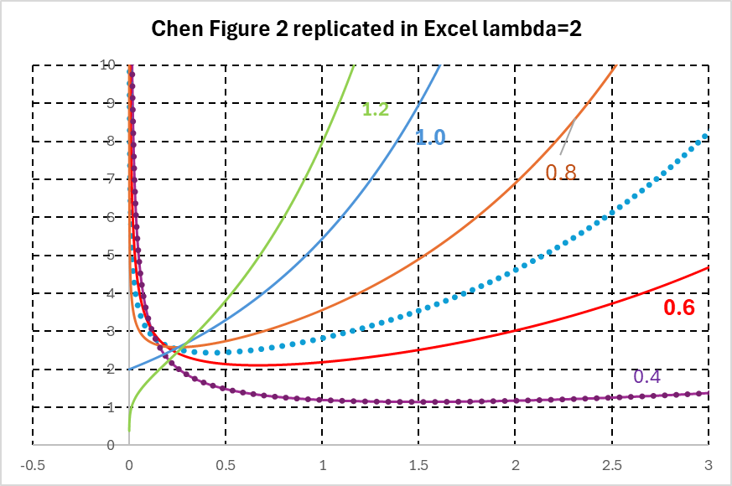

We calculated cumulative hazard (CH) for the “lambda 2 // beta 0.6” curve and then survival (S = exp(- CH)). The resulting survival data was then used to reconstruct the corresponding KM plot and this was modelled using stgenreg commands for bathtub and Chen models (see Methods section in main text). The results are shown above right, both models fit well to the reconstructed KM plot and are almost identical suggesting that both models are suitable for cases where hazard is characterised by a bathtub shape.

Supplement section 2: Rayleigh parametric models

Rayleigh 2 parameter hazard function

$$h\left(t\right)=a+2bt$$

Rayleigh 2 parameter survival function

$$S\left(t\right)=exp⁡(-at-bt^{2})$$

Rayleigh 1 parameter hazard
$$h\left(t\right)=2bt$$

Rayleigh 1 parameter survival function
$$S\left(t\right)=exp⁡(-bt^{2})$$

Supplement section 3: Benfari et al., 2019 study of functional tricuspid regurgitation.

A] Reconstructed KM plots and extrapolated bathtub and Chen models

B] Bathtub hazard for each FTR category.
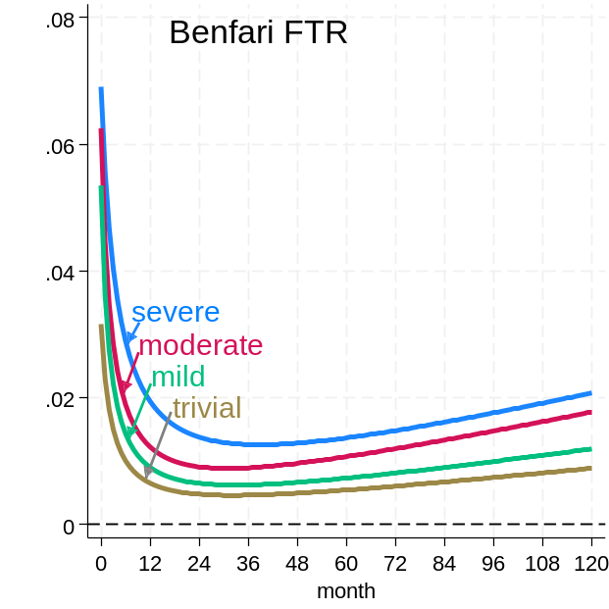

C] Standard models of trivial, mild, moderate and severe FTR.
Abbreviations used for parametric models in Figures are listed below:

Weib Weibull
loglog loglogistic
lognorm lognormal
Gom Gompertz
exp exponential
ggamma generalised gamma

TRIVIAL FTR
MILD FTR

MODERATE FTR
SEVERE FTR

Supplement section 4: Essayagh et al., mortality of FTR patients under medical management
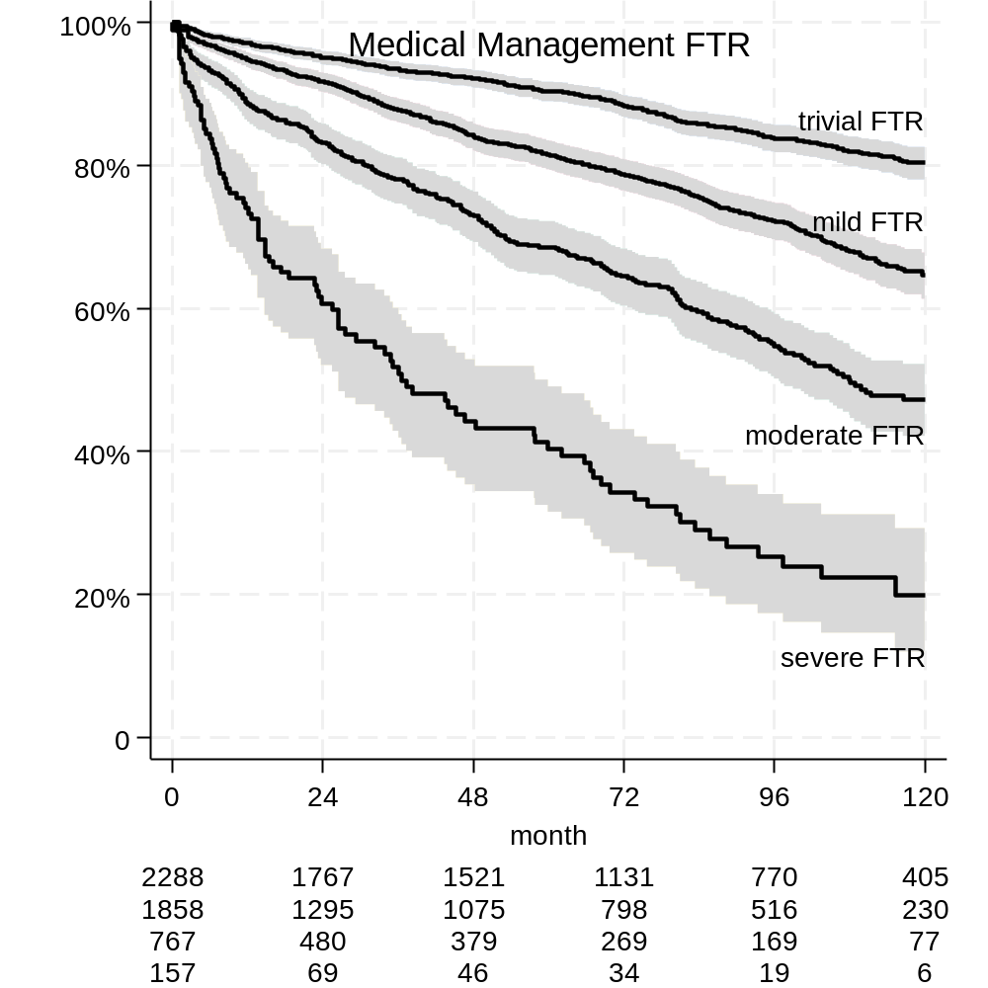
A] Reconstructed Kaplan Meier plots

B] Standard models
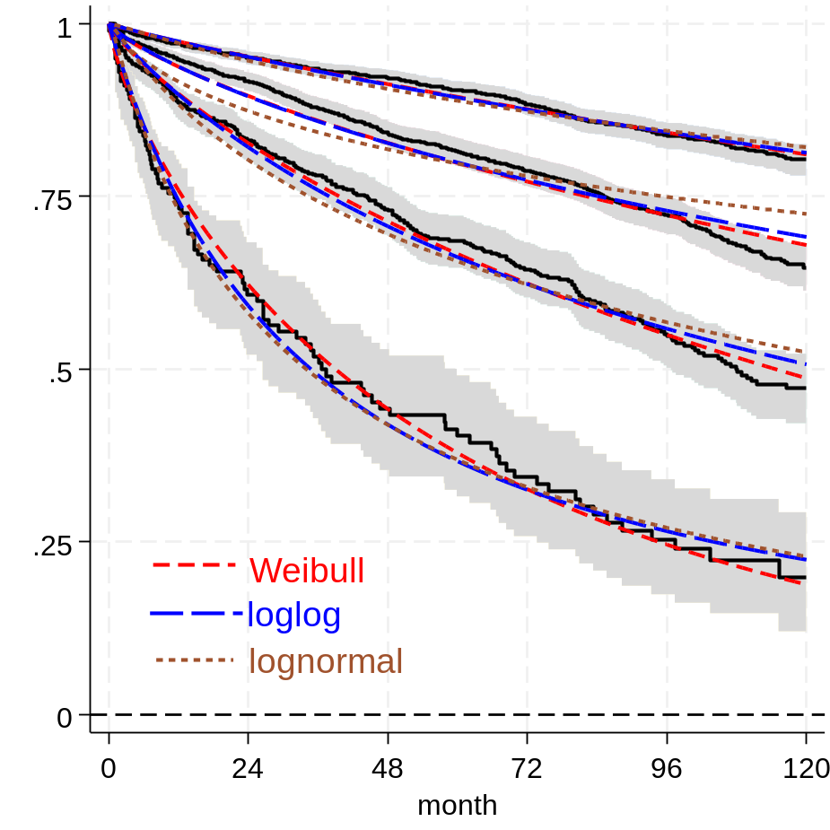

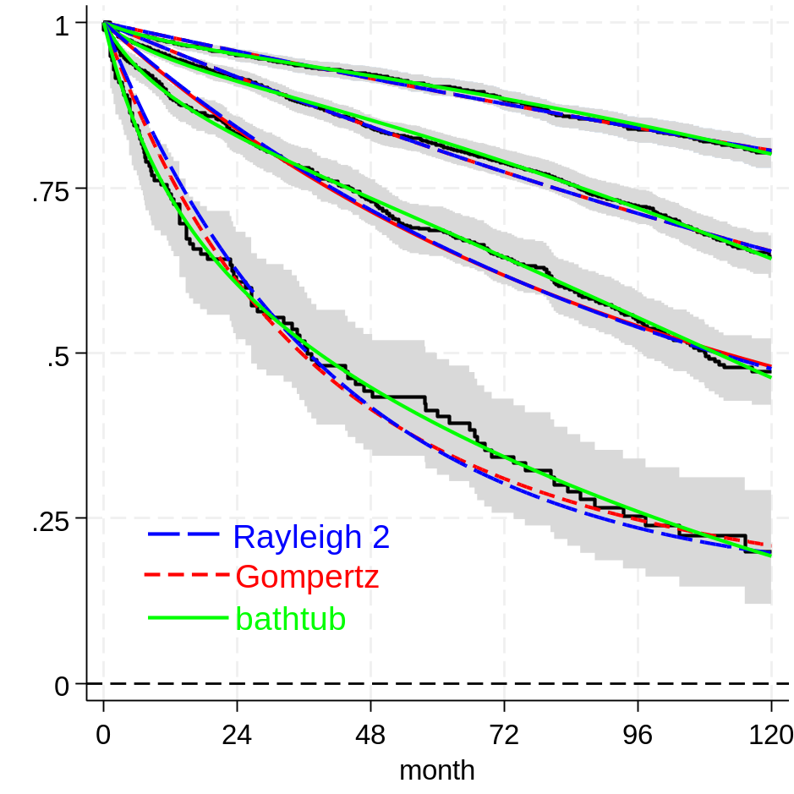

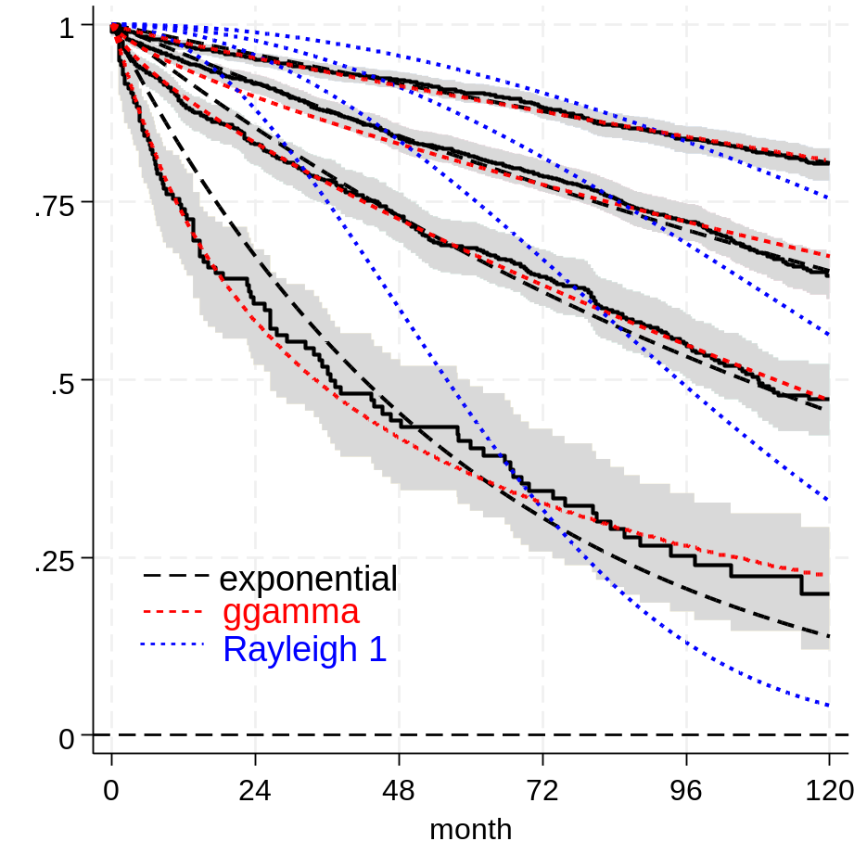

Note :Rayleigh and Gompertz survival models are the same for trivial mild moderate FTR

C] Upper: Extrapolated standard survival models; Lower: Chen (green) bathtub (red) models .
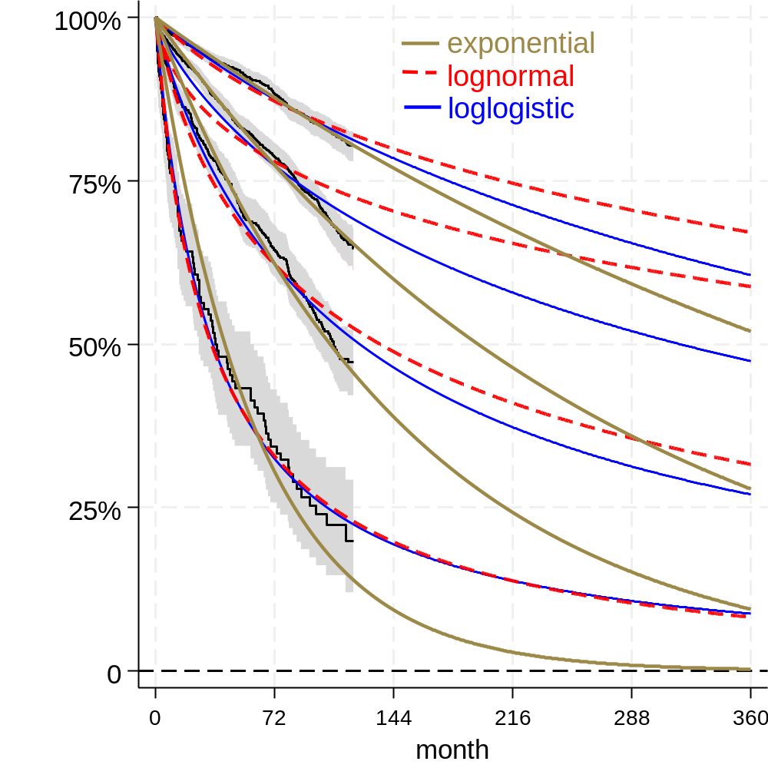
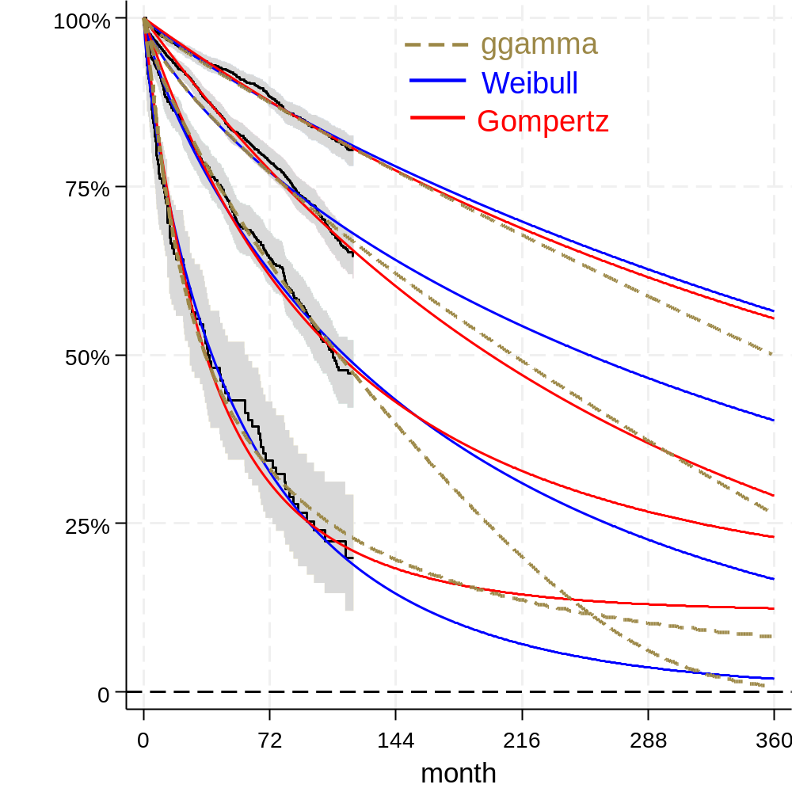

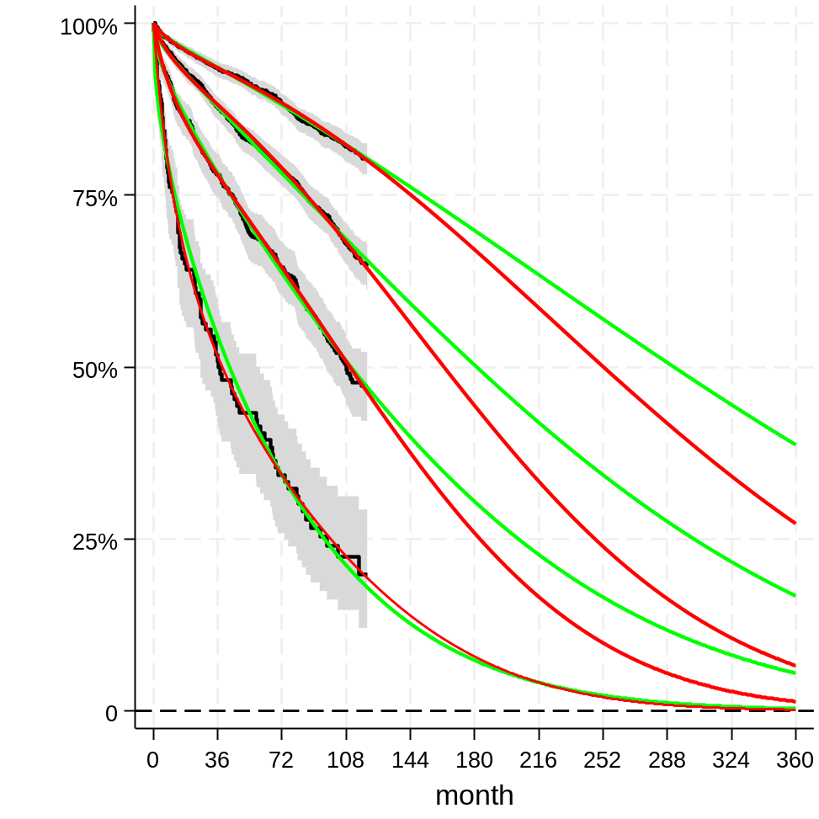

Supplement section 5: Tribouilloy et al., 2024 study of isolated functional tricuspid regurgitation
Left: Extrapolated parametric models. Rightr: bathtub and Chen model hazards.
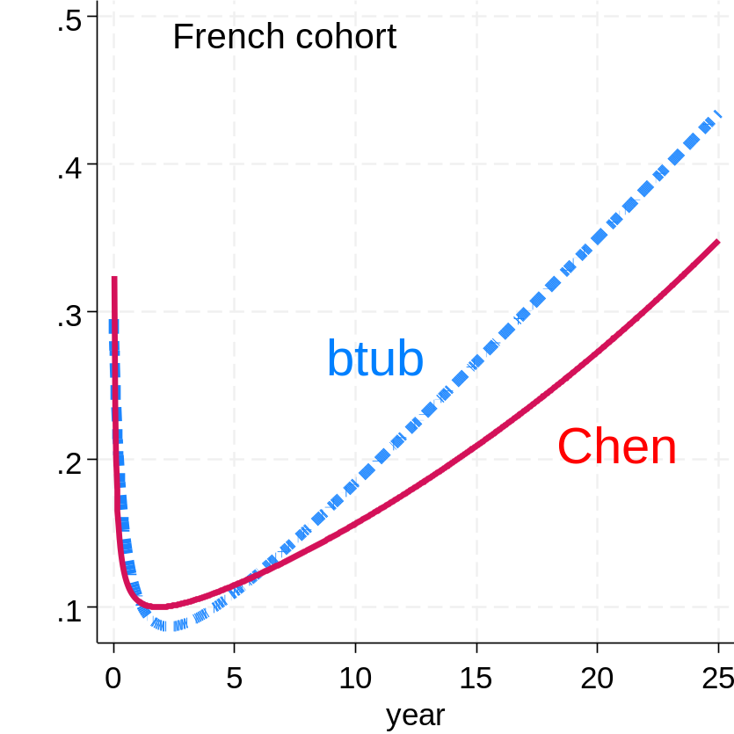
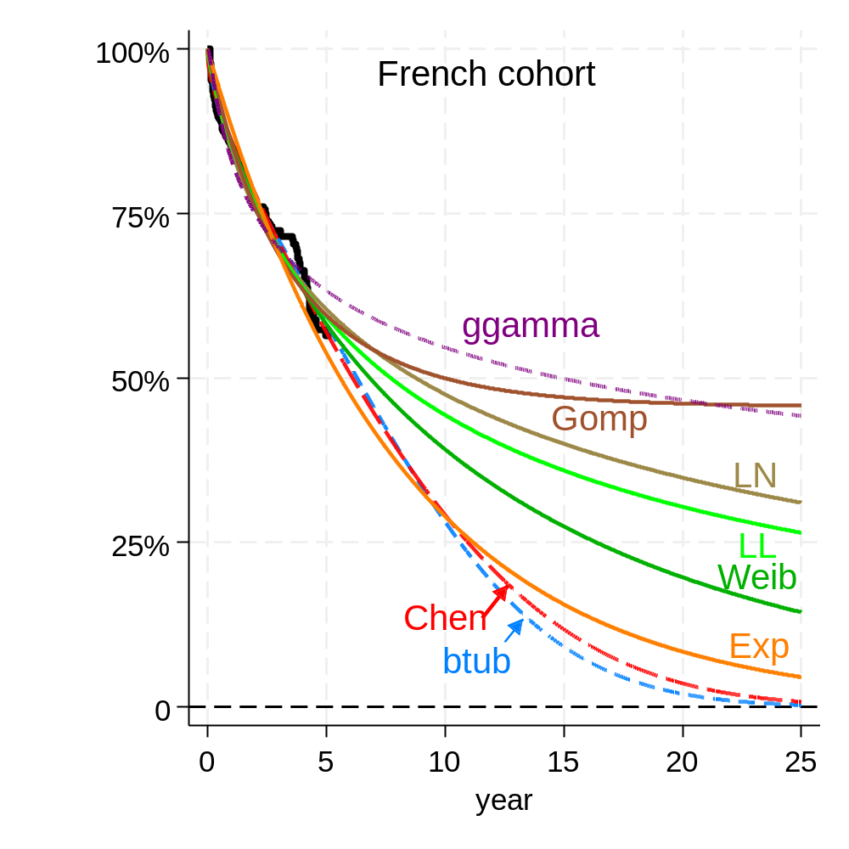

Except for Chen and bathtub models all models shown have implausible survival at 25 years extrapolation

Supplement section 6: Triscend II RCT treatment of functional tricuspid regurgitation.
A] Triscend II control arm
Upper: hazard plots for Rayleigh, bathtub and Chen models. Middle: Bathtub Rayleigh and Chen mortality plot. Lower: Extrapolated parametric models for cumulative mortality.
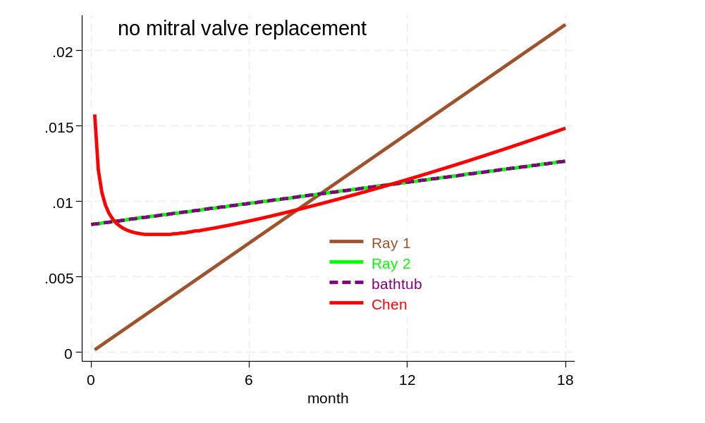
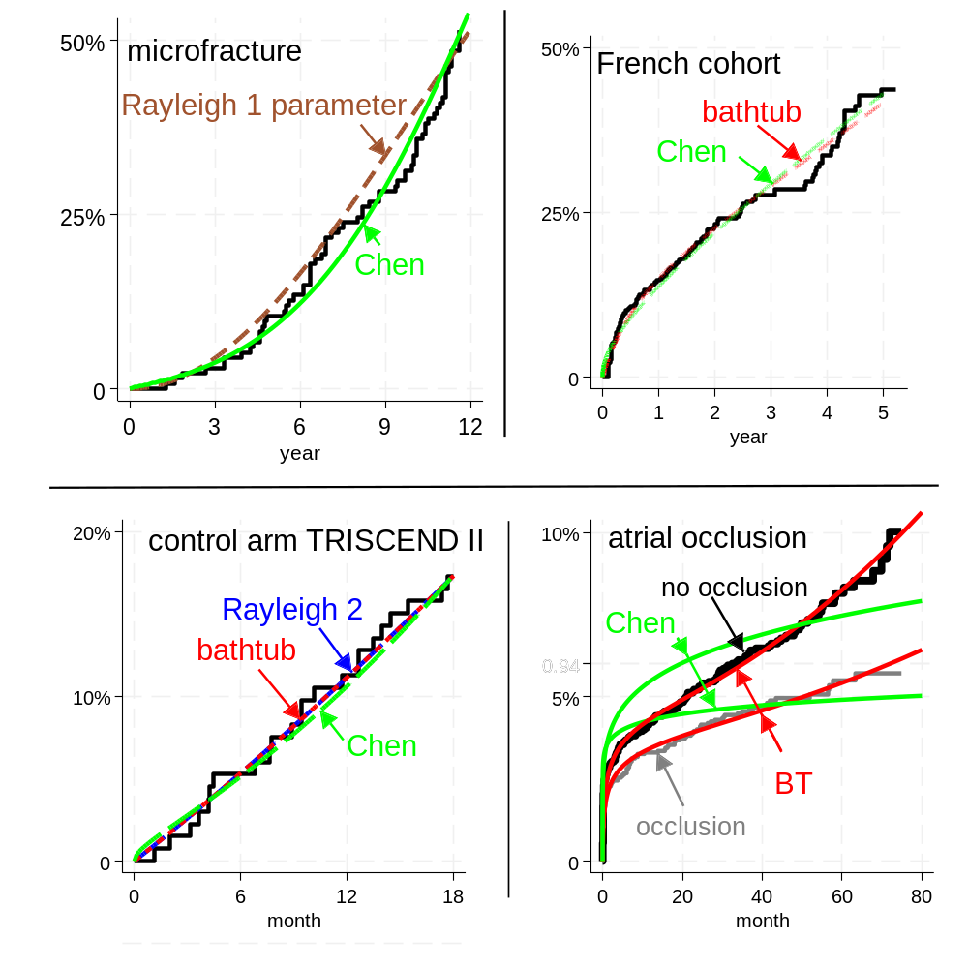
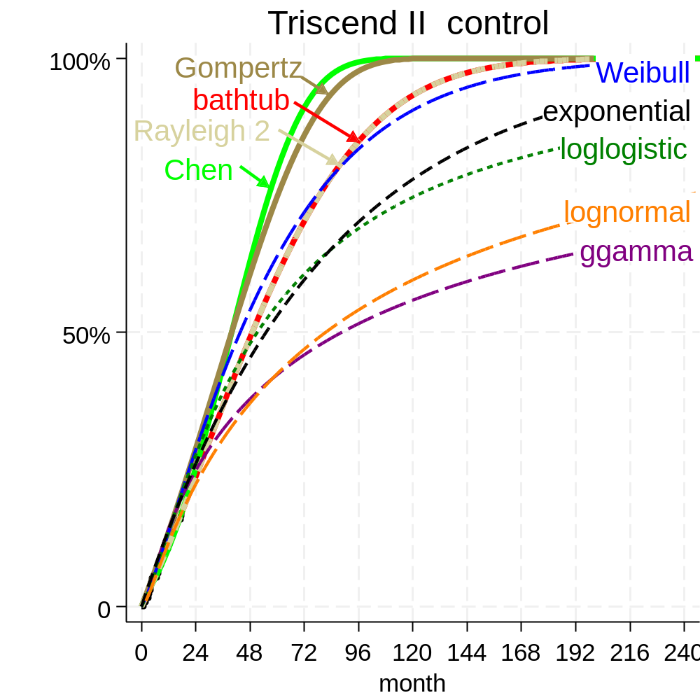

B] Triscend II RCT Intervention arm: Extrapolated models of cumulative mortality.
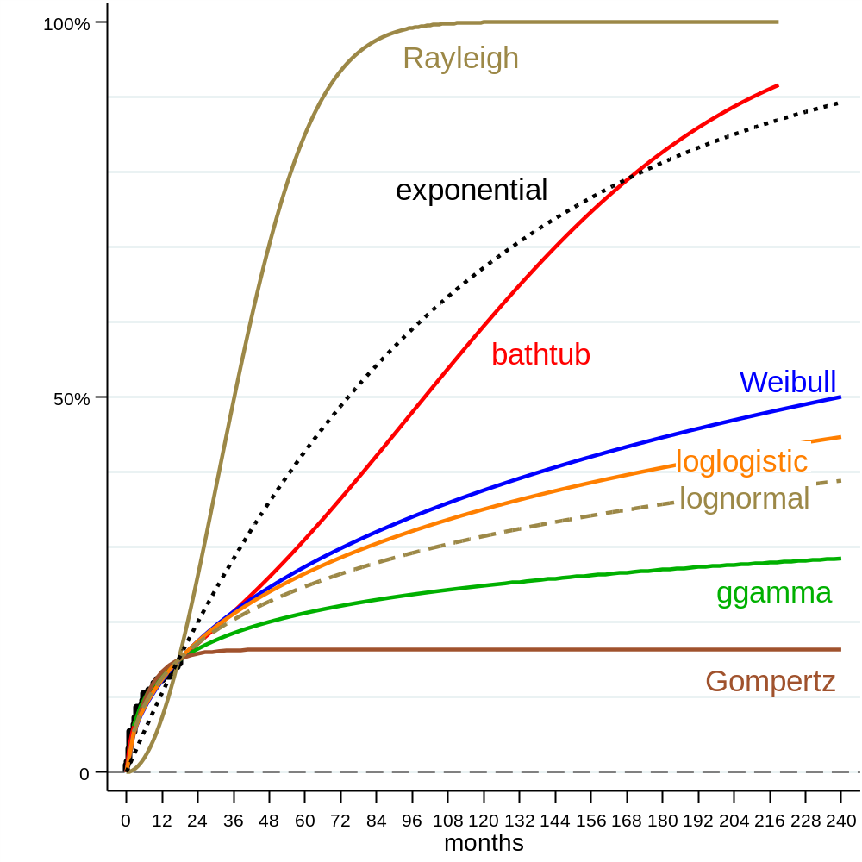

Supplement section 7: Bae et al., 2013 study of Microfracture for osteoarthritic knee.

Upper: Extrapolated parametric models for cumulative failure extrapolated to 25 years.
Lower: model hazard plots extrapolated to 25 years.

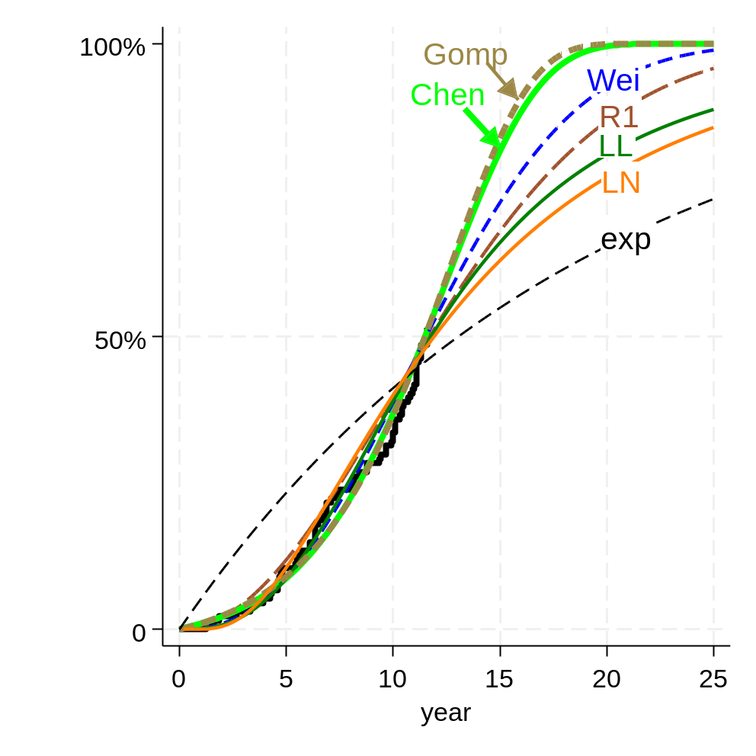

Abbreviations: Gomp Gomppertz; Wei Weibull; LL loglogistic; LN lognormal; exp exponential; R1 Rayleigh 1 parameter.

Except for the exponential model all models shown have reasonably good visual fit to about 12 years but differ on extrapolation.

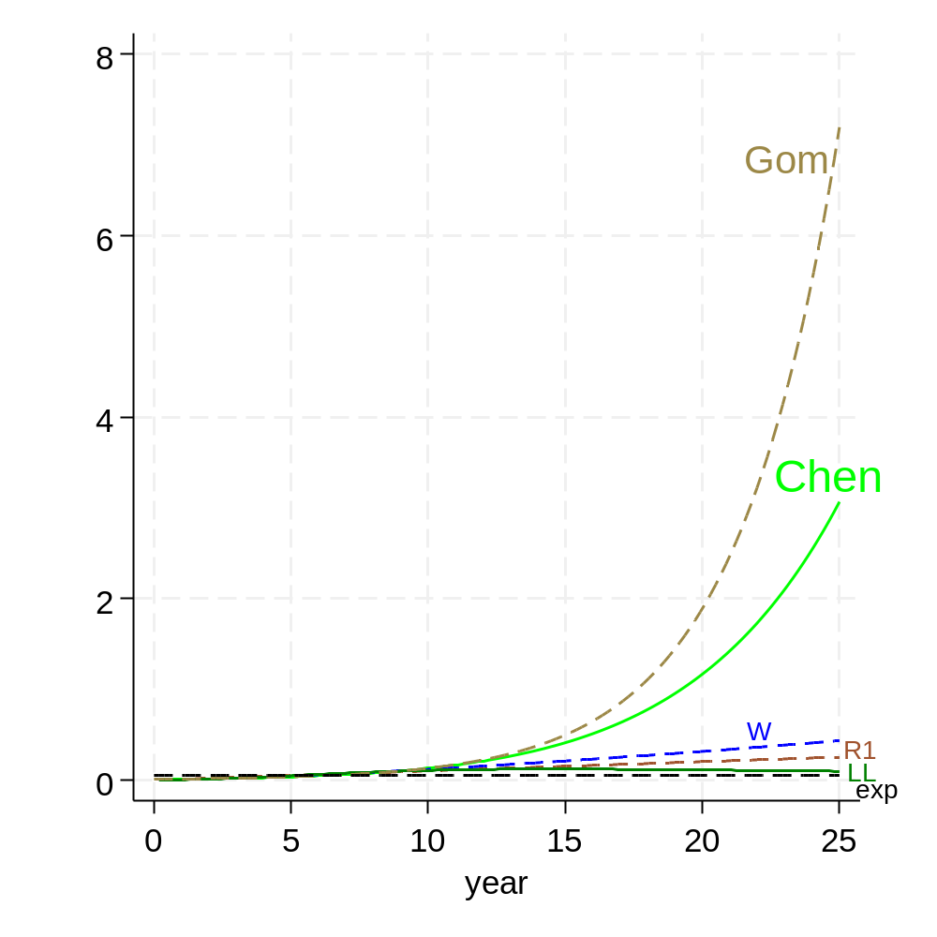

Abbreviations: Gom Gomppertz; W Weibull; LL loglogistic; LN lognormal; exp exponential; R1 Rayleigh 1 parameter.
The hazard for models other than Gompertz and Chen remain barely changed through time.

Supplement section 8: Whitlock et al., 2021 Left atrial appendage occlusion during cardiac surgery to prevent stroke or embolism.
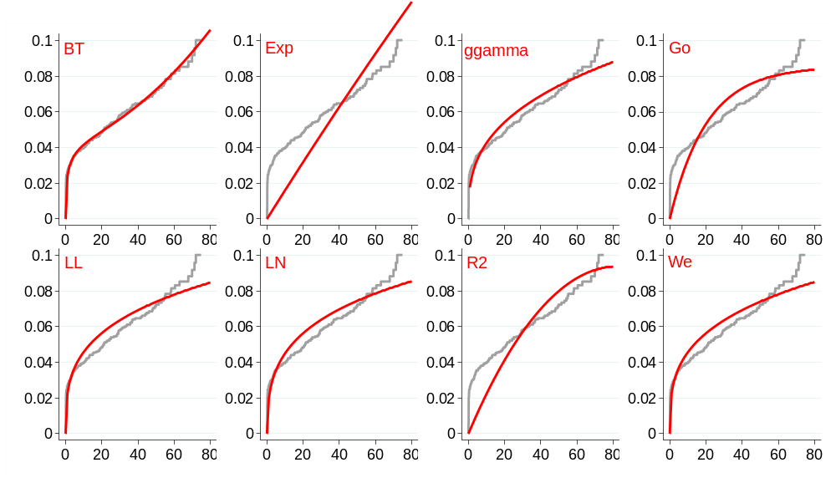
A] No occlusion of atrial appendage (control arm): standard parametric models
Abbreviations: BT bathtub, Exp exponential, Go Gompertz, LL loglogistic, LN lognormal, R Rayleigh 1, We Weibull.
B] Occlusion of atrial appendage (intervention arm): standard parametric models
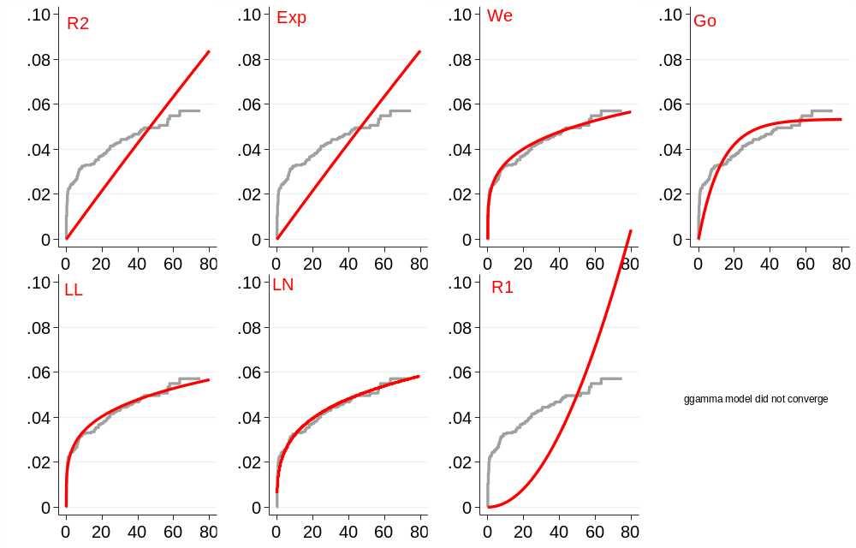
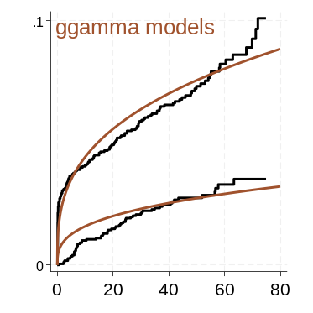
Abbreviations: R2 Rayleigh 2 parameters, Exp exponential, We Weibull, Go Gompertz, LL loglogistic, LN lognormal, R1 Rayleigh 1 parameter, Lower right shows generalised gamma models for both trial arms.

Supplement section 9: Total Hip Replacement (National Joint Registry report 20)
A] Standard models for Osteoarthritis of the hip (The blue line is the digitised trace of the NJR cumulative incidence KM)

Loglogistic, ggamma and Weibull models have poor visual fit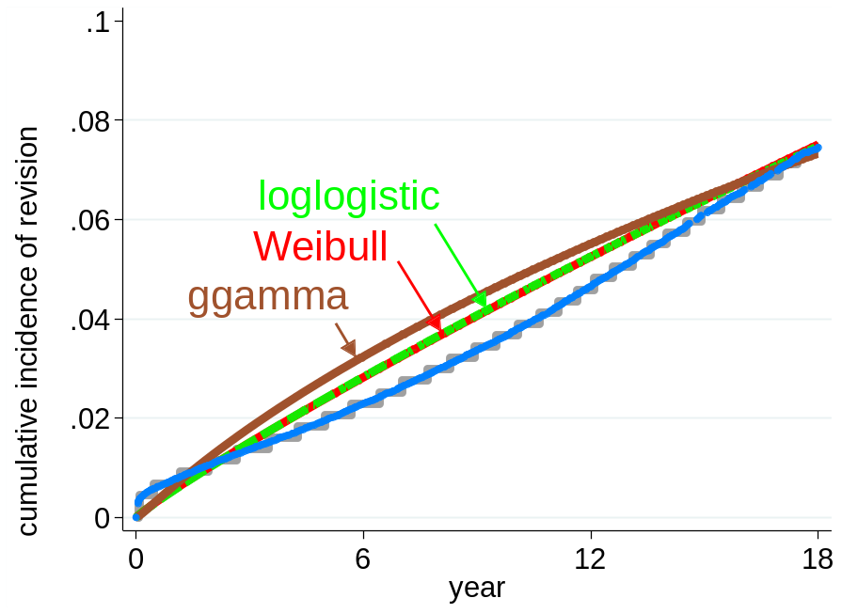 | Rayleigh 2, and Gompertz models have poor visual fit over the first five years.  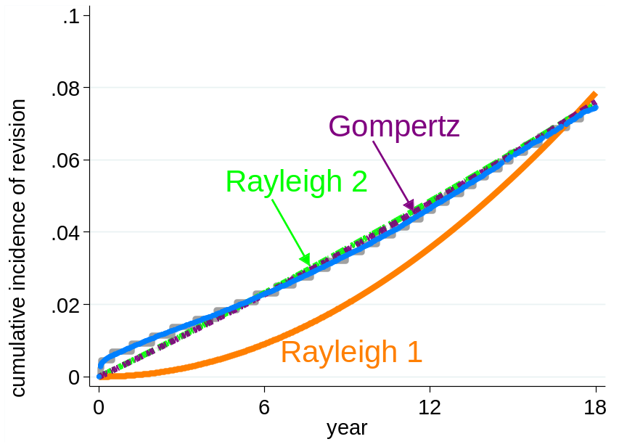
Lognormal and exponential models have poor visual fit
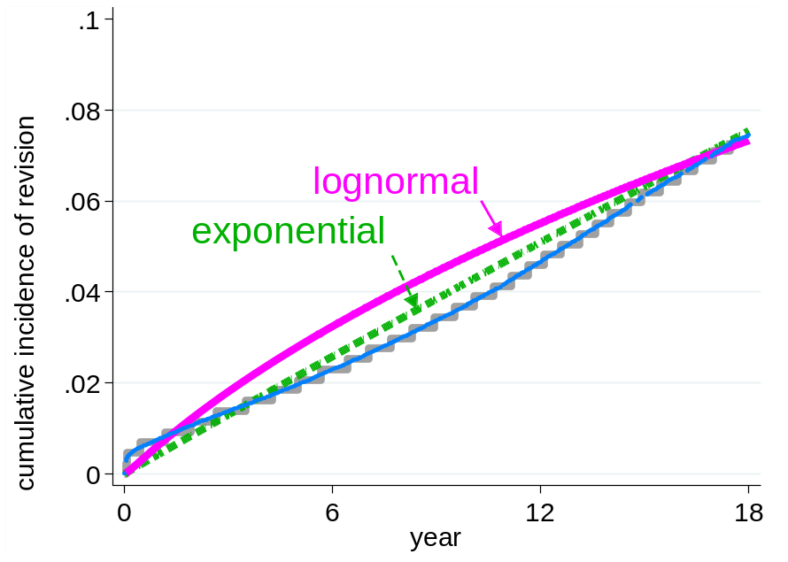

B]. Standard models for cemented Metal on Polythene devices (National Joint Registry report 20).
Except for the Gompertz model all have poor visual fit; the Gomppertz model has poor fit over the first few months.

C] Standard models for cemented ceramic on polythene devises. (National Joint Registry report 20)

Lognormal, exponential Weibull and Rayleigh 1 models have poor visual fit. | Loglogistic and ggamma models have poor visual fit; Gompertz and Rayleigh 2 models have poor visual fit over the first five years.

D] Standard models for Re-revision of Total Hip Replacement (National Joint Registry report 20)
All models shown have poor visual fit

Supplement section 10: Changing performance of THR
Uncemented Metal on Polythene device failure varied through time according to the National Joint Registry analyses itemised in Reports 9 and 20. The relevant reconstructed KM plots are shown below. In both cases bathtub models provide superior visual fit.
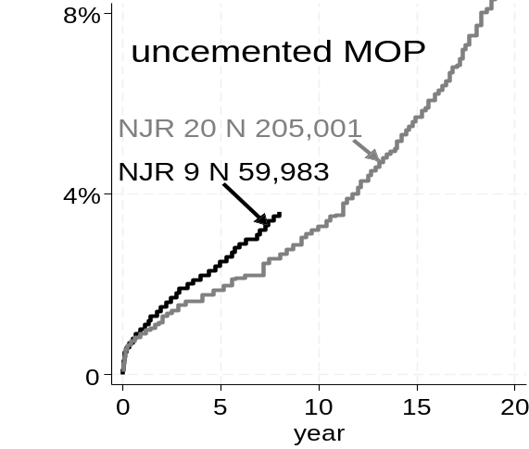
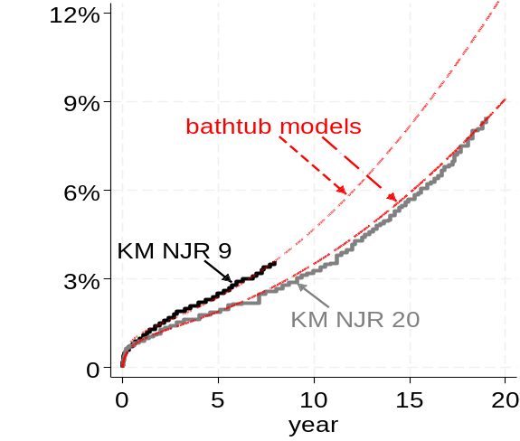

.

An analogous discordance is reported in the Swedish Arthroplasty Registry (SAR).
SAR 2018 Fig 7.1.1 and Table 7.1.3 provides implant failure for “standard” patients and for “other” patients after primary operation over the period 2008 to 2018. The SAR 2023 Report also provides implant failure for primary THR received over periods 1996 to 2004 and 2005 to 2013. These failure rates differ and are summarised below.
